Practical No: 1
Aim: Write a program to Create a class and Implement or demonstrates the concepts of constructor, this and static.
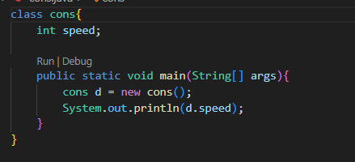
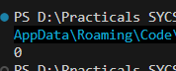
- Default Constructor:
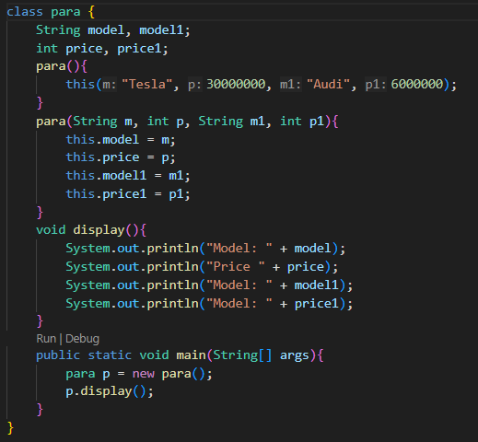
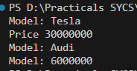
- Parameterised Constructor:

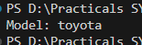
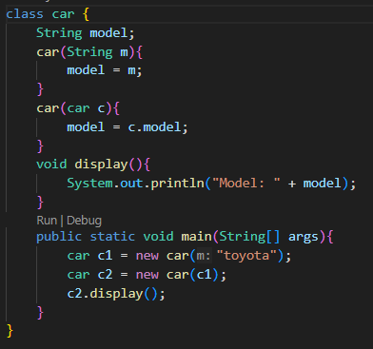
- Copy Constructor:
- Using this keyword:
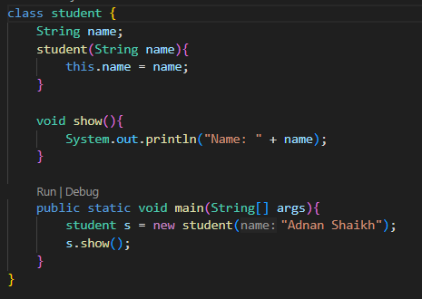
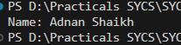

- Static Keyword:
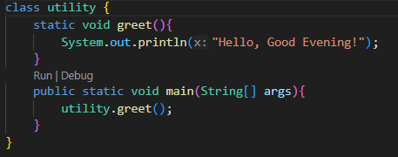
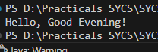
b) Aim: Write a program to implement the concept of inheritance and method overriding.
1. Single Inheritance:
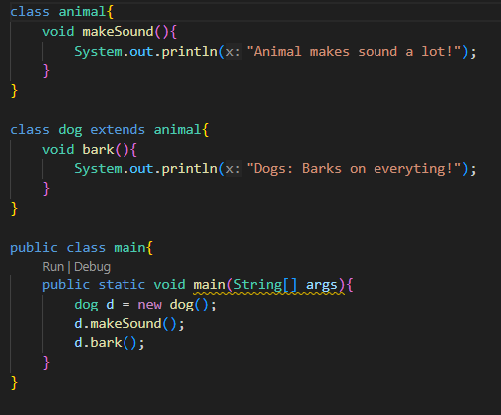
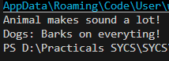

2. Multilevel Inheritance:
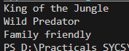
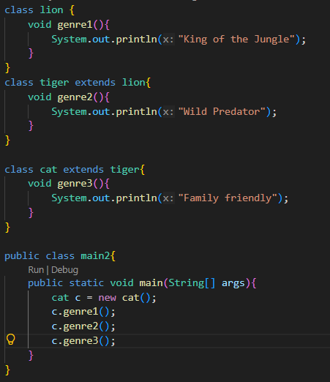
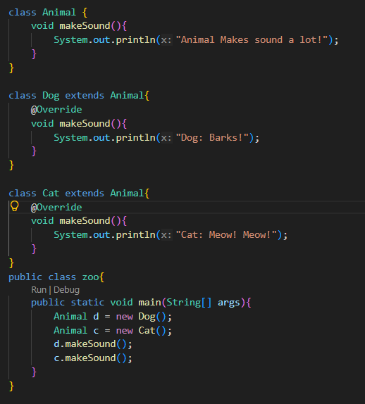
3. Method Overriding:

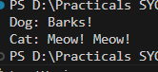
c) Aim: Write a program to demonstrate Polymorphism (Using in Method), Abstraction, and Encapsulation:
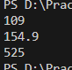
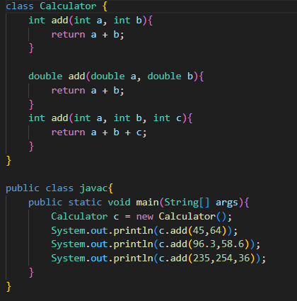
d) Abstraction and Encapsulation:
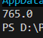
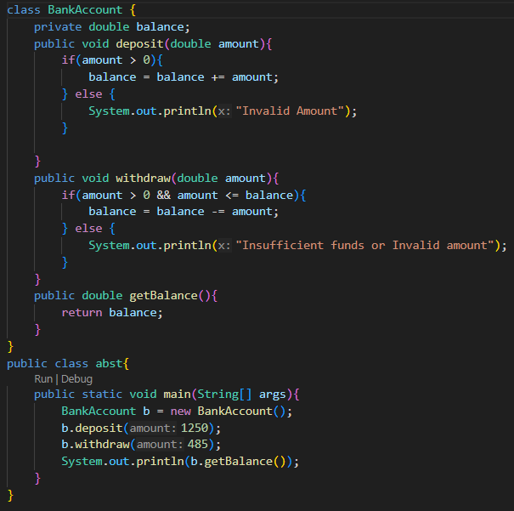
e) Abstract class and Method:
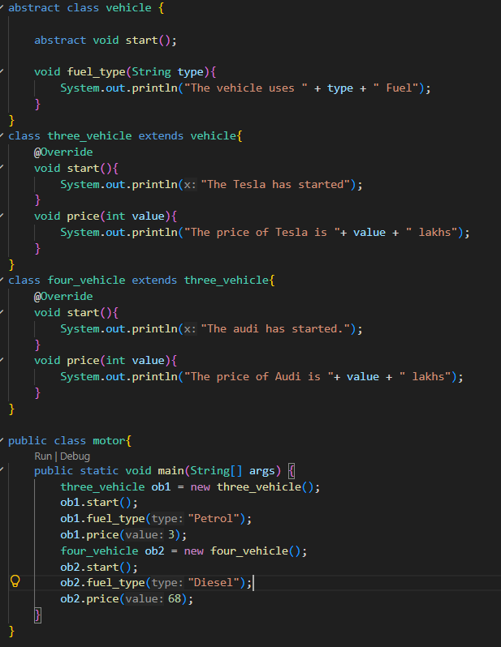
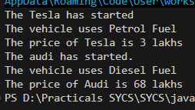

Practical No: 2
A)Aim: Write a program to implement predefined packages (java.util, java.io, etc.).
- Using java.util.Scanner for input:-
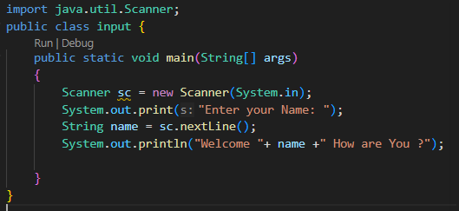
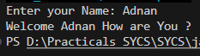
- Using java.lang.Math for Calculation:-
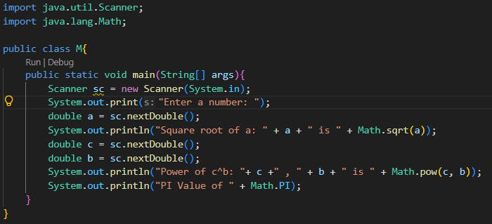
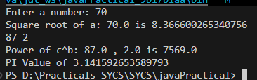
- Using java.time.LocalDate for time:- 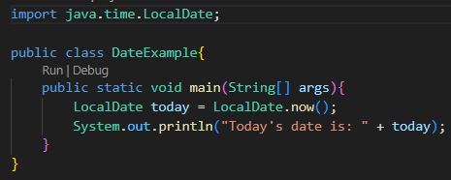
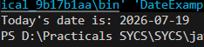
- Using java.io.File:-
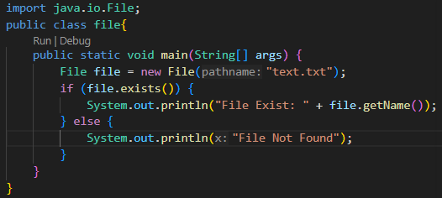
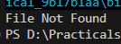
- Using java.net.URL for URL:-
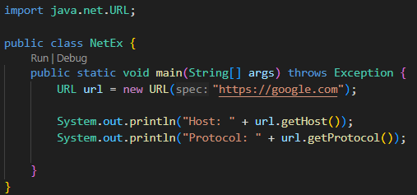
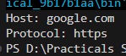

- Using java.security;-
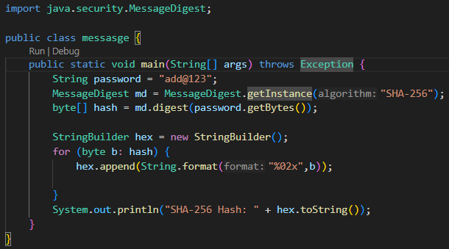
B)Write a Program to create and use a user defined packages.
- Create a package src.myapp.utils.Mathutils.java:
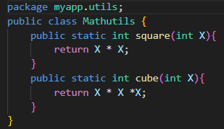
- Create another file to import packages:
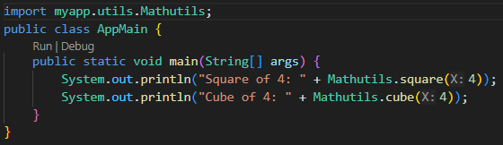
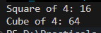

C)Aim: Write a program to demonstrate the use of access specifiers (Public, Private, Protected).
- Public Specifier: -
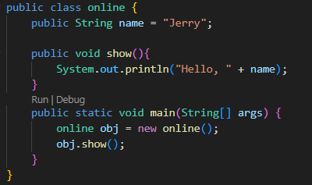
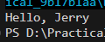
- Private Specifier: -
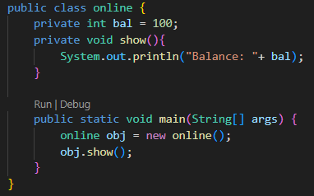
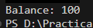0
- Protected Specifier: -
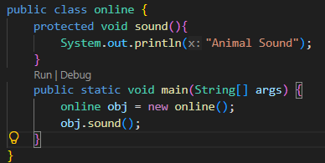
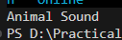

Practical No: 3
Aim: Write a program to demonstrate pre-defined Exception using try-catch finally.
- Arithmetic Exception:
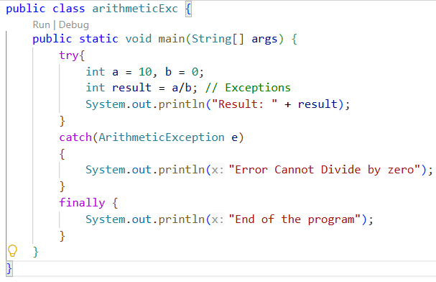
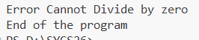

- Null Pointer Exception:
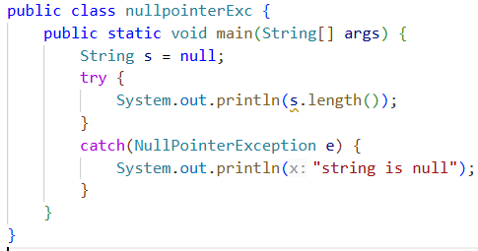
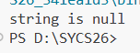

- Array Index Out of Bound Exception:
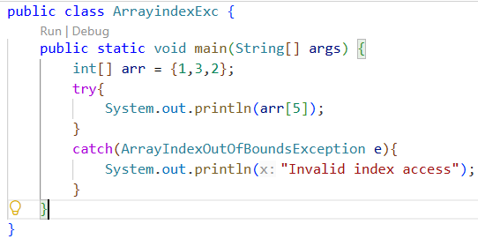
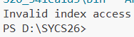
- Number Formatting:
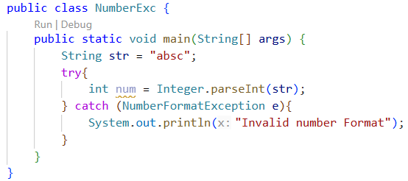
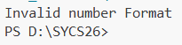
- Write a program to use Throw and Throws keywords:
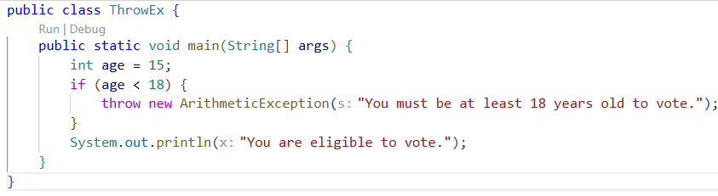

- Write a program to create and start Threads using thread class and Runnable Interface.
- Thread:
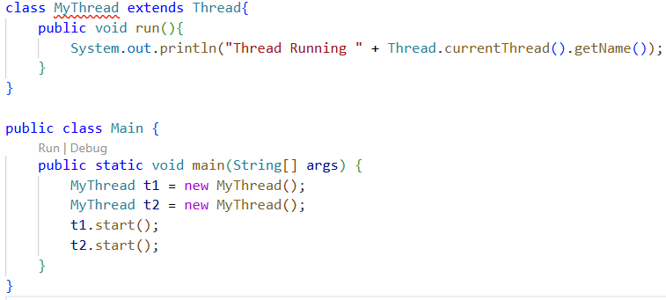
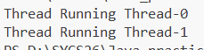
- Write a program to defined user defined exception.
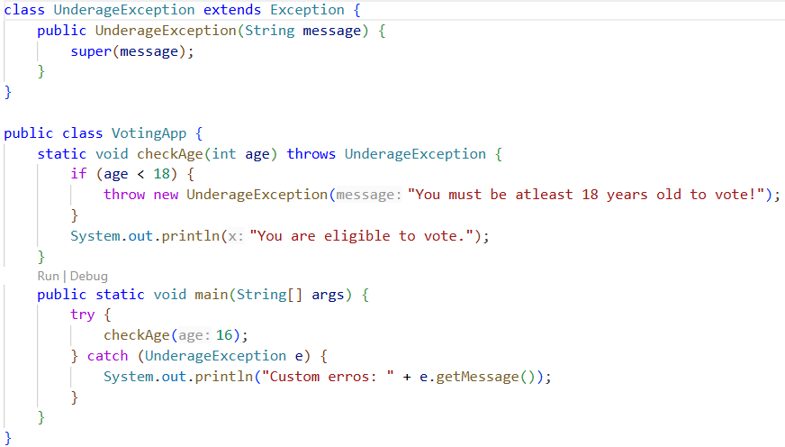

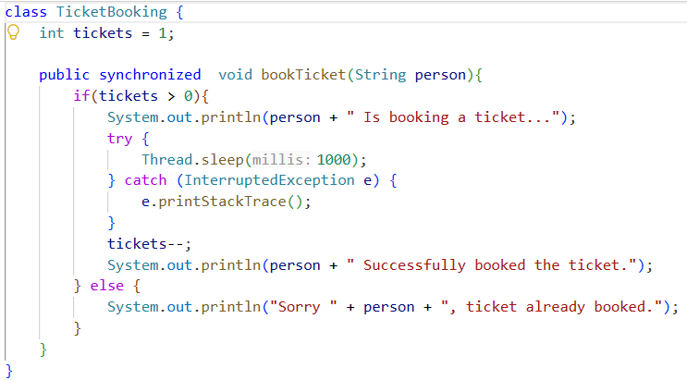
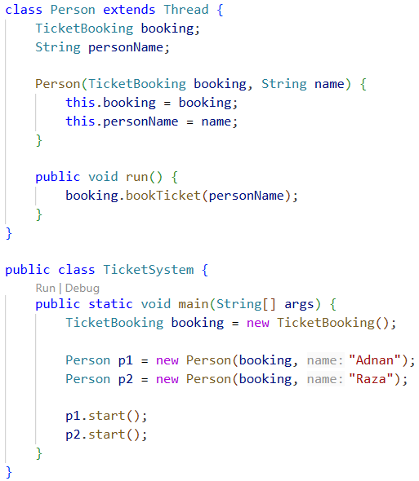
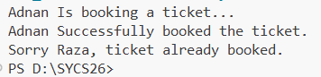
- Write a program to demonstrate thread Lifecycle.
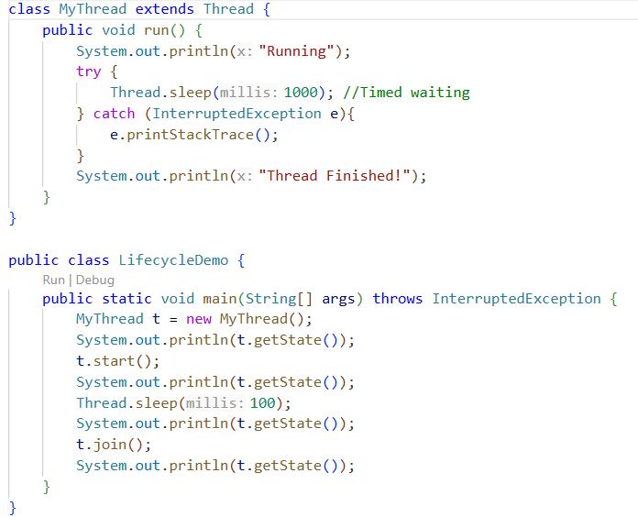
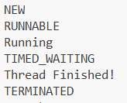
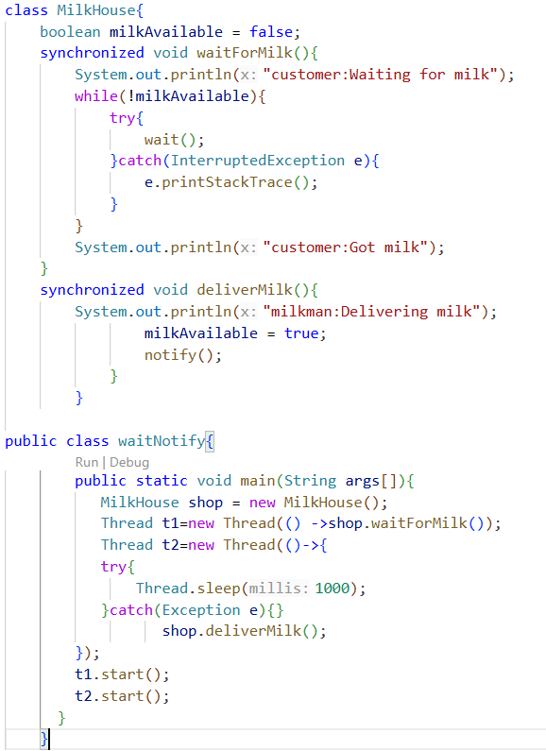
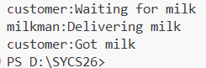

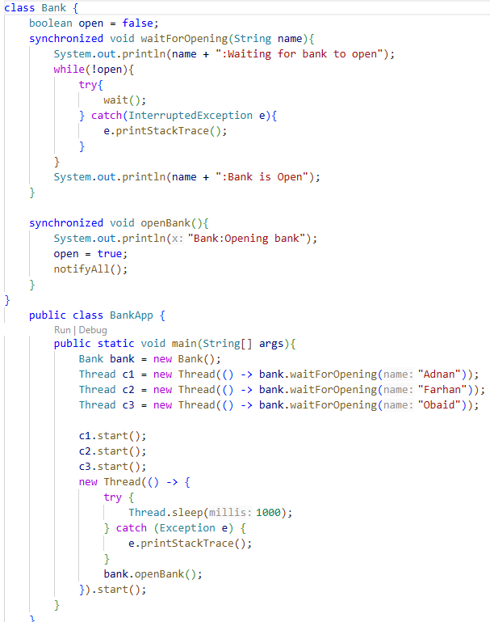
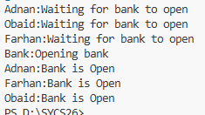

Practical No: 4
Aim: Write a program to demonstrate method or list interface using Array List and Linked list.
1.Array List:
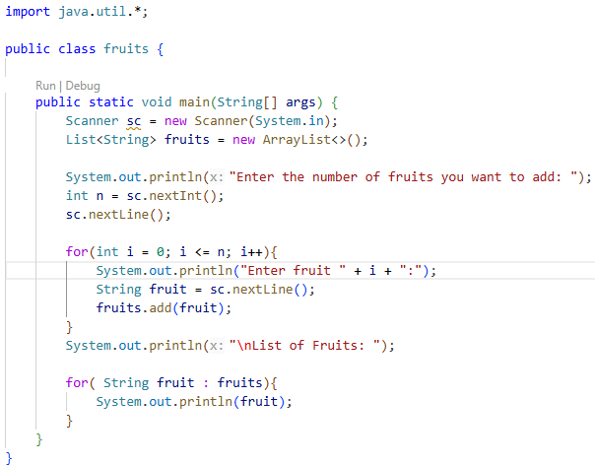
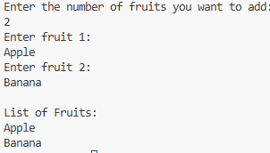
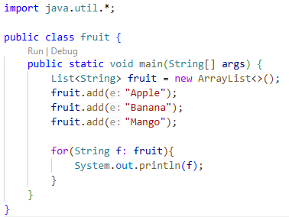
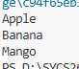
2.Linked List:
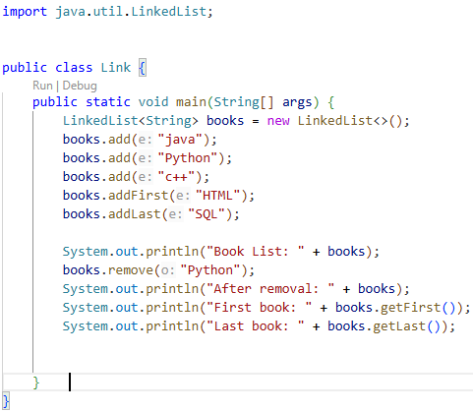
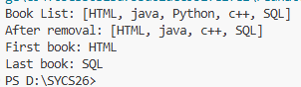

B) Aim: Write a program to demonstrate method or set interface using Hash Set and Tree Set.
1. Hast Set:
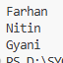
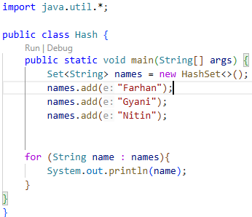
- Tree Set:
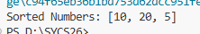
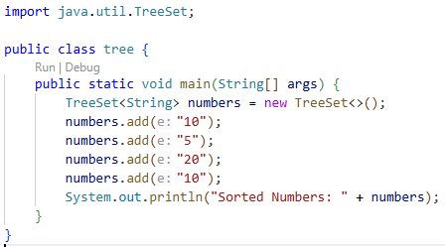

- Aim: Write a program to demonstrate method or Map interface using Hash Map.
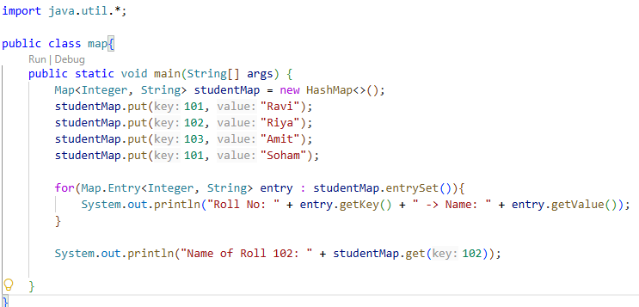
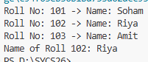

Practical No: 5
- Write a program using Swing components (JFrame, JPanel, JButton, JTextField, JLabel) to create a Simple Form.
- J Frame:
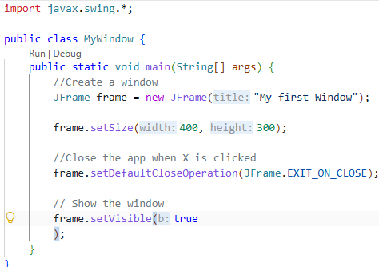
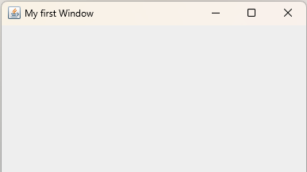

- J Panel:
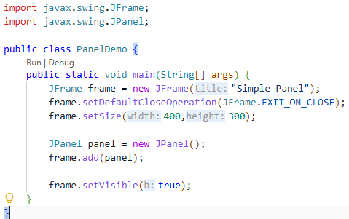
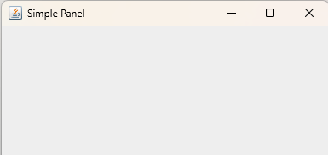
- J Button:
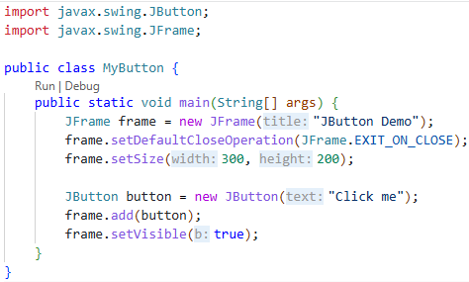
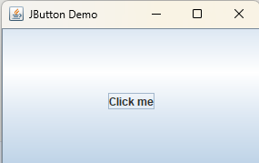
- J TextField:
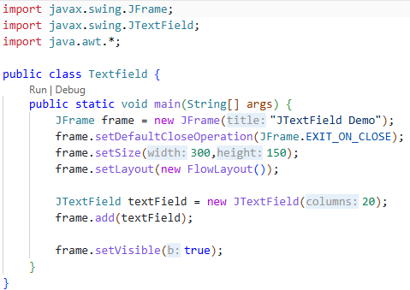
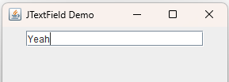

- J Label:
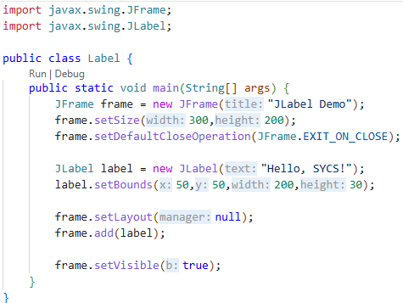
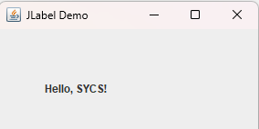

- Aim: Write a program to demonstrate the use of Different Layout Managers.
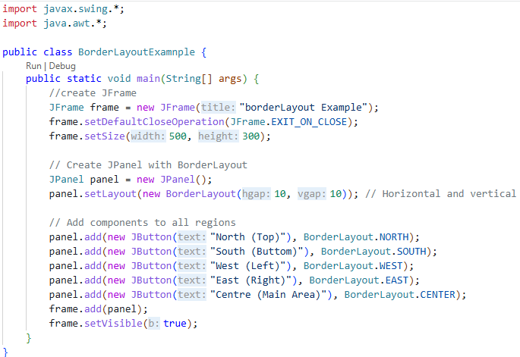
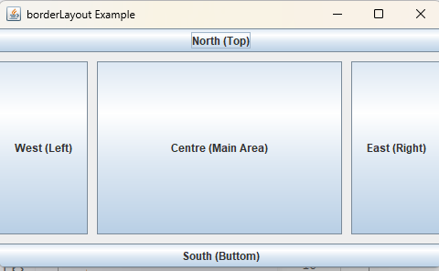

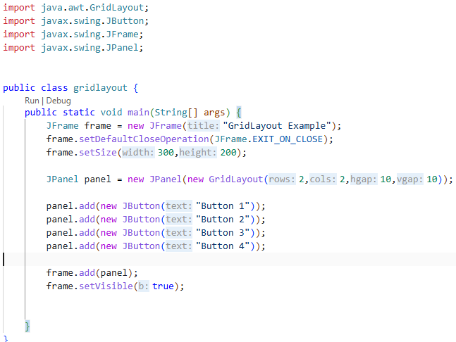
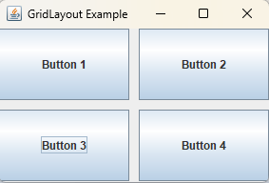

Practical No: 6
- Aim: Write a program Using Swing to design a Student Resume Form.
import java.awt.*;
import java.awt.event.ActionEvent;
import java.awt.event.ActionListener;
import javax.swing.*;

public class P5 extends JFrame implements ActionListener{
JFrame main_frame;
JLabel lname, lcontact , lemail;
JLabel lschool, lsy , lsa;
JLabel ljcollege, ljcy , ljca;
JLabel lscollege, lscy , lsca;
JLabel laddress, lskills;

JTextField sname, scontact, semail;
JTextField sschool, ssy, ssa;
JTextField sjcollege, sjcy, sjca;
JTextField sscollege, sscy, ssca;

JTextArea saddress, sskills;

JRadioButton male;
JRadioButton female;

ButtonGroup gender;

JButton submit , reset;

P5(){
main_frame= new JFrame("Resume Form");

lname=new JLabel("Name");
lcontact=new JLabel("Contact Number");
lemail=new JLabel("Email");
lname.setBounds(10,10,300,30);
lcontact.setBounds(10,50,300,30);
lemail.setBounds(10,80,300,30);

lschool=new JLabel("School Name");
lsy=new JLabel("Passing Year");
lsa=new JLabel("Aggregate");
lschool.setBounds(10,250,200,50);
lsy.setBounds(310,250,200,50);
lsa.setBounds(610,250,200,50);

ljcollege=new JLabel("Jr. College Name");
ljcy=new JLabel("Passing Year");
ljca=new JLabel("Aggregate");
ljcollege.setBounds(10,350,200,50);
ljcy.setBounds(310,350,200,50);
ljca.setBounds(610,350,200,50);

lscollege=new JLabel("Sr. College Name");
lscy=new JLabel("Passing Year");
lsca=new JLabel("Aggregate");
lscollege.setBounds(10,450,200,50);
lscy.setBounds(310,450,200,50);
lsca.setBounds(610,450,200,50);

laddress =new JLabel("Address");
lskills= new JLabel("Skills");
laddress.setBounds(10,140,100,30);
lskills.setBounds(300,140,100,30);

sname=new JTextField();
scontact=new JTextField();
semail=new JTextField();
sname.setBounds(220,10,300,30);
scontact.setBounds(220,40,300,30);
semail.setBounds(220,70,300,30);

sschool=new JTextField();
ssy=new JTextField();
ssa=new JTextField();
sschool.setBounds(10,300,300,30);
ssy.setBounds(310,300,300,30);
ssa.setBounds(610,300,300,30);

sjcollege=new JTextField();
sjcy=new JTextField();
sjca=new JTextField();
sjcollege.setBounds(10,400,300,30);
sjcy.setBounds(310,400,300,30);
sjca.setBounds(610,400,300,30);

sscollege=new JTextField();
sscy=new JTextField();
ssca=new JTextField();
sscollege.setBounds(10,500,300,30);
sscy.setBounds(310,500,300,30);
ssca.setBounds(610,500,300,30);

saddress=new JTextArea();
sskills=new JTextArea();
saddress.setBounds(10,170,275,70);
sskills.setBounds(300,170,275,70);

male=new JRadioButton("Male");
female=new JRadioButton("Female");
male.setBounds(220,110,100,30);
female.setBounds(320,110,100,30);

gender=new ButtonGroup();

submit=new JButton("Submit");
reset=new JButton("Reset");
submit.setBounds(275,550,100,30);
reset.setBounds(425,550,100,30);

gender.add(male);
gender.add(female);

main_frame.add(lname);
main_frame.add(lcontact);
main_frame.add(lemail);

main_frame.add(sname);
main_frame.add(scontact);
main_frame.add(semail);

main_frame.add(laddress);
main_frame.add(lskills);

main_frame.add(saddress);
main_frame.add(sskills);

main_frame.add(male);
main_frame.add(female);

main_frame.add(lschool);
main_frame.add(lsy);
main_frame.add(lsa);

main_frame.add(lscollege);
main_frame.add(lscy);
main_frame.add(lsca);

main_frame.add(sscollege);
main_frame.add(sscy);
main_frame.add(ssca);

main_frame.add(sschool);
main_frame.add(ssy);
main_frame.add(ssa);

main_frame.add(ljcollege);
main_frame.add(ljcy);
main_frame.add(ljca);

main_frame.add(sjcollege);
main_frame.add(sjcy);
main_frame.add(sjca);

main_frame.add(submit);
main_frame.add(reset);

submit.addActionListener(this);
reset.addActionListener(this);

main_frame.setSize(1000,1000);
main_frame.setLayout(null);
main_frame.setVisible(true);
}
public void actionPerformed(ActionEvent e){
if(e.getSource()==submit){
JOptionPane.showMessageDialog(this,"Information are saved successfully..");
}
else if (e.getSource()==reset){
sname.setText("");
scontact.setText("");
semail.setText("");
sschool.setText("");
ssy.setText("");
ssa.setText("");
sjcollege.setText("");
sjcy.setText("");
sjca.setText("");
sscollege.setText("");
sscy.setText("");
ssca.setText("");
saddress.setText("");
sskills.setText("");
gender.clearSelection();
}
}
public static void main(String [] args){
P5 f = new P5();
f.setDefaultCloseOperation(DISPOSE_ON_CLOSE);
}
}
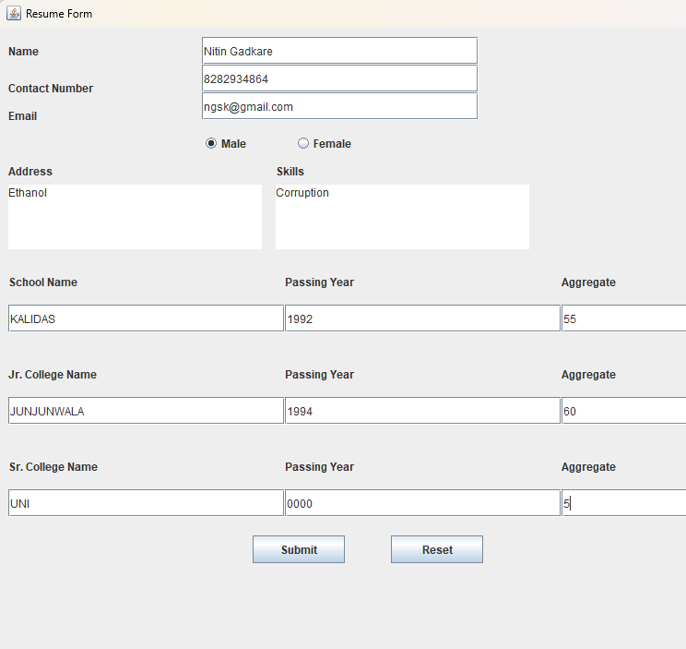
- Aim: Write a Program to Implement Event Handling Using ActionListener.
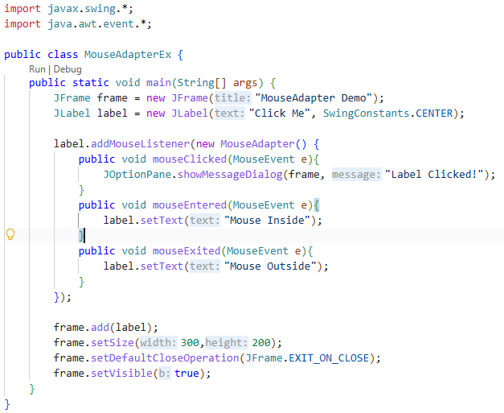
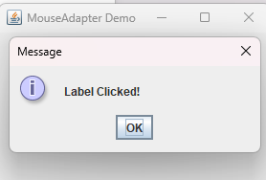

- Aim: Write a program to demonstrate the use of Adapter Classes in Swing
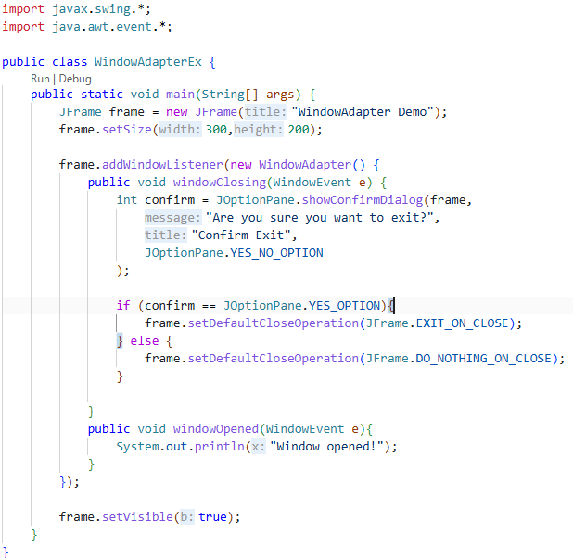
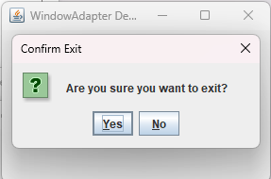

Practical No: 7
- Aim: Design a Calculator GUI and Perform arithmetic operations using Event Handling.
package JAVA_practical.pract7;

import javax.swing.*;
import java.awt.*;
import java.awt.event.ActionEvent;
import java.awt.event.ActionListener;

public class Main extends JFrame implements ActionListener{

private JTextField textField;
private JButton[] numberButtons;
private JButton[] functionButtons;
private JButton addButton, subButton, mulButton, divButton, eqButton, clrButton, backspaceButton;
private JPanel panel, textFieldPanel;

private double num1 = 0, num2 = 0, result = 0;
private char operator;

public Main() {
setTitle("CalCulator");
setSize(350,450);
setDefaultCloseOperation(EXIT_ON_CLOSE);
setResizable(false);

textField = new JTextField();
textField.setEditable(false);
textField.setHorizontalAlignment(JTextField.RIGHT);
textField.setPreferredSize(new Dimension(300,50));
textField.setFont(new Font("Arial", Font.PLAIN, 40));

textFieldPanel = new JPanel(new BorderLayout());
textFieldPanel.add(textField, BorderLayout.CENTER);

numberButtons = new JButton[10];
for (int i = 0; i < 10; i++){
numberButtons[i] = new JButton(String.valueOf(i));
numberButtons[i].addActionListener(this);
numberButtons[i].setFont(new Font("Arial", Font.PLAIN, 20));
}

addButton = new JButton("+");
subButton = new JButton("-");
mulButton = new JButton("*");
divButton = new JButton("/");
eqButton = new JButton("=");
clrButton = new JButton("C");
backspaceButton = new JButton("<");

functionButtons = new JButton[]{addButton, subButton, mulButton, divButton, eqButton, clrButton, backspaceButton};
for (JButton button : functionButtons) {
button.addActionListener(this);
button.setFont(new Font("Arial", Font.PLAIN, 20));
}
panel = new JPanel(new GridBagLayout());
GridBagConstraints gbc = new GridBagConstraints();
gbc.gridx = 0;
gbc.gridy = 0;
gbc.gridwidth = 4;
gbc.fill = GridBagConstraints.HORIZONTAL;
gbc.insets = new Insets(10, 10, 10, 10);
panel.add(textFieldPanel, gbc);

gbc.gridwidth = 1;
gbc.gridy = 1;
gbc.fill = GridBagConstraints.BOTH;
panel.add(clrButton, gbc);
gbc.gridx++;
panel.add(addButton, gbc);
gbc.gridx++;
panel.add(subButton, gbc);
gbc.gridx++;
panel.add(backspaceButton, gbc);

gbc.gridx = 0;
gbc.gridy++;
panel.add(numberButtons[7], gbc);
gbc.gridx++;
panel.add(numberButtons[8], gbc);
gbc.gridx++;
panel.add(numberButtons[9], gbc);
gbc.gridx++;
panel.add(mulButton, gbc);

gbc.gridx = 0;
gbc.gridy++;
panel.add(numberButtons[4], gbc);
gbc.gridx++;
panel.add(numberButtons[5], gbc);
gbc.gridx++;
panel.add(numberButtons[6], gbc);
gbc.gridx++;
panel.add(divButton, gbc);

gbc.gridx = 0;
gbc.gridy++;
panel.add(numberButtons[1], gbc);
gbc.gridx++;
panel.add(numberButtons[2], gbc);
gbc.gridx++;
panel.add(numberButtons[3], gbc);
gbc.gridx++;
panel.add(eqButton, gbc);

gbc.gridx = 0;
gbc.gridy++;
gbc.gridwidth = 4;
panel.add(numberButtons[0], gbc);

add(panel);
setVisible(true);

}
public static void main(String[] args) {
new Main();
}

@Override
public void actionPerformed(ActionEvent e){
for(int i = 0; i < 10; i++) {
if (e.getSource() == numberButtons[i]) {
textField.setText(textField.getText().concat(String.valueOf(i)));
}
}

if (e.getSource() == clrButton) {
textField.setText("");

}
if ( e.getSource() == backspaceButton) {
String currentText = textField.getText();
if (currentText.length() > 0) {
textField.setText(currentText.substring(0,currentText.length() - 1));
}
}

if (e.getSource() == addButton) {
num1 = Double.parseDouble(textField.getText());
operator = '+';
textField.setText("");
}
if (e.getSource() == subButton) {
num1 = Double.parseDouble(textField.getText());
operator = '-';
textField.setText("");
}
if (e.getSource() == mulButton) {
num1 = Double.parseDouble(textField.getText());
operator = '*';
textField.setText("");
}
if (e.getSource() == divButton) {
num1 = Double.parseDouble(textField.getText());
operator = '/';
textField.setText("");
}

if (e.getSource() == eqButton) {
num2 = Double.parseDouble(textField.getText());

switch (operator) {
case '+':
result = num1 + num2;
break;
case '-':
result = num1 - num2;
break;
case '*':
result = num1 * num2;
break;
case '/':
if (num2 != 0) {
result = num1 / num2;
} else {
result = Double.POSITIVE_INFINITY;
}
break;

}

textField.setText(String.valueOf(result));
num1 = result;
}
}
}

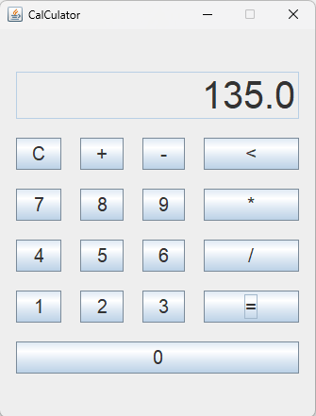

Practical No: 8
- Aim: Create and deploy a simple Servlet and display HTML output.
Pom.xml:
<project xmlns="http://maven.apache.org/POM/4.0.0"
xmlns:xsi="http://www.w3.org/2001/XMLSchema-instance"
xsi:schemaLocation="http://maven.apache.org/POM/4.0.0
http://maven.apache.org/xsd/maven-4.0.0.xsd">

<modelVersion>4.0.0</modelVersion>

<groupId>org.example</groupId>
<artifactId>ServletDemo</artifactId>
<version>1.0-SNAPSHOT</version>

<packaging>war</packaging>

<dependencies>

<dependency>
<groupId>jakarta.servlet</groupId>
<artifactId>jakarta.servlet-api</artifactId>
<version>6.0.0</version>
<scope>provided</scope>
</dependency>

</dependencies>

<build>
<finalName>ServletDemo</finalName>
</build>

</project>

HelloServlet.java:
package com.mycompany;

import jakarta.servlet.ServletException;
import jakarta.servlet.annotation.WebServlet;
import jakarta.servlet.http.HttpServlet;
import jakarta.servlet.http.HttpServletRequest;
import jakarta.servlet.http.HttpServletResponse;

import java.io.IOException;
import java.io.PrintWriter;

@WebServlet("/hello")
public class HelloServlet extends HttpServlet {

@Override
protected void doGet(HttpServletRequest request,
HttpServletResponse response)
throws ServletException, IOException {

response.setContentType("text/html");

PrintWriter out = response.getWriter();

out.println("<html>");
out.println("<body>");

out.println("<h1>Hello Students</h1>");
out.println("<h2>Servlet Practical Using IntelliJ IDEA</h2>");
out.println("<p>HTML Generated by Java Servlet</p>");

out.println("</body>");
out.println("</html>");
}
}

Index.jsp:
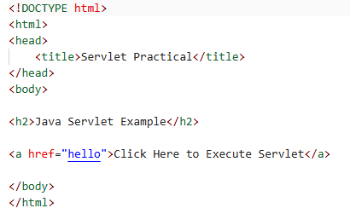
Output:
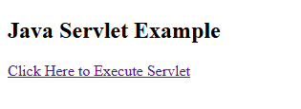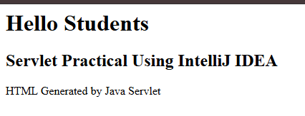

- Aim: Demonstrate the Servlet LifeCycle: init(), service(), destroy().
Pom.xml:
<project xmlns="http://maven.apache.org/POM/4.0.0"
xmlns:xsi="http://www.w3.org/2001/XMLSchema-instance"
xsi:schemaLocation="http://maven.apache.org/POM/4.0.0
http://maven.apache.org/xsd/maven-4.0.0.xsd">

<modelVersion>4.0.0</modelVersion>

<groupId>org.example</groupId>
<artifactId>ServletDemo</artifactId>
<version>1.0-SNAPSHOT</version>

<packaging>war</packaging>

<dependencies>

<dependency>
<groupId>jakarta.servlet</groupId>
<artifactId>jakarta.servlet-api</artifactId>
<version>6.0.0</version>
<scope>provided</scope>
</dependency>

</dependencies>

<build>
<finalName>ServletDemo</finalName>
</build>

</project>

HelloServlet.java:
package org.example.servletlifecycle;

import java.io.*;

import jakarta.servlet.http.*;
import jakarta.servlet.annotation.*;

@WebServlet(name = "helloServlet", value = "/hello-servlet")
public class HelloServlet extends HttpServlet {
private String message;

public void init() { message = "Hello World!";}

public void doGet(HttpServletRequest request, HttpServletResponse response) throws IOException {
response.setContentType("text/html");

//Hello
PrintWriter out = response.getWriter();
out.println("<html><body>");
out.println("<h1>" + message + "</h1>");
out.println("</body></html>");
}

public void destroy() {

}
}

LifeCycleServlet.java:
package org.example.servletlifecycle;

import java.io.IOException;
import java.io.PrintWriter;

import jakarta.servlet.ServletException;
import jakarta.servlet.http.HttpServlet;
import jakarta.servlet.http.HttpServletRequest;
import jakarta.servlet.http.HttpServletResponse;
import jakarta.servlet.annotation.WebServlet;

@WebServlet("/lifecycle")
public class LifeCycleServlet extends HttpServlet {

@Override
public void init() throws ServletException {
System.out.println("init() method Called");
}

@Override
protected void service(HttpServletRequest request,
HttpServletResponse response)
throws ServletException, IOException {

System.out.println("service() method called");

response.setContentType("text/html");

PrintWriter out = response.getWriter();

out.println("<html>");
out.println("<body>");
out.println("<h1>Servlet Life Cycle Demo</h1>");
out.println("<h2>service() method executed successfully.</h2>");
out.println("</body>");
out.println("</html>");
}

@Override
public void destroy() { System.out.println("destroy() method called");}
}

Output:
http://localhost:8080/ServletLifeCycle/lifecycle
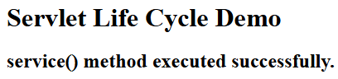

http://localhost:8080/ServletLifeCycle/
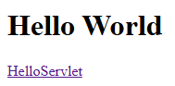
http://localhost:8080/ServletLifeCycle/hello-servlet
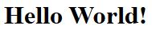

Practical No: 9
- Aim: Demonstrate ServletConfig and ServletContext.

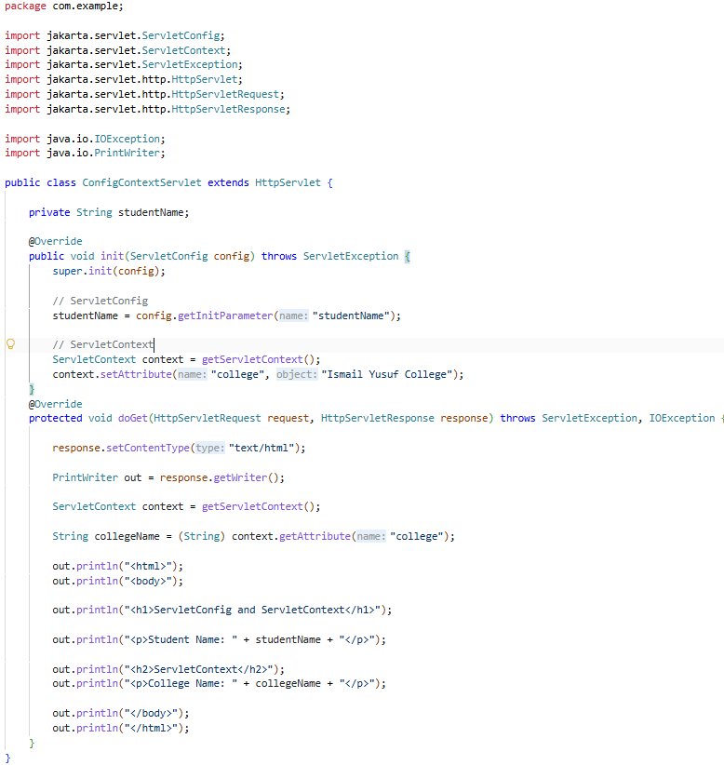
ConfigContextServlet.java:

Web.xml:
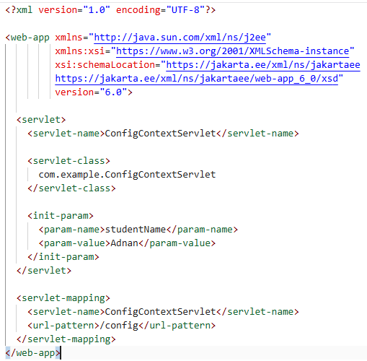

OUTPUT:
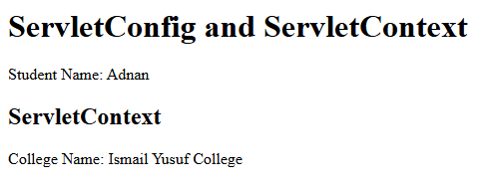

- Aim: Demonstrate RequestDispatcher using forward() and include().

Tomcat Configuration:
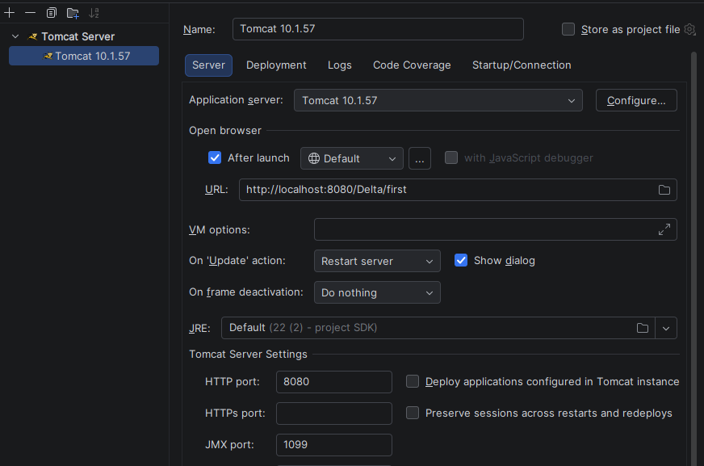

FirstServlet.java:
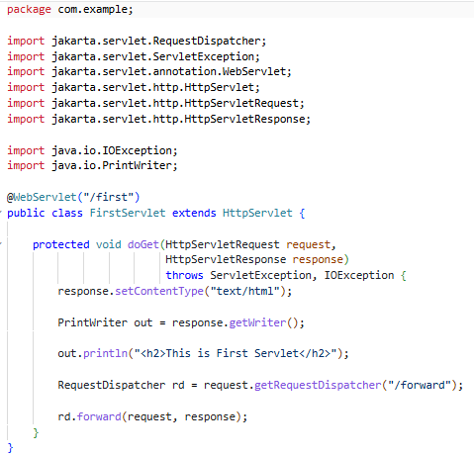
ForwardServlet.java:
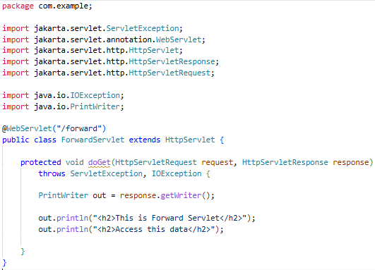
IncludeServlet.java:
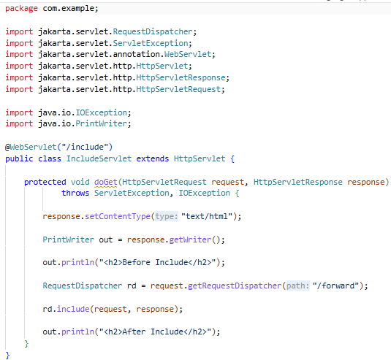

OUTPUT:
http://localhost:8080/Delta/first
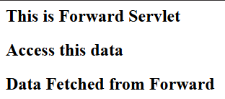
http://localhost:8080/Delta/forward
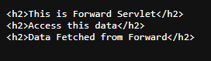
http://localhost:8080/Delta/include
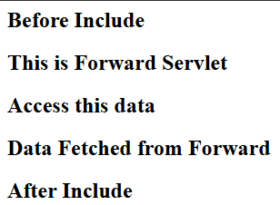

Practical No: 10
- Aim: Implement Response Redirection in Servlet.

Age.html:
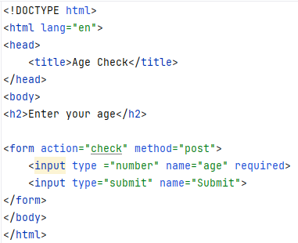

AgeCheckServlet.java:
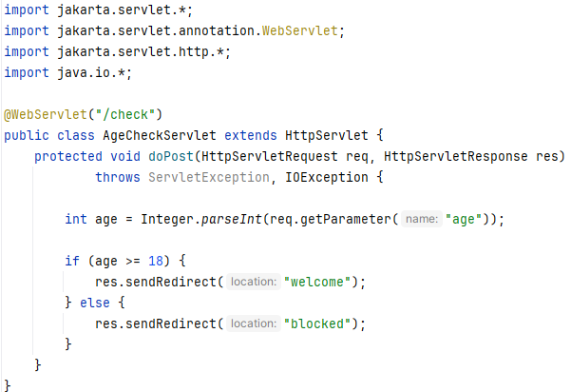

WelcomeServlet.java:
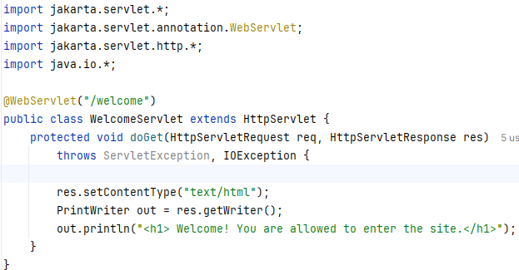

BlockedServlet.java:
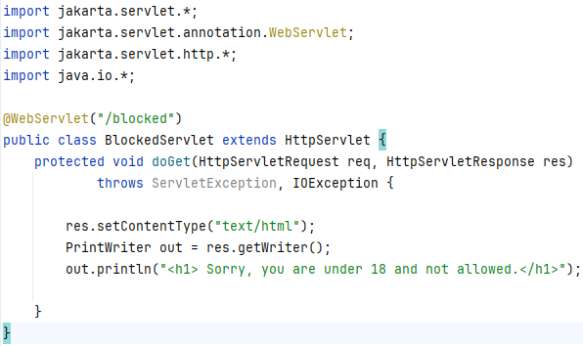

Web.xml:
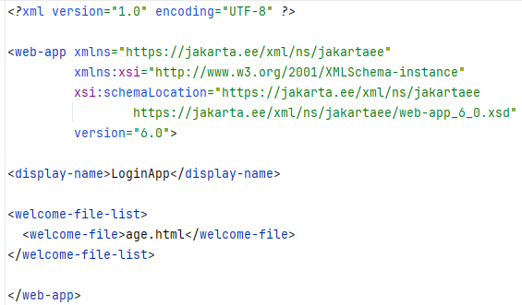

OUTPUT:
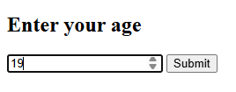

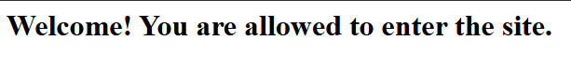

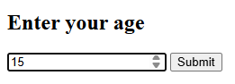

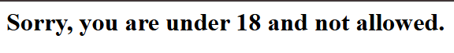

- Aim: Implement Session Tracking using Cookies.

Get Session Cookies:
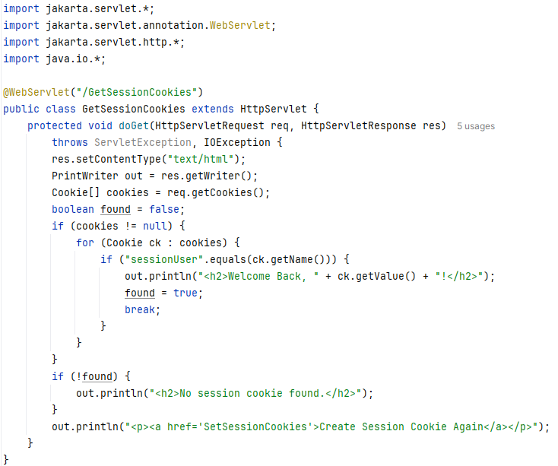

Set Session Cookies:
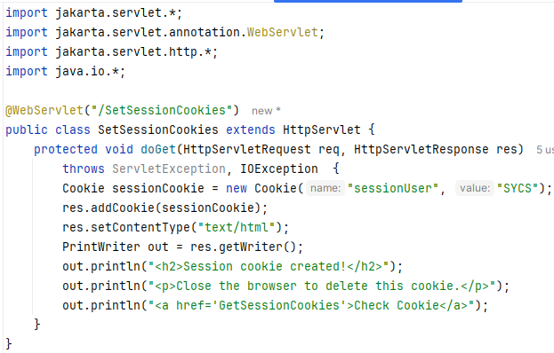
Web.XML
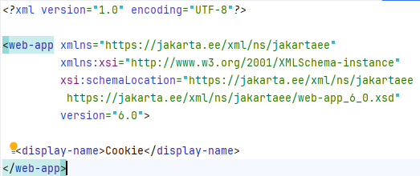

OUTPUT:

http://localhost:8080/Cookie/SetSessionCookies

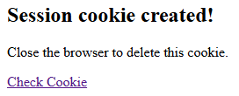

http://localhost:8080/Cookie/GetSessionCookies

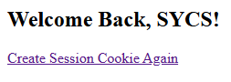

- Aim: Implement Session Tracking using URL Rewriting and HttpSession.

      - Login.html
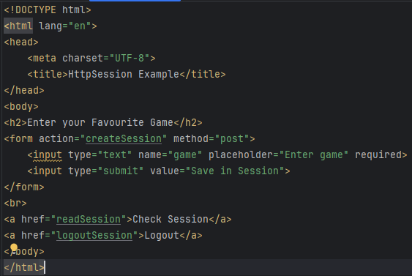

      - CreateSessionServlet
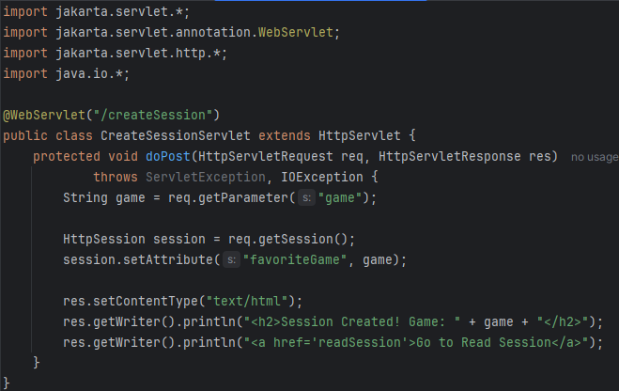

      - ReadSessionServlet
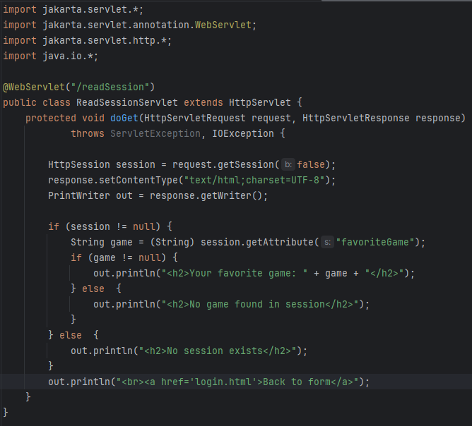

      - LogoutSessionServlet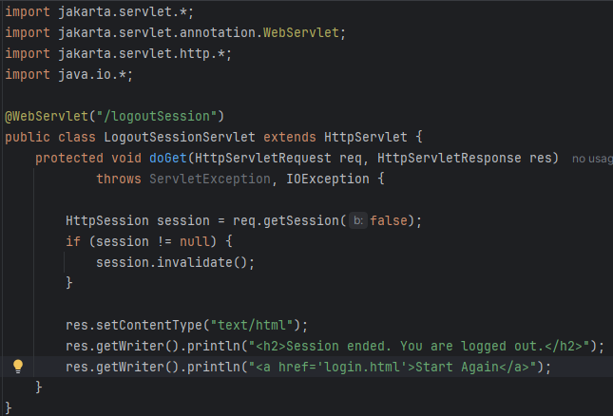
OUTPUT:
