Logo
DATA ANALYTICS
(Course Code)
Record File
Semester-IV

Submitted by:
Student Name:
system ID:
Roll No.:
Section:
Submitted To:

Table of Contents
S. No. | CONTENT | Page No.
1 | Name of the project
2 | Problem Statement with data set  - Project Objective  - Dataset Description (2019)
3 | Work Done By me  - Data Cleaning & Validation  - Funnel Metric Calculation  - Week-on-Week Analysis  - Dashboard Creation
4 | My Analysis  - Conversion Performance  - Funnel Stage Insights  - Traffic vs Orders Analysis  - Week-on-Week Insights
5 | Graph Description:  - Orders Trend  - Traffic Trend  - Overall Conversion Trend  - Funnel Breakdown  - Week-on-Week Comparison
6 | Conclusion:  - Summary of Findings
7 | References / Source of Information

Project Report
1. Name of the Project:
Swiggy Funnel Conversion Analysis Report
2. Problem Statement with Data Set:
Problem Statement:
Swiggy is a food delivery platform where users go through multiple stages before placing an order. However, not all users complete the journey. The key challenge is to analyze user drop-offs across different funnel stages and identify inefficiencies affecting overall conversion.
The objectives of this project are:
• Analyze user flow across funnel stages
• Identify stages with highest drop-offs
• Track overall conversion performance
• Perform week-on-week comparison for meaningful insights
• Detect whether issues are demand-driven or conversion-driven
Data Set:
The dataset used contains daily session-level data for the year 2019. Each row represents user activity for a given day. The dataset includes:
• Date
• Listing Sessions
• Menu Sessions
• Cart Sessions
• Payment Sessions
• Order Sessions
Figure 2.1: Session Details Data from Excel Dataset
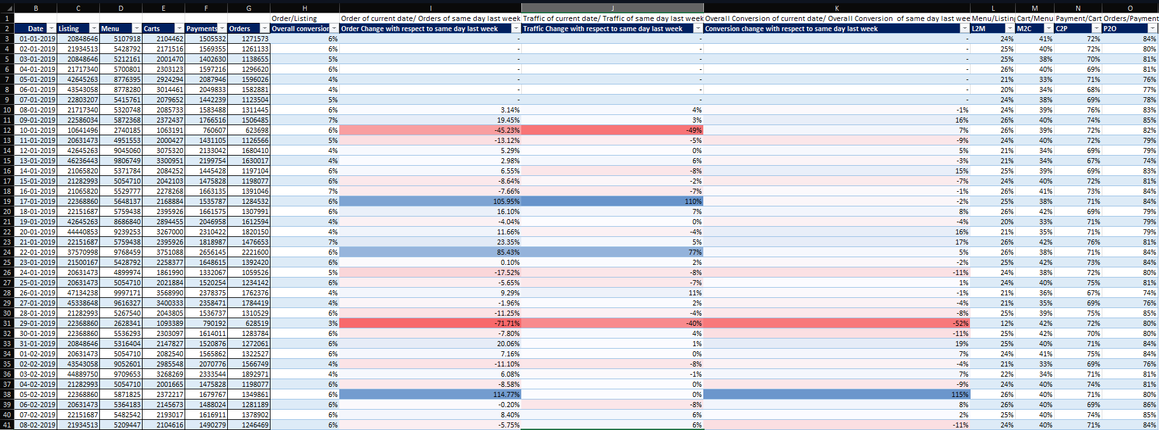
(Figure 2.1: Raw Funnel Dataset from Excel)
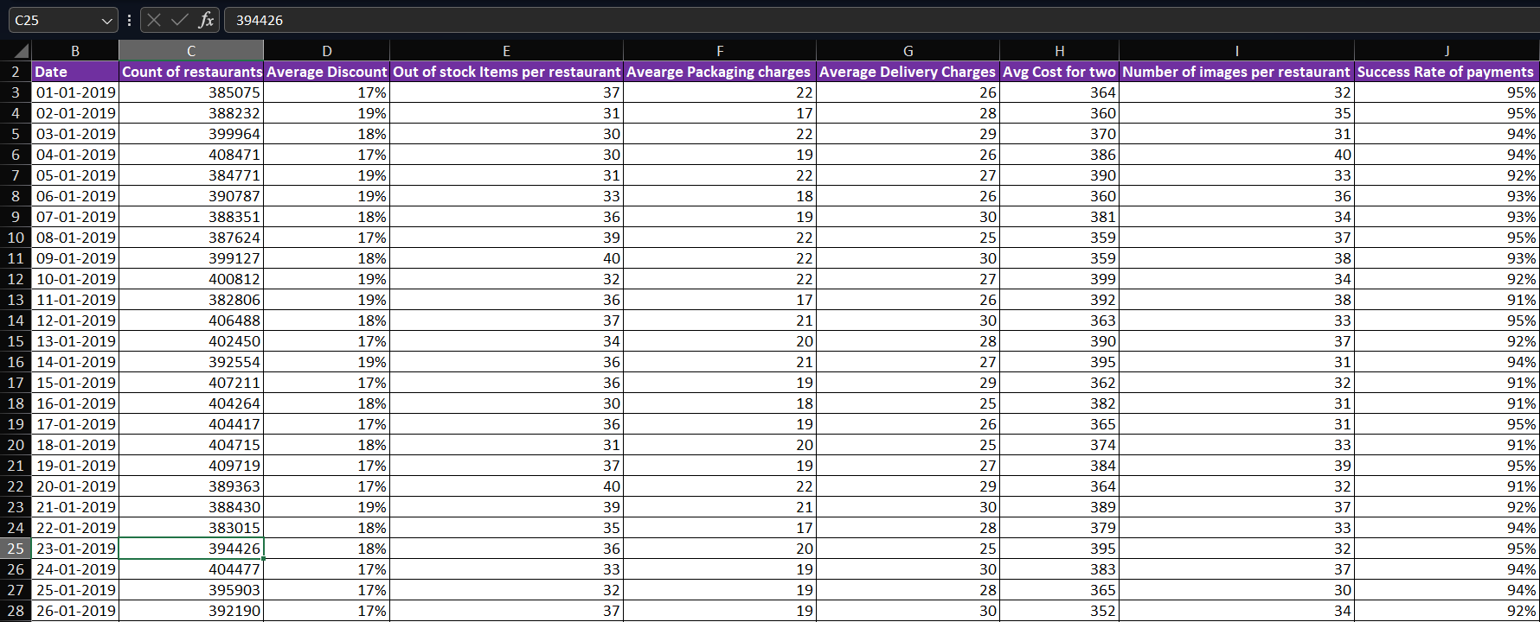
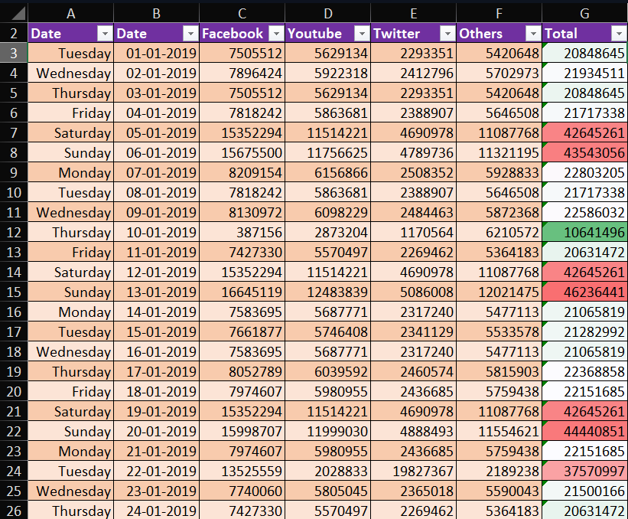
Figure 2.3: Supporting_Data Data from Excel Dataset

Figure 2.2: Channel wise traffic Data from Excel Dataset

3. Work Done By Me:
For this project, I used Microsoft Excel to convert raw session data into meaningful insights. The workflow included:
• Data Cleaning & Validation:
Ensured all session values were numeric and logically consistent
• Funnel Metric Calculation:
Calculated stage-wise conversion rates:
• Listing → Menu (L2M)
• Menu → Cart (M2C)
• Cart → Payment (C2P)
• Payment → Order (P2O)
• Overall Conversion = Orders ÷ Listing Sessions
• Week-on-Week Analysis:
Compared performance with same weekday of previous week to remove bias
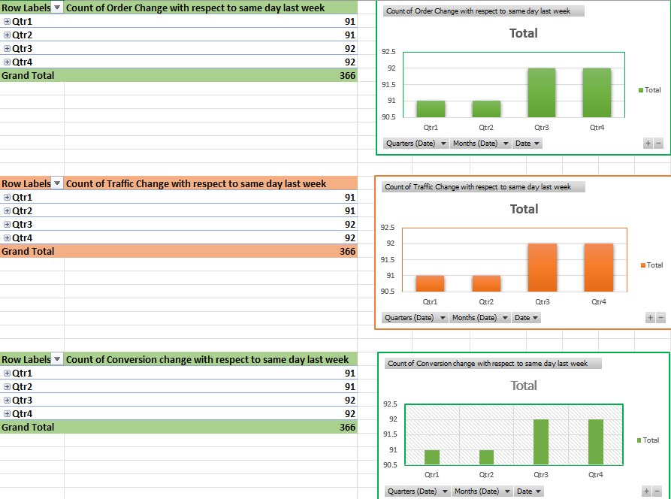
• Dashboard Creation:
Built a dashboard with trend charts for:
• Orders
• Traffic (Listing Sessions)
• Conversion Rates
• Funnel Stage Breakdown
Figure 3.1: Funnel Dashboard Overview

4. My Analysis:
My analysis of the Swiggy funnel data revealed the following key insights:
• Overall Conversion Performance:
The average conversion rate is approximately 5.4%, indicating that only a small fraction of users complete the full journey
• Funnel Stage Performance:
• Best Stage: Payment → Order (P2O)
• Weakest Stage: Menu → Cart (M2C) → major drop-off point
• Traffic vs Orders Insight:
• When both traffic and orders drop → demand issue
• When traffic is stable but orders drop → conversion problem
• User Behavior Trends:
• High drop-offs at early stages indicate browsing without intent
• Checkout stages are relatively stable
• Week-on-Week Insights:
• Helps identify real performance changes instead of daily fluctuations
• Highlights consistent patterns in user behavior

5. Graph Description:
5.1 Graph: Orders Trend
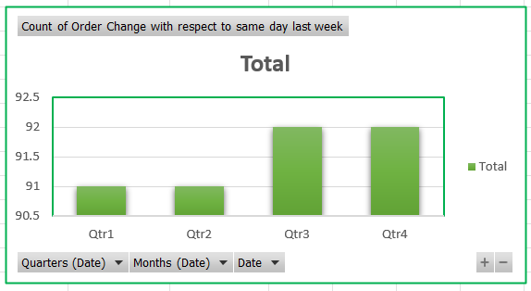
• Description: Daily order volume over time
• Analysis:
• Peaks observed during weekends
• Sudden drops indicate either demand issues or funnel inefficiencies
Figure 5.1: Orders Trend Analysis
5.2 Graph: Traffic Trend (Listing Sessions)
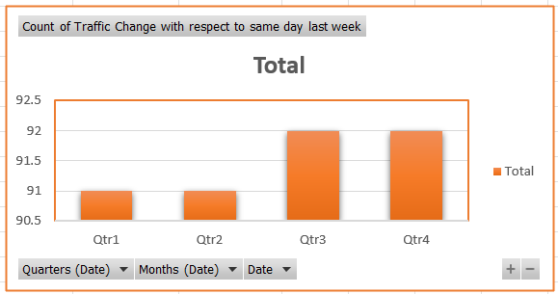
• Description: Represents total users entering the platform
• Analysis:
• Direct indicator of demand
• Stable traffic with declining orders indicates conversion issues
Figure 5.2: Traffic Trend
5.3 Graph: Overall Conversion Trend

• Description: Orders ÷ Listing Sessions over time
• Analysis:
• Fluctuations highlight efficiency of funnel
• Declining trend signals internal system or UX issues
Figure 5.3: Overall Conversion Trend

5.4 Graph: Funnel Conversion Breakdown
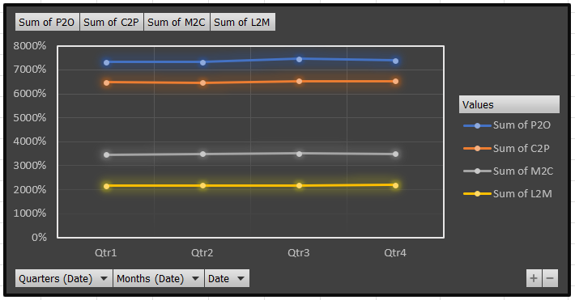
• Description: Stage-wise conversion (L2M, M2C, C2P, P2O)
• Analysis:
• P2O is most stable stage
• M2C has lowest conversion → major bottleneck
• Indicates pricing or decision friction
Figure 5.4: Funnel Breakdown Chart

5.5 Graph: Week-on-Week Comparison
• Description: Comparison with same weekday of previous week
• Analysis:
• Removes weekday bias
• Helps detect true performance shifts
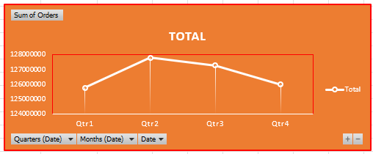
Figure 5.5: WoW Analysis
6. Conclusion:
The Swiggy Funnel Analysis highlights that while the platform has strong user traffic, the overall conversion rate remains relatively low (~5.4%).
The primary issue lies in the Menu to Cart stage, where the highest drop-off occurs. This suggests potential problems related to pricing, product selection, or user decision-making.
The analysis also demonstrates that:
• Demand fluctuations impact orders directly
• Conversion inefficiencies are the main reason for performance drops
• Funnel-based analysis is effective for identifying root causes
Improving conversion at critical stages, especially M2C, can significantly enhance overall business performance.
7. References / Source of Information
Dataset Source
- Swiggy Funnel Case Study Dataset (2019)
• Daily session-level dataset containing user journey stages
• Includes Listing, Menu, Cart, Payment, and Order sessions
- Dataset is provided by the teacher
Software & Tools
- Microsoft Excel (Office 2021):
• Data cleaning and preprocessing (handling numeric consistency, validation)
• Funnel conversion calculations using formulas
• Week-on-week comparison analysis
• Dashboard creation using charts and visualization tools

