**Superstore Sales Analysis Report**

Intern Name: Mohammad Adnan Shoeb Akhtar

Company: **Brainwave Matrix Solutions**

Project Title: Superstore Sales Dashboard

Toolset: Power BI | DAX | Excel

Date: May 19, 2025

# Introduction

This report presents a comprehensive Power BI dashboard designed to analyze Superstore sales data across different categories, regions, and customer segments. The main goal of this project was to derive actionable insights and visualize performance metrics in an interactive, user-friendly way. The analysis includes insights on:  
- Sales trends  
- Best-selling products  
- Total profit  
- Supplier performance  
- Key business metrics derived using Excel, DAX queries, and Power BI

# Key Metrics Visualized

Total Quantity Sold: 5,239 units  
Total Sales: $341,000  
Overall Profit: $27,000  
Average Delivery Days: 4

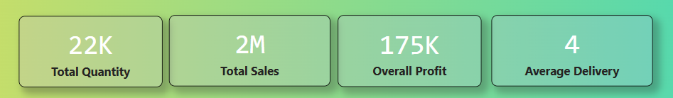

# Monthly Sales Overview

Sales were analyzed over the years 2019 and 2020. A clear upward trend was observed, especially in Q4 of 2020, with December showing the highest spike at **$166,185.85**.

**Visualization:** Line chart showing Year-over-Year monthly sales comparison (2019 vs 2020).

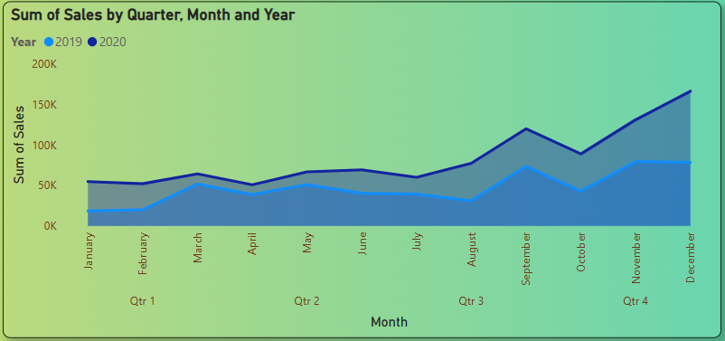

# Top Performing Categories & Sub-Categories

**By Category (Top 3 by Total Sales):**  
- Office Supplies: $643,707.69  
- Technology: $470,587.99  
- Furniture: $451,508.65

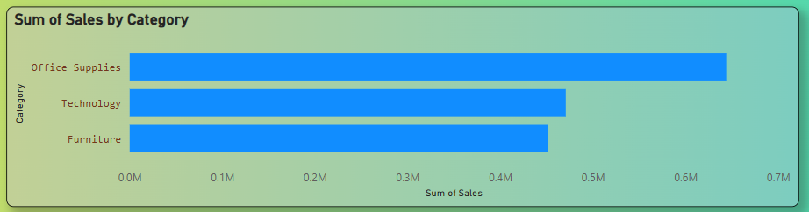

**By Sub-Category (Top 3 by Total Sales):**  
- Phones: $196,563.55  
- Chairs: $181,946.00  
- Binders: $174,978.39

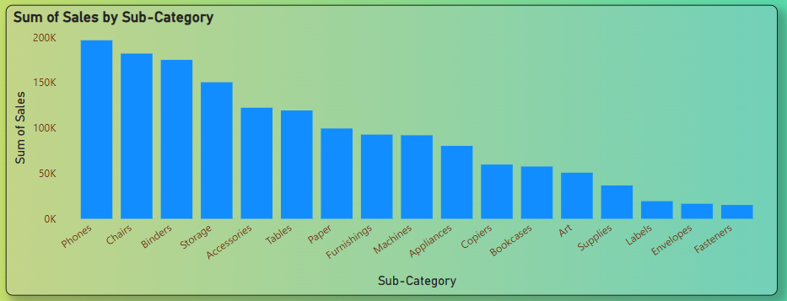

# Regional Sales Performance

The West region led in sales contribution with $522,441.05, followed by the East and Central regions.  
  
**Sales by Region:**  
- West: $171,000  
- East: $169,000  
- Central: $133,000  
- South: $81,000

**Visualization Insight:** Region slicer for interactive analysis.



# Shipping Mode Analysis

Standard Class was the most preferred shipping method with over $912,000 in sales, indicating its popularity for cost-effective delivery.  
  
Ship Mode Breakdown:  
- Standard Class: $303,000  
- Second Class: $112,000  
- First Class: $82,000  
- Same Day: $30,000

**Visualization:** Stacked bar chart showing sales by ship mode.

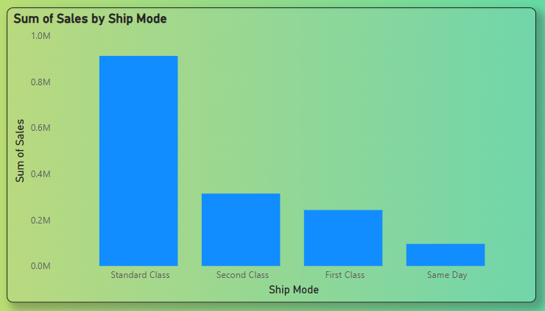

# Power BI Dashboard & KPIs

An interactive Power BI dashboard was created to display key performance indicators (KPIs) and visualizations enabling quick insights and deeper exploration.  
  
**Key KPIs Displayed:**  
- Total Sales: $1,565,804.32  
- Total Orders: 7,298  
- Total Profit: $175,262.11  
- Average Ship Time (Days): 4  
- Top Region by Sales: West ($522,441.05)  
- Top Category by Sales: Office Supplies ($643,707.69)  
- Top Sub-Category: Phones ($196,563.55)

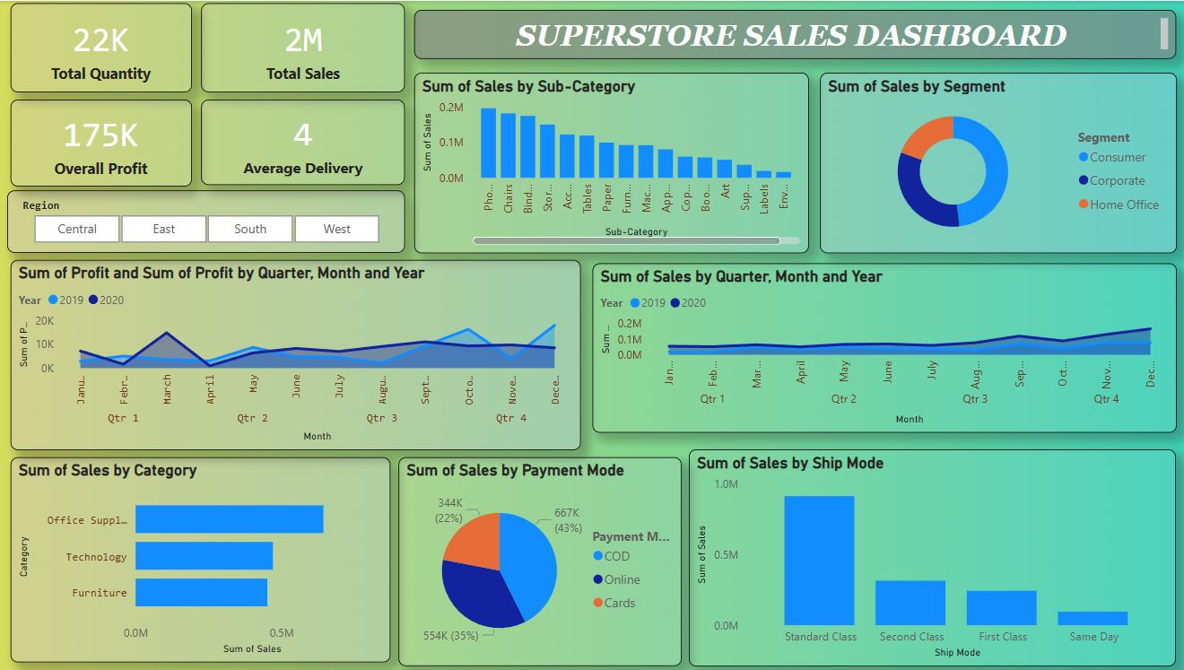

# Dashboard Visualizations

- Sales by Category: Horizontal bar chart (Furniture, Office Supplies, Technology)  
- Sales by Sub-Category: Bar chart (Phones, Chairs, Binders)  
- Monthly Sales Trend (YoY): Line chart (2019 vs 2020)  
- Sales by Ship Mode: Bar chart (Standard, Second, First Class, Same Day)  
- Sales by Region: Map visualization and summary table  
- Sales by Segment: Donut chart (Consumer, Corporate, Home Office)  
- Payment Mode Breakdown: Donut chart (Cards, Online, COD)

# Interactivity Features

- Year selection (2019, 2020)  
- Region filter (Central, East, South, West)  
- Category/Sub-Category filters  
- Ship Mode & Payment Mode slicers

# Insights & Recommendations

- Prioritize inventory for Office Supplies and Phones, which lead in sales  
- Optimize Standard Class logistics, as it’s the most used shipping mode  
- Monitor Furniture category profitability due to its low profit margin despite high sales

# Tools Used

- Power BI: For interactive dashboard creation  
- Excel: For data pre-processing and pivot summaries