Big Data



|  |  |
| --- | --- |
| Study Program: | **BSSE/BSCS** |
| **Semester:** | **Spring 2022** |
| **Course Code/Title:** | **Big Data Programming** |
| **Resource Person:** | **Mr. Mazhar Javed**  **Mazhar.awan@umt.edu.pk** |
| **Weight age** | **20 %** |
| **Due Date** | **13th July 2022** |
| **Student Name** | **Muhammad Adnan Asad** |
| **Roll No** | **F2018065185** |

Command used to install pyspark

Importing pyspark dependency and checking version which is 3.3.0

Importing more dependencies, then we create an app named ml-diabetes and in the third line loading the dataset from google drive. At the end we print the dataframe.

This command imports pandas as pd and with the help of pandas it shows the first 5 records of the dataset.

Data is grouped by outcome, we can see that 268 have positive outcome while 500 have negative outcome.

Another function to simply display the dataset by the help of topandas() function.

We can calculate the count, mean, stand deviation, min and max for all the numbers in the dataset. The command to achieve this function is called transpose()

Shows all the columns

Plotting a scatter matrix for the dataset.

This checks for any and all missing rows

This code will remove all unnecessary columns of data and show the remaining data.

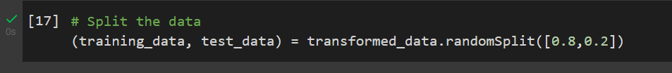

This code will split the data into training and testing data with a 80% and 20% ratio respectivally.

These are the models, the first one is the random forest classifier, in the first part the model is defined and then fitted with the training data. In the third part we test the model and at the end show the results and check its accuracy. The model shows a 76% accuracy.

This is a Decision Tree Classifier model, here we fit it and test it in the first part. We then show our predictions and in the second part we check those predictions to reveal a 77% accuracy.

This one is a Logistic Regression Model, same as before we import dependencies, define model then fit it with the training data, then test it with testing data and alas compare predictions with the real data to check accuracy and we get 77%.

This model is a gradient boosted tree classifier model, here we import dependencies, define it, train it test it and check our predictions revealing 80% accuracy.