First create a new react project using vite.

Install tailwind css and react router dom

Configure tailwind css by import some fonts and start using fonts and utility classes using the following syntax:

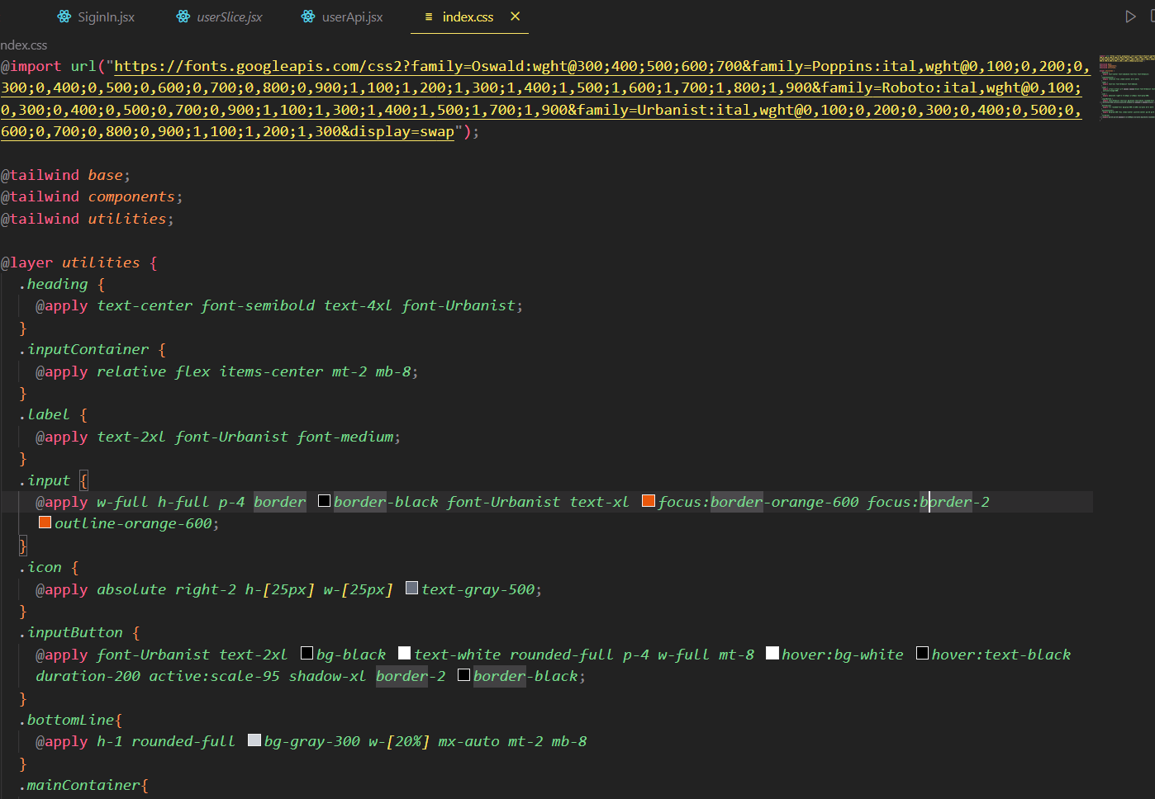

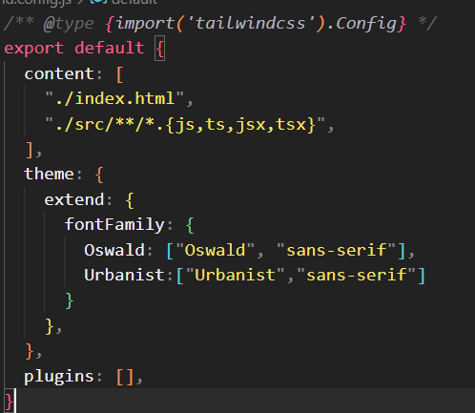

Add react router dom and start using it using the following syntax

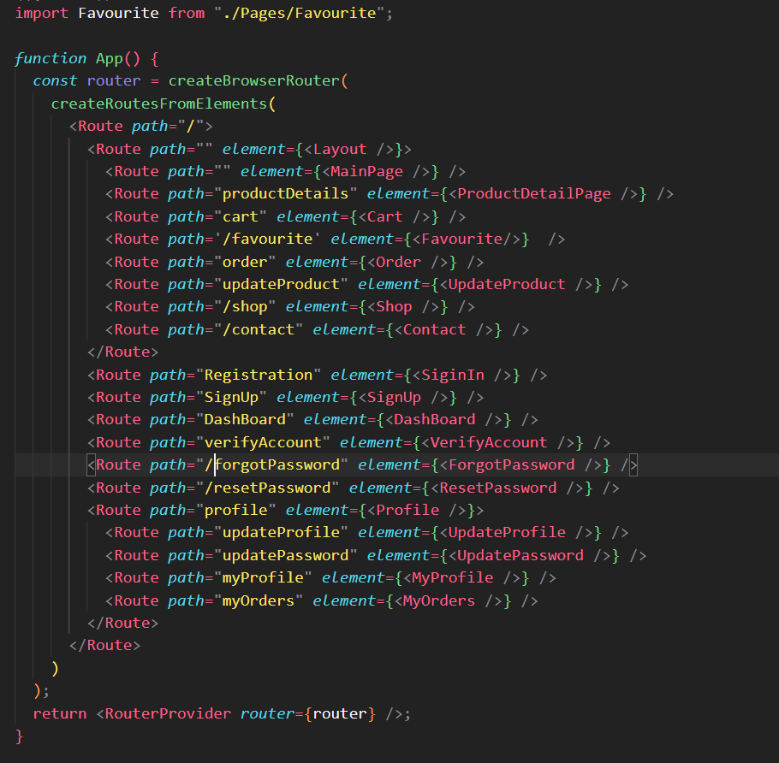

Wrap all the routes inside a / path.

Then if you want a layout you have to make it as a parent element.

So in this example all the routes start from /

Then there is a route that contains a layout component and inside this we have some other routes.

It was because we wanted these routes to have a header and a footer.

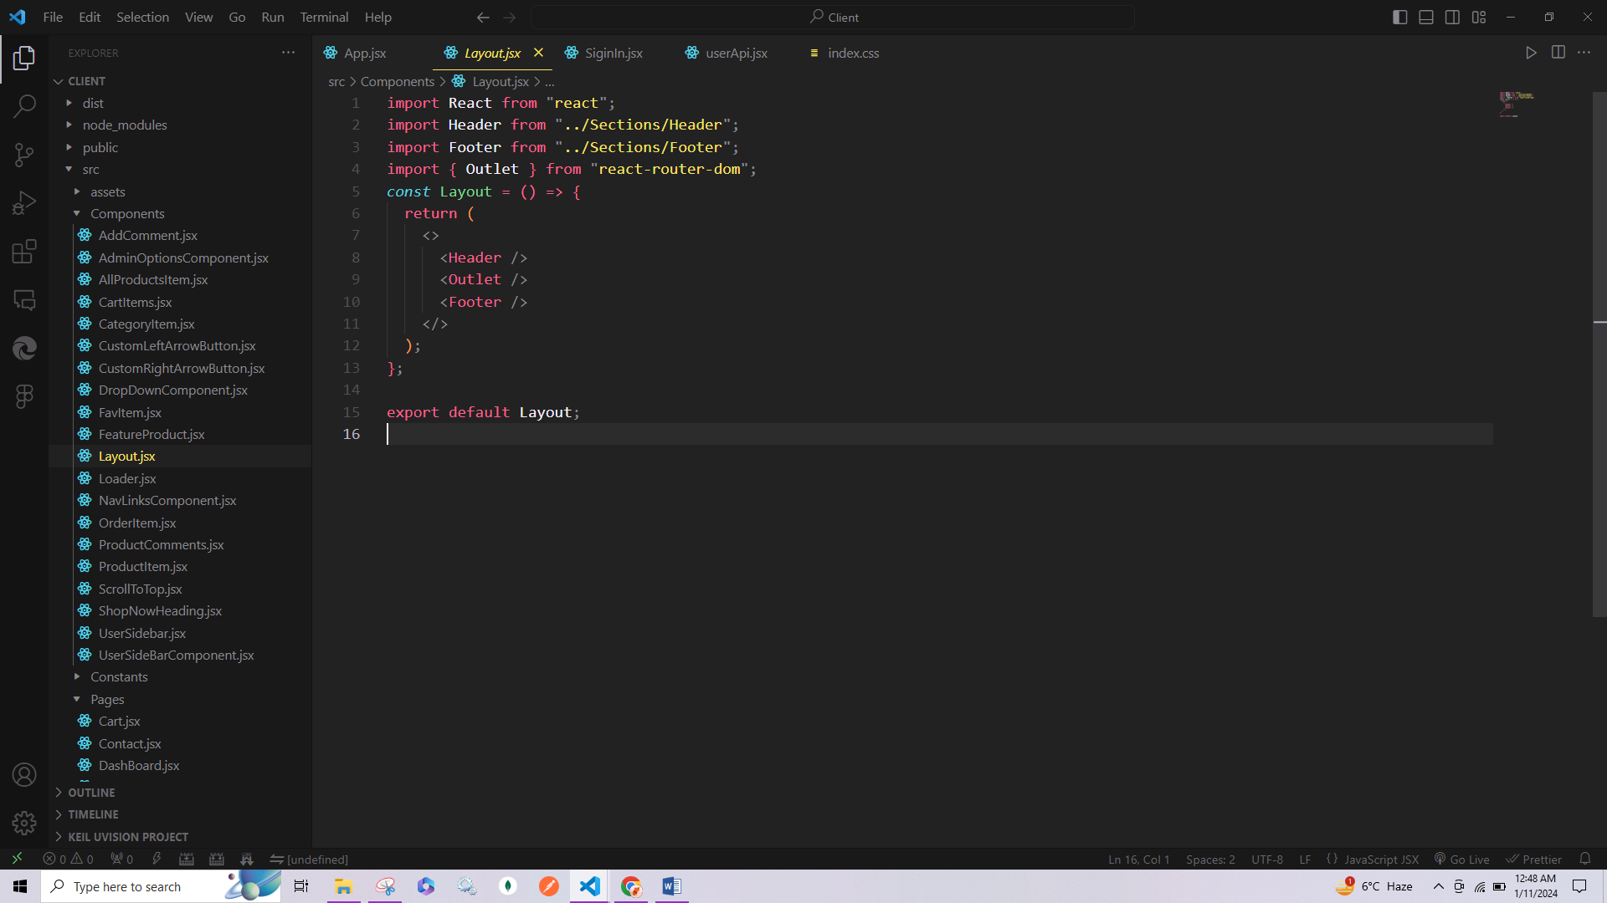

Then you need to setup redux toolkit

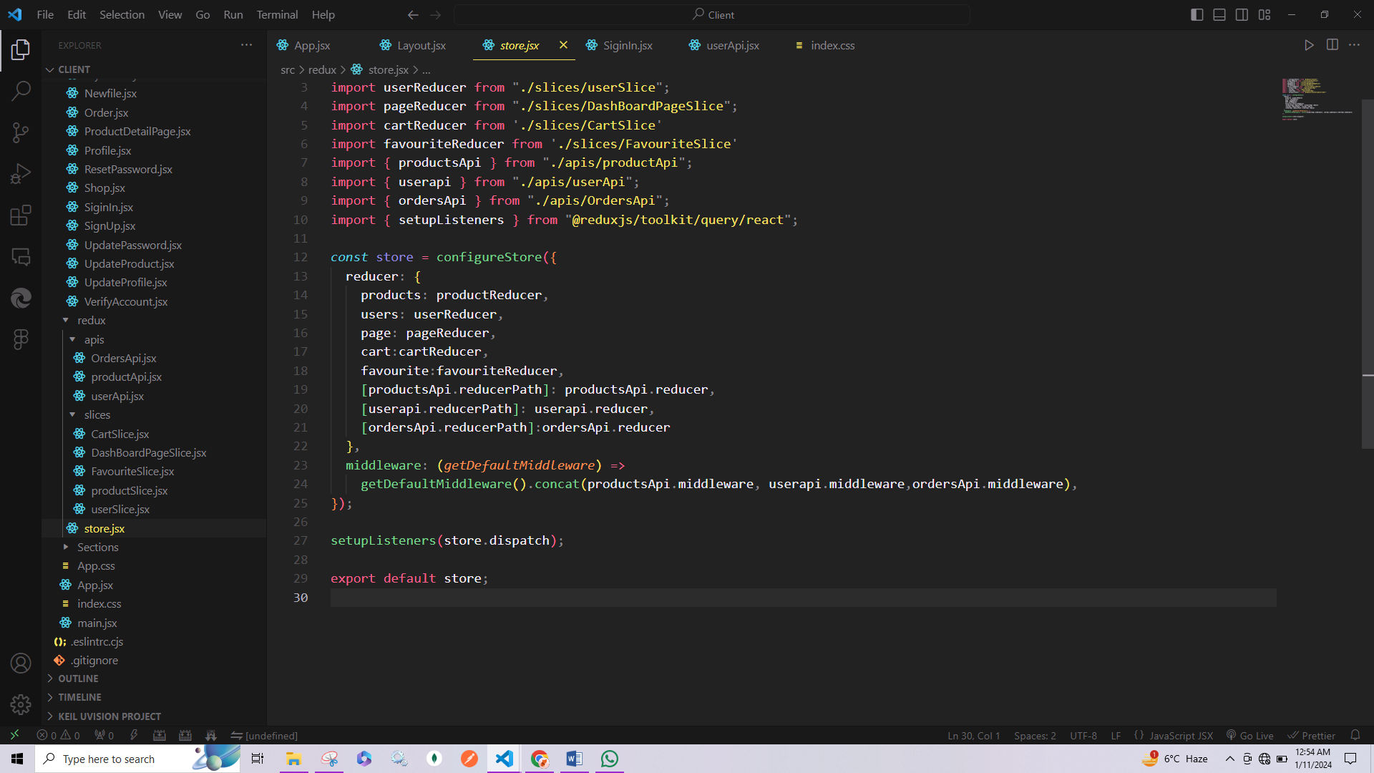

Then create slices and apis

