## PROBLEM STATEMENT

**KPI’s REQUIREMENT**

We need to analyze key indicators for our pizza sales data to gain insights into our business performance, Specifically we want to calculate the following matrics.

1. Total Revenue
2. Average order value
3. Total Pizza sold
4. Total Orders
5. Average pizza per order

**CHARTS REQUIREMENTS**

We would like to visualize various aspects of our pizza sales data to get insights and understand key trends. We have identified following requirements for creating charts.

1. Daily trend for total order

Create a bar chart to display daily trend of total order over a specific time period. This chart will help us identify any fluctuations in order volumes on daily basis.

1. Monthly trend for total order

Create a line chart of hourly trend for total order throughout the day. This chart will allow us to identify peak hours of high order activity.

1. Percentage of sales by pizza category

Create a pie chart that shows the distribution of sales across different categories . This chart will provide insights into the popularity of various pizza categories and their contributions to overall sales.

1. Percentage of sales by pizza size

Create a pie chart that shows the distribution of sales across different sizes . This chart will provide insights into the popularity of various pizza size and their contributions to overall sales.

1. Total pizza sold by pizza category

Create a funnel chart that represents the total number of pizzas sold by each category. This chart will allow us to compare the sales performance with different pizzas

**PIZZA SALES SQL QUERIES**

**A.KPI’s**

**1.Total revenue**

SELECT SUM(total_price) AS "Total_revenue" FROM pizza_sales;

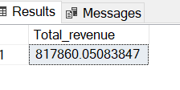

**2.Average order value**

SELECT SUM(total_price)/COUNT(DISTINCT(order_id)) AS "Average order value" FROM pizza_sales;

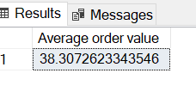

**3. Total pizza sold**

SELECT SUM(quantity) AS sum_all_piza FROM pizza_sales;

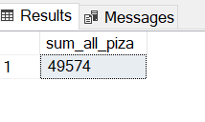

**4.Total orders**

SELECT COUNT(DISTINCT(order_id)) AS total_orders FROM pizza_sales;

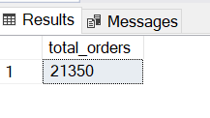

**5.Average pizza per order**

SELECT SUM(quantity) / COUNT(DISTINCT(order_id)) AS "Average_per_order" FROM pizza_sales;

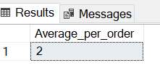

**CHARTS REQUIREMENTS**

1. Daily trend for total order

SELECT DATENAME(DW, order_date) AS "order_day", COUNT(DISTINCT(order_id)) AS "total_orders" FROM pizza_sales

GROUP BY DATENAME(DW, order_date);

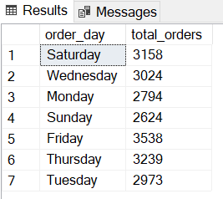

1. Monthly trend for total order

SELECT DATENAME(MONTH, order_date) AS "month", COUNT(DISTINCT(order_id)) AS "total_order"

FROM pizza_sales

GROUP BY DATENAME(MONTH, order_date);

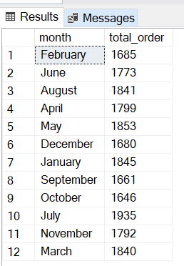

1. Percentage of sales by pizza category

SELECT pizza_category, (SUM(total_price)/ (SELECT SUM(total_price) FROM pizza_sales))*100 AS "percentage_of_category"

FROM pizza_sales

GROUP BY pizza_category;

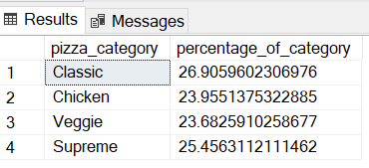

For gaining 1st month we write following code

SELECT pizza_category, (SUM(total_price)/ (SELECT SUM(total_price) FROM pizza_sales WHERE MONTH(order_date)=1))*100 AS "percentage_of_category"

FROM pizza_sales

WHERE MONTH(order_date)=1

GROUP BY pizza_category;

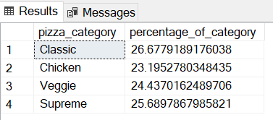

1. Percentage of sales by pizza size

SELECT pizza_size, SUM(total_price) AS "Total_price", CAST((SUM(total_price)/( SELECT SUM(total_price)

FROM pizza_sales))*100 AS DECIMAL (10,2)) AS "Percrntage of sales" FROM pizza_sales

GROUP BY pizza_size;

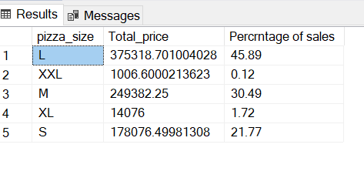

1. Total pizza sold by pizza category

SELECT pizza_category, CAST(SUM(total_price) AS DECIMAL(10,2)) AS "Total_price" FROM pizza_sales

GROUP BY pizza_category;

