**ASSIGNMENT**

**COM-101**

**Introduction to C Programming**

**By**

**Adnan Kaisar Wani**

**Roll Number**

**2023a1r050**

**Semester**

**1st (A3)**

**Department Name**

**CSE**



**Model Institute of Engineering & Technology (Autonomous)**

(Permanently Affiliated to the University of Jammu, Accredited by NAAC with “A” Grade)

Jammu, India

2023

**1.Write a C program to find the sum of elements in an array.**

**Ans)** Code

#include <stdio.h>

int main() {

    int n, sum = 0;

    printf("Enter the number of elements in the array: ");

    scanf("%d", &n);

    int arr[n];

    printf("Enter %d elements:\n", n);

    for (int i = 0; i < n; i++) {

        scanf("%d", &arr[i]);

    }

    for (int i = 0; i < n; i++) {

        sum += arr[i];

    }

    printf("Sum of elements: %d\n", sum);

    return 0;

}

Output

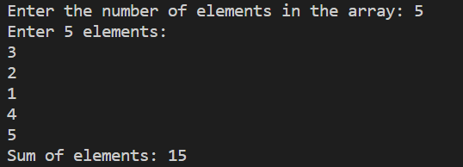

**Q2) Write the program for calculator using elseif and do while.**

**Code**

**Sol)** #include <stdio.h>

int main() {

    char operator;

    double num1, num2, result;

    do {

        printf("Enter an operator (+, -, *, /) or 'q' to quit: ");

        scanf(" %c", &operator);

        if (operator == 'q') {

            break;

        }

        printf("Enter two numbers: ");

        scanf("%lf %lf", &num1, &num2);

        if (operator == '+') {

            result = num1 + num2;

        } else if (operator == '-') {

            result = num1 - num2;

        } else if (operator == '*') {

            result = num1 * num2;

        } else if (operator == '/') {

            if (num2 != 0) {

                result = num1 / num2;

            } else {

                printf("Error: Division by zero\n");

                continue;

            }

        } else {

            printf("Invalid operator\n");

            continue;

        }

         printf("Result: %.2lf\n", result);

     } while (1);

     printf("Calculator closed.\n");

    return 0;

}

**Output**

