TRUE NORTH PIZZERIA SALES ANALYSIS
SQL VALIDATION REPORT
Section 1: Purpose
This document summarizes the SQL Server queries used to validate the key metrics and analysis behind the True North Pizzeria sales dashboard. For each business question, the report shows the query used, and a screenshot of the output table/result.
Section 2: KPI validation
- Total Revenue:
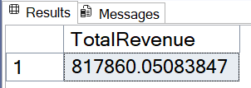
SELECT SUM(total_price) AS Total_Revenue FROM pizza_sales;

- Average Order Value:
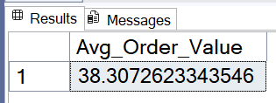
SELECT SUM(total_price) / COUNT(DISTINCT order_id) AS Avg_Order_Value FROM pizza_sales;

- Total Pizzas Sold:

SELECT SUM(quantity) AS Total_Pizzas_Sold FROM pizza_sales;
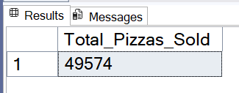

- Total Orders:
SELECT COUNT(DISTINCT order_id) AS Total_Orders FROM pizza_sales;

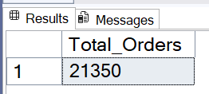

- Average Pizzas Per Order:
SELECT CAST(CAST(SUM(quantity) AS DECIMAL(10,2)) /
CAST(COUNT(DISTINCT order_id) AS DECIMAL(10,2)) AS DECIMAL(10,2)) AS Avg_Pizzas_per_order FROM pizza_sales;

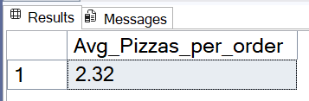
Section 3: Time based analysis
- Daily Trend for Total Orders
SELECT DATENAME(DW, order_date) AS order_day, COUNT(DISTINCT order_id) AS Total_orders
FROM pizza_sales
GROUP BY DATENAME(DW, order_date);
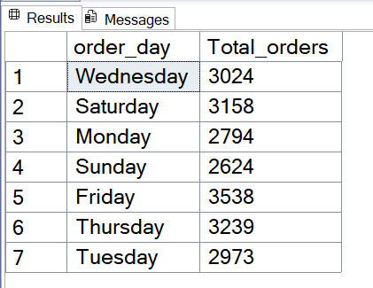

- Monthly Trend for Total Orders
SELECT DATENAME(MONTH, order_date) AS Month_Name, COUNT(DISTINCT order_id) AS Total_orders
FROM pizza_sales
GROUP BY DATENAME(MONTH, order_date)
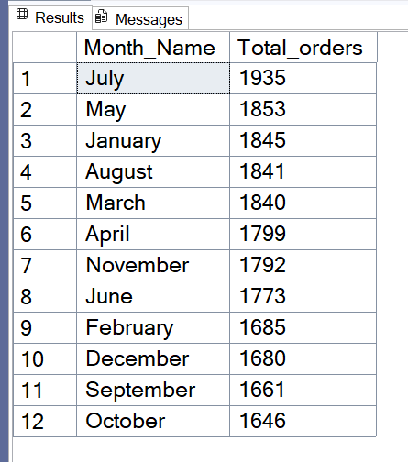
ORDER BY Total_orders DESC;

Section 4: Category and size performance
- Percentage of Sales by Pizza Category

SELECT pizza_category, SUM(total_price) AS Total_Sales, SUM(total_price) * 100 / (SELECT SUM(total_price) FROM pizza_sales) AS PCT
FROM pizza_sales
GROUP BY pizza_category;
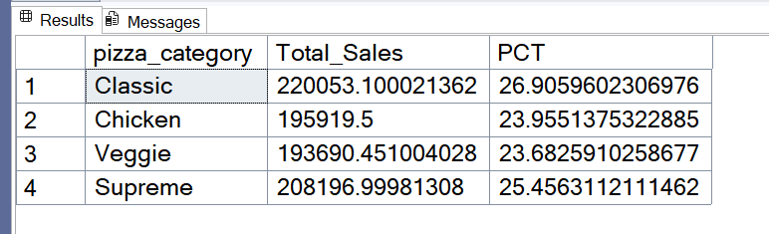

- This is if you want if for a single month (in this its for month of January)
SELECT pizza_category, SUM(total_price) AS Total_Sales, SUM(total_price) * 100 / (SELECT SUM(total_price)
FROM pizza_sales WHERE MONTH(order_date) = 1) AS PCT
FROM pizza_sales
WHERE MONTH(order_date) = 1
GROUP BY pizza_category;

- Percentage of Sales by Pizza Size
- The ORDER BY PCT DESC and the CAST function used here is optional
SELECT pizza_size, CAST(SUM(total_price) AS DECIMAL(10, 2)) AS Total_Sales, CAST(SUM(total_price) * 100 /
(SELECT SUM(total_price) FROM pizza_sales) AS DECIMAL(10, 2)) AS PCT
FROM pizza_sales
GROUP BY pizza_size
ORDER BY PCT DESC;

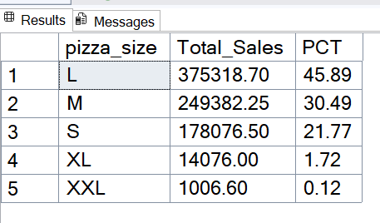

- Total Pizzas Sold by Pizza Category

SELECT pizza_category, CAST(SUM(total_price) AS DECIMAL(10, 2)) AS Total_Price
FROM pizza_sales
GROUP BY pizza_category;

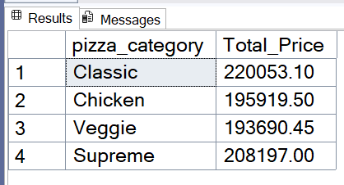

Section 5: Product Performance

- Top 5 best Sellers by Total Revenue, Total Quantity, and Total Orders

1a. Total Revenue

SELECT TOP 5 pizza_name, SUM(total_price) AS Total_Revenue
FROM pizza_sales
GROUP BY pizza_name
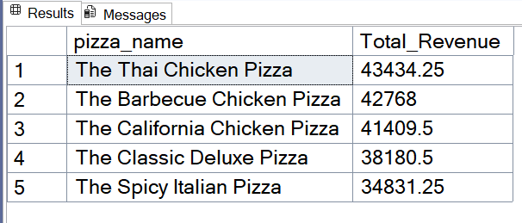
ORDER BY Total_Revenue DESC;

1b. Total Quantity

SELECT TOP 5 pizza_name, SUM(quantity) AS Total_Quantity
FROM pizza_sales
GROUP BY pizza_name
ORDER BY Total_Quantity DESC;

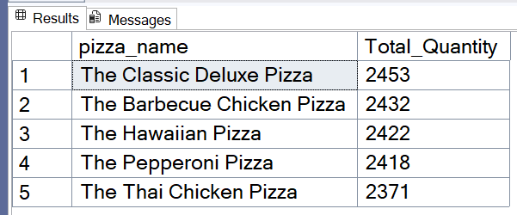

1c. Total Orders

SELECT TOP 5 pizza_name, COUNT(DISTINCT order_id) AS Total_Orders
FROM pizza_sales
GROUP BY pizza_name
ORDER BY Total_Orders DESC;

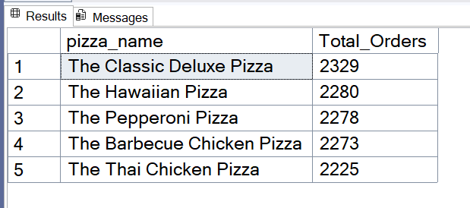

- Bottom 5 Worst Sellers by Total Revenue, Total Quantity, and Total Orders

2a. Total Revenue

SELECT TOP 5 pizza_name, SUM(total_price) as Total_Revenue
FROM pizza_sales
GROUP BY pizza_name
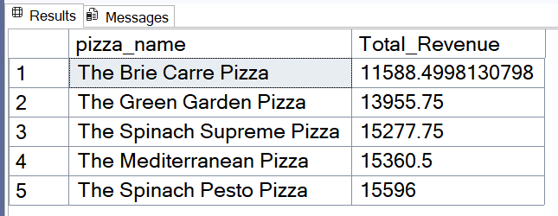
ORDER BY Total_Revenue;

2b. Total Quantity

SELECT TOP 5 pizza_name, SUM(quantity) AS Total_Quantity
FROM pizza_sales
GROUP BY pizza_name
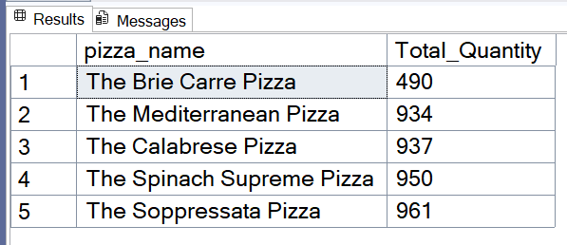
ORDER BY Total_Quantity;

2c. Total Orders

SELECT TOP 5 pizza_name, COUNT(DISTINCT order_id) AS Total_Orders
FROM pizza_sales
GROUP BY pizza_name
ORDER BY Total_Orders;

