Parking System Refactor & EV Charging: DDD Microservices Architecture
Final Submission — Design, DDD, and Microservices Proposal
Date: 2025-11-01

1. Introduction
This document presents the refactoring approach and the proposed domain-driven microservices architecture for the Parking System extended with EV Charging. It includes original and redesigned UML diagrams, DDD modeling, microservices with per-service databases, explicit APIs and events, and a demo video link.

2. Original Design (Before Refactor)
The original codebase exhibited tight coupling between UI and core domain logic, duplicated vehicle types, and global state patterns that hindered extension for EV charging. The following UML pair documents the baseline structure and behavior.

2.1 Original – Structural (Class Diagram)
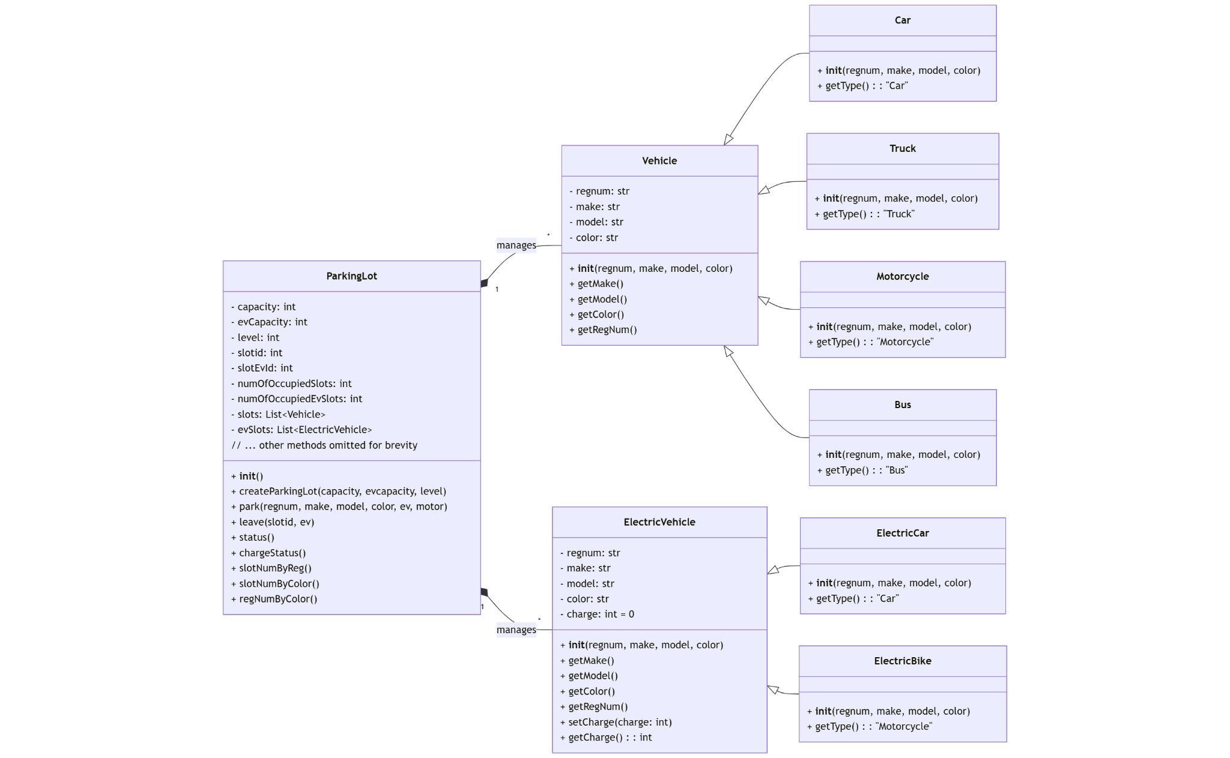
Caption: Figure 1. Original class diagram showing coupling between interface and ParkingLot, duplication in Vehicle hierarchy, and lack of clear aggregate boundaries.

2.2 Original – Behavioral (Activity/Sequence)
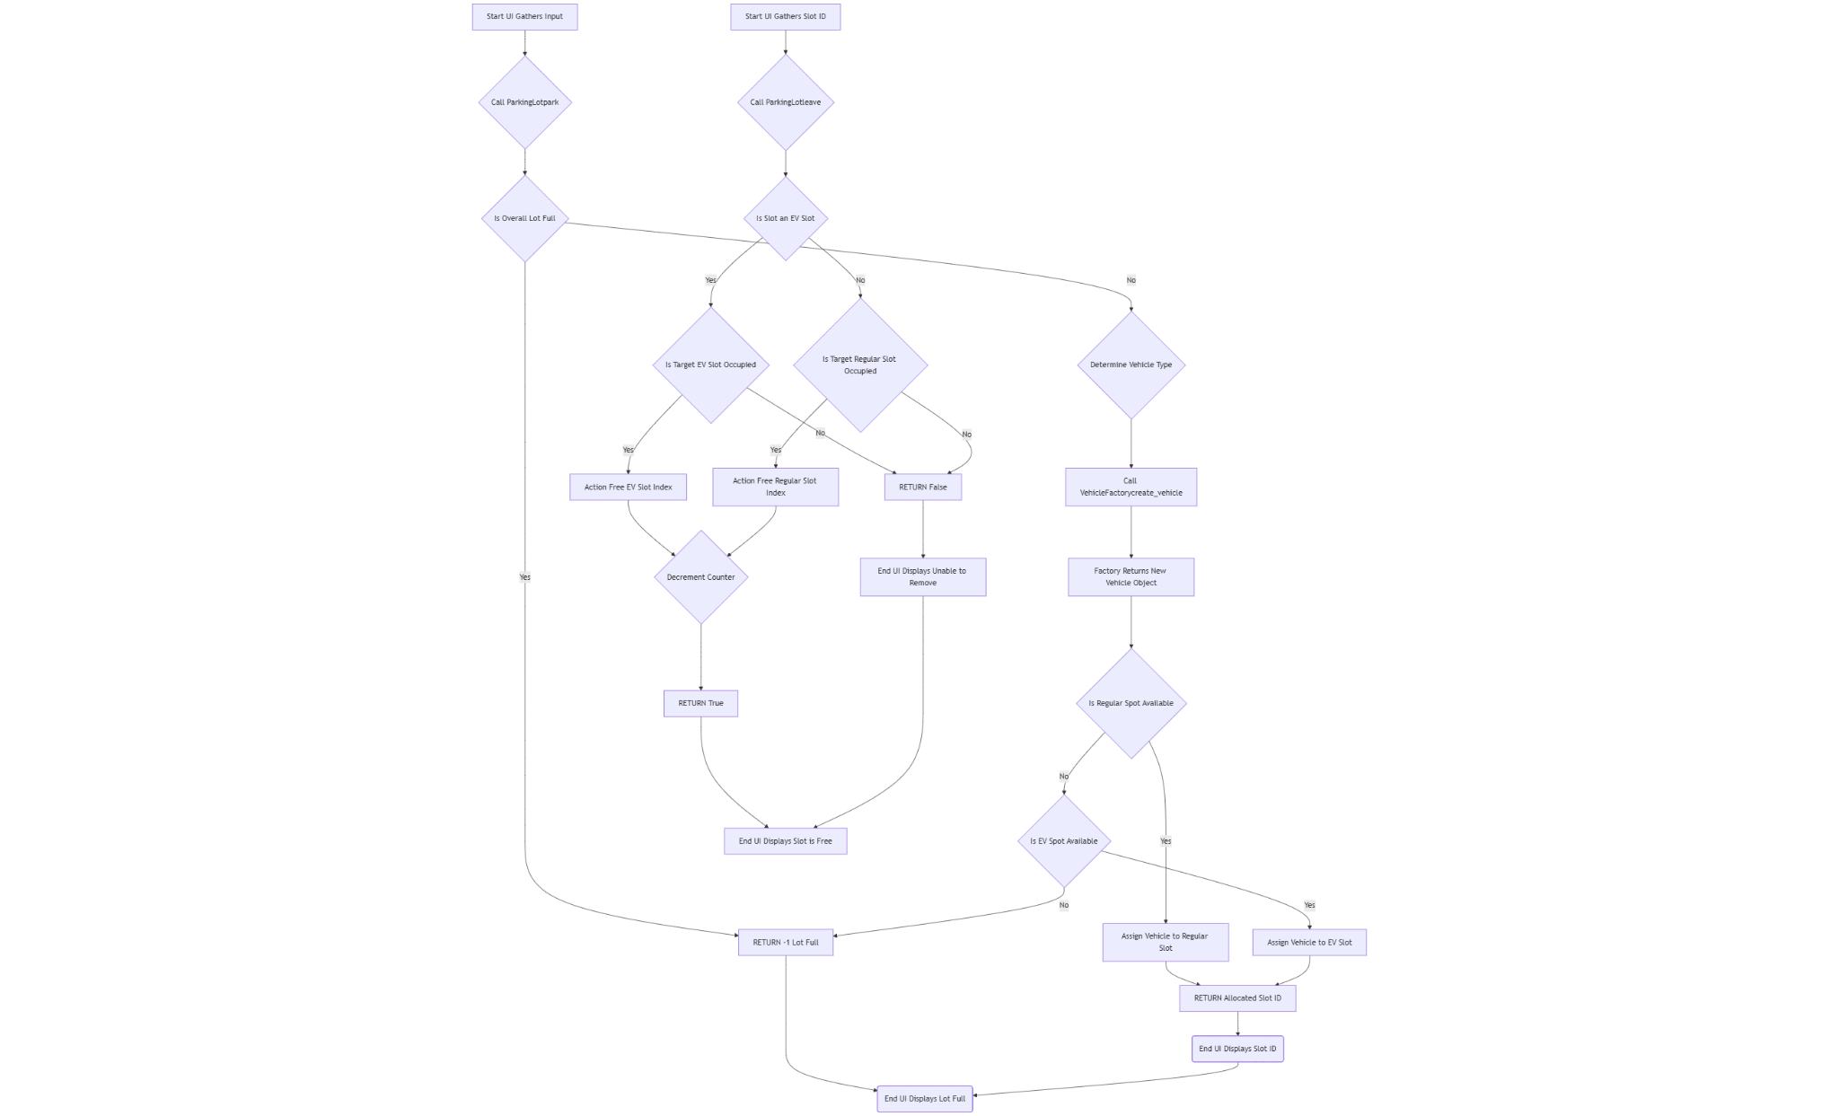
Caption: Figure 2. Original behavioral diagram (e.g., 'park vehicle') where UI directly manipulates model objects without clear service boundaries.

3. Redesigned Overview (After Refactor)
The redesign applies object-oriented patterns to decouple concerns and introduce extensibility for EV charging. Key improvements include the Factory pattern for vehicle creation, Strategy for policy-based pricing/selection, and elimination of anti-patterns.

3.1 Redesigned – Structural (Class Diagram)
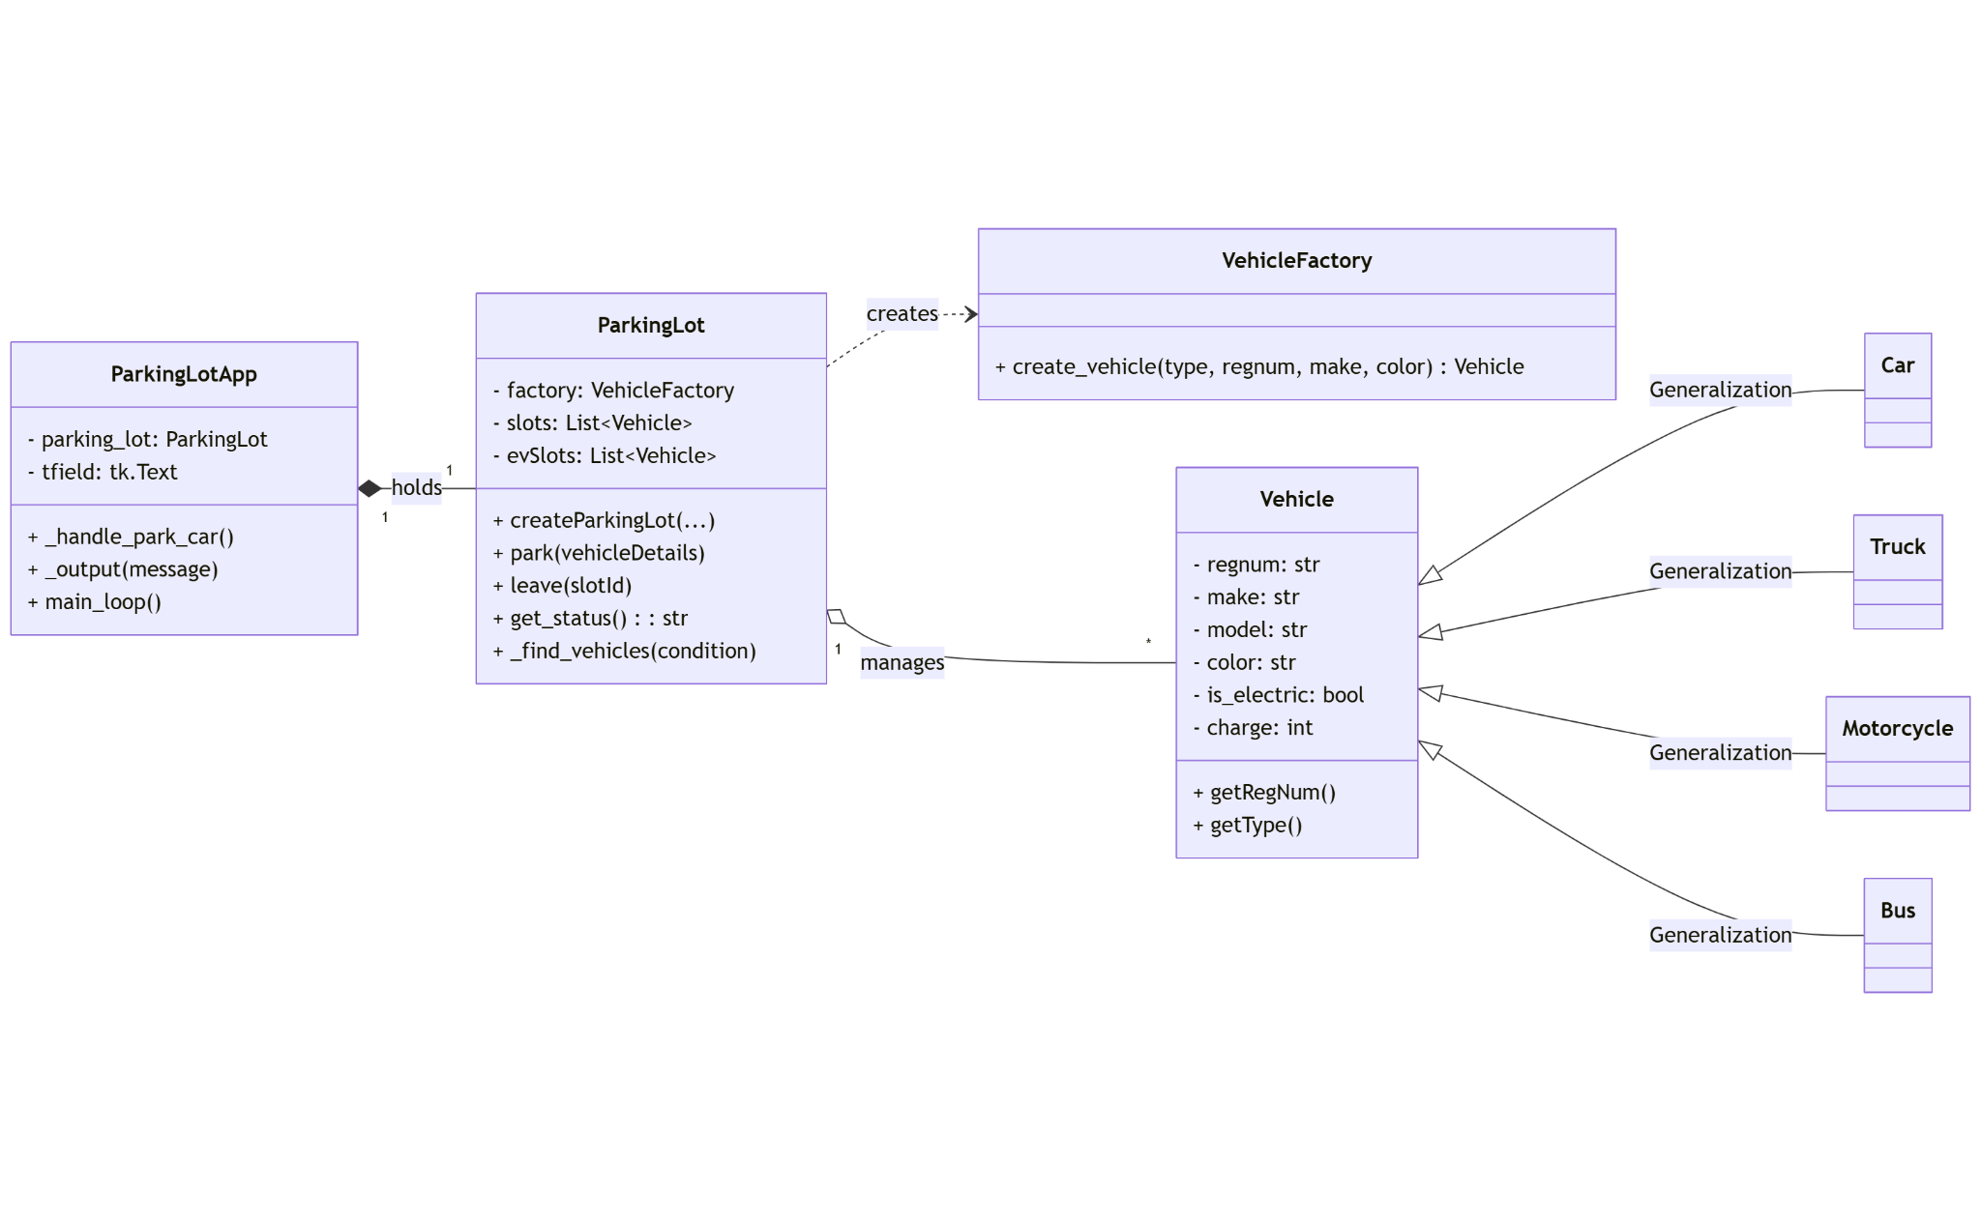
Caption: Figure 3. Redesigned class diagram with clearer domain model, unified Vehicle abstraction, and presenters/controllers separated from domain services.

3.2 Redesigned – Behavioral (Activity/Sequence)
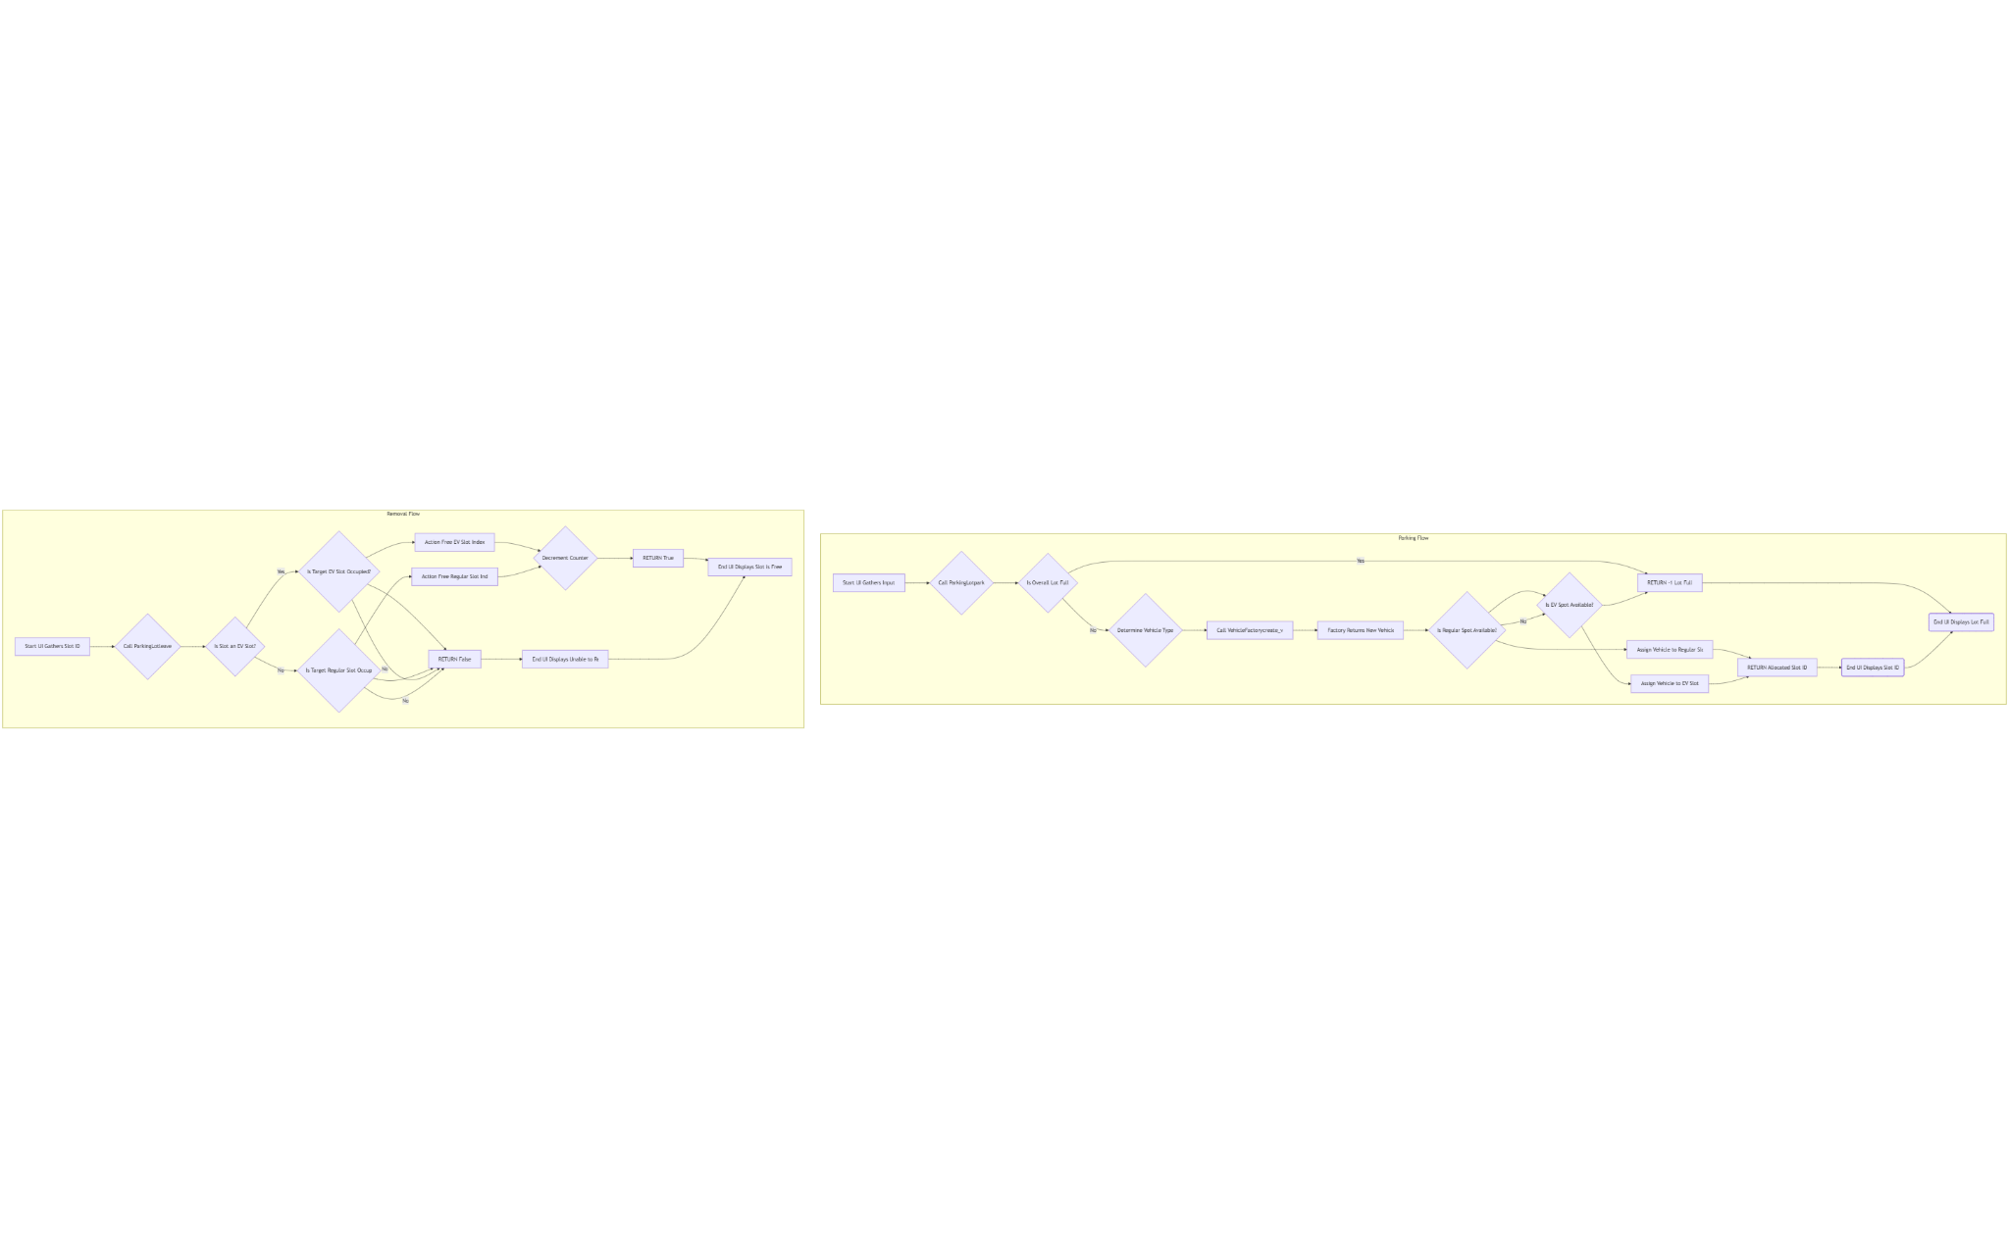
Caption: Figure 4. Redesigned behavior for the 'park vehicle' flow demonstrating decoupled presentation and domain interactions via services.

4. Domain-Driven Design (DDD)
We define bounded contexts that map directly to microservices. Each context has its own ubiquitous language, entities, value objects, and aggregates; integration is event-driven, minimizing direct coupling.

4.1 Bounded Contexts & Ubiquitous Language
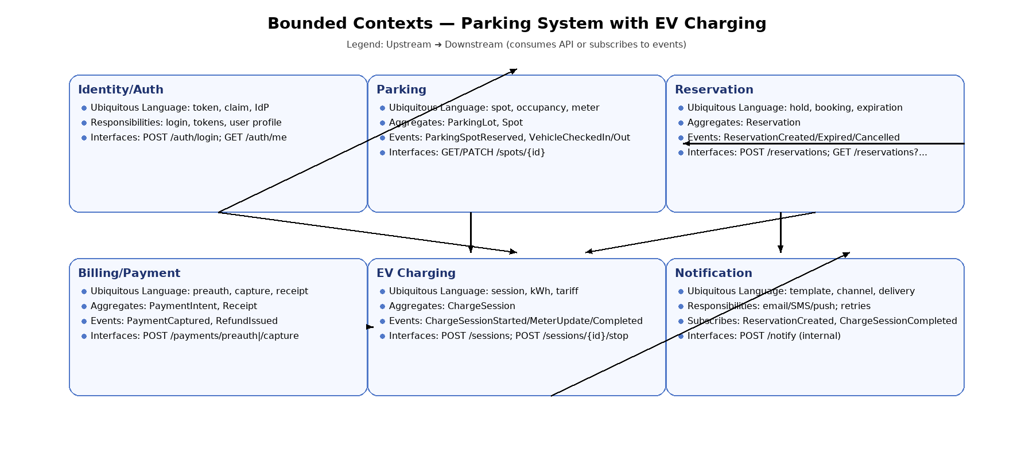Caption: Figure 5. Bounded-context diagram: Parking, Reservation, EV Charging, Billing/Payment, Identity/Auth, Notification.
Sample ubiquitous language per context:
• Parking: spot, occupancy, meter, check-in, check-out
• Reservation: hold, booking, expiration, reservationId
• EV Charging: connector, session, kWh, tariff, meterStart/meterStop
• Billing/Payment: preauthorization, capture, receipt, refund
• Identity/Auth: token, claim, identity provider (IdP)
• Notification: template, channel, delivery, retry

4.2 Entities, Value Objects, Aggregates
Examples: Parking has aggregate root ParkingLot with Spots (entity) and MeteringConfig (value object). Reservation has Reservation aggregate with policies as value objects. EV Charging has ChargeSession aggregate with immutable MeterReadings (value objects). Billing has PaymentIntent and Receipt aggregates.

5. Microservices Architecture
Clients access services through an API Gateway/BFF. Services communicate synchronously via REST/gRPC and asynchronously through a message bus. Each service owns an isolated database; no cross-service writes. External integrations include a payment provider, an external IdP, and physical EV chargers via a device adapter.

5.1 High-level Architecture Diagram
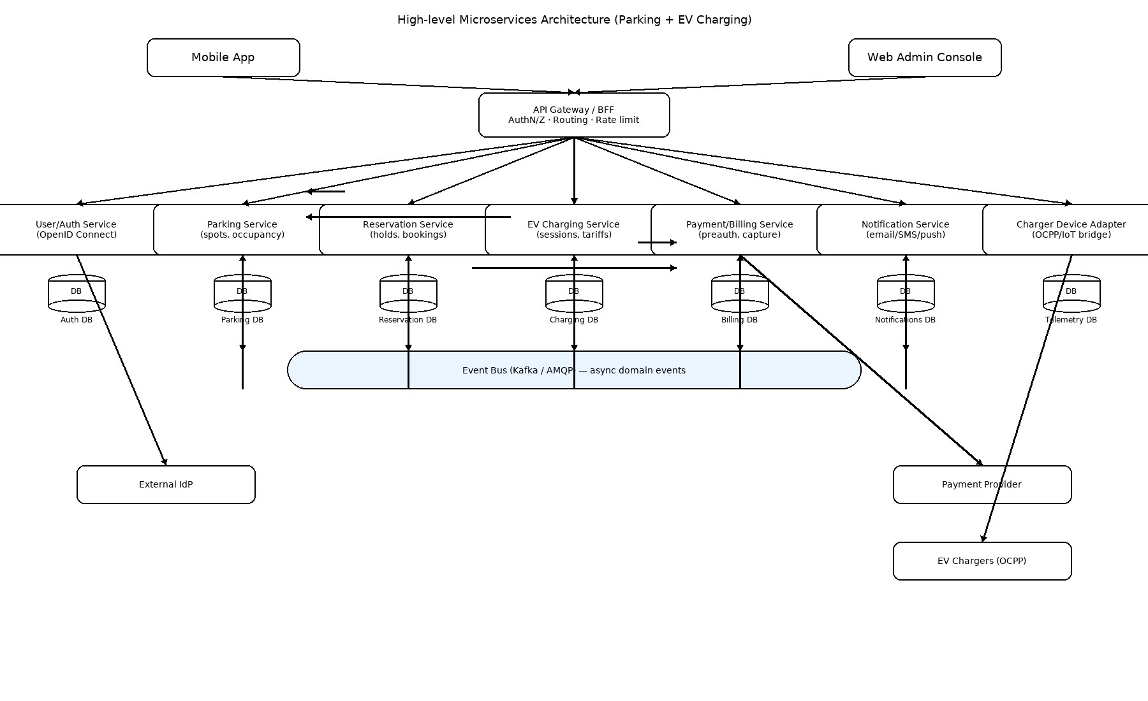Figure 6. High-level microservices architecture with per-service databases and event bus.

5.2 Service APIs & Events
Representative external API surface exposed via the API Gateway, and domain events for async workflows.
Service | REST APIs (representative) | Domain Events (pub/sub)
EV Charging | POST /sessions; POST /sessions/{id}/stop; GET /sessions/{id} | ChargeSessionStarted; ChargeMeterUpdate; ChargeSessionCompleted
Parking | GET /spots/{id}; PATCH /spots/{id} | ParkingSpotReserved; VehicleCheckedIn; VehicleCheckedOut
Reservation | POST /reservations; GET /reservations?vehicleId=&spotId= | ReservationCreated; ReservationExpired; ReservationCancelled
Billing / Payment | POST /payments/preauth; POST /payments/capture; GET /receipts/{id} | PaymentCaptured; RefundIssued
Notification | POST /notify (internal trigger) | Subscribes to completion/lifecycle events
Identity / Auth | POST /auth/login; GET /auth/me (behind Gateway) | —

5.3 Per-Service Data Ownership
Parking → Parking DB; Reservation → Reservation DB; EV Charging → Charging DB (time-series capable); Billing/Payment → Billing DB; Identity/Auth → Auth DB; Notification → Notifications DB; Device Adapter → Telemetry DB. No shared schemas; cross-context projections use events and dedicated read models.

5.4 Key Flows — EV Charging (Happy Path) Diagram
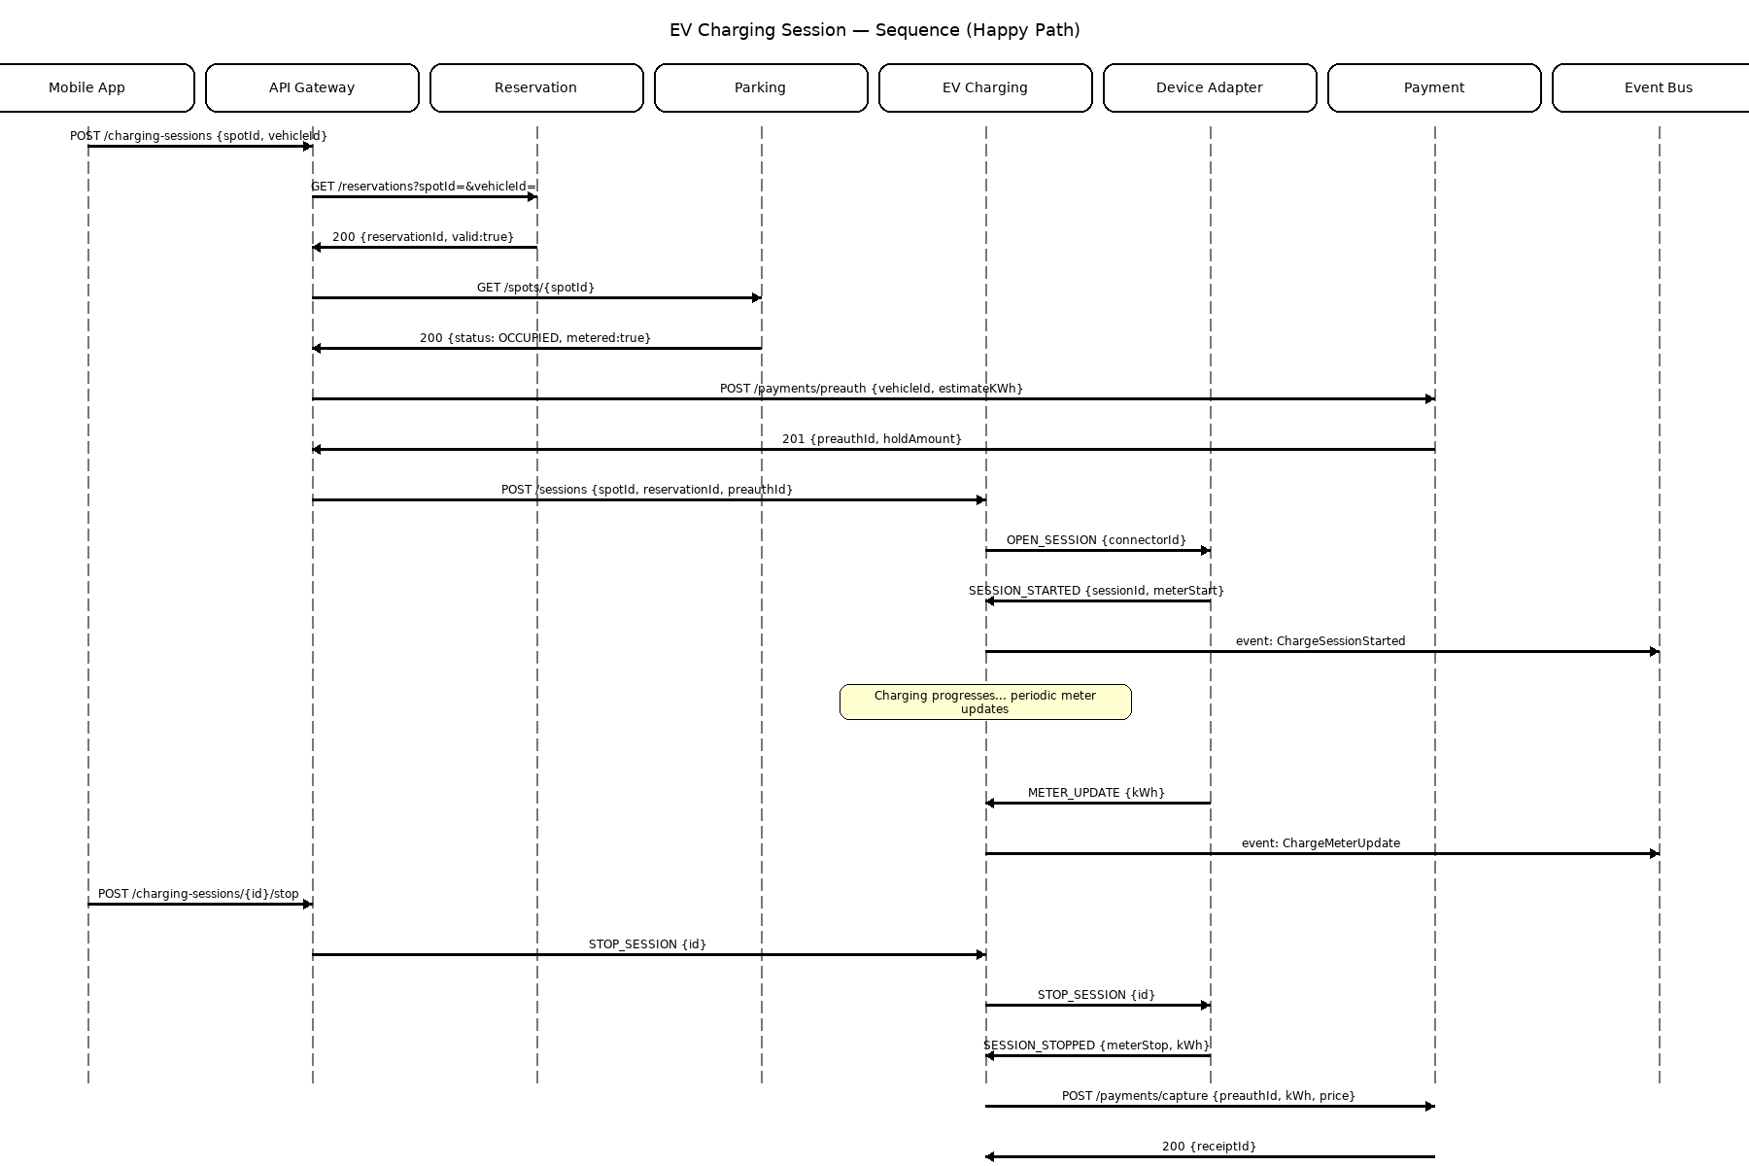Figure 7. Sequence showing session start, metering, stop, and payment capture with event publication.

6. Demo Video (Link)
INSERT VIDEO LINK HERE →

7. Assumptions & Trade-offs
• OCPP/WebSocket integration is modeled via a Device Adapter service and simulated in local environments.
• Payments use provider tokens; the system stores only non-PCI metadata.
• Eventual consistency is acceptable for non-critical read models (e.g., notifications).

