University of Palestine
Software Engineering and Artificial Intelligence
Software Engineering

Sahmi
Graduation Project
Contributors:
Adnan Qasem 120211953
Ahmed Qudaih 120210025
Moomen Jibril 120210102
Abdullah Alotti 120211678
Mohammed Almadhoun 120210381
Ikrayyem Alabadla 320200012
Supervisors:
Dr. Eyad Almassri & Dr. Alaa AbuZaiter
2026

Abstract
Sahmi is a web-based impact-investment and crowdfunding prototype designed to connect Palestinian entrepreneurs and their projects with investors and supporters seeking transparent social and economic impact. The current repository provides public discovery of active, verified projects, role-oriented investor and entrepreneur dashboards, staff project verification, contribution records, synchronized funding totals, and an SSE notification when an investment first enters confirmed status. Milestone and repayment models and REST endpoints also exist, although they are not integrated into dedicated frontend workflows.
The implementation consists of a React 18 and TypeScript single-page frontend built with Vite and a Django REST Framework backend. It uses JWT bearer tokens stored in browser local storage, SQLite by default, optional PostgreSQL through configuration and Docker Compose, and Redis Pub/Sub for confirmed-investment Server-Sent Events (SSE). Celery is configured, but only a placeholder notification task exists and Docker Compose starts no worker. The repository does not yet implement payment processing or receipt upload, persistent messaging, notification APIs, KYC workflows, AI execution, audit logging, production monitoring, or a verified public deployment.
Academically, Sahmi demonstrates requirements traceability, role-oriented interfaces, domain modeling, REST API design, and event-driven funding updates. Practically, it is a functional development-stage foundation rather than a production-ready financial system: project and investment records are implemented, while money movement, payment verification, several simulated dashboard functions, and identified authorization and privacy defects require further work.
Keywords: Impact Investment, Crowdfunding, Palestinian Entrepreneurship, React, TypeScript, Django REST Framework, JWT, PostgreSQL, SQLite, Server-Sent Events.

Contents
CHAPTER 1 - INTRODUCTION 2
1.1 Introduction 2
1.2 Overview 2
1.3 Problem Statement 3
1.4 Objectives 3
1.5 Scope and Limitations 4
1.5.1 Scope 4
1.5.2 Limitations 5
1.6 Conclusion 5
1.7 Outline 6
CHAPTER 2 - LITERATURE REVIEW 8
2.1 Introduction 8
2.2 Used Technology 8
2.3 Additional Tools 11
2.4 Related Works 13
2.5 Comparison (Gap Analysis) 16
2.6 Verification of Ideas 16
2.7 Conclusion 16
CHAPTER 3 - PROJECT METHODOLOGY 19
3.1 Introduction 19
3.2 Selected Methodology 19
3.2.1 Why Agile? 19
3.3 Implementation of Agile in Our Project 19
3.3.1 Requirement Analysis (Sprint 1) 19
3.3.2 System Design (Sprints 2-3) 20
3.3.3 Development & Iterative Implementation (Sprints 4-7) 20
3.3.4 Testing & Quality Assurance (Sprints 8-9) 21
3.3.5 Deployment & Feedback Collection (Sprints 10-12) 21
3.4 Conclusion 21
CHAPTER 4 - SYSTEM ANALYSIS AND DESIGN 24

Contents (continued)
4.1 Introduction 24
4.2 Stakeholders and Requirements 24
4.3 UML and Architecture Views 26
4.4 Data Requirements 28
4.5 Conclusion 29
CHAPTER 5 - IMPLEMENTATION AND INTERFACE DESIGN 31
5.1 Introduction 31
5.2 Technology Implementation 31
5.3 Feature Modules and Interfaces 31
5.4 Deployment and Operational Design 36
5.5 Current Gaps and Future Work 37
5.6 Conclusion 38
CHAPTER 6 - TESTING AND QUALITY ASSURANCE 40
6.1 Introduction 40
6.2 Testing Methodology 40
6.3 Testing Objectives 40
6.4 Test Scenarios and Cases 40
6.5 Quality and Security Validation 41
6.6 Conclusion 41
References 42
Appendix A - API Map 44
Appendix B - Traceability Matrix 47

List of Figures
Figure 1. Django. 8
Figure 2. HTML5. 9
Figure 3. CSS3. 9
Figure 4. Bootstrap (reviewed, not used in the current frontend). 10
Figure 5. JavaScript. 10
Figure 6. PostgreSQL. 11
Figure 7. Trello. 11
Figure 8. Google Sheets & Google Docs. 12
Figure 9. GitLab (legacy reference; the current repository uses GitHub). 12
Figure 10. Visual Studio Code. 12
Figure 11. Docker. 12
Figure 12. Docker Compose. 13
Figure 13. NGINX (not configured in the current repository). 13
Figure 14. DigitalOcean (not configured or deployed by the repository). 13
Figure 15. Continuous Integration/Continuous Deployment (CI/CD) (planned; no workflow configured). 13
Figure 16. Kickstarter. 14
Figure 17. GoFundMe. 14
Figure 18. Informal Local Methods (Social Media & Direct Transfers). 15
Figure 19. Agile. 19

List of Figures (continued)
Figure 20. Use case view of the main Sahmi stakeholders and platform interactions. 26
Figure 21. Conceptual core domain model aligned with Sahmi requirements. 27
Figure 22. Target server-controlled investment confirmation and live-update sequence. 28
Figure 23. Proposed Sahmi system architecture and integration boundaries. 28
Figure 24. Conceptual public landing and project-discovery interface. 31
Figure 25. Conceptual project detail and contribution interface. 32
Figure 26. Conceptual authentication and account-type onboarding interface. 33
Figure 27. Conceptual five-step project submission wizard. 33
Figure 28. Conceptual administrative project verification workspace. 34
Figure 29. Conceptual investor portfolio dashboard. 34
Figure 30. Conceptual entrepreneur project and analytics dashboard. 35
Figure 31. Conceptual investment transaction and repayment monitoring interface. 36
Figure 32. Conceptual messaging and account-settings workspace. 36
Figure 33. Conceptual Docker-oriented deployment topology for the Sahmi platform. 37

List of Tables
Table 1. List of Abbreviations and Acronyms. VII
Table 2. Similar Applications Comparison. 16
Table 3. Stakeholders and Their Needs. 24
Table 4. Functional requirements summary. 25
Table 5. Non-functional requirements summary. 26
Table 6. Core data entities. 28
Table 7. Deployment configuration scope. 37
Table 8. Feature modules and implementation status. 38
Table 9. Planned test cases. 41
Table 10. Planned acceptance criteria traceability. 41
Table 11. API map. 44
Table 12. Repository traceability matrix. 47

List of Abbreviations and Acronyms
Term | Description
AI | Artificial Intelligence
API | Application Programming Interface
CI/CD | Continuous Integration / Continuous Deployment
CSRF | Cross-Site Request Forgery
CSS3 | Cascading Style Sheets, version 3
DB | Database
DRF | Django REST Framework
ERD | Entity Relationship Diagram
ES6+ | ECMAScript 6 and above
JWT | JSON Web Token
HTML5 | Hypertext Markup Language version 5
HTTP | Hypertext Transfer Protocol
HTTPS | Hypertext Transfer Protocol Secure
MVP | Minimum Viable Product
SSE | Server-Sent Events
NGINX | High-performance web server and reverse proxy
ORM | Object-Relational Mapping
P2P | Peer-to-Peer
RBAC | Role-Based Access Control
RDBMS | Relational Database Management System
REST | Representational State Transfer
RTL | Right-to-Left
SQL | Structured Query Language
UAT | User Acceptance Testing
UI | User Interface
UX | User Experience
VS Code | Visual Studio Code
XSS | Cross-Site Scripting
Table 1. List of Abbreviations and Acronyms.

Chapter 1
Introduction
_______________________________________________________________________________________________
1.1 Introduction
1.2 Overview
1.3 Problem Statement
1.4 Objectives
1.5 Scope and Limitations
1.5.1 Scope
1.5.2 Limitations
1.6 Conclusion
1.7 Outline

CHAPTER 1 | INTRODUCTION

1.1 Introduction
This chapter presents an overview of the Sahmi crowdfunding platform, outlining the project’s motivation, objectives, scope, and overall significance. It introduces the challenges associated with financing projects in emerging and constrained economic environments, particularly the limited access to traditional funding channels faced by entrepreneurs and initiative owners within the Palestinian context. Many promising projects struggle to obtain financial support due to high entry barriers, lack of trust, and the absence of accessible digital funding platforms tailored to local needs.
In recent years, the rapid growth of digital platforms has transformed the way individuals and communities collaborate, invest, and support innovative ideas. Crowdfunding has emerged as an effective mechanism for enabling collective participation in project funding, promoting transparency, and empowering communities to contribute directly to economic and social development. However, despite its global adoption, there remains a shortage of localized crowdfunding solutions that address regional constraints, regulatory considerations, and trust-related concerns.
Sahmi responds to these challenges with a development-stage web platform that connects project owners and potential investors. The implemented repository combines staff project verification, status-based contribution records, role-oriented dashboards, synchronized funding totals, and an SSE notification for transitions into confirmed status; edits, deletions, and transitions out of confirmed do not emit events. It does not yet process or verify money, and its current authorization and privacy gaps must be resolved before the platform can be described as production-secure.
This chapter establishes the background and problem statement of the project, clarifies its objectives, and defines its scope. It also highlights the importance of Sahmi in supporting local initiatives, fostering financial inclusion, and promoting digital innovation. By the end of this chapter, the reader will gain a clear understanding of the motivation behind developing Sahmi and the foundational concepts that guide its design and implementation, thereby setting the stage for the subsequent chapters of the project.

1.2 Overview
The digital transformation of financial interactions has revolutionized how communities support innovation, yet it has also introduced significant challenges regarding trust and accessibility. In many emerging markets, entrepreneurs and social activists often rely on informal networks or social media to solicit funding for their projects. However, these unregulated interactions often occur without transparency or structured oversight, leaving both project owners and contributors vulnerable to financial mismanagement, lack of accountability, and a high risk of fraud.
Several global crowdfunding platforms, such as Kickstarter and GoFundMe, have pioneered structured environments for collective funding by offering centralized project tracking and verified payment flows. Additionally, specialized platforms focus on social impact by providing a space for charitable donations. While these global models have proven effective in Western markets, their application within the Palestinian context is often limited. Local users face significant barriers, including restricted access to international payment gateways, high cross-border transaction fees, and a lack of localized content that addresses the unique socio-economic landscape of the region. Without a dedicated local platform, many promising Palestinian initiatives remain underfunded, while potential investors are hesitant to contribute due to the absence of a trusted verification mechanism.
Moreover, many existing alternatives lack a rigorous administrative approval process tailored to local sensitivities and regulatory needs. This creates a gap where individuals seeking to support local growth are left with few options other than unverified, direct transfers that carry substantial risk.
This project, Sahmi, builds upon these realities by providing a localized crowdfunding prototype that bridges informal peer-to-peer funding and restrictive global platforms. It records projects and investment requests, allows staff to verify projects, and updates public funding totals when an investment record enters the confirmed state. The current code does not upload transfer receipts or confirm transactions with a bank, wallet, or payment provider; those controls remain future work.

1.3 Problem Statement
The increasing reliance on digital platforms for social and economic development has made it easier for individuals to present ideas and seek financial support from a global and local audience. However, this growth has also exposed critical gaps in transaction security, project legitimacy, and community trust within the crowdfunding sector. In many cases, funding requests take place through informal channels such as social media or direct messaging without any structured oversight or verification. This leaves both project owners and potential investors vulnerable to fraud, financial mismanagement, and a total lack of accountability.
This challenge is particularly significant in the Palestinian context, where entrepreneurs and initiative owners struggle to find a centralized, trustworthy hub to showcase their work. Currently, project owners often resort to unverified bank transfers or cash collections, which can damage their credibility and discourage serious investors who fear that their funds may not be used for the intended purpose. Conversely, when investors are willing to support a cause, they lack a reliable way to track the project’s funding progress or verify that the initiative has been vetted by a competent authority. This situation is further complicated by the fact that once a contribution is made, there is no formal mechanism to hold the project owner accountable for reaching their stated milestones.
Existing solutions attempt to address parts of this issue but fall short in providing a localized and accessible answer. Global crowdfunding giants like Kickstarter or GoFundMe offer structured environments and secure mechanisms, but these are often inaccessible to Palestinian users due to strict international payment gateway requirements, high cross-border fees, and a lack of support for local financial realities. Furthermore, these platforms do not provide the localized administrative oversight necessary to verify projects within the specific regulatory and social landscape of Palestine.
The gap, therefore, lies in the absence of a secure, affordable, and culturally adapted crowdfunding system designed to protect both initiators and supporters in the local market. Users who are excluded from global platforms or who prefer local initiatives are left without adequate safeguards, resulting in continued exposure to financial loss and the stagnation of promising ideas. Addressing this gap is not only of practical importance in fostering financial inclusion and social entrepreneurship in Palestine, but also of academic value, as it demonstrates how role-based software architecture and manual verification workflows can bridge the shortcomings of existing global models in constrained economic environments.

1.4 Objectives
The primary objective of this research is to develop Sahmi as a transparent web-based crowdfunding prototype for the Palestinian context. The platform connects project owners and investors through structured project, contribution, and dashboard workflows while making the remaining payment, security, and production-readiness work explicit. The specific objectives include:
- Establish Project Review and Oversight. Provide a staff verification action that marks a project as verified and active for public listing, while recognizing that detail-route visibility and privilege assignment still require security hardening.
- Facilitate Transparent Investment Tracking. Store investment requests and calculate funded_amount and distinct investor_count from confirmed records, with SSE updates and an eight-second polling fallback on the project page.
- Provide a Traceable Contribution-State Workflow. Record payment-method labels, transaction identifiers, and pending, confirmed, canceled, or completed states. Actual provider confirmation, receipt upload, and administrator-only investment confirmation are not yet implemented.
- Empower Local Entrepreneurs and Initiative Owners. Create a dedicated space for Palestinian project owners to showcase their ideas, set clear financial goals, and reach potential investors without the barriers imposed by international platforms.
- Strengthen Role-Oriented Access. Maintain Investor, Entrepreneur, and Admin account types and protected frontend routes, while closing the current self-assigned-admin, category-write, investment-status, milestone, repayment, and data-exposure permission gaps.
- Promote Financial Inclusion and Social Entrepreneurship. Encourage community participation in local development by making the platform accessible and user-friendly, supporting initiatives that contribute to the social and economic empowerment of the region.
- Ensure Technical Maintainability. Use a modular React and Django REST architecture, relational models, reusable UI components, typed frontend services, and container-oriented backend configuration as a foundation for future growth.
- Contribute Academically and Practically. Demonstrate how localized software can address challenges in constrained environments, providing a development-stage crowdfunding prototype for academic study and future local application.

1.5 Scope and Limitations
This section defines the implemented scope of the Sahmi prototype and the limitations that remain visible in the current repository.

1.5.1 Scope
This research focuses on the design and development of Sahmi, a web-based crowdfunding and initiative-tracking prototype tailored to Palestinian projects. The current scope is limited to the following:
- Platform and Access: A responsive English, left-to-right React 18 and TypeScript single-page application built with Vite, React Router, React Query, Axios, Tailwind CSS, and shadcn/Radix components, backed by a Django REST API.
- Role-Oriented Functionality: Public visitor pages plus interfaces for three account types:
- Investors: Browse verified project listings, submit investment records, and view investment and transaction data.
- Entrepreneurs: Create, edit, soft-delete, and monitor their projects through project and analytics dashboards.
- Administrators: Staff accounts can call the project-verification action. Django admin registers users, categories, projects, investments, milestones, and repayments, but model management there requires the corresponding Django permissions or superuser status; no dedicated frontend verification workspace or secure payment-confirmation workflow is implemented.
- Core Crowdfunding Records: Store project states including draft, active, closed, successful, failed, and paused. Staff verification activates a project, but other lifecycle transitions are not automated and unverified detail records remain accessible by known slug.
- Funding Tracking: Synchronize funded_amount and distinct investor_count from confirmed investment records after database commit and publish one Redis event when a record enters confirmed status. The project page starts eight-second polling only after SSE failure; edits to already confirmed records, deletions, and transitions out of confirmed do not emit an SSE event.
- Contribution Recording: Accept card, bank_transfer, and paypal labels with optional transaction identifiers. Status defaults to pending only when omitted; the current API accepts client-supplied status and other workflow fields. The repository has no gateway, webhook, receipt upload, or provider-verification integration.
- Reporting Boundary: Dashboards and transaction-detail views summarize repository data, but formal project or investment PDF report generation is not implemented; the settings page contains simulated invoice-download behavior only.
- Technology Posture: React/TypeScript/Vite on the frontend; a declared Django dependency range of 4.2 through 5.2, Django REST Framework, Simple JWT, and django-filter on the backend; SQLite by default and PostgreSQL 16 as a Docker/configuration target.

1.5.2 Limitations
- Payment Processing: The platform has no automated gateway, webhook, bank API, receipt upload, or receipt-review flow. An investment is an internal record whose status defaults to pending only when the client omits it; any authenticated caller can currently submit another status and can create against any project state. The owning investor can later change the project, amount, quantity, status, transaction identifier, payment method, and notes. These workflow fields must be server-controlled before production use.
- No Native Mobile Application: The current phase focuses exclusively on a responsive web platform; native iOS or Android applications are outside the current scope.
- Localization: The current interface is English and left-to-right. A simulated language selector includes Arabic, but translated content, RTL layout, Palestinian wallet integration, and multi-currency support are not implemented.
- Deployment and Connectivity: Sahmi is a browser application that depends on its API and network access. The repository provides local and container-oriented backend artifacts, but it does not establish a live cloud deployment, offline synchronization, or a production hosting topology.
- Legal & Financial Liability: While the platform provides a verification workflow, the legal enforcement of project delivery and the final distribution of funds outside the platform remain the responsibility of the project owners and local authorities.
- MVP and Security Boundaries: Persistent messaging, notification delivery, KYC workflows, AI execution, audit logs, payment processing, PDF reporting, production monitoring, and several authorization/privacy corrections remain future work.

1.6 Conclusion
In conclusion, Sahmi provides a development-stage foundation for more transparent Palestinian project funding. The current system supports public project discovery, project submission, staff verification, role-oriented dashboards, investment records, confirmed-total synchronization, and an SSE notification path for transitions into confirmed status. Because it does not verify or transfer money and still contains authorization and privacy defects, it should not yet be presented as a production-secure financial service.
The implemented lifecycle covers project creation, draft storage, staff verification and activation, owner editing and soft deletion, pending investment creation, confirmed-total calculation, transaction views, and SSE with polling fallback. The architecture separates a React frontend from a Django REST backend and uses modular apps and relational models; formal reporting and receipt-based validation are outside the current implementation.
Future work should first close privilege-escalation, object-permission, sensitive-profile exposure, and investment-confirmation defects, then add payment-provider or receipt verification, persistent messaging, notification delivery, KYC and audit workflows, broader automated tests, corrected container configuration, and a verified production deployment. These boundaries keep the academic contribution accurate while defining a practical roadmap.

1.7 Outline
This project is organized into several chapters to present the Sahmi platform in a clear and systematic manner:
Chapter 1 - Introduction: Provides the project background, motivation, objectives, and problem statement. It highlights trust and financing challenges in the Palestinian context and introduces Sahmi as a localized crowdfunding prototype whose payment, privacy, and authorization controls remain incomplete.
Chapter 2 - Literature Review: Reviews existing studies and global crowdfunding platforms (such as Kickstarter and GoFundMe). It analyzes their strengths and limitations when applied to emerging economies and outlines the technological approaches used in similar systems. This chapter identifies the specific gap that Sahmi aims to fill regarding local verification and financial inclusion.
Chapter 3 - Project Methodology: Explains the Agile approach and organizes the work into documented sprint-style phases while distinguishing the proposed process from repository-verifiable implementation evidence.
Chapter 4 - System Analysis and Design: Defines stakeholders, functional and non-functional requirements, business rules, architecture views, data entities, and the implementation exceptions that affect authorization and privacy.
Chapter 5 - Implementation and Interface Design: Describes the React and Django REST implementation, feature interfaces, deployment artifacts, live-update workflow, and current gaps and future work.
Chapter 6 - Testing and Quality Assurance: Presents planned test scenarios and acceptance criteria, identifies the limited automated evidence currently present, and prioritizes security and permission regression testing.

Chapter 2
Literature Review
_______________________________________________________________________________________________
2.1 Introduction
2.2 Used Technology
2.2.1 Backend Technologies
2.2.2 Frontend Technologies
2.2.3 Database
2.3 Additional Tools
2.4 Related Works
2.5 Comparison (Gap Analysis)
2.6 Verification of Ideas
2.7 Conclusion

CHAPTER 2 | LITERATURE REVIEW

2.1 Introduction
This chapter reviews the existing platforms, academic studies, and technologies related to crowdfunding and secure financial tracking, focusing on both the tools used in system development and the solutions that provide similar services globally and locally.
The chapter first presents the repository’s actual software stack: a React and TypeScript single-page application, a Django REST Framework API, relational storage, and Redis-backed SSE updates. It then analyzes well-known global crowdfunding applications such as Kickstarter and GoFundMe and identifies the gap Sahmi targets. Intended payment verification and localization features are clearly separated from the status-based records and English interface that exist today.

2.2 Used Technology

2.2.1 Backend Technologies

2.2.1.1 Django
Django is a high-level Python web framework that encourages rapid development and structured design. In Sahmi, it supplies the backend models, ORM, administration site, authentication foundation, and REST API integration; the user-facing frontend is a separate React application rather than Django templates. Project verification, investment records, and funding synchronization are implemented through Django models, serializers, views, permissions, and signals [1].
Django includes protections against common web vulnerabilities such as SQL injection, cross-site scripting, cross-site request forgery, and clickjacking when its facilities are used correctly [1]. Sahmi uses Django password validation and hashing plus JWT bearer authentication through Simple JWT. These framework protections do not correct the repository’s current privilege-assignment, object-permission, and sensitive-data exposure defects, which require explicit remediation.
Django REST Framework (DRF) exposes the JSON API consumed by the React frontend, while django-filter supports project and transaction queries and drf-spectacular provides a schema and Swagger UI [2]. Django’s ORM maintains relational links among users, projects, investments, milestones, repayments, and notifications. Schema validation currently reports generator errors and warnings, so the OpenAPI output is available but not yet complete or fully reliable.

Figure 1. Django.

2.2.1.2 Advantages of Django
- Framework Security Features: Django supplies password hashing, validation, ORM query parameterization, CSRF middleware, and clickjacking protection. Sahmi’s API uses JWT bearer tokens, and application-specific permission defects must still be fixed before these foundations constitute a secure system.
- Django Admin Interface: Django admin registers users, categories, projects, investments, milestones, and repayments, with project image and document inlines. Authorized staff members need the corresponding model permissions or superuser status to manage those models. The API project-verification action checks staff status only; no receipt-verification feature exists.
- Object-Relational Mapper (ORM): Django’s ORM ensures data integrity by allowing developers to interact with the database using Python code rather than raw SQL. This prevents database-related errors and makes it easier to handle complex relationships between Users, Projects, and Investments.
- Modular Foundation: Django provides authentication, session support, URL routing, an ORM, and administration facilities. These features accelerate development and provide a basis for future scaling, which still requires production measurement, caching, infrastructure, and load testing.

2.2.2 Frontend Technologies
The Sahmi frontend is a responsive English, left-to-right single-page application. It presents public pages, authentication, project discovery and detail, a five-step project form, project editing, investor and entrepreneur dashboards, analytics, transactions, messages, and settings. Core project and investment views consume the backend API, while messages, most settings actions, and parts of the investor network remain simulated.
The implementation uses React 18 with TypeScript, React Router, TanStack React Query, Axios, Tailwind CSS, and shadcn/Radix components, built by Vite. Rendering and navigation occur in the browser, with the Django service acting as a REST API rather than a template renderer. Design tokens and reusable components provide the visual system; Bootstrap is not installed or used [11].

2.2.2.1 Hypertext Markup Language version 5 (HTML5)
HTML5 provides the semantic structure for Sahmi’s pages and forms. The repository uses headings, navigation, main content areas, forms, inputs, buttons, tables, dialogs, and status text across authentication, project, dashboard, transaction, and settings interfaces. Further keyboard and screen-reader testing remains necessary [6].

Figure 2. HTML5.

2.2.2.1.1 Advantages of HTML5
- Semantic elements improve accessibility and SEO.
- Modern form controls reduce reliance on extra libraries.
- Clean separation of content from style and logic, easing maintenance.

2.2.2.2 Cascading Style Sheets version 3 (CSS3)
CSS3 is applied primarily through Tailwind utility classes and the project’s design tokens. Flexbox, Grid, responsive breakpoints, transitions, and component variants support navigation, project cards, dashboards, charts, status badges, dialogs, and feedback states. This styling does not currently include a complete RTL implementation [7].

Figure 3. CSS3.

2.2.2.2.1 Advantages of CSS3
- Responsive layouts (Flexbox/Grid) for mobile and desktop.
- Reusable design tokens via CSS variables for brand consistency.
- Smooth transitions that improve clarity of state changes.

2.2.2.3 React, TypeScript, Tailwind CSS, and UI Components
The current frontend combines React component composition, TypeScript types, Tailwind CSS utilities, and shadcn/Radix primitives. React Query manages server state, Axios handles API calls, and reusable components provide buttons, dialogs, tabs, tables, charts, forms, toasts, and responsive layouts. Bootstrap was reviewed in earlier documentation but is not a project dependency [5], [8], [15], [19], [20].

Figure 4. Bootstrap (reviewed, not used in the current frontend).

2.2.2.3.1 Advantages of the Current Frontend Stack
- Typed React components and frontend service interfaces make data flow and route composition easier to maintain.
- Tailwind utilities and shadcn/Radix primitives support responsive, reusable, and accessible-by-design interface building.
- React Query, Axios, and shared UI components reduce duplicated request, state, and presentation logic.
The current user interface is English and left-to-right. An Arabic option appears only in a simulated settings selector; translated content, persisted language preferences, and RTL layout are future work.

2.2.2.4 TypeScript and JavaScript (ES6+)
TypeScript and modern JavaScript power Sahmi’s component logic, form state, API services, validation feedback, charts, and route behavior. Axios attaches JWT bearer tokens and attempts one access-token refresh, while React Query manages loading, error, cache, and refetch behavior. The project-detail page uses EventSource for SSE and switches to an eight-second polling interval if the stream fails [9], [10], [15], [19].

Figure 5. JavaScript.

2.2.2.4.1 Advantages of TypeScript and JavaScript
- Live UI refresh for confirmed investment-status events through SSE, with an eight-second polling fallback.
- A strong ecosystem for typed services, responsive forms, charts, dialogs, and toast feedback.
- Modular code (ES modules) that is easier to test and maintain.

2.2.2.5 Integration with Backend
The frontend communicates with the backend through REST endpoints using Axios and JWT bearer tokens. Project-specific Server-Sent Events carry confirmed-investment updates from Redis, and polling provides a fallback. The repository contains no WebSocket implementation and does not itself prove an HTTPS frontend deployment; secure transport must be supplied by production hosting.

2.2.3 Database (DB)
Sahmi uses SQLite as the default development database and for in-memory tests. Docker Compose provisions PostgreSQL 16, but the sample environment still points at SQLite and must be corrected to use the database container. PostgreSQL is therefore a supported deployment target rather than evidence of an active production database [3].
Relational constraints link investment records to users and projects. After investment saves or deletes, transaction-on-commit signal handlers recalculate each project’s funded_amount as the sum of confirmed amounts and investor_count as the number of distinct confirmed investors. This mechanism records application state; it does not prove that money moved through a provider.
Project, investment, milestone, and repayment models define indexes for common status, date, project, and investor queries. DRF pagination and related-object query loading support the current API. The repository does not implement PDF report generation, a database cache, or measured production performance guarantees.
Database transport encryption, database-level roles, backups, and encryption at rest depend on the eventual production environment and are not configured by this repository. Django’s ORM reduces raw SQL exposure, but application permissions, serializer field exposure, and deployment secrets remain separate security responsibilities.
Overall, the database layer provides a relational foundation for the prototype. SQLite supports the default local workflow, PostgreSQL 16 is available through Docker configuration, and production reliability still requires corrected environment settings, backup and migration procedures, monitoring, and security hardening.

Figure 6. PostgreSQL.

2.3 Additional Tools

2.3.1 React–REST API Separation
Sahmi separates a React and TypeScript browser application from a Django REST Framework API. Django models and services govern stored data, while DRF serializers and viewsets expose JSON endpoints and the React client renders the user interface. This is not a Django-template frontend, although Django’s internal model/view concepts still organize the backend.

2.3.2 Trello
Trello was utilized as a project management tool to organize tasks into visual boards. For the development of Sahmi, Trello provided a clear overview of the project’s progress, showing which features (such as user authentication or project submission) were in progress, completed, or pending review [17].

Figure 7. Trello.

2.3.3 Google Sheets & Google Docs
Google Sheets is a cloud-based spreadsheet tool used for organizing, analyzing, and visualizing data. It supports real-time collaboration, formula functions, charts, and data import/export. Users can work simultaneously on the same sheet and track changes [13].
Google Docs is an online word processing tool that allows users to create, edit, and share documents in real time. It supports collaborative editing, formatting options, and integration with other Google Workspace tools, supporting team-based editing and documentation [12].

Figure 8. Google Sheets & Google Docs.

2.3.4 Git and GitHub
Git provides local version control, and the configured repository remote is hosted on GitHub. The project history, branches, and remote URL therefore identify GitHub—not GitLab—as the current collaboration and source-hosting platform [14], [16].

Figure 9. GitLab (legacy reference; the current repository uses GitHub).

2.3.5 Visual Studio Code (VS Code)
VS Code is a lightweight, free source-code editor developed by Microsoft. It supports multiple programming languages and offers features such as syntax highlighting, intelligent code completion, debugging, and integration with extensions that enhance development workflows [18].

Figure 10. Visual Studio Code.

2.3.6 Hosting and Deployment Tools

2.3.6.1 Docker
The backend includes a Python 3.13-based Dockerfile that installs the declared requirements and defaults to Gunicorn on port 8000. This packages the API service consistently, but the image defaults to development settings unless deployment supplies the production settings module [4], [21].

Figure 11. Docker.

2.3.6.2 Docker Compose
The supplied Docker Compose file defines three services: the Django API using the development runserver command, PostgreSQL 16, and Redis 7. It does not include the React frontend or a Celery worker. The sample environment selects SQLite, points Redis at localhost, and omits Vite’s configured localhost and 127.0.0.1 port 8080 origins from CORS, so database, Redis, and CORS values must be corrected before the supplied setup works as intended [22].

Figure 12. Docker Compose.

2.3.6.3 High-performance Web Server and Reverse Proxy (Nginx)
Nginx can serve static assets and reverse-proxy a production application, but no Nginx configuration is present in the Sahmi repository. It remains a deployment option rather than an implemented component [23].

Figure 13. NGINX (not configured in the current repository).

2.3.6.4 DigitalOcean
DigitalOcean is a possible hosting provider for a future deployment. The repository contains no DigitalOcean configuration, infrastructure definition, or evidence of a live deployment, so it must not be described as the current host [24].

Figure 14. DigitalOcean (not configured or deployed by the repository).

2.3.6.5 Continuous Integration / Deployment (CI/CD)
Continuous integration and deployment can automate builds, tests, and releases, but the repository contains no GitHub Actions, GitLab CI, or Jenkins workflow. CI/CD is planned operational work rather than an implemented capability [25].
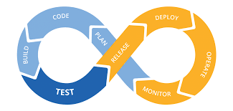
Figure 15. Continuous Integration/Continuous Deployment (CI/CD) (planned; no workflow configured).

2.4 Related Works
This section explores well-known crowdfunding models and the current informal alternatives used in the region. By comparing their functions, strengths, and limitations, it highlights the need for a localized, secure, and transparent platform of the kind Sahmi aims to become.

2.4.1 Kickstarter
How it works: Kickstarter is a prominent reward-based crowdfunding platform. It follows an all-or-nothing model in which project owners set a goal and deadline; if the goal is not met, funds are not collected. It is commonly used for creative projects, technology products, and independent films.
Strengths:
- Extensive international reach and strong brand recognition.
- Strong focus on creative and innovative initiatives.
- Clear project presentation tools and milestone tracking.
Weaknesses:
- Payment Barriers: Requires Stripe or specific international bank accounts, which are largely inaccessible to Palestinian project owners.
- High Fees: Charges significant commission fees plus payment processing costs.
- Rigid Model: The all-or-nothing approach may not suit social or community-based projects in emerging markets.
- Lack of Local Oversight: Does not provide localized administrative vetting tailored to regional regulations.

Figure 16. Kickstarter.

2.4.2 GoFundMe
How it works: GoFundMe focuses on personal and social causes, such as medical bills, education, or disaster relief. Unlike Kickstarter, it usually allows flexible funding, meaning project owners can keep the amount raised even if they do not reach the target.
Strengths:
- Relatively straightforward to set up for personal and social campaigns.
- Strong social sharing features and community engagement.
Weaknesses:
- Regional Restrictions: GoFundMe is frequently restricted or unsupported in many Arab countries, including Palestine, due to banking and compliance issues.
- Verification Gaps: Relies heavily on self-reported data, which can lead to trust issues if there is no local administrative body to verify project authenticity.
- Currency/Payment Limitations: Does not natively support local Palestinian digital wallets or direct bank transfers.

Figure 17. GoFundMe.

2.4.3 Informal Local Methods (Social Media & Direct Transfers)
How they work: Many Palestinian initiatives raise funds by posting calls for support on social media, such as Facebook and Instagram, and asking contributors to send money directly through bank transfers or local digital wallets such as Jawwal Pay.
Strengths:
- Zero platform fees.
- Culturally familiar and uses local payment channels.
Weaknesses:
- Limited Transparency: Investors have no way to track the total amount raised in real time or see how funds are spent.
- Security Risks: High vulnerability to fraud; anyone can claim to have a project without verification.
- Lack of Organization: Project owners typically lack a structured dashboard to manage supporters or generate reports.
- No Progress Visualization: The lack of a funding bar or clear goal tracking may reduce contributor engagement.
Global platforms provide mature payment infrastructure but may not fit the project’s intended local context, while informal funding lacks structured records. Sahmi currently bridges part of this gap through verified project listings, project dashboards, internal investment status records, synchronized totals, and live status updates. It does not yet verify receipts or integrate a payment provider, and its current access-control gaps must be resolved before it can serve as a trusted intermediary.
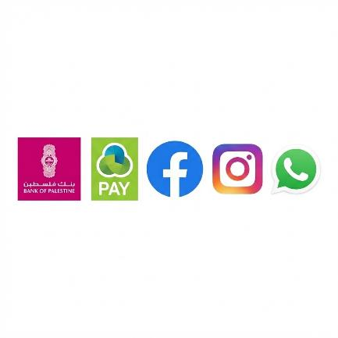
Figure 18. Informal Local Methods (Social Media & Direct Transfers).

2.5 Comparison (Gap Analysis)
Feature | Global Crowdfunding  (Kickstarter/GoFundMe) | Local Charity  Organizations | Informal Methods  (Social Media/WhatsApp) | Sahmi
Fees | High (Platform + Gateway) | High administrative overhead | Zero | No implemented platform or gateway fee calculation
Payment  Access | Restricted in Palestine | Traditional / offline | Manual / direct | Internal method/status records; no receipt or provider verification
Admin  Vetting | Automated / minimal local context | Strict / bureaucratic | None | Project verification exists; access-control gaps remain
Real-time  Tracking | Yes | No (mostly offline reports) | No | One Redis SSE event when a record enters confirmed; eight-second polling begins only after SSE failure.
Use Case | Creative / global tech | Humanitarian / relief | P2P / social | Social entrepreneurship and initiatives
Table 2. Similar Applications Comparison.
Gap explanation: Current local options range from international services with regional constraints to informal social-media transfers with little structured tracking. Sahmi contributes a project-verification workflow, internal investment records, confirmed-total calculation, dashboards, and live updates. The present system records bank_transfer, card, or paypal labels but does not upload receipts, contact payment providers, calculate platform fees, or guarantee that a confirmed status represents real money movement.

2.6 Verification of Ideas
Unlike platforms that focus on either international crowdfunding or humanitarian relief, Sahmi targets the missing middle—social entrepreneurship and community-driven initiatives. This concept is assessed through a three-part analysis:
- Market Analysis: A review of platforms such as Kickstarter and GoFundMe revealed significant barriers for Palestinian users, specifically regarding Stripe/PayPal integration and high cross-border transaction fees.
- Requirements Assessment: The project documentation identifies a trust gap around informal funding and prioritizes project verification, visible totals, and contribution histories. The repository itself does not provide evidence of completed stakeholder interviews or user-acceptance research, so those claims require separate team records.
- Technical Feasibility: The React and Django REST implementation demonstrates project records, staff verification, JWT-authenticated APIs, investment states, confirmed-total signals, Redis SSE, and polling. It also reveals permission defects—especially self-assigned staff status and investor-controlled confirmation—that must be corrected before the workflow is secure.
This validation establishes a functional prototype architecture, not a completed financial intermediary. The current interface is English and left-to-right, payments are not provider-verified, and localization, secure confirmation, auditability, and production deployment remain roadmap requirements.

2.7 Conclusion
In conclusion, this chapter reviewed existing platforms and funding models related to secure crowdfunding and digital transactions.
The analysis of global leaders such as Kickstarter and GoFundMe revealed that while these solutions are technologically advanced and reliable, they remain largely inaccessible to the Palestinian market due to high international transaction fees, rigid banking requirements, and a lack of localized administrative oversight.
Furthermore, the review of informal local methods (social media and direct transfers) highlighted a significant trust gap that hinders the growth of social entrepreneurship in the region.
The gap analysis supports the need for localized, transparent project funding. The implemented Sahmi prototype addresses project discovery, staff project verification, contribution records, funding totals, and live updates, while payment or receipt verification and production-grade authorization remain unfinished.

Chapter 3
Project Methodology
_______________________________________________________________________________________________
3.1 Introduction
3.2 Selected Methodology
3.2.1 Why Agile?
3.3 Implementation of Agile in Our Project
3.3.1 Requirement Analysis (Sprint 1)
3.3.2 System Design (Sprints 2-3)
3.3.3 Development & Iterative Implementation (Sprints 4-7)
3.3.4 Testing & Quality Assurance (Sprints 8-9)
3.3.5 Deployment & Feedback Collection (Sprints 10-12)
3.4 Conclusion

CHAPTER 3 | PROJECT METHODOLOGY

3.1 Introduction
This chapter outlines the iterative approach used to organize the Sahmi prototype. Selecting an appropriate methodology helps structure changing requirements, interface work, backend integration, and validation. For the current repository, the important iteration areas are project approval, investment-state handling, total synchronization, dashboards, and live updates. The sprint groupings below describe the documented development plan; where historical execution evidence is unavailable, they are not presented as proof that every activity or deliverable was completed.

3.2 Selected Methodology
Agile was selected as the project’s organizing methodology because it supports incremental delivery and adaptation. Instead of treating the system as one sequential release, the work can be divided into small increments covering the React interface, Django REST API, project workflows, investment states, live updates, testing, and deployment readiness. The repository demonstrates iterative feature additions, but it does not by itself verify sprint duration, ceremonies, or every claimed deliverable [26].

3.2.1 Why Agile?
The Agile methodology is particularly well suited for the Sahmi project for several key reasons:
- Iterative Refinement of Funding Workflows: Agile supports repeated review of project submission, staff verification, pending investment creation, confirmed-total synchronization, Redis events, and polling behavior.
- Incremental Security Review: Short cycles make it possible to test JWT handling, route guards, serializers, and object permissions as features evolve. The current code shows that this review remains incomplete because privilege escalation and several write-permission defects are still present.
- Stakeholder Feedback: Agile makes room for feedback from entrepreneurs, investors, administrators, and local users. Any claim that specific sessions or UAT were completed requires team records beyond the repository.
- Focus on High-Value Features: The documented MVP prioritizes public discovery, authentication, project submission and verification, investment records, totals, and role dashboards before payment-provider, messaging, notification, KYC, AI, and audit integrations.
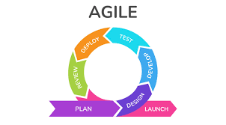
Figure 19. Agile.

3.3 Implementation of Agile in Our Project
The project documentation organizes development into 12 sprint-style iterations. The groupings below provide a retrospective roadmap from requirements through deployment readiness, but the repository does not establish two-to-four-week durations or prove that every listed activity was executed. Current implementation and test evidence are stated explicitly in each phase.

3.3.1 Requirement Analysis (Sprint 1)
The first documented iteration established the requirements baseline for the Sahmi prototype.
- Activities: The requirements review identified project discovery, project legitimacy, visible funding progress, account roles, and constraints on international and local payment workflows. Claims about completed market research or stakeholder consultations require separate evidence and are not inferred from source code.
During this sprint, the team created detailed user stories:
- As an Investor, I want to create a pending investment request so that an authorized process can later confirm or reject it; the current API instead accepts client-supplied status during creation and lets the owning investor later mutate multiple workflow fields.
- As a Project Owner, I want to see a real-time progress bar so I can track how close I am to my funding goal.
- Functional requirements cover verified public listings, JWT authentication, role-oriented dashboards, project submission and editing, investment states, confirmed-total synchronization, SSE, and polling. Non-functional requirements cover data integrity, permissions, privacy, usability, and deployment readiness; Arabic/RTL and receipt verification are future requirements.
- Deliverable: A requirements backlog and traceability baseline represented by the SRS, implementation chapters, API map, and future-work list.

3.3.2 System Design (Sprints 2-3)
These documented iterations translate the requirements into the current React and Django REST architecture and its security boundaries.
- Activities: The system separates a React/TypeScript SPA from a Django REST API. Relational models support users, categories, projects, images, documents, investments, milestones, repayments, and notifications. SQLite is the default database, while Docker Compose provisions PostgreSQL 16 as an optional target.
- API Design: DRF endpoints use JWT bearer authentication, filtering, pagination, serializers, and permissions. Django’s CSRF middleware exists, but bearer-token calls do not rely on a claim that every request is protected by CSRF; current permission and serializer defects remain part of the security backlog.
- Frontend and UX: The interface uses React 18, TypeScript, Vite, Tailwind CSS, and shadcn/Radix components and has an English, left-to-right layout. Project, authentication, dashboard, transaction, message, and settings screens are present, with simulated areas identified explicitly.
- Deliverable: Architecture and UML views, REST endpoint documentation, interface designs, and an implementation-gap register aligned with the repository.

3.3.3 Development & Iterative Implementation (Sprints 4-7)
This phase represents the core implementation plan, with functional components grouped into incremental repository features.
- Activities: Working from the prioritized Product Backlog, the team implemented features incrementally:
- Sprint 4: JWT authentication, investor and entrepreneur registration, role-oriented frontend route guards, and current-user profile APIs. Public admin assignment through registration or profile PATCH remains a critical defect.
- Sprint 5: Five-step project creation, owner editing and soft deletion, staff verification, and verified public listing. Known-slug detail access and self-assigned staff status still weaken the intended boundary.
- Sprint 6: Pending investment records, payment-method and transaction metadata, minimum-amount validation, confirmed-total signals, and transaction views. No receipt upload or provider verification is implemented.
- Sprint 7: Redis-backed SSE, an eight-second polling fallback, project funding updates, and API-derived dashboards and analytics. Formal PDF reporting is not implemented.
- Current automated evidence is limited to one Django test of confirmed-investment total synchronization and event dispatch plus one trivial Vitest assertion. Broader code review, unit, integration, permission, and frontend test evidence is not present in the repository.
- Deliverable: A runnable development-stage web application with implemented core records and interfaces, accompanied by a clearly defined security, testing, and integration backlog.

3.3.4 Testing & Quality Assurance (Sprints 8-9)
These documented iterations define the quality assurance needed before Sahmi can be treated as robust or production-ready; they are not a claim that the complete strategy has already been executed.
- Activities: The planned strategy combines backend model, serializer, view, signal, and permission tests; frontend component and service tests; API-contract checks; security regression tests; and end-to-end user journeys.
- Current Backend Test Evidence: One Django TestCase confirms that changing an investment to confirmed synchronizes project totals and invokes the event publisher.
- Current Frontend Test Evidence: Vitest and jsdom are configured, but the only test asserts that true is true and does not exercise a component or service.
- Security Testing Priority: Add regression cases for public admin self-assignment, category writes, investor-controlled status changes, milestone and repayment writes, unverified project detail visibility, and nested entrepreneur data exposure.
- End-to-End and Acceptance Testing: Playwright stub files exist, but they import an undeclared lovable-agent-playwright-config package; no runnable end-to-end configuration, end-to-end cases, or documented UAT results are present.
- Deliverable: A future evidence set containing automated results, coverage reports, security regression outcomes, bug records, and documented stakeholder acceptance.

3.3.5 Deployment & Feedback Collection (Sprints 10-12)
The final documented iterations focus on deployment readiness and feedback planning rather than an already completed public release.
- Activities: The backend Dockerfile defaults to Gunicorn, while Docker Compose runs the API with Django runserver alongside PostgreSQL 16 and Redis 7. Compose includes no frontend or Celery worker. The sample environment selects SQLite, points Redis to localhost, and omits Vite’s port 8080 origins from CORS, so its database, Redis, and CORS values require correction. The repository contains no NGINX, DigitalOcean, CI/CD workflow, or verified user-feedback evidence.
- Deliverable: Local and container-oriented development artifacts plus a production-readiness backlog; a live, fully functional public deployment is not established by the repository.

3.4 Conclusion
In summary, Agile provides a useful structure for iterating on Sahmi’s React interface, REST API, project workflow, contribution records, dashboards, and live updates. The current result is a functional prototype, not a completed secure financial platform. Authorization, privacy, payment verification, automated testing, container configuration, and production deployment remain priority work.

Chapter 4
System Analysis and Design
_______________________________________________________________________________________________
4.1 Introduction
4.2 Stakeholders and Requirements
4.3 UML and Architecture Views
4.4 Data Requirements
4.5 Conclusion

CHAPTER 4
SYSTEM ANALYSIS AND DESIGN

4.1 Introduction
This chapter translates the Sahmi requirements into stakeholders, functional and non-functional requirements, business rules, data entities, and design views. It distinguishes intended role boundaries from current behavior: the public list filters for verified active projects, but known-slug details expose unverified records and nested entrepreneur information; several write and privilege controls also require remediation.

4.2 Stakeholders and Requirements

4.2.1 Stakeholders and Their Needs
Stakeholder | Primary Needs
Visitor | Explore public information and the filtered list of verified active projects; known-slug details currently require tighter visibility and profile-data filtering; register or log in.
Investor | Search and filter projects; create and track investment records; see transactions and expected returns. Investors can currently mutate their own investment status, which is a critical security gap.
Entrepreneur | Submit a project; upload media; edit owned projects; understand review status; view funding and investor activity.
Administrator | Verify and activate projects; manage registered models through Django admin. Public registration and profile PATCH can currently assign the admin user type and staff status, so this boundary is not secure.
Platform operations | Run the frontend and backend, configure storage, database, and Redis, and plan monitoring and provider integrations. Compose starts no frontend or Celery worker, and no production deployment is evidenced.
Table 3. Stakeholders and Their Needs.

4.2.2 Functional Requirements
The following table consolidates requirements from the source specification. The FR identifiers connect planned behavior, implementation areas, API routes, tests, and acceptance criteria; they do not imply that every requirement is complete or securely enforced.
ID Range | Module | Requirement Summary
FR-001–006 | Public website and navigation | Homepage, marketing content, navigation, footer, project exploration, and calls to action.
FR-010–027 | Authentication and session management | Register, login, profile, password change, JWT storage/refresh, client-side token removal on logout, validation, and disabled-account behavior. Current register and profile serializers incorrectly permit self-assignment of the admin role.
FR-030–035 | Role-based access | Protected route redirects and intended investor, entrepreneur, and admin boundaries, with current exceptions in privilege assignment and several API write permissions.
FR-040–060 | Project discovery and detail | Verified active public listing, filtering, ordering, details, tabs, and view count. Known-slug details currently expose unverified projects and a full nested entrepreneur serializer.
FR-070–096 | Project creation and management | Five-step project wizard, validation, multipart cover-image upload, owner editing, date recalculation, soft delete, and review confirmation. Supporting-document upload is not exposed by the wizard.
FR-100–105 | Administrative oversight | Staff project verification and Django admin data management, plus target rejection, KYC, reporting, and audit functions. Self-assigned staff status currently undermines the intended admin-only boundary.
FR-110–137 | Investment and live funding | Investment requests and internal method/status records, minimum validation, confirmed-total synchronization, Redis SSE, and polling. Any authenticated caller can currently choose status during creation and target any project state, while the owning investor can later mutate project, amount, quantity, status, transaction metadata, method, and notes; no provider or receipt verification exists.
FR-140–183 | Role dashboards and analytics | Investor and entrepreneur dashboard cards, transactions, portfolio/project analytics, and future investor-network aggregation.
FR-190–213 | Messages, settings, and support | Current UI scope and future persistence for messages, settings, billing, notifications, and contact requests.
FR-220–274 | Categories, milestones, repayments, notifications, AI, audit, payment | Implemented models and CRUD routes for categories, milestones, and repayments; a notification model without API delivery; and planned payment, AI, audit, recommendation, and notification integrations.
Table 4. Functional requirements summary.

4.2.3 Business Rules
- Project creation checks for an entrepreneur or staff account, but public registration and current-profile PATCH can set user_type to admin and thereby grant staff status.
- Project writes are limited to the owner or staff and verification checks staff status; however, owners can write workflow fields, and the self-staff defect can bypass the intended verification boundary.
- The public project list filters active, verified, non-deleted projects, but public detail, payment, and event actions expose any non-deleted project by known slug. Detail nests the full UserSerializer for the entrepreneur and exposes verification notes plus business-plan, financial-projection, ownership-proof, and supporting-document URLs; payment responses and SSE payloads disclose confirmed investors’ display names, amounts, dates, and payment methods.
- Any authenticated user can currently write categories. Milestone creation and repayment creation or mutation are also insufficiently constrained by object ownership.
- Confirmed investment amounts and distinct investors define project totals, but an investor may currently update an owned investment status and trigger confirmation, synchronization, and SSE publication.
- The API checks the project minimum for common creation requests, but zero or certain partial-update combinations can bypass complete cross-field validation.
- Expected return is calculated from investment amount and project expected ROI when the stored value is initially empty; it is not automatically recalculated after every later change.
- When a stored refresh token exists, a failed refresh clears frontend tokens and redirects to login. A 401 with no refresh token does not follow that full cleanup path.

4.2.4 Non-Functional Requirements
Quality Attribute | Requirement Summary
Performance | Related-object query loading, paginated lists, Redis SSE, and an eight-second polling fallback are implemented; production performance and caching have not been measured or configured.
Reliability | Loading/error/empty/retry states; post-commit total synchronization; resilience when Redis/SSE is unavailable.
Usability | Responsive navigation, field-level validation, destructive-action confirmation, scannable dashboard cards, helpful empty states, toasts.
Accessibility | Semantic controls, textual status cues, and Radix primitives provide an accessibility foundation, but keyboard and screen-reader coverage of critical flows remains a testing target rather than verified completion.
Compatibility | Current major-browser support is targeted. SQLite is the default; Compose provisions PostgreSQL and Redis only after service URLs are corrected; configuration is environment-based.
Maintainability | Backend modules and reusable UI components support maintenance, but API contracts require alignment. drf-spectacular exposes schema and Swagger routes, while validation currently reports errors and warnings that must be repaired.
Security | JWT, password hashing, production HTTPS settings, CORS, and object permissions exist, but critical gaps include self-assigned staff, authenticated category writes, client-controlled investment workflow fields, overly broad milestone/repayment writes, unverified detail visibility, sensitive profile/document/payment-event exposure, local token storage without refresh-token revocation, and absent rate limits and audit logging.
Table 5. Non-functional requirements summary.

4.3 UML and Architecture Views

4.3.1 Use Case Diagram
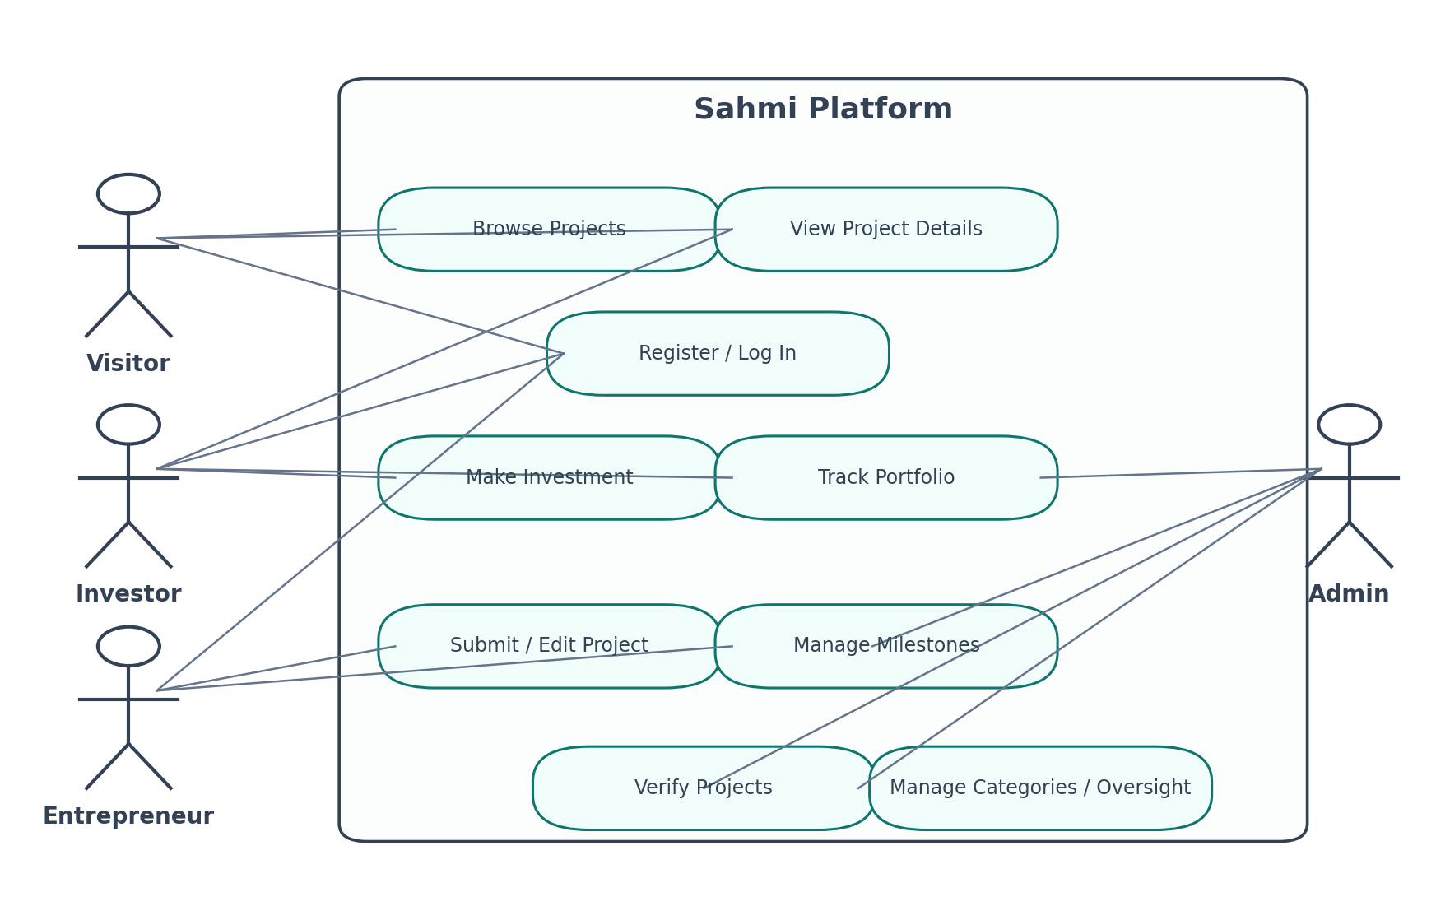
Figure 20. Use case view of the main Sahmi stakeholders and platform interactions.

4.3.2 Class Diagram
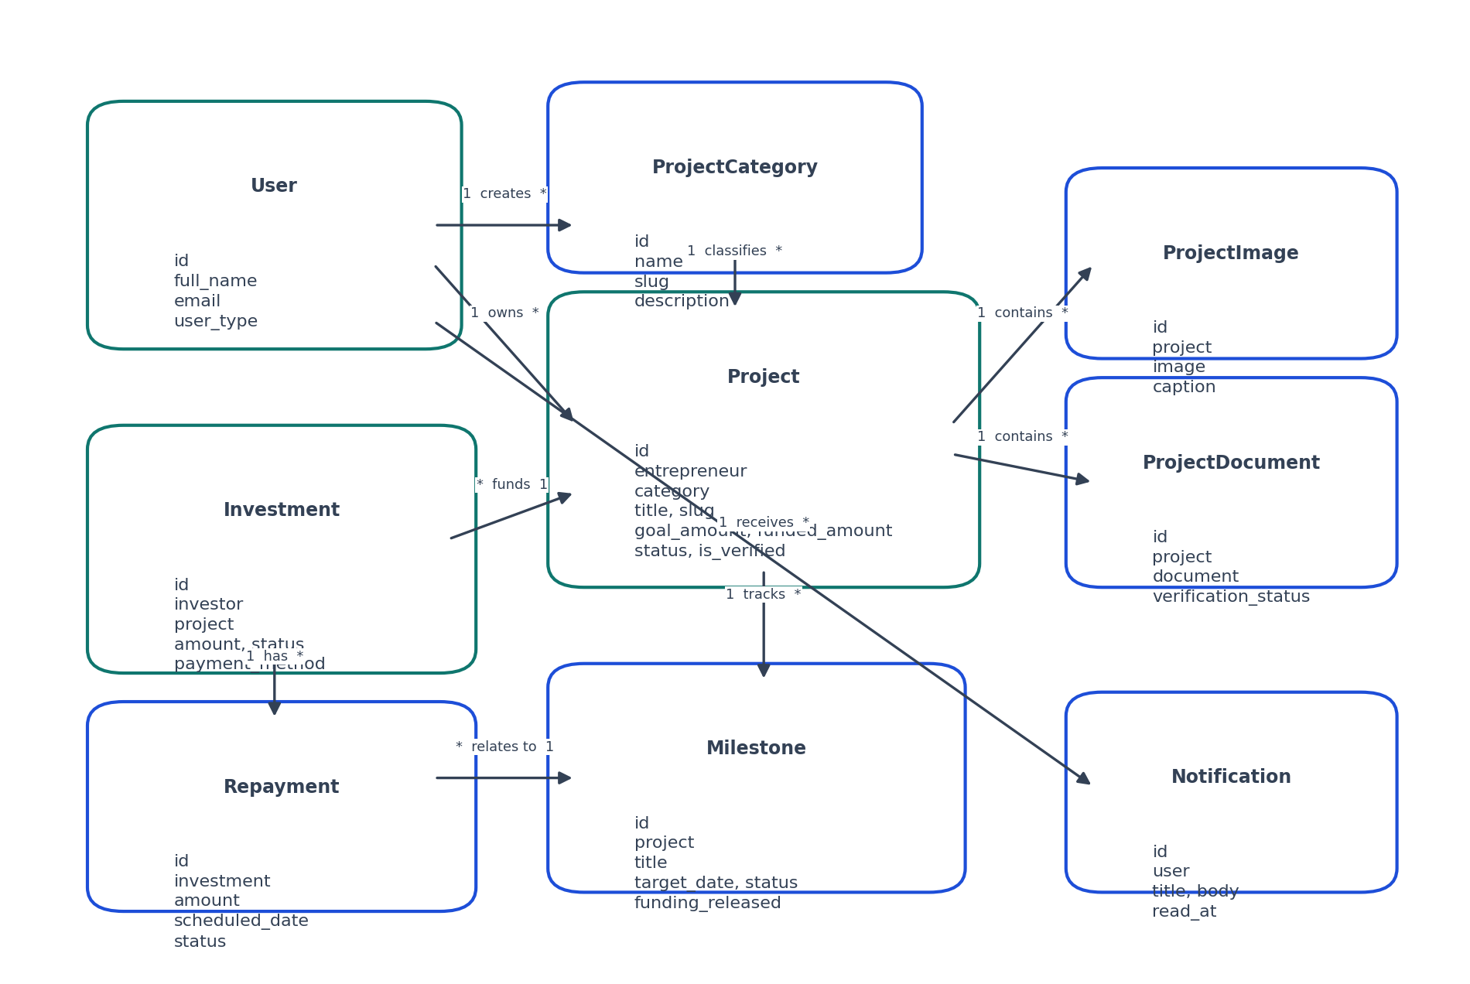
Figure 21. Conceptual core domain model aligned with Sahmi requirements.

4.3.3 Investment Confirmation Sequence Diagram
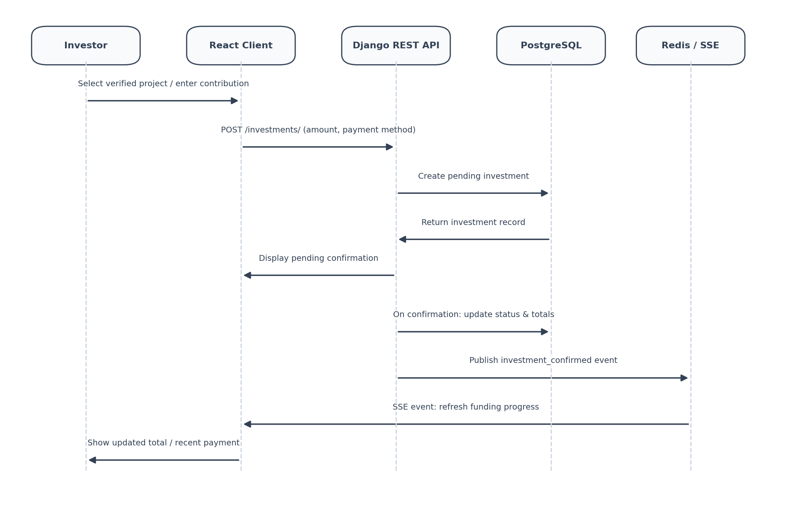
Figure 22. Target server-controlled investment confirmation and live-update sequence.

4.3.4 System Architecture Diagram
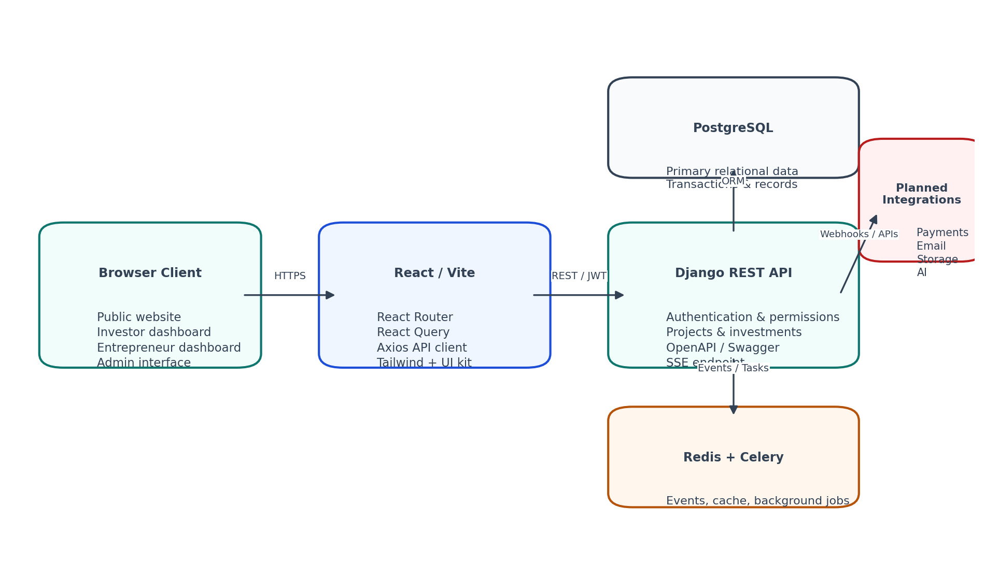
Figure 23. Proposed Sahmi system architecture and integration boundaries.

4.4 Data Requirements
Most domain models inherit from an abstract base model with UUID and timestamp fields; the custom User model separately uses a UUID and Django’s account timestamps. The core data set consists of users, categories, projects, project images/documents, investments, milestones, repayments, and notifications. The table summarizes stored entities rather than implying complete workflows for every field.
Entity | Core Purpose | Relationship Role
User | Identity, account type, profile fields, authentication relationships. | Owns projects, makes investments, receives notifications.
ProjectCategory | Name, slug, description. | Classifies projects for discovery and filtering.
Project | Narrative, funding goal, ROI, status, verification, dates, totals. | Owned by entrepreneur; belongs to category; has media, investments, milestones.
ProjectImage | Image and alt_text. | Belongs to project.
ProjectDocument | File and title; no document-verification state is implemented. | Belongs to project; planned richer verification workflows.
Investment | Amount, payment method, status, expected return, transaction information. | Links investor to a project; totals count only confirmed records.
Milestone | Title, description, target and actual dates, status, deliverables, project percentage, funding released, and order. | Belongs to project; supports future delivery visibility.
Repayment | Amount, scheduled/actual dates, status, transaction ID. | Belongs to investment; supports return/payment tracking.
Notification | Title, body, read timestamp. | Belongs to user; API delivery is future work.
Table 6. Core data entities.

4.5 Conclusion
The analysis establishes a coherent intended platform boundary, but the backend is not yet authoritative for every authorization decision. The diagrams summarize the target design; the documented serializer, visibility, privilege, and object-permission exceptions define the security work required before production use.

Chapter 5
Implementation and Interface Design
_______________________________________________________________________________________________
5.1 Introduction
5.2 Technology Implementation
5.3 Feature Modules and Interfaces
5.4 Deployment and Operational Design
5.5 Current Gaps and Future Work
5.6 Conclusion

CHAPTER 5
IMPLEMENTATION AND INTERFACE DESIGN

5.1 Introduction
This chapter presents the system implementation as described by the project repository and source requirements. The visual figures are conceptual wireframes derived from the stated UX and route requirements; they are not presented as production screenshots. They show how public discovery, authentication, project creation, verification, investment tracking, and role-based dashboards can be organized in a coherent responsive interface.

5.2 Technology Implementation
The frontend is a React 18 and TypeScript single-page application using React Router, React Query, Axios, Tailwind CSS, shadcn/Radix components, and Vite. The backend uses Django, Django REST Framework, Simple JWT, django-filter, and drf-spectacular. SQLite is the default database; Docker Compose provisions PostgreSQL 16 and Redis 7 with the API, but the sample database, Redis, and CORS values require correction, including Vite’s omitted port 8080 origins. Redis supports project SSE publication. Celery is configured with a placeholder task, yet Compose starts no worker.

5.3 Feature Modules and Interfaces

5.3.1 Landing Page and Project Discovery
The public experience introduces Sahmi’s mission, links to project exploration, and presents featured projects. The browse route supports search, category filters, sorting, loading, error, empty, retry, and clear-filter states. The public list is restricted to active, verified, non-deleted projects, but direct detail access is not equivalently filtered and must be tightened.
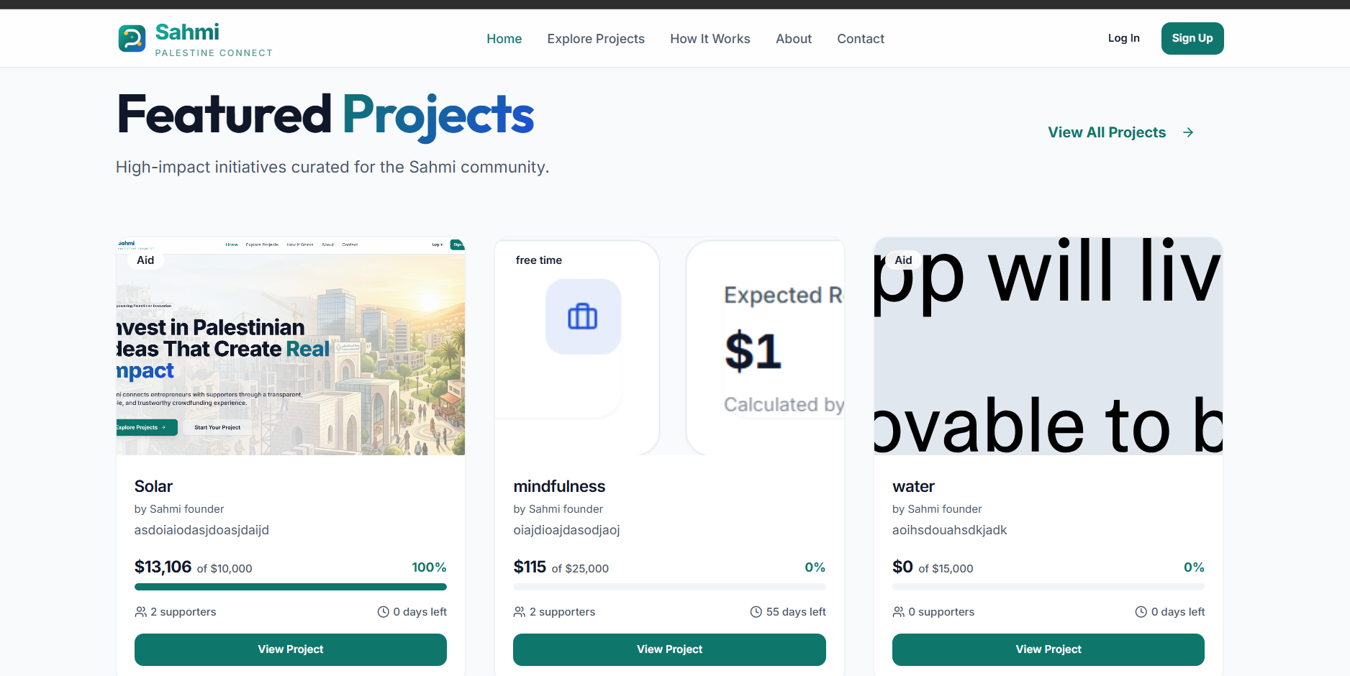
Figure 24. Conceptual public landing and project-discovery interface.

5.3.2 Project Detail and Contribution Flow
The project detail route uses a slug and displays API-backed cover media, category, verification and status badges, funding totals, goal, investor count, days left, minimum investment, expected ROI, story text, and confirmed investment records. Funding-plan text derives from project fields, while updates, team, and FAQ content is largely static. Any authenticated user can submit an investment record, choose its status at creation, and target any project state. Only records stored as confirmed count toward totals; the owning investor can later mutate project, amount, quantity, status, transaction metadata, payment method, and notes. Public details also expose unverified projects, sensitive entrepreneur and project-document data, and confirmed-investor metadata.
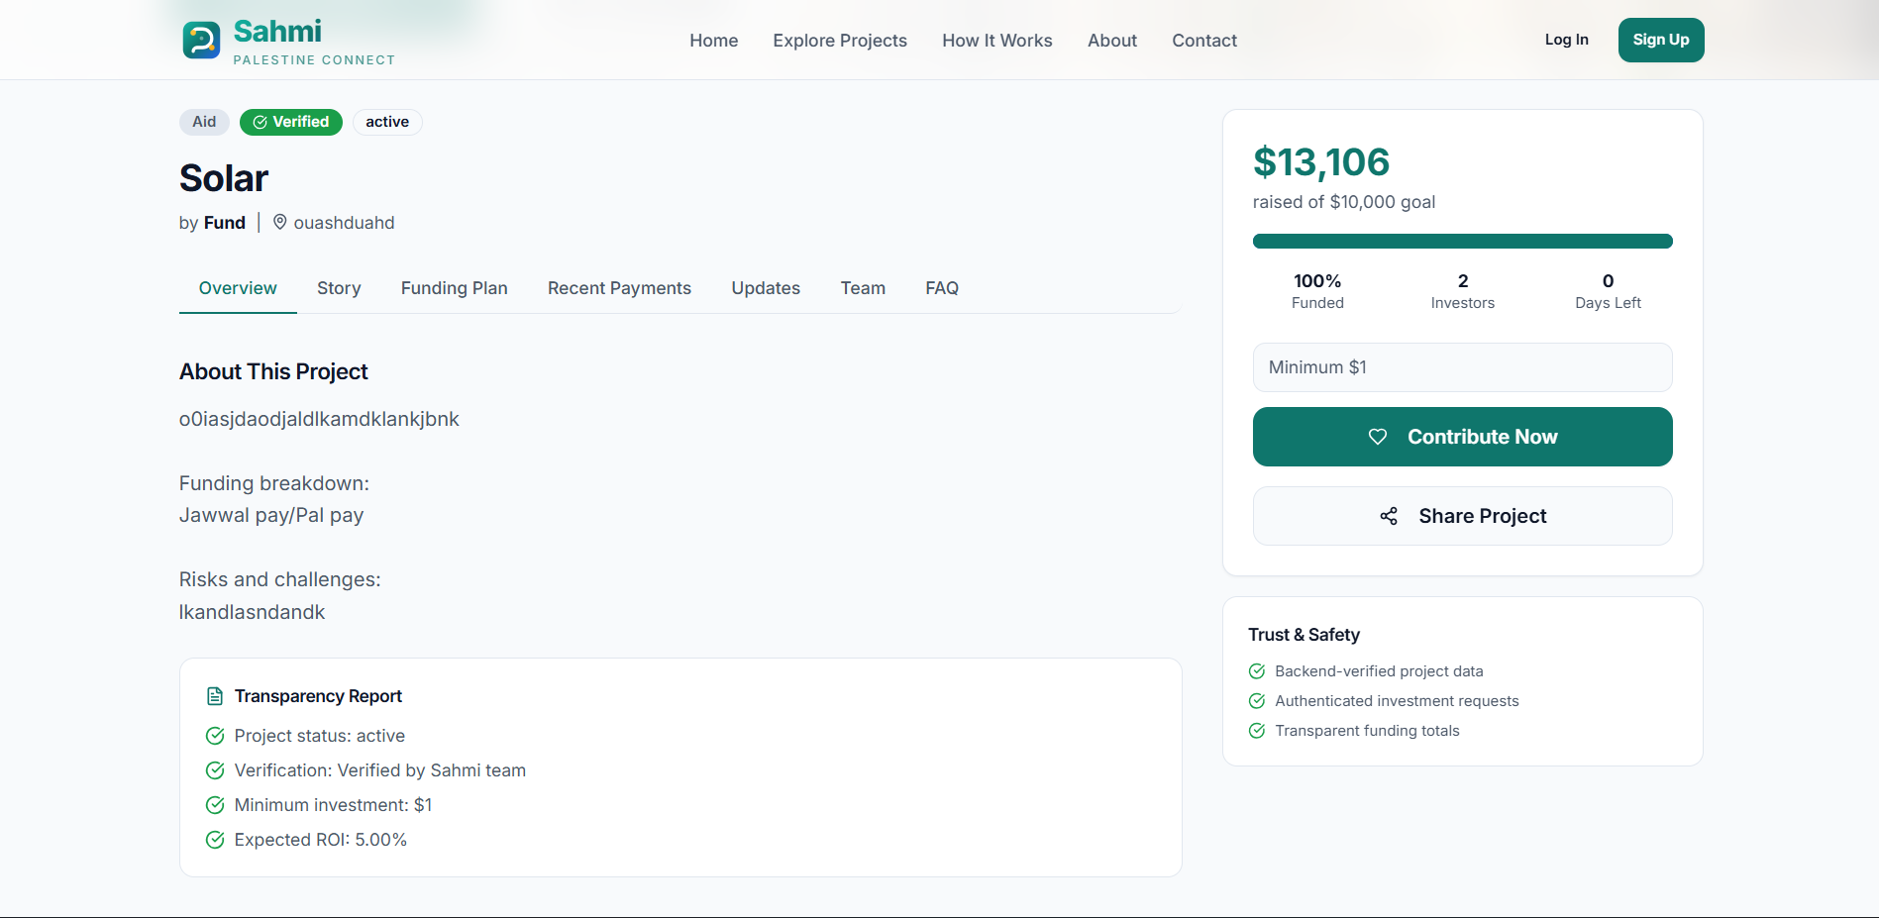
Figure 25. Conceptual project detail and contribution interface.

5.3.3 Authentication and Account Types
Registration supports investor and entrepreneur choices in the official UI, and login returns access and refresh tokens with user data. The frontend stores tokens in local storage, attaches bearer tokens, and attempts one refresh after a 401. The password-change API and frontend service validate the current password and confirmation, but the Settings page never calls that service; its password fields and other actions are local simulations. Logout only removes browser-stored tokens; the backend does not revoke or blacklist refresh tokens. The public register API and current-profile PATCH also accept user_type=admin, creating a critical privilege-escalation defect.
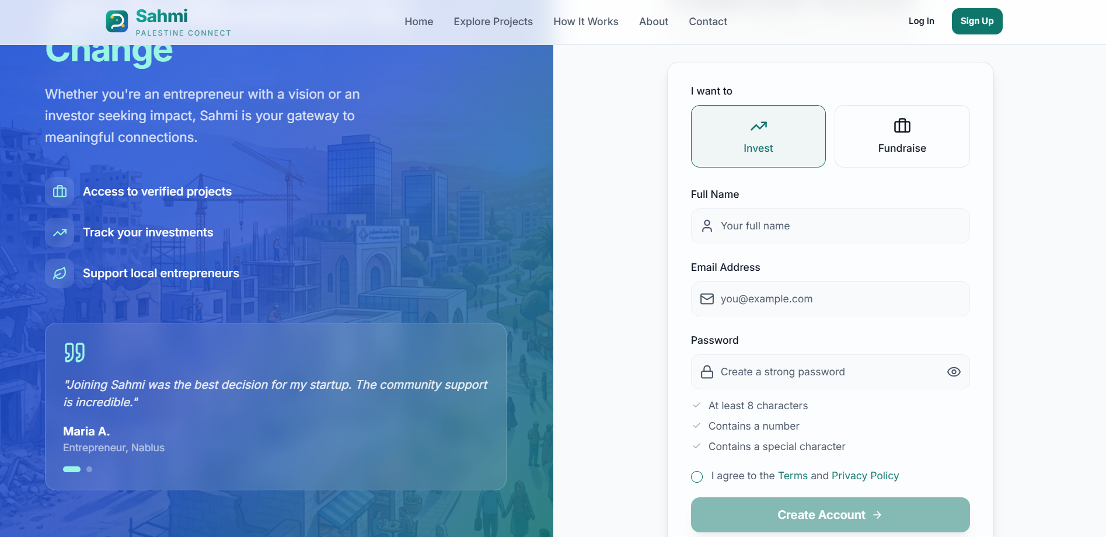
Figure 26. Conceptual authentication and account-type onboarding interface.

5.3.4 Project Creation Wizard
Entrepreneurs and staff create projects through five steps: Basic Info, Project Story, Funding Goal, Media, and Review. The form collects title, category, descriptions, location, goal, minimum investment, expected ROI, duration, optional cover image, and optional video URL. It sends multipart data, assigns ownership, and normally relies on draft/unverified defaults. It does not upload supporting documents, and self-assigned staff status can bypass the intended role boundary.
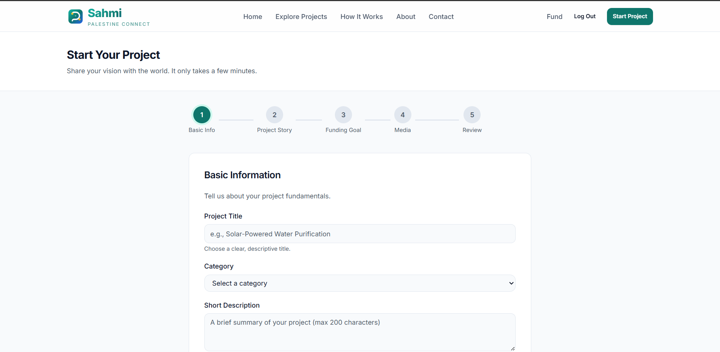
Figure 27. Conceptual five-step project submission wizard.

5.3.5 Administrative Project Verification
The verification action sets a project to active and records the verifier, timestamp, and optional notes. Staff accounts can call it because the API checks staff status. Django admin registers users, categories, projects, investments, milestones, and repayments, with project media inlines, but model management requires corresponding Django permissions or superuser status. Future work includes rejection, KYC, reports, and audit logs. Because staff status can currently be self-assigned through user_type, the verification boundary requires immediate hardening.
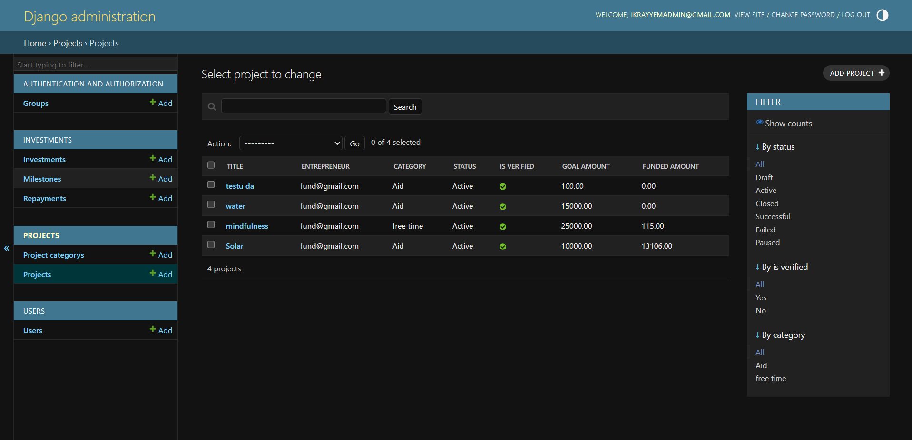
Figure 28. Conceptual administrative project verification workspace.

5.3.6 Investor Dashboard and Transactions
The investor dashboard refetches investments and up to three verified projects every five seconds. Its Total Invested, expected-return total, monthly performance, and category allocation include investment records of every status. The transactions page likewise labels the sum of every record as Total Paid and describes every record as an active investment, although it separately computes a confirmed/completed subtotal that is not displayed.
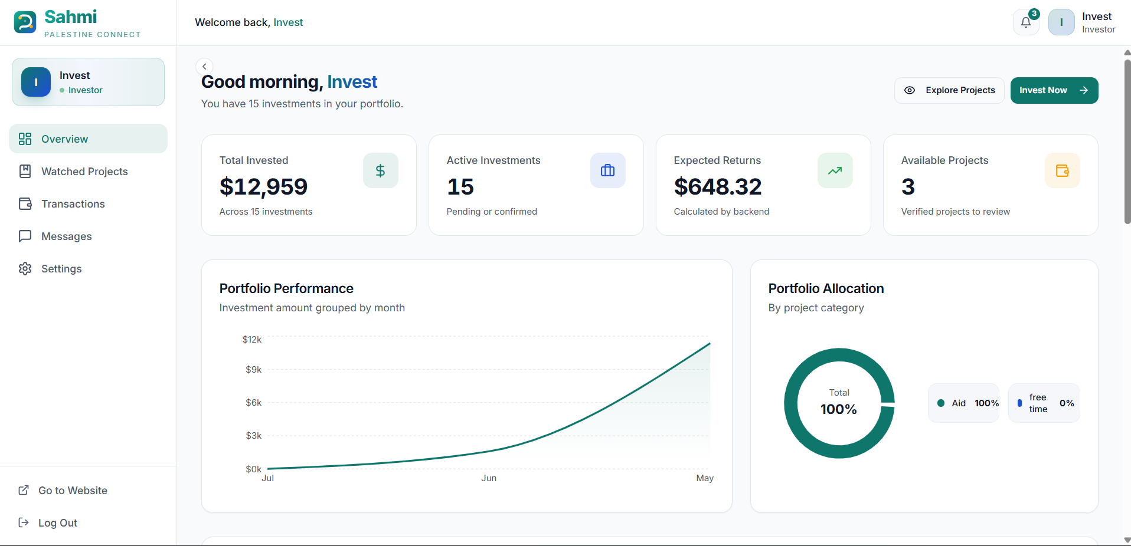
Figure 29. Conceptual investor portfolio dashboard.

5.3.7 Entrepreneur Dashboard and Analytics
The entrepreneur dashboard derives headline project totals from API project fields, but its monthly Funding Raised chart sums every visible investment record regardless of status. The analytics page also charts every status, and its displayed total view count is floored at 2.5 times the summed investor count rather than always using the stored view_count. In addition, every project-detail GET increments view_count, including polling and refetches. Recent messages and the investor-network list remain mock or static content.
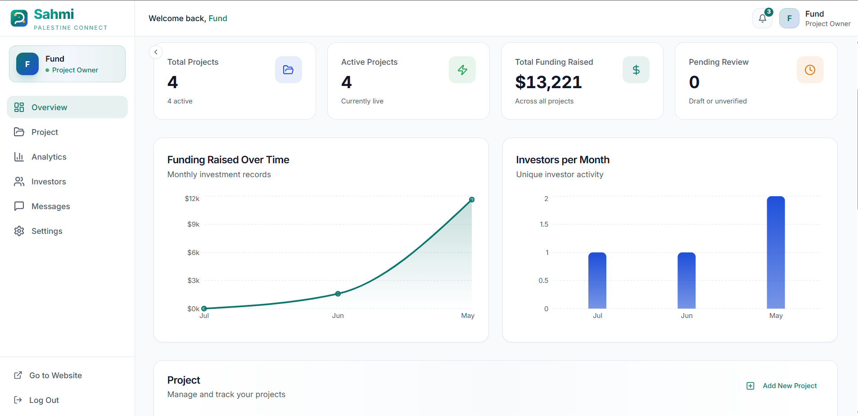
Figure 30. Conceptual entrepreneur project and analytics dashboard.

5.3.8 Transaction, Repayment, Messages, and Settings Workspaces
The backend exposes milestone and repayment CRUD, but the frontend has no dedicated repayment service or persistent repayment workspace, and current write permissions are too broad. The Settings page only reads the current name and email from auth context; profile save, password fields, 2FA, notification preferences, wallet deposits and withdrawals, provider connections, invoice downloads, and session revocation are local simulations. Messages use mock conversations and local-only sends. Persistent APIs, secure permissions, delivery preferences, wallet/billing records, and contact rules remain future work.
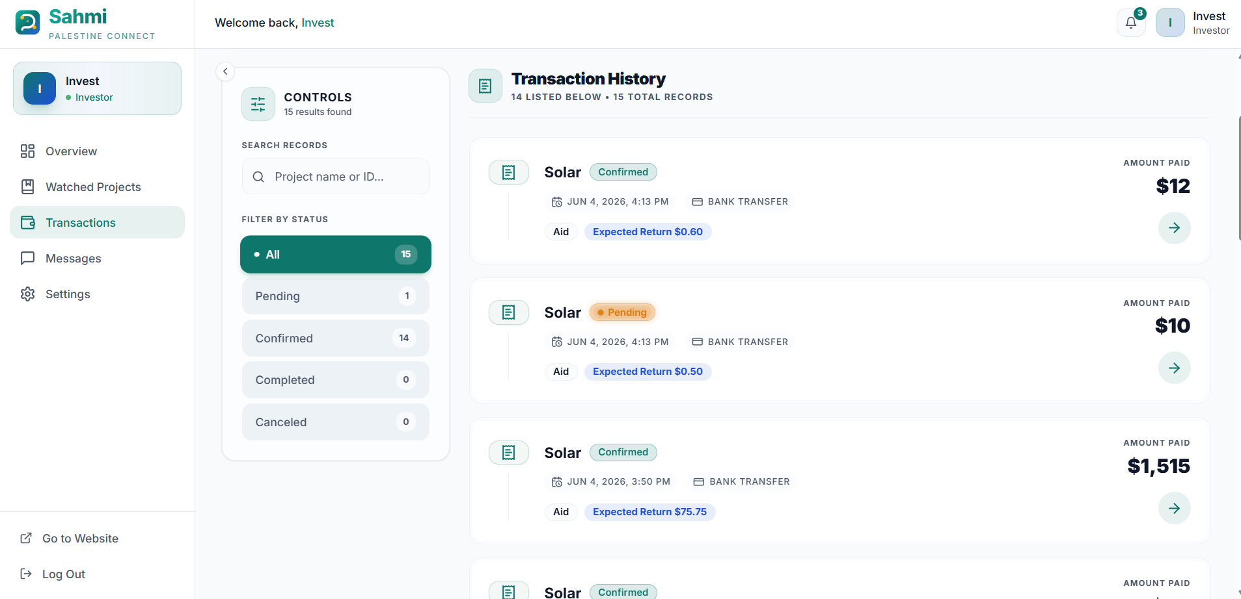
Figure 31. Conceptual investment transaction and repayment monitoring interface.
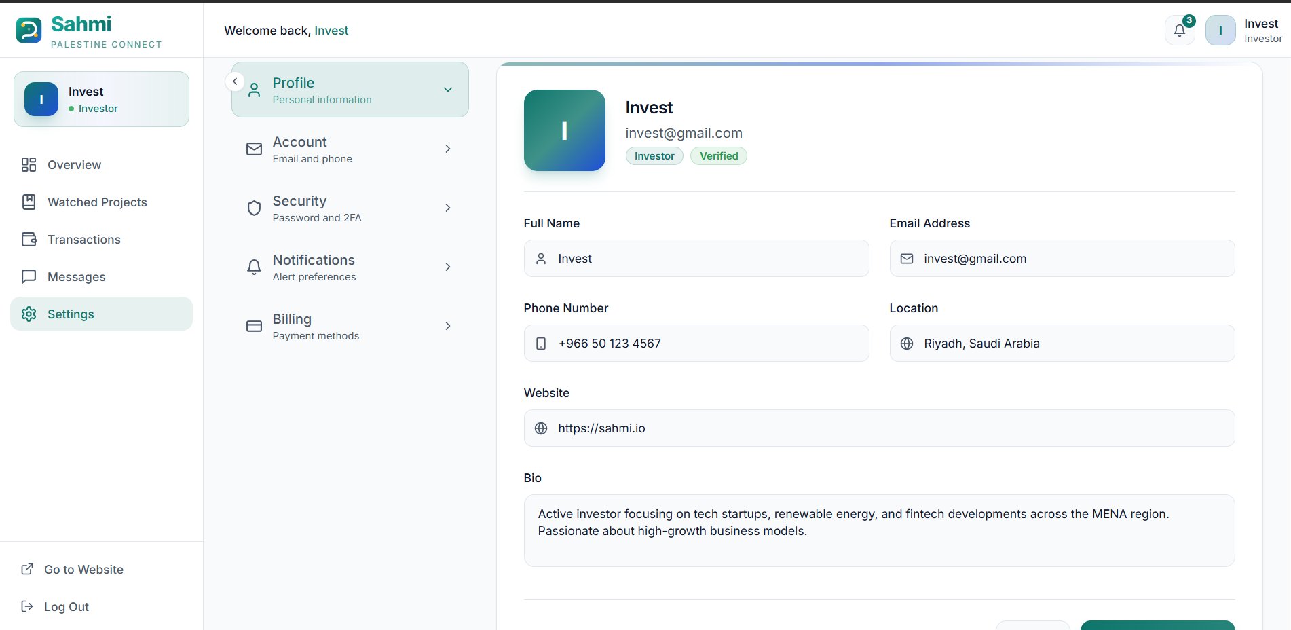
Figure 32. Conceptual messaging and account-settings workspace.

5.3.9 Real-Time Funding Updates
A transition into confirmed status synchronizes project totals after commit and publishes one Redis event. Saves and deletions always resynchronize database totals, but edits to an already confirmed record, deletion, or transitions out of confirmed publish no SSE event. The client starts eight-second polling only after SSE failure, so those changes can remain stale while SSE stays connected. Confirmed status reflects database state, not verified money movement.

5.4 Deployment and Operational Design
Docker Compose defines the Django API, PostgreSQL 16, and Redis 7. Compose overrides the image command with Django runserver; the Dockerfile itself defaults to Gunicorn on port 8000. No frontend or Celery worker service is included. The sample environment selects SQLite, points Redis to localhost, and omits Vite’s configured port 8080 origins from CORS, so database, Redis, and CORS values must be corrected for the supplied setup. Static/media hosting, production settings, secrets, monitoring, backups, and external storage remain deployment work.
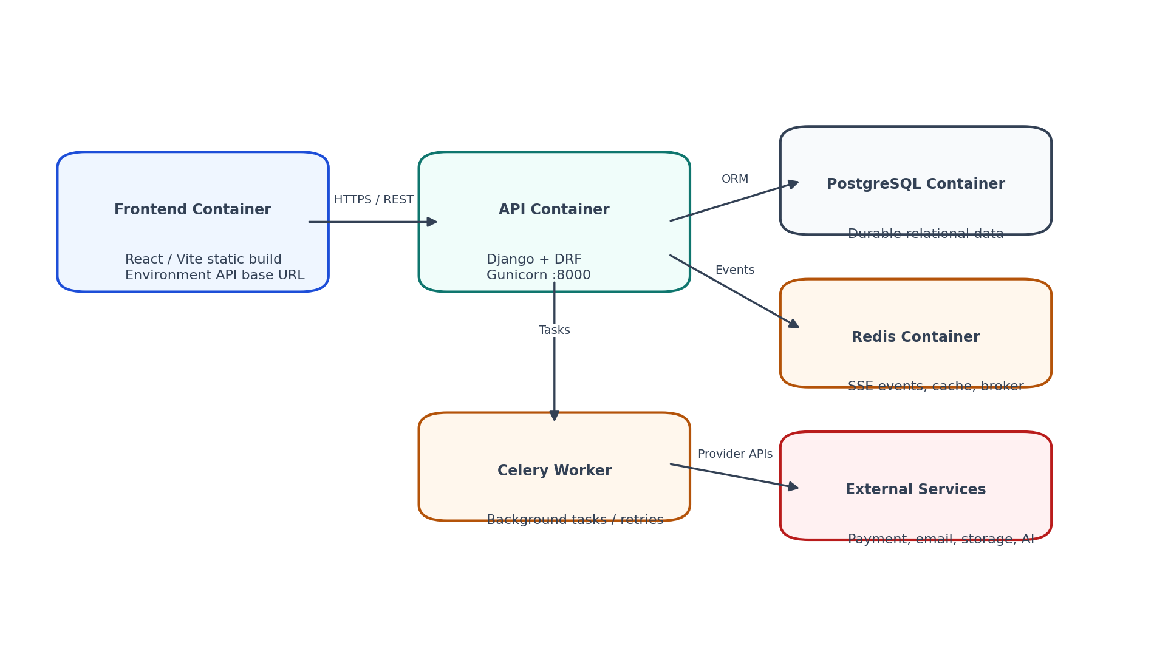
Figure 33. Conceptual Docker-oriented deployment topology for the Sahmi platform.
Layer | Configuration / Responsibility | Operational Note
Frontend | React/Vite build on port 8080 with VITE_API_BASE_URL; the frontend is not included in Docker Compose and needs a separate hosting workflow. The sample CORS origins use port 5173 and omit the configured port 8080 origins. | Build and deploy through frontend workflow.
API | Compose runs Django runserver on 0.0.0.0:8000; the Dockerfile default is Gunicorn when not overridden. | Containerized backend service.
Database | PostgreSQL 16 is provisioned in Compose, but the sample DATABASE_URL still selects SQLite and requires correction. | Migration and backup strategy required.
Event/task layer | Redis 7 supports Pub/Sub and is configured as the Celery broker/result backend; no Celery worker service is started. | Fallback polling preserves user experience.
External services | Payment, email, object storage, AI, monitoring, and production hosting are future integrations, not active services. | Future provider integrations; keys via environment variables.
Table 7. Deployment configuration scope.

5.5 Current Gaps and Future Work
Area | Current Gap / Future Work
Authentication and privileges | Forgot-password, terms, and privacy routes are missing; more critically, public registration and /auth/me/ PATCH can assign user_type=admin and staff status.
Contact | Contact form submission is simulated; backend/email integration is required.
Messaging | Messages and investor-network data are mock/static frontend content; persistence APIs are pending.
Notifications | A Notification model exists, but no API routes or delivery operations are exposed; the dashboard notification popover is a hard-coded, role-filtered sample list.
Payments | No gateway, webhook, receipt upload, or provider confirmation exists. Any authenticated caller can create an investment for any project state and supply status directly; the owning investor can later mutate project, amount, quantity, status, transaction metadata, payment method, and notes, potentially changing confirmed totals and events.
KYC / audit | KYC fields exist but submission/review APIs and audit logs are not implemented.
AI / recommendations | Model fields exist; task execution, discovery ranking, and recommendations remain future work.
Security hardening | Tokens are stored in local storage without refresh-token revocation. Self-staff escalation, sensitive profile/document/payment-event exposure, absent rate limits, CSP, and audit logs, current TypeScript type-check failures, schema warnings, and production-secret handling require remediation.
Object permissions | Authenticated category writes; arbitrary-project investment creation with client-supplied status; investor mutation of project, amount, quantity, status, transaction metadata, method, and notes; overly broad milestone/repayment creation or mutation; public unverified detail access; exposed profile/document/payment-event data; and writable project workflow fields require stricter permissions and serializers.
Table 8. Feature modules and implementation status.

5.6 Conclusion
The current repository provides a substantial web prototype foundation, but authoritative authorization and production readiness have not been achieved. Priority work is to close privilege, object-permission, data-exposure, and payment-confirmation defects; resolve current TypeScript and OpenAPI errors; expand automated tests; correct container configuration; and integrate the planned services.

Chapter 6
Testing and Quality Assurance
_______________________________________________________________________________________________
6.1 Introduction
6.2 Testing Methodology
6.3 Testing Objectives
6.4 Test Scenarios and Cases
6.5 Quality and Security Validation
6.6 Conclusion

CHAPTER 6
TESTING AND QUALITY ASSURANCE

6.1 Introduction
Testing for Sahmi should focus on the project lifecycle, data integrity, authorization, privacy, and user feedback. Current execution evidence is limited to one meaningful Django signal test and one trivial Vitest assertion; both pass under their local runners. The Vite production bundle completes, but TypeScript type checking fails. Playwright stub files depend on an undeclared package and contain no end-to-end cases. The tables therefore define planned verification cases and expected outcomes, including cases that expose known current failures.

6.2 Testing Methodology
The planned quality strategy is layered: backend tests should cover models, serializers, permissions, views, signals, and API contracts; frontend tests should cover components and services with Vitest and jsdom; and Playwright should cover completed user journeys. At present, the single meaningful Django TestCase and the single trivial Vitest assertion pass. The Vite production bundle completes with a large-chunk warning, but tsc --noEmit fails on animation variant types, a missing page prop, timer typing, and an Axios response cast. Playwright stubs import an undeclared package, and drf-spectacular validation reports schema errors and warnings.

6.3 Testing Objectives
- Confirm that the public project list contains only verified, active, non-deleted projects and that detail, payment, and event routes do not expose unverified records.
- Confirm registration, login, token refresh, profile access, password change, and logout behavior.
- Confirm route and API authorization across roles, including rejection of self-assigned staff, unauthorized category writes, investor-controlled status changes, and improper milestone or repayment writes.
- Confirm project wizard validation, ownership, soft deletion, and administrator verification.
- Confirm minimum-investment validation, confirmed-total synchronization, SSE/polling behavior, and server-controlled investment confirmation; a confirmed record must not be treated as proof of provider payment.
- Confirm user-interface loading/error/empty states and responsive navigation.
- Confirm that planned features are not falsely treated as completed production controls.

6.4 Test Scenarios and Cases
ID | Scenario | Precondition / Action | Expected Result | Trace
TC-01 | Register an investor without privilege escalation | Visitor supplies valid investor data, then attempts public registration with user_type=admin. | Investor account and auth payload are created; public admin assignment is rejected. The second expectation currently fails and requires remediation. | FR-010–016
TC-02 | Log in and refresh session | Registered user logs in; API later returns 401 for an authenticated call. | Client stores tokens, refreshes once, retries; on refresh failure, clears state and redirects to login. | FR-017–023
TC-03 | Public list and detail visibility | Visitor requests the project list and directly requests a known draft or unverified project slug. | List includes only active verified records, and non-public details are denied without sensitive entrepreneur fields. Current detail behavior fails this expectation. | FR-040–048; BR-006
TC-04 | Entrepreneur submits project | Entrepreneur completes wizard with valid data and optional cover image. | Project is owned by user and defaults to draft/unverified; media uses multipart handling. | FR-070–083
TC-05 | Authorized staff verifies project | A server-authorized staff user—not a self-promoted account—posts the verification action. | is_verified becomes true; status becomes active; verifier metadata and notes are saved. | FR-100–103; BR-004–005
TC-06 | Reject low investment | Authenticated investor submits an amount below project minimum. | Server rejects request with validation error; no investment is created. | FR-110–115; BR-011
TC-07 | Protect investment confirmation and totals | Authorized staff confirms an investment while the investor attempts to PATCH the owned record’s status. | Only the authorized confirmation succeeds; totals synchronize after commit. Investor self-confirmation is currently possible and must be fixed. | FR-130–132; BR-007–009
TC-08 | Live project update | Project details page is connected to project SSE endpoint. | Confirmed event updates funding and recent-investment UI; polling is used if SSE fails. | FR-133–137; NFR-005
TC-09 | Project authorization and self-staff prevention | A non-owner attempts to change another project and attempts to gain staff access by setting user_type=admin. | Both attempts are denied; only the genuine owner or server-authorized staff path remains allowed. Self-staff assignment currently fails this expectation. | FR-034; FR-090–096; SR-009
TC-10 | Investment read and write visibility | Investor, project entrepreneur, unrelated user, and staff request or mutate an investment record. | Scoped reads are allowed; unrelated access is denied; confirmation and privileged workflow fields are server-controlled. Current investor status writes require correction. | FR-119–123; SR-010
TC-11 | Password change | Authenticated user supplies wrong current password or mismatched confirmation. | Validation fails; correct current password + valid new password succeeds. | FR-026–027; SR-005
TC-12 | Container development smoke test | Docker Compose starts after DATABASE_URL and REDIS_URL are corrected to container service names and migrations are applied. | The API runs with Django runserver on port 8000 alongside PostgreSQL 16 and Redis 7; docs load with known schema warnings. This is not a production deployment. | DR-001–007; AC-016
Table 9. Planned test cases.

6.5 Quality and Security Validation
The planned test program should prioritize authentication, serializers, permissions, project visibility, investment synchronization, milestones, repayments, and API contracts. Current coverage is not demonstrated against the 80 percent target: the repository has one meaningful backend test and a placeholder frontend test, and frontend type checking currently fails. Security regression cases must cover self-staff escalation, category writes, client-controlled investment fields, milestone/repayment permissions, unverified details, and sensitive profile, document, payment, and event data. Type checking and corrected OpenAPI validation must become release gates.
Acceptance ID | Verification Statement
AC-001 | Visitor can browse public pages and verified active projects.
AC-002–003 | Target: investor/entrepreneur registration, login, session refresh, and logout work while public admin assignment and profile-based privilege escalation are rejected.
AC-004–006 | Target: project submission, genuine-staff verification, and safe public discovery are connected without exposing draft details or sensitive nested profiles.
AC-007–009 | Target: contribution creation, server-controlled confirmation, total synchronization, and SSE/polling update behavior work without implying provider payment verification.
AC-010–011 | Target: investor and entrepreneur dashboards show correctly scoped API data, with mock and simulated content clearly separated.
AC-012–013 | Target: owners and genuine staff may mutate permitted project fields; non-owners and self-promoted accounts cannot bypass authorization.
AC-014–017 | Target: pagination/filtering, corrected OpenAPI output, container configuration, and broad automated tests are validated; currently only one synchronization test is meaningful.
Table 10. Planned acceptance criteria traceability.

6.6 Conclusion
Sahmi’s testing plan is intended to validate its trust boundaries: who may see or change data, how project state becomes public, how confirmed records affect totals, and how the interface reflects backend state. The current sparse test evidence does not prove these boundaries; the selected cases establish the remediation and validation baseline for the MVP.

References
[1] Django Software Foundation. “Django Documentation.” Available: https://docs.djangoproject.com/en/stable/.
[2] Encode. “Django REST Framework Documentation.” Available: https://www.django-rest-framework.org/.
[3] PostgreSQL Global Development Group. “PostgreSQL Documentation.” Available: https://www.postgresql.org/docs/.
[4] Python Software Foundation. “Python Documentation.” Available: https://docs.python.org/3/.
[5] React Team. “React Documentation.” Available: https://react.dev/.
[6] MDN Web Docs. “HTML Documentation.” Available: https://developer.mozilla.org/en-US/docs/Web/HTML.
[7] MDN Web Docs. “CSS Documentation.” Available: https://developer.mozilla.org/en-US/docs/Web/CSS.
[8] Tailwind Labs. “Tailwind CSS Documentation.” Available: https://tailwindcss.com/docs.
[9] MDN Web Docs. “JavaScript Documentation.” Available: https://developer.mozilla.org/en-US/docs/Web/JavaScript/.
[10] Microsoft. “TypeScript Documentation.” Available: https://www.typescriptlang.org/docs/.
[11] Vite Team. “Vite Documentation.” Available: https://vite.dev/guide/.
[12] Google. “Google Docs Editors Help.” Available: https://support.google.com/docs/.
[13] Google. “Google Sheets Help.” Available: https://support.google.com/docs/topic/9054603.
[14] GitHub. “GitHub Documentation.” Available: https://docs.github.com/.
[15] TanStack. “TanStack Query Documentation.” Available: https://tanstack.com/query/latest/docs/framework/react/overview.
[16] Git. “Git Documentation.” Available: https://git-scm.com/doc.
[17] Atlassian. “Trello Documentation.” Available: https://help.trello.com/.
[18] Microsoft. “Visual Studio Code Documentation.” Available: https://code.visualstudio.com/docs/.
[19] Axios. “Axios Documentation.” Available: https://axios-http.com/docs/intro.
[20] shadcn. “shadcn/ui Documentation.” Available: https://ui.shadcn.com/docs.
[21] Docker Inc. “Docker Documentation.” Available: https://docs.docker.com/.
[22] Docker Inc. “Docker Compose Documentation.” Available: https://docs.docker.com/compose/.
[23] NGINX Inc. “NGINX Documentation.” Available: https://nginx.org/en/docs/.
[24] DigitalOcean. “DigitalOcean Docs.” Available: https://docs.digitalocean.com/.
[25] GitHub. “GitHub Actions Documentation.” Available: https://docs.github.com/en/actions/.
[26] J. Sutherland and K. Schwaber. “The Scrum Guide.” Scrum.org, 2020. Available: https://scrumguides.org/.

Chapter A
API Map
_______________________________________________________________________________________________
A.1 Backend API base
A.2 Auth endpoints
A.3 Projects and category endpoints
A.4 Investment, milestone, and repayment endpoints

APPENDIX A
API MAP
The following map reflects the current Sahmi routes and their actual access behavior. Security gaps are stated explicitly rather than replaced by intended permissions.
Method | Endpoint | Access | Purpose
POST | /api/v1/auth/register/ | Public | Create a user and return JWTs; user_type is currently writable and can improperly assign admin/staff.
POST | /api/v1/auth/login/ | Public | Authenticate by email/password.
POST | /api/v1/auth/refresh-token/ | Public | Refresh access token.
GET/PATCH | /api/v1/auth/me/ | Authenticated | Read/update current profile; PATCH currently permits user_type privilege escalation.
POST | /api/v1/auth/change-password/ | Authenticated | Change current password.
GET/POST; GET/PUT/PATCH/DELETE | /api/v1/categories/; /api/v1/categories/{id}/ | Public read / Any authenticated write (gap) | List categories; all authenticated users can currently create or mutate them.
GET/POST | /api/v1/projects/ | Public list / Entrepreneur or staff create | List verified active projects; create is role-checked but self-staff escalation can bypass the intended boundary.
GET/PUT/PATCH/DELETE | /api/v1/projects/{slug}/ | Public read / Owner or staff write | Retrieve any non-deleted slug, including unverified records, with the full nested entrepreneur serializer, verification notes, and project-document URLs; owner/staff may edit or soft delete.
POST | /api/v1/projects/{slug}/verify/ | Staff (self-staff escalation is a current gap) | Verify and activate a project; the intended admin boundary requires privilege hardening.
GET | /api/v1/projects/my/ | Authenticated | List owner projects or all for staff.
GET | /api/v1/projects/{slug}/payments/ | Public | List confirmed investment records for any non-deleted project, including unverified projects; responses expose investor display names, amounts, dates, and payment methods.
GET | /api/v1/projects/{slug}/events/ | Public | Stream project SSE updates for any non-deleted project; confirmed-event payloads expose investor display name, amount, date, and payment method.
GET/POST | /api/v1/investments/ | Authenticated; list is role-scoped | List role-scoped investments or create an internal record; status defaults to pending only when omitted, and no provider payment occurs. Any authenticated caller can currently supply another status and target any project state.
GET/PUT/PATCH/DELETE | /api/v1/investments/{id}/ | Investor read/write; project owner read; staff full | Retrieve or mutate by current permission; an investor can improperly change the project, amount, quantity, status, transaction identifier, payment method, and notes on an owned record.
GET/POST; GET/PUT/PATCH/DELETE | /api/v1/milestones/; /api/v1/milestones/{id}/ | Authenticated; reads scoped, creation too broad | List/create milestones; any authenticated user can currently create against an arbitrary project.
GET/POST; GET/PUT/PATCH/DELETE | /api/v1/repayments/; /api/v1/repayments/{id}/ | Authenticated; reads scoped, writes too broad | List/create repayments; visible non-staff users can mutate records and any authenticated user can create one.
Table 11. API map.

Planned endpoint families include email verification and password reset, avatar and KYC operations, portfolio performance, notification actions, conversations/messages, recommendations/search, administrator reporting, rejection workflows, and audit logs. They are not represented as complete current functionality.

Chapter B
Traceability Matrix
_______________________________________________________________________________________________
B.1 Requirement-to-component traceability
B.2 Repository implementation areas

APPENDIX B
TRACEABILITY MATRIX
Traceability connects requirements to source files, tests, and known gaps. It helps reviewers distinguish implemented behavior from intended controls and follow authorization, deployment, and testing defects to the responsible modules.
Area | Requirement Focus | Primary Frontend Files | Primary Backend Files
Routing | Public/protected routes and role redirects. | src/App.tsx | backend/config/urls.py
Authentication | Registration, login, refresh, session, password change, and the user_type privilege-escalation defect. | src/hooks/useAuth.tsx; src/services/authService.ts; Login/Register pages | backend/apps/users/*
Projects | Browse, detail, create, edit, verification, media upload. | src/services/projectsService.ts; BrowseProjects; ProjectDetails; StartProject; EditProject | backend/apps/projects/*
Investments | Contribution request, transactions, dashboard aggregates. | src/services/investmentsService.ts; dashboards; project details | backend/apps/investments/*
Dashboards | Investor and entrepreneur cards, analytics, views. | src/pages/dashboard/*; src/components/dashboard/* | projects and investments APIs
Live updates | SSE subscription and cache refresh. | src/pages/ProjectDetails.tsx | projects/views.py; investments/services.py; investments/signals.py
Styling | Design tokens and UI component composition. | src/index.css; tailwind.config.ts; src/components/ui/* | Not applicable
Deployment | Frontend build plus backend Dockerfile/Compose behavior, environment corrections, and absent production services. | package.json; Vite config | backend/Dockerfile; docker-compose.yml; settings modules
Tests | One meaningful backend signal test, one trivial frontend assertion, and Playwright stubs that depend on an undeclared package and contain no E2E cases. | vitest.config.ts; src/test/*; playwright.config.ts and playwright-fixture.ts (unrunnable stubs until their undeclared package is added or the configuration is replaced) | backend/apps/investments/tests.py (one meaningful Django TestCase); backend/pytest.ini (pytest configuration, but pytest dependencies are undeclared)
Table 12. Repository traceability matrix.

