**SurveyCTO Tutorial (Info Graphs)**

To begin, you need to upload a SurveyCTO form, typically in the formats of "xlxs," "XML," or "gsheet." If you're new to the website, you can sign up by visiting the [SurveyCTO](https://www.surveycto.com/) website.

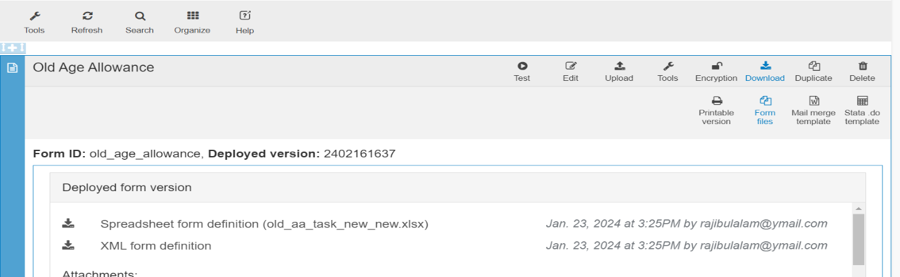

Upload from here (your file) for Test.

How to Upload Survey Form & Attach Preload Dataset.

You now have the option to attach one or multiple preload datasets (previously automated or generated from previous surveys). Additionally, you can attach images/ audio/video with the survey form from this section.

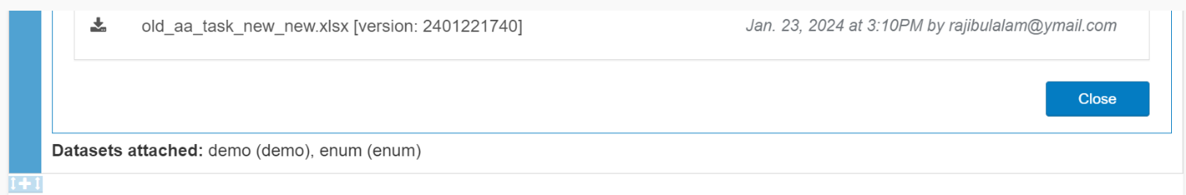

Click here to add your preload dataset.

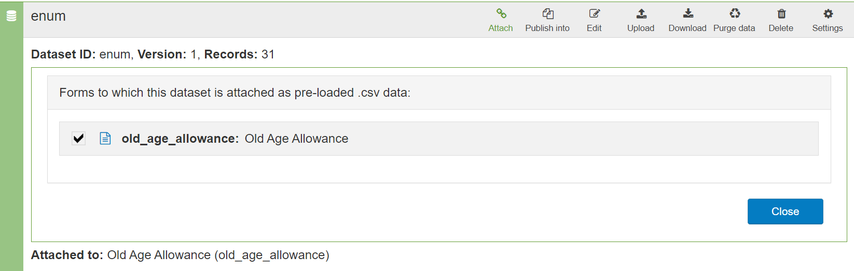

To attach, Click Attach & and click Tik mark and close.

We possess two preloaded datasets: one containing the 'Supervisor & Enumerator List', and the other containing details such as 'Zila, Upazila, Union, Ward, Para, Survey Household ID, Household Person name, Age, and NID Number'. Rather than manual input, we opt to retrieve these datasets from the preload dataset. Each survey comprises various phases like Baseline Survey or Endline Survey. When initiating a survey, we first devise a questionnaire and commence data collection. Subsequently, the data amassed during the survey becomes valuable for future use, such as during an Endline survey. For instance, if we surveyed a household during the Baseline survey and stored the data, during the Endline survey, we may approach the same individual with a different set of inquiries. Hence, we can retrieve the pertinent data from the Baseline dataset and pose different questions accordingly.

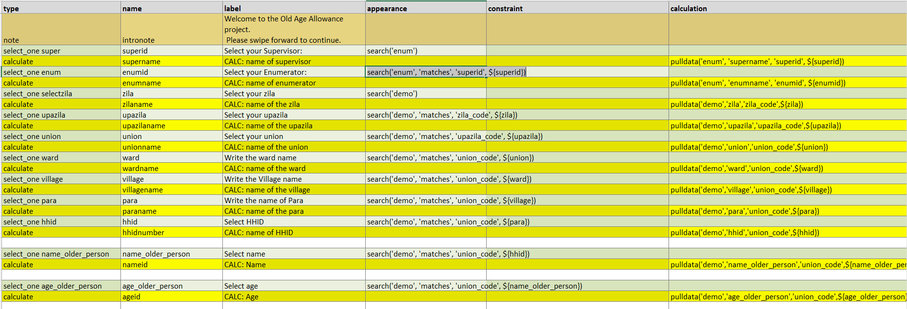Pulldata Example:

Choice List: Preload data set column.

Initiate filtering through search function.

Preload data function.

We are pulling data from preload data “superid” Column.

Preload data function.

This value is from calculated field. the form.

This value is from xlxs form.

We are pulling data to show in the form.

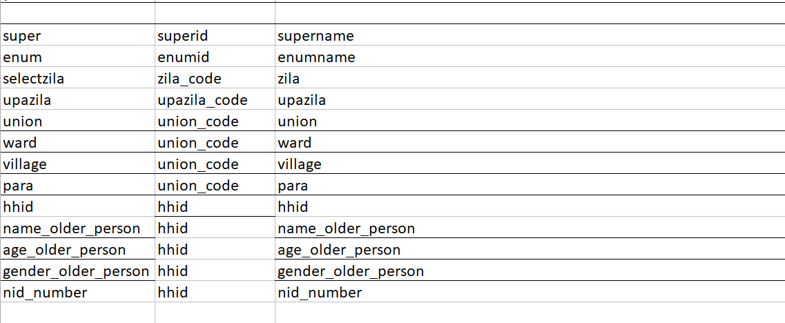

Choice List: Preload data set column.

Here, the fundamental distinction between the 'appearance' and 'calculation' columns lies in their respective functionalities. In the 'appearance' column, we incorporate various visual modifications and plugins, while in the 'calculation' column, we execute calculations of different kinds. The 'search' function comes into play when filtering values from a dataset is necessary, whereas 'pull' is utilized to display data within the survey form.

**Function:** **pulldata(“preload-dataset name”, “calculate label”, “pre-load dataset column”, $“{surveyform variable}”)**

**Search(“preload-data set name”, “matches [it’s a function]”, (“preload-dataset column”, (“XLXS survey form variable label name”)**

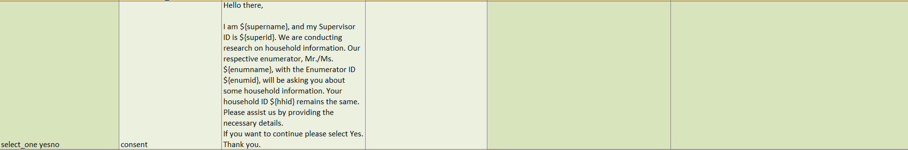

XLXS form