Title: Create a Logo Using Photoshop
Creating a logo in Photoshop involves several steps to conceptualize and design a unique visual representation of a brand or concept. Here's an introductory guide:

Step 1: Understand the Brand and Concept
- Brief: Gather information about the brand, its values, target audience, and the message the logo should convey.
- Research: Explore competitors' logos, industry trends, and styles to get inspiration.

Step 2: Plan and Sketch
- Ideation: Brainstorm and sketch various logo ideas on paper or digitally to visualize concepts.
- Simplicity: Focus on simplicity and versatility as logos should be easily recognizable and scalable.

Step 3: Set Up Photoshop
- Create a New Document: Open Photoshop and create a new canvas with appropriate dimensions and resolution for the logo.
- Layers and Organization: Use layers to organize elements and keep the design flexible.

Step 4: Design the Logo
- Typography: Choose fonts or create custom lettering that aligns with the brand's personality.
- Iconography/Graphic Elements: Design symbols, icons, or shapes that represent the brand's identity.
- Color Scheme: Select a color palette that resonates with the brand and evokes the desired emotions.
- Balance and Proportion: Ensure visual balance and proportion in the logo elements.

Step 5: Refinement
- Feedback: Share your initial designs for feedback and iterate based on suggestions.
- Fine-Tuning: Refine details, adjust colors, sizes, and positions to achieve a polished look.

Step 6: Export and Save
- File Formats: Save the final logo in various file formats like PNG (for web), SVG (for scalability), and high-resolution versions for print.
- Transparent Background: If needed, ensure the logo has a transparent background for versatile use.

Step 7: Presentation and Brand Guidelines
- Presentation: Showcase the final logo design in mockups or real-world scenarios for presentation.
- Brand Guidelines: Develop guidelines that outline logo usage, color codes, spacing rules, etc., to maintain consistency.
In crafting the logo for Adib Tech Farm, I utilized a variety of tools available in Photoshop to design and refine the elements.

create a new file in photoshop:
- Open Photoshop.
- Go to "File" > "New" (Ctrl + N / Cmd + N).
- Name your file, set dimensions, resolution, color mode, and background.
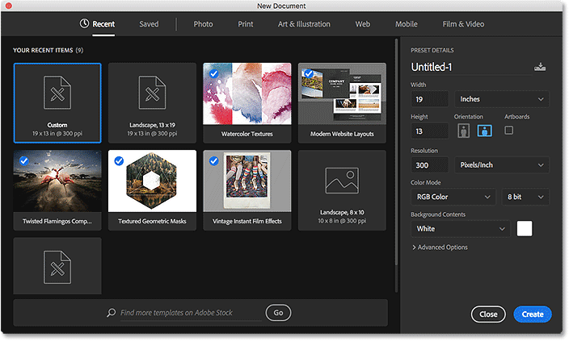
- Click "Create" or "OK."
Select shape(select Ellips):
- Open Photoshop.
- Go to "File" > "New" (Ctrl + N / Cmd + N).
- Name your file, set dimensions, resolution, color mode, and background.
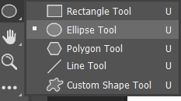
- Click "Create" or "OK."
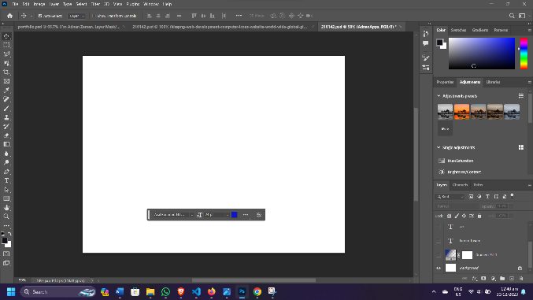
merge two shape:
- Select both shapes in the Layers panel by holding Shift and clicking each shape layer.
- Use "Layer" > "Merge Layers" or the shortcut "Ctrl + E" (Windows).
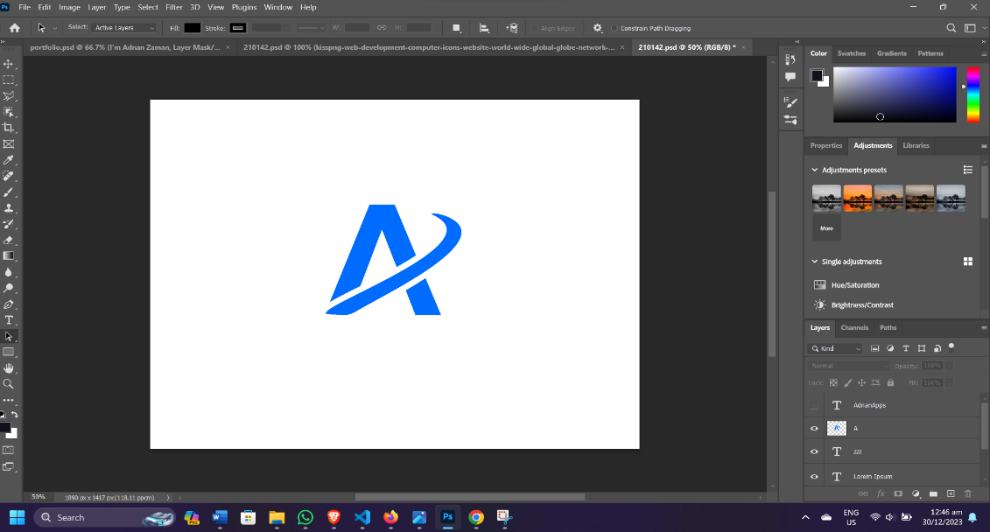
- The shapes will merge onto a single layer.

create a red blood drop shape:
- Select the Ellipse Tool (shortcut: U) in Photoshop.
- Draw a red ellipse on the canvas while holding Shift for a perfect circle.
- Use the Pen Tool (shortcut: P) to add a tapering triangle at the bottom for the drop's tail.
- Adjust the shape and color to resemble a blood drop.
- Refine the drop's appearance by tweaking proportions and adding effects.
- Save your image in your preferred format.

- 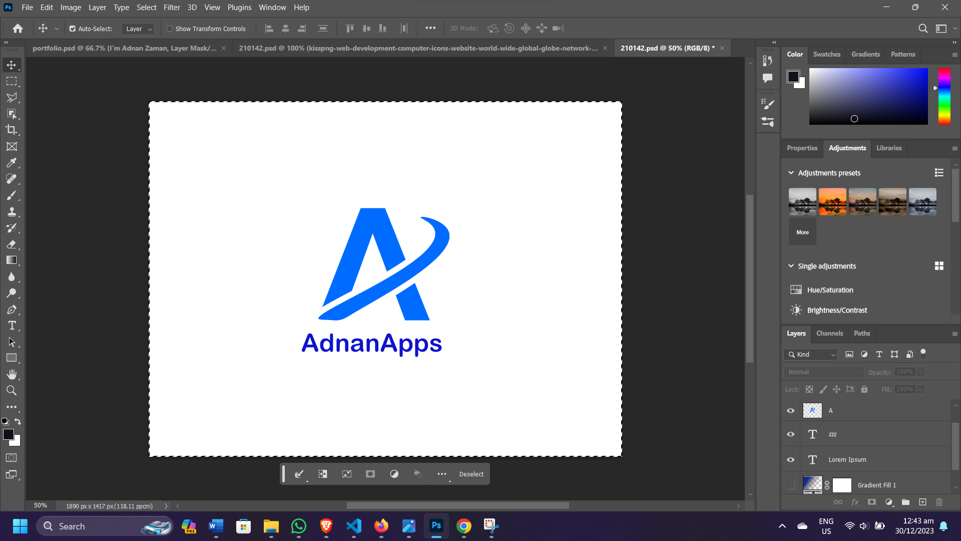

Add text in photoshop:
- Select the Text Tool ("T") in Photoshop.
- Click on the canvas and start typing your text.
- Use the Options Bar to adjust font, size, color, and alignment.
- Move and transform the text using the Move Tool ("V") or Ctrl/Cmd + T.
- Save your work when satisfied.
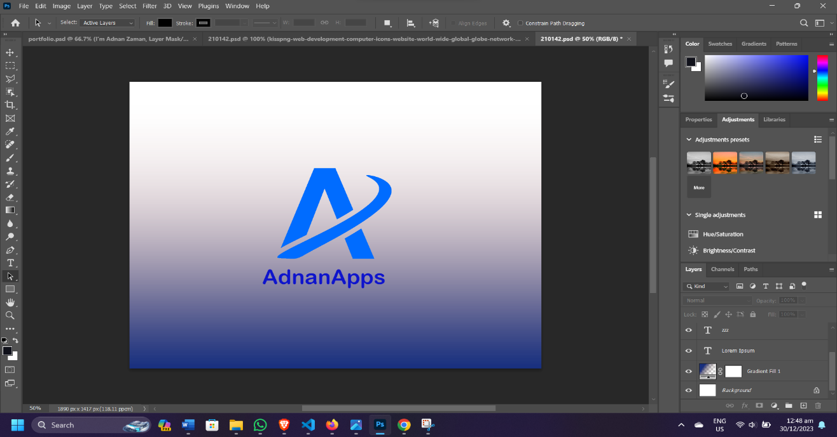

Title: Create a Visiting Card using Photoshop
Creating a professional-looking business card or visiting card in Photoshop involves designing a small canvas with essential contact information and branding elements. Here's a general tutorial:
- New Document:
  - Create a new document (File > New) in Photoshop.
  - Set dimensions for a standard visiting card (e.g., 3.5 inches by 2 inches).
- Design Layout:
  - Design the layout with a background, logo, and text.
  - Add company name, contact details, and branding info using separate text layers.
- Styling and Effects:
  - Choose suitable fonts, colors, and styles for text.
  - Consider incorporating graphics or effects if desired.
- Alignment and Spacing:
  - Ensure proper alignment and spacing for a clean design.
- Proof and Save:
  - Check for errors, typos, and design consistency.
  - Save the file in editable format (PSD) and a print-ready format (PDF, JPEG).

Select shape(select Rectangle):
- Open Photoshop.
- Go to "File" > "New" (Ctrl + N).
- Name your file, set dimensions, resolution, color mode, and background.
- Click "Create" or "OK."
select ruler:
To use rulers in Photoshop:
- Show Rulers:
  - Go to the top menu and click on "View."
  - Select "Rulers" or use the shortcut "Ctrl + R" (Windows) or "Cmd + R" (Mac) to toggle the rulers on/off.
- Using Rulers:
  - Once activated, rulers will appear along the top and left edges of the canvas.
  - Click and drag from the ruler onto the canvas to create guides for precise alignment or measurements.
  - To remove a guide, click and drag it back onto the ruler area.
- Ruler Units:
  - To change ruler units, right-click on the ruler and select the desired measurement unit (pixels, inches, centimeters, etc.).

select a shape and color it navy blue and merge it:
- Use a shape tool to create a shape on the canvas.
- Select the shape layer.
- Choose navy blue as the fill color.
- Hold Shift and select the shape layer and any other layer.
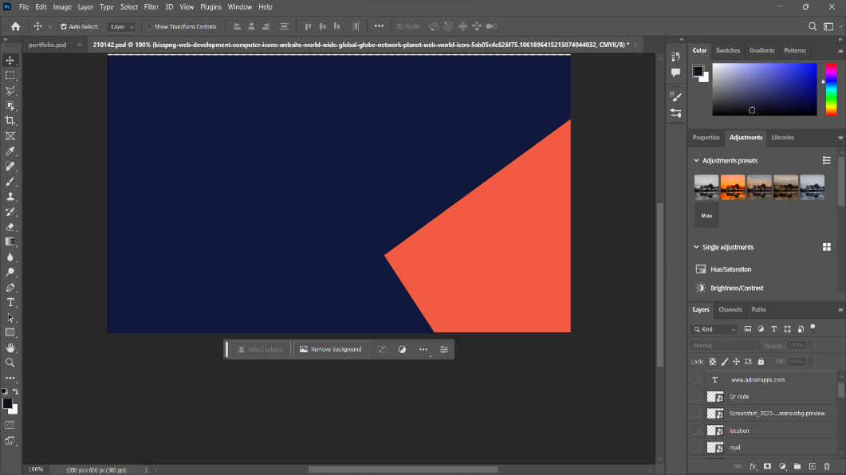
- Merge the layers (Layer > Merge Layers or Ctrl/Cmd
- Create New Layer: Add a new layer in Photoshop.
- Select Star Brush: Use a star-shaped brush tool.
- Adjust Brush Size: Set the brush size as desired.
- Paint Stars: Click or drag on the canvas to create multiple stars.
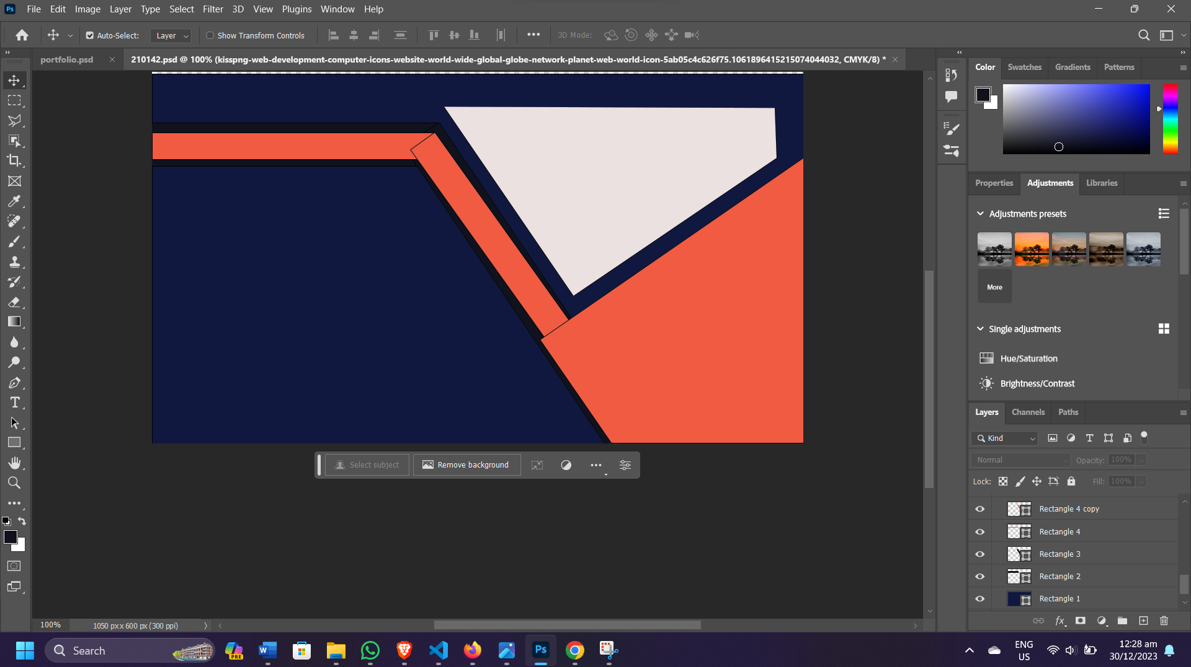
- Adjust Layer Effects: Modify layer opacity or blending mode for different effects.
- Save Your Work: Save the file in your preferred format.
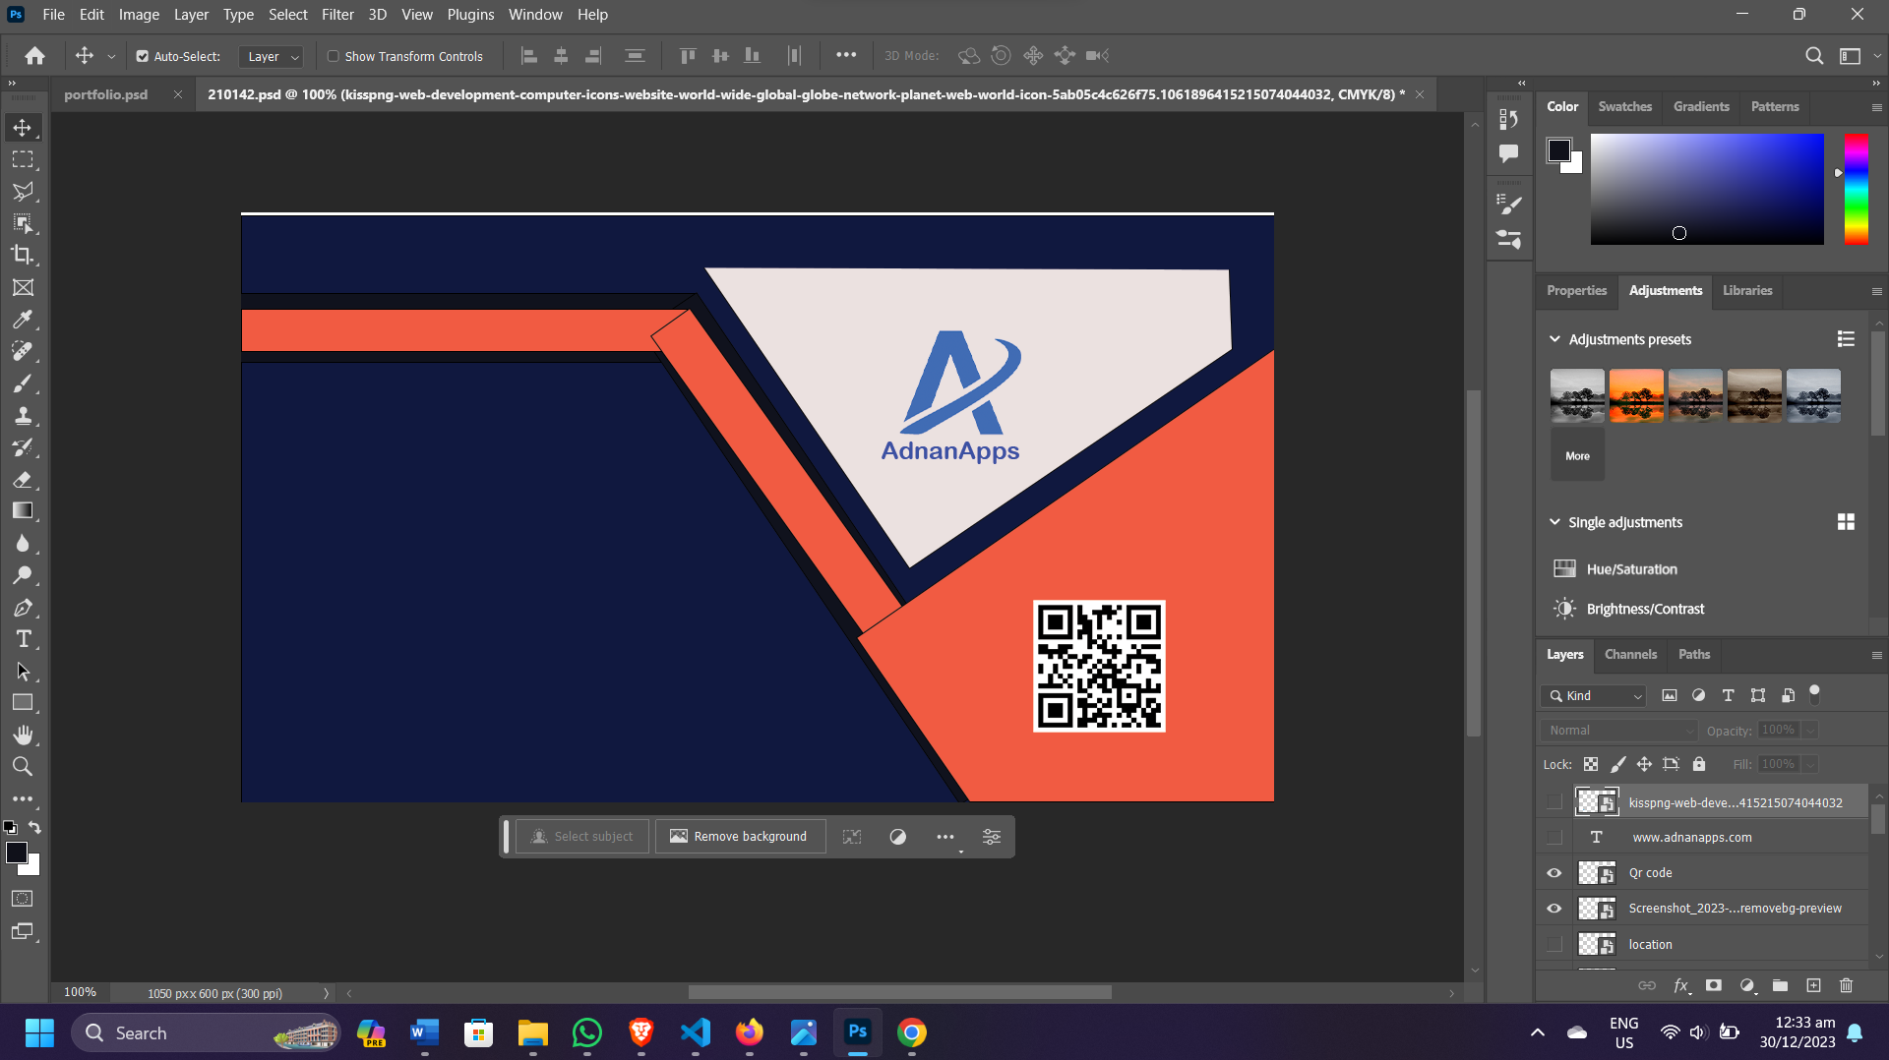

add text and logo:

Adding Text:
- Select Text Tool:
  - Click on the "T" icon in the toolbar or press the "T" key to activate the Text Tool.
- Click on Canvas:
  - Click on the canvas where you want to add text. This creates a text box.
- Type Your Text:
  - Start typing your desired text. It will appear inside the text box.
- Text Attributes:
  - Use the Options Bar to modify font, size, color, alignment, etc.
  - Highlight the text to change its attributes.

Adding a Logo:
- Place Logo:
  - Go to "File" > "Place Embedded" or "Place Linked" to import your logo into the Photoshop document.
- Position and Resize:
  - Use the Move Tool (shortcut: V) to position the logo where desired.
  - Resize it by dragging the corners while holding Shift to maintain proportions.
- Adjustments (if needed):
  - Apply adjustments like scaling, rotating, or changing opacity using the Transform controls (Ctrl/Cmd + T).
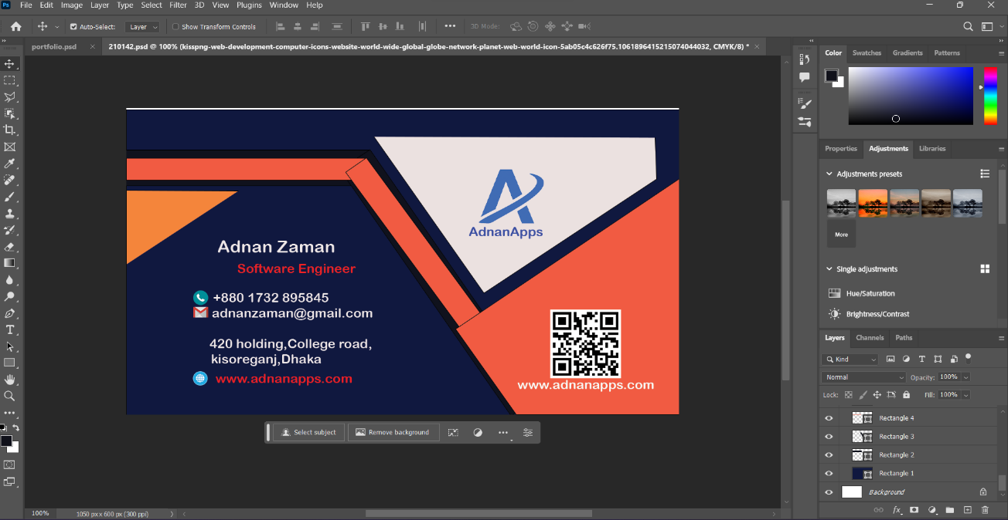

Final Steps:
- Save & Export: Save your work in PSD format for future edits and export a flattened, high-resolution file for print/web.
- Feedback: Get feedback from others to catch any overlooked issues.
- Print Test (if applicable): If printing, do a test print to ensure colors and layout look as intended.

