FINAL-YEAR INTERNSHIP REPORT
On
Sales Data ETL & Analytics on Databricks
by
SHAIK MOHAMMED ADNAN

Under the esteemed guidance of
Mr. G Pradeep Reddy _{M. Tech.}

Assistant Professor
Dept. of Computer Science and Engineering



DEPARTMENT OF COMPUTER SCIENCE AND ENGINEERING
JAWAHARLAL NEHRU TECHNOLOGICAL UNIVERSITY
COLLEGE OF ENGINEERING
(Autonomous)
ANANTAPURAMU – 515002,
ANDHRA PRADESH
2025-2026

JAWAHARLAL NEHRU TECHNOLOGICAL UNIVERSITY ANANTAPUR COLLEGE OF ENGINEERING (Autonomous)
ANANTHAPURAMU-515002
ANDHRA PRADESH
DEPARTMENT OF COMPUTER SCIENCE AND ENGINEERING


CERTIFICATE

This is to certify that the internship entitled, “ Sales Data ETL & Analytics on Databricks”, is bona fide work of S. Mohammed Adnan bearing admission number: 23005A0501, respectively, submitted to the faculty of Computer Science and Engineering, in partial fulfilment of requirements for the award of the degree of BACHELOR OF TECHNOLOGY in COMPUTER SCIENCE AND ENGINEERING, JNTUA College of Engineering, Ananthapuramu at Varseno Solutions.

Signature of Project Guide | Signature of H.O.D
Mr. G Pradeep Reddy, M. Tech. | Dr.R.RAJA SEKHAR, M.Tech, Ph.D.
Assistant Professor, | Professor & H.O.D,
Department of CSE, | Department of CSE,
JNTUA College of Engineering, | JNTUA College of Engineering,
Ananthapuramu– 515002 | Ananthapuramu– 515002

JAWAHARLAL NEHRU TECHNOLOGICAL UNIVERSITY ANANTAPUR COLLEGE OF ENGINEERING (Autonomous)
ANANTHAPURAMU-515002
ANDHRA PRADESH
DEPARTMENT OF COMPUTER SCIENCE AND ENGINEERING



DECLARATION

We hereby declare that the final-year internship entitled “Sales Data ETL & Analytics on Databricks” is a bona fide work carried out by me and the results embodied in this internship report have not been reproduced or copied from any source. The work carried out and results embodied in this report have not been submitted to any other University or Institution for the award of any degree or diploma.

Name of the candidate Roll number Signature

S. MOHAMMED ADNAN 23005A0501

Place: Anantapur
Date:

ACKNOWLEDGEMENT

I would like to thank our guide G. Pradeep Reddy, _{M. Tech}., Assistant Professor, Department of Computer Science and Engineering, JNTUA College of Engineering Anantapur, for guiding us throughout the preparation of this internship and for correcting me wherever required.
This is to express a deep sense of gratitude that is more than indebtedness to
Dr. R.Raja Sekhar, M.Tech, Ph.D. Head of the department, Computer Science and Engineering, JNTUA College of Engineering Ananthapuramu, for his valuable guidance. His advice, assistance and patience are greatly appreciated by the Computer Science and Engineering Department for providing outstanding information and assistance for the completion of the project.
I also express my sincere thanks to the principal of JNTUA College of engineering Anantapur, Prof. P. Chenna Reddy, _{M. Tech, Ph.D}., for his encouragement and for providing the required facilities throughout the project.
Sincere thanks are expressed to all organizations and their staff for their encouragement and for providing the required facilities throughout the project.
The Computer Science and Engineering department staff are also thanked for their excellent monitoring and suggestions, which contributed to the successful completion of the final year internship project. Additionally, gratitude is extended to all the students and people of the locality for their cooperation in final year internship.
Above all, thanks are given to the parents, whose encouragement allowed the team to complete the project work according to their wishes.

With gratitude,
S. Mohammed Adnan,
23005A0501
ABSTRACT
This project explores end-to-end sales data analysis using Databricks and Apache Spark, focusing on understanding customer behaviour, regional sales performance, and overall revenue trends. The dataset, sourced in CSV and JSON formats, was ingested using Databricks Volumes to ensure seamless and persistent access across collaborative sessions. Comprehensive data cleaning and transformation steps were carried out, including handling missing values, correcting inconsistent data types, and removing invalid or empty entries. Processed data was stored as Delta Lake tables, which provided robust support for ACID transactions, schema evolution, and time travel, enabling accurate historical comparisons and safe iterative development.
Key performance indicators (KPIs) were computed using Spark SQL and Data Frame operations, such as monthly revenue analysis, top-performing products, sales contribution by region, and a detailed churn analysis distinguishing between new and returning customers. Particular emphasis was placed on identifying retention patterns and understanding their impact on annual revenue. In addition, performance optimization techniques like partitioning and caching were applied to enhance query efficiency. The insights were visualized through dynamic, interactive dashboards built within Databricks, tailored to serve both technical and non-technical stakeholders.
This project not only illustrates the scalability and flexibility of the Databricks environment for big data analytics but also delivers actionable insights to support strategic business decision.

.
Table of Contents

 | S. No | Chapter Name |  | Pg. No
 | 1 | Introduction |  | 1
 | 2 | Objectives |  | 2-3
 | 3 | Tools and Technologies |  | 4-6
 | 4 | Project Review |  | 7-8
 | 5 | Methodology |  | 9-14
 |  | 5.1 Raw Data |  | 9
 |  | 5.2 Data Ingestion |  | 10
 |  | 5.3 Bronze Table (Raw Layer)  5.4 Silver Table (Clean Layer)  5.5 Data Parsing  5.6 Gold Table (Aggregated KPIs)  5.6.1 Monthly Revenue  5.6.2 Top Products  5.6.3 Churn Rate |  | 11  12  13  13  13  14  14
 | 6 | Dashboards and Insights  6.1 Monthly Revenue Trend Chart  6.2 Top Selling Products  6.3 Category- Wise Sales Breakdown  6.4 Region- Wise Sales Distribution  6.5 Churn Rate  6.6 Discount Impact Analysis |  | 15-17  15  15  16  16  17  17
 | 7 | Key Findings |  | 18-19
 | 8 | Conclusion |  | 20
 | 9 | Future Scope  References |  | 21-22  23
 |  | List of Figures
S. NO |  |  | FIGURE NAME |  | Page No.
1 |  |  | Methodology |  | 9-14
2 |  |  | Raw Data |  | 9-10
3 |  |  | Data Ingestion |  | 10-11
4 |  |  | Bronze Table |  | 12
5 |  |  | Silver Table |  | 12
6 |  |  | Data Parsing |  | 13
7 |  |  | Monthly Revenue |  | 13
8 |  |  | Top Products |  | 14
9 |  |  | Churn Rate |  | 14
10 |  |  | Dash Board and Insights |  | 15-17
11 |  |  | Monthly Revenue Trend Chart |  | 15
12 |  |  | Top Selling Products |  | 15
13 |  |  | Category Wise Sales |  | 16
14 |  |  | Region Wise Sales |  | 16
15 |  |  | Churn Rate Based on Customers |  | 17
16 |  |  | Discount Impact Analysis |  | 17

CHAPTER 1
INTRODUCTION
The rapid growth of data in modern business environments has increased the need for scalable, efficient, and collaborative analytics platforms. This project leverages Databricks and Apache Spark to conduct comprehensive sales data analysis, with the objective of uncovering patterns in customer behaviour, regional sales performance, and revenue trends.
The dataset—comprising both CSV and JSON files—was ingested into Databricks Volumes, ensuring persistent, team-wide access and a consistent foundation for the analytics workflow. A structured approach to data cleaning and transformation addressed missing values, inconsistent data types, and invalid records, establishing a reliable base for analysis.
The cleaned and processed data was stored in Delta Lake tables, unlocking powerful features like ACID transactions, schema enforcement, and time travel. These capabilities enabled iterative development and historical comparisons without compromising data integrity.
Using Spark SQL and PySpark, key performance indicators (KPIs) such as monthly revenue trends, customer churn rates, top-performing products, and regional sales contributions were computed to drive business insights. To further enhance performance, the pipeline employed optimization techniques like partitioning, caching, and efficient query structuring.
The results were visualized using interactive Databricks dashboards, making the insights accessible to both technical and non-technical stakeholders.
This project not only provided a hands-on exploration of end-to-end analytics in a modern big data environment but also showcased the practical strengths of Databricks as a unified platform for data ingestion, transformation, analysis, and visualization. While the pipeline was not fully automated, the structured and modular design ensures reproducibility, clarity, and scalability for future enhancements.
**********

CHAPTER 2
OBJECTIVES
The primary objective of this project is to design and implement a structured, end-to-end sales data analytics workflow using the Databricks platform, with emphasis on scalability, data reliability, and actionable business insights. The solution is built to handle raw, multi-format data, apply transformation processes to ensure data quality, and ultimately deliver interactive visual outputs that aid in informed decision-making.

2.1 Data Ingestion
The analytics pipeline begins with the ingestion and storage of sales records from various sources, aiming for consistent access and streamlined integration:
- Multi-format File Support: Sales records are imported in both CSV and JSON formats to accommodate diverse source systems.
- Persistent Storage: Databricks Volumes are utilized to store the ingested data, ensuring persistent and scalable access across collaborative environments.
- Seamless Integration: The ingestion process is designed to feed directly into the transformation and analysis stages, eliminating the need for repeated uploads or manual interventions.

2.2 Data Cleaning and Transformation
To ensure analytical accuracy and enhance the usability of the data, several preprocessing steps were performed:
- Missing Value Handling: Gaps in the dataset were identified and handled using appropriate imputation or exclusion strategies to prevent analytical bias.
- Data Type Standardization: Inconsistent data types across columns were corrected to ensure compatibility in downstream Spark and SQL operations.
- Data Aggregation: Grouping and summarization techniques were applied to generate meaningful metrics such as total revenue, average sales, and product-wise performance.
- Validation and Deduplication: Invalid or duplicate records were removed to uphold the integrity and reliability of the dataset.
2.3 Delta Lake Integration
To provide a reliable and version-controlled data storage layer, Delta Lake was used:
- ACID Transactions: Ensure safe and consistent data updates across transformations.
- Time Travel: Enable historical data comparisons for trend analysis and rollback capabilities.
- Schema Enforcement: Prevent incompatible schema changes from corrupting datasets.

2.4 Analytical Querying
The analytical phase focused on generating key performance indicators using Spark SQL and Data Frame operations:
- Monthly Revenue Trends: Track and compare monthly sales performance.
- Top-selling Products: Identify products with the highest contribution to revenue.
- Customer Retention Metrics: Distinguish between new and returning customers to analyse churn and loyalty patterns.

2.5 Visualisation
Insights were presented through visually engaging and interactive dashboards within Databricks:
- KPI Dashboards: Display business metrics in a clear, concise, and filterable format.
- Interactive Filters: Allow dynamic exploration of different time frames, regions, and product categories.
- Audience Accessibility: Ensure usability for both technical analysts and non-technical stakeholders.

************

CHAPTER 3
TOOLS AND TECHNOLOGIES
This project leverages the Databricks ecosystem, Apache Spark, and supporting tools to build a scalable and efficient sales data analytics workflow. Each technology was selected for its ability to handle large datasets, ensure data reliability, and provide actionable insights through robust analytical and visualization capabilities.

3.1 Databricks – Unified Analytics Platform
Databricks served as the central environment for collaborative development, data processing, and integrated visualization.
Key Features:
- Collaborative Workspace: Enables multiple users to work on shared notebooks in real time.
- Scalable Processing: Seamlessly handles both small-scale and large-scale datasets.
- Integrated Visualization: Supports built-in charting tools and dashboard creation without leaving the platform.

3.2 Apache Spark (PySpark) – Distributed Data Processing
Apache Spark, accessed via PySpark, was used for large-scale data transformation and computation.
Key Features:
- High-Performance Data Processing: Executes both Data Frame and SQL-based operations quickly.
- Distributed Computing: Splits workloads across multiple nodes for scalability.
- Flexible API: Offers both Python-based (PySpark) and SQL interfaces for analysis.

3.3 Delta Lake – ACID-Compliant Data Storage
Delta Lake was implemented to store cleaned and transformed datasets with advanced data management features.

Key Features:
- ACID Transactions: Ensures data reliability and consistency during updates.
- Schema Enforcement: Prevents schema mismatches that could corrupt data.
- Time Travel: Allows historical data comparison and rollback when needed.

3.4 Databricks Volumes – Persistent Data Access
Databricks Volumes were used to ingest raw sales data in CSV and JSON formats.
Key Features:
- Persistent Storage: Keeps files accessible across sessions and projects.
- Multi-format Support: Handles structured and semi-structured data formats.
- Seamless Integration: Directly accessible in Databricks notebooks for processing
3.5 Spark SQL – Analytical Querying
Spark SQL was applied for querying structured datasets and computing business metrics.
Key Features:
- KPI Computation: Calculates revenue trends, product performance, and customer segmentation.
- SQL Familiarity: Allows analysts to work with familiar SQL syntax alongside PySpark code.
- Optimized Execution: Leverages Spark’s distributed engine for fast query performance.
3.6 Databricks SQL Dashboards – Interactive Visualization
Databricks SQL Dashboards were created to visualize and present insights.
Key Features:
- Interactive Charts and Tables: Allows filtering and drill-down into specific metrics.
- Real-Time Updates: Reflects changes in underlying data without manual refresh.
- Audience-Friendly: Suitable for both technical and non-technical stakeholders.

3.7 Pandas – Lightweight Data Exploration
Pandas was used in the initial stages for quick checks and exploratory analysis before scaling up to Spark.
Key Features:
- Fast Inspection: Quickly loads and inspects small datasets.
- Data Cleaning: Performs lightweight preprocessing and sanity checks.
- Prototyping: Tests logic on small data samples before Spark execution.
************

CHAPTER 4
PROJECT REVIEW
This project provided a comprehensive, hands-on learning experience in designing and executing a structured sales data analytics workflow using the Databricks platform and Apache Spark. It served as an applied exploration of modern big data tools and techniques, bridging the gap between theoretical knowledge and real-world implementation.
From the outset, the project addressed the challenges of working with multi-format datasets specifically CSV and JSON files—while also dealing with common data quality issues such as missing values, inconsistent data types, and invalid records. These challenges reinforced the importance of robust data cleaning and transformation practices, which were carried out in a systematic and replicable manner, closely resembling the architecture of a standard data pipeline framework.
A key technological choice, the integration of Delta Lake, proved highly beneficial for long-term data management. Features such as schema enforcement ensured that only compatible data structures were committed, while time travel allowed for historical analysis and rollback capabilities, providing confidence in iterative data transformations. This made it possible to experiment with data processing logic without the risk of losing earlier, valid versions of the dataset.
The analytical stage highlighted the flexibility and power of Spark SQL, which was used alongside PySpark Data Frame operations. This hybrid approach allowed for:
- Efficient computation of key performance indicators (KPIs) such as monthly revenue trends, product sales rankings, and regional performance metrics.
- Customer retention and churn analysis, which differentiated between new and returning customers to understand loyalty patterns.
- The ability to switch seamlessly between code-based analysis and SQL-based querying, accommodating different analyst preferences and skill sets.
One of the most impactful deliverables of this project was the creation of interactive dashboards using Databricks SQL. These dashboards transformed raw analytical results into clear, visually engaging reports, enabling effective communication of insights to both technical analysts and non-technical decision-makers. The inclusion of interactive filters and drill-down capabilities allowed stakeholders to explore the data dynamically, fostering a deeper understanding of business performance trends.
While the project pipeline was not fully automated, the clear structure and step-by-step methodology ensured reproducibility, making it easier to revisit, maintain, and enhance in future iterations. The hands-on nature of the work not only reinforced technical skills in data engineering and analytics but also emphasized the importance of designing processes that are scalable, maintainable, and business-aligned.
Overall, the project successfully demonstrated how a modern analytics platform like Databricks, combined with the processing power of Apache Spark and the reliability of Delta Lake, can transform raw, messy datasets into strategically valuable insights. This experience has provided a strong foundation for future projects, particularly those that require end-to-end data processing, advanced analytics, and effective data visualization for decision support.
************

CHAPTER 5
Methodology
This project followed the Lakehouse architecture model within Databricks to ensure a structured, layered, and auditable data pipeline. The methodology was divided into sequential steps, starting from raw data storage to the generation of business-ready insights and dashboards.

5.1 Raw Data
The dataset consisted of sales transaction records stored in CSV and JSON formats. Each record contained the following key attributes:
- Order Information: OrderID, OrderDate
- Customer Information: CustomerID, CustomerName
- Product Details: ProductID, ProductName, Category, Sub-Category
- Sales Metrics: Quantity, Unit Price, Total Sales
- Regional Data: Region
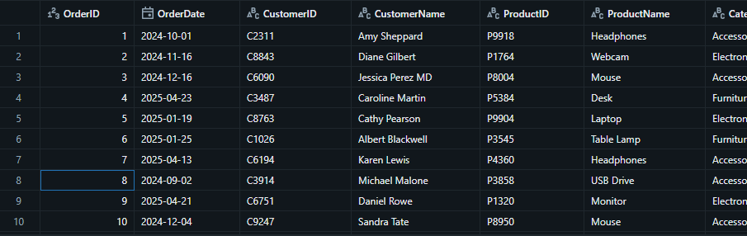
Figure 5.1: Structure of Raw Sales Data in CSV and JSON Formats
These files were stored in the Volumes feature of Databricks (/Volumes/default/sales/raw-data) to ensure persistent and consistent access throughout the project lifecycle.

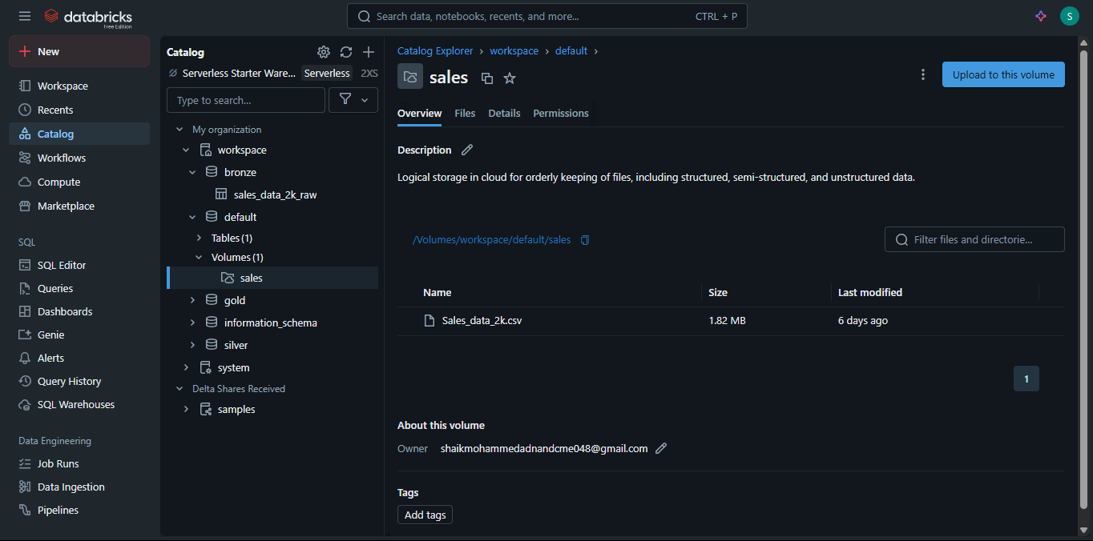
Fig 5.2: The unity catalogue- a structured way of working
5.2 Data Ingestion
Using PySpark, the raw files were ingested from the Volumes location into Spark Data Frames for further processing.
Initial Data Observations:
- Missing values in ProductName and Total Sales
- Empty strings in CustomerName
- Mixed data types in OrderDate (string vs. date formats)
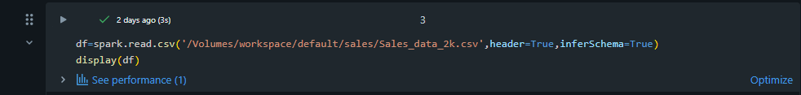
Fig 5.2: Reading the .CSV file into a Data Frame
This ingestion step ensured that raw data was loaded and available in a distributed format for downstream processing.
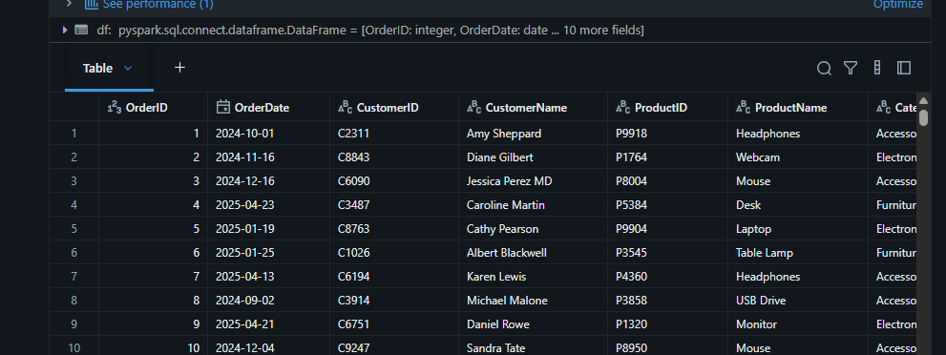
Fig 5.2: The .CSV file, once ingested or say uploaded into the Volumes
5.3 Bronze Table (Raw Layer)
In line with Lakehouse best practices, the Bronze layer stored the ingested raw data in Delta format without major transformation.
Purpose of Bronze Layer:
- Preserve the original dataset for auditing and traceability.
- Enable Time Travel for historical data versioning.
- Enforce schema structure for consistency.
Table Schema:
- OrderID (Integer)
- OrderDate (String)
- CustomerID (String)
- ProductName (String)
- Quantity (Integer)
- Unit Price (Float)
- Total Sales (Float)
- Region (String)
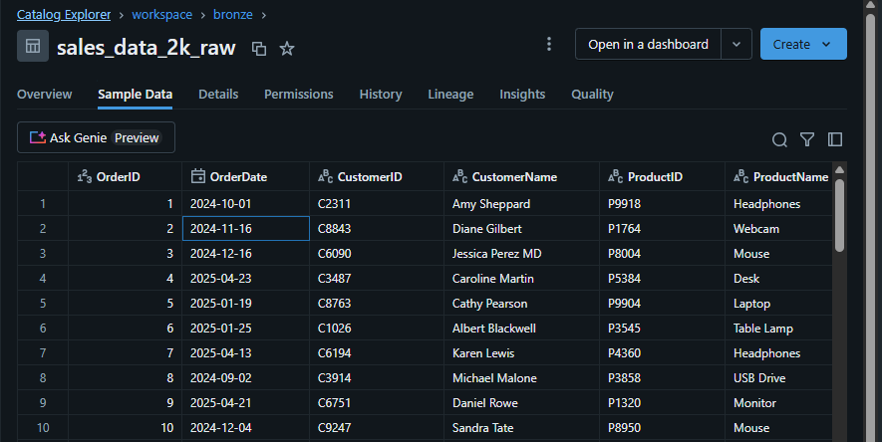
Fig 5.3: The .CSV file in the Bronze Layer yet to be worked on.

5.4 Silver Table (The Clean Layer)
The Silver layer applied transformations to produce clean, analysis-ready data.
Key Transformations:
- Missing Value Handling: Filled nulls in ProductName and Total Sales using fillna() and logical rules.
- Data Type Standardization: Converted OrderDate to a proper date format and ensured numeric consistency.
- Deduplication: Removed duplicate records to prevent inflated metrics.
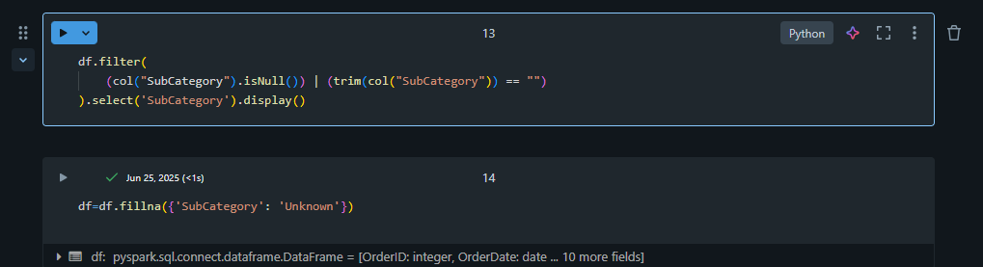
Fig 5.4: Filling the Null and empty strings with the Place holder “Unknown”.
The resulting Silver Table provided a reliable dataset for analytical querying.
5.5 Data Parsing
Additional parsing steps were applied during the Silver stage to enhance data quality:
- Parsing OrderDate into appropriate date components for time-based analysis.

- Ensuring string trimming and case normalization for text fields.

- Validating numeric ranges for Customer ID and Product ID.

5.6 Gold Table (Aggregated KPIs)
The Gold layer contained aggregated metrics designed to deliver actionable business insights. These were computed using Spark SQL queries on the Silver Table and stored as Delta Tables for efficient querying and visualization.
5.6.1 Monthly Revenue
Calculated total sales revenue per month by truncating OrderDate to month-level granularity. This metric was used to identify seasonal sales trends and monthly performance patterns.

5.6.2 Top Products
Ranked products by total units sold, highlighting the top 10 best-selling items. This analysis guided product promotion and inventory decisions.
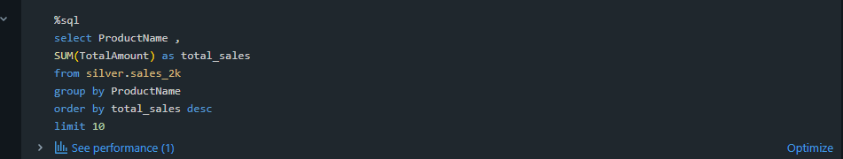
5.6.3 Churn Rate - New vs Returning Customers
Segmented revenue contributions into new customers and returning customers to measure customer retention and loyalty impact on sales performance.
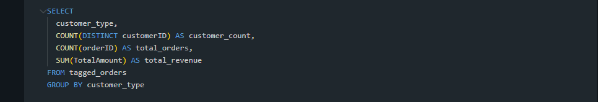
************

CHAPTER-6
Dashboards and Insights
The final output of the project involved building a set of interactive dashboards using Databricks SQL. These dashboards translated aggregated KPIs into visual insights to assist stakeholders in interpreting sales performance, customer behaviour, and market trends.
Monthly Revenue Trend Chart
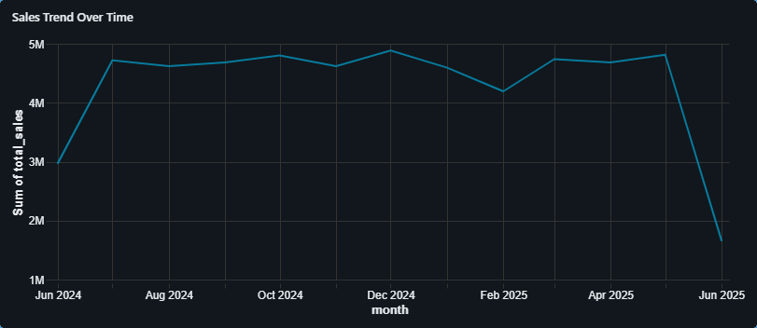
Figure 6.1 – Monthly Revenue Trend Chart Shows monthly revenue trends across the reporting period to identify seasonal peaks and sales performance over time.
Top selling Products
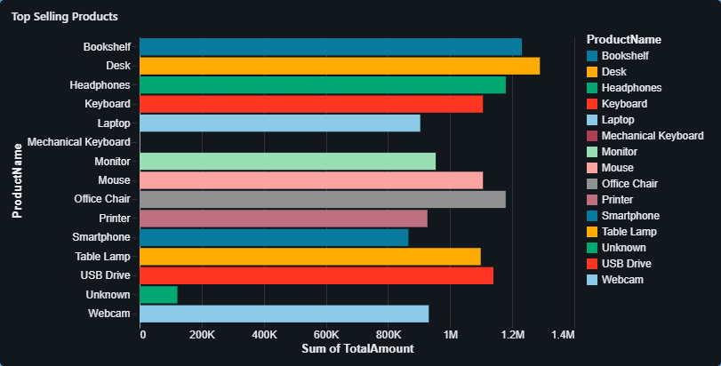
Figure 6.2 – Top 10 Selling Products by Units Sold Displays top-performing products, helping understand customer demand patterns.
Category-Wise Sales Breakdown
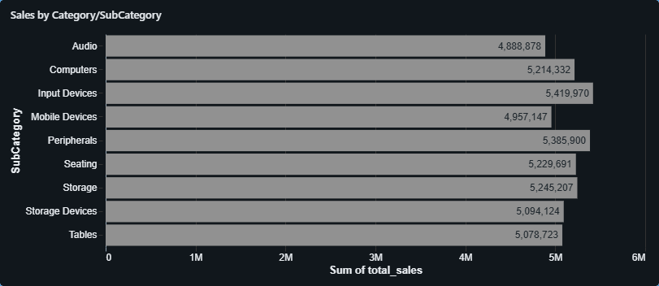
Figure 6.3 – Category-Wise Sales Breakdown Visualizes sales distribution by product categories and sub-categories to identify top and underperforming segments.
Region-Wise Sales Distribution
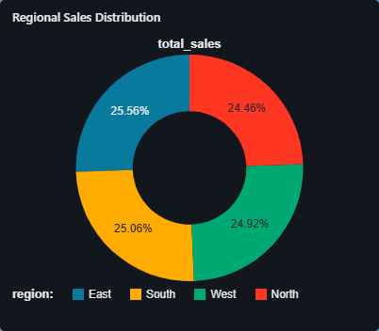
Figure 6.4– Region-Wise Sales Distribution Pie chart or geo map showing the revenue contribution from different regions.

Churn rate based on New vs Returning Customers

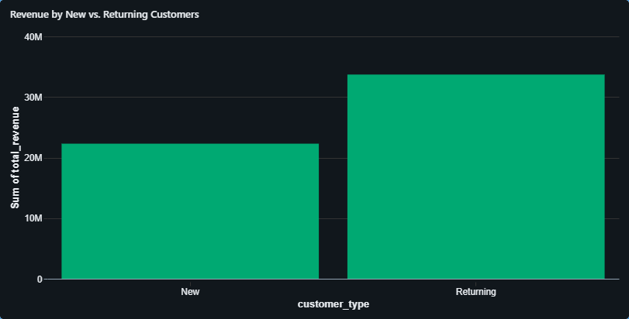
Figure 6.5 – Churn Rate Based on New vs. Returning Customers Compares the revenue split between new and repeat customers to understand customer retention.
Discount Impact Analysis
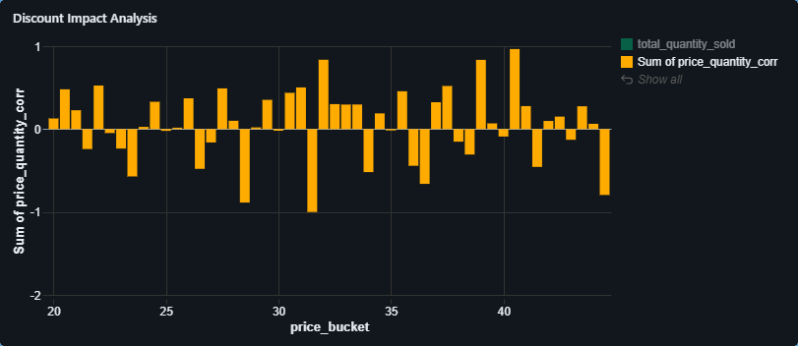
Figure 6.6 – Discount Impact Analysis on Quantity Sold Examines how different pricing tiers affect purchase volume, indicating the impact of discounts.
************

CHAPTER 7
KEY FINDINGS
- Consistent Monthly Revenue with Notable Drop in June 2025
The Monthly Revenue Trend chart illustrates a stable revenue stream from July 2024 to May 2025, consistently exceeding ₹4 million. However, June 2025 experienced a sharp decline below ₹2 million, which may indicate either incomplete data ingestion or a real drop in sales performance.
- High Demand for Tech Accessories and Office Supplies
The Top-Selling Products chart highlights a strong market demand for products such as Desks, Headphones, Keyboards, and USB Drives. This suggests an increased focus on ergonomic and tech-enhanced office setups.
- Top Customers Significantly Influence Revenue
The Top Customers visualization reveals that individual clients like Customer IDs C9957 and C5150 each contributed over ₹35,000, reinforcing the importance of customer retention and engagement strategies aimed at high-value clients.
- South and East Regions Outperform Others
According to the Product Performance by Region matrix, the South and East zones consistently lead in product sales, particularly for items such as Bookshelves and Headphones. This indicates stronger logistics, marketing penetration, or customer presence in these regions.
- Returning Customers Are Key Revenue Drivers
The New vs. Returning Customer Revenue chart shows that nearly 60% of total revenue came from repeat customers. This underscores successful retention strategies and the effectiveness of building long-term customer relationships.
- Balanced Revenue Across Sub-Categories
The Sales by Category/Subcategory analysis suggests an evenly distributed contribution from Input Devices, Storage Devices, and Computers, each hovering around ₹5 million in total revenue. This balanced performance reflects healthy product diversification.

- Seasonal Peaks Observed in Average Order Value (AOV)
The AOV Trend chart shows slight seasonal spikes in November 2024 and May 2025, with overall values fluctuating between ₹2,600 and ₹2,900. This aligns with promotional or festive buying cycles.
- Discount Effectiveness Varies Across Price Tiers
Insights from the Discount Impact Analysis chart indicate that certain pricing bands (like ₹30–₹40) saw increased sales with discounts, while others showed no such benefit. This suggests that discount strategies should be data-driven and tier-specific.
************

.

CHAPTER 8
CONCLUSIONS
This project successfully demonstrated the power of a structured data pipeline in transforming raw sales data into meaningful business insights using the Databricks platform and Apache Spark. By adopting the Lakehouse architecture, data was methodically processed through Bronze (raw), Silver (cleaned), and Gold (aggregated insights) layers ensuring both traceability and analytical readiness.
Key performance indicators such as monthly revenue trends, top-performing products, regional sales distribution, and customer retention patterns were derived through Spark SQL and PySpark transformations. These insights were presented through dynamic dashboards, making complex data both interpretable and actionable for technical and non-technical stakeholders alike.
A major takeaway from the analysis was the significance of customer loyalty: returning customers accounted for a substantial portion of the revenue, highlighting the importance of retention strategies. Regional disparities in sales revealed opportunities for location-specific marketing and logistics improvements. Additionally, the discount impact analysis indicated that price sensitivity varies across segments informing more data-driven pricing strategies in the future.
The project also benefited greatly from Databricks features such as Delta Lake’s ACID compliance and time travel capabilities, which enabled safe, versioned data handling and iterative improvements throughout the workflow.
In conclusion, this end-to-end analytics project not only achieved its technical goals but also delivered practical business value. It stands as a strong example of how modern big data platforms can be leveraged to derive actionable insights, foster informed decision-making, and support scalable data-driven strategies.
************

CHAPTER 9
FUTURE SCOPE
While this project has effectively showcased the capabilities of Databricks and Apache Spark for structured sales data analysis, there are several avenues for future enhancements that can elevate its scalability, automation, and predictive power:
Real Time Data Processing
The current implementation is based on batch processing of static files. In future iterations, the integration of real-time streaming tools such as Apache Kafka, Azure Event Hubs, or AWS Kinesis can enable near-instantaneous updates. This would allow the system to deliver real-time insights into customer behaviour, order trends, and inventory movement.
Machine Learning Integration
With a clean and reliable pipeline in place, machine learning models can be trained on historical data to forecast future trends, including:
- Customer churn likelihood
- Sales demand forecasting
- Product recommendation systems
- Databricks' native MLflow framework supports model tracking, versioning, and deployment, making it a natural extension of the current workflow.
Automated Data Pipelines
Currently, the ETL process involves manual execution. Future development can involve:
- Databricks Workflows for scheduling notebook jobs
- Delta Live Tables for declarative pipeline automation.
- These enhancements would reduce human error, ensure consistency, and make the system production-ready for continuous data ingestion and transformation.
Advanced Visualisations and BI Integration
While Databricks SQL dashboards offer quick insights, connecting Delta tables to external BI tools such as Power BI, Tableau, or Google Data Studio would provide:
- More advanced visualization capabilities
- Improved cross-platform reporting
- Better scalability for executive-level users
Multi – Source Data Integration
Incorporating additional data sources such as:
- Marketing campaign performance
- Customer feedback or NPS data
- Competitor pricing and inventory
This would enable multi-dimensional analysis, resulting in more holistic business intelligence.
Data Governance and Security
For enterprise-level deployment, proper data governance is essential. Future enhancements could include:
- Unity Catalogue for fine-grained access control
- Role-based permission at workspace and data level
- Data lineage tracking and audit trails
- This would ensure compliance, security, and responsible data sharing across teams.

REFERENCES
[1] | Databricks Documentation  https://docs.databricks.com/  Reference for workspace setup, notebooks, Delta Lake features, and dashboards.
[2] | Apache Spark Documentation  https://spark.apache.org/docs/latest/  For PySpark, Spark SQL, and data processing APIs.
[3] | Delta Lake Documentation  https://docs.delta.io/latest/delta-intro.html  Used for understanding ACID transactions, schema enforcement, and time travel.
[4] | Databricks SQL Dashboards  https://docs.databricks.com/sql/index.html  Source of best practices on interactive dashboards for business intelligence.
[5] | Pandas Documentation  https://pandas.pydata.org/docs/  For early-stage data inspection and manipulation.
[6] | Databricks Academy  https://www.databricks.com/learn/training/academy  Courses and labs on data engineering, machine learning, and analytics with Databricks.
[7] | YouTube – Databricks Channel  https://www.youtube.com/@databricks  Visual resources for features like Delta Lake, time travel, and dashboard creation.
[8] | Kaggle Notebooks / Datasets  https://www.kaggle.com/  For exploratory examples and reference on sales analytics problems.

