Environment Validation report

XML Documentation for AEM

Divraj Singh

divrsing@adobe.com

for <customer name>

on <Managed Services or on Prem>  
Validation done on <date-validated> by <Person Name>

Table of Contents

Document Overview 2

Who should read this document? 2

Why is this important? 2

What needs to be done? 2

Point of Contact 3

Customer Information 4

Environment Information 5

Version Details 5

AEM Author Details 5

AEM Publish Details 5

AEM Dispatcher Details 5

System Configuration 5

Validation of Author Setup 6

Screenshots 6

Configure data store 6

Update Lucene index 6

Java memory optimization 7

Client library minification on Author instance 7

Configure concurrent publishing threads 7

Configure batch size of nodes for AEM Site output generation 8

Patch Xerces Jar while using custom DITA-OT for publishing 8

Optimize number of post-processing threads 8

Validation of Publish Setup 9

Disable Post Processing on all publish instances 9

Validation of Dispatcher Setup 10

Enable AllowEncodedSlashes 10

If HTTPS Protocol enabled 10

# Document Overview

This document drives the doneness of Infrastructure setup for the ***product XML Documentation for Adobe Experience Manager***

## Who should read this document?

Adobe cloud team consultant or IT team setting up AEM server for XML Documentation implementation

## Why is this important?

The AEM setup should make configuration updates specifically as highlighted in the [Best Practices Guide](https://helpx.adobe.com/content/dam/help/en/xml-documentation-solution/3-5/XML-Documentation-for-Adobe-Experience-Manager_Best-Practices_EN.pdf) for any XML Documentation implementation to work as expected and for same the IT team / managed services team should perform the steps given in this document before handing over the server to implementation partner or customer or end users.

Without the configuration given in Best Practices, the system is prone to be in-performant.

## What needs to be done?

The following sections drives the steps given in Best Practices Guide, and requires you to fill in the details:

* Customer Information
* Environment information
* Validation of Setup based on Best Practices

Once the above steps are complete, send the filled document to point of contacts mentioned in next section

# Point of Contact

For any issues running over the steps, you may contact the XML documentation team:

* Richa Kala : Customer Success Manager : [kala@adobe.com](mailto:kala@adobe.com)
* Kiran Mohan : Solution Consultant : [kimohan@adobe.com](mailto:kimohan@adobe.com)
* Divraj Singh : Solution Consultant : [divrsing@adobe.com](mailto:divrsing@adobe.com)

# Customer Information

|  |  |
| --- | --- |
| Customer Name | Name and primary contact details |
| Implementation Partner | Company name and primary contact details |
| Infrastructure Hosting | Choose an item. |
| Go Live Date | Click or tap to enter a date. |

# Environment Information

## Version Details

|  |  |
| --- | --- |
| AEM Version (with service pack) | e.g. 6.4 Service Pack 6 |
| XML Documentation Version | e.g. 3.5.1. |

## AEM Author Details

|  |  |
| --- | --- |
| Instance Type | Author Choose an item. |
| Number of Instances | e.g. 1 |
| Operating System (with version) | e.g. Linux - 3.10.0-1062.el7.x86_64. |
| Java (version and license) | e.g. Oracle Corporation - 1.8.0_202-b08 |

## AEM Publish Details

|  |  |
| --- | --- |
| Instance Type | Publish Choose an item. |
| Number of Instances | e.g. 2 |
| Operating System (with version) | e.g. Linux - 3.10.0-1062.el7.x86_64. |
| Java (version and license) | e.g. Oracle Corporation - 1.8.0_202-b08 |

## AEM Dispatcher Details

|  |  |
| --- | --- |
| Instance Type | Dispatcher Choose an item. |
| Number of Instances | e.g. 2 |
| Operating System (with version) | e.g. Linux - 3.10.0-1062.el7.x86_64. |
| Java (version and license) | e.g. Oracle Corporation - 1.8.0_202-b08 |

## System Configuration

Paste screenshot of system configuration, run “lscpu” command on server *(example shown below, remove the below screenshot and the same for your instance(s))*:

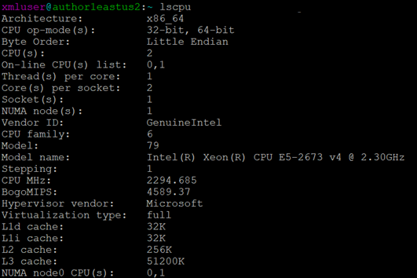

# Validation of Author Setup

Validation should be done as per steps given in [Best Practices Guide](https://helpx.adobe.com/content/dam/help/en/xml-documentation-solution/3-5/XML-Documentation-for-Adobe-Experience-Manager_Best-Practices_EN.pdf)

|  |  |  |
| --- | --- | --- |
| **Validation Step** | **Status** | **Description / Reason** |
| Configure data store | Doneness |  |
| Update Lucene index | Doneness |  |
| Java memory optimization | Doneness |  |
| Client library minification on Author instance | Doneness |  |
| Configure concurrent publishing threads | Doneness |  |
| Configure batch size of nodes for AEM Site output generation | Doneness | e.g. Since custom DITA-OT is not configured hence this check is not required. |
| Patch Xerces Jar while using custom DITA-OT for publishing | Doneness |  |
| Optimize number of post-processing threads | Doneness |  |
| Turn off post processing on Publish instances |  |  |
| Dispatcher Config |  | Refer [this link](https://nam04.safelinks.protection.outlook.com/?url=https%3A%2F%2Fhelpx.adobe.com%2Fexperience-manager%2Fkb%2FURLs-with-encoded-slashes-do-not-work-in-AEM.html&data=02%7C01%7Cdivrsing%40adobe.com%7C2f20f1413ce64ba313c508d793d71208%7Cfa7b1b5a7b34438794aed2c178decee1%7C0%7C0%7C637140424296582029&sdata=wK6mlezuaGIx3F9JR7iHTIOnbErR%2F0kSqhLTRnEc0Dc%3D&reserved=0) to follow steps to add the following setting to dispatcher vhost: AllowEncodedSlashes On |

## Screenshots

Attach/Replace screenshots wherever applicable

### Configure data store

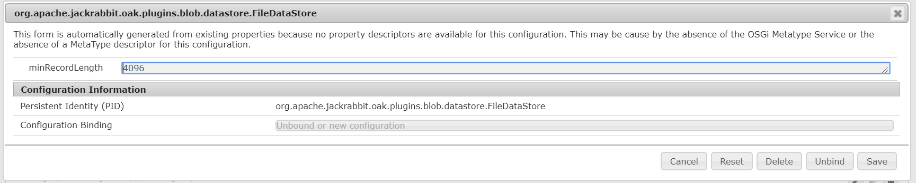

### Update Lucene index

Exclude /content/fmdita from oak:index/lucene.

**Note**: XML Documentation solution never uses Lucene indexes to search for content in /content/fmdita node  


Excluding data property from oak:index/lucene, follow steps given below:

1. Browse to oak:index/lucene in repository
2. Add node '/oak:index/lucene/indexRules/nt:base/properties/data': refer screenshot attached



Exclude "contentLastModified" property from oak:index/lucene, follow steps given below:

1. Browse to oak:index/lucene in repository
2. Add node '/oak:index/lucene/indexRules/nt:base/properties/contentLastModified': refer screenshot attached



### Java memory optimization



### Client library minification on Author instance

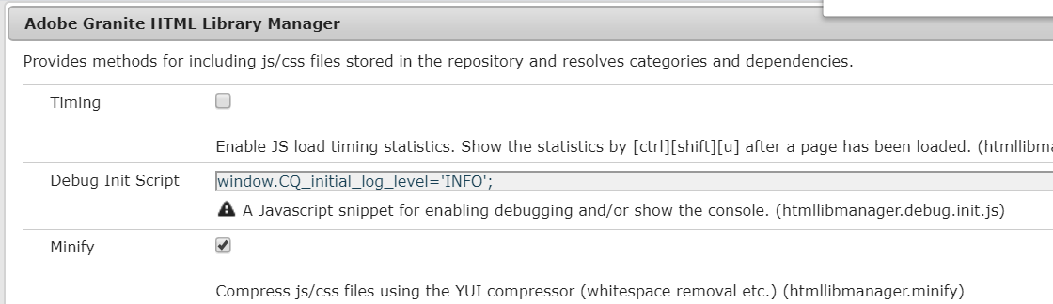

### Configure concurrent publishing threads

If not required, mention reason

### Configure batch size of nodes for AEM Site output generation

If not required, mention reason

### Patch Xerces Jar while using custom DITA-OT for publishing

Add details here

### Optimize number of post-processing threads



# Validation of Publish Setup

## Disable Post Processing on all publish instances

To ensure that no post processing of XML happens on publish instance, explicitly turn off post processing on publish instances:





# Validation of Dispatcher Setup

If dispatcher is setup in front of an **Author instance** then, please do following:

## Enable AllowEncodedSlashes

Refer below link to see details on the configuration:

<https://helpx.adobe.com/in/experience-manager/kb/URLs-with-encoded-slashes-do-not-work-in-AEM.html>

## If HTTPS Protocol enabled

Instruction for HTTPs environment:

1. Edit the aem_author_csp.vhost and change the script-src value from 'self' to script-src 'unsafe-eval'
2. Change the symling in enabled_vhost folder for aem_author.vhost file to point to the aem_author_csp.vhost file
3. Restart apache.