# Adobe Marketing Cloud Privacy & Security Overview

The privacy and security of our customers is a top priority for Adobe. Rest assured that we treat safeguarding your data and your privacy as a solemn trust never to be violated. To that end, Adobe works continuously to be compliant with the top industry standards for privacy and security.

## Compliance

*To request a copy of any of the compliance certificates or audit reports listed below or to request additional information, please email your sales rep or account manager.*

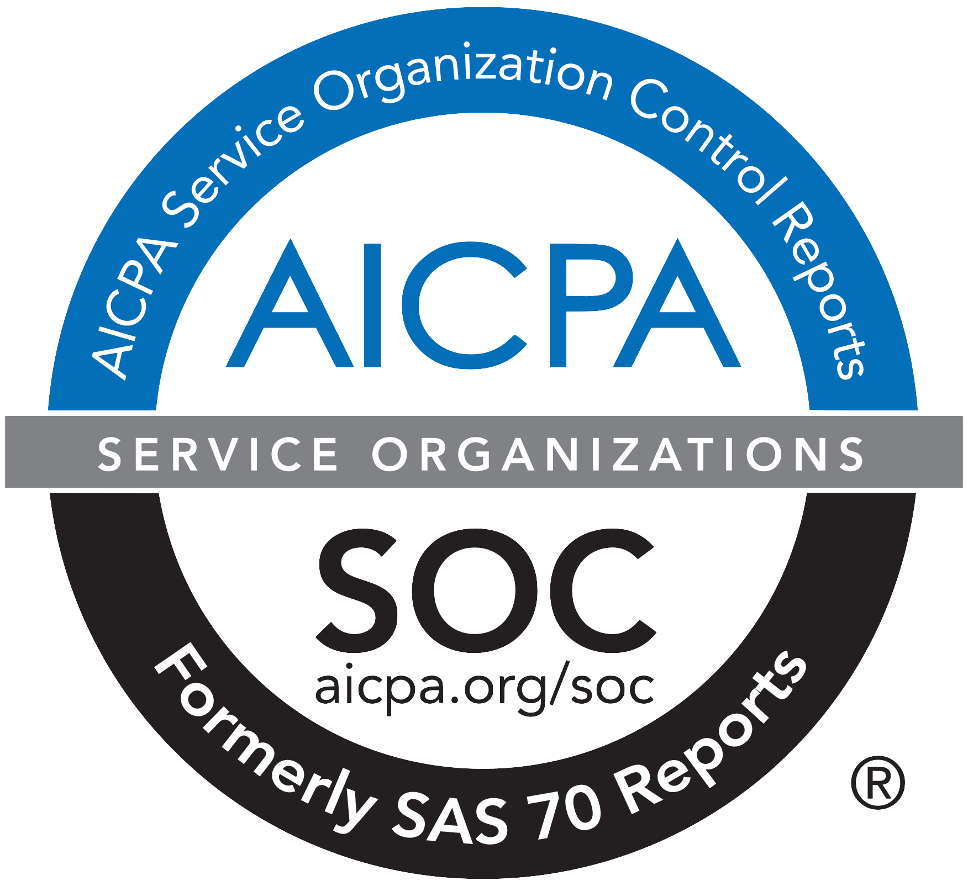**SOC 2** is a set of security principles that define leading practice controls relevant to security, confidentiality, and privacy. All Adobe Marketing Cloud solutions — Adobe Analytics, Adobe Audience Manager, Adobe Campaign, Adobe Experience Manager (except AEM Mobile), Adobe Media Optimizer, Adobe Primetime, Adobe Social, and Adobe Target — are compliant with SOC 2 – Type 1.

**The Gramm-Leach-Bliley Act (GLBA)** requires that financial institutions safeguard their customers’ personal data. Adobe Marketing Cloud supports your company’s ability to be compliant with GLBA. This applies to all Adobe Marketing Cloud solutions, including Adobe Analytics, Adobe Audience Manager, Adobe Campaign, Adobe Experience Manager, Adobe Media Optimizer, Adobe Primetime, Adobe Social, and Adobe Target.

**ISO 27001** is a set of globally adopted standards that outline stringent security requirements and provide a systematic approach to managing the confidentiality, integrity, and availability of customer information. Adobe Experience Manager Managed Services and Adobe Connect Managed Services are compliant with ISO 27001. All Marketing Cloud solutions will be compliant by the second half of 2016.

**The Health Insurance Portability and Accountability Act (HIPAA)** is legislation that governs the use of electronic medical records, and it includes provisions to protect the security and privacy of personally identifiable health-related data, called *protected health information* (PHI). Adobe Experience Manager Managed Services and Adobe Connect Managed Services are fully HIPAA-compliant.

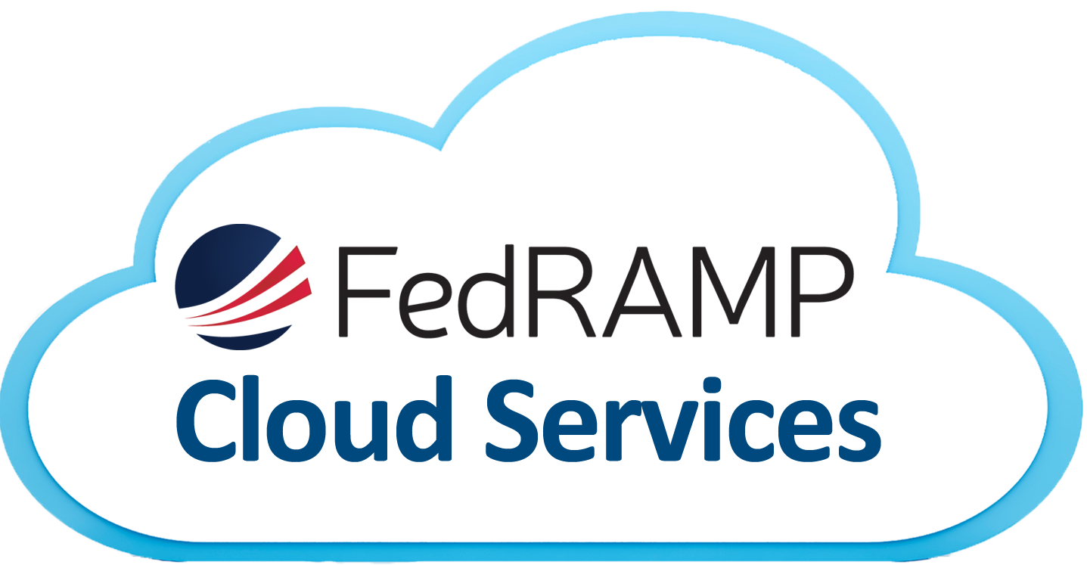**The Federal Risk and Authorization Management Program (FedRAMP)** is a collection of mandatory standards established by the U.S. Federal Government for security assessment and purchase approval for cloud solutions. Adobe Experience Manager Managed Services and Adobe Connect Managed Services are compliant with FedRAMP.

## Additional Resources

**Privacy Center**

Adobe values your privacy and trust. Answers to questions about privacy can be found in the [Adobe Privacy Center.](http://www.adobe.com/privacy.html) This site provides details about the privacy practices of Adobe’s products, services, and apps. It also answers questions about what data is collected by companies who use Adobe Marketing Cloud solutions, and how that data is used in advertising and on-site personalization.

**White Papers**

*Below are summaries of white papers found on* [*adobe.com/security*](http://www.adobe.com/security/resources.html)*. They contain in-depth information about each Adobe Marketing Cloud Solution and an overview of Adobe’s overall security program.*

**Adobe Security and Privacy Certifications**

This white paper explains in detail how the Adobe Common Controls Framework was implemented to protect our infrastructure, applications, and services and to help us comply with a number of industry-accepted best practices, standards, and certifications.

**Adobe Marketing Cloud Security Overview**

From our rigorous integration of security into our software development process to the physical security of Adobe corporate and data center locations, this paper describes the procedures that address the security of your Adobe Marketing Cloud experience and data.

**Adobe Analytics Security Overview**

This paper describes the Adobe Analytics application architecture, including data collection, data processing, and data storage for both Analytics and Analytics Premium. It also lists the locations of Adobe Analytics hosted data centers.

**Adobe Audience Manager Security Overview**

This overview explains Adobe Audience Manager’s application architecture, application security, network architecture, and network management. Because Audience Manager is hosted on Amazon Web Services (AWS), we also explain the processes and controls that AWS requires.

**Adobe Campaign Security Overview**

This document describes Adobe Campaign’s application architecture and deployment models. It also summarizes Campaign’s application security, network architecture, and network.

**Adobe Experience Manager Security Overview**

This paper outlines Adobe Experience Manager’s application architecture and its five capabilities, and describes user authentication for Experience Manager in depth.

**Adobe Media Optimizer Security Overview**

This overview includes Adobe Media Optimizer’s application architecture and basic data flow narrative, as well as Media Optimizer’s application security, network architecture, and network management.

**Adobe Primetime Security Overview**

This document reviews Adobe Primetime’s five capabilities and hosting structure, and details Primetime’s application security, network architecture, and data flow.

**Adobe Social Security Overview White Paper**

This paper explains the application security and network architecture of Adobe Social (including the four components: listening, publishing, moderation, and social analytics) is explained. It also lists the locations of Adobe Social hosted data centers .

**Adobe Target Security Overview White Paper**

This paper describes Adobe Target’s application architecture and includes diagrams of Target’s data flow.  It also outlines Target’s application security, network architecture, and network management.