## SALES ENGAGE FOR SALESFORCE: REPORTS & DASHBOARDS

Using fields installed as a part of our package you can create reports & dashboards to

1) Enrich the insights into the organization for management

2) Enhance the views into prospects and pipeline for Sales Reps

3) Surface activity levels of each team member to drive productivity

* Reports are built around standard Salesforce objects, report types and Sales Engage Custom Fields
* The dashboard and reports will populate with data once the team starts using Sales Engage

## 

## Sales Engage Custom Salesforce Fields

MSE offers custom fields for activity, account, contact, leads, and opportunities, which can be used either to enrich the reporting you already have in Salesforce or to build out new reports. You can reference all available Sales Engage Custom Salesforce field in the chart below.

|  |  |  |  |
| --- | --- | --- | --- |
| Custom Activity Fields | Description | Type | Data Type |
| MSE Call Local Presence ID | As a user I can choose Local Presence as an option when I make calls from MSE Phone. Incoming call will show a local number for the receiver | Activity | Text |
| MSE Call Recording URL | Calls can be recorded and a link for this recording will be logged here | Activity | Text |
| MSE Campaign | Logs name of the MSE campaign the Contact/Lead is on | Activity | Text |
| MSE Campaign URL | Logs URL to the campaign that was created in MSE. Clicking on this will open the campaign in MSE web app | Activity | Text |
| MSE Campaign Current Step | If a contact/lead is on a campaign, this field will log the name of the step the contact/lead is currently on | Activity | Text |
| MSE Email Attachment Viewed | Logs data when an email is sent with an attachment and this attachment is viewed by the recipient | Activity | Checkbox |
| MSE Email Clicked | Logs a check mark when recipeint clicks a link in the email | Activity | Checkbox |
| MSE Email Replied | Logs a check mark when recipeint replies to email | Activity | Checkbox |
| MSE Email Status | Shows if an email is sent/in progress/bounce (tracking bounced email depends on the delivery channel used) | Activity | Text |
| MSE Email Template | Logs name of the MSE template that was used in email sent to Lead/Contact | Activity | Text |
| MSE Email Template URL | Logs URL to the template that was created in MSE. Clicking on this will open the template in MSE web app | Activity | Text |
| MSE Email URL | [Clicking on this URL will open command center in MSE and pull up People Detail View history tab where user can see the sent email](https://monosnap.com/file/njaTnOIlJRzUG47DYei9awPSz3EJHk) | Activity | Text |
| MSE Email Viewed | Logs a check mark when recipient views an email | Activity | Checkbox |

## Reports With MSE Custom Fields

Using MSE’s custom fields you can create reports such as the priority call report using Sales Engage email engagement data to help reps focus time on the people or opportunities with the most momentum.

Step 1: Go to SFDC Report Tab

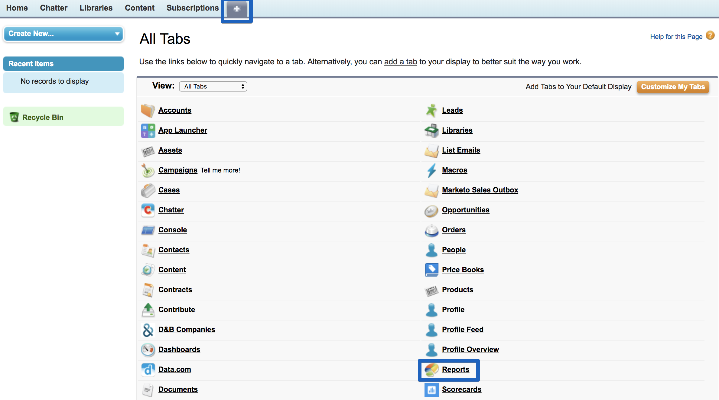

Step 2: Create a Report with ‘Tasks and Events’

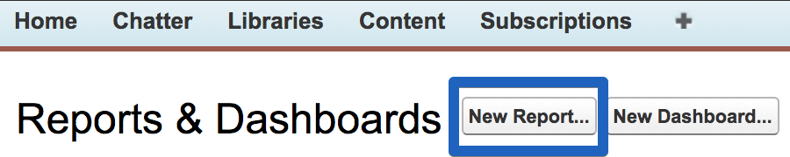

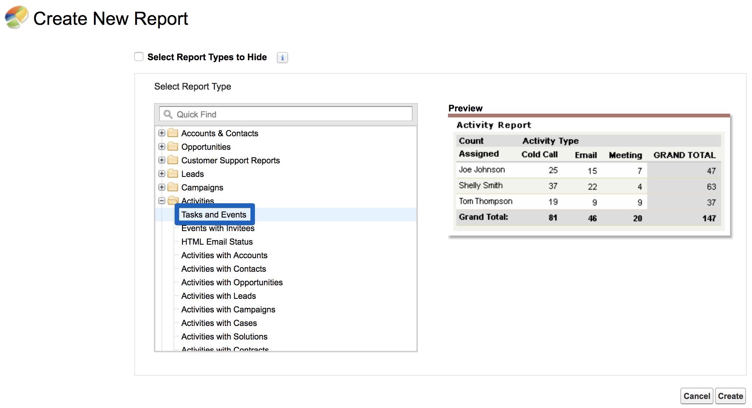

Step 3: Set your filters and choose a date range

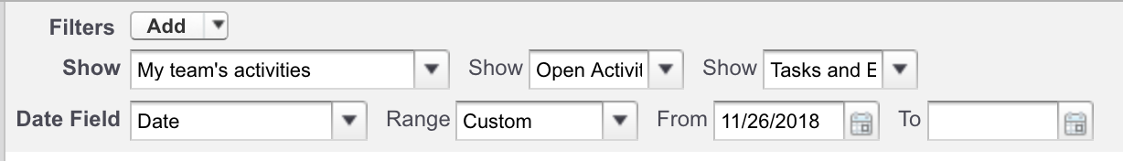

Step 4: Drag Sales Engage data into your columns by typing Sales Engage into the field search. Example: Once you add Sales Engage data add a column for phone number so you can take action on this report and use it as a call list.

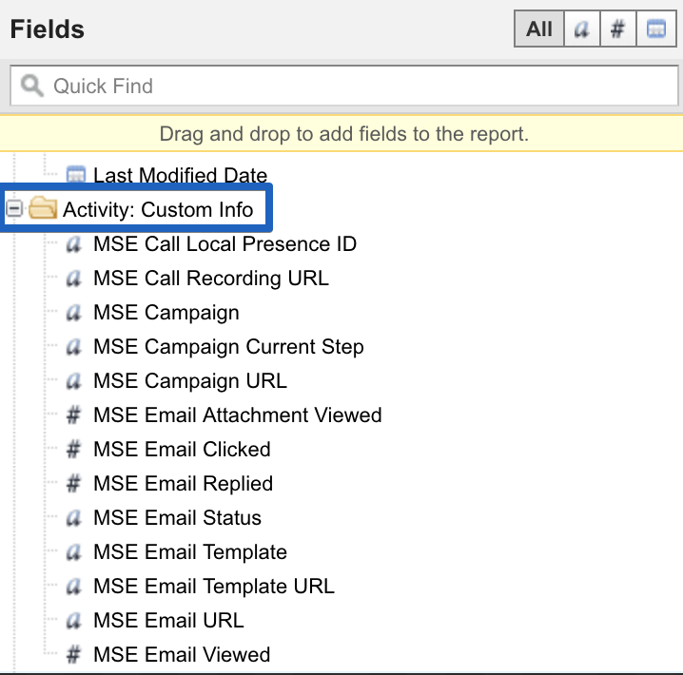

Step 5: You can now create reports using these fields. Continue on to the next section to take a look at our recommended reports.

Tip: If you intend to use formulas, change your report format to summary

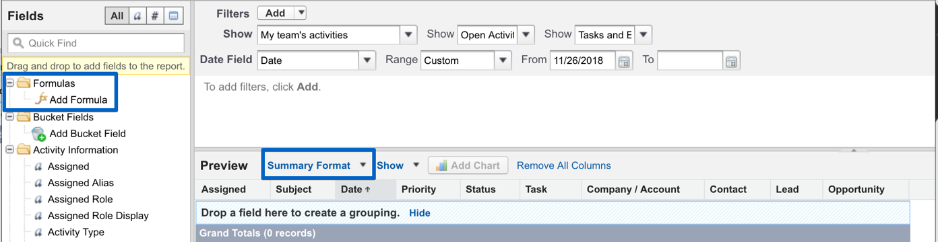

**Examples of reports**

**Report: Call and Email Activity - AEs** [**Columns: Subject**](javascript:document.report.sort.value%3D%27SUBJECT%27%3Bdocument.report.sortdir.value%3D%27up%27%3Bdocument.report.runPageAction.value%3D%27SORTDETAIL%27%3Bdocument.report.submit%28%29%3B), Priority, Status, Company/Account, Contact, Lead, Opportunity, Activities #

Filter & Group Details:

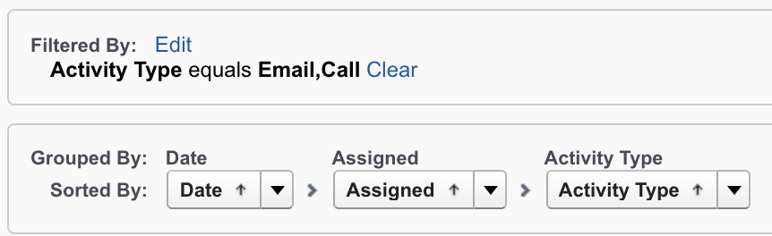

Formula Used for Activities #

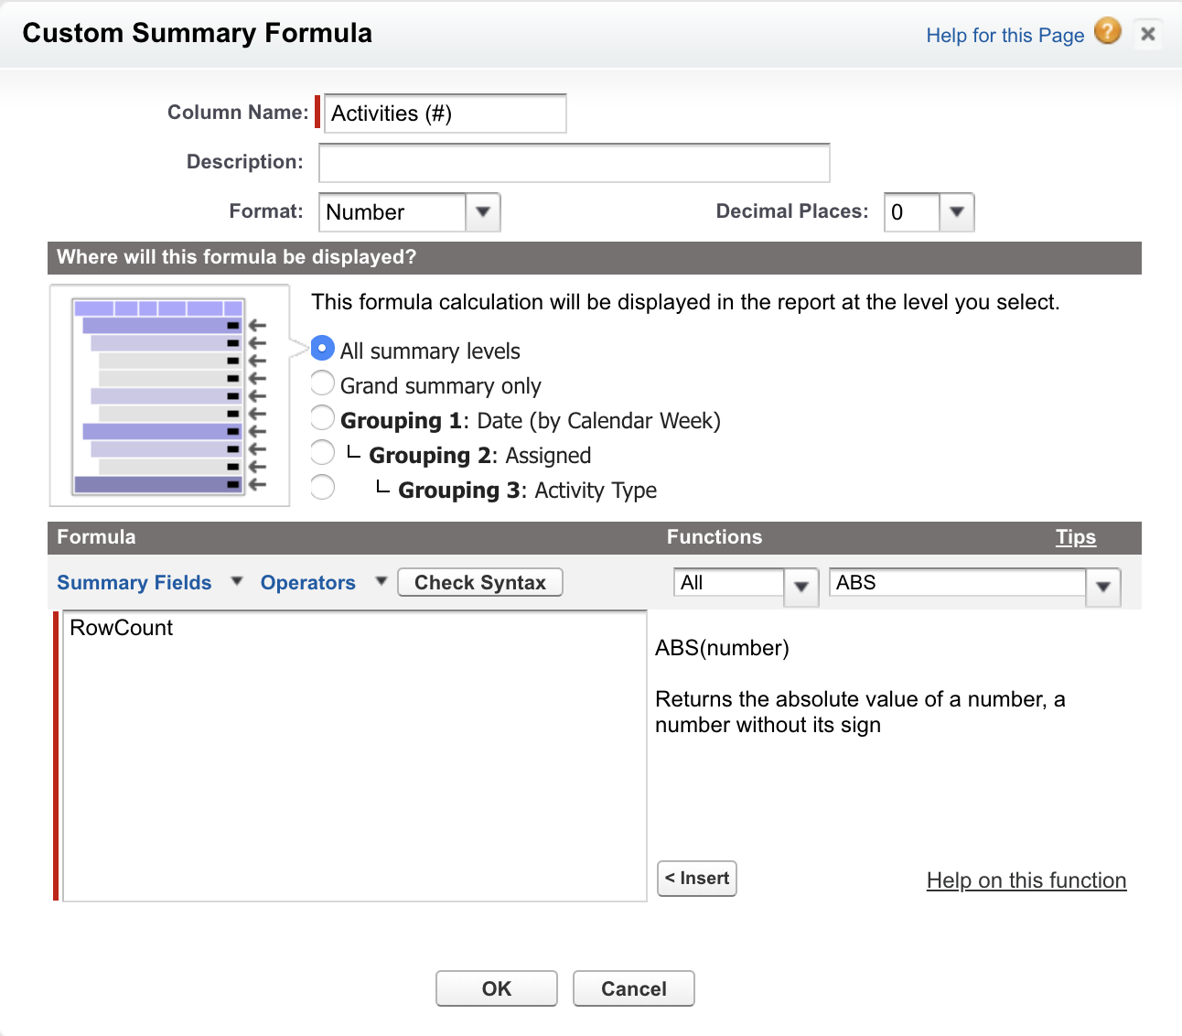

Tip: Do not forget to group columns while creating a formula

Report: Call and Email Activity - SDRs

Columns: Subject, Company / Account, Contact, Lead, Opportunity, Activities (#)

Filter & Group Details:

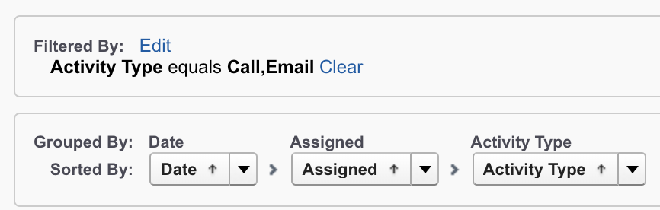

Formula Used for Activities #

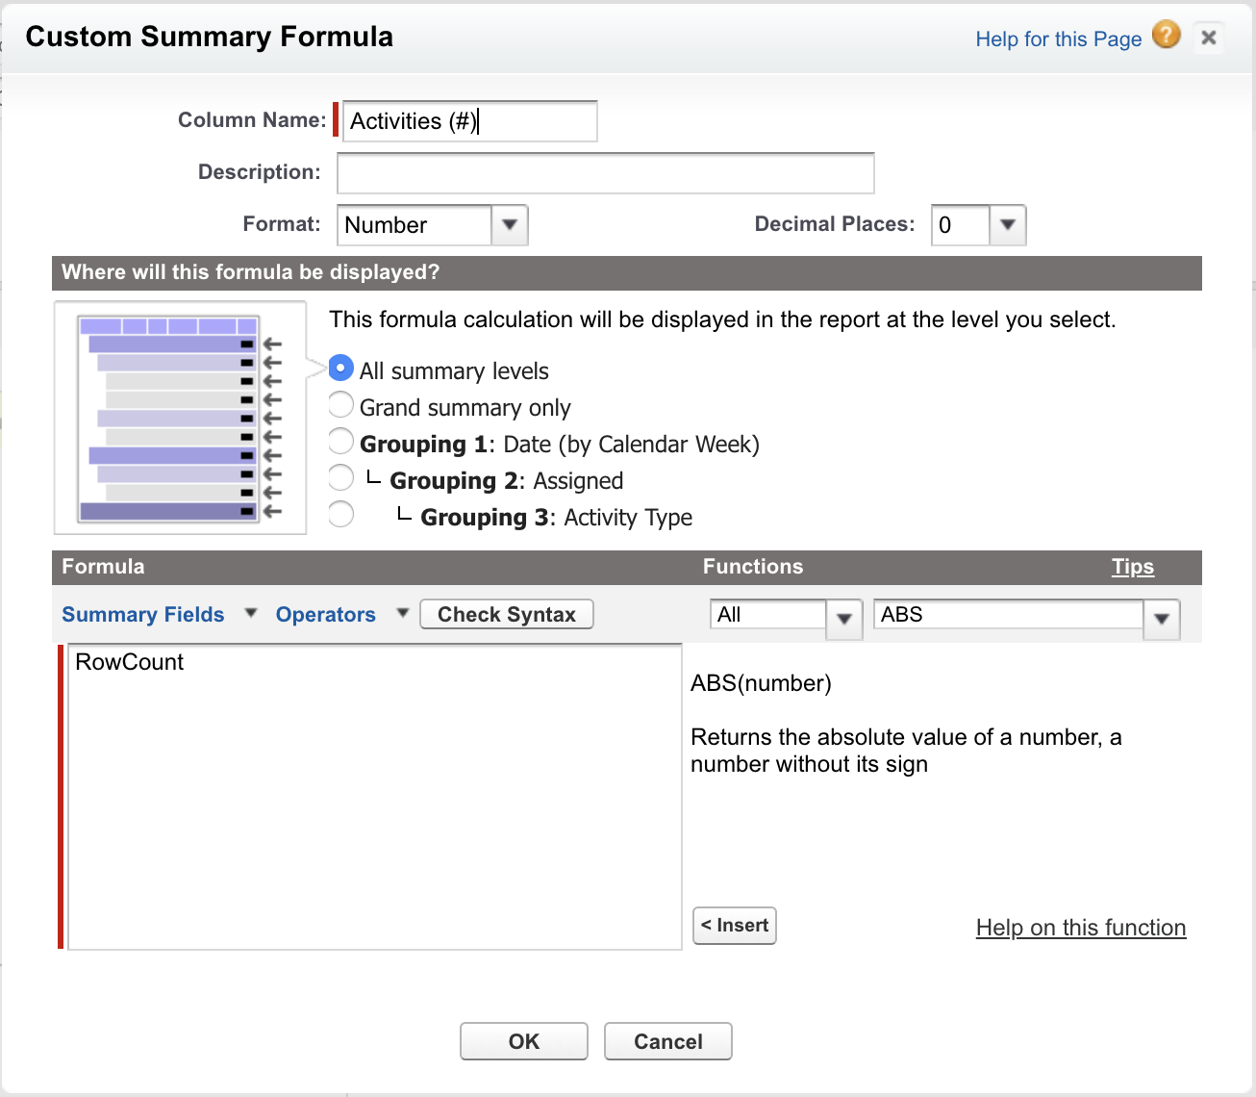

**Report: Calls Made (SDR Activity Goals)**  
Columns: Subject, Company / Account, Contact, Lead, Opportunity, Date, Comments, Calls Made

Filter & Group Details:

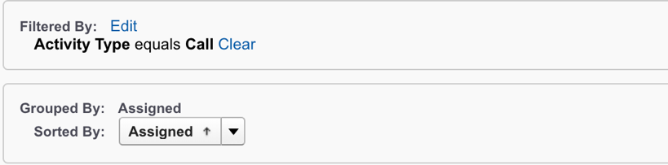

Formula Used for Call Made  
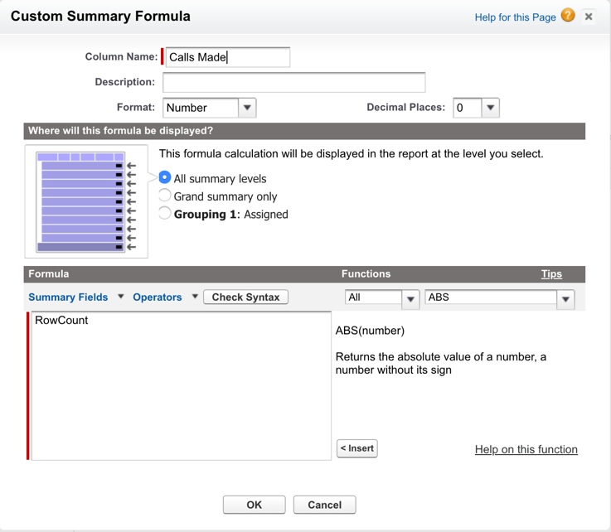

**Report: Closed Business**

Columns: Opportunity Name, Type, Lead Source, Amount, Expected Revenue, Close Date, Next Step, Stage, Probability (%), Fiscal Period, Age, Created Date, Owner Role, Account Name

Filter & Group Details:

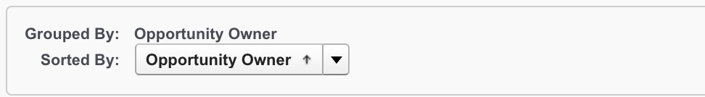

**Report: Closed Won Opportunities This Quarter**

Columns: Opportunity Name, Amount, Close Date, Created Date, Account Name, Opportunity Owner, Owner Role

Filter & Group Details:

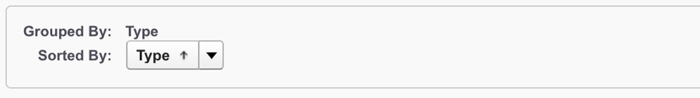

**Report: Email Activity and Top Opportunities**Columns: Assigned, Subject, Opportunity Owner, Account Name, Amount, Emails Sent, Amount

Filter & Group Details:

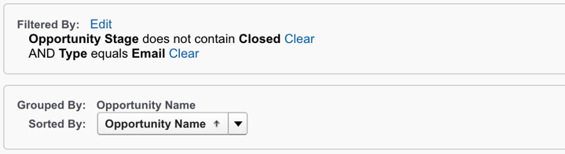

Formula Used for Email Sent

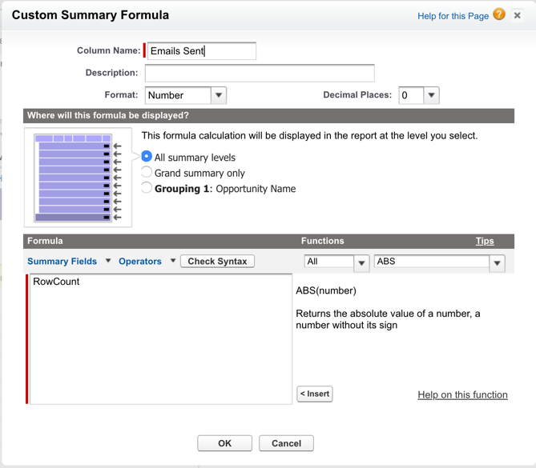

Formula Used for Amount

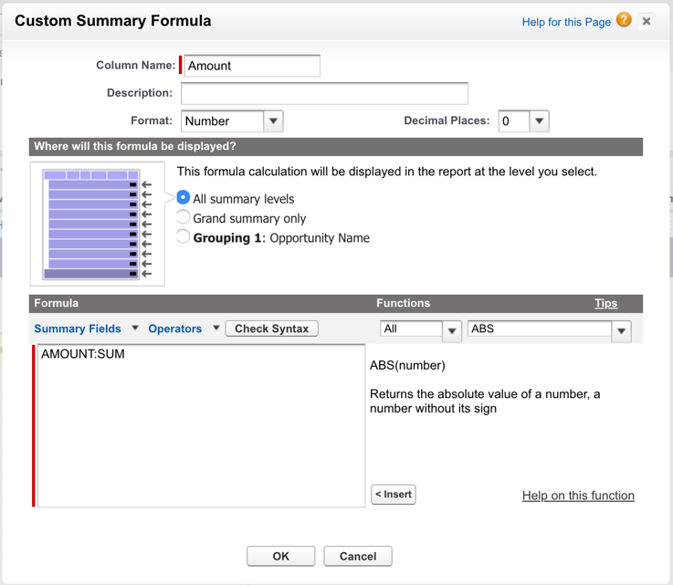

**Report: Email Activity with Closed Won Opportunities**Columns: Assigned, Opportunity Owner , Subject, Amount, MSE Email Viewed, MSE Email Click, MSE Email Replied, Emails Sent

Filter & Group Details:

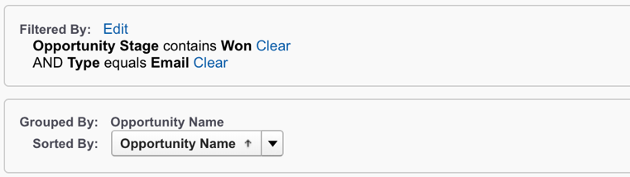

Formula Used for Email Sent:

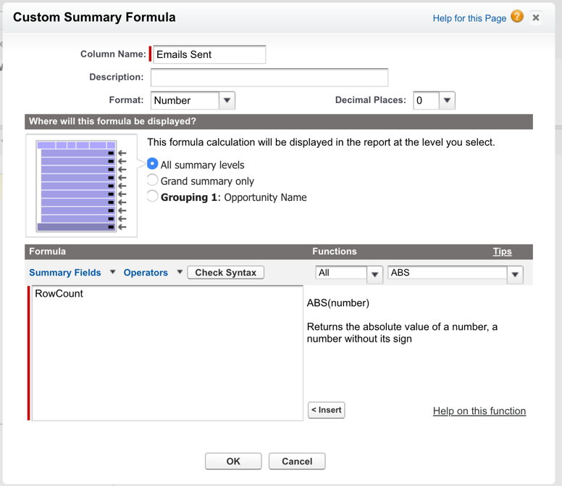

**Report: Email Activity with Open Opportunities**Columns: Assigned, Subject, Opportunity Owner, Account Name, Amount, Emails Sent, Amount

Formula for Email Sent

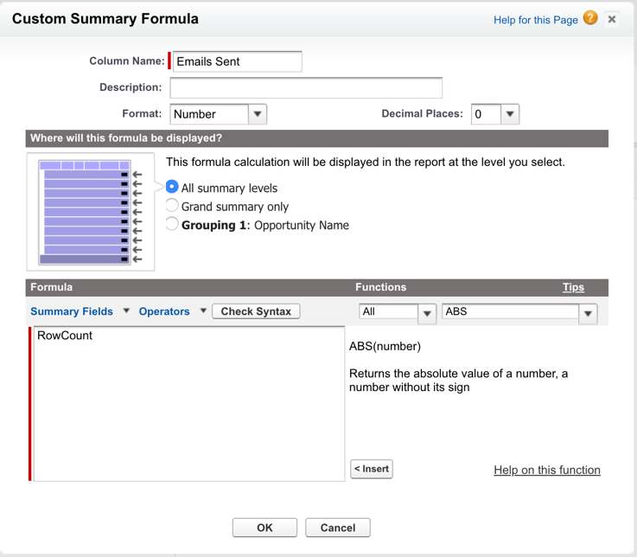

**Report: Email Performance Metrics – AEs (Most Effective Closers)**Columns: Subject, Company / Account, Created Date, Contact, Lead, MSE Email Viewed, MSE Email Clicked, MSE Email Replied, Emails Sent, MSE Email Viewed %, MSE Email Clicked %, MSE Email Replied %

Filter & Group By Details:

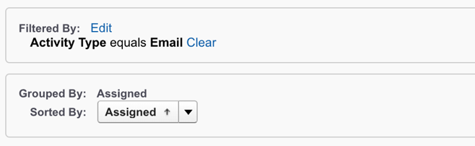

Formula for Emails Sent

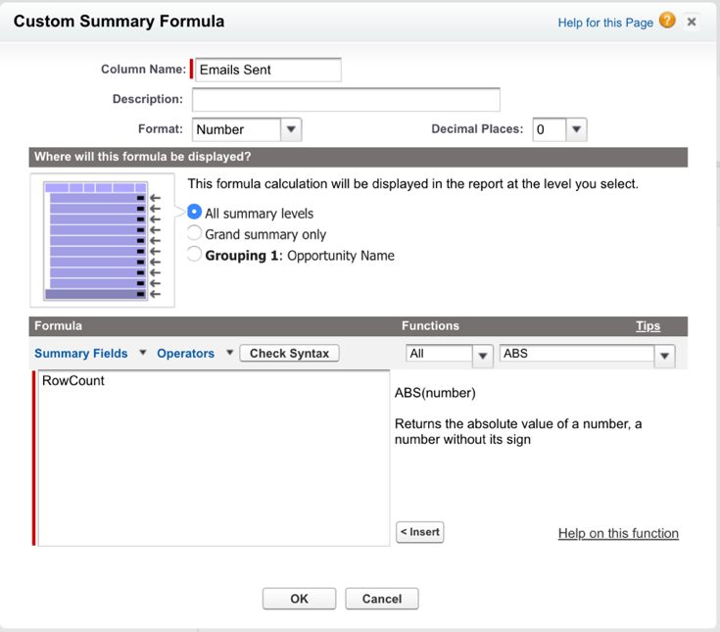

Formula for MSE Email Viewed %

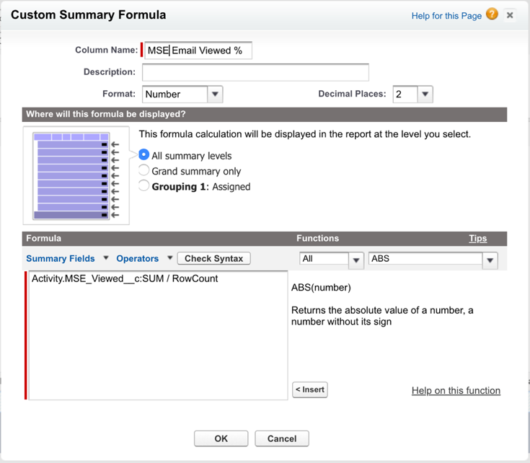

Formula for MSE Email Clicked %

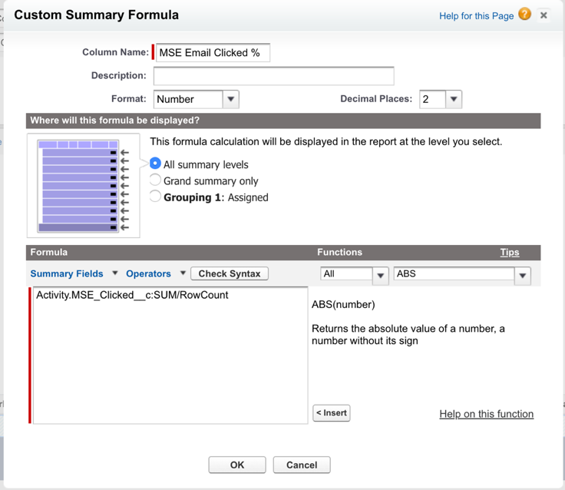

Formula for MSE Email Replied %

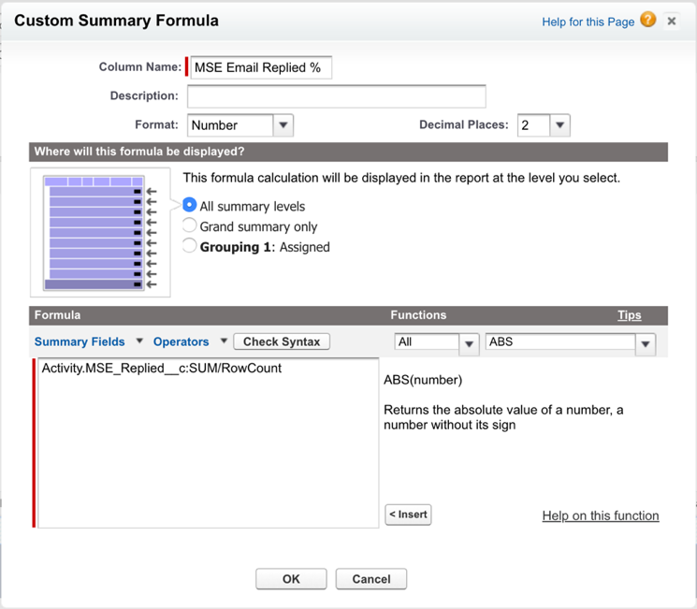

**Report: Email Performance Metrics – SDRs (Most Effective SDRs)**Columns: Subject, Company / Account, Created Date, Contact, Lead, MSE Email Viewed, MSE Email Clicked, MSE Email Replied, Emails Sent, MSE Email Viewed %, MSE Email Clicked %, MSE Email Replied %

Filter & Group Details:

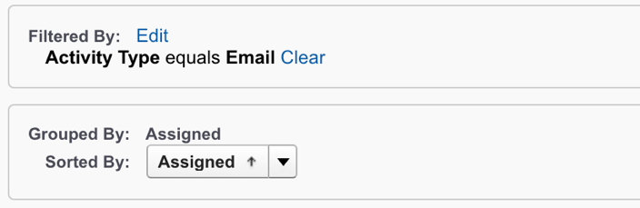

Formula for Emails Sent

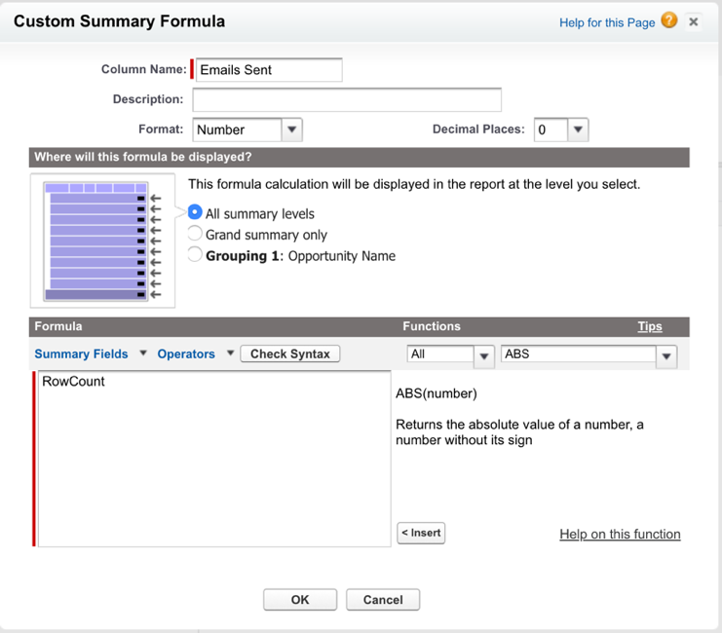

Formula for MSE Email Viewed %

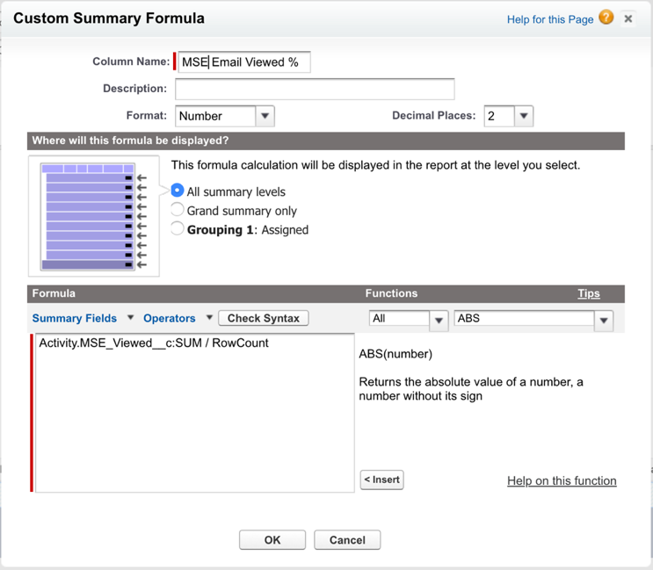

Formula for MSE Email Clicked %

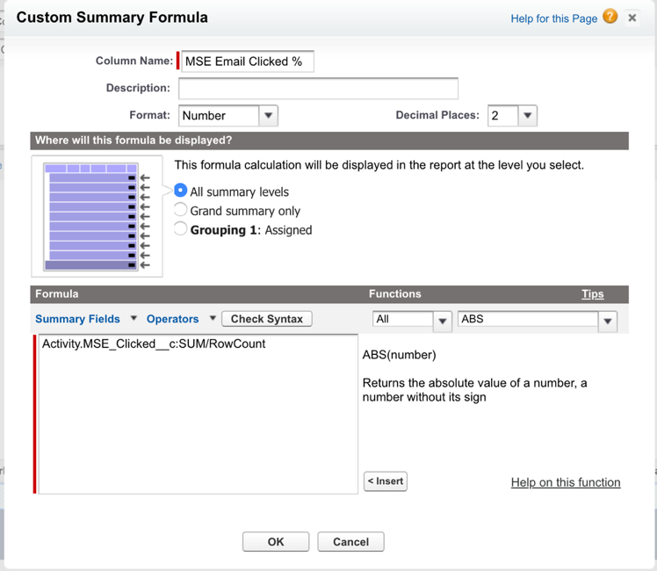

Formula for MSE Email Replied %



**Report: MSE Campaign Performance**Columns: Subject, Company / Account, Name, Created Date, Assigned, Contact, Lead, Marketo Sales Email Viewed, Marketo Sales Email Clicked, Marketo Sales Email Replied, Marketo Sales Email Clicked %, Marketo Sales Email Replied %, Marketo Sales Email Viewed %

Filter & Group Details:

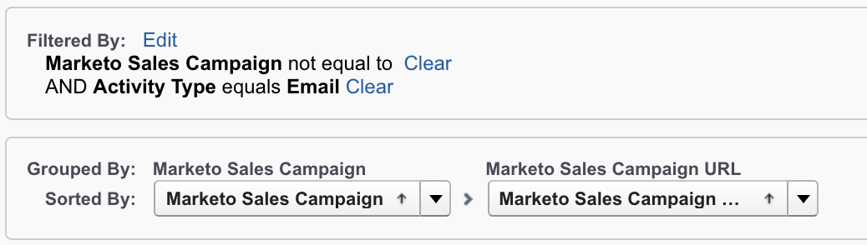

Formula Used: Same as previous reports

**Report: Open Opportunities by Stage**Columns: Account Name, Opportunity Name, Amount, Probability (%), Close Date, Opportunity Owner, Owner Role, Amount by Stage

Filter & Group Details:

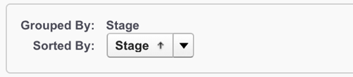

Formula Used for Amount By Stage

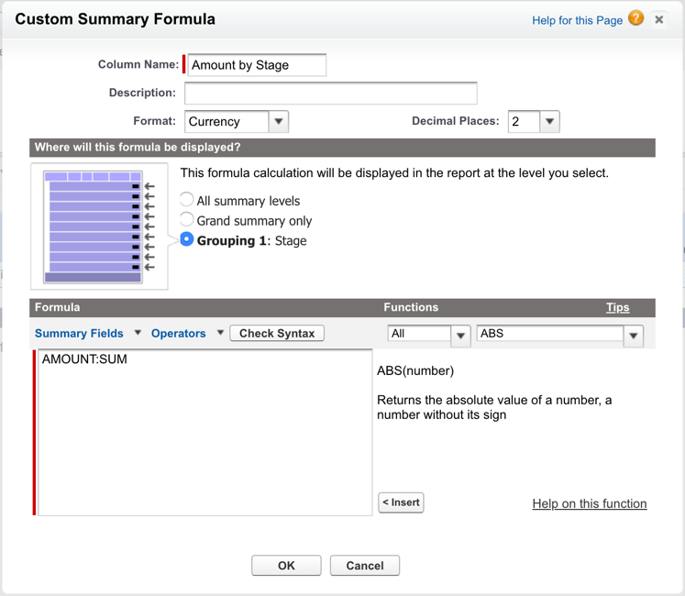

**Report: Opportunities in the Pipeline: Pipeline by Rep**

Columns: Opportunity Name, Account Name, Type, Amount, Close Date, Stage, Probability (%), Created Date, Owner Role

Filter & Group Details:

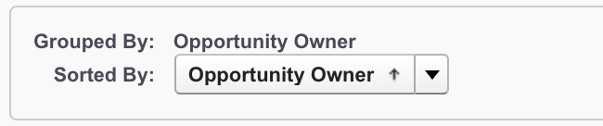

**Report: Template Performance: Most Effective Templates**

Columns: Assigned, Subject, Name, Company / Account, Marketo Sales Email Viewed, Marketo Sales Email Clicked, Marketo Sales Email Replied, # of Emails Sent, Marketo Sales Email Clicked %, Marketo Sales Email Replied %, Marketo Sales Email Viewed %

Filter & Group Details:

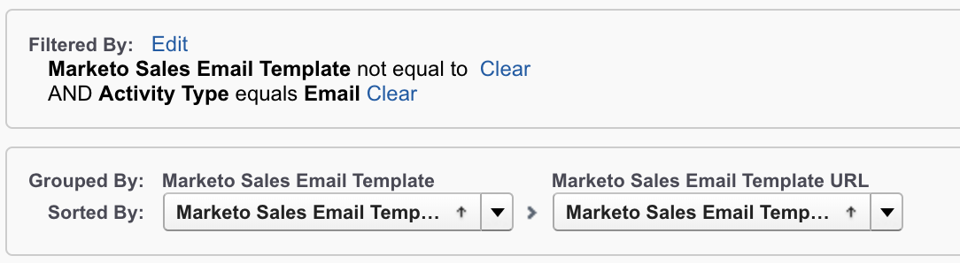

Formula Used for # Email Sent:

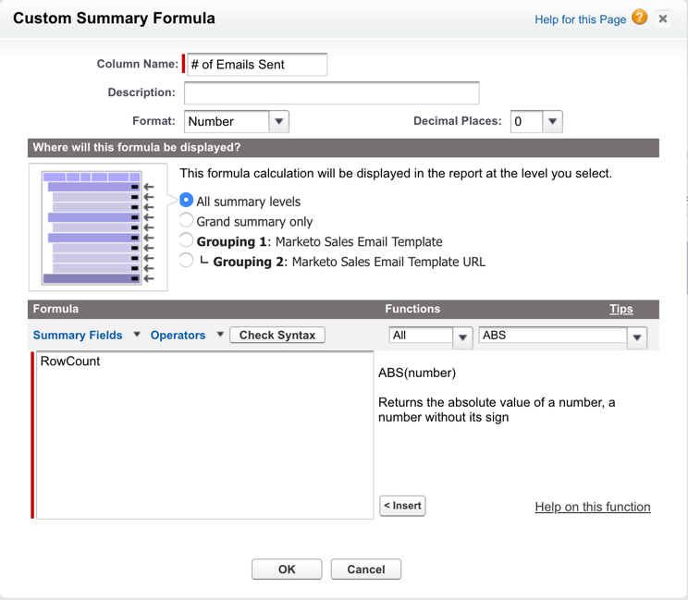

Formula Used for Marketo Sales Email Clicked %

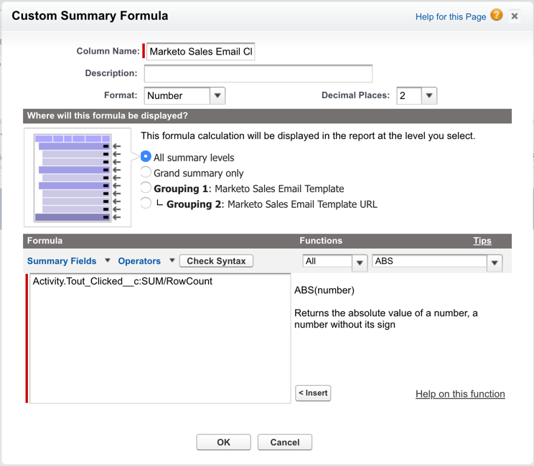

Formula Used for Marketo Sales Email Replied %

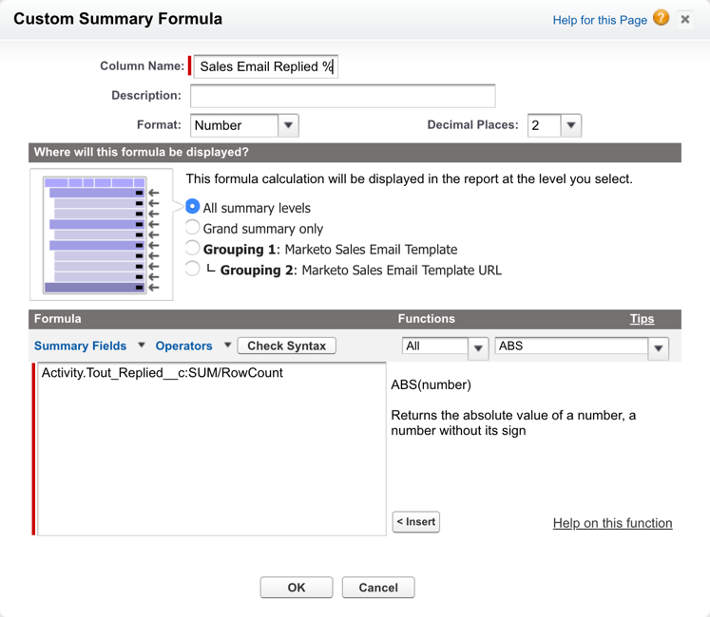

Formula Used for Marketo Sales Email Viewed %  
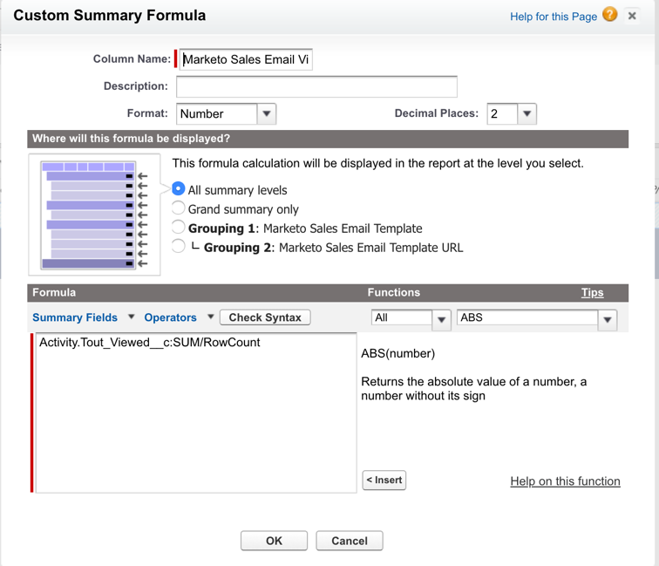

**Report: Total Pipeline for Current Quarter: Total Pipeline for Current Fiscal Quarter**Columns: Opportunity Name, Account Name, Type, Opportunity Owner, Amount, Stage, Probability (%), Created Date

Filter & Group Details:

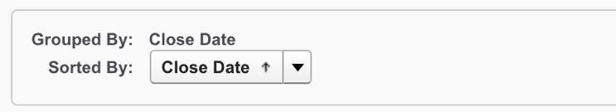

**Report: Total Pipeline for Next Quarter: Total Pipeline for Next Fiscal Quarter**Columns: Opportunity Name, Account Name, Type, Opportunity Owner, Amount, Stage, Probability (%), Created Date

Filter & Group Details:

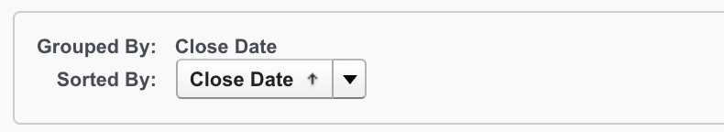

## Customizations for Dashboards

All Dashboards and Reports can be customized to for your organization, including filtering the source reports for custom fields in your Salesforce instance and/or adjusting the formatting of each dashboard component.

You’ll find MSE recommended customizations based on our experience on how Sales Engage integration with Salesforce can create value and drive meaningful insights for organizations in the chart below on pages

|  |  |  |  |
| --- | --- | --- | --- |
| Dashboard Name | Type | Source Report | Customization |
| Pipeline Summary | Metric | Total Pipeline for Current Quarter and Total Pipeline for Next Quarter | Filter reports by specific opportunity stages or opportunity types depending on how your company defines pipeline |
| Quarter-to-Date Closed Won | Gauge | Closed Won Opportunities This Quarter Shows all Opportunities with “Closed Won” as the Opportunity Status | Set the breakpoints for the dial in the dashboard editor based on your company’s targets |
| Opportunities in the Sales Funnel | Funnel Chart | Open Opportunities By Stage Shows all Opportunities with “Open” as the Opportunity Status and your company’s Opportunity Stages | Filter the report by specific opportunity stages to show a zoomed in view of your Sales Funnel |
| Closed Business | Table | Closed Business Shows all Opportunities with “Closed Won” as the Opportunity Status | None |
| Pipeline by Rep | Horizontal Bar Chart | Opportunities in the Pipeline Shows all opportunities with “Open” as the Opportunity Status | To only display a specific team (ie. Pipeline), filter the Report by “Owner Role” (or another Opportunity Owner field) |
| Top Opportunities in the Pipeline | Table | Email Activity & Top Opportunities Shows all Open Opportunities (Opportunity Stage does not contain “Closed”) | Filter the report by specific opportunity stages or opportunity types depending on how your company defines pipeline |
| AE Activity Level | Line Chart | Call and Email Activity - AEs Shows all Tasks with Activity Type equal to “Email” or “Call” | To only display a specific team (ie. AEs), filter the Report by “Assigned Role”  Adjust the “Activity Type” filter on the report to pull in additional activities your team is measured on (I.E. Meeting Booked) |
| Activities for Closed Won Opportunities | Table | Email Activity With Closed Won Opportunities Shows all Opportunities with Opportunity Stage contains “Won” | You can filter by opportunity type. Sorted by Sum of Amount in descending order |
| Most Effective Closers | Table | Email Performance Metrics - AEs | To only display a specific team (ie. AEs), filter the Report by “Assigned Role” Set conditional highlighting breakpoints depending on your team’s targets Sorted by Emails Sent in descending order |
| Most Effective SDRS | Table | Email Performance Metrics - SDRs | To only display a specific team (ie. AEs), filter the Report by “Assigned Role” Set conditional highlighting breakpoints depending on your team’s targets Sorted by Emails Sent in descending order |
| Opportunities with the Highest Potential to Close | Table | Email Activity With Open Opportunities Shows all Open Opportunities (Opportunity Stage does not contain “Closed”) and Tasks with Type equal to “Email” | Filter reports by specific opportunity stages or opportunity types to get a more granular view Sorted by Sum of Sales Engage Emails Tracked in descending order |
| Most Effective Templates to Get a Reply | Table | Template Performance Shows all Tasks with “Email” as Activity Type | Filter the report by a minimum threshold of number of emails sent Sorted by Average Sales Engage Replied |
| SDR Team Activity Level | Line Chart | Call and Email Activity - SDRs Shows all Tasks with Activity Type equal to “Email” or “Call” | To only display a specific team (ie. Pipeline), filter the Report by “Assigned Role” Adjust the “Activity Type” filter on the report to pull in additional activities your team is measured on (I.E. Meeting Booked) |
| SDR Call Activity Goals | Table | Calls Made Shows all Tasks with Activity Type equal to “Call” and Includes links to call recordings | To only display a specific team (ie. Pipeline), filter the Report by “Assigned Role” Set conditional highlighting breakpoints depending on your team’s targets Sorted by Calls Made in descending order |
| Most Effective Campaigns to Get a Reply | Table | Sales Engage Campaign Performance Shows all Tasks with “Email” as Activity Type | Filter the report by a minimum threshold of number of emails sent Sorted by Average Sales Engage Replied in descending order |

You can reference the Salesforce Video and Help Articles below, for guidance on customizing reports and Dashboards within Salesforce.

* [Getting Started With Reports and Dashboards](https://help.salesforce.com/HTViewQuickStarts?id=000113375)
* [Dashboard Overview](http://salesforce.vidyard.com/watch/jm5Arf95A87Q88j39YCTkQ)
* [Using the Drag and Drop Report Builder](http://resources.docs.salesforce.com/200/20/en-us/sfdc/pdf/salesforce_report_builder_impl_guide.pdf)
* [5 Ways to Get the Most Out of Your Reports and Dashboards](http://help.salesforce.com/apex/HTViewSolution?id=000025298&language=en_US)
* [How to change Visual settings for dashboard chart components](https://help.salesforce.com/HTViewHelpDoc?id=chart_visual_settings.htm&language=en_US)
* [How to Modify a Dashboard Component](https://help.salesforce.com/apex/HTViewHelpDoc?id=dashboard_builder_component_editor.htm&language=en_US)
* [How to Change the Data Settings for Dashboard Components](https://help.salesforce.com/apex/HTViewHelpDoc?id=chart_data_settings.htm&language=en_US)