****Library Management System****

The goal of this project is to design and implement an Oracle SQL-based Library Management System. The system allows you to manage books, authors, library members, and book loans. It seeks to keep track of available books, their authors, and members' borrowing activity. The database manages interactions between books and authors, members and books, and borrower history through loans.

Here is a summary of the final database architecture for a library system based on your specifications:

1. **TABLES**

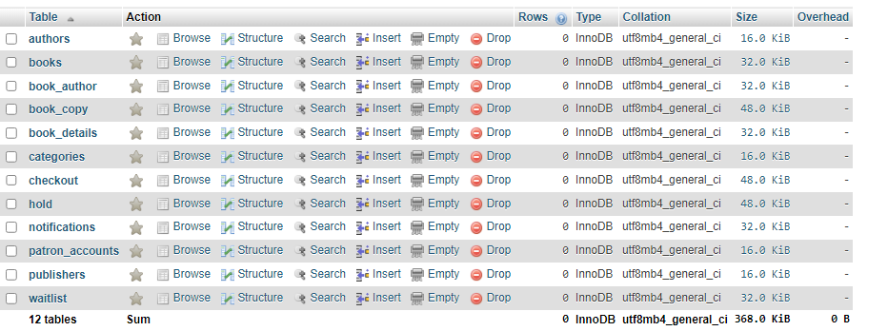

1. **Update Data (DML)**

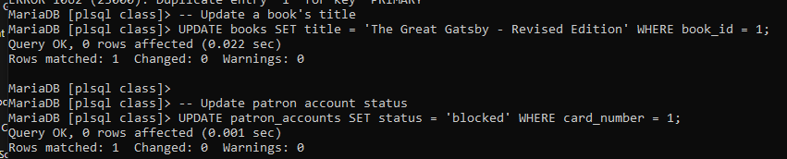

1. **Delete Data (DML)**

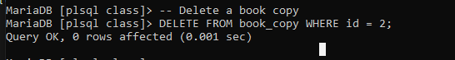

1. **Perform Joins**

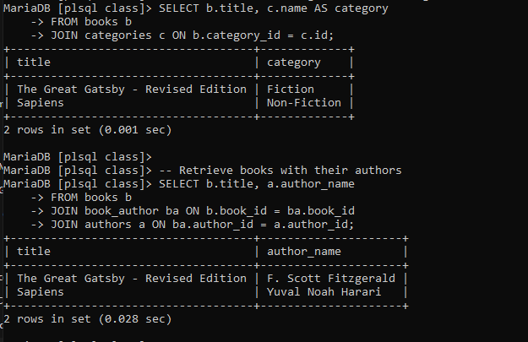

1. **Basic SQL Commands (SELECT, INSERT, UPDATE, DELETE)**

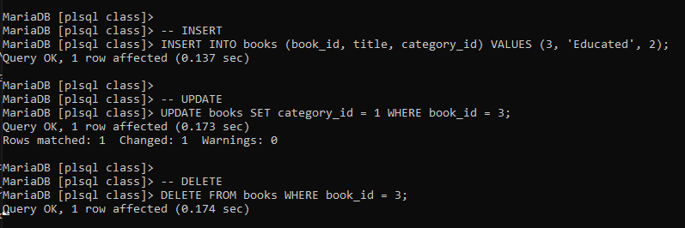

1. **Perform Subqueries**

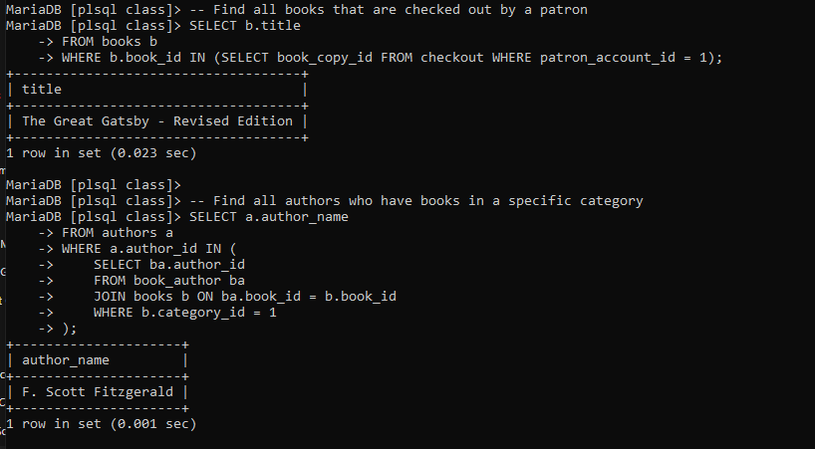

1. **DCL (Data Control Language)**

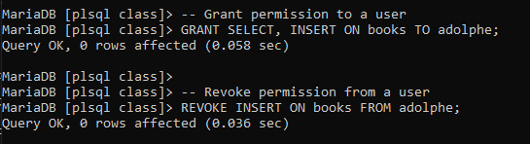

1. **TCL (Transaction Control Language)**

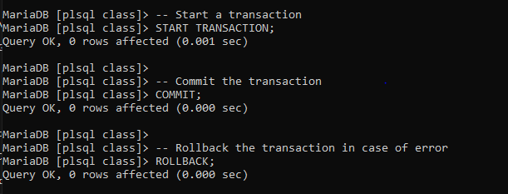

1. **conceptual diagram.**

