

[Fundamentals] Cloud & DevOps Assessment Mexico, Argentina

Azure Practical Task



October 1, 2024

learn.epam.com

Contents

1. Create Azure Web App with Azure App Services. 1

2. Create GitHub repo with simple personal website. 2

Create GitHub repo 2

Commit your first change 2

Next steps 4

3. Deploy an application with GitHub Actions and Azure Static Web Apps. 5

Important 10

References 11

Azure Practical Task

## Create Azure Web App with Azure App Services.

Go to [Azure portal](https://portal.azure.com/). Azure Static Web Apps is very simple and easy to work with. There are 3 ways to create the Azure Static Web Apps, i.e., VS Code, Azure portal, and Azure CLI.

Select an option from the 3 given, in this example was selected **Access student benefits**.

Figure 1Create Azure Portal Account

## Create [GitHub](https://github.com/) repo with simple personal website.

### Create [GitHub](https://github.com/) repo

GitHub repositories store a variety of projects. In this guide, you'll create a repository and commit your first change.

1. In the upper-right corner of any page, select, then click **New repository**.

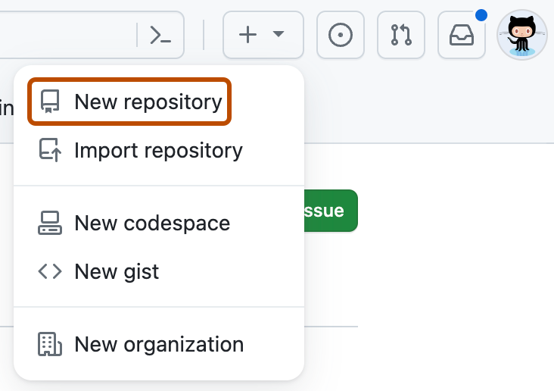

1. Type a short, memorable name for your repository. For example, "hello-world".

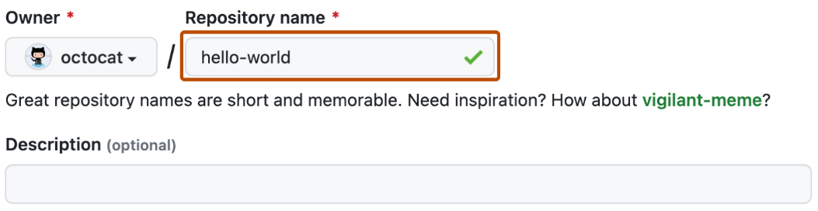

1. Optionally, add a description of your repository. For example, "My first repository on GitHub."
2. Choose a repository visibility.
3. Select **Initialize this repository with a README**.
4. Click **Create repository**.

Congratulations! You've successfully created your first repository and initialized it with a *README* file.

### [Commit your first change](https://docs.github.com/en/repositories/creating-and-managing-repositories/quickstart-for-repositories?tool=webui#commit-your-first-change)

A [commit](https://docs.github.com/en/get-started/learning-about-github/github-glossary#commit) is like a snapshot of all the files in your project at a particular point in time.

When you created your new repository, you initialized it with a *README* file. *README* files are a great place to describe your project in more detail or add some documentation such as how to install or use your project. The contents of your *README* file are automatically shown on the front page of your repository.

Let's commit a change to the README file.

1. In your repository's list of files, select **README.md**.

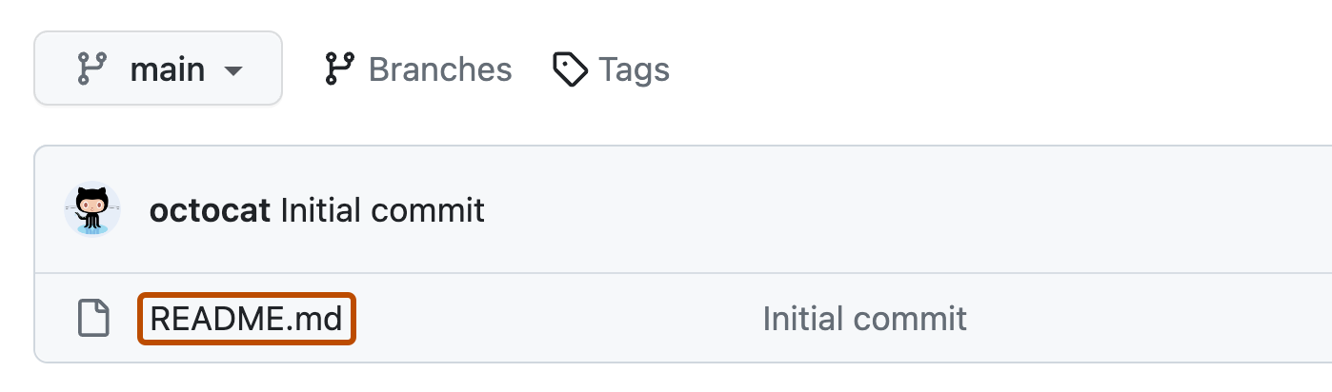

1. In the upper right corner of the file view, click to open the file editor.

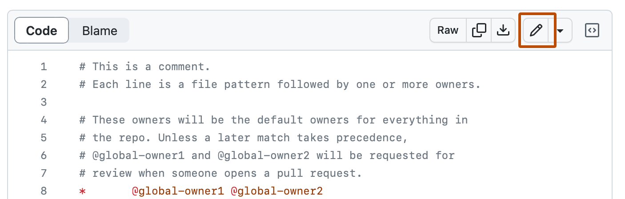

1. In the text box, type some information about yourself.
2. Above the new content, click **Preview**.

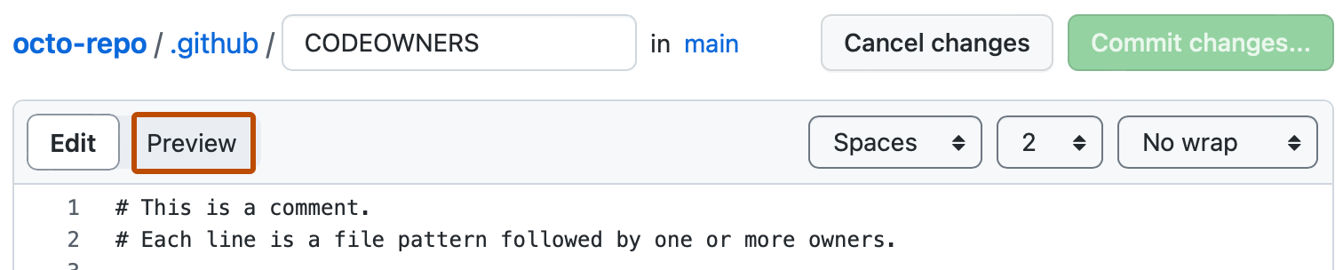

1. Review the changes you made to the file. If you select **Show diff**, you will see the new content in green.

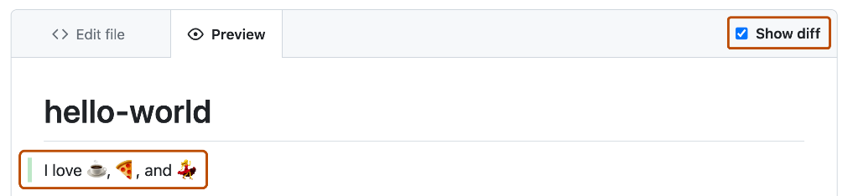

1. Click **Commit changes...**
2. In the "Commit message" field, type a short, meaningful commit message that describes the change you made to the file. You can attribute the commit to more than one author in the commit message.
3. Below the commit message fields, decide whether to add your commit to the current branch or to a new branch. If your current branch is the default branch, you should choose to create a new branch for your commit and then create a pull request.

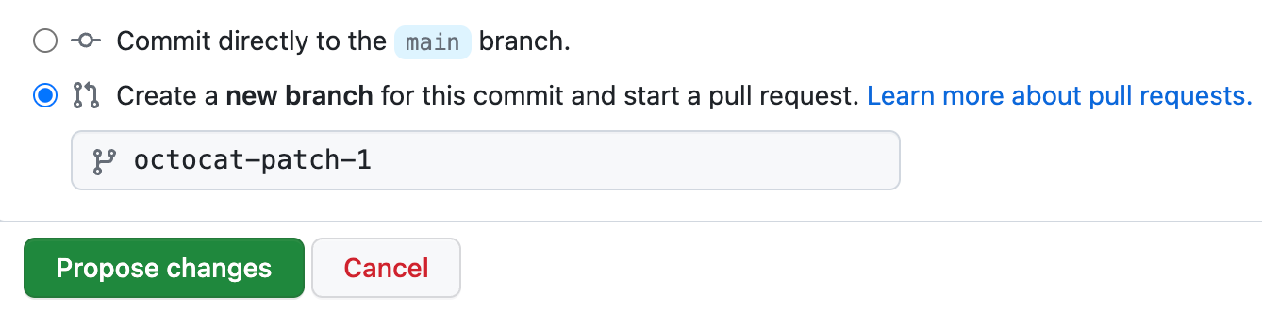

1. Click **Commit changes** or **Propose changes**.

### [Next steps](https://docs.github.com/en/repositories/creating-and-managing-repositories/quickstart-for-repositories?tool=webui#next-steps)

You have now created a repository, including a *README* file, and created your first commit on GitHub.

* You can now clone a GitHub repository to create a local copy on your computer. From your local repository you can commit and create a pull request to update the changes in the upstream repository.
* You can find interesting projects and repositories on GitHub and make changes to them by creating a fork of the repository. Forking a repository will allow you to make changes to another repository without affecting the original.
* Each repository on GitHub is owned by a person or an organization. You can interact with the people, repositories, and organizations by connecting and following them on GitHub.
* GitHub has a great support community where you can ask for help and talk to people from around the world. Join the conversation on [GitHub Community](https://github.com/orgs/community/discussions).

**Create the files to generate the simple web site inside your cloned GitHub repository.**

## Deploy an application with GitHub Actions and Azure Static Web Apps.

Give a resource Group name at the **Static Web App details**.

Figure 2 Creation of the Static Web App

Select the **Plan type**, **Deployment details** and then select the **Organization**.

Figure 3 Creation of the Static Web App

Select the desired **Repository** to deploy on Azure Cloud services and choose the appropriate branch from which you will deploy the project. Additionally, select the type of **Build Presets** for your project. Complete the remaining required information, and then click the **Next: Advanced** button.

Figure 4 Creation of the Static Web App

Select **Azure Functions and staging details** API and continue.

Figure 5 Creation of the Static Web App

Set **Tags** if needed, read the hint for more information about it, then continue.

Figure 6 Creation of the Static Web App

Check the details of the instance to be generated and then click on the button **Create**.

Figure 7 Creation of the Static Web App

Now your site web is completely deployed on the Cloud Azure. Click on **Go to resource**.

Figure 8 Creation of the Static Web App

Figure 9 Creation of the Static Web App

Here pressing on the **Visit your site** button, you can see the static app deployed on Cloud Azure under the DNS provided by Microsoft.

Here is the Azure Static Web App developed for this task.

Figure 10 Creation of the Static Web App

This is the web site address provided by Microsoft with the DNS azurestaticapps.net:

<https://witty-wave-096ae4210.5.azurestaticapps.net/>

Direct link to the deployed web site: [Adolfo Carrillo](https://witty-wave-096ae4210.5.azurestaticapps.net/)

The repository was set with an access modifier of type ‘Public’ because a non-individual reviewer was assigned. Here next is the address to the repository used on this deployment.

GitHub repository used on this deployment: [Simple-personal-website](https://github.com/AdolfCarr/Simple-personal-website)

### Important

Please note that the CI/CD jobs and actions are configured and managed by Azure Cloud. This configuration can be found in the root directory of the project's GitHub repository, specifically in the .github/workflows folder. Inside this folder, you will find the .yml file that automates the entire deployment workflow on Azure Cloud.

Figure 11 GitHub repository of the Static Web App

# References

GitHub, Inc. (2024). *creating-and-managing-repositories/quickstart-for-repositories* . Retrieved from docs.github.com: https://docs.github.com/en/repositories/creating-and-managing-repositories/quickstart-for-repositories?tool=webui

Microsoft. (2024). *Azure Static Web Apps* . Retrieved from learn.microsoft.com: https://learn.microsoft.com/en-us/training/paths/azure-static-web-apps/

Planet, D. (2023, Octuber 03). *Create Azure Static Web App service with GitHub | Azure Static web app*. Retrieved from www.youtube.com: https://www.youtube.com/watch?v=XM6h2l3ln0E