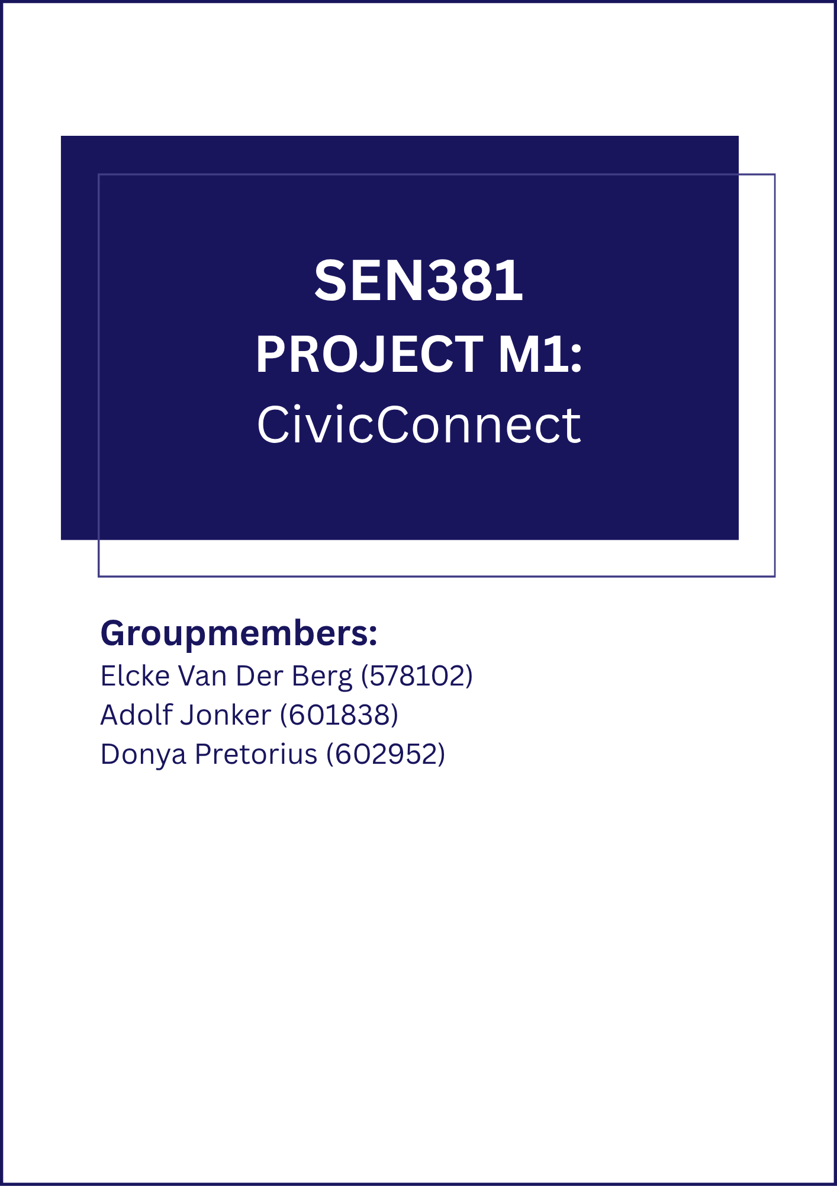

Table of Contents
Problem & Business Need 3
Stakeholder Analysis 4
Meaningful conflicts / competing expectations: 4
Scope Baseline 5
In Scope 5
Out of Scope 5
Deferred / Future Scope 5
Defended Exclusion 5
Requirements & Acceptance Criteria 6
Functional Requirements (FRs) 6
Non-Functional Requirements (NFRs) 7
Constraints 9
Scope 9
Schedule 9
Cost/Resources 9
Quality 9
Security 9
Initial RTM 10
Initial Risk Register 11
Forward Engineering Considerations 12
Engineering Decision Log 13
Team Working Agreement / Process Approach 14
GitHub Repository & Governance Controls 15
AI Usage Register 16
Baseline Sign-Off 17
Bibliography 18

Problem & Business Need

CivicConnect addresses the operational problems created by managing community service requests (facility faults, damaged equipment, security concerns, IT support, maintenance issues, lost property, and similar operational requests) through fragmented channels — email, telephone, WhatsApp, spreadsheets and paper records.
The current process produces recurring failures: requests are duplicated, overlooked, incorrectly assigned or lost; requesters have little visibility of progress; staff struggle to prioritise and coordinate; accountability for status changes is weak; management lacks reliable information on outstanding, overdue and resolved work; reporting is manual and difficult to audit; and sensitive information is handled inconsistently across informal channels. There is no single controlled record of a request's lifecycle. Similar fragmentation and lack of structured tracking have been documented in IT service environments more broadly (Aglibar, et al., 2022; Smolle, 2025), reinforcing that this is a recognised organisational problem rather than one unique to this scenario.
The primary business value of CivicConnect is a single, controlled digital platform that provides a reliable, traceable and usable way to submit, manage, monitor and report on service requests. Value is realised through improved visibility and accountability for requesters, staff and management, not merely by the existence of a submission form. Every request carries a clear status, an identifiable owner and a complete history.

Stakeholder Analysis
Stakeholder | Core Need | Influence | Interest | What "Success" Looks Like to Them
Requester | Easy submission + visibility of request status | Low | High | Quick submission, clear status, timely resolution
Staff | Clear view of assigned work + low-friction status updates | Medium | High | Manageable workload, clear ownership, simple updates
Management/  Oversight | Reliable information on open/overdue/resolved work | High | High | Auditable data, trend visibility, decision support
Dev Team (the three of us) | A buildable, defensible, well-scoped system | Medium | High | Controlled scope, traceable requirements, defensible in defence
IT/Operations (future maintainer) | Maintainable system, low operational burden | Low | Medium | Manageable technical debt, clear documentation, sustainable cost

Meaningful conflicts / competing expectations:
- Speed vs. Structure — Requesters want minimal-friction submission; staff need enough structured detail to triage. Resolved via FR001 + NFR002.
- Transparency vs. Staff Workload — Requesters want timely status visibility; staff do not want status-updating to become a separate chore. Resolved via FR004 + NFR001.
- Reporting Depth vs. Scope Discipline — Management wants rich analytics; the Master Brief explicitly warns against uncontrolled scope growth. Partially resolved via FR012 (baseline satisfies the minimum business capability); full resolution is deliberately deferred — see Defended Exclusion below. (A genuine limitation, not a gap — the team judged partial satisfaction preferable to uncontrolled scope growth and can defend that trade-off directly.)

Scope Baseline

In Scope
- Requester: submit a request (FR001), view own request status (FR002), view own request history (FR003), receive status-change feedback (FR004).
- Staff: view relevant requests (FR005), search/filter/sort (FR006), view full details (FR007), assign/accept responsibility (FR008), controlled status transitions (FR009), record comments/resolution notes (FR010), resolve/close requests (FR011).
- Management: aggregate activity summary (FR012), filter by category/status (FR013).
- Role-based access control (NFR003).
- Complete, unaltered audit trail of status changes (NFR004).
- Core usability on desktop and common mobile browser widths (NFR005).

Out of Scope
- Advanced analytics/reporting (trend charts, exports, custom dashboards) beyond FR012's basic status-count summary.
- Multi-channel integration (auto-ingestion from WhatsApp, email or phone).
- Native mobile application (responsive web only).
- Automated request routing/AI-based categorisation or prioritisation.
- SLA breach automation (auto-escalation on overdue requests).
- Public-facing API for third-party integration.

Deferred / Future Scope
- Advanced management reporting and analytics (directly addresses stakeholder conflict #3).
- SLA-based automated escalation (NFR004 already captures the timestamps required; can be layered on later without rework).
- Multi-channel request ingestion (genuine pain point but exceeds schedule/cost/team-capability constraints for the educational project).

Defended Exclusion
Advanced analytics is deliberately excluded from the baseline despite Management's need for "reliable information about outstanding, overdue and resolved work."
Rationale: The Master Brief states additional features "do not automatically attract additional marks" and that "a smaller, controlled, high-quality solution may demonstrate stronger Software Engineering than a larger unfinished solution." Full analytics would add data-modelling, UI, testing and evidence obligations across every remaining milestone and would compete with the capacity required to deliver core traceability, security and quality evidence to a defensible standard.
Trade-off accepted: Management receives FR012's basic summary view (satisfying the minimum business capability), while richer analytics is recorded as deferred future scope. This preserves the option to add it later without making it a baseline commitment the team could fail to deliver.

Requirements & Acceptance Criteria

Functional Requirements (FRs)
ID | Requirement | Source | Priority | Acceptance Criteria
FR001 | Requester shall submit a new service request with title, description and a required category selected from a controlled list. | Requester capability; conflict #1 | High | Submission is rejected if category is missing; successful submission returns a unique request ID and confirmation.
FR002 | Requester shall view the status of any request they submitted. | Requester capability | High | Status (Open/Assigned/In Progress/Resolved/Closed) is retrievable within two navigation steps of login.
FR003 | Requester shall view a history/list of previously submitted requests. | Requester capability | Medium | List displays at least: request ID, category, date submitted, current status.
FR004 | Requester shall receive meaningful feedback when a request's status changes. | Requester capability; conflict #2 | High | Updated status is visible to the requester without requiring a manual refresh or enquiry to staff.
FR005 | Staff shall view service requests relevant to their authorised role. | Staff capability | High | List is filtered to the staff member's authorised scope.
FR006 | Staff shall search, filter or sort requests by status, category or date. | Staff capability | Medium | Filtering by status and category, and sorting by date, are available.
FR007 | Staff shall view full details of a specific request. | Staff capability | High | All submitted fields, status and action history are visible within two navigation steps of the request list.
FR008 | Staff shall assign or accept responsibility for a request. | Staff capability | High | Request is linked to exactly one responsible staff member; the assignment is visible.
FR009 | Staff shall update request status through defined, controlled transitions, per the following state model: Open → Assigned → In Progress → Resolved → Closed (Resolved and Closed are distinct, separately authorised steps — see FR011). | Staff capability; conflict #2 | High | Only transitions defined in the state model above are permitted; any attempt to skip a state (e.g. Open → Closed with no intervening action) is prevented or clearly flagged.
FR010 | Staff shall record comments or resolution notes on a request. | Staff capability | Medium | At least one comment/note can be attached and remains visible in the request history.
FR011 | Authorised staff shall resolve or close a request. | Staff capability | High | Only authorised staff can set the status to Resolved or Closed; Resolved and Closed are recorded as separate, sequential actions per FR009's state model.
FR012 | Management shall view an aggregate service activity summary (counts by status). | Management capability; conflict #3 | Medium | Summary displays counts of Open, Overdue, Resolved and Closed requests.
FR013 | Management shall view requests filtered by category, status or other justified dimension. | Management capability | Medium | Filtering by at least category and status is available.

Non-Functional Requirements (NFRs)
ID | Requirement | Source | Priority | Acceptance Criteria (Measurable)
NFR001 | Status changes shall become visible to the requester without a separate manual notification step. | Conflict #2 | High | Updated status is visible to the requester on the next page load or within 5 seconds of a staff action (whichever is sooner).
NFR002 | The minimal submission path shall require no more than six fields. | Conflict #1 | Medium | Field count on the minimal submission path ≤ 6.
NFR003 | The system shall restrict access to request data according to role (RBAC). Role-based access control is a long-established standard for managing access in networked systems (Sandhu, et al., 2000), and this project applies the same principle to restrict request data by role. | Security constraint (Master Brief §16) | High | A requester cannot retrieve another requester's data via the UI or by direct request.
NFR004 | The system shall retain a complete and unaltered history of status changes for each request. Tracking requirements, linking them to their sources, the evidence behind them, and associated downstream artefacts is recognised as a persistent challenge in software engineering (Mucha, et al., 2024), which is why this project includes a clear audit trail for all status changes. This non-functional requirement applies specifically to the audit history of each request, which is separate from the change-control process for the requirement baseline outlined in §11 of the Master Brief. | Traceability/accountability need | High | Every status change is logged with timestamp and actor identity; the history is not editable or deletable through normal user actions.
NFR005 | Core submission and status-view functions shall remain usable on desktop and common mobile browser widths. Consistent, well-structured responsive interface design directly supports a sustainable and usable experience across devices (Li, et al., 2022). | Requester accessibility | Medium | Usable at 375px width without horizontal scrolling for the core submission and status-view flows.

Constraints

CivicConnect is created with a fixed scope, schedule, cost/resources, quality and security constraints. This is recorded in the table below. The engineering implications are also provided for later architecture and construction decisions so that boundaries are already considered instead of discovering them at a later state.
ID | Category | Constraint | Engineering Implication
CON001 | Scope | The set of requirements for milestone one (FR001-FR013, NFR001-NFR005) is fixed and controlled once they are agreed on. This means that any new feature cannot be added during the development project unless it follows the following formal approach: A request is made, the impact of the change is assessed, the change is the authorised, then it can be implemented, verified and the baseline is updated. | New feature requests cannot simply be added in without going through a documented impact analysis and must receive authorisation. This is done to protect the schedule and quality of the project as well as keeping a auditable baseline history which can be referred back to at later stages of the project.
CON002 | Schedule | The Project must be delivered over four fixed milestones with no time for rework or delays. | Forces defensible delivery. Deferred items such as SLA automation, multi channel ingestion are deliberately excluded now rather than be attempted under time pressure later.
CON003 | Cost / Resources | Team consists of three group members with limited combined team capabilities and experience. The project has no budget. Free or low cost services must be preferred where applicable and likely real world operating costs still need to be identified. | Technology choices at later stages will be limited to free or open source stacks. This limits load and scalability as well as rule out paid infrastructure level security tooling creating the need to add more security responsibility into the application layer.
CON004 | Quality | Quality attributes such as reliability of the audit trail and usability across devices must be explicitly defined upfront and later backed by measurable results such as test results, acceptance criteria met and quality gates passed. | Measurable acceptance criteria and visible evidence trail (RTM, Risk Register, Decision log) will be required so that quality can be demonstrated and proven rather than just simply being claimed at defence.
CON005 | Security | Security must be addressed at every stage in the project. This will include reviewing trust boundaries, authentication, authorisation, least privilege and an established access control principle (Sandhu, Ferraiolo & Kuhn, 2000). | RBAC (NFR003) and an immutable audit trail (NFR004) must be designed in as a authorisation/least privilege controls from the beginning and not added on at a later stage as an afterthought. Because of this the milestone 2 data model, access control and later ci/security checks will be directly shaped by this.

Constraint Interaction and trade off
In this baseline the most significant interaction is between the schedule (CON002) - Cost (CON003) and Quality (CON004) - Security (CON005). CivicConnect cannot deliver a fully featured system with rich management analytics and multi-channel request intake and still provide fully detailed defensible evidence of traceability, security and quality within the provided timeframe. This due to the fixed academic schedule and the three-person team constraints that limits the project. Because of this the team has chosen to focus on a smaller set of well structured evidence and testable requirements (FR001-FR0013, NFR001-NFR005) rather than a larger and less controlled feature set.
This is the same reasoning that was already recorded in the Scopes baseline defended exclusion where advanced analytics were deferred in favour of FR012's basic status count summary. The two are intentionally consistent and this can be seen by looking at the constraints section where the explanation for why the trade off had to be made was due to a limited schedule and limited resources.
The second related trade off is Cost vs Security. Because free tier hoisting and database services (CON003) are Preferred due to there being no budget. It is unlikely that these services will provide enterprise grade security features and infrastructure without the need for manually adding it to the Project. This puts a strain on the security of the project specifically for complying with RBAC (NFR003) and the audit trail integrity (NFR004) this Security concern will need to be integrated into the application layer which will be a direct constraint on the milestone 2 architecture and data model.

Initial Requirements Tracibility Matrix (RTM)

The RTM traces requirements from its originating stakeholder need or source through the requirements itself, to the acceptance criteria. The RTM is also structured so later evidence can be added without rebuilding it. The full expected chain of the RTM runs as follows, Stakeholder/Source -> requirements -> Design/Architecture -> issue/PR -> Implementation -> Test -> Acceptance/Release evidence. In the table below the Source, Requirements and Acceptance Criteria portions of the chain are established. Design and Test ref columns will only have the placeholder to be determined (TBD) for now as these columns will be filled in with Milestone two and three when design evidence and test evidence will be determined respectively. Once a requirement is a baseline it cannot be changed without an approved change record. Marinating this structured traceability is a recognised consistent challenge in software engineering practice (Mucha, Kaufmann & Riehle, 2024), because of this The RTM will be treated as a live artefact from this milestone onwards.
RTM ID | Source | Req ID | Requirement (summary) | Priority | Acceptance Criteria (summary) | Design Ref (M2) | Test Ref (M3) | Status
RTM-001 | Requester stakeholder need: easy submission; Conflict #1 | FR001 | Submit request with title, description and required category | High | Rejected if category missing; successful submission returns unique request ID | TBD | TBD | Baselined
RTM-002 | Requester stakeholder need: visibility of status | FR002 | Requester can view status of any submitted request | High | Status retrievable within 2 navigation steps of login | TBD | TBD | Baselined
RTM-003 | Requester stakeholder need: history of requests | FR003 | Requester can view history/list of previously submitted requests | Medium | List shows ID, category, date submitted, current status | TBD | TBD | Baselined
RTM-004 | Requester stakeholder need (Conflict #2) | FR004 | Requester receives feedback when status changes | High | Updated status visible without manual refresh or enquiry to staff | TBD | TBD | Baselined
RTM-005 | Staff stakeholder need: relevant workload view | FR005 | Staff can view requests relevant to their authorised role | High | List filtered to staff member's authorised scope | TBD | TBD | Baselined
RTM-006 | Staff stakeholder need: manageable workload | FR006 | Staff can search, filter or sort requests | Medium | Filter by status/category and sort by date available | TBD | TBD | Baselined
RTM-007 | Staff stakeholder need: clear ownership | FR007 | Staff can view full details of a specific request | High | All fields, status and action history visible within 2 steps of the list | TBD | TBD | Baselined
RTM-008 | Staff stakeholder need: clear ownership | FR008 | Staff can assign or accept responsibility for a request | High | Request linked to exactly one responsible staff member; assignment visible | TBD | TBD | Baselined
RTM-009 | Staff stakeholder need (Conflict #2) | FR009 | Staff update status via controlled transitions (Open→Assigned→In Progress→Resolved→Closed) | High | Only defined transitions permitted; skipped states prevented or flagged | TBD | TBD | Baselined
RTM-010 | Staff stakeholder need: accountability | FR010 | Staff can record comments/resolution notes on a request | Medium | At least one note attached and visible in request history | TBD | TBD | Baselined
RTM-011 | Staff stakeholder need: accountability | FR011 | Authorised staff can resolve or close a request | High | Only authorised staff set Resolved/Closed; recorded as separate sequential actions | TBD | TBD | Baselined
RTM-012 | Management stakeholder need: reliable oversight (Conflict #3) | FR012 | Management can view aggregate activity summary (counts by status) | Medium | Summary displays counts of Open, Overdue, Resolved, Closed | TBD | TBD | Baselined
RTM-013 | Management stakeholder need: reliable oversight | FR013 | Management can filter requests by category, status or justified dimension | Medium | Filtering by at least category and status available | TBD | TBD | Baselined
RTM-014 | (Conflict #2) transparency vs staff workload | NFR001 | Status changes visible to requester without a separate manual notification step | High | Visible on next page load or within 5 seconds of a staff action | TBD | TBD | Baselined
RTM-015 | (Conflict #1) speed vs structure | NFR002 | Minimal submission path requires no more than 6 fields | Medium | Field count on minimal path ≤ 6 | TBD | TBD | Baselined
RTM-016 | Lifecycle-wide security requirement: authorisation/least privilege (see CON005) | NFR003 | System restricts access to request data by role (RBAC) | High | A requester cannot retrieve another requester's data via UI or direct request | TBD | TBD | Baselined
RTM-017 | Traceability/accountability need (CON005) | NFR004 | System retains complete, unaltered history of status changes | High | Every status change logged with timestamp and actor identity; not editable/deletable by normal users | TBD | TBD | Baselined
RTM-018 | Requester accessibility need | NFR005 | Core submission/status-view usable on desktop and common mobile widths | Medium | Usable at 375px width without horizontal scrolling for core flows | TBD | TBD | Baselined

End to End Trace Example
FR001 traces from the source to acceptance criteria and illustrates how the RTM will extend through later milestones.
- Source: Requester stakeholders need for easy submission this further defined by Conflict #1 (Speed vs Structure) which is that requesters want minimal friction, staff need enough structured detail to triage.
- Requirement: (FR001) Requester will submit a new service request with a title, description and a required category selected from a controlled list.
- Supporting NFR: (NFR002) minimal submission path is six or less fields.
- Acceptance criteria: submission is rejected if the category is missing. A successful submission returns a unique request ID and conformation.
- Current Status: baselined at milestone one, not yet designed or tested. At Milestone two this will gain a design reference and at milestone 3 it will gain a test reference.

Initial Risk Register

Forward Engineering Considerations

Engineering Decision Log

Team Working Agreement / Process Approach

GitHub Repository & Governance Controls

AI Usage Register

Baseline Sign-Off

Bibliography
Aglibar, K. D. M. et al., 2022. Ticketing System: A Descriptive Research on the Use of Ticketing System for Project Management and Issue Tracking in IT Companies. International Journal of Computing Sciences Research, Volume 7, pp. 1066-1075.
Li, W., Zhou, Y., Luo, S. & Dong, Y., 2022. Design Factors to Improve the Consistency and Sustainable User Experience of Responsive Interface Design. Sustainability, 14(15), p. 9131.
Mucha, J., Kaufmann, A. & Riehle, D., 2024. A systematic literature review of pre-requirements specification traceability. Requirements Engineering, Volume 29, pp. 119-141.
Sandhu, R., Ferraiolo, D. & Kuhn, R., 2000. The NIST model for role-based access control: Towards a unified standard. In: Proceedings of the Fifth ACM Workshop on Role-Based Access Control. Berlin, ACM.
Smolle, M.-T., 2025. From Request to Delivery – Innovative Process Design for IT Demand and Portfolio Management at STRABAG, Vienna: s.n.

