**Context:**

This file includes two fresh maths questions inspired by the given examples, maintaining the same style and difficulty. One question involves calculating combinations of ice cream and sauces, while the other focuses on determining the dimensions of a box containing glass jars. Both questions adhere to the necessary format, utilising LaTeX for equations, tables and a appropriate diagram.

**Question 1:**

@title Ice Cream and Sauce Combinations

@description Determine the number of unique ice cream combinations possible.

@question A dessert shop sells ice cream with one flavour and one type of sauce. The table below shows the available options for each. How many different ice cream combinations can be made?

## Ice Cream Choices

|  |  |
| --- | --- |
| Ice Cream Flavor | Sauce Type |
| Vanilla | White Chocolate |
| Strawberry | Chocolate |
| Chocolate | Raspberry |
| Pistachio |  |

@instruction Choose the correct number of combinations from the options.

@difficulty easy

@Order Q1

@option Three

@option Four

@option Seven

@option Nine

@@option Twelve

@explanation There are 4 ice cream flavours and 3 sauces. Using the multiplication principle: $4 \times 3 = 12$ combinations.

@subject Quantitative Math

@unit Data Analysis & Probability

@topic Counting & Arrangement Problems

@plusmarks 1

**Question 2:**

@title Dimensions of a Box of Glass Jars

@description Estimate the dimensions of a rectangular box containing 6 tightly packed empty cylindrical jars.

@question The top view of a rectangular box containing 6 tightly packed empty cylindrical jars is shown below. Each jar has a radius of 4 cm and a height of 12 cm. Which of the following is closest to the dimensions, in centimetres, of the box?

[Top view diagram]

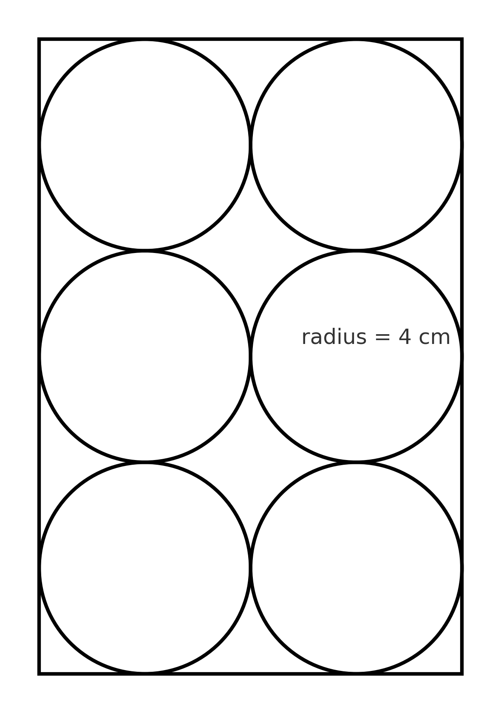

@instruction Choose the option that best matches the box's dimensions.

@difficulty moderate

@Order Q2

@option 8 × 16 × 24

@@option 12 × 16 × 24

@option 12 × 24 × 16

@option 16 × 24 × 12

@option 8 × 24 × 12

@explanation Each jar's diameter is $8$ cm (i.e twice the 4 cm radius). With 2 columns and 3 rows in a single layer: width $= 2 \times 8 = 16$ cm, length $= 3 \times 8 = 24$ cm, and height equals the jar height $= 12$ cm. Thus the box dimensions are $12 \times 16 \times 24$ cm.

@subject Quantitative Math

@unit Geometry and Measurement

@topic Area & Volume

@plusmarks 1