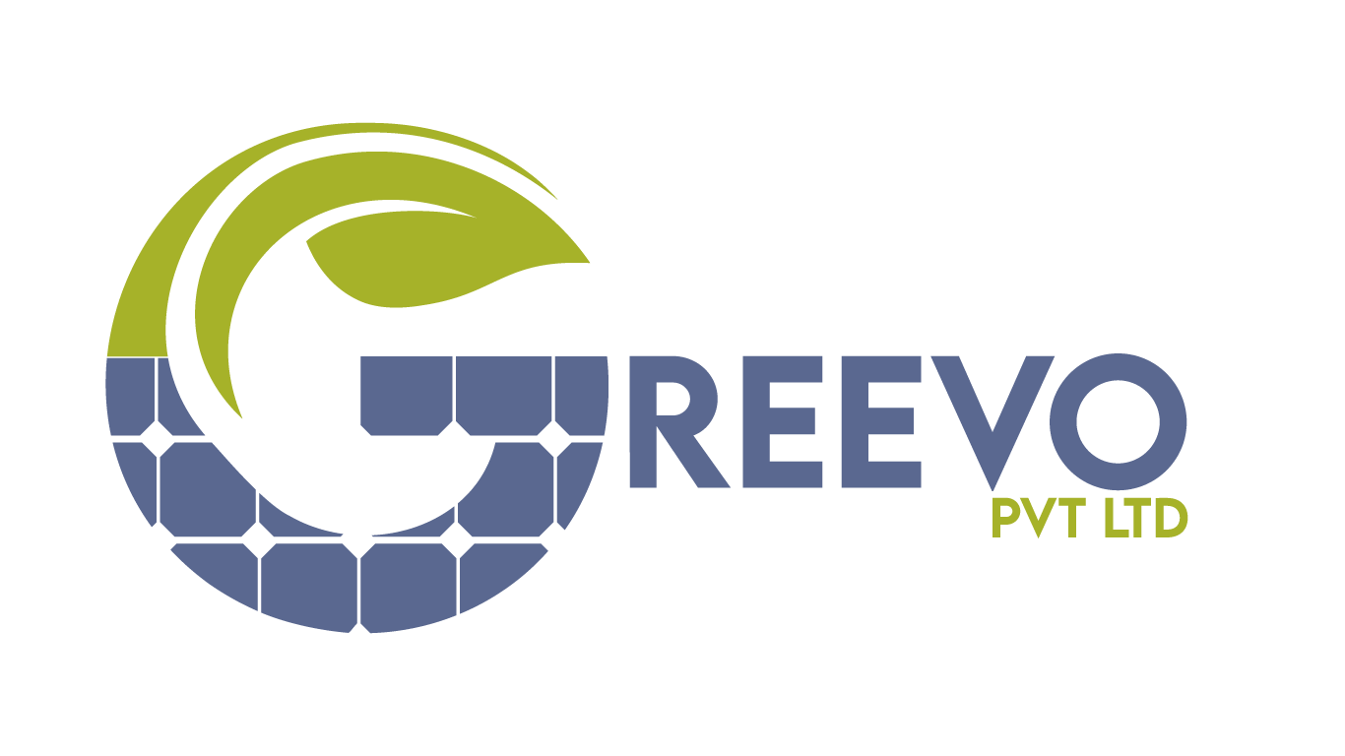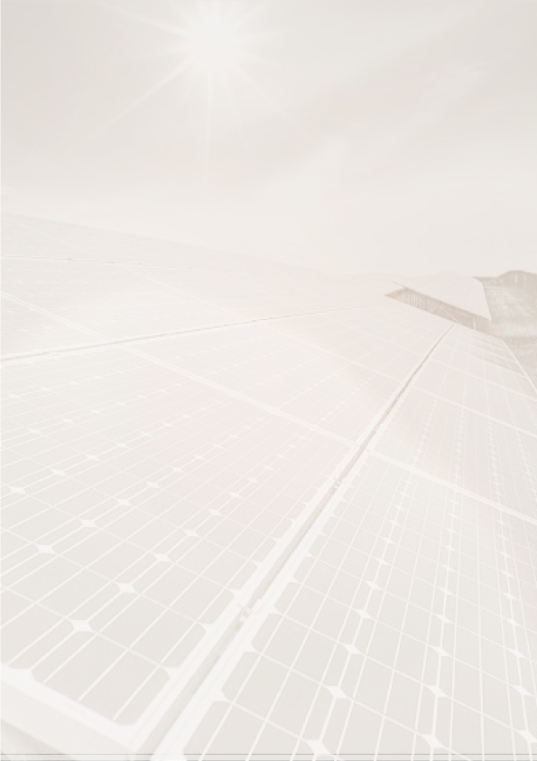**­**

**System Size:**

**[sw] kW Hybrid System**

## 

[sales@greevo.com.pk |](mailto:sales@greevo.com.pk) [www.Greevo.com.pk](http://www.greevo.com.pk/) | 051 5147181



2nd Floor, Plaza 39, Westaria

DHA Phase 2, Islamabad

Dear Sir,

We appreciate the opportunity to propose an innovative solar solution for your premises. At GREEVO PVT LTD, we believe in delivering solar solutions that go beyond the ordinary. Our commitment lies in providing you with a solar energy system that ensures maximum energy production, reliability, and sustainability.

Our range features high-performance mono-perc crystalline solar panels, known for their exceptional performance standards in Pakistan. With a warranty extending up to 25 years, these panels consistently outshine conventional options due to their superior irradiance capabilities and reduced temperature coefficient.

GREEVO takes pride in its seasoned team of Electrical Engineers and skilled technicians who possess extensive expertise in solar systems. Our promise is to adhere to rigorous international electrical, safety, and quality standards, ensuring a seamless installation process.

We invite you to embark on a sustainable journey with GREEVO. Together, let's shape a greener future.

Best regards,

GREEVO PVT LTD

Contact: 0321-9293992

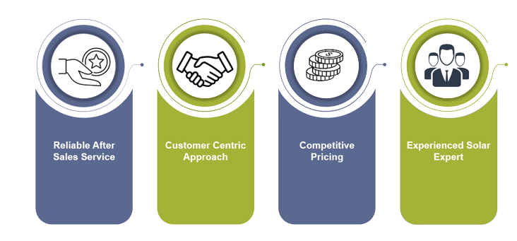

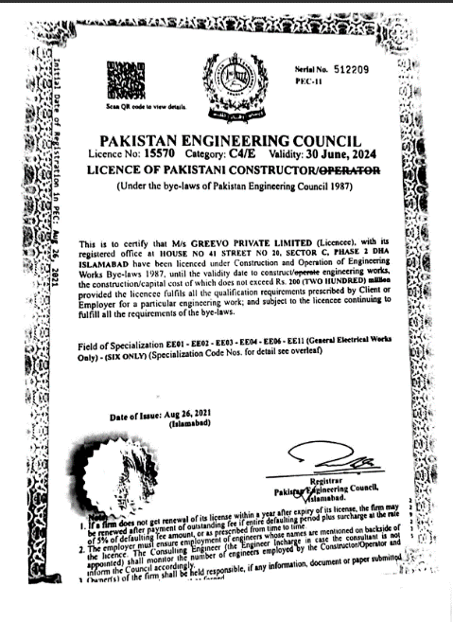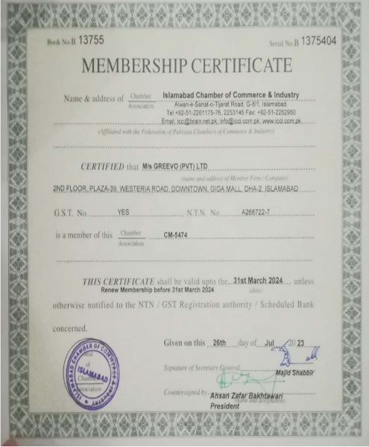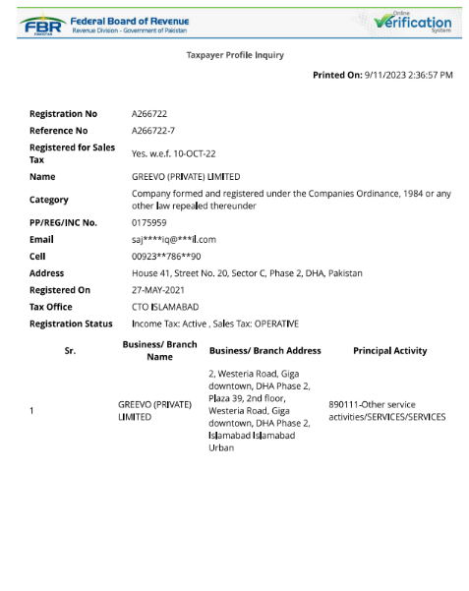



[sales@greevo.com.pk |](mailto:sales@greevo.com.pk) [www.Greevo.com.pk](http://www.greevo.com.pk/) | 051 5147181

We are SECP Registered.



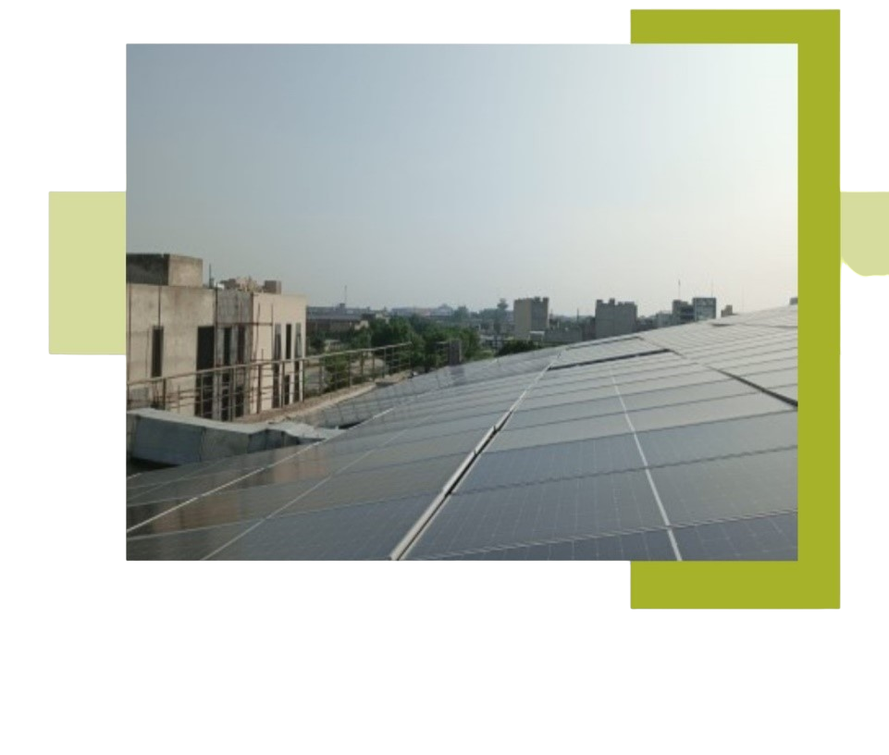

Div HQ 40 Okara – 1.2 MW

Div HQ 14 Okara – 0.7 MW

PAF – 500 KW

Bannu Cannt – 200 KW

Div 07 Miranchah – 350 KW

Mari Petroleum – 250 KW

Al-Umar floor mill – 250 KW

Lit food Chain – 90 KW

Domestic – 1.7 MW

**Our Projects**

Pakistan Armed Forces

Special Communication Organization

National Agricultural Research Centre (NARC)

Frontier Core Northern Areas (FCNA)

Capital Development Authority CDA

Pakistan Air Force (PAF)

Lit Food Chain

**Our Proud Clients**

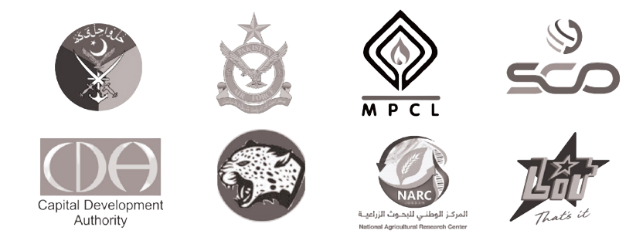

[sales@greevo.com.pk |](mailto:sales@greevo.com.pk) [www.Greevo.com.pk](http://www.greevo.com.pk/) | 051 5147181

|  |  |  |  |  |  |  |
| --- | --- | --- | --- | --- | --- | --- |
| **Sr. No** | **Description** | | | | **UoM** | **Qty** |
| 1.1 | **PV Module** | Mono / bifacial 144 cells. | | 12-&25-years Guarantee Period | Nos. | [nop] |
| A Grade Tier-1 Mono PERC  **Longi/JA/Jinko/Astro/Trina or equivalent** |
| [PW]W or above | | [sw] kW |
| 1.2 | **Structure** | **Elevated**   * H Beam * C Channel | | [sw] kW PV Array | Sets | [nos] |
| **Raised** |
| 1.3 | **Inverter** | Monitoring G2/G3.  (Optional) | | [iwy] years warranty as per manufacturer  terms and conditions | Pcs | [noi] |
| [iw] kW Hybrid Inverter  Crown/Solarmax/Maxpower  or equivalent | Support 1.25 PV Array | |
| 1.4 | Flexible pipe, conduits, HDPE, PVC Pipes, Flexible pipe holdings and other accessories, HDPE with UPVC Joints, Saddles and fittings | | | | | 01 set |
| 1.5 | **PV Balance:** Protection, AC Breakers, DC breakers, AC SPD, Change Overs, Relay, MCCB, AC Batteries Fitting wires, Bootlace ferrules, DB cabinets, thimbles, Manual Changeover Switch | | | | | 01 set |
| 1.6 | 06 mm Solar XLPE, UV Resistive wire 1 core tint coated Pure Copper Flex cable. | | | | | 01 set |
| AC Cable single core 6 mm | | | | |
| Thimbles, Connectors, Shrouds, Cable ties, Saddles and complete Hybrid Protection Kit. Etc. | | | | |
| 1.7 | Earthing /Grounding of System and Modules. Lightening arrestor complete kit. | | | | | 01 Set |
| 2.1 | Installation | | Installation Testing and Commissioning of Hybrid Sys | | | Per Watt |
| 2.2 | Carriage | | Loading and unloading of equipment at site | | | 01 Job |
| 2.3 | Foundation work | | concrete Pads | | | N/A |
|  | **Total Price** | | | | | **[calculated_price] PKR** |
| **[value_in_words] Rupees Only** | | | | | | |
| **5 kW Hybrid System with Normal Structure [calculated_price_normal] PKR** | | | | | | |
| **5 kW Hybrid System with Raised Structure [calculated_price] PKR** | | | | | | |



**Quotation- [sw] kW Hybrid Solar System**

**Battery Bank**

|  |  |  |  |  |  |  |
| --- | --- | --- | --- | --- | --- | --- |
| a | Battery Bank | Daewoo Deep cycle | 180 AH& 12 Vdc | 1 years warranty as per manufacturer | Pcs  [bv] | [bp] PKR |

**Net Meter Licensing and Installation**

|  |  |  |
| --- | --- | --- |
| **3.1** | Cost of Net Metering Licensing and Installation | [nmc] PKR |

[sales@greevo.com.pk |](mailto:sales@greevo.com.pk) [www.Greevo.com.pk](http://www.greevo.com.pk/) | 051 5147181



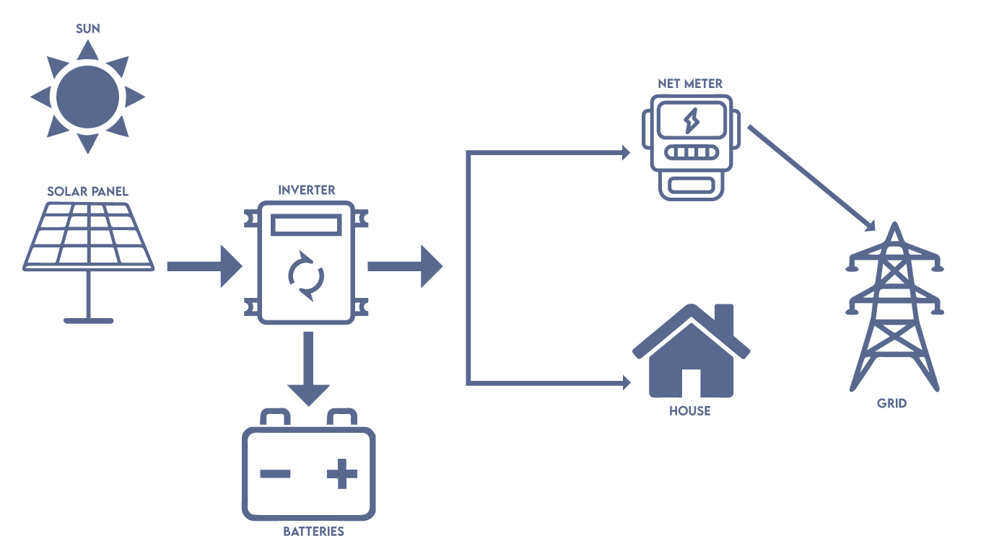

* Hybrid systems transition smoothly between solar power, battery storage, and the grid for optimized energy use.
* They provide reliable backup power during grid outages, ensuring essential loads remain operational.
* Advanced controllers manage energy flows intelligently, storing excess solar energy and reducing grid dependence.
* Priority is given to self-consumption of solar-generated electricity, enhancing energy bill savings.
* Hybrid systems can also contribute to grid stability by providing support during peak demand periods, helping to balance the grid and reduce strain on the electrical infrastructure.

**Pictorial Flow Chart**

[sales@greevo.com.pk |](mailto:sales@greevo.com.pk) [www.Greevo.com.pk](http://www.greevo.com.pk/) | 051 5147181



**Term & Conditions**



|  |  |  |
| --- | --- | --- |
| **Indicative Price** | PKR [mentioned above], which is based on USD-PKR exchange rate of [280] PKR=1USD as at the date of this quotation is valid for 1 days. | |
| The impact of any depreciation in PKR with respect to the USD-PKR exchange rate forms part of the total product price and will be charged to the customer as set out below**.** | |
| **Price Validity** | Project price may vary with respect to dollar exchange rate and material availability issue. | |
| **Payment Option** | **Delivery Timeline** | **Payment Terms** |
| Option1: Within 12 days from date of confirmation of order | 60%Advance at the time of award of Contract.  20% on material delivery.  18% After Installation  2% After Net Metering  **Kindly ensure all payments are settled in accordance with the plan before the site team departs.** |
| **Other Terms** | All payments to be made by crossed cheque in the name of **Greevo (Pvt.) Limited.** Order by Customer will be deemed confirmed/accepted upon receipt of advance payment as per Payment Option selected by the Customer. Final Price of System will be calculated on USD-PKR exchange rate as at the date of installation or date of final payment by the customer. Balance, if any, due on account of exchange rate variation shall be paid by Customer upon invoice raised by Greevo (Pvt.  Ltd)before installation of System at site. | |
| **Operation & Maintenance** | One (01) year free-of-cost O&M services as per prevailing company policy. Thereafter, Customer will be charged for O&M subject to contract. | |
| **Distribution** | Above quoted price is exclusive of load distribution charges | |
| **Force Majeure Events** | Force majeure events, such as natural disasters, fall outside the company's responsibility. | |
| **Load Distribution Charges and responsibility** | The quoted price does not cover load distribution charges; consumers are accountable for these charges. If load distribution exceeds 1 DB or requires separate equipment, it is the customer's responsibility. | |
| **Delayed or Unpaid Payments** | In case of delayed or unpaid payments, after-sales services will not be provided, and M/S Greevo Pvt Ltd reserves the right to dismantle and seize system components equal to the outstanding amount. | |
| **System Modifications** | Any modifications or alterations to the system without prior consent from Greevo will nullify after-sales support. | |
| **System Relocation** | Adequate filter cleaning and ventilation are required when changing the system's location; any heating errors will not be the company's liability. | |
| **Overload Errors** | The company will not address overload errors. | |
| **Work Hours Schedule** | Summer work hours commence at 7 am, while winter work hours start at 8 am, continuing until the site is completed | |
| **Length of wire** | Length of wire for standard site is 80 ft DC, 30 ft | |
| **Customized Products** | Any change in product other than the quoted products will be charged differently. | |
| **Net-Metering**  **(Not Applicable for Local Grids)** | Greevo will assist Customer in procuring Net Metering. The obligation to procure required approvals rests with the Customer. In no circumstances shall Greevo be held liable on any account  If the said approval is not granted by NEPRA. Greevo will assist Customer to prepare the required documentation for Net-Metering. | |
| Other Customer responsibilities for Net-Metering include: | |
| DC/AC Earthing. | |
| Meter Name change. | |
| Sanction load change. | |
| Net-Metering demand notice payment. | |
| **Note:** Fee for facilitation services rendered in Net-Metering will be charged separately at per actual. It will be applicable as per the laws of NEPRA and local DISCO. This is an additional service for Customer support. Time line for Net-Metering to be operational depends on the DISCO/NEPRA  approvals. | |

Note: Kindly provide attested copy of below mentioned documents for processing net-metering at the time of signing this quotation otherwise company will not be responsible for any delay in the process.

* Valid CNIC (Invalid/ Forged/ Expired/ non attested copy is not acceptable)
* Electricity bill (Non attested copy is not acceptable)

[sales@greevo.com.pk |](mailto:sales@greevo.com.pk) [www.Greevo.com.pk](http://www.greevo.com.pk/) | 051 5147181

* Proof of property ownership (in case of name change only)



**Acknowledgments**

I ACKNOWLEDGE AND REPRESENT THAT I HAVE READ THE TERMS AND CONDITIONS OF THIS PROPOSAL AND I FULLY UNDERSTAND WHAT IS STATED HEREIN. I EXPRESSLY AGREE TO ALL THE TERMS AND CONDITIONS SET OUT HERE IN AND TO ADHERE TO ALL PAYMENTS OBLIGATIONS AND OTHER ANCILLARY OBLIGATIONS. IN SIGNING THIS PROPOSAL, I AM NOT RELYING ON ANY OTHER REPRESENTATION MADE BY THE COMPANY TO ME.

Customer Signature Sales Representative Signature

[sales@greevo.com.pk |](mailto:sales@greevo.com.pk) [www.Greevo.com.pk](http://www.greevo.com.pk/) | 051 5147181

NAME:

DATE:

CNIC NO:



**Regards**

We look forward to helping you achieve more energy independence, providing a good investment for years to come and helping you make a more positive environmental impact.

Thanks & Regards,

### Sajjad Rafiq

**CEO/Director Tech** **Greevo PVT Ltd.**

[sales@greevo.com.pk |](mailto:sales@greevo.com.pk) [www.Greevo.com.pk](http://www.greevo.com.pk/) | 051 5147181



**FAQs**



**1.How does a hybrid system work?**

A hybrid solar system combines solar panels with a battery. It can switch between regular power and battery power based on how much energy is needed and available.

**2. What is dual port functioning?**

Dual-port inverters do two things: they use regular power and also save extra power in a battery. This helps when there's a power cut, so you still have electricity.

**3. What's the difference between grid-tie and hybrid systems?**

A grid-tie system only sends extra energy back to the power company. A hybrid system stores extra power in batteries, which you can use later when needed, like during a power outage.

**4. Why do I need a battery during the day with a hybrid system?**

You need a battery during the day because sunshine varies. The battery stores extra energy for use when there's not much sun or if the regular power goes out.

**5. Can I add batteries to a grid-tie inverter?**

Usually, grid-tie inverters are meant for solar panels and don't work with batteries.

**6. My off-grid system isn't making as much energy as expected?**

To make an off-grid system produce more energy, make sure it matches the amount of energy you use and can store in your batteries.

**7. How can I increase off-grid system generation?**

To get more power from an off-grid system, use electricity based on how much sun you have and how much your system can make.

**8. How much can four 230 AH batteries power?**

Four 230 AH batteries can run appliances that use 8 kW of power. This means you can use multiple appliances for a certain amount of time.

**9. Using a hybrid system by turning off input AC.**

If you turn off input AC, your system might run on battery power only.

**10. Why is my grid-tie system making less energy than expected?**

Things like shade, dirt on your panels, wear and tear, and power cuts can make your system make less energy than you thought.

**11. What is net metering?**

Net metering lets you sell extra power back to the power company and get credits on your bill if you have a grid-tie solar system.

**12. I see Error 4 and F02 on my hybrid inverter. What does it mean?**

These error codes are different for each inverter. Look in your inverter's manual or ask the manufacturer to help you fix the problem.

**13. My grid-tie inverter app shows spikes in power and voltage errors.**

These issues could happen because the power from the grid changes or the inverter isn't working right. Ask a technician to check it out.

**14. Should I choose lithium batteries?**

Lithium batteries last longer and store more energy, but they cost more upfront. It depends on your budget and what you need.

**15. How can I get the most out of my solar energy?**

Place your panels right, keep them clean, and use energy-efficient appliances and lights to make the most of your solar power.

**16. Why do grid-tie or hybrid systems stop sending power back to the grid when it's down?**

For safety, these systems stop sending power to the grid during outages to keep the grid from getting damaged.

**17. Why do grid-tie inverters stop making power when the grid is down?**

Grid-tie inverters work with the grid, so they stop making power when the grid is down to keep everyone safe.

[sales@greevo.com.pk |](mailto:sales@greevo.com.pk) [www.Greevo.com.pk](http://www.greevo.com.pk/) | 051 5147181