NovaStore E-Commerce
Data Management System
SQL Project Documentation
Mehmet Anil ULKU
MehmetAnilULKU_NovaStore_Proje.sql

Section 1: Database Design (DDL)
The NovaStoreDB database was created with 5 relational tables. Tables were created in dependency order: parent tables first (Categories, Customers), then dependent tables (Products, Orders, OrderDetails).

1.1 Table Structure and Columns
Table Name | Column Name | Data Type | Description
Categories | CategoryID | INT PK IDENTITY | Auto-incrementing primary key
 | CategoryName | VARCHAR(50) NOT NULL | Category name
Products | ProductID | INT PK IDENTITY | Auto-incrementing primary key
 | ProductName | VARCHAR(100) NOT NULL | Product name
 | Price | DECIMAL(10,2) | Product price
 | Stock | INT DEFAULT 0 | Stock quantity
 | CategoryID | INT FK -> Categories | Category reference
Customers | CustomerID | INT PK IDENTITY | Auto-incrementing primary key
 | FullName | VARCHAR(50) | Customer full name
 | City | VARCHAR(20) | City information
 | Email | VARCHAR(100) UNIQUE | Unique email address
Orders | OrderID | INT PK IDENTITY | Auto-incrementing primary key
 | CustomerID | INT FK -> Customers | Customer reference
 | OrderDate | DATETIME DEFAULT GETDATE() | Order date
 | TotalAmount | DECIMAL(10,2) | Total order amount
OrderDetails | DetailID | INT PK IDENTITY | Auto-incrementing primary key
 | OrderID | INT FK -> Orders | Order reference
 | ProductID | INT FK -> Products | Product reference
 | Quantity | INT | Number of items purchased

1.2 Create Database
CREATE DATABASE NovaStoreDB;
USE NovaStoreDB;

1.3 Categories Table
CREATE TABLE Categories (
CategoryID INT PRIMARY KEY IDENTITY(1,1),
CategoryName VARCHAR(50) NOT NULL
);

1.4 Products Table
CREATE TABLE Products (
ProductID INT PRIMARY KEY IDENTITY(1,1),
ProductName VARCHAR(100) NOT NULL,
Price DECIMAL(10,2),
Stock INT DEFAULT 0,
CategoryID INT FOREIGN KEY REFERENCES Categories(CategoryID)
);

1.5 Customers Table
CREATE TABLE Customers (
CustomerID INT PRIMARY KEY IDENTITY(1,1),
FullName VARCHAR(50),
City VARCHAR(20),
Email VARCHAR(100),
UNIQUE (Email)
);

1.6 Orders Table
CREATE TABLE Orders (
OrderID INT PRIMARY KEY IDENTITY(1,1),
CustomerID INT FOREIGN KEY REFERENCES Customers(CustomerID),
OrderDate DATETIME DEFAULT GETDATE(),
TotalAmount DECIMAL(10,2)
);

1.7 OrderDetails Table
CREATE TABLE OrderDetails (
DetailID INT PRIMARY KEY IDENTITY(1,1),
OrderID INT FOREIGN KEY REFERENCES Orders(OrderID),
ProductID INT FOREIGN KEY REFERENCES Products(ProductID),
Quantity INT
);

Section 2: Data Entry (DML - INSERT)
Sample data was inserted to test the system: 5 categories, 12 products, 5 customers, 8 orders and 10 order details.

Categories
CategoryID | CategoryName
1 | Electronics
2 | Clothings
3 | Books
4 | Cosmetics
5 | Home & Lifestyle

Products (12 items)
ProductID | ProductName | Price | Stock | CategoryID
1 | MacBook Air | 1200.00 | 15 | 1
2 | iPhone 14 | 999.99 | 25 | 1
3 | Cotton T-Shirt | 19.99 | 50 | 2
4 | Blue Jeans | 49.99 | 40 | 2
5 | SQL for Beginners | 29.50 | 100 | 3
6 | Science Fiction Novel | 15.00 | 30 | 3
7 | Rose Perfume | 85.00 | 20 | 4
8 | Red Lipstick | 25.00 | 60 | 4
9 | Desk Lamp | 35.00 | 15 | 5
10 | Coffee Mug | 12.50 | 100 | 5
11 | Wireless Mouse | 25.99 | 5 | 1
12 | Winter Jacket | 120.00 | 10 | 2

Section 3: Querying and Analysis (DQL)

Query 1 — Products with stock below 20
Used: SELECT, WHERE, ORDER BY DESC
SELECT ProductName, Stock
FROM Products
WHERE Stock < 20
ORDER BY Stock DESC;

Query Result:
ProductName | Stock
MacBook Air | 15
Desk Lamp | 15
Winter Jacket | 10
Wireless Mouse | 5

Query 2 — Customer Order Join (INNER JOIN)
Used: INNER JOIN (Customers + Orders)
SELECT FullName, City, OrderDate, TotalAmount
FROM Customers
INNER JOIN Orders ON Customers.CustomerID = Orders.CustomerID;

Query Result:
FullName | City | OrderDate | TotalAmount
Ahmet Yilmaz | Istanbul | 2023-10-01 | 1200.00
Ayse Demir | Ankara | 2023-10-05 | 19.99
Ahmet Yilmaz | Istanbul | 2023-10-10 | 44.50
Mehmet Kaya | Izmir | 2023-10-12 | 999.99
Fatma Celik | Bursa | 2023-10-15 | 85.00
Ali Yildiz | Antalya | 2023-10-20 | 155.00
Ayse Demir | Ankara | 2023-10-22 | 25.99
Ahmet Yilmaz | Istanbul | (today) | 25.00

Query 3 — Products ordered by Ahmet Yilmaz (5-table JOIN)
Used: Customers -> Orders -> OrderDetails -> Products -> Categories chained JOIN
SELECT FullName, ProductName, Price, CategoryName
FROM Customers
INNER JOIN Orders ON Customers.CustomerID = Orders.CustomerID
INNER JOIN OrderDetails ON Orders.OrderID = OrderDetails.OrderID
INNER JOIN Products ON OrderDetails.ProductID = Products.ProductID
INNER JOIN Categories ON Products.CategoryID = Categories.CategoryID
WHERE Customers.FullName = 'Ahmet Yilmaz';

Query Result:
FullName | ProductName | Price | CategoryName
Ahmet Yilmaz | MacBook Air | 1200.00 | Electronics
Ahmet Yilmaz | SQL for Beginners | 29.50 | Books
Ahmet Yilmaz | Science Fiction Novel | 15.00 | Books
Ahmet Yilmaz | Red Lipstick | 25.00 | Cosmetics

Query 4 — Product count per category (GROUP BY + COUNT)
SELECT CategoryName, COUNT(ProductID) AS ProductCount
FROM Categories
LEFT JOIN Products ON Categories.CategoryID = Products.CategoryID
GROUP BY CategoryName;

Query Result:
CategoryName | ProductCount
Books | 2
Clothings | 3
Cosmetics | 2
Electronics | 3
Home & Lifestyle | 2

Query 5 — Total revenue per customer (SUM + ORDER BY DESC)
SELECT FullName, SUM(TotalAmount) AS TotalSpend
FROM Customers
INNER JOIN Orders ON Customers.CustomerID = Orders.CustomerID
GROUP BY Customers.FullName
ORDER BY TotalSpend DESC;

Query Result:
FullName | TotalSpend
Ahmet Yilmaz | 1269.50
Mehmet Kaya | 999.99
Ali Yildiz | 155.00
Fatma Celik | 85.00
Ayse Demir | 45.98

Query 6 — Days elapsed since each order (DATEDIFF)
SELECT OrderID, OrderDate,
DATEDIFF(day, OrderDate, GETDATE()) AS DaysPassed
FROM Orders;

Description:
DATEDIFF(day, OrderDate, GETDATE()) calculates the number of days between the order date and today. Results vary depending on when the query is executed.

Section 4: Advanced Database Objects

4.1 VIEW — vw_OrderSummary
A VIEW was created to avoid rewriting long JOIN queries every time. It presents customer name, order date, product name and quantity as if they were in a single table.
CREATE VIEW vw_OrderSummary AS
SELECT FullName, OrderDate, ProductName, Quantity
FROM Customers
INNER JOIN Orders ON Customers.CustomerID = Orders.CustomerID
INNER JOIN OrderDetails ON Orders.OrderID = OrderDetails.OrderID
INNER JOIN Products ON OrderDetails.ProductID = Products.ProductID;

Note: The project brief specifies the name vw_SiparisOzet. This VIEW was created with an English name (vw_OrderSummary). The content and functionality are identical.

4.2 Database Backup (BACKUP DATABASE)
T-SQL command to back up the NovaStoreDB database after project completion:
BACKUP DATABASE NovaStoreDB
TO DISK = 'C:\Yedek\NovaStoreDB.bak'

Section 5: Table Relationship Diagram
The diagram below shows the Foreign Key relationships between the 5 tables in NovaStoreDB.

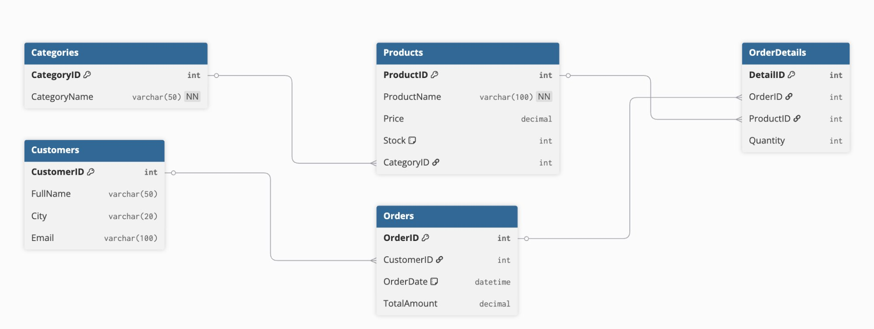

Relationship Chain: Categories -> Products -> OrderDetails <- Orders <- Customers

