Theme: Chess

Title: Checkmate CHESS

Rationale:

Chess is a game for everyone. It is not defined by age. An eight-year-old kid can defeat a 40-year old man and vice versa. This website is built for such enthusiasts to be an avenue of learning and growth of their chess career. Whether professional or not, someone who wants to know chess or who knows chess would learn something new or improve his/her game by reading through the website.

Objectives:

This site aims to

1. guide chess enthusiasts to learn the game, and continue developing their game,
2. provide a comprehensive guide on the learning curve one should take when learning chess, and
3. guide people on the road to the Grand Master stage.

Site map:

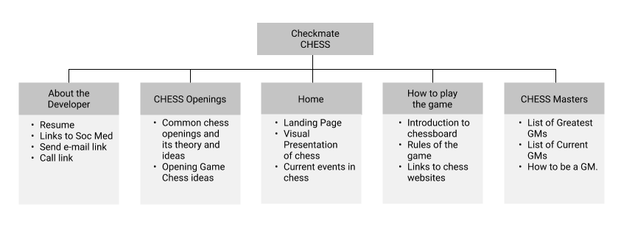

Landing Pages:

1. Home
2. How to play the game
3. Chess Openings
4. Chess Grandmaster (How to be a grandmaster)
5. About the developer

To-do:

1. Checkmate CHESS Branding Logo (Deadline: October 24, 2021)
   1. Make chess the center
   2. Should match/contrast the color scheme of the page.
   3. This should be appealing and can be seen on dark and light backgrounds.
   4. Needed tool: Adobe Illustrator
2. UI Design (Deadline: October 25, 2021)
   1. This should be browser-friendly
   2. Use proper principles of design to emphasize on proper points.
   3. Needed tool: Adobe Illustrator/Figma
3. HTML Coding (October 27, 2021)
   1. Use proper HTML5 and CSS for coding.
   2. Use semantic tags for SEO.
   3. Reduce nested div elements.
   4. Needed tool: VS Code
4. Website Testing (October 28, 2021)
   1. Make sure that UX is good.
   2. Make sure that there are no broken links.
   3. Make sure that all buttons are functional (at this point, we only need an e-mail and call button which can be created through the a tag. No Javascript required.
   4. Needed tools: Live Server, Web Browsers and Multiple devices, VS Code
5. Website Debugging (October 29, 2021)
   1. Refer to the results of Website Testing.
   2. Needed tools: Live Server, Web Browsers and Multiple devices, VS Code