

WattWise: Optimal Home-Battery Dispatch under Sri Lanka’s Time-of-Use Tariff

Dynamic Programming vs a Genetic Algorithm

IT5082 - Optimization Methods
Group Assignment
MSc in AI (SLIIT)

Kasun Kalhara Perera: MS26900636
Bimsara Sandaruwan: MS26916262
October 2026 · GitHub: github.com/Adore96/WattWise

Contents
Abstract 3
1. Introduction and Problem Selection 4
1.1 Context 4
1.2 Why this problem is realistic and non-trivial 5
1.3 Problem class and complexity 5
1.4 Objectives 5
2. Problem and Data Description 6
2.1 Data source 6
2.2 Cleaning and resampling 6
2.3 Battery parameters and calibration 7
2.4 Scope and the capacity sweep 8
3. Mathematical Formulation 9
4. Optimization Methods 9
4.1 Exact method: Dynamic Programming 13
4.2 Heuristic method: Genetic Algorithm 14
4.3 Why these two methods together 15
5. Implementation and Reproducibility 18
6. Results 19
6.1 Solution quality and feasibility 19
6.2 GA behaviour 20
6.3 Runtime 22
6.4 Scalability 22
6.5 Sensitivity to battery efficiency 24
7. Discussion and Future Work 25
7.1 What the comparison shows 25
7.2 Why the GA falls short 25
7.3 Limitations 26
7.4 Future work 26
8. Individual Contributions 27
References 28
Appendix A. Code 28

Abstract
A home with rooftop solar and a battery has to decide, every half hour, whether to charge the battery, discharge it into the house, or leave it alone. Under the Ceylon Electricity Board (CEB) optional domestic Time-of-Use (ToU) tariff, energy bought between 18:30 and 22:30 costs Rs 106/kWh, more than three times the Rs 33/kWh charged overnight, so the timing of those decisions directly changes the bill. We model this as a 48-stage sequential decision problem and instantiate it with five days of real 5-minute logs from a working solar + battery system in Horana, Sri Lanka. We solve it with an exact Dynamic Programming (DP) method and a Genetic Algorithm (GA) heuristic that share a single model and cost function, and compare them over battery sizes of 0, 2, 4 and 7 kWh. The DP finds the optimal schedule for the discretised model in about 1–2 s per day and cuts the mean daily energy bill from Rs 196.7 (no battery) to Rs 54.8 at 7 kWh, a 72 % saving. The GA always returns feasible schedules but stays 15–24 % above the DP optimum on average, and its gap grows to 486 % when the horizon is stretched to five days with the same budget. A further finding is that letting charge carry over between days cuts the five-day bill from Rs 274 to Rs 79, which is the largest saving still left on the table.

1. Introduction and Problem Selection

1.1 Context
Rooftop solar has become common in Sri Lankan homes, and an increasing number of systems now include a battery. The battery is only valuable if it is used at the right times: solar energy is produced at midday, when grid energy is relatively cheap, while the household’s most expensive energy is drawn in the evening. CEB’s optional domestic ToU tariff, as revised by the Public Utilities Commission of Sri Lanka (PUCSL) with effect from 11 May 2026 [1], makes this explicit with three price bands (Table 1).
Table 1. CEB optional domestic Time-of-Use energy charges used in this study (PUCSL decision, effective 11 May 2026 [1]). A fixed charge of Rs 2,500/month also applies but does not depend on dispatch, so it is excluded from the objective.
Band | Hours | Energy charge (Rs/kWh) | Ratio to off-peak
Off-peak | 22:30 – 05:30 | 33 | 1.0×
Day | 05:30 – 18:30 | 47 | 1.4×
Peak | 18:30 – 22:30 | 106 | 3.2×

The decision problem is therefore: for each 30-minute slot of the day, how much energy should the battery charge or discharge so that the cost of energy bought from the grid is as small as possible, without breaking the battery’s physical limits? Figure 1 shows the system and the single decision variable $a_{t}$.
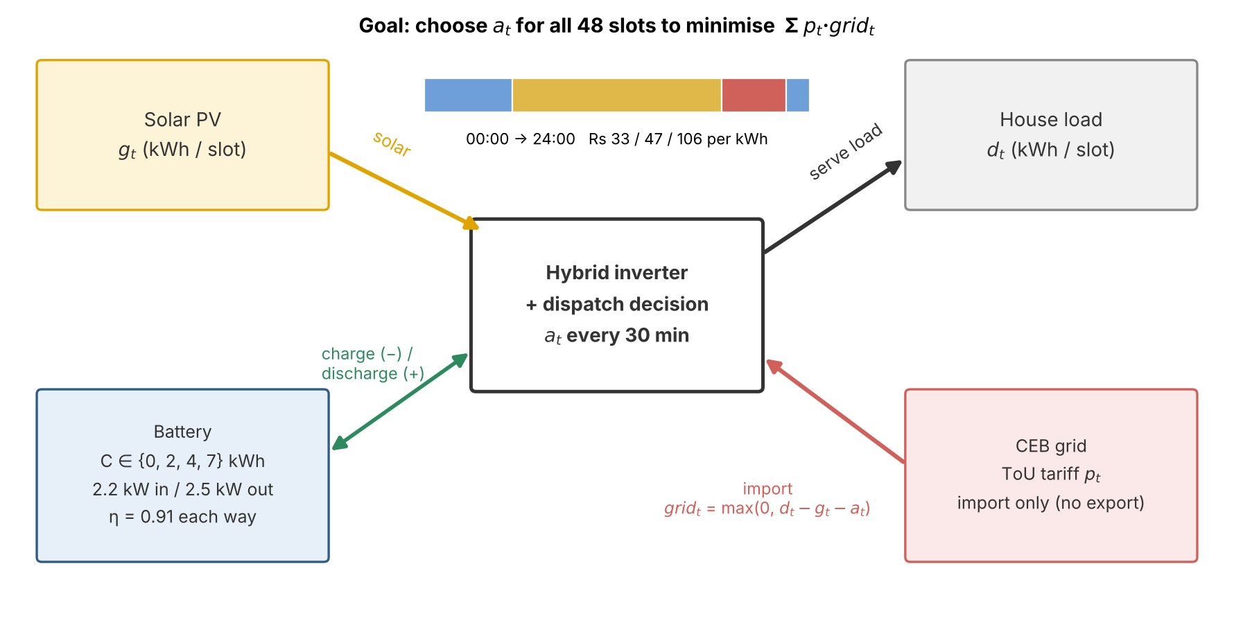
Figure 1. The household system. Every 30 minutes the inverter decides the battery energy $a_{t}$ (positive = discharge to the house, negative = charge). Solar first serves the load; the grid covers whatever is left, at the tariff price of that slot. Nothing is exported.

1.2 Why this problem is realistic and non-trivial
The problem is real: the data comes from a working installation (a hybrid inverter with solar panels and a nominal 7 kWh battery), the tariff is the one currently offered to Sri Lankan households, and the decision is exactly what a home energy management system makes. It is non-trivial for three reasons:
- Decisions are coupled over time. Energy discharged at 19:00 must have been stored earlier, so each decision changes what is possible in every later slot. A slot-by-slot greedy rule cannot see this, and in our results it costs 35–70 % more than the optimum (Section 6).
- The physics are asymmetric. Charging and discharging have different rate limits (2.2 kW vs 2.5 kW), each direction loses about 9 % of the energy, the battery must keep a 20 % reserve, and exporting to the grid is not allowed. These make the feasible region irregular.
- The cost function is non-smooth. The bill is t​ptmax0,dt-gt-at: once the battery covers the house load, discharging more is worth nothing, so the objective has kinks at every slot.

1.3 Problem class and complexity
It is important to be precise here. For a single battery with continuous charge levels, this problem can be linearised into a linear program (or a small mixed-integer program if simultaneous charging and discharging must be ruled out explicitly), so in its basic form it is not NP-hard, and an exact solution is always possible in principle. What makes it computationally interesting is the size of the search space and the way it grows. With $T=48$ slots and the SoC discretised in steps of $δ=0.001$ kWh, a 7 kWh battery has 5,601 SoC levels and 2,375 possible moves per slot, so there are roughly $5,{601}^{48}$ candidate schedules. Brute force is impossible, but DP solves it in $O\left(T⋅N⋅K\right)$ time (stages × states × moves), which is polynomial in the number of grid points but grows quickly as the grid is refined: this is a pseudo-polynomial algorithm. The problem becomes NP-hard when it gains integer structure, for example several batteries with on/off commitments or minimum run times, which is where heuristics become essential. This motivates comparing an exact method that is guaranteed optimal on our model with a heuristic that does not depend on the model’s special structure (Section 4.3).

1.4 Objectives
- Formulate battery dispatch under the CEB ToU tariff as an optimization model with explicit variables, objective and constraints.
- Instantiate and validate it with real household data rather than synthetic profiles.
- Solve it with one exact method (DP) and one metaheuristic (GA) that share the same model.
- Compare the two on solution quality, feasibility, runtime and scalability, across battery sizes of 0, 2, 4 and 7 kWh.

2. Problem and Data Description

2.1 Data source
All data comes from the authors’ own solar + battery installation in Horana, Kalutara district. The inverter’s monitoring app exports one spreadsheet per day with 5-minute readings of solar production (kW), household consumption (kW), grid power (kW), battery power (kW) and battery state of charge (SoC, %). The data is therefore real, first-party and not synthetic. In line with the assignment brief, it is used only to instantiate and validate the optimization model (load, solar and battery parameters), not to train a model.
Six days were logged in September 2026. Five are used: 10, 11, 13, 16 and 17 September. They include a heavy-load day (10 Sep, 10.1 kWh), a high-solar day (11 Sep, 14.1 kWh of production) and three lighter days.

2.2 Cleaning and resampling
The raw logs were turned into a model-ready table by scripts/build_profiles.py:
- Gap repair. Each day is reindexed onto a complete 5-minute grid (288 readings). Missing readings are linearly interpolated and the number repaired is recorded per day. 11 September was missing one reading (05:20), which is negligible.
- Excluded day. The 12 September log had a gap of about three hours (39 missing readings) during the morning solar ramp. Interpolating across a ramp would invent the shape of the solar curve, so the day was dropped and replaced by a re-logged 13 September. The faulty file is kept in data/raw/excluded/ as evidence.
- Resampling to 30-minute slots. Power readings are averaged per 30 minutes and converted to energy (kWh = mean kW × 0.5 h). Thirty minutes is the coarsest step that never splits a slot across two tariff bands, because all CEB band boundaries (05:30, 18:30, 22:30) fall on the half hour. Hourly slots would mix two prices in three slots per day.
- Sign convention. Positive battery power means discharging and negative means charging. This was checked against the logged SoC, not assumed.

The result, data/profiles_30min.csv, has 5 days × 48 slots, each with solar $g_{t}$, load $d_{t}$, band and price $p_{t}$. Table 2 summarises it and Figure 2 shows one day against the tariff.
Table 2. Daily energy totals (kWh) and the no-battery energy bill (Rs) for the five days used. “Net load” is the energy the grid must supply with no battery, t​max0,dt-gt; “surplus” is solar beyond the load.
Day | Load | Solar | Net load | Solar surplus | No-battery bill (Rs) | Repaired readings
10 Sep | 10.14 | 11.72 | 5.36 | 6.93 | 338.67 | 0
11 Sep | 9.58 | 14.07 | 3.07 | 7.56 | 160.91 | 1
13 Sep | 6.84 | 7.99 | 3.50 | 4.65 | 187.27 | 0
16 Sep | 5.62 | 7.63 | 2.70 | 4.72 | 158.78 | 0
17 Sep | 5.75 | 8.46 | 2.64 | 5.34 | 137.68 | 0
Mean | 7.59 | 9.98 | 3.45 | 5.84 | 196.66
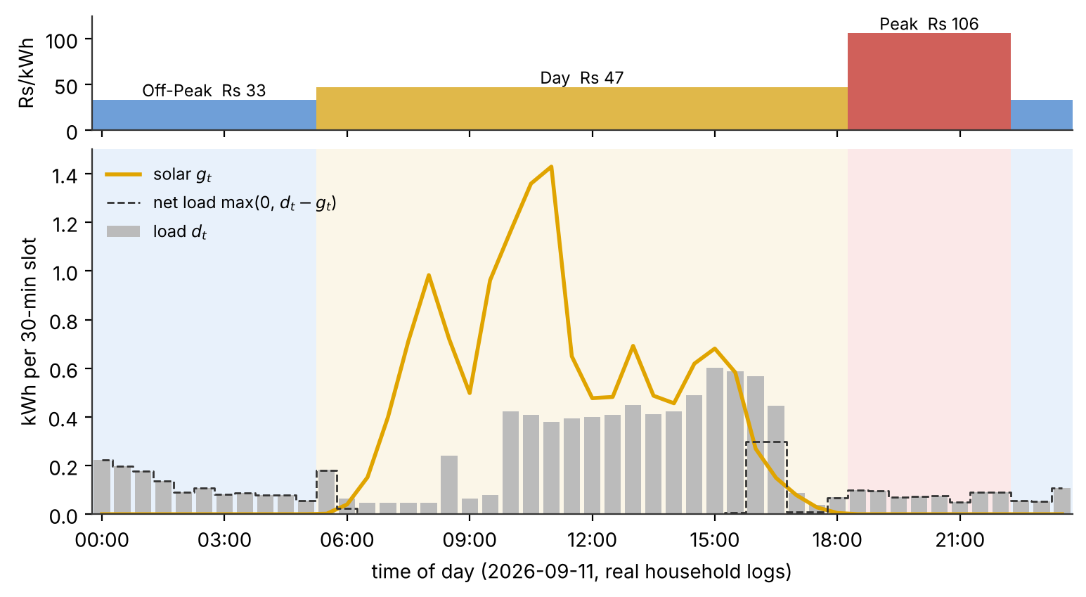
Figure 2. Top: the CEB ToU price for each 30-minute slot. Bottom: real load and solar on 11 September 2026. Solar exceeds the load for most of the day, but almost all of the evening load falls in the Rs 106 peak band.
Two features of the data drive the rest of the study. First, on every day solar production exceeds total load, so there is always surplus energy available to store. Second, the evening peak band carries only 28 % of the grid energy with no battery but 53 % of the cost (Rs 517 of Rs 983 over the five days). Moving evening demand onto stored solar is where the savings come from.

2.3 Battery parameters and calibration
The battery’s limits were taken from the logs, not from a datasheet. The largest observed charge and discharge powers were about 2.2 kW and 2.5 kW, which become per-slot limits of 1.10 kWh and 1.25 kWh. The usable range is 20–100 % of capacity, which keeps the reserve the inverter holds back.
The charge and discharge efficiency was fitted to the data by scripts/calibrate_eta.py. It replays the logged battery power through the SoC model over 206 windows and chooses the round-trip efficiency and effective capacity that best reproduce the logged SoC. The fit gives a round-trip efficiency of 0.83 (0.91 each way) and an effective capacity of 6.86 kWh (close to the nominal 7 kWh), with an SoC error of 0.74 percentage points RMSE (Figure 3). The model initially used a placeholder of 0.95 each way. The calibrated value is used for all results, and Section 6.5 checks how sensitive the results are to it.
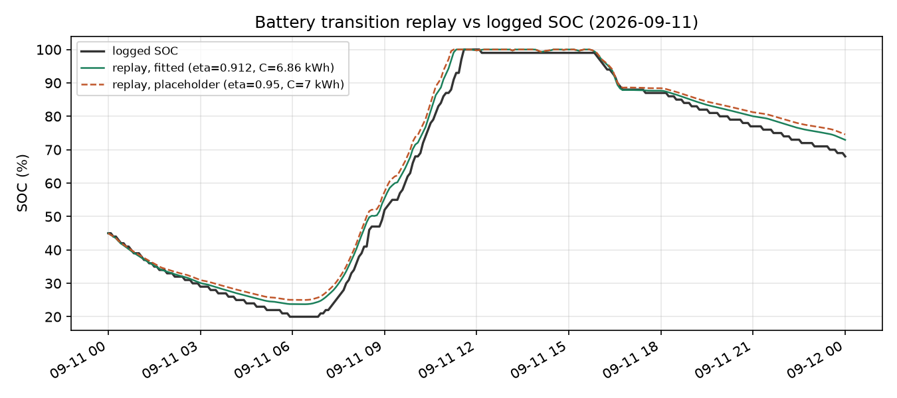
Figure 3. Logged SoC vs SoC replayed through the battery model, with the fitted efficiency (0.91 each way) and the original placeholder (0.95). The fitted value tracks the logged SoC closely.

2.4 Scope and the capacity sweep
With its 7 kWh battery, the real household already draws very little from the grid, so optimizing only the installed size would produce one thin result. We therefore sweep the battery capacity over $C∈\{0,2,4,7\}$ kWh, using the same real load and solar data at every size. $C=0$ is the no-battery baseline. This shows where optimized dispatch matters most, and it doubles as a sizing question a household considering a battery would actually ask.

3. Mathematical Formulation
First, we model a single data battery operation (charge & discharge) as a deterministic optimization problem with 48 half-hour time steps. This formulation is shared by both methods: the DP (Section 4.1) and the GA (Section 4.2) optimize the same objective subjective to the same constraints.

3.1 Sets and indices
The day is divided into equal time slots.
$$t ∈ \{0, 1, …, T-1\}$$ | The slot index, with $T = 48$ and slot length $Δt = 0.5 h$.
$$C ∈ \left\{0, 2, 4, 7\right\} kWh$$ | The battery capacity, treated as a swept parameter rather than a fixed constant (Section 2.4). C = 0 is the no-battery baseline.

3.2 Parameters
All parameters are fixed inputs, taken from the data (Section 2) or calibrated from the logs (Section 2.3).
Table 3. Model parameters, with each value or its source — taken from the data or calibrated from the logs (Section 2).
Symbol | Meaning | Value / source
$$d_{t}$$ | household load in slot t (kWh) | data
$$g_{t}$$ | solar production in slot t (kWh) | data
$$p_{t}$$ | grid price in slot t (Rs/kWh) | Table 1 (33 / 47 / 106)
$$C$$ | battery capacity (kWh) | swept {0, 2, 4, 7}
$${SoC}_{min}$$ | reserve floor (kWh) | 0.2 C
$$R_{c}$$ | max charge power (kW) | 2.2
$$R_{d}$$ | max discharge power (kW) | 2.5
$$η_{c}, η_{d}$$ | charge / discharge efficiency | 0.91 each (Section 2.3)
$$Δt$$ | slot length (h) | 0.5

The per-slot energy limits follow from the power limits:
at most $R_{c} . Δt = 1.10 kWh$ can be charged and $R_{d} . Δt = 1.25 kWh$ discharged in any slot.

3.3 Decision and state variables
The model has a single decision per slot (the battery action: charge/discharge) and a single state (the stored energy) that links one slot to the next.
Decision variable: $a_{t}$ (kWh, house side) - the battery action in slot $t$.
- $a_{t}>0$ : Discharge into the house
- $a_{t}>0$ : Charge the battery
- $a_{t}>0$ : Idle

The full-day schedule is the vector a = ($a_{0}, …, a_{47}$)

State variable: ${SoC}_{t}$ (kWh)
The battery’s state of charge at the start of slot $t$. This is the only information carried from one slot to the next.

3.4 Objective
The objective is to minimize the total cost of energy bought from the grid over the day:
$$\min_{a}\sum_{t=0}^{T-1}{P_{t} . max (0, d_{t}-g_{t}-a_{t})}$$

The term $max (0, d_{t}-g_{t}-a_{t})$ is the grid energy imported in slot $t$. In other words, the part of the household load which is not covered by solar or the battery. This is a definition, not a constraint because the grid covers any remaining demand, while excess energy is not exported (Constraint C2). Also, the price $p_{t}$ varies across tariff bands, making the timing of $a_{t}$ important.

3.5 Constraints
For a schedule to be physically feasible, the battery must stay within its operating limits across all 48 slots. These limits are defined by the five constraints as below. They are labeled as C1 to C5 for easy reference in other sections.

(C1) Charge/discharge rate limits
The battery cannot charge or discharge faster than its power limits allows in one slot:
$$-R_{c} Δt ≤ a_{t} ≤ R_{d} Δt ∀ t$$

(C2) No grid export
The battery may not discharge more than the household’s net load in any slot, so no energy is ever sent back to the grid:
$$a_{t} ≤ max\left(0, d_{t}-g_{t}\right) ∀ t$$

(C3) State-of-charge (SoC) transition
The stored energy evolves with the action, applying the efficiency loss on each side:
$${SoC}_{t+1} = \left\{\begin{aligned}{SoC}_{t}-\frac{a_{t}}{η_{d}} if a_{t}≥ 0 (discharge) \\ {SoC}_{t} + η_{d}\left|a_{t}\right| if a_{t}≥ 0 (charge)\end{aligned}\right.$$

(C4) Capacity bounds with reserve
The state of charge stays within usable range all times, keeping a 20% reserve:
$$0.2 C ≤ \text{So}{\text{C}}_{\text{t}} ≤ C ∀ t$$

(C5) Initial and terminal conditions
The battery starts each day at the reserve floor, and energy left at the end of the day is given no value:
$${SoC}_{0} = 0.2C$$

3.6 Modelling assumptions
Table 4. Modelling assumptions and how each is represented in the model.t​max0,dt-gt
Assumption | Rule in the model
Curtailment | Any solar energy left after meeting the load and battery charging demand is wasted. No income is received for exporting excess energy to grid (C2)
Day independence | Each day is optimized separately. Which means each day starting from the minimum reserve SoC of the battery. The remaining charge of the battery is not carried over to the next day.
Grid charging | The battery can charge from the grid during off-peak hours. This is subjective to confirmation of the inverter configurations.
Deterministic | Solar generation ($g_{t}$) and demand ($d_{t}$) are assumed to be known for every time slot. The model finds the optimal battery dispatch using correct information, without relying on forecasts.

3.7 Nature of the optimization problem
The model is non-linear as written, as the cost uses a $max(0, .)$ term, and state-of-charge update (C3) behaves different ways for discharging and charging operations. But both of these can be converted into linear form. For grid imports, we use an auxiliary variable $u_{t}>0$ with the condition $u_{t}≥d_{t}-g_{t}-a_{t}$. Charging and discharging operation is represented using two separate non-negative variables. With these conversions, the problem becomes linear program, or a mixed-integer linear program (MILP) if a binary variable is added in order to stop the battery from charging and discharging at the same time.
Due to these reasons, the single-battery problem is not NP-hard, and can be solved exactly in principle. The difficulty is the size of the discretized search space (section 1.3), which grows with the SoC resolution. The problem becomes NP-hard when integer decisions are introduced, such as managing multiple batteries or enforcing minimum run-times. This is where a heuristic becomes particularly useful (Section 4.3).

4. Optimization Methods

4.1 Exact method: Dynamic Programming
Why DP. The problem has the structure DP needs: it splits into stages (the 48 slots), the past only affects the future through one number (the SoC at the start of the slot), and the cost is a sum of per-slot costs. Bellman’s principle of optimality [2] then holds: an optimal schedule from any slot onward depends only on the current SoC, not on how that SoC was reached. DP gives a schedule that is provably optimal for the discretized model, which is exactly what is needed as a reference point for judging the heuristic.
Stages, states and actions.
- Stage $t=0,…,T-1$: one 30-minute slot.
- State $s$: the SoC at the start of the slot, restricted to a grid $s∈\{0.2C, 0.2C+δ, …, C\}$ with step $δ$ (kWh). There are $N=0.8C/δ+1$ levels.
- Action $k$: the number of grid steps the SoC moves in the slot ($k>0$ discharge, $k<0$ charge, $k=0$ hold). The next state is $s-kδ$, which is always on the grid, so no rounding or interpolation of the value function is needed.
The house-side energy of a move is recovered from the SoC change and the efficiency (when discharging, the SoC falls by $a/η_{d}$; when charging, it rises by $\left|a\right| η_{c}$):

$$a\left(k\right)=\left\{\begin{matrix}k δ η_{d}, & k≥0 \text{discharge} \\ k δ/η_{c}, & k<0 \text{charge}\end{matrix}\right.$$

The rate limits become limits on $k$, rounded down so a move can never exceed the physical rate: $k≤⌊R_{d}Δt/\left(η_{d}δ\right)⌋$ and $-k≤⌊R_{c}Δt η_{c}/δ⌋$. The no-export constraint removes any move with $a\left(k\right)>max\left(0,d_{t}-g_{t}\right)$, and moves that would leave the SoC range are infeasible.
Bellman recursion. Let $V_{t}\left(s\right)$ be the minimum cost from slot $t$ to the end of the day, starting at SoC $s$. With no value for energy left at the end, $V_{T}\left(s\right)=0$, and for $t=T-1,…,0$:

$$V_{t}\left(s\right)=\min_{k∈K_{t}\left(s\right)}\left[ p_{t}⋅max\left(0, d_{t}-g_{t}-a\left(k\right)\right)+V_{t+1}\left(s-kδ\right) \right]$$

where $K_{t}\left(s\right)$ is the set of feasible moves. The minimising move, written $π_{t}\left(s\right)$, is stored in a policy table. Solving runs in two passes (Figure 4): a backward pass fills $V$ and $π$ from the last slot to the first, then a forward pass starts at the reserve floor $0.2C$ and follows $π$ to recover the schedule $a_{0},…,a_{T-1}$.
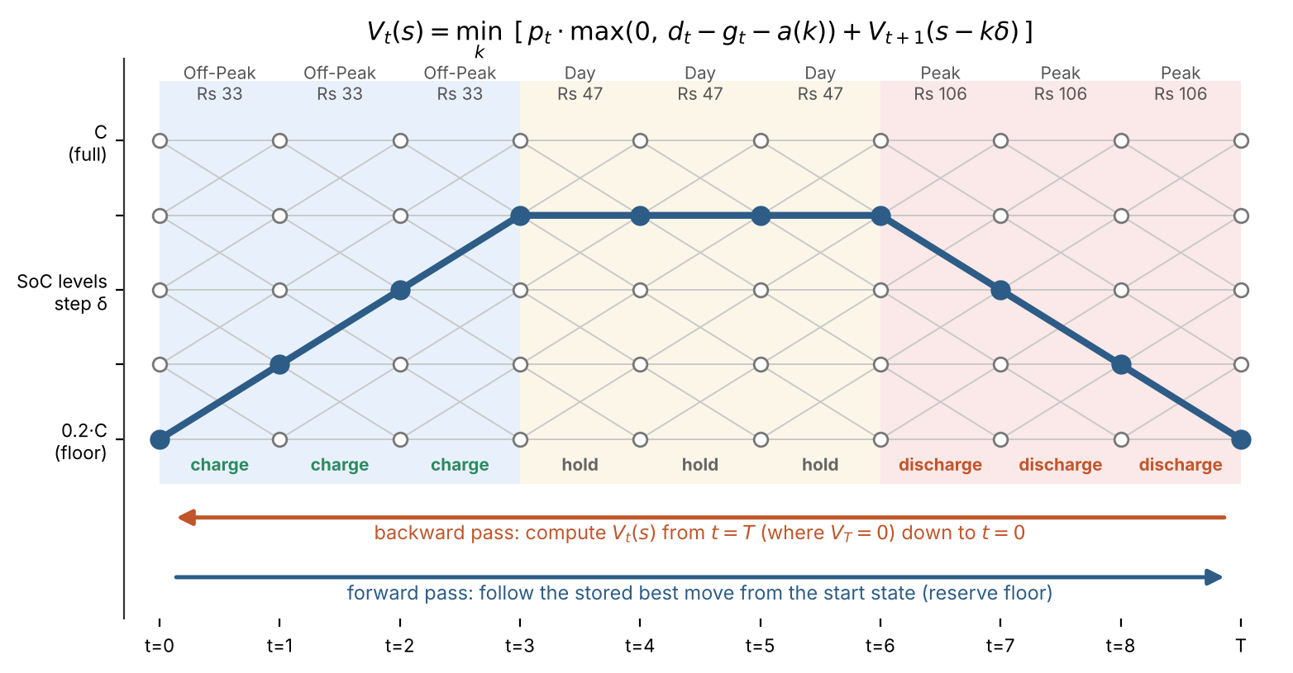
Figure 4. DP on a stage × SoC grid (schematic: 9 stages and 5 levels; the real model has 48 stages and up to 5,601 levels). Grey lines are feasible moves; the blue path is the optimal policy, which charges when energy is cheap, holds, and discharges in the peak band.
Choice of grid step. The DP is exact for the grid, so $δ$ controls how close it is to the continuous problem. With $δ=0.001$ kWh the bill is within about 1 % of the extrapolated continuous optimum (Section 6.4). At $C=7$ this gives $N=5,601$ states and $K=2,375$ moves per slot. The inner loop is vectorised over states with NumPy, so one day solves in about 2 s.
Validation. Two checks make sure the DP does what it claims:
- Hand-solved example (tests/test_dp_hand_example.py): a 1 kWh battery over three slots (off-peak, day, peak) with 1 kWh of load only in the peak slot. Doing nothing costs Rs 106; the optimum is to charge off-peak and discharge at peak for Rs 33. The test checks the full value and policy tables against values worked out by hand, at two grid steps.
- Replay check: every DP schedule is replayed through the shared simulate() function, which re-applies every constraint independently. All 20 day × capacity schedules are feasible, and the replayed bill matches the DP’s value to within floating-point error.

4.2 Heuristic method: Genetic Algorithm
Why a Genetic Algorithm
Unlike Dynamic programing, that we discussed, the Genetic algorithms do not use the stage structure of the problem. It only needs a way to score a complete schedule to know how bad or well the particular schedule is. This makes GA a good alternative to DP and can be used for more complex methods where DP’s small-state assumption no longer holds (Section 4.3). And also, since bill function is non-smooth due to the max (0,.) term, which creates a kink when the battery exactly meets the load, gradient-based methods are less suitable, while the GA does not require gradients. A day schedule is naturally a 48-dimension vector of continuous charge or discharge values, which maps directly onto a real-valued chromosome. We chose a GA over local search and simulated annealing because its population explores many regions of the schedule space in simultaneously, which is more robust to the many local optima created by the coupled SoC constraint. Figure 5 shows the full GA pipeline, such as population, selection, crossover, mutation, and elitism.

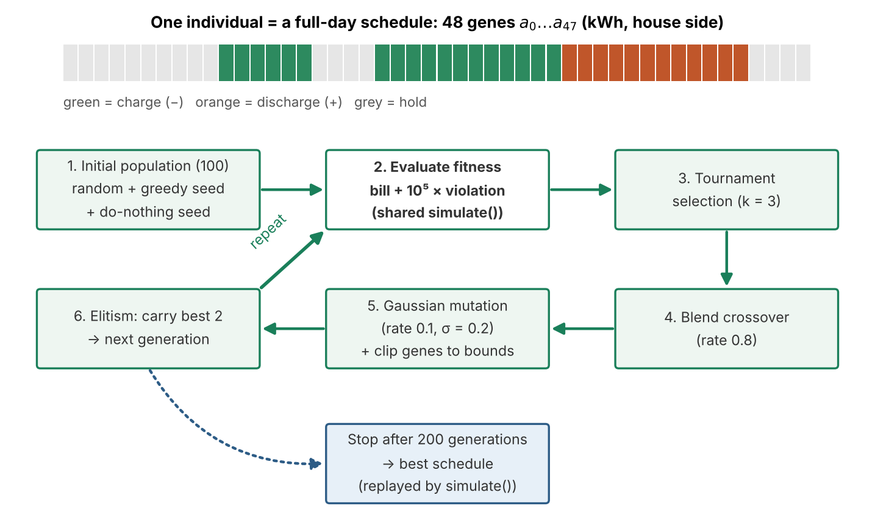
Figure 5. The Genetic Algorithm used in this study. Each individual is a full-day schedule of 48 battery decisions; the fitness is the bill plus a penalty for SoC violations.

Encoding
In GA pipeline, one individual (chromosome) represents a complete day’s schedule. It contains 48 battery actions, a = (a0, …, a47), one for each time slot. Each value follows the sign conversion of model (positive means discharge, negative means charge), and is measured on the house side.

Initial population
The population of 100 individual is initialized to balance exploration with good starting points. In this case, we used three initialization strategies. Most individuals are randomly generated using $N(0, 0.3)$ and clipped to the per-slot bounds. And two individuals are the greedy rule (charge using surplus solar and discharge during peak hours) and the do-nothing schedule (which is always feasible). Seeding just two informed individuals’ speeds convergence without collapsing the population’s diversity.

Fitness and constraint handling
The GA minimizes a penalized cost:
$$fitness = bill + P . (total constraint violation), with P={10}^{5}$$
Constraints are enforced in two ways, matching how tightly they couple the slots:
- Per-slot bounds (rate limits C1 and no-export C2) are enforced by clipping each gene to its feasible range whenever an individual is created or mutated. Since these constraints are depend only on the current slot, clipping guarantees they are never violated.
- SoC bounds (C4), which couple all slots, are handled using a graded penalty. The penalty increases as the state of charge moves further outside the range [0.2C, C], giving the search a direction back toward feasibility.
When we tried to enforce every constraint with a penalty alone, most of the schedules, around 97% were infeasible. As a result, the GA got stuck because the penalties overwhelmed the actual electricity bill. So, we instead force the per-slot limits to stay legal by clipping, and use the penalty only for the SoC limits. This is a common approach for GAs.

Operators and parameters
Each generation applies tournament selection, blend (arithmetic) crossover, Gaussian mutation, and elitism, with the settings below.
Table 5. Genetic Algorithm operators and parameter values.t​max0,dt-gt
Parameter | Value
Population size | 100
Generation | 200
Selection | tournament, k=3
Crossover | blend, rate 0.8
Mutation | Gaussian, rate 0.1 per gene, σ = 0.2 kWh
Elitism | top 2 carried over unchanged
Penalty weight P | 10⁵

We used trial and error methods to tune the parameters. For example, the population size and number of generations were increased until the results stopped improving. The mutation rate and σ were set to maintain sufficient exploration while preserving good solutions. Also, penalty coefficient was set high enough to prevent infeasible solutions from outperforming feasible ones. Elitism guarantees the best schedule found is never lost, so the GA’s result is always at least as good as the greedy seed.

Output
The best individual found by the GA is evaluated using the same simulate () function as the DP. Therefore, the reported bill and the feasibility check are computed identically for both methods. This means that any difference in the results comes from the difference between the two methods, not from the difference models.

4.3 Why these two methods together
The two methods are complementary. DP exploits the problem’s stage structure to give a guaranteed optimum (for the grid) with a predictable runtime, but it relies on a small state: one battery, one SoC number. Its cost grows with the number of states, so several batteries or extra state variables (for example battery degradation) would quickly make it impractical. The GA does not rely on that structure. It only needs a way to score a schedule, so it would extend to a richer model unchanged, but it gives no optimality guarantee. Comparing them on the same model answers a practical question: how much does the heuristic lose against the true optimum, and how does that loss change as the problem grows? Both import src/model.py and are scored by the same simulate (), so any difference in results comes from the method, not from different models.

5. Implementation and Reproducibility
The project is implemented in Python (NumPy, pandas, Matplotlib) with Jupyter notebooks for walkthroughs and plots. Both solvers are written by hand rather than with a solver library. This keeps every step of the DP recursion and every GA operator visible and testable, which matters for a comparison study, and the DP’s tailored state grid would not map directly onto a generic LP or MILP solver.
Table 6. Repository structure (github.com/Adore96/WattWise).
Path | Purpose
data/raw/, data/profiles_30min.csv | Raw 5-minute logs (committed) and the cleaned 30-minute table
scripts/build_profiles.py | Raw logs → tariff-aligned 30-minute profiles (Section 2.2)
scripts/calibrate_eta.py | Fits efficiency and capacity to the logged SoC (Section 2.3)
src/model.py | Shared model: data loading, parameters, simulate() (bill + constraint check)
src/dp_solver.py | Exact method: backward-induction DP
src/heuristic_solver.py | Heuristic: Genetic Algorithm
src/compare.py | All experiments → results/*.csv
tests/ | DP hand-example tests (pytest)
notebooks/ | DP and GA walkthroughs; result figures
scripts/make_report_figures.py | Conceptual figures for this report

One model, two solvers. The most important design decision is that model.py is the single source of truth for the problem. The GA was first developed in its own notebook with its own battery model. It was then refactored to import the shared module, so both methods optimise the same constraints and are scored by the same function. This also removed a subtle mismatch: the original GA allowed discharging beyond the house load (effectively exporting), which the shared model forbids.
Reproducing the results. From the repository root, pip install -r requirements.txt, then python scripts/build_profiles.py data/raw/*.xlsx, python -m pytest, and python src/compare.py regenerate every CSV in results/ (about 15 minutes). The notebooks regenerate the figures. Timings were measured on one machine (Windows 11, Intel CPU, Python 3.14, NumPy 2.5.3, pandas 3.0.6; recorded in results/machine.txt), using the median of 5 repeats for the DP and 10 seeds for the GA.
Version control. Each member worked on their own branch (kalhara-dev, bimsara-dev), and work was merged into main through pull requests. The repository has 46 commits from both members (Section 8).

6. Results
All results are means over the five real days unless stated otherwise. DP uses $δ=0.001$ kWh and $η=0.91$; the GA uses 10 seeds per case (population 100, 200 generations). “Gap” is the GA bill relative to the DP optimum for the same day and capacity, averaged over days.

6.1 Solution quality and feasibility
Table 7. Mean daily energy bill (Rs) by battery size and method. DP saving = 1 − mean DP bill / mean no-battery bill.
Battery | No battery | Greedy rule | GA mean (best seed) | DP (exact) | DP saving | GA mean gap | GA feasible
2 kWh | 196.7 | 103.4 | 89.3 (84.9) | 76.8 | 61 % | 23.6 % | 100 %
4 kWh | 196.7 | 93.3 | 66.5 (63.4) | 56.8 | 71 % | 16.6 % | 100 %
7 kWh | 196.7 | 93.3 | 62.2 (59.4) | 54.8 | 72 % | 14.8 % | 100 %

Three results stand out (Table 7, Figure 6):
- Optimized dispatch roughly halves what a simple rule leaves behind. Even a 2 kWh battery run by the DP cuts the bill by 61 %, and 7 kWh reaches 72 %. The greedy rule (charge from surplus solar, discharge only in the peak band) is 35–70 % more expensive than the DP, because it never charges ahead of the early-morning and day-band load and never uses stored energy outside the peak.
- The GA is always feasible but never optimal. All 150 GA runs with a battery (5 days × 3 sizes × 10 seeds) produced feasible schedules, and none was worse than the greedy seed (elitism guarantees this), but no run came within 1 % of the DP optimum. The mean gap is 15–24 % and is largest for the smallest battery. With less room, a schedule must be timed precisely, and random perturbations rarely find that timing.
- Capacity beyond about 4 kWh adds little for single days. Going from 4 to 7 kWh lowers the DP bill by only Rs 2 a day. Section 6.4 shows this changes once charge can be carried between days.
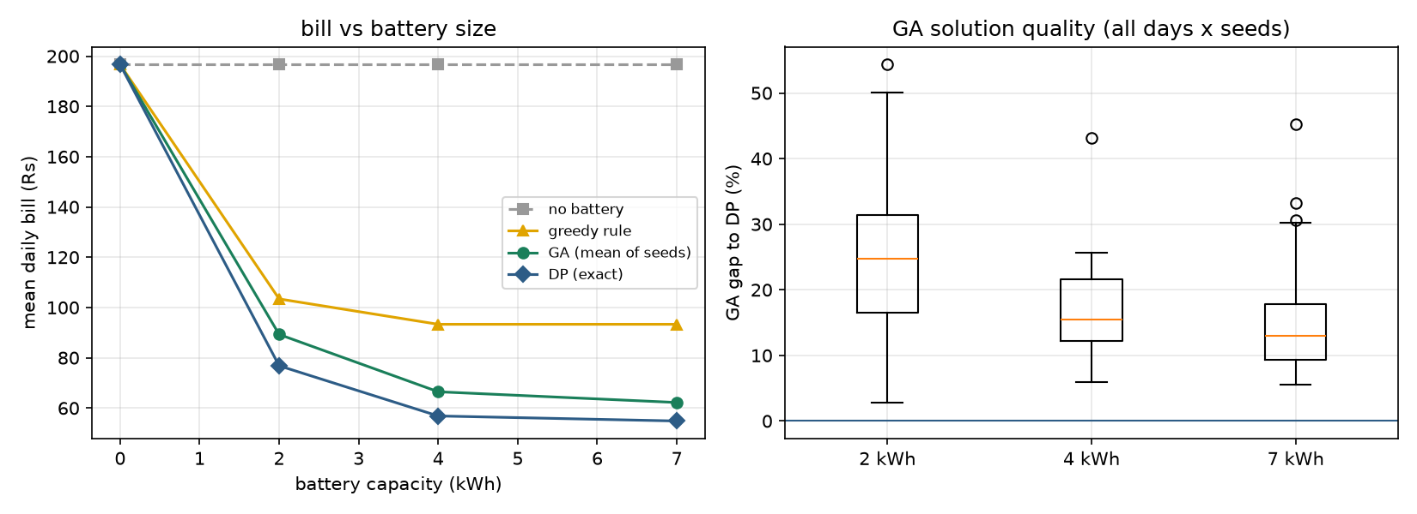
Figure 6. Left: mean daily bill vs battery size for each method. Right: distribution of the GA’s gap to the DP optimum over all days and seeds.
Table 8. DP saving vs no battery (%) per day. Only the heavy-load day (10 Sep) benefits strongly from a battery larger than 2 kWh.
Day | 2 kWh | 4 kWh | 7 kWh
10 Sep | 47.1 | 74.7 | 77.6
11 Sep | 65.7 | 67.4 | 67.4
13 Sep | 64.3 | 64.3 | 64.3
16 Sep | 74.1 | 76.4 | 76.4
17 Sep | 69.7 | 69.7 | 69.7

Figure 7 shows what the optimal schedule looks like on 11 September with a 4 kWh battery.
The DP charges from the midday solar surplus, covers the short late-afternoon shortfall, and then spreads the remaining stored energy across the evening peak, discharging exactly the house load in each peak slot and nothing more (no export). The battery ends the day back at the 20 % floor, because leftover energy has no value in a single-day model.
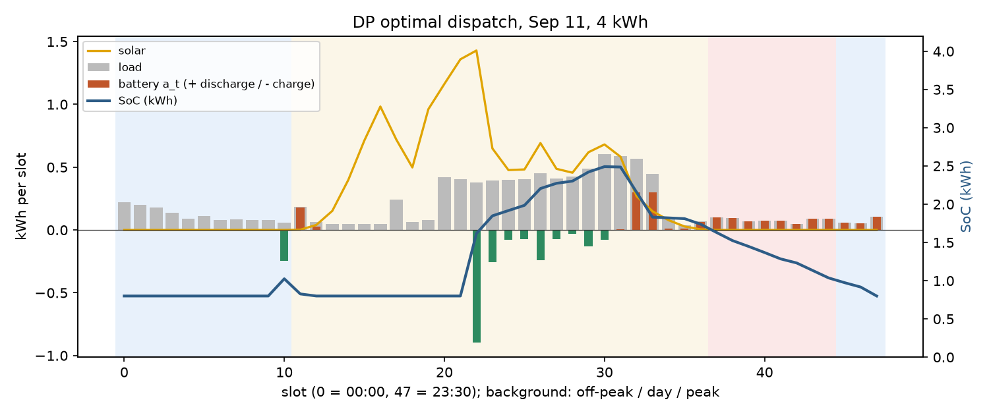
Figure 7. DP optimal dispatch on 11 September with a 4 kWh battery. Bars: battery energy per slot (orange = discharge, green = charge); line: SoC. Background: off-peak / day / peak bands.

6.2 GA behavior
Convergence
For 11 September with a 4-kWh battery, the GA’s best bill starts at the greedy seed value of Rs.92.5, and then improved with steps as illustrated in the figure 8. The convergence curve shows a series of sudden drops rather than a smooth decline. Between the sudden drops, the best bill stays flat for long stretches. For example, best bill remains on Rs 65 from generation 90 to 145 before improving again. At the end, the bill has reached about Rs 59, which is still above the DP optimum of Rs 52.4. This step pattern is common in GA. The best schedule improves only when mutation or crossover produces a better individual. As a result, the progress occurs in sudden jumps as we can see in the figure below. These improvements are separated by flat periods where no better solution is found.
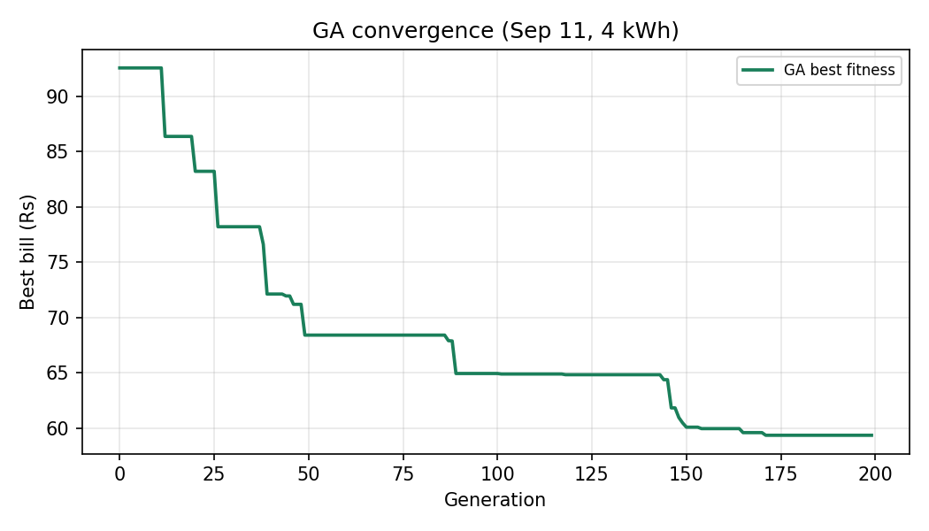
Figure 8. GA best-so-far bill over 200 generations (11 September, 4 kWh). Improvement is step-wise with long plateaus; the run ends at ~Rs 59, above the DP optimum of Rs 52.4.

Dispatch quality
Figure 9 shows the actual schedule the GA chose for 11 September with a 4-kWh battery, plotted on the same axes as the DP schedule in Figure 7. Compared with the DP schedule, the dispatch of the GA is visibly noisier. Because it contains many small charge and discharge actions across the off-peak and day bands rather than forming the DP’s single clean charge block. These ups and downs waste round-trip efficiency. Also, its peak-band discharge is also less precisely timed. Crucially, the GA ends the day with around 1.8 kWh remaining in the battery. This is higher than the minimum SoC of 0.8 kWh. As a result, about 1 kWh of stored energy remains unused. The DP would have discharged this energy during peak hours to reduce the electricity bill. For these reasons, the cost difference between the GA and DP was around 15–24%.
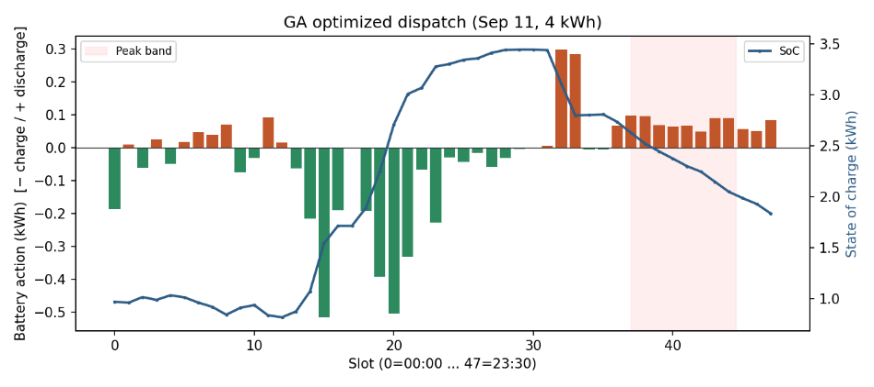
Figure 9. GA dispatch on 11 September with a 4 kWh battery (same axes as Figure 7). Bars: battery energy per slot (orange = discharge, green = charge); line: SoC. Note the noisy charging and the energy left unused at day’s end.

Seed reliability
Because the GA is stochastic, we ran 10 random seeds per case and report the best, mean, and worst (results/sweep_summary.csv). All 150 battery runs (5 days × 3 sizes × 10 seeds) produced feasible schedules. None of these performed worse than the greedy seed, confirming that the constraint handling and elitism worked as intended. Results varied by a few percent across the ten random seeds tested. DP optimum is Rs 52.4 on September 11. GA’s best was Rs 55.5, a 5.9% gap, while its mean was Rs 58.8. The worst result was Rs 63.9, and all schedules remained feasible. Across all days, the mean gap ranged from 15% to 24%. The largest gap occurred with the smallest battery. With 2 kWh available, precise timing matters, but random perturbations rarely discover the best schedule.

6.3 Runtime
At the main grid step, one day takes the DP 0.9 s (2 kWh), 1.5 s (4 kWh) and 2.2 s (7 kWh), compared with 1.4–1.6 s for 200 GA generations. DP runtime grows with capacity, because the number of SoC levels grows with $C$, while the GA’s runtime depends only on its budget (population × generations × the cost of one simulate() call). For the problem as posed, the exact method is about as fast as the heuristic and strictly better in quality, so there is no runtime argument for the GA at this size.

6.4 Scalability
Grid step (DP). Table 9 and Figure 10 vary $δ$ at $C=7$. Halving $δ$ doubles both the number of states and the number of moves, so the work grows roughly as $1/δ^{2}$. The bill converges roughly linearly in $δ$. At coarse grids, small discharges that would exactly match the house load in a slot cannot be represented, so some peak energy is still bought. Below $δ=0.002$ the improvement is under 1 %.

Table 9. DP grid-step study at C = 7 kWh (mean over 5 days).
δ (kWh) | SoC levels | Moves / slot | Mean bill (Rs) | Runtime (s)
0.1 | 57 | 24 | 116.0 | 0.007
0.05 | 113 | 48 | 81.4 | 0.07
0.01 | 561 | 238 | 59.6 | 0.08
0.005 | 1,121 | 475 | 56.8 | 0.17
0.002 | 2,801 | 1,187 | 55.3 | 0.58
0.001 | 5,601 | 2,375 | 54.8 | 1.82
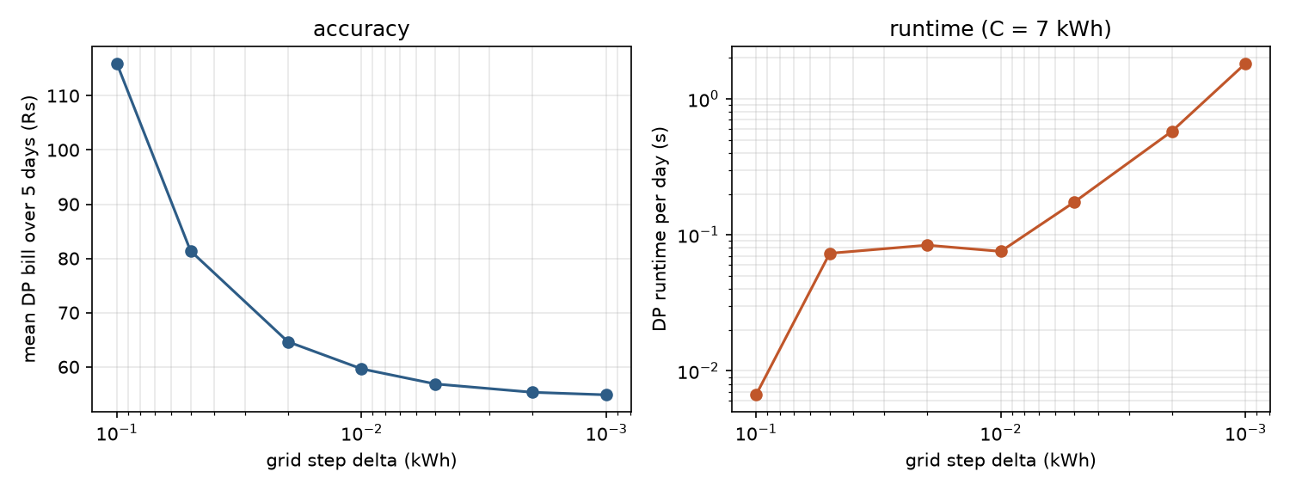
Figure 10. DP bill (left) and runtime (right) as the SoC grid step δ shrinks, C = 7 kWh.

Horizon length (DP vs GA). To see how each method scales with problem size, consecutive days were chained into one horizon of 48, 96 and 240 slots, with the battery’s charge carried across midnight (Table 10, Figure 11). The DP stays exact, and its runtime grows linearly with the number of slots (1.9 s → 9.8 s), as $O\left(T⋅N⋅K\right)$ predicts. The GA’s runtime also grows only mildly, but with the same budget its quality collapses: the mean gap rises from 9 % to 118 % to 486 %. A longer horizon means a longer chromosome (up to 240 genes) and many more SoC constraints coupling the genes, so random variation almost always breaks a constraint somewhere, and the penalty then dominates the search.
Table 10. Horizon study at C = 7 kWh: 1, 2 and 5 chained days (bills in Rs). The last column solves each day separately from the 20 % floor.
Horizon | Slots | DP bill | DP time (s) | GA mean bill | GA gap | GA time (s) | DP, days separate
1 day | 48 | 75.8 | 1.9 | 82.9 | 9.4 % | 1.3 | 75.8
2 days | 96 | 76.8 | 3.8 | 167.3 | 117.9 % | 2.3 | 128.1
5 days | 240 | 79.0 | 9.8 | 463.4 | 486.4 % | 4.7 | 274.2
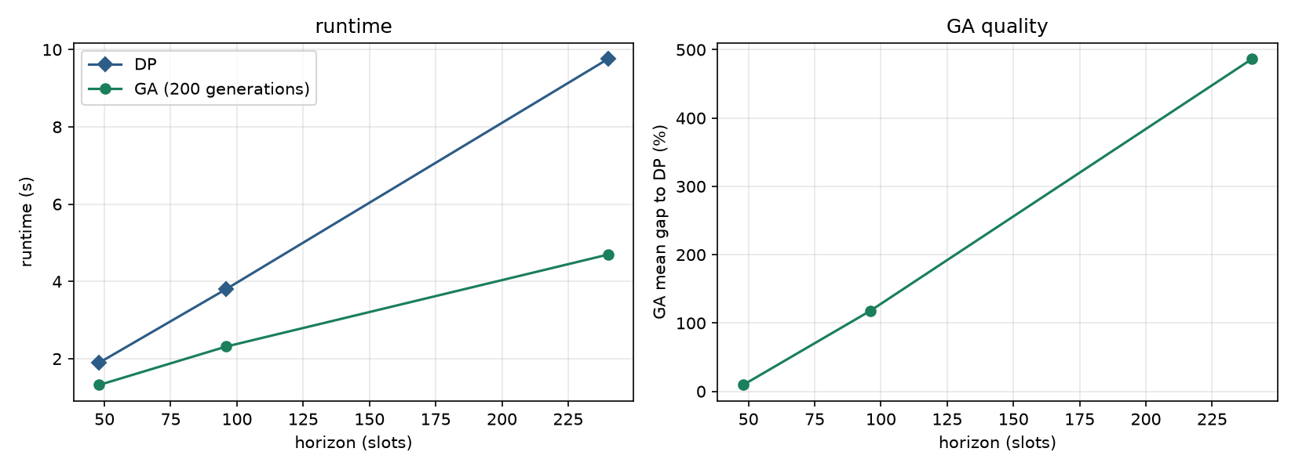
Figure 11. Horizon scaling: runtime (left) and GA quality gap (right) as days are chained, C = 7 kWh.

The last column of Table 10 gives a second, practical result. When the five days are solved as one horizon, the bill is Rs 79. When each day is solved on its own, starting from the 20 % floor every morning, the same five days cost Rs 274, more than three times as much. In the single-day model, the battery must end every day empty and start every night with nothing stored for the off-peak and early-morning load. Carrying the afternoon’s surplus solar into the next night removes most of that cost. The start-at-floor assumption, not the choice of algorithm, is the largest remaining source of cost.

6.5 Sensitivity to battery efficiency
Because the efficiency was estimated from data, the DP was re-run with $η=0.95$ and $η=1.0$ (lossless). With a perfect battery the mean 7 kWh bill falls from Rs 54.8 to Rs 52.1, and the 2 kWh bill from Rs 76.8 to Rs 69.9 (Table 11). The conclusions do not depend on the exact efficiency: the ranking of methods and the shape of the capacity curve are unchanged, and using the placeholder 0.95 would have overstated the savings by only Rs 1–3 per day.
Table 11. Mean DP bill (Rs) for different charge/discharge efficiencies.
Battery | η = 0.91 (fitted) | η = 0.95 | η = 1.0
2 kWh | 76.8 | 73.5 | 69.9
4 kWh | 56.8 | 54.9 | 52.2
7 kWh | 54.8 | 53.8 | 52.1

7. Discussion and Future Work

7.1 What the comparison shows
For this problem, Dynamic Programming is the right tool. It is exact on the grid, about as fast as the GA for one day, scales linearly with the horizon, and its grid step gives a clear trade-off between accuracy and runtime. The GA’s advantage is generality: it would accept a different battery model or cost function with no change to the algorithm, while the DP would need a new state design. That generality has a measurable price here, 15–24 % for one day and several hundred percent for a five-day horizon at a fixed budget.
The results also show where each method’s assumptions break. DP’s cost grows with the number of states. One battery has one SoC number, which keeps DP fast, but two batteries would square the state space ($5,{601}^{2}≈3×{10}^{7}$ states per slot) and three would make it impractical: the “curse of dimensionality” [5]. The GA’s cost does not grow that way, which is why heuristics remain relevant for larger home or community systems even though they lose here.

7.2 Why the GA falls short
Coupled SoC constraint
The state of charge (SoC) at any slot depends on all earlier actions. So that this creates a narrow, tightly coupled feasible region. A single gene mutation can shift the whole SoC trajectory. This may push later slots outside the allowed bounds, making the overall schedule infeasible. Penalty-only handling made about 97% schedules infeasible. This result is discussed in Section 4.2 of this report. Even with clipping and a graded penalty keeping every run feasible, the search spends much of its effort staying inside this region rather than lowering the bill.
Crossover smooths sharp timing
The optimal schedule is sharply timed (Figure 7). However, blend crossover averages two parents, blurring these actions and producing the noisy, spread-out dispatch seen in Figure 9. This operator therefore works against the structure needed for the optimal schedule.
Fixed budget does not scale with the horizon
The chromosome increases from 48 genes for one day to 240 genes for five days, while the search budget remains fixed at 100 individuals and 200 generations. The gap to the DP optimum rises from about 6% for one day to 88% for two days. For five days, the gap exceeds 450% at longer horizons, the GA performs worse than solving each day independently using the DP.
Possible improvements
A few changes could help the GA get closer to the optimum:
- Repair operator: after each change, adjust the schedule so the battery level always stays within its limits. This way every schedule is legal from the start, and no penalty is needed.
- Different encoding: instead of describing charge or discharge amounts in each slot, describe the battery’s level in each slot. This makes the limits far easier to keep.
- Add local search (memetic GA): after the GA creates a schedule, do a quick fine-tuning step to sharpen the charge and discharge timing.
- Bigger budget for longer problems: give the GA a larger population and more generations when the schedule covers more days, so it has enough search power to keep up.

7.3 Limitations
- Perfect foresight. Load and solar are taken from the logs, so the DP is a lower bound on what a real controller could achieve without forecasts. The figures are best read as the value of optimal dispatch, not a guaranteed saving.
- Five days, one month. The days come from September, before the north-east monsoon. Solar and load vary by season, so the savings figures should not be extrapolated to a full year without more data.
- Simplified battery. Efficiency is constant and battery degradation is not modelled. Cycling has a cost that would make small charge/discharge moves less attractive.
- Energy charge only. The fixed monthly charge is excluded because dispatch cannot change it, so percentage savings refer to the energy component of the bill.
- Grid charging. The model allows the battery to charge from the grid at off-peak. This should be confirmed against the inverter’s actual configuration.

7.4 Future work
- Rolling-horizon optimization. Replace the start-at-floor assumption with a multi-day or rolling horizon, which Section 6.4 shows is worth roughly Rs 39 a day on these days. This is the most valuable extension.
- Forecast uncertainty. Re-solve every slot with forecast load and solar (model predictive control), or use stochastic DP over solar scenarios, to measure how much of the optimal saving survives imperfect forecasts.
- Independent LP check. Formulate the linearised model in PuLP or OR-Tools and confirm the DP optimum with a separate solver.
- Degradation-aware objective. Add a per-kWh cycling cost to the objective and study how it changes the optimal schedule and the best battery size.
- Better heuristics for the cases where DP does not scale (Section 7.2).

8. Individual Contributions
The work was split by module, and each member owned their module end-to-end. Commit history and pull requests on GitHub record who did what.
Table 12. Contribution of each member.
Area | Kasun Kalhara Perera | Bimsara Sandaruwan
Problem and data | Problem selection; real data from own installation; cleaning and resampling pipeline (build_profiles.py); efficiency calibration (calibrate_eta.py) | Data loader and inspection for 30-minute profiles; cleaning-script update
Model | Shared model.py / simulate(); refactoring both solvers onto it | Battery model extensions: SoC reserve, two-way efficiency, asymmetric rate limits
Exact method | DP solver, hand-example tests, replay validation, DP notebook | —
Heuristic | Moving the GA into src/ | GA design and implementation, greedy seed, penalty design, GA notebook
Experiments | Comparison framework (compare.py): capacity sweep, grid-step, horizon, efficiency studies | Capacity-sweep experiments, convergence and seed-reliability analysis, GA figures
Report | Sections 1, 2, 4.1, 4.3, 5, 6.1, 6.3–6.5, 7.1, 7.3–7.4, 8; report figures | Sections 3, 4.2, 6.2, 7.2
Repository | Repository setup, README, pull-request merges | Branch bimsara-dev, 21 commits
Commits | 25 | 21

References
[1] Public Utilities Commission of Sri Lanka, “Decision on Electricity Tariffs,” May 2026. [Online]. Available: https://www.pucsl.gov.lk/wp-content/uploads/2026/05/Full-Final_Decision-on-Electricity-Tariffs-May-2026.pdf
[2] R. Bellman, Dynamic Programming. Princeton, NJ: Princeton University Press, 1957.
[3] K. Deb, “An efficient constraint handling method for genetic algorithms,” Computer Methods in Applied Mechanics and Engineering, vol. 186, no. 2–4, pp. 311–338, 2000.
[4] D. E. Goldberg, Genetic Algorithms in Search, Optimization, and Machine Learning. Reading, MA: Addison-Wesley, 1989.
[5] D. P. Bertsekas, Dynamic Programming and Optimal Control, vol. I, 4th ed. Belmont, MA: Athena Scientific, 2017.

Appendix A. Code
The full source code is submitted separately as plain text (report/code_appendix.txt), generated from the repository by scripts/build_code_appendix.py. The live repository with full commit history is at github.com/Adore96/WattWise.

