Prereqs and coreqs as sets of eligible students

As noted in the syllabus, “STA 2023 (introductory stats) or equivalent or permission of instructor is a prerequisite for IDS 3932 (the seminar), enrollment in IDS 3932 is a corequisite for IDS 3932L (the lab), and enrollment in IDS 3932L is not a corequisite for IDS 3932.” These pre and corequisites may be described as a series of logical relationships.

## An illustration using R

Our first use of the programming language R is drawn directly from the syllabus. This document includes comments, code, and results, and was generated using the R markdown package, together with a supplemental package expressly written to produce Venn diagrams.

The document which generated this (prereqs.Rmd) and all code will be stored in the class github repository (<https://github.com/kevinlanning/introDataScience>). If you want to run this on your own computer, you will likely need to first *install* the Venndiagram package, that is, copy it on to your machine using the following command:

install.packages (“VennDiagram”)

## Code

library (VennDiagram)  
draw.quad.venn (  
 area1=15, # estimated n students in lab  
 area2=32,  
 area3=150,  
 area4=350,  
 n12=15,   
 n13=15,  
 n14=15,  
 n23=32,  
 n24=32,  
 n34=150,  
 n123=15,  
 n124=15,  
 n134=15,  
 n234=32,  
 n1234=15,  
 category = c("In IDS3932L",  
 "In IDS3932",  
 "Had STA2023",  
 "Is a WHC student"),  
 fill = c("orange",  
 "red",  
 "green",  
 "blue")  
)

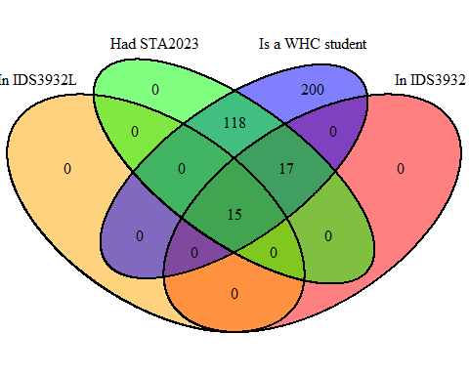

## Questions and concerns

What do the numbers in the code above describe?

What do the zeros in the graph describe?

Do you think that this is a good graph? *(Hint: I don’t)*

What are its strengths and weaknesses?

How might you improve upon it?