**Mobile Application Development 3701ICT**

Trimester 1, 2024

Assignment 2

**Fake Store**

Milestone 1

Student Name: Aidan Lietz

Student ID: S5259616

Student Email: aidan.lietz@griffithuni.edu.au

Course Code: 3701ICT

Lab: Nathan Monday 4pm

Lab Tutor: Dr Larry Wen

Table of Contents

Project Overview 3

GitHub Repository 3

Screenshots 3

Source Code Snippets 8

Reflection 9

Conclusion 9

## Project Overview

The "Fake Store" mobile application aims to provide users with a seamless shopping experience by leveraging React Native to create an interactive and user friendly application. The primary objectives include implementing features such as a splash screen, category screen with dynamic fetching from the Fake Store API, product list screen, and product detail screen. Our approach will prioritize clean code, efficient data fetching, and intuitive user interface design to meet the requirements outlined in Milestone 1.

## GitHub Repository

URL link to GitHub (Public): <https://github.com/Ados43/MobAppDev-Assignment2>

## Screenshots

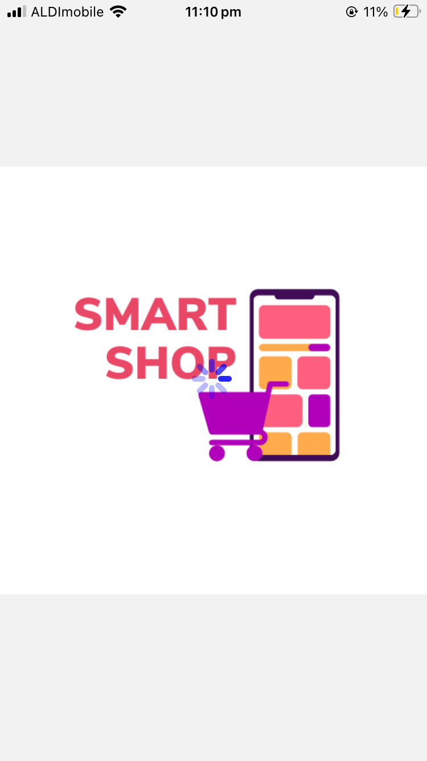Splash Screen:

Main Screen (Category Screen):

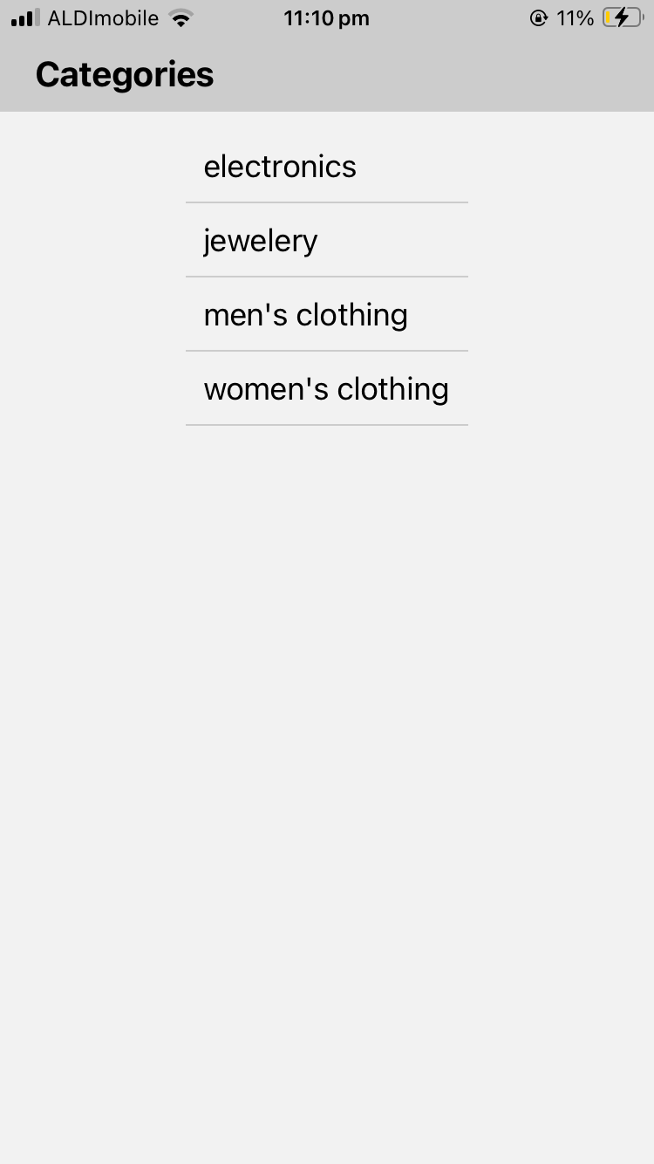

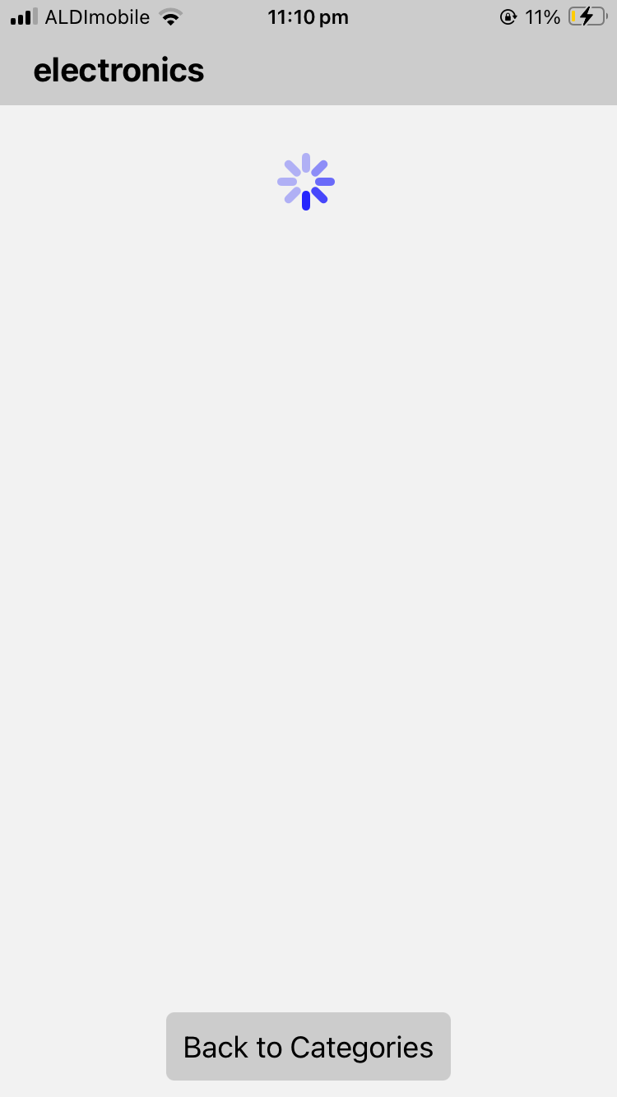Loading Screen (For each new page):

Product List Screen:

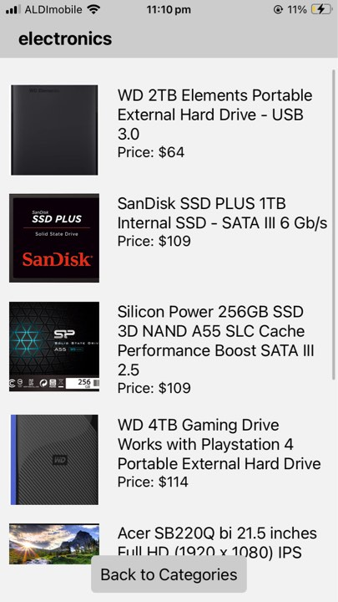

Product Detail Page:

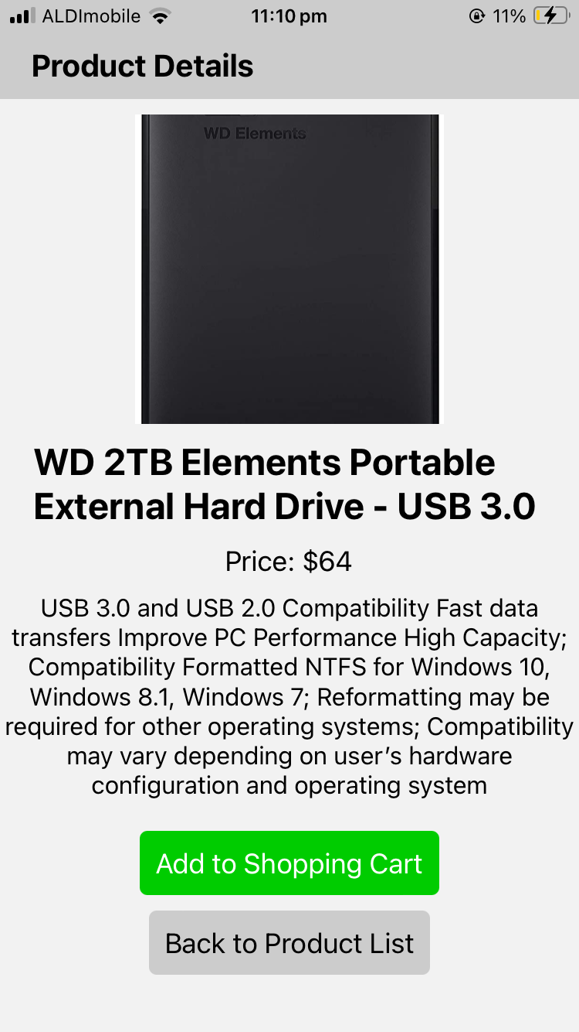

## Source Code Snippets

Fetching Categories (Category / Main screen) with error handling:

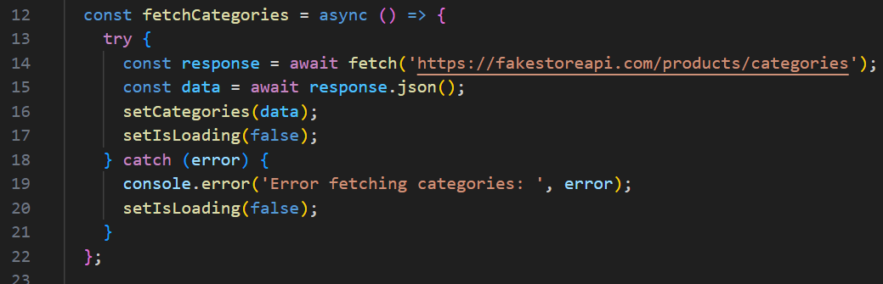

Navigating to ProductListScreen and passing through which category should show:

How the loading screen and Activity Indicator (Loading Icon) is displayed:

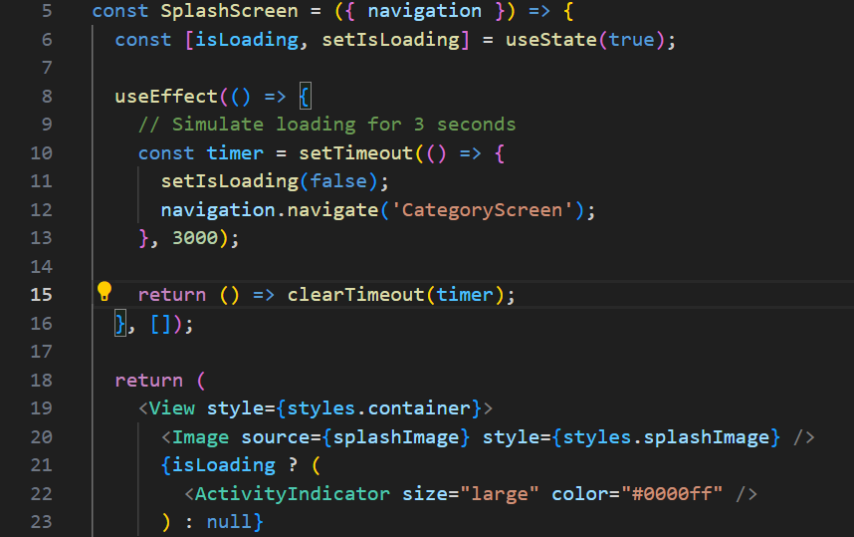

## Reflection

Throughout the development process, I encountered challenges related to managing data fetching and error handling, navigation between screens, using activity Indicator between loading, and passing through information from one screen to another. However, these obstacles provided valuable learning experiences and opportunities for growth and improvement. I look forward to further refining my skills in upcoming milestones and future courses.

## Conclusion

In this milestone, I successfully implemented key features of the "Fake Store" application, including the splash screen, category screen, product list screen, product detail screen while using activity indicators in between, buttons to go back to the previous page, and dynamically fetching data where needed. By adhering to best practices in React Native development and leveraging the capabilities of the Fake Store API, I have laid a solid foundation for building a functional and user-friendly shopping application. I am excited to continue iterating on this project and incorporating additional features in future milestones.

Declaration: I declare that the work submitted in this assignment is my own and adheres to the university's Student Conduct Policy.

Signature:



Date: 28/04/2024