African Medical Question Answering Assistant:
Grounded Retrieval with Fine-Tuned Sentence Embeddings
Author: Adossi Fred William
GitHub: https://github.com/Adossi-design/African-Medical-Question-Answering-Assistant
Demo video: to be added
Live application: to be added once the Streamlit Community Cloud app has been published and tested

1. Abstract
Reliable health information that reflects African disease patterns and health systems is not always easy to find, and general-purpose chatbots can produce fluent answers that contain invented medical claims. In this project I built an English question answering assistant that answers health questions only with human-written answers from AfriMed-QA v2.5, a pan-African medical question answering dataset, and that refuses questions outside medicine or not covered by the data. After cleaning, 1,206 Short Answer Questions formed the knowledge base, divided into 711 training, 141 validation and 354 test records according to the dataset's official split. I compared a TF-IDF retrieval baseline with a pretrained sentence-embedding model, multi-qa-MiniLM-L6-cos-v1, and with versions of that model that I fine-tuned with the Multiple Negatives Ranking loss. Fine-tuning raised the validation mean reciprocal rank from 0.711 to 0.837, but on the expert-written test set the pretrained model remained slightly better, with a Recall@1 of 0.316 against 0.285 for the final model, a drop that my analysis links to all training data coming from a single crowdsourced source. A confidence threshold chosen on validation data refused 98.7% of non-medical and 94.8% of uncovered medical test questions, compared with 75.6% and 74.1% for the baseline. The results show that retrieval combined with a confidence check is a practical way to keep answers grounded, and they also show that limited coverage, very short reference answers and the difference between crowdsourced and expert questions restrict what a small dataset can support.

2. Introduction
Access to reliable health information remains uneven across Africa. A survey of 47 countries by the WHO Regional Office for Africa found an average density of only 1.55 physicians, nurses and midwives per 1,000 people in the region, and concluded that the shortage and uneven distribution of health workers remain a major obstacle to universal access to health services [1]. When a health professional is not easily available, people often look for information elsewhere, and conversational AI systems are becoming a common source. These systems write fluently, but they are known to produce statements that no source supports, a problem usually called hallucination [2]. In a medical setting such errors can mislead the person asking, which makes grounding and caution as important as fluency.
Most medical question answering resources also reflect the health systems of other regions. MedQA, for example, was built from medical licensing examinations in the United States, mainland China and Taiwan [3], and the consumer health collection used by Ben Abacha and Demner-Fushman was drawn from websites of the United States National Institutes of Health [4]. AfriMed-QA was created to address this gap. It contains about 15,000 open and closed-ended questions sourced from over 60 medical schools in 16 African countries and covering 32 medical specialties, and its authors used it to show that the performance of large language models varies across specialties and countries [5]. The dataset therefore offers questions and human-written answers grounded in African medical practice, which makes it a suitable basis for an assistant designed for this context.
In this project I use AfriMed-QA to build an English question answering assistant for educational medical information. Instead of generating new text, the assistant retrieves the human-written answer whose meaning is closest to the user's question, so every answer it gives comes from the dataset. It also has to recognise paraphrased questions rather than only exact wording, and it has to refuse questions that are unrelated to medicine or about topics that the dataset does not cover. The intended users are students, health workers and members of the public who are looking for educational information, and the system is not meant to diagnose patients or prescribe treatment.
This leads to three research questions:
1. Does meaning-based retrieval with sentence embeddings answer African medical questions better than word matching with TF-IDF?
2. Does fine-tuning a pretrained embedding model on AfriMed-QA improve retrieval, and does any improvement carry over from crowdsourced training questions to expert-written test questions?
3. Can a similarity threshold chosen on validation data reliably refuse non-medical questions and questions about medical topics that the dataset does not cover?
The rest of this report reviews related work, describes the data and how I prepared it, explains the methods, presents and discusses the results, and describes the web application and the limitations of the work. When the evidence is limited, I state this and keep the conclusion within what the results show.

3. Related Work
Work related to this project comes from four directions: medical question answering, resources for African languages and medicine, retrieval with sentence embeddings, and the problem of knowing when not to answer. The paragraphs below take them in turn and end with what they mean for this project.
Medical question answering: Medical question answering has been studied both as a retrieval problem and as a generation problem. Ben Abacha and Demner-Fushman collected question and answer pairs from trusted NIH websites and answered new consumer questions by recognising which existing questions they entail, so that the returned answer always comes from a reliable source [4]. Later work moved towards large language models. On MedQA, a multiple-choice benchmark built from medical licensing examinations [3], the models studied by Singhal et al. reached state-of-the-art accuracy at the time, although the same authors found through human evaluation that the generated answers remained inferior to those of clinicians [6]. Generated answers also carry the risk of hallucination, which Ji et al. describe as a common problem across natural language generation tasks [2]. For an educational assistant built on a small dataset, these findings support a retrieval approach, in which the system can only return answers that people have written.
African medical and language resources: African languages and contexts have long been under-represented in NLP research. The Masakhane community showed that participatory research, in which African researchers and speakers build resources together, can produce useful datasets and models for low-resourced settings [7]. AfriMed-QA extends this effort to medicine. Olatunji et al. evaluated 30 large language models on it and found clear differences in performance across specialties and countries, as well as multiple-choice results that lag behind those on the United States MedQA benchmark [5]. Their work uses the dataset to benchmark existing models, whereas I use its Short Answer Questions as the knowledge base of a small, grounded assistant.
Retrieval with sentence embeddings: The simplest retrieval methods compare texts through the words they share. TF-IDF weighting, which gives more importance to terms that are frequent in a document but rare in the collection, has been a standard way to represent documents since early work on term weighting [8]. Such methods cannot match texts that express the same meaning with different words. The Transformer architecture [9] and pretrained encoders such as BERT [10] made it possible to represent words in context, and Sentence-BERT adapted these encoders to produce sentence embeddings that can be compared efficiently with cosine similarity [11]. To make such models practical on modest hardware, MiniLM compresses large Transformers into much smaller ones through self-attention distillation [12].
Training dense retrievers: Dense retrieval models are usually trained with in-batch negatives. Henderson et al. trained a response suggestion model in which the other responses in a batch serve as negative examples [13], and Karpukhin et al. showed that a dense passage retriever trained in a similar way can outperform a strong word-matching baseline in open-domain question answering [14]. Gururangan et al. showed that adapting a pretrained model to the target domain usually improves its performance [15], which motivates fine-tuning on AfriMed-QA. At the same time, the BEIR benchmark showed that dense retrievers often generalise poorly to domains that differ from their training data, where word-matching baselines can remain competitive [16], which suggests that improvements on one kind of question may not carry over to another.
Knowing when not to answer: A reliable assistant must also recognise when it should not answer. SQuAD 2.0 made this explicit for reading comprehension by adding questions that cannot be answered from the given text [17]. Kamath et al. studied selective question answering under domain shift and showed that models tend to be overconfident on inputs that differ from their training data, so deciding when to abstain is especially difficult outside the training domain [18]. A related problem affects nearest-neighbour search in high-dimensional spaces, where some points, known as hubs, appear among the nearest neighbours of many other points [19], which can cause the same answer to be returned for unrelated questions.
What this means for this project: Grounded retrieval, domain adaptation and abstention have each been studied, but mostly on data from outside Africa and without a focus on small models that can run on limited hardware. In this project I bring these elements together for African medical questions. I build a retrieval assistant on AfriMed-QA with a small fine-tuned embedding model, test its ability to refuse with real non-medical and uncovered medical questions, and examine how the difference between crowdsourced and expert questions affects the results.

4. Dataset and Data Preparation

4.1 Source and selection
The data comes from AfriMed-QA v2.5 [5], which I obtained as the file afri_med_qa_15k_v2.5_phase_2_15275.csv from the official GitHub repository [20], and I checked that my copy is byte-identical to the official file. The repository licenses the data under CC BY-NC-SA 4.0, while its Hugging Face dataset card states CC BY-SA 4.0, so I followed the stricter licence and share the processed data only for non-commercial educational use. The file contains 15,275 records in 30 columns. Figure 1 shows that most of them are consumer queries, which have no answers, or multiple-choice questions, which expect a choice among options. Only the 1,236 Short Answer Questions (SAQ) pair a question with a written human answer, so they formed the starting point of the knowledge base.
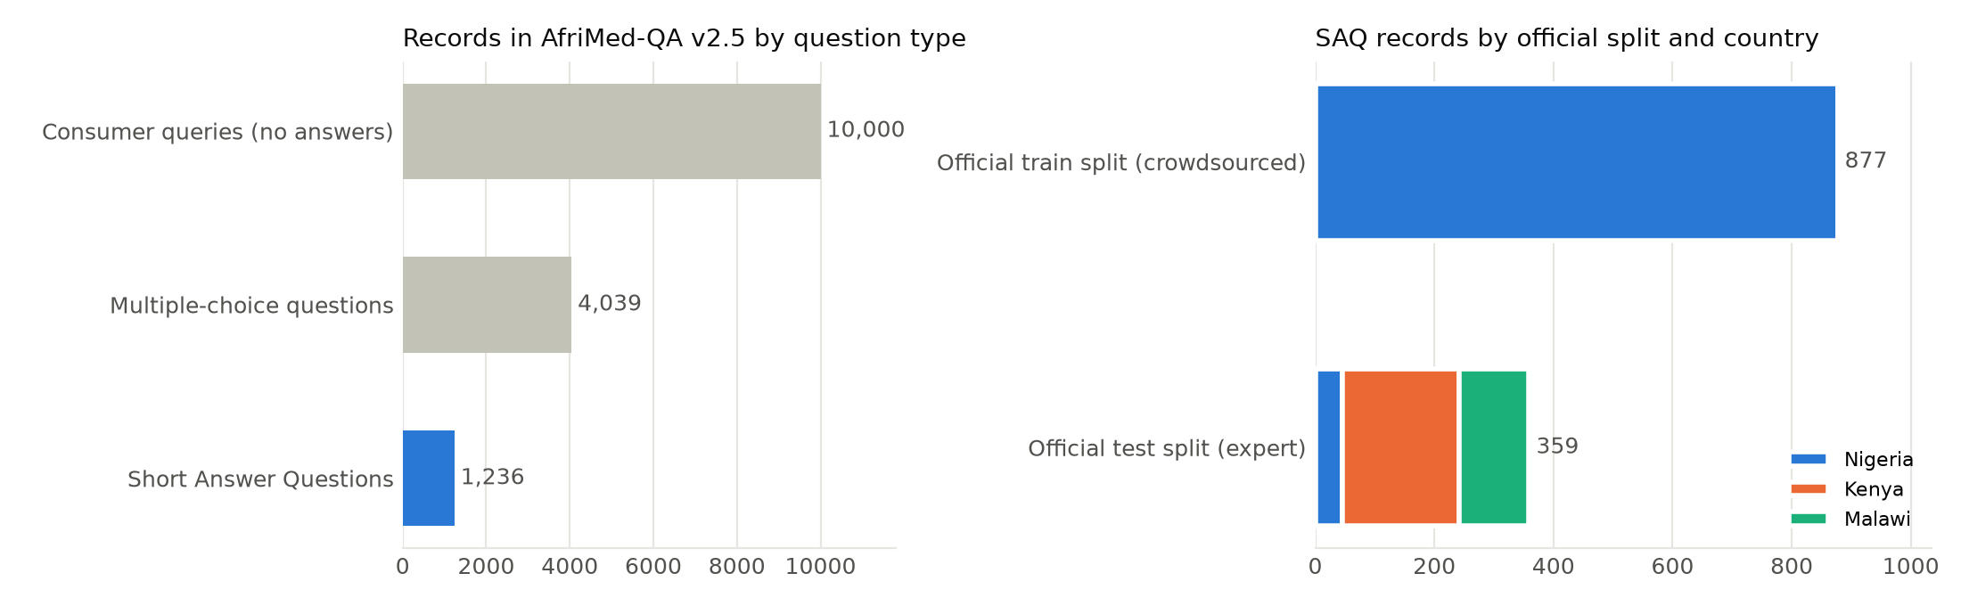
Figure 1. Records in AfriMed-QA v2.5 by question type (left), and the SAQ records in each official split by contributor country (right).
For these records the answer is stored in the answer_rationale column, which is filled for every SAQ record while the multiple-choice answer columns are empty. The dataset also offers a question_clean column, but when I compared it with the original question column I found that it splits medical terms apart, turning G6PD into "G 6 PD" and HER2 into "HER 2", so I used the original questions and applied my own cleaning.

4.2 Characteristics of the data
The SAQ records have no missing questions or answers and no duplicate questions, and Table 1 summarises their main characteristics. The most important property is visible on the right of Figure 1: the dataset's official split follows the source of the records exactly. All 877 official training records are crowdsourced questions from Nigeria, whereas all 359 official test records were written by experts in Kenya, Malawi and Nigeria. The two groups also differ in style. Crowdsourced questions are general, such as "What is the most common cause of ... in Africa?", and their fluent one-sentence answers often repeat the question's wording. Expert questions resemble examination prompts, such as "Complications of thyroidectomy", and their answers are often short lists. Only 50 records carry human quality ratings, and topic coverage is thin: a keyword count found 32 questions about malaria, 35 about HIV and 16 about hypertension, while many diseases do not appear at all.
Table 1. Main characteristics of the 1,236 SAQ records.
Property | Value
Contributor country | Nigeria 923, Kenya 195, Malawi 118
Source | 877 crowdsourced records (official training split) and 359 expert records (official test split)
Specialty | Recorded for 361 records, about half of them General Surgery
Question length | Median of 12 words, maximum of 114
Answer length | Median of 29 words, from a single word up to 900 words
Human quality ratings | 50 records, of which 6 were rated as incorrect

4.3 Cleaning and removal of records
I kept the cleaning deliberately light. I removed noise such as "Answer:" prefixes, exam marks like "(2marks)", a transcript tag and, in four questions, answer text that had been pasted into the question itself. I did not lowercase the text, remove stop words or apply stemming, because the Transformer model relies on natural sentences, and I kept the line breaks inside answers because many expert answers are lists.
I then removed 30 records for the reasons listed in Table 2. To find near-duplicates, I flagged every pair of records whose questions had a TF-IDF cosine similarity of at least 0.80 or whose answers had a similarity of at least 0.90, which produced 136 pairs, and I read each pair myself. The clearest problem was a conflict about the first-line treatment of uncomplicated malaria, which appeared three times with different answers. Two of them were wrong, since "Subranoid" is not a recognised medicine and pyrethroids are insecticides rather than a treatment, so I removed them and kept the answer recommending artemisinin-based combination therapy, which agrees with the WHO guidelines for malaria [21]. I also removed six records that the dataset's own reviewers rated as incorrect, together with eight records about genealogy and child labour that had no medical content. Most flagged pairs were nevertheless kept, because they asked about different diseases or populations, or were sub-questions of the same clinical case.
Table 2. Records removed during data preparation.
Reason for removal | Records
Near-duplicate, with the same question meaning and an almost identical answer | 9
Not health-related (genealogy or child labour) | 8
Rated as incorrect by the AfriMed-QA reviewers | 6
Malformed, with the answer in the question field instead of a question | 3
Conflicting answer about malaria treatment | 2
Answer belonging to a different question | 1
Exact duplicate after cleaning | 1
Total | 30

4.4 Training, validation and test sets
I kept the official split, as the project guidelines required. The test set therefore consists of the 354 official test records that remained after cleaning, and I never used it for training or for choosing settings. I took the validation set from the official training records only. To prevent data leakage, I placed near-identical records in the same group using the similarity thresholds described above, and GroupShuffleSplit kept each group within a single set. Table 3 shows the result. Because every training and validation record is crowdsourced while every test record is expert-written, the test results measure how well the models transfer to a different kind of question, and I expected them to be lower than the validation results.
Table 3. The three sets used in the project.
Set | Records | Source | Countries | Median answer tokens
Training | 711 | Crowdsourced | Nigeria | 42
Validation | 141 | Crowdsourced | Nigeria | 41
Test | 354 | Expert | Kenya 190, Malawi 118, Nigeria 46 | 51.5
Total | 1,206

The model used in this project reads text as WordPiece tokens, accepts at most 512 tokens and was trained on texts of up to 250 tokens, according to its model card [22]. Figure 2 shows that the questions are short, while the test answers are longer and more varied, with 47 of them exceeding 250 tokens. I did not shorten any answers, because the user should see the complete answer, so only the five answers longer than 512 tokens are truncated when they are embedded.
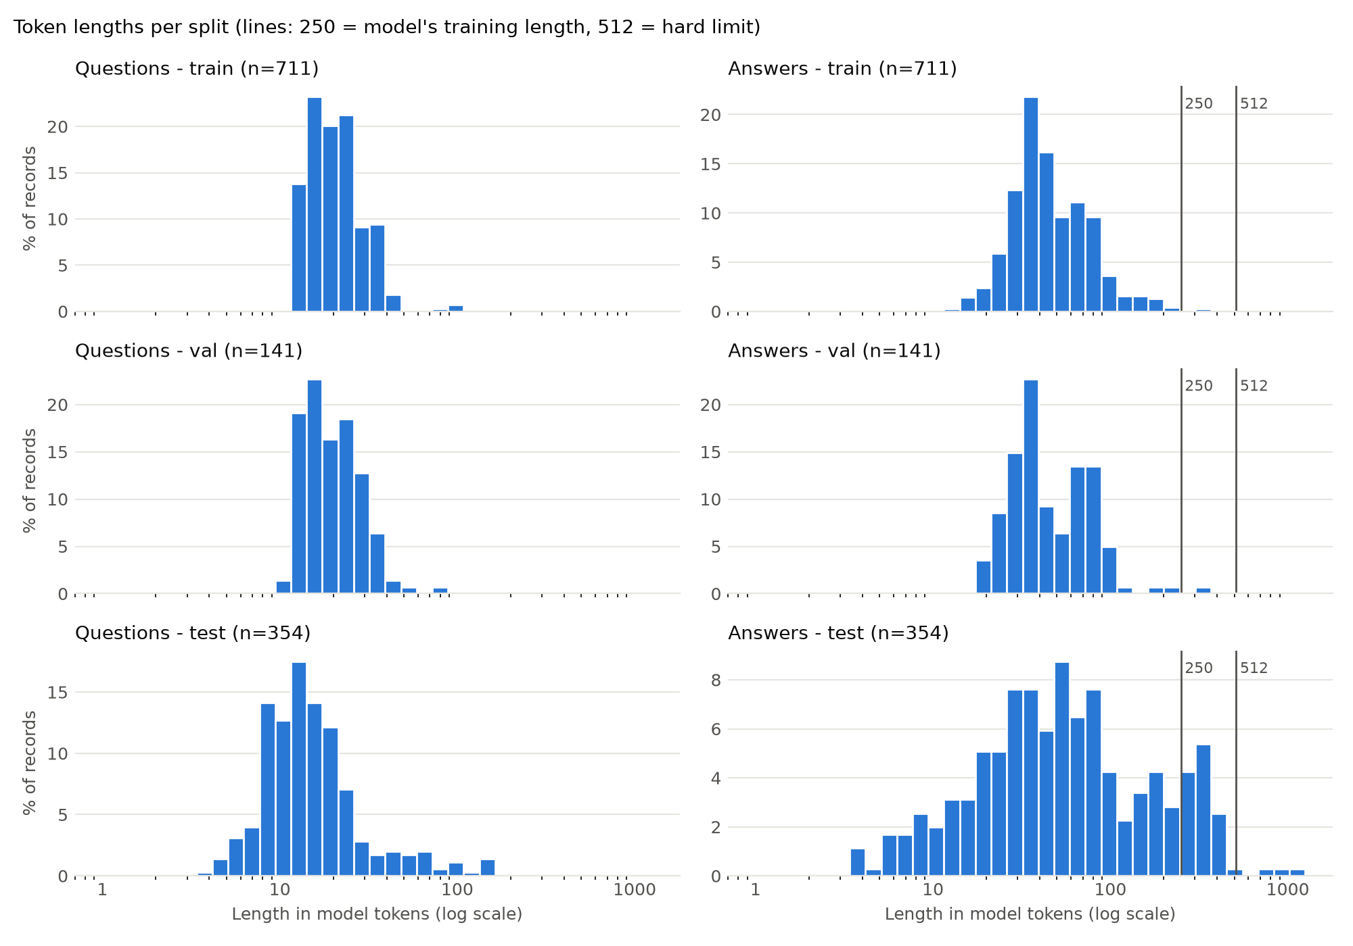
Figure 2. Length of questions and answers in model tokens for each set. The vertical lines mark the 250-token length the model was trained on and the 512-token input limit.

4.5 Additional question sets for evaluation
Two further sets of questions were needed to test the requirements of the assistant. The first contains 40 paraphrased questions, 20 based on validation questions and 20 on test questions, reworded in everyday English to test whether the assistant understands questions phrased differently from the dataset. These paraphrases are used only for evaluation, never for training, and because there are only 40 of them, I treat their results as indicative rather than conclusive.
The second set contains questions that the assistant should refuse, all taken from real sources rather than written for the project. Non-medical questions came from the development set of SQuAD 2.0 [17], excluding the articles related to health or biology. Medical questions about uncovered topics came from the AfriMed-QA consumer queries, which are otherwise unused, and I restricted them to diseases whose key words never appear in the knowledge base, such as psoriasis, vertigo and COVID-19. The validation and test sides used different articles and different diseases, and I added the three example questions from the assignment brief to the test side, which gave 133 questions for choosing the thresholds and 136 for testing them.

5. Methodology

5.1 Overview
The assistant follows a simple retrieval pipeline, shown in Figure 3. The user's question is cleaned in the same way as the dataset questions, turned into a vector, and compared with the vectors of the 1,205 unique answers in the knowledge base using cosine similarity, since one answer is shared by two of the 1,206 records. The most similar answer is shown together with the dataset question it belongs to, unless its similarity falls below a confidence threshold, in which case the assistant refuses. The following sections describe the two ways of turning text into vectors, the fine-tuning procedure, the confidence check and the evaluation.
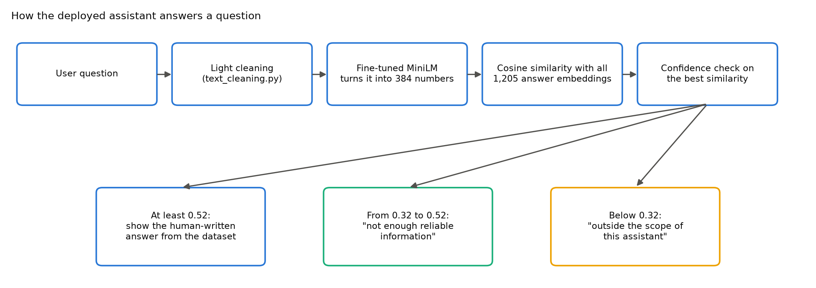
Figure 3. How the deployed assistant answers a question. The two thresholds were chosen on validation data, as described in Section 5.5.

5.2 TF-IDF baseline
The baseline represents each text with TF-IDF weights over unigrams and bigrams, using sublinear term frequency and removing English stop words, and it compares the question vector with each answer vector through cosine similarity. I chose it because it is simple, fast and easy to explain, and because it is a strong reference whenever questions and answers share vocabulary. Its obvious weakness is that it treats different words as unrelated even when they have the same meaning.

5.3 Pretrained sentence embeddings
The main model is multi-qa-MiniLM-L6-cos-v1 from the Sentence-Transformers library, a six-layer MiniLM model [12] with 22.7 million parameters. Its tokenizer splits the text into WordPiece tokens, the Transformer layers produce a contextual vector for each token, and the token vectors are averaged and normalised to length 1, giving a 384-dimensional sentence embedding. According to its model card, the model was trained on about 215 million question and answer pairs for semantic search [22]. I chose it because it was designed for matching questions with answers and because it is small enough to run on a laptop CPU and on free hosting, which matters for a system intended for settings with limited resources.

5.4 Fine-tuning
Fine-tuning continued the training of all model weights on the 711 training pairs. I used the Multiple Negatives Ranking loss, which follows the in-batch negative approach of Henderson et al. [13]. Figure 4 shows the idea on six validation questions and their answers, scored with the pretrained model. For a batch of N pairs, the model computes a similarity matrix of this kind between every question and every answer, multiplies the similarities by a scale of 20, and applies a cross-entropy loss in which each question's own answer, on the diagonal, is the correct class and the other N minus 1 answers act as negatives. Training therefore raises the diagonal and lowers the rest of each row. When two questions in a batch had identical answers, I masked the duplicate so that it was not treated as a wrong answer. This is the loss with which the pretrained model was originally trained, so fine-tuning continues the same task on AfriMed-QA.
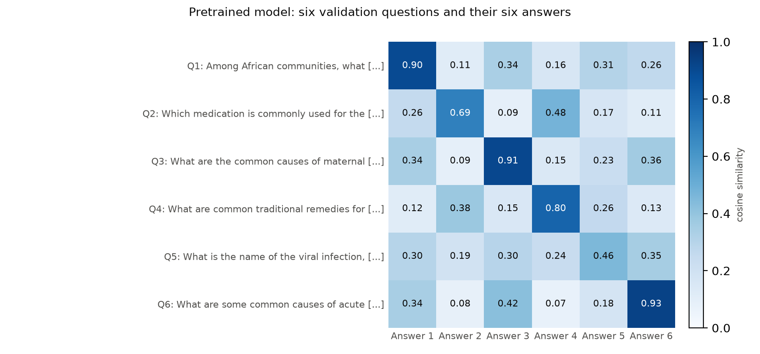
Figure 4. Cosine similarity between six validation questions (rows) and their human-written answers (columns), computed with the pretrained model. The correct answers lie on the diagonal.
In this small sample the question's own answer already has the highest similarity in all six rows, but the margins differ. The fifth question gives its own answer only 0.46, which is 0.11 above the next answer, and small margins like this one become a real problem when the correct answer has to beat 1,204 other answers rather than five.
Training used the AdamW optimiser [23] with a learning rate of 2e-5 unless stated otherwise, a weight decay of 0.01, a linear learning-rate schedule with warm-up over the first 10% of steps, and a maximum length of 256 tokens. Each run lasted up to five epochs, and after every epoch I evaluated the model on the validation set so that the epoch with the best validation MRR could be kept. Table 4 lists the experiments. Each experiment changed one setting at a time, and I repeated the main configuration with three random seeds to measure how much the results vary by chance.
Table 4. Experiments and the reason for each.
Run | Setting | Reason
E1 | TF-IDF baseline | A reference point that relies only on shared words.
E2 | Pretrained model without training | Measures the effect of meaning-based retrieval alone.
E3 | Fine-tuned with a learning rate of 2e-5 and a batch size of 32, seeds 42, 43 and 44 | The main configuration and its variability.
E4 | Learning rate of 5e-5 | Tests faster adaptation.
E4b | Learning rate of 1e-5 | Tests gentler adaptation.
E5 | Batch size of 64 | More in-batch negatives, but fewer updates per epoch.
E6 | Question compared with dataset questions as well as answers | Tests the requirement to recognise paraphrased questions.

5.5 Confidence thresholds
The similarity of the best-matching answer serves as the assistant's confidence. If it is at least the answer threshold, the answer is shown. If it lies between a lower scope threshold and the answer threshold, the assistant replies that it does not have enough reliable information, and if it falls below the scope threshold, the assistant replies that the question is outside its scope. I chose both thresholds on validation data. For every candidate value from 0.00 to 1.00 in steps of 0.01, I computed the share of answerable validation questions that would be answered and the share of the questions to be refused that would be refused. I set the answer threshold to the value with the highest balanced accuracy, the average of the two shares, and then chose the scope threshold below it to best separate non-medical questions from uncovered medical ones. This is a simple form of the selective answering studied by Kamath et al. [18], and I applied the same procedure to the TF-IDF baseline for comparison.

5.6 Evaluation
I evaluated every model in the same way. Each validation or test question was compared with all 1,205 answers, and I recorded the rank of its own human-written answer. Recall@1 is the share of questions whose correct answer is ranked first, which corresponds to what the user sees. Recall@3 is the share with the correct answer among the top three, and the mean reciprocal rank (MRR) is the average of one divided by the rank of the correct answer, which gives partial credit when the correct answer is close to the top. I compared questions with answers rather than with dataset questions, because each held-out question is itself stored in the dataset and would otherwise simply find its own copy. I selected models using validation MRR only, and I used the test set after all choices had been made.

5.7 Implementation and own contribution
I implemented the project in Python with PyTorch [24], Hugging Face Transformers [25], Sentence-Transformers [11], scikit-learn [26] and Streamlit [27], and all experiments ran on a laptop CPU. The existing resources I used were the AfriMed-QA dataset, the pretrained multi-qa-MiniLM-L6-cos-v1 model, the SQuAD 2.0 questions and these libraries. My own work consisted of the data analysis and cleaning decisions, the leakage-free split, the evaluation setup and question sets, the fine-tuning loop and experiments, the confidence thresholds, the error analysis and the web application. Five notebooks carry out these steps in order, and the functions they share are kept in a small src folder.

5.8 Where the evaluation is not perfectly fair
A few features of the setup favour one model or one set of questions over another, and they should be kept in mind when reading the results.
Validation data resembles the training data: The validation questions come from the same crowdsourced Nigerian source as the training questions, while the test questions come from experts in three countries. Choosing the best epoch, learning rate, batch size and thresholds on validation data therefore favours models that fit the crowdsourced style, and the validation scores are likely to be optimistic. I kept this design because the guidelines required the official split, and for this reason I report the test results separately.
The strict metric: Recall@1 counts an answer as correct only if it belongs to the question's own record. When two records answer nearly the same question, returning the other record's answer is useful to the user but counts as a miss, so the metric slightly underestimates every model, including the baseline.
Small question sets: The paraphrase set has only 40 questions, so a single question changes its Recall@1 by 2.5 percentage points. The refusal sets were built with a keyword filter, so a few uncovered medical questions may still be partly related to records in the knowledge base. Differences of a few points on these sets should therefore not be read as meaningful.
One model family: All embedding results come from a single small model. A larger or different pretrained model might behave differently, particularly on the expert test questions, but I did not test other models within the CPU-only setup of this project.

6. Experiments and Results

6.1 Retrieval results
Figure 5 summarises Recall@1 for the three main models, and Table 5 gives the full results of every run. Moving from TF-IDF to pretrained embeddings improved every measure without any training on AfriMed-QA: validation Recall@1 rose from 0.553 to 0.624, test Recall@1 from 0.237 to 0.316, and Recall@1 on the paraphrased questions from 0.075 to 0.475.
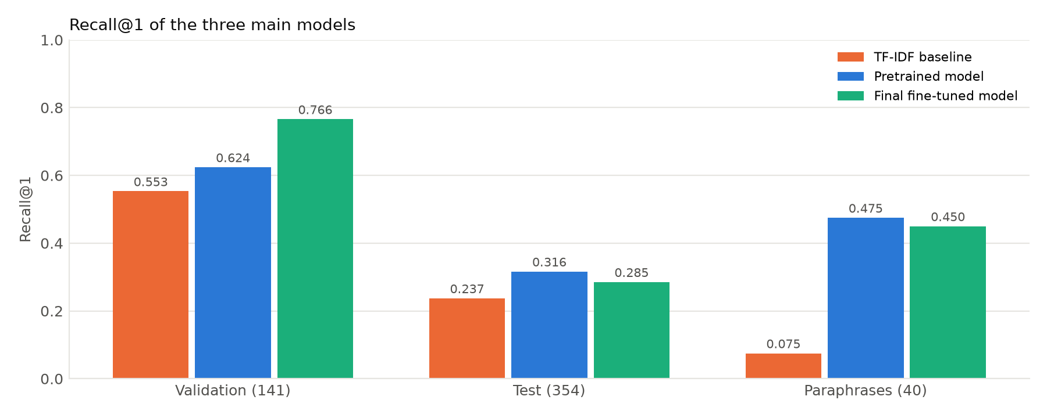
Figure 5. Recall@1 of the TF-IDF baseline, the pretrained model and the final fine-tuned model (E5) on the validation, test and paraphrased questions.
Table 5. Retrieval results over the 1,205 answers of the knowledge base. E3 is the mean and standard deviation of three seeds, and "Para." refers to the 40 paraphrased questions.
Run | Val R@1 | Val R@3 | Val MRR | Test R@1 | Test R@3 | Test MRR | Para. R@1
E1 TF-IDF | 0.553 | 0.709 | 0.656 | 0.237 | 0.325 | 0.294 | 0.075
E2 Pretrained | 0.624 | 0.794 | 0.711 | 0.316 | 0.424 | 0.388 | 0.475
E3 Fine-tuned | 0.749 ± 0.004 | 0.889 ± 0.004 | 0.826 ± 0.005 | 0.290 ± 0.009 | 0.398 ± 0.003 | 0.373 ± 0.006 | 0.450
E4 LR 5e-5 | 0.766 | 0.886 | 0.833 | 0.277 | 0.370 | 0.355 | 0.450
E4b LR 1e-5 | 0.752 | 0.886 | 0.826 | 0.285 | 0.427 | 0.376 | 0.450
E5 Batch 64 (final) | 0.766 | 0.894 | 0.837 | 0.285 | 0.396 | 0.372 | 0.450

The gain on paraphrases is the most telling, because TF-IDF can only match a paraphrase when it happens to reuse the dataset's words. Figure 6 compares the two representations on four sentence pairs. "What are the symptoms of malaria?" and "What are the signs of a fever caused by mosquito parasites?" share no content words, so their TF-IDF similarity is 0.00, while their embedding similarity is 0.70. The unrelated pair about repairing a laptop receives a low score from both methods.
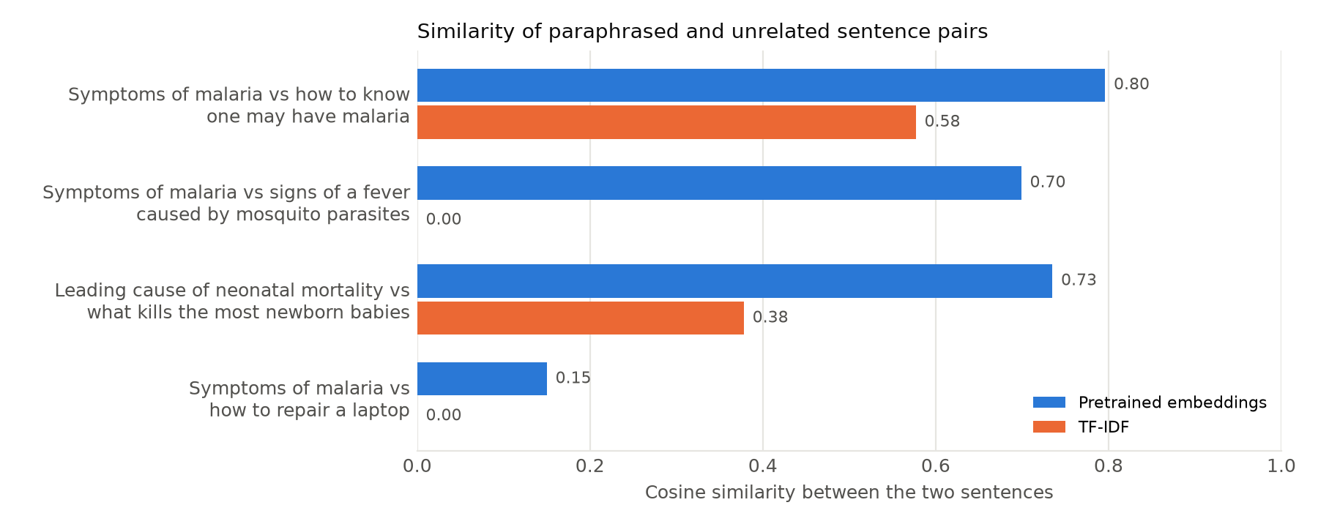
Figure 6. Cosine similarity of four sentence pairs with the pretrained embeddings and with TF-IDF. The first three pairs are paraphrases, and the last pair is unrelated.
Fine-tuning improved the results on the validation set considerably. The validation MRR rose from 0.711 to 0.826 on average across the three seeds, and the standard deviation of 0.005 shows that this gain is much larger than the variation caused by randomness. Figure 7 shows how the improvement developed. Every run passed the pretrained score within the first epoch and then levelled off between 0.81 and 0.84, while the training loss kept falling to between 0.02 and 0.13, which indicates that the model began to overfit its 711 training pairs after two to four epochs.
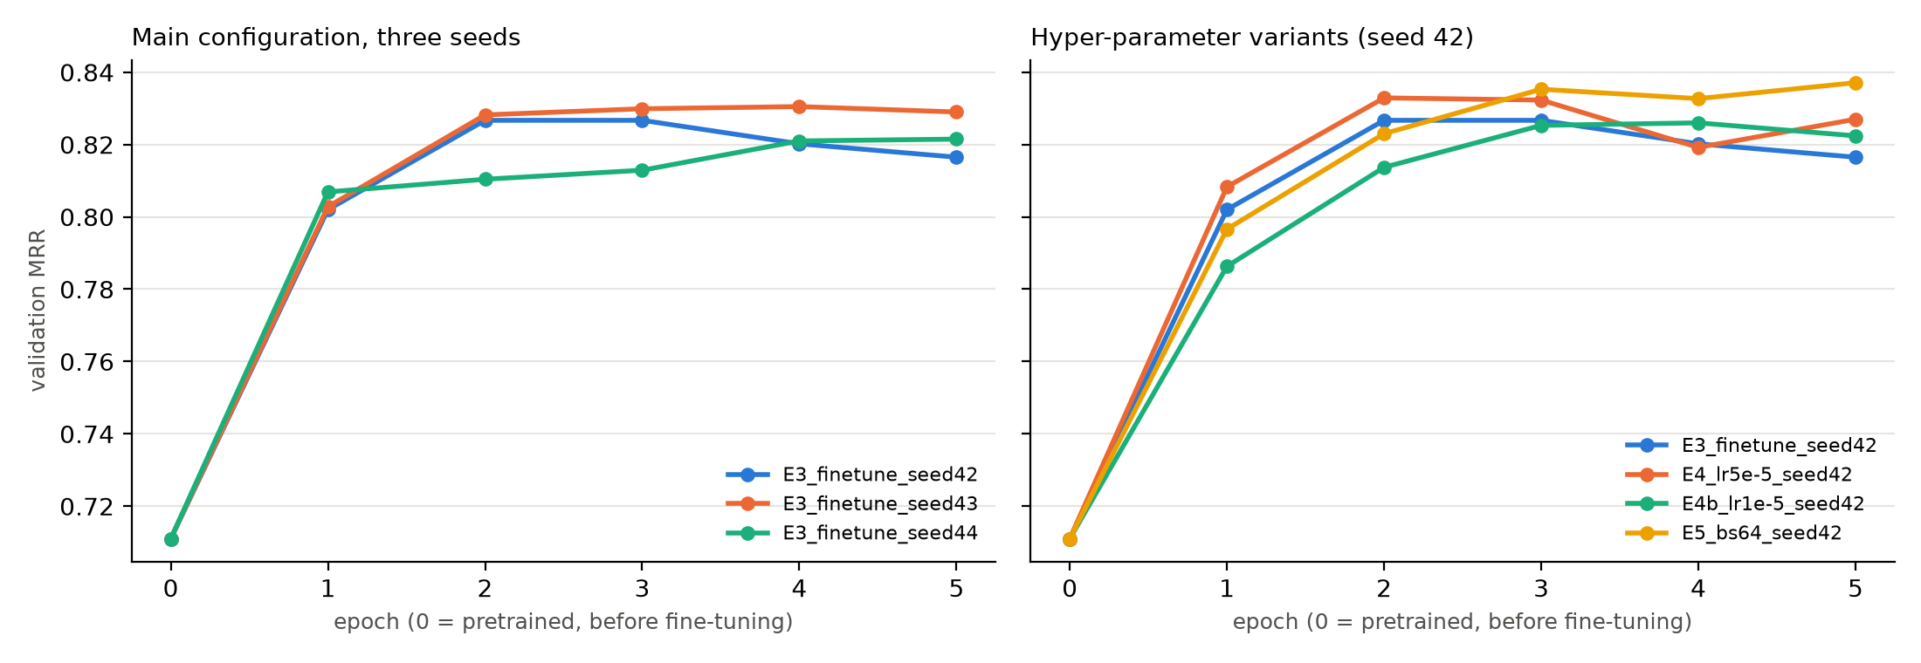
Figure 7. Validation MRR after each epoch, where epoch 0 is the pretrained model. The left panel shows the three seeds of the main configuration, and the right panel the learning-rate and batch-size variants.
The test set told a different story. Every fine-tuned run had a lower test Recall@1 than the pretrained model, between 0.277 and 0.297 against 0.316, and the mean of the three seeds lay about three standard deviations below the pretrained result. The other experiments were consistent with this pattern. The highest learning rate gave the best validation score among the E3 and E4 runs but the worst test score, while the lowest learning rate behaved almost like the default on the test set and did not recover the pretrained model's performance. The batch size of 64 reached the highest validation MRR, 0.837, and therefore became the final model under the rule I fixed in advance, although its advantage over the E3 mean amounts to only about two seed standard deviations.
To understand the drop, I checked how often each model returned a training answer as its top result for a test question, which is always wrong. Table 6 shows that this happened for 13.0% of the test questions with the pretrained model and for between 14.4% and 22.6% with the fine-tuned models, with the highest share for the highest learning rate. The fine-tuned models had therefore learned to favour the answers they were trained on, which helps to explain why the validation gains did not carry over to the expert test questions.
Table 6. Share of test questions for which the top answer came from the training set.
Model | Test R@1 | Top answer from training set | Among wrong answers
E2 Pretrained | 0.316 | 13.0% | 19.0%
E3 seed 42 | 0.280 | 18.1% | 25.1%
E3 seed 43 | 0.297 | 14.4% | 20.5%
E3 seed 44 | 0.294 | 15.5% | 22.0%
E4 LR 5e-5 | 0.277 | 22.6% | 31.2%
E4b LR 1e-5 | 0.285 | 15.3% | 21.3%
E5 Batch 64 (final) | 0.285 | 16.1% | 22.5%

6.2 What the question is compared with (E6)
Experiment E6 tested whether the assistant should compare the user's question with the dataset questions as well as with the answers. Table 7 shows a clear trade-off. Comparing with the dataset questions helped the paraphrased questions, particularly on the test side where many answers are short, but it halved the accuracy on held-out validation questions, because many dataset questions share templates such as "What is the leading cause of ... in Nigeria?" and "What is the second leading cause of ... in Nigeria?". Storing each record as a single question and answer text gave the most balanced paraphrase results, but it could not be measured on held-out questions, since each question would appear inside its own stored text. I therefore kept the answers-only option, which was the only one measurable on the validation set and was far ahead there, and I did not use the test-side paraphrase results for the decision.
Table 7. Recall@1 of the fine-tuned model for three ways of comparing the question with the knowledge base.
Compared with | Held-out validation | Validation paraphrases | Test paraphrases
Answers only | 0.766 | 0.55 | 0.35
Dataset questions and answers, higher score kept | 0.383 | 0.60 | 0.70
Question and answer stored as one text | Not measurable | 0.65 | 0.65

6.3 Confidence thresholds
On the validation data, the balanced accuracy peaked at 0.968 with an answer threshold of 0.52, and I set the scope threshold at 0.32. Figure 8 shows why a single similarity score can serve as a confidence measure. Non-medical questions have a median similarity of about 0.27 to their best answer, uncovered medical questions fall in between, and validation questions have a median of about 0.76.
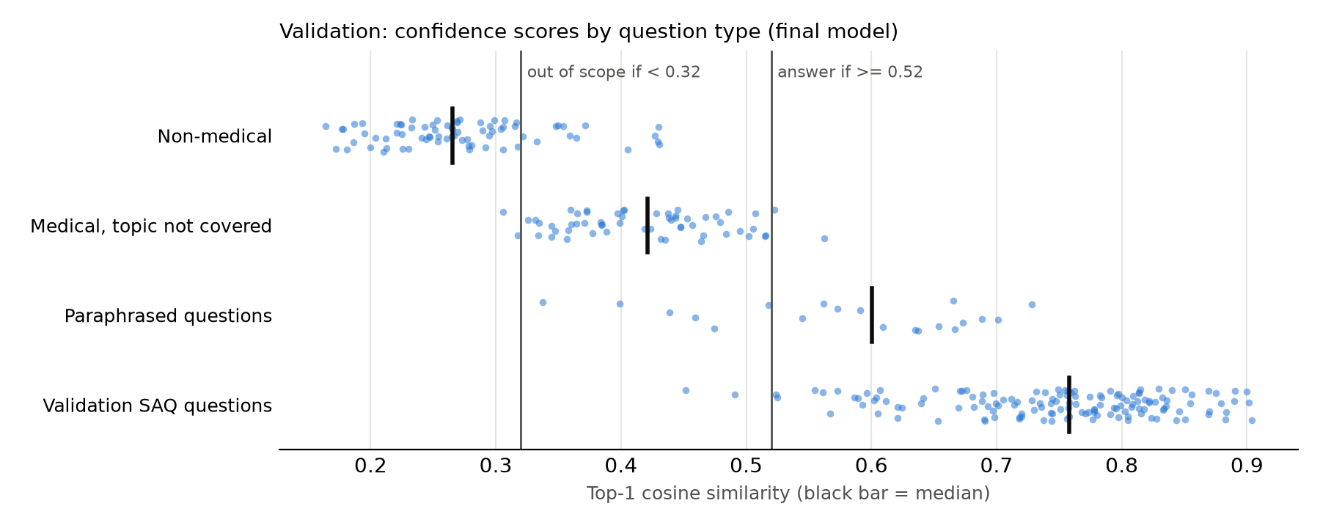
Figure 8. Top-1 cosine similarity of the final model on the validation question sets. Black bars mark the medians, and the vertical lines mark the scope threshold (0.32) and the answer threshold (0.52).
Figure 9 shows the trade-off behind the choice. Raising the threshold refuses more of the questions that should be refused, but it also refuses more answerable questions. A threshold of 0.45 would have answered 98.1% of the answerable validation questions but let 12.8% of the questions to be refused through, while a threshold of 0.60 would have refused all of them but answered only 86.3% of the answerable questions.
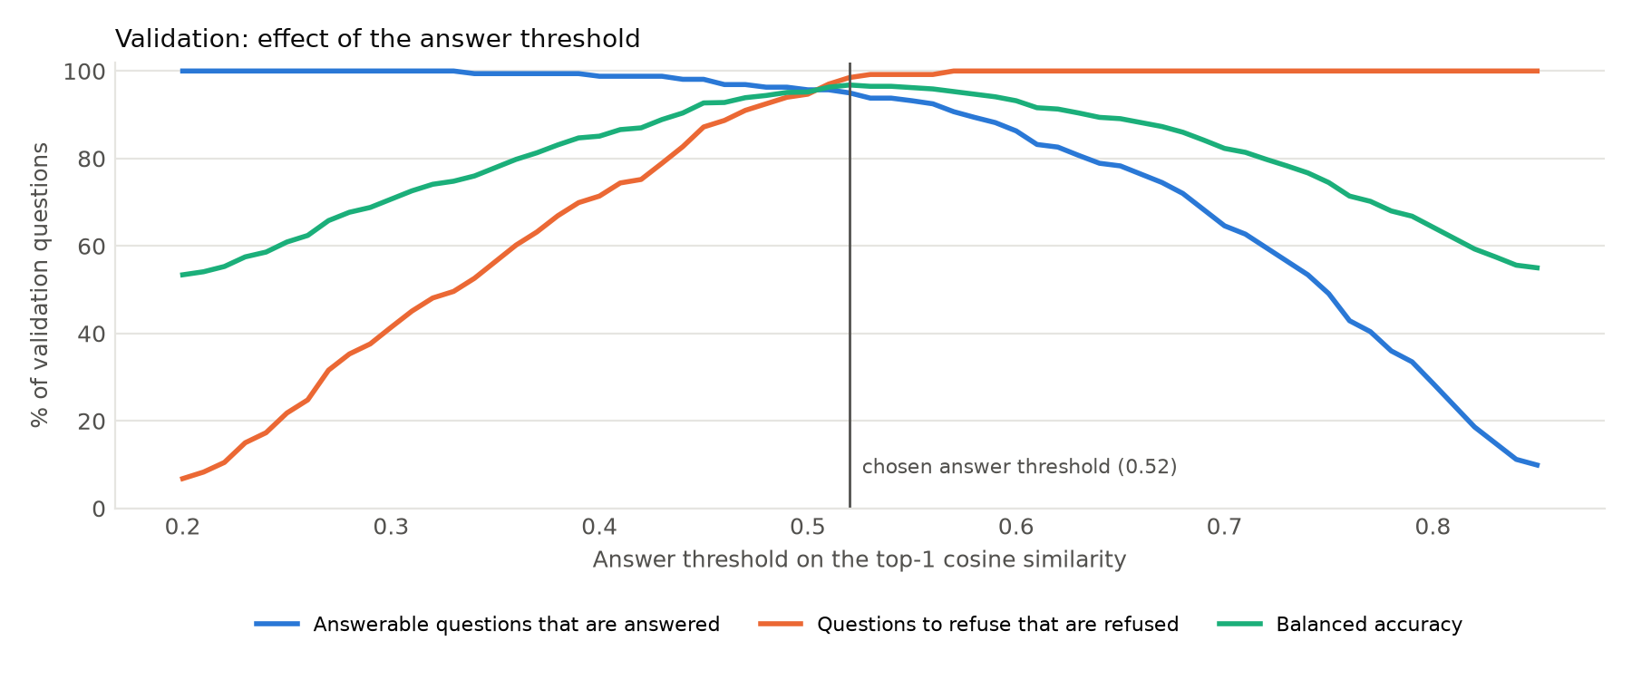
Figure 9. Effect of the answer threshold on the validation questions. The vertical line marks the chosen threshold of 0.52, where the balanced accuracy is highest.
Table 8 and Figure 10 show how the thresholds behaved on the unseen test questions. The final model refused 98.7% of the non-medical questions and 94.8% of the uncovered medical questions, including all three examples from the brief, although "How can I cook rice?" scored 0.37 and received the "not enough reliable information" message rather than the out-of-scope message. With thresholds chosen in the same way, TF-IDF answered about a quarter of both kinds of questions, including "How do I repair my laptop?". The cost of the final model's caution appears on the expert test questions, of which only 54.0% were answered and 22.0% were answered correctly, because the expert questions produce lower similarity scores than the crowdsourced questions on which the thresholds were chosen.
Table 8. Behaviour of the confidence check on the test questions.
Question type | Final model answered | Final model correct | Final model refused | TF-IDF answered | TF-IDF correct
Expert dataset questions (354) | 54.0% | 22.0% | 46.0% | 55.1% | 14.1%
Paraphrased questions (20) | 70.0% | 35.0% | 30.0% | 35.0% | 0.0%
Uncovered medical questions (58) | 5.2% | n/a | 94.8% | 25.9% | n/a
Non-medical questions (78) | 1.3% | n/a | 98.7% | 24.4% | n/a

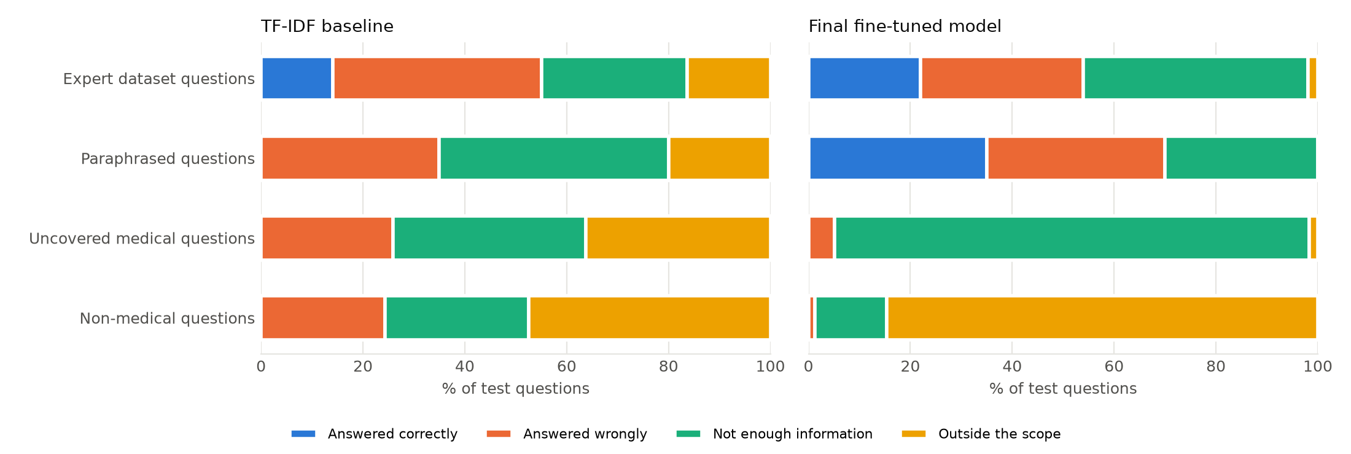
Figure 10. How each kind of test question was handled by the TF-IDF baseline (left) and the final model (right). For the questions that should be refused, any answer counts as answered wrongly.

7. Error Analysis and Discussion

7.1 Where the model fails
Breaking the test results down by group showed that answer length was the strongest factor. Figure 11 shows that the final model ranked the correct answer first for 87.2% of the test questions with answers longer than 250 tokens, but for only 9.1% of those with answers of 50 tokens or fewer. Differences between countries followed the same pattern. Nigerian expert questions, whose answers have a median length of 328.5 tokens, reached a Recall@1 of 0.935, while Kenyan questions, with a median of 47.5 tokens, reached only 0.158, and Malawian questions lay in between at 0.237. The pretrained model was ahead of the final model in every one of these groups, so the drop after fine-tuning was not limited to one country or one kind of answer. The test errors were also mostly complete misses, since the correct answer was not in the top ten for 45.5% of the test questions, compared with 5.0% on the validation set.
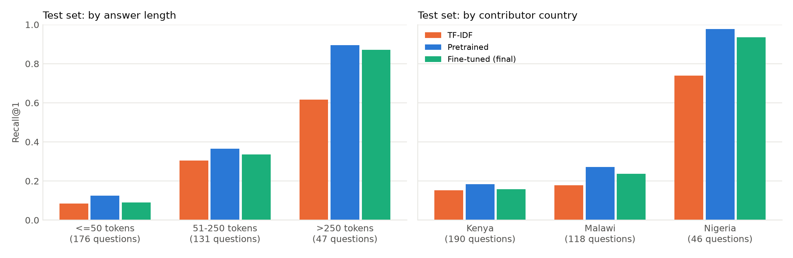
Figure 11. Test Recall@1 of the three main models by answer length (left) and by contributor country (right).

7.2 Types of errors
Reading the failed examples revealed a few recurring types of error. The most common involved very short reference answers. For "From which cells does medullary carcinoma arise?", the correct answer "Parafollicular cells" was ranked 100th, because linking a question to a one- or two-word answer requires specialised knowledge that a small model trained on 711 pairs often lacks. Paraphrases failed for the same reason: "Which test confirms that someone has rheumatoid arthritis?" has the one-word answer "Anti-CCP", which was ranked 694th. A second type of error came from matching the form of a question rather than its topic, as when "What are the diagnostic tests for Addison's Disease?" was matched with "Investigations for intestinal obstruction". The same mechanism allowed 4 of the 136 test questions that should have been refused to pass the threshold.
Other errors were milder. When two dataset questions are nearly identical, the model may return the other record's compatible answer, which the strict metric counts as wrong, and short prompts or abbreviations such as "What is ANDI and examples" received a low similarity to every answer and were refused. In one clinical case, the dataset's reference answer, "Duodenal atresia" for a four-week-old baby with projectile non-bilious vomiting, may itself be debatable, since this presentation is classically associated with pyloric stenosis. This is a reminder that only 50 records in the dataset carry expert quality ratings.

7.3 The malaria example
The malaria example from the assignment brief illustrates a different weakness. When asked "How can someone know they may have malaria?", the assistant returned the one-word answer "Malaria", which belongs to the question "What is the commonest parasitic infection in Africa?" and scored 0.644, while the relevant records about the diagnosis and presentation of malaria scored between 0.40 and 0.47, as Figure 12 shows. An answer that consists only of a disease name is similar to almost any question about that disease, which is a form of the hubness problem described by Radovanović et al. [19], and across all validation and test questions some answers were ranked first for as many as 11 different questions. When each record was instead stored as a combined question and answer text, both malaria questions retrieved a clinical scenario in which malaria is the likely diagnosis, which suggests a practical direction for improvement.
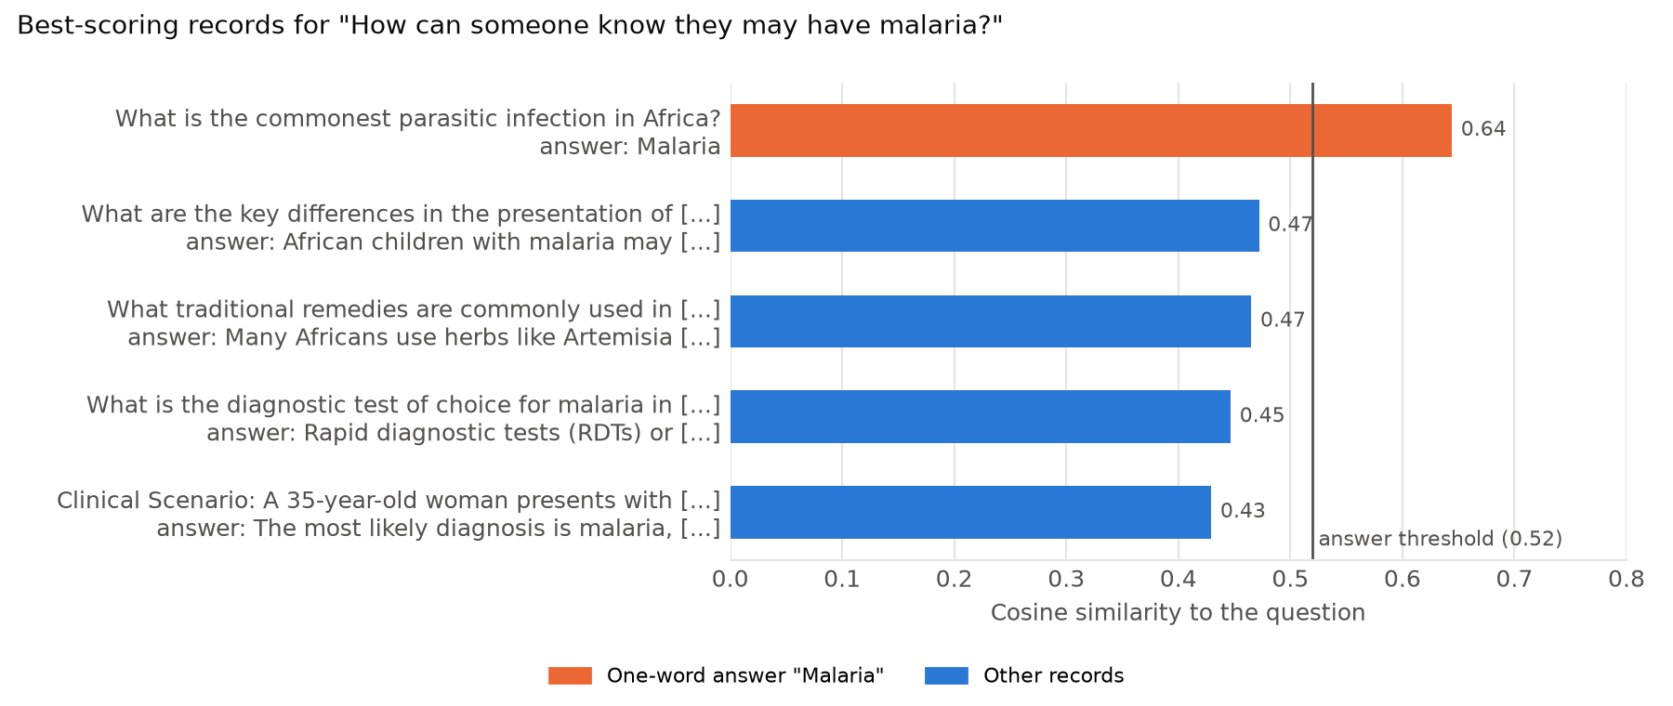
Figure 12. The five best-scoring records for "How can someone know they may have malaria?" with the final model. The one-word answer "Malaria" is the only record above the answer threshold.

7.4 Discussion
The results answer the three research questions with some nuance. First, meaning-based retrieval clearly outperformed word matching, especially on paraphrased questions, which confirms the value of sentence embeddings [11] for an assistant whose users will not use the dataset's exact wording. Second, fine-tuning on AfriMed-QA improved retrieval on questions similar to the training data, in line with the benefits of domain adaptation reported by Gururangan et al. [15], but it did not improve and slightly harmed performance on expert questions. This agrees with the finding of Thakur et al. that dense retrievers often generalise poorly beyond the distribution they were trained on [16], and it resembles, on a small scale, the way neural networks lose earlier abilities when they are trained further on a narrow task [28]. In this project a likely cause is visible in the data, since the training and validation sets contained only crowdsourced questions from one country. Third, a threshold chosen on validation data refused most non-medical and uncovered questions, but because it was tuned on crowdsourced questions it was too cautious for the expert ones, which agrees with the observation of Kamath et al. that deciding when to answer becomes harder under domain shift [18].
The most important lesson is therefore about evaluation rather than modelling. A validation set that resembled the training data gave an optimistic picture, and only the separate expert test set revealed how the system behaves on a different kind of question. For a real deployment, the validation data should reflect the questions that the system will actually receive.

8. Deployment
I packaged the final model, its thresholds and the knowledge base in a single folder and published the folder in a Hugging Face model repository, from which the web application downloads it when it starts. The application is a chat interface built with Streamlit [27], in which the user's questions appear on the right and the assistant's replies on the left. Each question is passed to the assistant module, which cleans it, embeds it with the fine-tuned model, compares it with the answer embeddings computed when the application starts, and applies the same decision function that was used during evaluation. The reply is either the human-written answer from the dataset or one of the two refusal messages, and answers that describe traditional remedies receive an additional caution, because such answers report contributors' practices rather than clinical guidance. The sidebar offers a button that starts a new chat, four example questions, a short description of the assistant and a disclaimer stating that the system provides educational information and does not replace professional medical advice, diagnosis or treatment. No external AI service is used at any point.
The similarity score, the matched dataset question and the source of each record are useful for evaluation, but they would distract ordinary users, so the interface hides them. They remain available through a debug setting in the application code, which displays them under every reply during development. The message box also accepts attached files, as many chat interfaces do, but the assistant only reads typed questions and tells the user so when a file is attached.
Figure 13 shows the application answering a question about the treatment of malaria, and Figures 14 and 15 show the two refusal messages. I took these screenshots from the application running on my laptop.
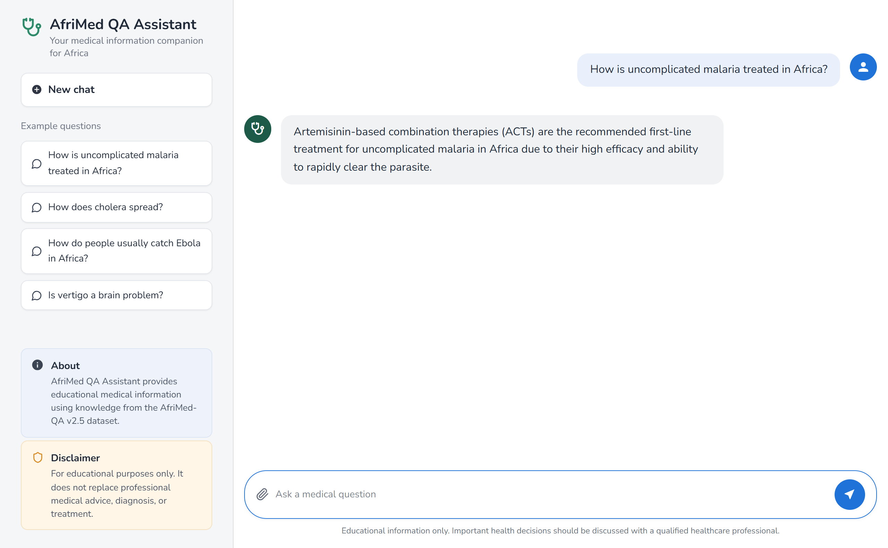
Figure 13. The chat interface answering "How is uncomplicated malaria treated in Africa?" with the human-written answer from the knowledge base.
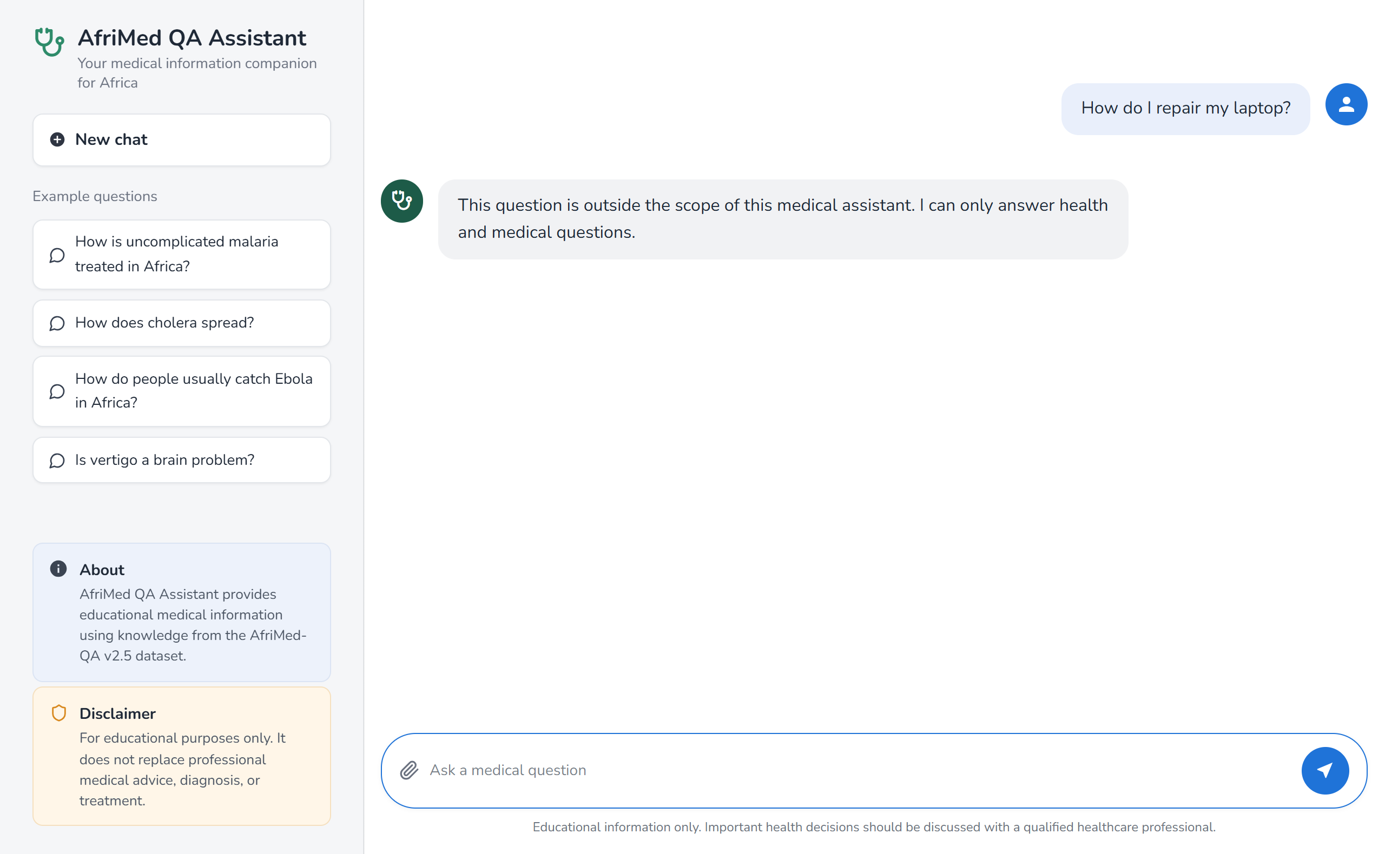
Figure 14. The assistant refusing "How do I repair my laptop?" as outside its scope.
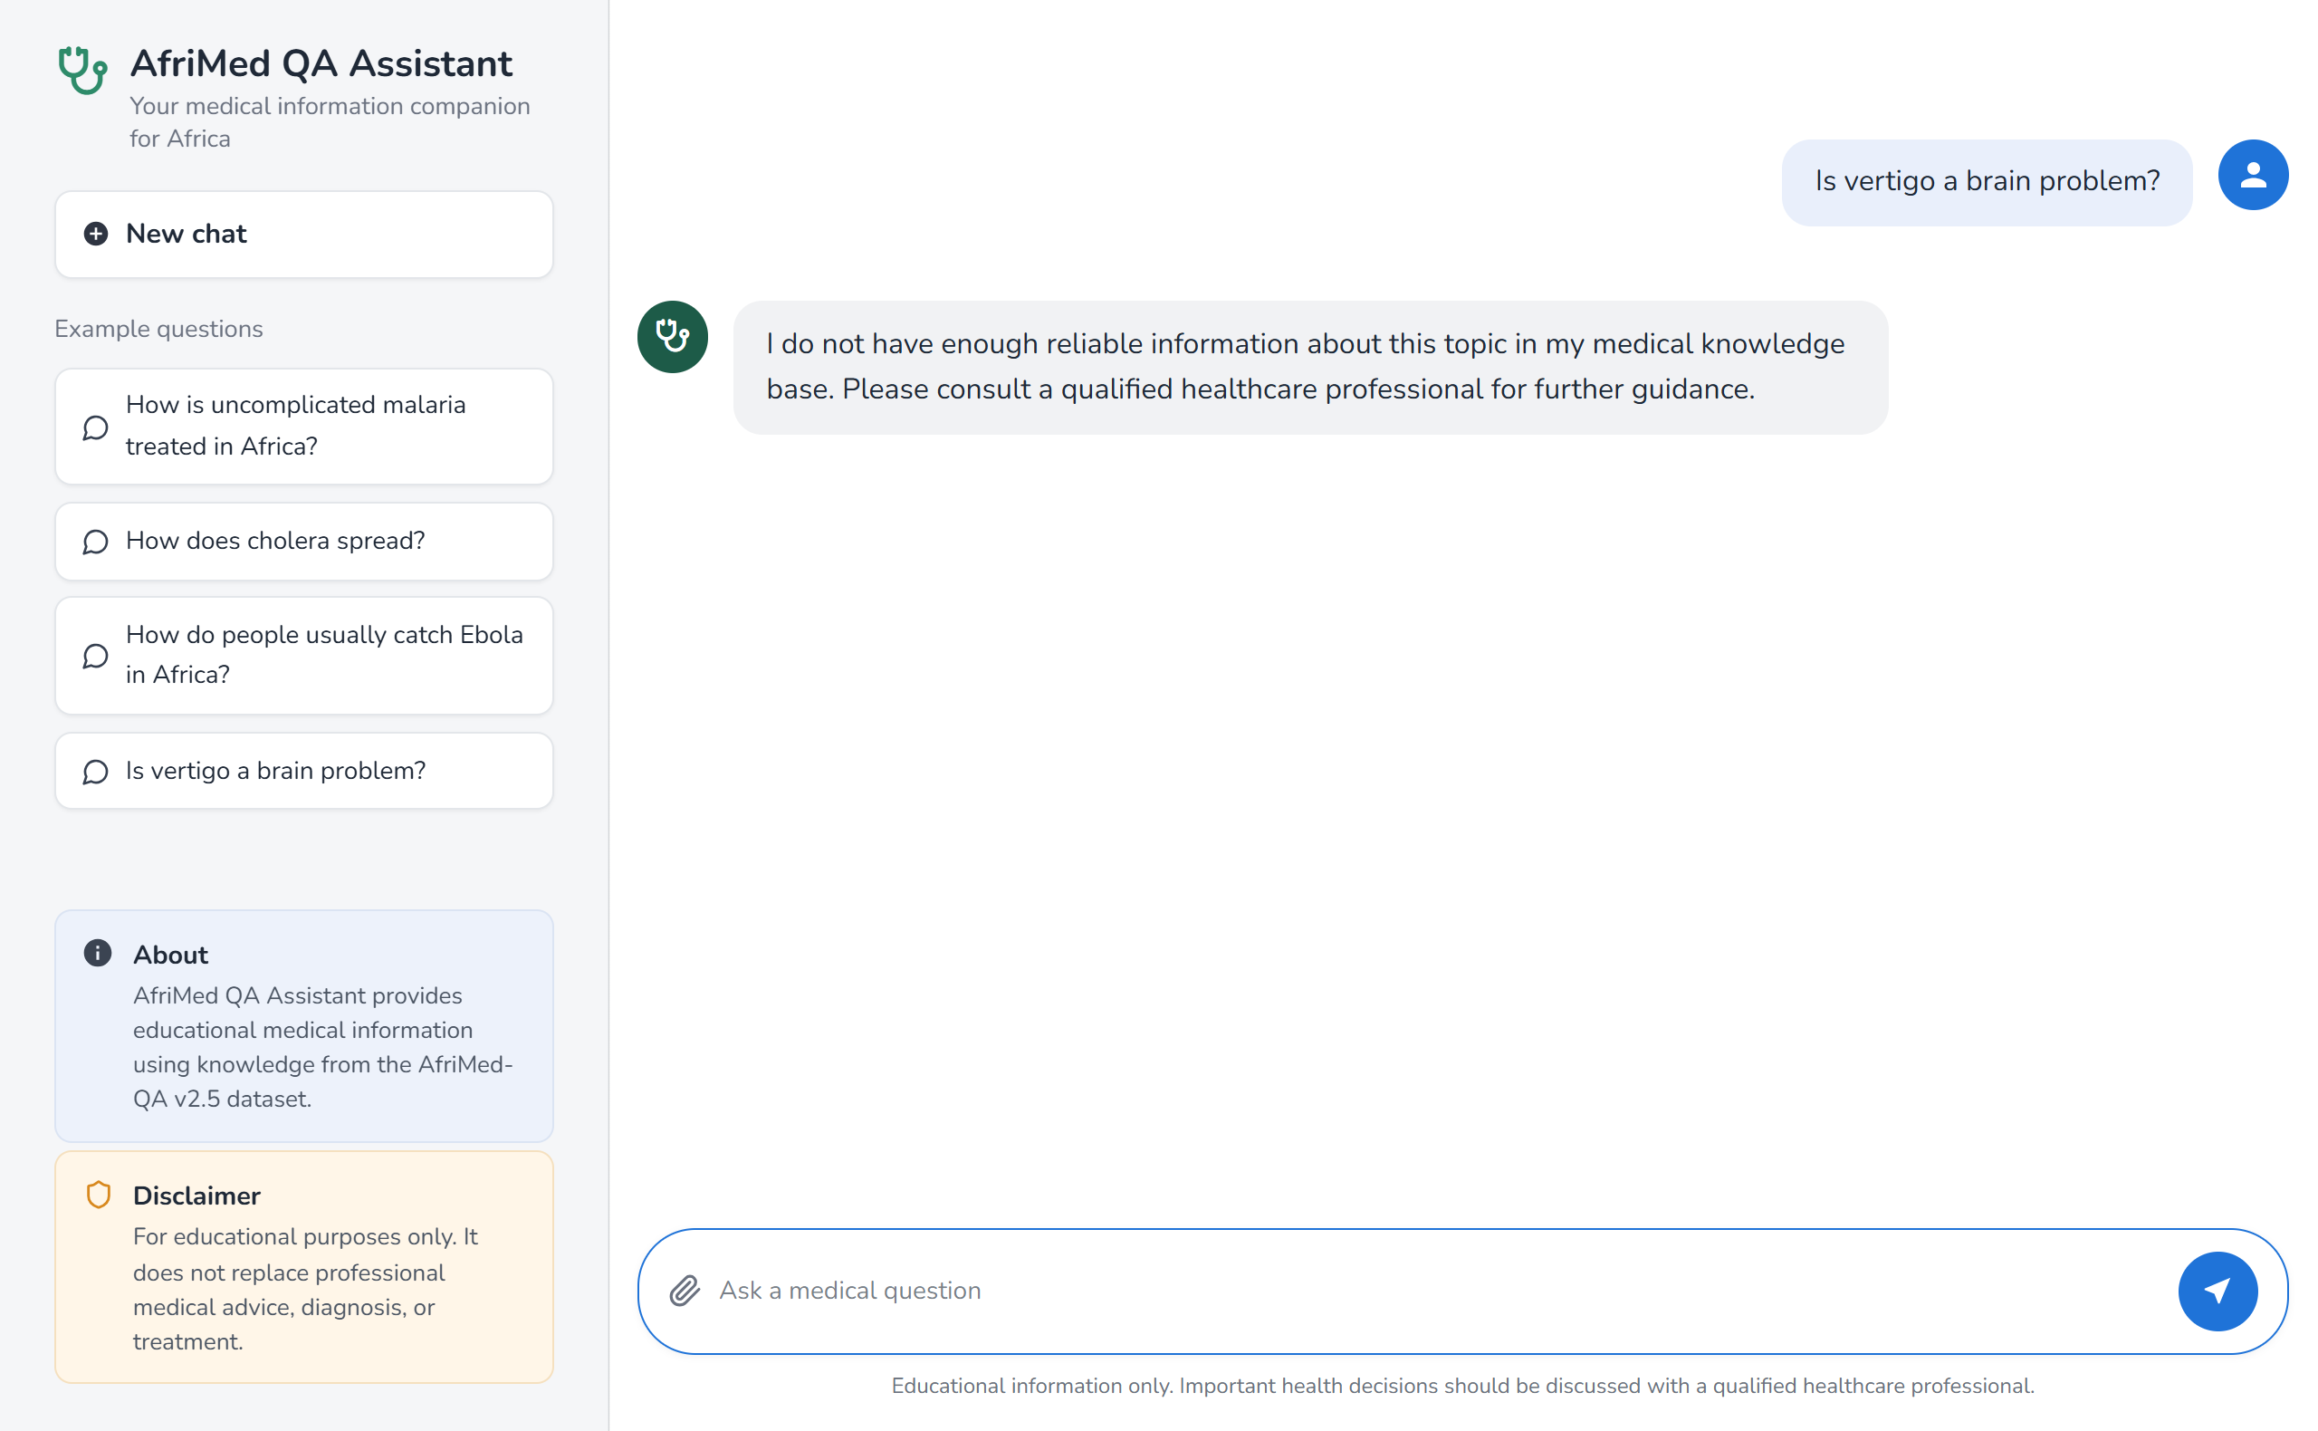
Figure 15. The assistant replying to "Is vertigo a brain problem?" that it does not have enough reliable information.
The application is prepared for Streamlit Community Cloud, which installs the libraries listed in the repository and runs the application directly from GitHub, and on Linux the requirements install the CPU-only build of PyTorch to keep the installation small. The public link will be added at the top of this report once the application has been published and tested.

9. Limitations and Future Work
Coverage: A knowledge base of 1,206 records cannot cover every disease or medicine. Questions about missing topics can only be refused, or occasionally answered with a loosely related record, which happened for 5.2% of the uncovered medical test questions.
Data from one source: All training and validation questions were crowdsourced in Nigeria, so the model and the thresholds were tuned to one style of question, and the validation set could not reveal how poorly they would transfer to expert questions from Kenya and Malawi. Only 50 records carry quality ratings, and my manual cleaning decisions were made without review by a medical expert.
What the system can do: The system works only in English and returns stored answers, so it cannot combine information from several records or adapt an answer to a user's situation.
Future work: Including expert questions in both the training and the validation data would make fine-tuning and threshold selection reflect the questions the system is meant to answer. Storing each record as a combined question and answer text, giving less weight to answers that are too short to be informative, or adding a cross-encoder to re-rank the top candidates could reduce hub answers and failures on short answers. Review of the knowledge base by clinicians, a larger paraphrase set written by health workers and students, and support for African languages would make the assistant more reliable and more useful for its intended users.

10. Conclusion
In this project I built a question answering assistant that gives educational medical information using only human-written answers from AfriMed-QA v2.5 and refuses questions it cannot answer reliably. Meaning-based retrieval with a small pretrained sentence-embedding model outperformed TF-IDF on every evaluation set, with the largest difference on paraphrased questions. Fine-tuning on 711 crowdsourced question and answer pairs raised the validation MRR from 0.711 to 0.837, but it did not improve the results on expert-written test questions, and an analysis of the predictions showed that the fine-tuned models had learned to favour their training answers. A confidence threshold chosen on validation data refused 98.7% of the non-medical and 94.8% of the uncovered medical test questions, far more than the baseline, at the cost of refusing many expert questions. The work showed that grounding and refusal can be achieved with a simple and explainable system, and that the most important factor in whether such a system works is how well its training and validation data represent the questions it will receive.

11. References
[1] A. Ahmat, S. C. Okoroafor, I. Kazanga, J. A. Asamani, J. J. S. Millogo, M. M. A. Illou, K. Mwinga, and J. Nyoni, "The health workforce status in the WHO African Region: Findings of a cross-sectional study," BMJ Global Health, vol. 7, no. Suppl 1, Art. no. e008317, 2022, doi: 10.1136/bmjgh-2021-008317.
[2] Z. Ji et al., "Survey of hallucination in natural language generation," ACM Computing Surveys, vol. 55, no. 12, pp. 1-38, 2023, doi: 10.1145/3571730.
[3] D. Jin, E. Pan, N. Oufattole, W.-H. Weng, H. Fang, and P. Szolovits, "What disease does this patient have? A large-scale open domain question answering dataset from medical exams," Applied Sciences, vol. 11, no. 14, Art. no. 6421, 2021, doi: 10.3390/app11146421.
[4] A. Ben Abacha and D. Demner-Fushman, "A question-entailment approach to question answering," BMC Bioinformatics, vol. 20, Art. no. 511, 2019, doi: 10.1186/s12859-019-3119-4.
[5] T. Olatunji et al., "AfriMed-QA: A pan-African, multi-specialty, medical question-answering benchmark dataset," in Proc. 63rd Annu. Meeting Assoc. Comput. Linguistics (Volume 1: Long Papers), 2025, pp. 1948-1973, doi: 10.18653/v1/2025.acl-long.96.
[6] K. Singhal et al., "Large language models encode clinical knowledge," Nature, vol. 620, no. 7972, pp. 172-180, 2023, doi: 10.1038/s41586-023-06291-2.
[7] W. Nekoto et al., "Participatory research for low-resourced machine translation: A case study in African languages," in Findings Assoc. Comput. Linguistics: EMNLP 2020, 2020, pp. 2144-2160, doi: 10.18653/v1/2020.findings-emnlp.195.
[8] G. Salton and C. Buckley, "Term-weighting approaches in automatic text retrieval," Information Processing & Management, vol. 24, no. 5, pp. 513-523, 1988, doi: 10.1016/0306-4573(88)90021-0.
[9] A. Vaswani et al., "Attention is all you need," in Advances in Neural Information Processing Systems 30, 2017. [Online]. Available: https://arxiv.org/abs/1706.03762
[10] J. Devlin, M.-W. Chang, K. Lee, and K. Toutanova, "BERT: Pre-training of deep bidirectional transformers for language understanding," in Proc. 2019 Conf. North American Chapter Assoc. Comput. Linguistics: Human Language Technologies, 2019, pp. 4171-4186, doi: 10.18653/v1/N19-1423.
[11] N. Reimers and I. Gurevych, "Sentence-BERT: Sentence embeddings using Siamese BERT-networks," in Proc. 2019 Conf. Empirical Methods in Natural Language Processing and 9th Int. Joint Conf. Natural Language Processing (EMNLP-IJCNLP), 2019, pp. 3982-3992, doi: 10.18653/v1/D19-1410.
[12] W. Wang, F. Wei, L. Dong, H. Bao, N. Yang, and M. Zhou, "MiniLM: Deep self-attention distillation for task-agnostic compression of pre-trained transformers," 2020, arXiv:2002.10957. [Online]. Available: https://arxiv.org/abs/2002.10957
[13] M. Henderson et al., "Efficient natural language response suggestion for Smart Reply," 2017, arXiv:1705.00652. [Online]. Available: https://arxiv.org/abs/1705.00652
[14] V. Karpukhin et al., "Dense passage retrieval for open-domain question answering," in Proc. 2020 Conf. Empirical Methods in Natural Language Processing (EMNLP), 2020, pp. 6769-6781, doi: 10.18653/v1/2020.emnlp-main.550.
[15] S. Gururangan, A. Marasović, S. Swayamdipta, K. Lo, I. Beltagy, D. Downey, and N. A. Smith, "Don't stop pretraining: Adapt language models to domains and tasks," in Proc. 58th Annu. Meeting Assoc. Comput. Linguistics, 2020, pp. 8342-8360, doi: 10.18653/v1/2020.acl-main.740.
[16] N. Thakur, N. Reimers, A. Rücklé, A. Srivastava, and I. Gurevych, "BEIR: A heterogeneous benchmark for zero-shot evaluation of information retrieval models," in Proc. Neural Information Processing Systems Track on Datasets and Benchmarks, 2021. [Online]. Available: https://arxiv.org/abs/2104.08663
[17] P. Rajpurkar, R. Jia, and P. Liang, "Know what you don't know: Unanswerable questions for SQuAD," in Proc. 56th Annu. Meeting Assoc. Comput. Linguistics (Volume 2: Short Papers), 2018, pp. 784-789, doi: 10.18653/v1/P18-2124.
[18] A. Kamath, R. Jia, and P. Liang, "Selective question answering under domain shift," in Proc. 58th Annu. Meeting Assoc. Comput. Linguistics, 2020, pp. 5684-5696, doi: 10.18653/v1/2020.acl-main.503.
[19] M. Radovanović, A. Nanopoulos, and M. Ivanović, "Hubs in space: Popular nearest neighbors in high-dimensional data," Journal of Machine Learning Research, vol. 11, pp. 2487-2531, 2010.
[20] Intron Health, "AfriMed-QA," GitHub repository. [Online]. Available: https://github.com/intron-innovation/AfriMed-QA (accessed Sep. 28, 2026).
[21] World Health Organization, "WHO guidelines for malaria," 10 Sep. 2026. [Online]. Available: https://www.who.int/publications/i/item/guidelines-for-malaria
[22] Sentence-Transformers, "multi-qa-MiniLM-L6-cos-v1," Hugging Face model card. [Online]. Available: https://huggingface.co/sentence-transformers/multi-qa-MiniLM-L6-cos-v1 (accessed Sep. 28, 2026).
[23] I. Loshchilov and F. Hutter, "Decoupled weight decay regularization," in Proc. Int. Conf. Learning Representations (ICLR), 2019. [Online]. Available: https://arxiv.org/abs/1711.05101
[24] A. Paszke et al., "PyTorch: An imperative style, high-performance deep learning library," in Advances in Neural Information Processing Systems 32, 2019. [Online]. Available: https://arxiv.org/abs/1912.01703
[25] T. Wolf et al., "Transformers: State-of-the-art natural language processing," in Proc. 2020 Conf. Empirical Methods in Natural Language Processing: System Demonstrations, 2020, pp. 38-45, doi: 10.18653/v1/2020.emnlp-demos.6.
[26] F. Pedregosa et al., "Scikit-learn: Machine learning in Python," Journal of Machine Learning Research, vol. 12, pp. 2825-2830, 2011.
[27] Streamlit, "Streamlit documentation." [Online]. Available: https://docs.streamlit.io (accessed Sep. 30, 2026).
[28] J. Kirkpatrick et al., "Overcoming catastrophic forgetting in neural networks," Proceedings of the National Academy of Sciences, vol. 114, no. 13, pp. 3521-3526, 2017, doi: 10.1073/pnas.1611835114.

