Vaccine Sentiment Analysis Using Sequential NLP Models

Shima Byiringiro Serein
Adossi Fred William
Honourgod Kilechukwu Levison
Parfait Christian Henry UHIRIWE

October 2026

Institution:
African Leadership University

Public GitHub Repository:
https://github.com/Adossi-design/vaccine-sentiment-sequential-models

Demo Video:
https://youtu.be/CSpG5dTFAP4

Contribution Tracker:
https://youtu.be/CSpG5dTFAP4
Who built what: Adossi Fred William built the data investigation, the shared loading, cleaning, split and scoring code (src/data.py, src/preprocess.py, src/evaluate.py), and TF-IDF + Ridge and TF-IDF + SVR (notebook 01); Honourgod Kilechukwu Levison the Simple RNN (notebook 02); Parfait Christian Henry UHIRIWE the LSTM (notebook 03); and Shima Byiringiro Serein the GRU with its GloVe round (notebook 04), the shared training helpers (src/common.py) and the five-model comparison and error analysis (notebook 05, with contributions from Adossi Fred William, Honourgod Kilechukwu Levison and Parfait Christian Henry UHIRIWE).

1. Introduction
Vaccine hesitancy, the reluctance or refusal to vaccinate despite vaccines being available, was named one of ten threats to global health by the World Health Organization (2019). Decisions about vaccination are shaped as much by what people read and share online as by what a doctor tells them, and a shift in mood on social media can show up before it changes vaccination rates. Crowdbreaks, which supplied our labelled tweets, was built to track this: crowd workers label the sentiment of public tweets about health topics so that health teams can watch opinion move over time (Müller & Salathé, 2019).
The tweets come from a challenge on Zindi, an African data science platform (Zindi, 2020). Each is labelled -1 (negative), 0 (neutral) or +1 (positive), and the task is to predict that label as a continuous score judged by root mean squared error (RMSE). The tweets are almost entirely in English, so this project says more about these methods on English social media text than about vaccine sentiment in Africa's many languages. The task is sequential because meaning depends on word order: a negation such as “don't vaccinate” reverses the words after it, and sarcasm can invert what the words say. Counts of single words cannot tell these cases apart, and counts of word pairs catch a negation only when it sits next to the word it changes.
We therefore ask: how well do recurrent sequence models, specifically a Simple RNN, an LSTM and a GRU, predict vaccine sentiment in tweets compared with TF-IDF baselines, and what explains where they fail?
All three recurrent models beat always predicting the average label (RMSE 0.5769 to 0.5855 against 0.6459), but a tuned TF-IDF + Ridge model beats every one of them (0.5628). Starting the GRU from pretrained GloVe vectors narrows that gap without closing it (0.5700 over three seeds).

2. Related Work

2.1 Vaccine Sentiment on Social Media
Crowdbreaks also supplied one of the two datasets used by Naseem et al. (2021), whose measles and vaccination tweets had a share of anti-vaccine posts (about 11%) close to ours (10.4%). Their best model, a bidirectional GRU with attention built on a language model pretrained on vaccine tweets, reached an F1 of 0.819 on that dataset, and models built on COVID-Twitter-BERT (Müller et al., 2023) were their strongest baselines. Zhang et al. (2020) found a similar pattern for HPV-vaccine tweets, where a fine-tuned BERT model beat SVM baselines and recurrent models with attention. These studies report three-class F1, which cannot be compared directly with our RMSE, but they show that pretrained language models lead on this task. Our main models learn their word vectors from scratch, so we ask a narrower question: what can recurrent models learn from 8,001 tweets alone? One extra GRU round tests whether GloVe vectors pretrained on 2 billion tweets (Pennington et al., 2014b) close part of that gap. For African languages, the AfriSenti benchmark offers more than 110,000 labelled tweets in 14 languages (Muhammad et al., 2023), which our nearly all-English data cannot speak to.

2.2 Bag-of-Words Baselines
A sequential model is only worth its extra cost if it beats a model that ignores word order, so we included two baselines built on TF-IDF. TF-IDF weights each word by how often it appears in a tweet and how rare it is across all tweets (Salton & Buckley, 1988), which gives a sparse vector with no word order. On top of it we used Ridge regression, which shrinks the weights to cope with many correlated features (Hoerl & Kennard, 1970), and support vector regression, which ignores errors smaller than a margin called epsilon (Drucker et al., 1997). Such linear models are strong baselines for short sentiment text, especially with word pairs (Wang & Manning, 2012).

2.3 Simple Recurrent Networks
A SimpleRNN layer combines each word's embedding with one hidden state carried from the previous token, following the Elman network (Elman, 1990). It has no gates, so the training signal passed back through every step tends to shrink or grow at each one, and a link between an early word and the prediction becomes hard to learn in long sequences (Bengio et al., 1994; Pascanu et al., 2013). Our tweets are short (median 17 tokens), where this is usually manageable, so the Simple RNN is our reference point for judging whether the gates of the LSTM and GRU earn their extra complexity.

2.4 Long Short-Term Memory
The LSTM adds a memory cell controlled by gates, which keeps information over many steps without the gradient fading as quickly as in a plain recurrent network (Hochreiter & Schmidhuber, 1997), and a forget gate drops information that is no longer useful (Gers et al., 2000). A deep LSTM with attention was one of the top systems in the SemEval-2017 tweet sentiment task (Baziotis et al., 2017). About a third of both anti-vaccine and pro-vaccine tweets contain a negation, and we included the LSTM to test whether a memory cell carries a negation forward to the words it changes. Two of its runs drew on further work: reading tweets in both directions (Schuster & Paliwal, 1997) and dropout (Srivastava et al., 2014).

2.5 Gated Recurrent Units and Our Choice of Five Approaches
The GRU (Cho et al., 2014) is a lighter gated unit: an update gate decides how much of the previous state to carry over and a reset gate how much of it feeds the new candidate state. With no separate memory cell, it needs three blocks of recurrent weights where the LSTM needs four. Which gated unit works better depends on the data. Chung et al. (2014) found both clearly ahead of a plain recurrent network but could not rank them, and in a search of about 10,000 architectures the GRU beat a standard LSTM on every task except language modelling (Jozefowicz et al., 2015). Yin et al. (2017) found a GRU best for sentence sentiment, but its advantage over a CNN grew with sentence length, and on short sentences the two were comparable. With short tweets and only 8,001 of them for training, we included the GRU to test whether gating helps with about a quarter fewer recurrent weights than the LSTM. Zhang et al. (2020) found that a recurrent model without pretrained embeddings did not beat a linear SVM on HPV-vaccine tweets, which is why two linear baselines complete the five approaches in Table 1.
We left two other families out on purpose. A CNN reads fixed windows of a few words, close to what word pairs already give the TF-IDF models, and Yin et al. (2017) found it level with a GRU on short sentences, so it would add little contrast. A fine-tuned transformer such as COVID-Twitter-BERT is the known leader on this task (Müller et al., 2023), but it draws on millions of outside tweets, so it answers a different question from ours, and it needs GPU time that not every member had. The two baselines differ in their loss: Ridge minimises squared error, the same loss that RMSE scores, while the SVR's epsilon-insensitive loss ignores small errors and grows only linearly for large ones, so it is pulled less by the noisy and disputed labels described in section 3.
Approach | Why we included it | Data finding behind it
TF-IDF + Ridge | A strong, cheap baseline that ignores most word order; shrinkage copes with tens of thousands of correlated word and word-pair features. | Specific hashtags and words carry much of the label (97.8% of #vaccinateyourkids tweets are positive), and negations are common, so word pairs such as “not safe” let a bag of words see a negation next to its word.
TF-IDF + SVR | A second linear baseline with a different loss: errors smaller than epsilon cost nothing and larger ones grow linearly rather than squared, so a few large errors weigh less. | Labels are noisy: 43 near-duplicate groups carry conflicting labels and all 239 tweets with 1/3 agreement are labelled negative.
Simple RNN | The simplest architecture that reads word order at all; included as a reference point for whether the LSTM and GRU's gates earn their extra complexity. | Tweets are short (median 17 tokens), inside the range where a plain RNN's vanishing-gradient weakness is usually still manageable.
LSTM | A memory cell and gates can carry a negation forward to the words it changes (Hochreiter & Schmidhuber, 1997). | About a third of both anti-vaccine (34.6%) and pro-vaccine (34.4%) tweets contain a negation.
GRU | Gating with fewer weights than the LSTM; GRU against LSTM depends on the data (Chung et al., 2014). | Only 8,001 training tweets, so a smaller recurrent layer leaves less room to overfit.
Table 1. The five approaches and why we chose them.

3. Dataset and Exploratory Analysis
We use the challenge's training file (Zindi, 2020), since its test file has no labels. Each row has a tweet ID, the text (usernames and links already replaced by placeholders), a label of -1, 0 or 1, and an agreement value, the share of the three annotators who chose that label. One tweet (RQMQ0L2A) contained an unquoted line break that split it over two lines; we repaired it rather than dropping it, leaving 10,000 labelled tweets with no missing values.
The labels are imbalanced (Figure 1): 49.1% neutral, 40.5% positive and only 10.4% negative, a mean label of 0.3016. The smallest class also has the weakest labels: all 239 tweets with an agreement of 1/3 are negative, while every other tweet has at least 2/3. We therefore expected the largest errors on negative tweets, and kept agreement out of the inputs because a new tweet would not have it.
Near-duplicates add noise. After lowercasing and removing mentions, links, “RT” and punctuation, 188 groups cover 655 tweets, the largest with 59 copies, and 43 groups carry conflicting labels. Predicting each of these tweets by its group's mean label still gives an RMSE of 0.2435, so part of the error lies in the annotation. A random split would also leak copies from training into validation.
The tweets are short, with a median of 17 tokens and 99.9% at 32 tokens or fewer (Figure 2), and the median barely differs between labels (17 or 18), so length alone says little about sentiment. With sequences this short, we could not assume that the gates of the LSTM and GRU would help.
Several features that a standard cleaning would delete carry signal. Mentions appear in 54.3% of negative tweets against 38.2% of neutral and 39.5% of positive ones, links are most common in neutral tweets (48.6%), and the hashtag a tweet uses matters (97.8% of tweets with #vaccinateyourkids are positive, 90.5% of those with #cdcwhistleblower negative). We therefore kept all of these as tokens (section 5.2 tests this choice; the hashtags matter most). Other noise is rare, and code-switching is almost absent (Table 2).
Word order and context matter too. Negation marks that a tweet has an opinion, not which side it takes (Table 2). Topic words also mislead: 27.2% of tweets that mention autism are negative, against 10.4% overall, although some of them defend vaccines, and most “MMR” tweets with no vaccine word are neutral because the abbreviation means something else there. We therefore kept negations and stop words, and checked these cases again in the error analysis.
Finding | Evidence (notebook 01) | What we did
Imbalanced labels | -1: 10.4%, 0: 49.1%, +1: 40.5% | Stratified the split; class weights tried for the GRU
Disagreement sits in the negative class | All 239 tweets with 1/3 agreement are labelled -1 (23% of negatives) | Kept them; agreement never used as an input
Near-duplicates | 188 groups covering 655 tweets; 43 groups with conflicting labels | Kept each group on one side of the split
Short tweets | Median 17 tokens; 99th percentile 28; longest 48 | Recurrent models read up to 28 tokens
Long-tailed vocabulary | 12,776 distinct training words; 7,112 seen once | Recurrent models kept words seen at least twice (5,664, so 8.2% of validation tokens are unknown); the TF-IDF models kept every word
Noisy text | Links 43.7%, mentions 40.4%, HTML entities 5.9% of tweets | Kept placeholders as tokens (removing them cost little, section 5.2); decoded entities
Negation shows opinion, not direction | In 34.6% of negative and 34.4% of positive tweets, 17.1% of neutral | Kept negation words; motivates reading word order
Misleading topic words | 776 "MMR" tweets with no vaccine word, 748 of them neutral | Flagged as a likely error source
Almost no code-switching | 6 tweets with non-Latin letters, 18 with accented letters | No language-specific processing
Table 2. What the exploratory analysis found and what we did about it.
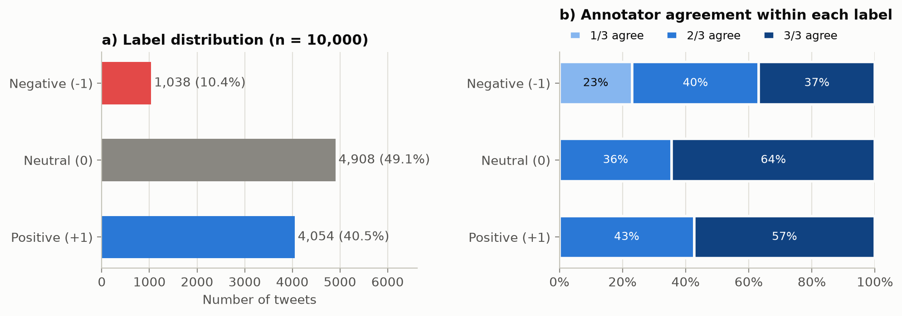
Figure 1. Label distribution and annotator agreement within each label (n = 10,000).
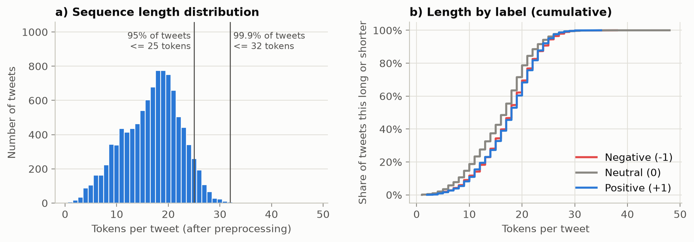
Figure 2. Tweet length in tokens after cleaning, overall and by label.

4. Methodology

4.1 Data Preparation, Split and Evaluation
All five models share one cleaning function, one split and one way of scoring, so that differences in their results come from the models and not from the data.
The cleaning (prepare_text in src/preprocess.py) follows section 3. It decodes HTML codes, straightens curly quotes, shortens letters repeated three or more times to two and lowercases the text. It keeps the mention and link placeholders, hashtags, emojis and the marks !, ? and … as tokens, keeps contractions such as “isn't” whole and removes the remaining punctuation. We did not remove stop words or stem, because stop-word lists include negations. The rules are fixed rather than fitted, so nothing is learned from the validation tweets, although the EDA that chose them covered all 10,000 tweets. To test these choices, notebook 05 retrained TF-IDF + Ridge and the GRU on four reduced cleanings (Table 6): without stop words (scikit-learn's list, negations included, plus “n't” contractions; Pedregosa et al., 2011), without the placeholders, emojis and marks, without hashtags, and without all three.
We made one grouped, stratified 80/20 split with seed 42 and saved the tweet IDs: all copies of a near-duplicate fall on the same side, and the strata are label and agreement together. This gave 8,001 training and 1,999 validation tweets (206 negative, 982 neutral and 811 positive). Every vectorizer, tokenizer and vocabulary was fitted on the training tweets only.
Our main metric is RMSE, the competition metric named in the challenge's starter notebook (Zindi, 2020). It suits ordered labels and gives extra weight to large errors (Chai & Draxler, 2014), which fits a task where scoring an anti-vaccine tweet as pro-vaccine is the worst mistake. A single number, however, mixes the average error with how unevenly the errors are spread (Willmott & Matsuura, 2005), so we report MAE next to it. Always predicting the training mean (0.3013) gives an RMSE of 0.6459 and an MAE of 0.5656. RMSE also says little about the rare anti-vaccine class that a monitoring tool most needs to find, so we add two secondary measures. The first is per-class recall and macro F1 on predictions rounded to the nearest label, since macro F1 weights each class equally however rare it is (Sokolova & Lapalme, 2009). The second is the ROC AUC for separating anti-vaccine tweets from the rest by their predicted score, which needs no rounding threshold (Fawcett, 2006).
All code is Python. Data handling uses pandas (McKinney, 2010) and NumPy (Harris et al., 2020), the baselines and metrics use scikit-learn (Pedregosa et al., 2011), the recurrent models use TensorFlow (Abadi et al., 2016) through its Keras API (Chollet et al., 2015), and the figures use Matplotlib (Hunter, 2007).

4.2 TF-IDF + Ridge and TF-IDF + SVR
Both baselines are a scikit-learn pipeline (Pedregosa et al., 2011) of a TF-IDF vectorizer and a linear regressor, fitted on the training tweets only. The vectorizer splits the cleaned text on spaces, so the tokens stay exactly as the shared cleaning left them, and the SVR uses a linear kernel.
We tuned both one change at a time from settings chosen by the EDA, keeping a change only if it lowered the validation RMSE. Appendix A.1 gives the order of the changes and every run (Table A1).

4.3 Recurrent Models and Tuning
The three recurrent models share one input pipeline. Each cleaned tweet passes through a Keras TextVectorization layer adapted on the 8,001 training tweets only (Keras Team, n.d.-b). Following the long-tailed vocabulary (section 3), it keeps the 5,664 tokens seen at least twice, plus a padding id and an [UNK] id for every other word, and cuts or pads each tweet to 28 tokens, the 99th percentile of training length, which truncates 0.7% of training tweets. Padding is masked so the recurrent layer skips it. Each model has an embedding learned from scratch, one recurrent layer and one linear output unit, and is trained to minimise mean squared error with Adam at a learning rate of 0.001 (Kingma & Ba, 2015) and early stopping with a patience of 3 epochs (Prechelt, 1998).
Each recurrent model was tuned by its owner, changing one setting at a time from a starting configuration (sequence length, embedding size, units, dropout and learning rate, plus bidirectional reading and agreement weighting for the LSTM) and keeping a change only if it beat the start by more than seed noise. To measure that noise, the starting configuration was retrained on two more seeds. For the Simple RNN and GRU, NOISE is the standard deviation of the three runs times √2, the spread expected between two single runs that differ only in their seed (Reimers & Gurevych, 2017): 0.0029 for the Simple RNN and 0.0072 for the GRU. The LSTM instead required a gain over its three-seed mean larger than one standard deviation (0.0039). Comparisons between two three-seed means vary less, so for those we also report the spread expected between them (the seed standard deviation times √(2/3), 0.0042 for the GRU). Final settings were rechecked on fresh seeds, because the best of many runs tends to overstate its true performance. Appendix A gives every run and the reason for each change.

4.4 Further GRU Rounds and a Controlled Comparison
Rounds 1 and 2 of the GRU tuning changed only the network's size and training settings. The error analysis then showed its main weakness: negative tweets received a mean prediction of 0.209, on the positive side of zero, and only 8 of the 206 fell below -0.5. Round 3 therefore changed what the loss rewards, weighting each training tweet by its label so that each label carries the same total weight, or a milder square-root version of those weights (He & Garcia, 2009; Yang et al., 2021). Round 4 tested the gap named in section 2.1, that our word vectors come from 8,001 tweets alone, by starting the embedding from 100-dimensional GloVe vectors (Pennington et al., 2014a) trained on 2 billion tweets (Pennington et al., 2014b), either frozen or fine-tuned; GloVe covers 87.3% of validation tokens. Every weighted and GloVe setting was trained with seeds 42, 43 and 44, so each run has a from-scratch, unweighted partner on the same seed. Table 3 sets the final settings of the three recurrent models side by side.
Setting | Simple RNN | LSTM | GRU
Final run | rnn-04 | lstm-final | gru-09
Embedding size | 32 | 64 | 64
Recurrent units | 64 | 64 | 64
Input dropout | 0.2 | 0.0 | 0.4
Batch size | 64 | 32 | 64
Parameters | 187,585 | 395,713 | 387,649
Runs logged | 15 | 13 | 27
Seeds for the final settings | 3 | 6 | 3
Rule for a real improvement | Beat the seed-42 baseline by more than 0.0029 | Beat the three-seed mean by more than 0.0039 | Beat the seed-42 baseline by more than 0.0072
Trained on | CPU, TensorFlow 2.21 | Colab T4 GPU, TensorFlow 2.20 | CPU, TensorFlow 2.21
Table 3. Final settings of the three recurrent models, which share the input pipeline, loss, optimiser and early stopping of section 4.3 (lstm-final is lstm-01 retrained on seed 42).
Because embedding size, dropout and batch size differ, a gap between two of these models mixes the cell type with each owner's tuning. The Simple RNN and GRU baselines share every setting, so notebook 05 also trained the LSTM on those settings with the same seeds (42, 43 and 44), through one code path in which only the recurrent layer differs.

5. Results and Discussion

5.1 Comparing the Five Approaches
Table 4 gives the validation results on the same 1,999 tweets. TF-IDF + Ridge had the lowest RMSE and the Simple RNN the highest, all well below the 0.6459 of always predicting the training mean. To see how much of this order could be chance, we resampled the validation tweets 2,000 times and scored every model on the same resamples (Koehn, 2004; Dror et al., 2018). The 95% intervals overlap (Figure 3), but most of their width comes from which tweets are drawn, which moves all five models together. On the same resample TF-IDF + Ridge beat every other model in at least 99.8% of cases, so its lead is small but not luck. The GRU and the LSTM beat the Simple RNN in 98.1% and 99.4% of resamples, but the GRU beat the LSTM in only 65.6% and TF-IDF + SVR beat the GRU in only 70.0%, so these three models, between 0.5740 and 0.5780, cannot be separated.
MAE gives a different order. TF-IDF + SVR had the second-lowest RMSE but the highest MAE (0.4626), and the LSTM the second-lowest MAE (0.4337) after TF-IDF + Ridge (0.4213). The orders differ because RMSE rewards trading many small errors for fewer large ones (Chai & Draxler, 2014; Willmott & Matsuura, 2005). Clipping the predictions to the label range lowered every RMSE slightly, most for TF-IDF + Ridge (0.5628 to 0.5607), without changing the order.
RMSE also hides what happens to the negative class. Rounded to the nearest label (Figure 4), recall on negative tweets runs from 0.0% for the Simple RNN to 12.1% for TF-IDF + SVR (0 to 25 of the 206), and about three quarters of them are rounded to neutral. Ranking the predictions instead (Figure 5; Fawcett, 2006), TF-IDF + SVR separated anti-vaccine tweets best, with an AUC of 0.716 against 0.641 for TF-IDF + Ridge and 0.550 for the Simple RNN; at a 10% false-alarm rate it found 41.7% of them against 28.2% for Ridge, and its AUC lead over Ridge held in every paired resample. Macro F1 separated the models less clearly (the SVR beat Ridge in only 88% of resamples). All five separated negative from positive tweets better (AUC 0.726 to 0.808) than negative from everything else, so the difficulty lies in telling negative tweets from neutral ones.
The model with the lowest RMSE is therefore not the best one for finding anti-vaccine tweets, and none of the five finds most of them. In our experiments, reading the words in order did not beat a tuned bag of words and word pairs. This matches Wang and Manning (2012) on short sentiment text and Zhang et al. (2020) on HPV-vaccine tweets, where a recurrent model without pretrained embeddings did not beat a linear SVM. Part of the TF-IDF lead is vocabulary, however. The final TF-IDF models keep every word and word pair, while the recurrent models map words seen only once in training to [UNK] (2.6% of validation tokens, besides 5.6% that neither family has seen), and keeping every word gained Ridge 0.0068 and the SVR 0.0147 (Table A1). Restricted to words and word pairs seen in at least two tweets (ridge-03 and svr-03), Ridge (0.5705) still beats the three saved recurrent models but is level with the fine-tuned GloVe GRU (0.5700, section 5.2), and the SVR (0.5917) falls behind all three.
Approach | RMSE | 95% interval | MAE | Mean ± sd over seeds | Macro F1 | AUC
TF-IDF + Ridge | 0.5628 | 0.542–0.583 | 0.4213 | one run | 0.502 | 0.641
TF-IDF + SVR | 0.5740 | 0.555–0.593 | 0.4626 | one run | 0.513 | 0.716
GRU | 0.5769 | 0.557–0.596 | 0.4436 | 0.5762 ± 0.0028 (3) | 0.476 | 0.614
LSTM | 0.5780 | 0.556–0.599 | 0.4337 | 0.5776 ± 0.0060 (6) | 0.473 | 0.579
Simple RNN | 0.5855 | 0.564–0.606 | 0.4458 | 0.5876 ± 0.0021 (3) | 0.445 | 0.550
Always predict the mean | 0.6459 |  | 0.5656
Table 4. Validation results of the five approaches on the same 1,999 tweets. Lower RMSE and MAE are better; macro F1 uses predictions rounded to -1, 0 or 1; AUC is for separating anti-vaccine tweets from the rest. For the recurrent models, every column except the seed mean is the saved seed-42 run.
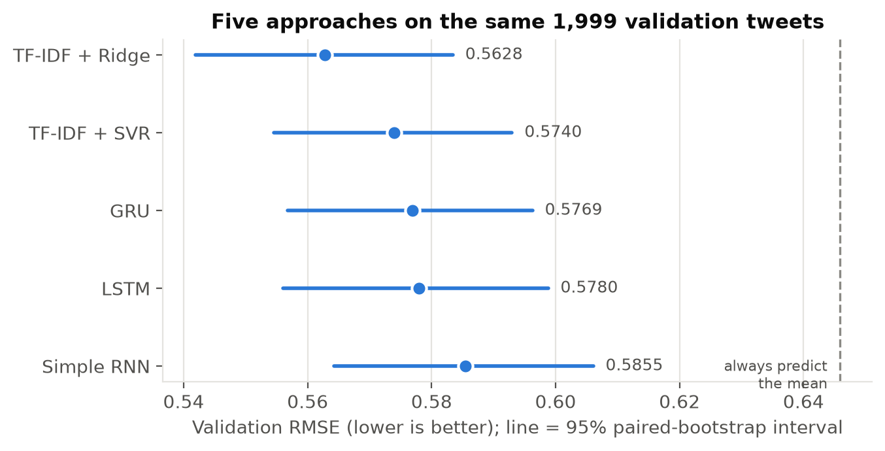
Figure 3. Validation RMSE with 95% paired-bootstrap intervals; the dashed line is always predicting the mean.
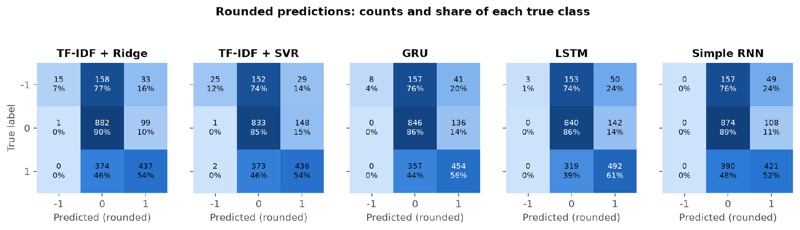
Figure 4. Confusion matrices after rounding each prediction to the nearest label.
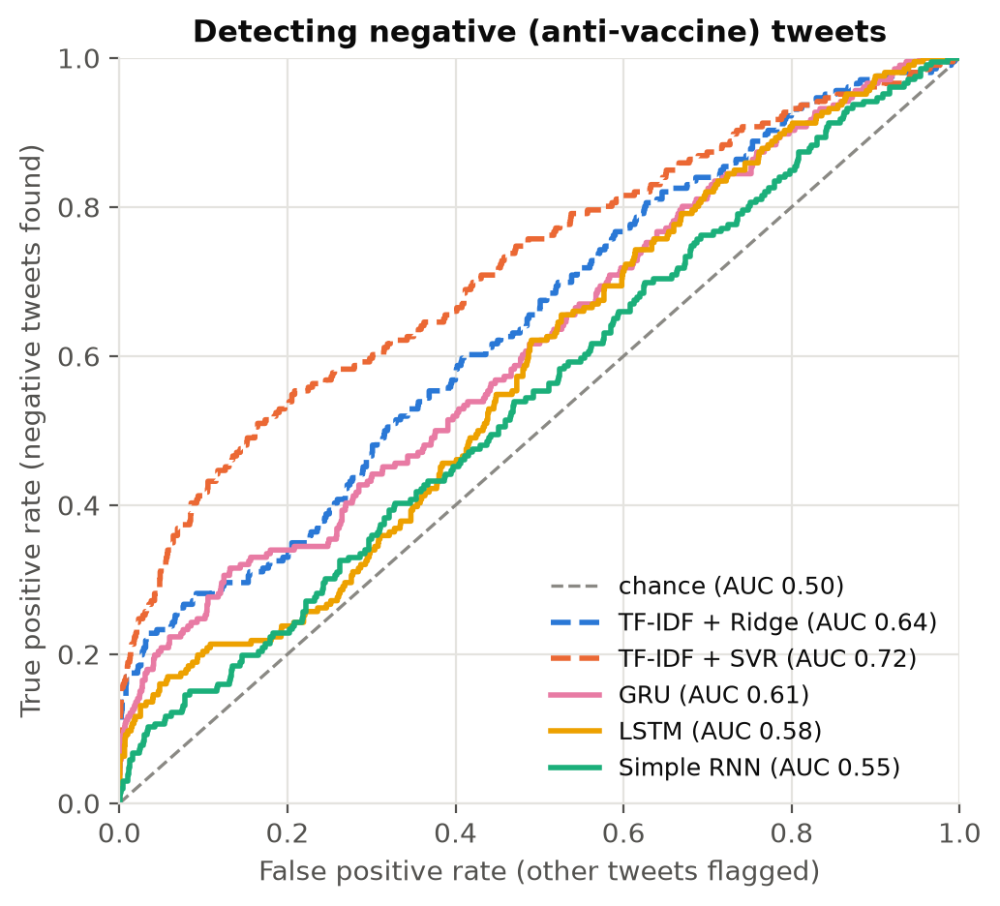
Figure 5. ROC curves for finding anti-vaccine tweets.

5.2 What the Experiments Showed
Tuning brought small gains, and most of them came from the text representation rather than from model settings (Appendix A): for both TF-IDF baselines, word pairs and keeping every word gave the largest gains. For the recurrent models, no single change beat its starting model by more than seed noise except dropout 0.4 for the GRU, and that only just. The saved runs reached their lowest validation RMSE after one or two epochs, after which validation RMSE rose while training RMSE kept falling (Figure 6), so all three began to overfit the 8,001 training tweets after one or two passes.
Class weighting traded the challenge metric for the anti-vaccine class (Table 5): balanced weights raised the AUC for anti-vaccine tweets to 0.730, slightly above TF-IDF + SVR (0.716), but also raised the RMSE to 0.6447, no better than always predicting the mean. Macro F1 stayed at 0.46 because positive tweets were pushed down along with the negative ones.
Pretrained vectors helped only when fine-tuned (Table 5). Fine-tuned GloVe lowered the RMSE on every seed, from a three-seed mean of 0.5762 to 0.5700, and gave the largest macro-F1 gain of any GRU change (0.462 to 0.496). The mean gain (0.0062) is below NOISE, so gru-09 stayed the saved model under our rule, but it is larger than the 0.0042 expected between three-seed means and appears on every seed, so it is probably more than seed noise. The gain came from neutral and positive tweets: the AUC for anti-vaccine tweets fell slightly (0.618 to 0.602), and frozen GloVe lowered it to 0.553 without changing the RMSE. General word vectors help the model read ordinary words, but stance on vaccines depends on context that co-occurrence statistics from general tweets do not carry, which fits the advantage of domain-specific pretraining reported by Müller et al. (2023) and Naseem et al. (2021).
On the shared settings (section 4.4), both gated cells beat the Simple RNN on every seed and by more than NOISE on average (three-seed means 0.5737 for the LSTM, 0.5800 for the GRU and 0.5886 for the Simple RNN; runs lfl-* in results/followup_experiments.csv), so the gain from gating does not come only from each owner's tuning. The LSTM also beat the GRU on every seed, by 0.0064 on average, more than the 0.0042 expected between means, but the tuned models rank them the other way within noise (section 5.1), so neither gated cell is clearly better.
The cleaning check supports the choices made in section 3 (Table 6): every reduced cleaning made both models worse. A standard cleaning cost TF-IDF + Ridge 0.0234 and the GRU 0.0197, more than NOISE on every GRU seed, and only then did the GRU's AUC for anti-vaccine tweets fall close to chance (0.537). The hashtags, only 3.3% of the training tokens, are the largest single part of that cost (Ridge 0.0101; GRU 0.0097, beyond NOISE on every seed). Removing the stop words, negations included, cost the GRU 0.0061, more than the 0.0042 expected between three-seed means, while removing the mentions, links, emojis and marks cost it only 0.0026. Ridge is one deterministic fit per variant, so its costs are single measurements.
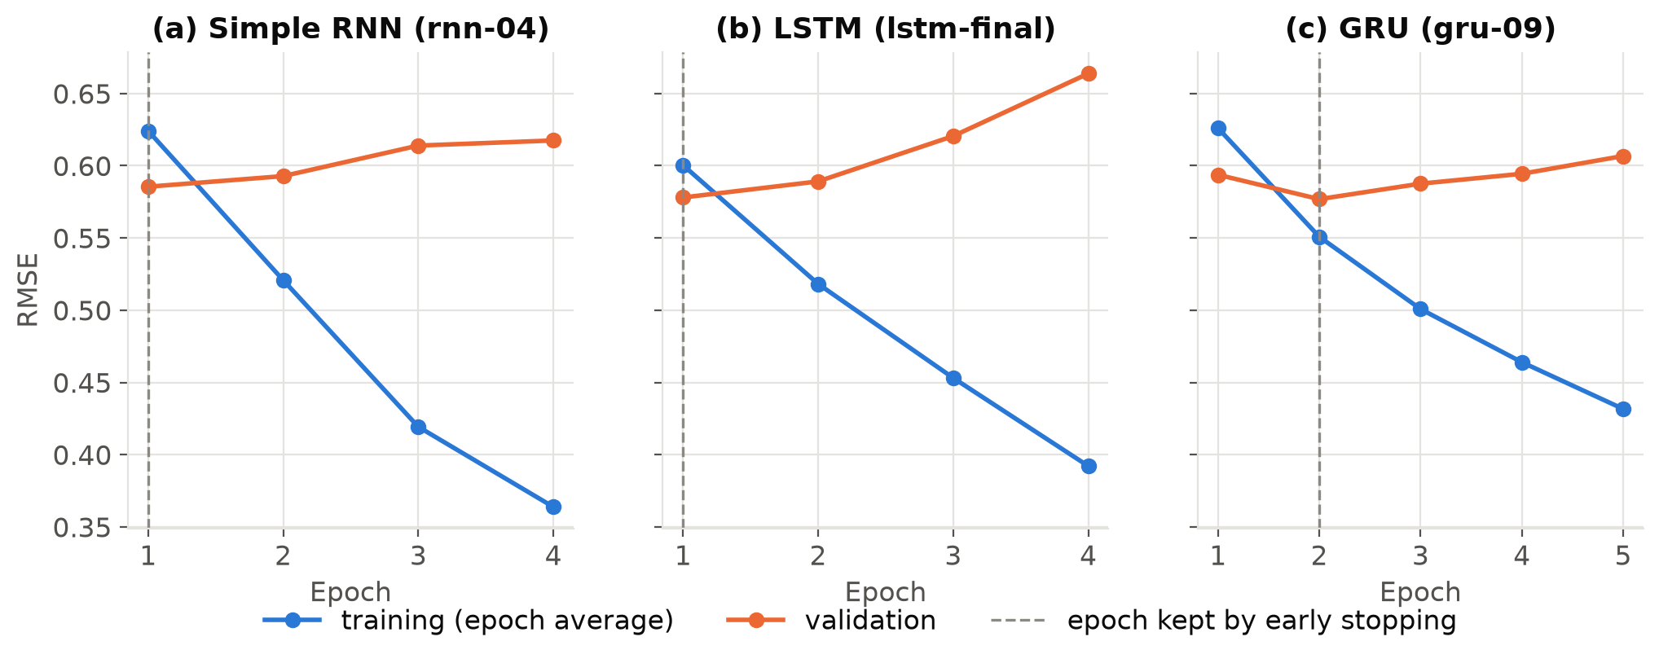
Figure 6. Training and validation RMSE per epoch for the saved (a) Simple RNN, (b) LSTM and (c) GRU runs, retrained on CPU with seed 42 (notebook 05); the dashed line marks the epoch kept by early stopping. The LSTM retrain reproduces the RMSE logged for lstm-final on a Colab T4 GPU (0.5780) to six decimals.
Variant | RMSE | Anti-vaccine tweets rounded to -1 | Macro F1 | AUC
Learned from scratch, no weighting | 0.5762 | 5.3% | 0.462 | 0.618
Square-root weights | 0.5967 | 13.1% | 0.462 | 0.684
Balanced weights | 0.6447 | 24.9% | 0.463 | 0.730
GloVe, frozen | 0.5758 | 3.7% | 0.469 | 0.553
GloVe, fine-tuned | 0.5700 | 4.7% | 0.496 | 0.602
Table 5. GRU variants on the gru-09 settings, mean of three seeds (42, 43 and 44).
Cleaning | Training tokens removed | Ridge RMSE | Ridge AUC | GRU RMSE | GRU AUC
Shared cleaning (used) | 0% | 0.5628 | 0.641 | 0.5762 | 0.618
Without stop words | 35.8% | 0.5673 | 0.617 | 0.5823 | 0.597
Without mentions, links, emojis, !, ? and … | 9.6% | 0.5666 | 0.637 | 0.5788 | 0.615
Without hashtags (word included) | 3.3% | 0.5728 | 0.631 | 0.5859 | 0.600
Standard cleaning (all three removed) | 48.6% | 0.5862 | 0.597 | 0.5959 | 0.537
Table 6. TF-IDF + Ridge (ridge-07, one fit) and the GRU (gru-09, mean of three seeds) retrained on reduced versions of the shared cleaning (notebook 05, runs clean-*); AUC is for anti-vaccine tweets.

5.3 Where the Models Differ
Anti-vaccine tweets are the hardest group for all five models by a wide margin (Figure 7), with RMSE between 1.17 and 1.32 on that class against 0.30 to 0.35 on neutral tweets. Within that pattern the families split: the TF-IDF baselines do best on anti-vaccine tweets, and the recurrent models do comparatively better on pro-vaccine tweets, where the LSTM reaches an RMSE of 0.500. The linear models seem to pick up phrases that reliably mark anti-vaccine content, while the recurrent models do not turn their reading of order into an advantage on the class where order should matter most.
Pooled over all tweets, a negation adds a similar 0.062 to 0.069 RMSE for every model, but tweets with a negation are more often pro-vaccine (55% against 36% without one), so the families only separate within each true label. On the 60 anti-vaccine tweets with a negation, the TF-IDF models do clearly better (SVR 1.20, Ridge 1.25) than the recurrent models (GRU 1.33, LSTM 1.41, Simple RNN 1.44), and the negation adds 0.05 to 0.07 to the TF-IDF error against 0.10 to 0.17 to the recurrent error. On the 280 pro-vaccine tweets with a negation the order flips (LSTM 0.44, Simple RNN 0.46, GRU 0.49, Ridge 0.51, SVR 0.55). The recurrent models seem to have learned a negation as a pro-vaccine cue, right on average in the training data but wrong for tweets telling people not to vaccinate. With only 60 negated anti-vaccine tweets, this is a pattern in the errors, not a direct test of what the networks compute.
The same holds for tweet length: on the longest tweets (21 to 36 tokens, 546 of the 1,999), where reading order should help most, the recurrent models still trail Ridge (0.61 to 0.62 against 0.60), unlike the growing GRU advantage that Yin et al. (2017) saw on longer sentences. No validation tweet is longer than 36 tokens, and the recurrent models read at most the first 28, so there is little long-range order to exploit.
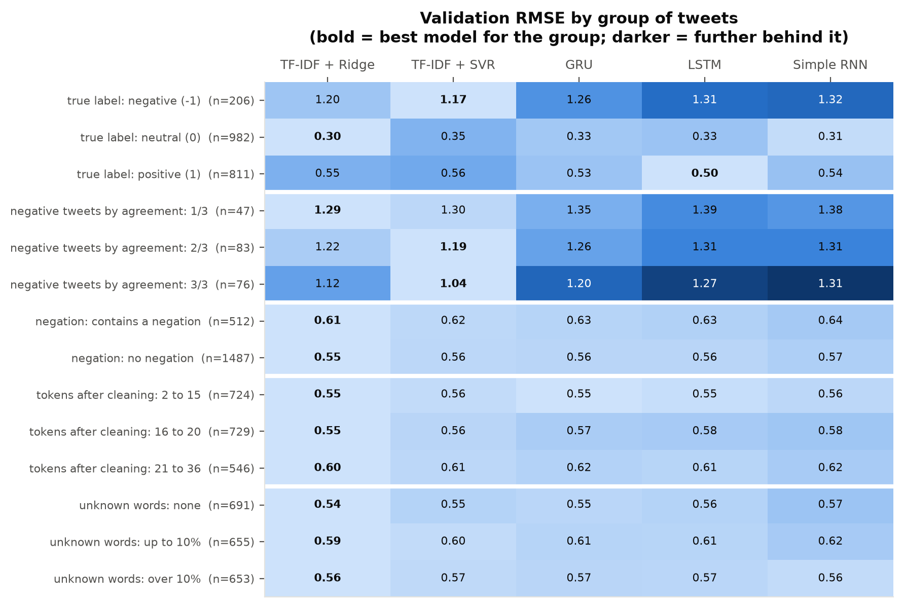
Figure 7. Validation RMSE by tweet group for each model; bold marks the best model in each row.

6. Error Analysis and Limitations

6.1 Errors Every Model Shares
Many of the hardest tweets are hard for every model. All five models are off by more than one class step on 123 validation tweets, and 122 of them are anti-vaccine tweets, 59% of the 206 in the validation set (Figure 8). The models' errors are also highly correlated (0.91 to 0.99), so combining them helps little: averaging all five gives an RMSE of 0.5638, and averaging TF-IDF + Ridge with the GRU (0.5624) beats Ridge alone (0.5628) in only 56% of resamples.
Reading the shared hard cases suggests four patterns (Table 7): tweets that report anti-vaccine news instead of arguing a position, tweets that negate a phrase that would otherwise sound pro-vaccine, sarcasm, and tweets whose stance rests on a claim, such as a joking link between childhood vaccines and autism, which a model can only read as anti-vaccine with outside knowledge. In Table 7, 47 of the 50 scores round to +1, the opposite of the label, and on the three negation examples Ridge is further from -1 than every recurrent model, so these hand-picked cases run against the TF-IDF models' average advantage on negated anti-vaccine tweets (section 5.3).
Annotator disagreement explains part of these errors: 37 of the 47 validation tweets where only one annotator chose the recorded label are among the shared errors, and 30% of the shared hard cases have this low agreement, against 0.5% of the other tweets. On negative tweets, error falls as agreement rises for every model, although for the Simple RNN almost all of the drop comes between 1/3 and 2/3 (1.38 to 1.31, then 1.31 at 3/3). Still, negative tweets on which all three annotators agreed have an RMSE above 1 for every model, so many of the worst errors are on tweets whose labels are not in doubt.
Code-switching and spelling variation are unlikely causes, since only 3 validation tweets contain accented letters and 21 elongated spellings. These patterns come from reading the hardest cases rather than from a full count, so they describe the kinds of tweets the models miss, not how often each kind occurs.
Pattern | Example tweet IDs (agreement) and scores: Ridge, SVR, Simple RNN, LSTM, GRU | Why the models miss it
Reporting anti-vaccine news rather than arguing | A3W81QVQ (2/3)  1.14, 0.94, 0.85, 0.81, 0.80  8FNX4C5D (1/3)  0.61, 0.48, 0.65, 0.79, 0.72  S1ZZQQHD (2/3)  0.75, 0.82, 0.57, 0.59, 0.58 | The stance is reported rather than expressed, so the wording looks like neutral news. Whether such tweets are anti-vaccine at all is debatable.
Negating a pro-vaccine phrase | 5KDOWBMS (3/3)  0.84, 0.56, 0.81, 0.81, 0.74  M4IVFSMS (3/3)  1.22, 1.09, 0.60, 0.64, 0.57  QK5Y1ZWX (2/3)  0.99, 0.88, 0.76, 0.83, 0.79 | The tweet uses the same words as a pro-vaccine appeal, and only a negation reverses them, so models that lean on vaccine words read it as pro-vaccine.
Sarcasm | AP8D8KXB (1/3)  1.00, 0.90, 0.77, 0.90, 0.84  DVMK1WEI (2/3)  0.79, 0.81, 0.62, 0.90, 0.74 | The literal words support vaccination and only the intended meaning opposes it, which word order alone does not reveal.
Stance carried by a claim or complaint (for example, vaccines and autism) | XRTV4HU8 (3/3)  0.43, 0.38, 0.85, 0.96, 0.83  4Y75EP2E (2/3)  0.71, 0.61, 0.83, 0.92, 0.76 | The words are not negative in themselves. Seeing the stance requires knowing that a claim such as vaccines causing autism is an anti-vaccine argument.
Table 7. Patterns among the tweets that all five models get badly wrong (122 of the 123 are labelled anti-vaccine, as are all the examples listed); after each ID, its annotator agreement and each model's predicted score (true label -1).
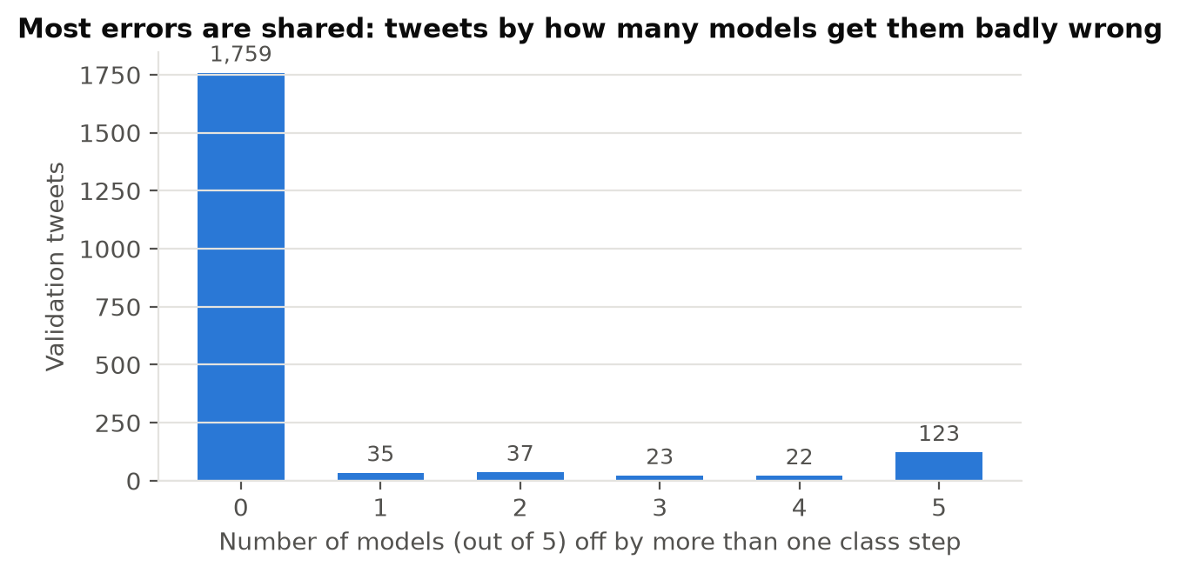
Figure 8. Validation tweets by how many of the five models are off by more than one class step.

6.2 Limitations
Data. Only 10.4% of the tweets are anti-vaccine, and every tweet whose three annotators all disagreed is labelled -1, so part of that class records disagreement rather than a clear stance. The tweets are almost all English.
Framing. Three ordered classes are treated as a score, so the squared-error loss pulls uncertain tweets towards the middle, which is why most anti-vaccine tweets are predicted neutral.
Models. Each recurrent model has one layer, the main runs learn their word vectors from 8,001 tweets, and only the GRU was tried with pretrained vectors. The recurrent models also used a smaller vocabulary than the final TF-IDF models (section 5.1), and none was trained on every word. Each owner tuned different settings under a different rule (Table 3), so gaps between the saved recurrent models mix architecture with tuning; section 5.2 separates the two only on untuned settings.
Evaluation. There is one split and no test set. The validation set also chose the stopping epochs and settings, so every score is slightly optimistic. The recurrent models were checked on only three to six seeds. Near-duplicates also flatter every score: counting each near-duplicate group in the validation set once raises every RMSE by about 0.01 (TF-IDF + Ridge from 0.5628 to 0.5727) without changing the ranking.
Preprocessing. The shared cleaning drops a plain three-dot ellipsis and turns “<3” into “3”; we found both gaps after training. The affected tweets show no extra error, so the models were not retrained. The cleaning check used one stop-word list, removed mentions, links, emojis and marks as one group, and kept settings tuned on our cleaning.
Environment. The LSTM was trained on a Colab GPU with TensorFlow 2.20 and the other models on CPU with TensorFlow 2.21. A CPU rerun matched the LSTM's logged RMSE exactly, but other setups may not.

6.3 Responsible AI
The class our models miss most is the one public-health teams care about most, so a monitoring tool built on them would under-count anti-vaccine content and could give false reassurance. The labels are the judgement of three crowd workers, whose own views may shape them, and their disagreement concentrates in the anti-vaccine class, so the models learn from the least reliable labels where accuracy matters most. The data also over-represents some voices: Twitter users are not a sample of any population, and several near-duplicate groups in the training split hold 15 or more copies of one tweet, so a few accounts or campaigns can shape what a model learns a stance sounds like. Such a model may also misjudge people who write in other varieties of English, including African varieties, or who code-switch, which our data cannot test. The tweets are public posts by real people, so we never publish their text, and the models should not be used to identify or target individual users. Any real use should report only aggregate trends, keep a human reviewer in the loop, treat the alert threshold as an explicit policy choice made from the ROC trade-off (Figure 5), and be tested on data from the community where it would be used.

7. Conclusion and Future Work
Recurrent sequence models address this problem only moderately well. All three beat always predicting the mean, and the gated GRU and LSTM beat the Simple RNN even on identical settings, but none beat a tuned TF-IDF + Ridge model, and TF-IDF + SVR ranked anti-vaccine tweets best. On tweets this short, counts of words and word pairs appear to capture most of the local order that matters, so reading the whole sequence added less than studies of longer text would suggest (Yin et al., 2017), although part of Ridge's lead comes from rare words that the recurrent models mapped to [UNK]. Fine-tuned GloVe brought the GRU to 0.5700, still behind Ridge and no better at finding anti-vaccine tweets, and the shared cleaning paid off: a standard cleaning cost TF-IDF + Ridge and the GRU about 0.02 RMSE each, with deleting hashtags the largest single part of that cost.
The errors point mainly at the data. The hardest tweets are the same for all five models: anti-vaccine tweets with disputed labels, stance that is reported rather than argued, sarcasm, and claims whose stance needs outside knowledge. Negation helps the recurrent models on pro-vaccine tweets and hurts them on anti-vaccine ones. Part of the problem is the objective: under squared error the cheapest prediction for an uncertain tweet is near the mean. Weighting the loss let the GRU rank anti-vaccine tweets about as well as the SVR, but only at a large cost in RMSE.
These conclusions rest on one validation split and almost entirely English tweets (section 6.2), so close rankings may change on new data and may not hold for African-language tweets. Six directions follow. Disputed labels should be handled explicitly, for example by reporting results by agreement level or modelling disagreement as its own outcome. Models should be trained for the anti-vaccine class with a classification loss judged by macro F1 or AUC. Outside knowledge should come from a domain-adapted transformer such as COVID-Twitter-BERT (Müller et al., 2023), since general GloVe vectors improved the GRU only slightly and not on the anti-vaccine class. A recurrent model given the full vocabulary, or subword units, would show how much of the TF-IDF lead is vocabulary. Predictions should be clipped to the label range, a small gain for every model at no cost. Finally, repeated or cross-validated splits would settle close rankings such as GRU against LSTM.

References
Abadi, M., Barham, P., Chen, J., Chen, Z., Davis, A., Dean, J., Devin, M., Ghemawat, S., Irving, G., Isard, M., Kudlur, M., Levenberg, J., Monga, R., Moore, S., Murray, D. G., Steiner, B., Tucker, P., Vasudevan, V., Warden, P., . . . Zheng, X. (2016). TensorFlow: A system for large-scale machine learning. In 12th USENIX Symposium on Operating Systems Design and Implementation (OSDI 16) (pp. 265–283). USENIX Association. https://www.usenix.org/conference/osdi16/technical-sessions/presentation/abadi
Baziotis, C., Pelekis, N., & Doulkeridis, C. (2017). DataStories at SemEval-2017 Task 4: Deep LSTM with attention for message-level and topic-based sentiment analysis. In Proceedings of the 11th International Workshop on Semantic Evaluation (SemEval-2017) (pp. 747–754). Association for Computational Linguistics. https://doi.org/10.18653/v1/S17-2126
Bengio, Y., Simard, P., & Frasconi, P. (1994). Learning long-term dependencies with gradient descent is difficult. IEEE Transactions on Neural Networks, 5(2), 157–166. https://doi.org/10.1109/72.279181
Chai, T., & Draxler, R. R. (2014). Root mean square error (RMSE) or mean absolute error (MAE)? Arguments against avoiding RMSE in the literature. Geoscientific Model Development, 7(3), 1247–1250. https://doi.org/10.5194/gmd-7-1247-2014
Cho, K., van Merriënboer, B., Gulcehre, C., Bahdanau, D., Bougares, F., Schwenk, H., & Bengio, Y. (2014). Learning phrase representations using RNN encoder–decoder for statistical machine translation. In Proceedings of the 2014 Conference on Empirical Methods in Natural Language Processing (EMNLP) (pp. 1724–1734). Association for Computational Linguistics. https://doi.org/10.3115/v1/D14-1179
Chollet, F., & others. (2015). Keras [Computer software]. GitHub. https://github.com/keras-team/keras
Chung, J., Gulcehre, C., Cho, K., & Bengio, Y. (2014). Empirical evaluation of gated recurrent neural networks on sequence modeling (arXiv:1412.3555). arXiv. https://doi.org/10.48550/arXiv.1412.3555
Dror, R., Baumer, G., Shlomov, S., & Reichart, R. (2018). The hitchhiker's guide to testing statistical significance in natural language processing. In Proceedings of the 56th Annual Meeting of the Association for Computational Linguistics (Volume 1: Long Papers) (pp. 1383–1392). Association for Computational Linguistics. https://doi.org/10.18653/v1/P18-1128
Drucker, H., Burges, C. J. C., Kaufman, L., Smola, A., & Vapnik, V. (1997). Support vector regression machines. In M. C. Mozer, M. I. Jordan, & T. Petsche (Eds.), Advances in Neural Information Processing Systems 9 (pp. 155–161). MIT Press.
Elman, J. L. (1990). Finding structure in time. Cognitive Science, 14(2), 179–211. https://doi.org/10.1207/s15516709cog1402_1
Fawcett, T. (2006). An introduction to ROC analysis. Pattern Recognition Letters, 27(8), 861–874. https://doi.org/10.1016/j.patrec.2005.10.010
Gers, F. A., Schmidhuber, J., & Cummins, F. (2000). Learning to forget: Continual prediction with LSTM. Neural Computation, 12(10), 2451–2471. https://doi.org/10.1162/089976600300015015
Harris, C. R., Millman, K. J., van der Walt, S. J., Gommers, R., Virtanen, P., Cournapeau, D., Wieser, E., Taylor, J., Berg, S., Smith, N. J., Kern, R., Picus, M., Hoyer, S., van Kerkwijk, M. H., Brett, M., Haldane, A., Fernández del Río, J., Wiebe, M., Peterson, P., . . . Oliphant, T. E. (2020). Array programming with NumPy. Nature, 585(7825), 357–362. https://doi.org/10.1038/s41586-020-2649-2
Hastie, T., Tibshirani, R., & Friedman, J. (2009). The elements of statistical learning: Data mining, inference, and prediction (2nd ed.). Springer. https://doi.org/10.1007/978-0-387-84858-7
He, H., & Garcia, E. A. (2009). Learning from imbalanced data. IEEE Transactions on Knowledge and Data Engineering, 21(9), 1263–1284. https://doi.org/10.1109/TKDE.2008.239
Hochreiter, S., & Schmidhuber, J. (1997). Long short-term memory. Neural Computation, 9(8), 1735–1780. https://doi.org/10.1162/neco.1997.9.8.1735
Hoerl, A. E., & Kennard, R. W. (1970). Ridge regression: Biased estimation for nonorthogonal problems. Technometrics, 12(1), 55–67. https://doi.org/10.1080/00401706.1970.10488634
Hunter, J. D. (2007). Matplotlib: A 2D graphics environment. Computing in Science & Engineering, 9(3), 90–95. https://doi.org/10.1109/MCSE.2007.55
Jozefowicz, R., Zaremba, W., & Sutskever, I. (2015). An empirical exploration of recurrent network architectures. In Proceedings of the 32nd International Conference on Machine Learning (Vol. 37, pp. 2342–2350). PMLR. https://proceedings.mlr.press/v37/jozefowicz15.html
Keras Team. (n.d.-a). GRU layer. In Keras 3 API documentation. Retrieved September 26, 2026, from https://keras.io/api/layers/recurrent_layers/gru/
Keras Team. (n.d.-b). TextVectorization layer. In Keras 3 API documentation. Retrieved September 26, 2026, from https://keras.io/api/layers/preprocessing_layers/text/text_vectorization/
Kingma, D. P., & Ba, J. (2015). Adam: A method for stochastic optimization [Paper presentation]. 3rd International Conference on Learning Representations (ICLR 2015), San Diego, CA, United States. https://doi.org/10.48550/arXiv.1412.6980
Koehn, P. (2004). Statistical significance tests for machine translation evaluation. In Proceedings of the 2004 Conference on Empirical Methods in Natural Language Processing (pp. 388–395). Association for Computational Linguistics. https://aclanthology.org/W04-3250/
McKinney, W. (2010). Data structures for statistical computing in Python. In S. van der Walt & J. Millman (Eds.), Proceedings of the 9th Python in Science Conference (pp. 56–61). https://doi.org/10.25080/Majora-92bf1922-00a
Muhammad, S. H., Abdulmumin, I., Ayele, A. A., Ousidhoum, N., Adelani, D. I., Yimam, S. M., Ahmad, I. S., Beloucif, M., Mohammad, S. M., Ruder, S., Hourrane, O., Brazdil, P., Jorge, A., Ali, F. D. M. A., David, D., Osei, S., Shehu Bello, B., Ibrahim, F., Gwadabe, T., . . . Arthur, S. (2023). AfriSenti: A Twitter sentiment analysis benchmark for African languages. In Proceedings of the 2023 Conference on Empirical Methods in Natural Language Processing (pp. 13968–13981). Association for Computational Linguistics. https://doi.org/10.18653/v1/2023.emnlp-main.862
Müller, M. M., & Salathé, M. (2019). Crowdbreaks: Tracking health trends using public social media data and crowdsourcing. Frontiers in Public Health, 7, Article 81. https://doi.org/10.3389/fpubh.2019.00081
Müller, M. M., Salathé, M., & Kummervold, P. E. (2023). COVID-Twitter-BERT: A natural language processing model to analyse COVID-19 content on Twitter. Frontiers in Artificial Intelligence, 6, Article 1023281. https://doi.org/10.3389/frai.2023.1023281
Naseem, U., Khushi, M., Kim, J., & Dunn, A. G. (2021). Classifying vaccine sentiment tweets by modelling domain-specific representation and commonsense knowledge into context-aware attentive GRU. In 2021 International Joint Conference on Neural Networks (IJCNN) (pp. 1–8). IEEE. https://doi.org/10.1109/IJCNN52387.2021.9533454
Pascanu, R., Mikolov, T., & Bengio, Y. (2013). On the difficulty of training recurrent neural networks. In Proceedings of the 30th International Conference on Machine Learning (Vol. 28, No. 3, pp. 1310–1318). PMLR. https://proceedings.mlr.press/v28/pascanu13.html
Pedregosa, F., Varoquaux, G., Gramfort, A., Michel, V., Thirion, B., Grisel, O., Blondel, M., Prettenhofer, P., Weiss, R., Dubourg, V., Vanderplas, J., Passos, A., Cournapeau, D., Brucher, M., Perrot, M., & Duchesnay, É. (2011). Scikit-learn: Machine learning in Python. Journal of Machine Learning Research, 12(85), 2825–2830. https://jmlr.org/papers/v12/pedregosa11a.html
Pennington, J., Socher, R., & Manning, C. D. (2014a). GloVe: Global vectors for word representation. In Proceedings of the 2014 Conference on Empirical Methods in Natural Language Processing (EMNLP) (pp. 1532–1543). Association for Computational Linguistics. https://doi.org/10.3115/v1/D14-1162
Pennington, J., Socher, R., & Manning, C. D. (2014b). GloVe: Global vectors for word representation (glove.twitter.27B) [Data set]. Stanford NLP Group. https://nlp.stanford.edu/projects/glove/
Prechelt, L. (1998). Early stopping, but when? In G. B. Orr & K.-R. Müller (Eds.), Neural networks: Tricks of the trade (Lecture Notes in Computer Science, Vol. 1524, pp. 55–69). Springer. https://doi.org/10.1007/3-540-49430-8_3
Reimers, N., & Gurevych, I. (2017). Reporting score distributions makes a difference: Performance study of LSTM-networks for sequence tagging. In Proceedings of the 2017 Conference on Empirical Methods in Natural Language Processing (pp. 338–348). Association for Computational Linguistics. https://doi.org/10.18653/v1/D17-1035
Salton, G., & Buckley, C. (1988). Term-weighting approaches in automatic text retrieval. Information Processing & Management, 24(5), 513–523. https://doi.org/10.1016/0306-4573(88)90021-0
Schuster, M., & Paliwal, K. K. (1997). Bidirectional recurrent neural networks. IEEE Transactions on Signal Processing, 45(11), 2673–2681. https://doi.org/10.1109/78.650093
Sokolova, M., & Lapalme, G. (2009). A systematic analysis of performance measures for classification tasks. Information Processing & Management, 45(4), 427–437. https://doi.org/10.1016/j.ipm.2009.03.002
Srivastava, N., Hinton, G., Krizhevsky, A., Sutskever, I., & Salakhutdinov, R. (2014). Dropout: A simple way to prevent neural networks from overfitting. Journal of Machine Learning Research, 15(56), 1929–1958. https://jmlr.org/papers/v15/srivastava14a.html
Wang, S., & Manning, C. D. (2012). Baselines and bigrams: Simple, good sentiment and topic classification. In Proceedings of the 50th Annual Meeting of the Association for Computational Linguistics (Volume 2: Short Papers) (pp. 90–94). Association for Computational Linguistics. https://aclanthology.org/P12-2018/
Willmott, C. J., & Matsuura, K. (2005). Advantages of the mean absolute error (MAE) over the root mean square error (RMSE) in assessing average model performance. Climate Research, 30(1), 79–82. https://doi.org/10.3354/cr030079
World Health Organization. (2019). Ten threats to global health in 2019. https://www.who.int/news-room/spotlight/ten-threats-to-global-health-in-2019
Yang, Y., Zha, K., Chen, Y.-C., Wang, H., & Katabi, D. (2021). Delving into deep imbalanced regression. In Proceedings of the 38th International Conference on Machine Learning (Vol. 139, pp. 11842–11851). PMLR. https://proceedings.mlr.press/v139/yang21m.html
Yin, W., Kann, K., Yu, M., & Schütze, H. (2017). Comparative study of CNN and RNN for natural language processing (arXiv:1702.01923). arXiv. https://doi.org/10.48550/arXiv.1702.01923
Zhang, L., Fan, H., Peng, C., Rao, G., & Cong, Q. (2020). Sentiment analysis methods for HPV vaccines related tweets based on transfer learning. Healthcare, 8(3), Article 307. https://doi.org/10.3390/healthcare8030307
Zindi. (2020). To vaccinate or not to vaccinate: It's not a question [Data set]. https://zindi.africa/competitions/to-vaccinate-or-not-to-vaccinate

Appendix A. Tuning runs
This appendix gives every tuning run behind sections 4 and 5, the reason for each change, and what each model's runs showed. Each table lists the runs on the shared validation set.

A.1 TF-IDF + Ridge and TF-IDF + SVR
We tuned both one change at a time: each run changed one setting of the best run so far and kept the change only if it lowered the validation RMSE (Table A1). Both started from the EDA (single words seen in at least two training tweets, raw counts and hashtags kept with their #; alpha = 1.0 for Ridge, C = 1.0 and epsilon = 0.1 for the SVR), and the order of the changes followed it too: word pairs first because negation is common, then log-scaled counts, then keeping every word to test whether rare words were worth their noise, then the regularisation and, for the SVR, epsilon, and finally removing the # from hashtags.
For both baselines the text representation mattered more than the model settings (Table A1): word pairs gave Ridge its largest gain and keeping every word and word pair gave the SVR its largest, while stronger or weaker regularisation made both worse, log-scaled counts and removing the # changed little, and a wider epsilon lowered the SVR's RMSE slightly but raised its MAE sharply.
Run | Setting tested | Features | RMSE | MAE | Kept
ridge-01 | starting settings (single words, words in at least 2 tweets, alpha 1.0) | 5,569 | 0.5791 | 0.4389 | start
ridge-02 | add word pairs | 19,187 | 0.5707 | 0.4313 | yes
ridge-03 | log-scaled term counts | 19,187 | 0.5705 | 0.4308 | yes
ridge-04 | keep every word and word pair | 77,644 | 0.5637 | 0.4226 | yes
ridge-05 | alpha 0.3 | 77,644 | 0.5757 | 0.4282 | no
ridge-06 | alpha 3.0 | 77,644 | 0.5670 | 0.4337 | no
ridge-07 | remove the # from hashtags | 76,458 | 0.5628 | 0.4213 | yes (final)
svr-01 | starting settings (single words, words in at least 2 tweets, C 1.0, epsilon 0.1) | 5,569 | 0.5991 | 0.4395 | start
svr-02 | add word pairs | 19,187 | 0.5924 | 0.4356 | yes
svr-03 | log-scaled term counts | 19,187 | 0.5917 | 0.4352 | yes
svr-04 | keep every word and word pair | 77,644 | 0.5770 | 0.4264 | yes
svr-05 | C 0.3 | 77,644 | 0.5824 | 0.4158 | no
svr-06 | C 3.0 | 77,644 | 0.5883 | 0.4404 | no
svr-07 | epsilon 0.3 | 77,644 | 0.5751 | 0.4634 | yes
svr-08 | remove the # from hashtags | 76,458 | 0.5740 | 0.4626 | yes (final)
Table A1. The 15 TF-IDF baseline runs on the shared validation set; each run changes one setting of the best run before it.

A.2 Simple RNN
The Simple RNN started from the shared pipeline of section 4.3 with a 64-dimensional embedding, 64 units and 0.2 dropout, then changed one setting at a time in ten runs, trying sequence length, embedding size, units, dropout and learning rate each at a lower and a higher value (Table A2). Two more seeds of the starting settings put NOISE at 0.0029 (section 4.3). No change beat the baseline by more than that, so we kept rnn-04 (a 32-dimensional embedding) as the simplest setting within NOISE of the best, as in the one-standard-error rule (Hastie et al., 2009).
Six of the Simple RNN's ten changes made it worse by more than NOISE, most of all a learning rate of 0.003 (+0.0257) and 128 units (+0.0122), signs of overshooting and overfitting. Its validation RMSE was lowest after one or two epochs in every run, so these settings left it no room to improve (Figure 6a).
Run | Setting tested | Seed | RMSE | Best epoch | Result
rnn-01 | starting settings (embedding 64, 64 units, dropout 0.2) | 42 | 0.5866 | 1 | start
rnn-02 | sequence length 24 | 42 | 0.5880 | 1 | no gain
rnn-03 | sequence length 48 | 42 | 0.5871 | 1 | no gain
rnn-04 | embedding 32 | 42 | 0.5855 | 1 | kept (final)
rnn-05 | embedding 128 | 42 | 0.5897 | 1 | no gain
rnn-06 | 32 units | 42 | 0.5920 | 1 | no gain
rnn-07 | 128 units | 42 | 0.5988 | 2 | no gain
rnn-08 | dropout 0 | 42 | 0.5934 | 1 | no gain
rnn-09 | dropout 0.4 | 42 | 0.5876 | 1 | no gain
rnn-10 | learning rate 0.0003 | 42 | 0.5958 | 2 | no gain
rnn-11 | learning rate 0.003 | 42 | 0.6123 | 2 | no gain
rnn-12 | starting settings, new seed | 43 | 0.5888 | 1 | noise check
rnn-13 | starting settings, new seed | 44 | 0.5906 | 1 | noise check
rnn-15 | final settings (rnn-04), new seed | 43 | 0.5878 | 2 | seed check
rnn-16 | final settings (rnn-04), new seed | 44 | 0.5897 | 1 | seed check
Table A2. The 15 Simple RNN runs (no run 14: nothing to combine). Round-1 runs change one setting of the starting settings; NOISE = 0.0029.

A.3 LSTM
The LSTM's starting model (lstm-01) had a 64-dimensional embedding, 64 units and no dropout, so that its learning curve would show whether it overfits before any regularisation is added. It did: validation RMSE was lowest after the first epoch and rose afterwards. With two more seeds, the three runs had a mean of 0.5748 and a standard deviation of 0.0039, so a change had to beat that mean by more than 0.0039 to count.
We then changed one setting at a time (Table A3): dropout of 0.3 and a 32-dimensional embedding to test the overfitting, 128 units to test whether memory size limited the model, bidirectional reading to test whether a late negation helps, weighting tweets by annotator agreement to test whether uncertain labels held it back, and a learning rate of 0.0003 because lstm-01 peaked in its first epoch. None of the six passed the threshold (Figure A1), so we kept the starting settings, which three fresh seeds (7, 123 and 2026) put at a mean of 0.5803 with a wider spread (standard deviation 0.0072). This rule differs from the seed-42 comparison used for the Simple RNN and GRU, but the conclusion holds under either, since the largest gain over the seed-42 run was 0.0032 (lstm-05).
The LSTM peaked within one or two epochs in every run, after which training RMSE kept falling while validation RMSE rose (Figure 6b). The two changes that raised its RMSE most (128 units and a 32-dimensional embedding) were only 0.0016 and 0.0015 worse than the seed-42 run, so these settings were not what limited it.
Run | Setting tested | Seed | RMSE | Best epoch | Result
lstm-01 | starting settings (embedding 64, 64 units, no dropout) | 42 | 0.5780 | 1 | start
lstm-01-seed43 | starting settings, new seed | 43 | 0.5704 | 1 | noise check
lstm-01-seed44 | starting settings, new seed | 44 | 0.5759 | 1 | noise check
lstm-02 | dropout 0.3 | 42 | 0.5782 | 1 | no gain
lstm-03 | 128 units | 42 | 0.5796 | 1 | no gain
lstm-04 | embedding 32 | 42 | 0.5795 | 1 | no gain
lstm-05 | bidirectional | 42 | 0.5748 | 1 | no gain
lstm-06 | loss weighted by annotator agreement | 42 | 0.5750 | 1 | no gain
lstm-07 | learning rate 0.0003 | 42 | 0.5750 | 2 | no gain
lstm-final | final settings (= lstm-01), retrained | 42 | 0.5780 | 1 | kept (final)
lstm-final-seed7 | final settings, new seed | 7 | 0.5796 | 1 | seed check
lstm-final-seed123 | final settings, new seed | 123 | 0.5878 | 2 | seed check
lstm-final-seed2026 | final settings, new seed | 2026 | 0.5735 | 1 | seed check
Table A3. The 13 LSTM runs. A change had to beat the three-seed starting mean (0.5748) by more than 0.0039.
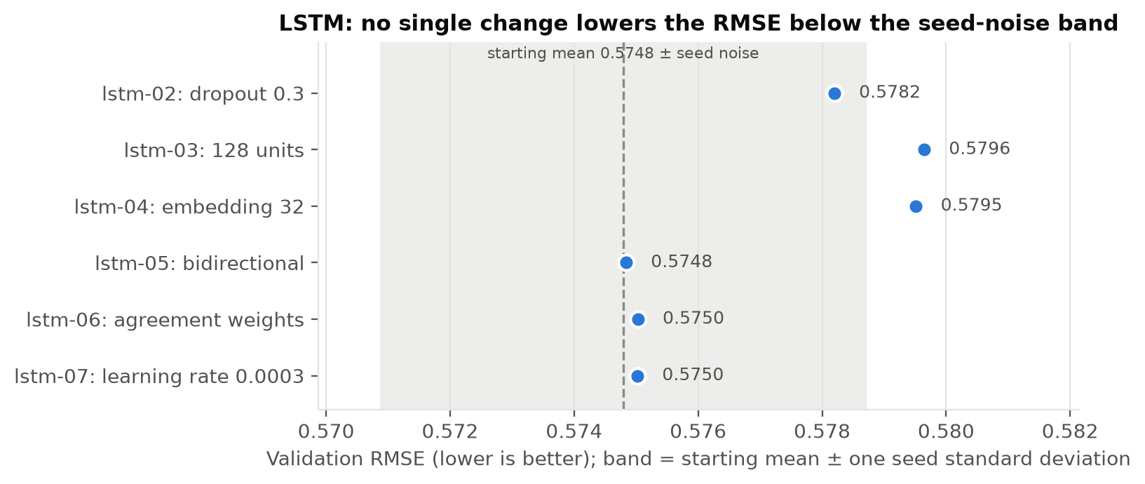
Figure A1. Validation RMSE of the six single-change LSTM runs against the three-seed mean of the starting model: no change lowers the RMSE below the band of seed noise.

A.4 GRU
The GRU baseline (gru-01) used exactly the Simple RNN's baseline settings, so the first comparison between the two cells is like for like. Round 1 changed one setting at a time to a lower and a higher value (Table A4), and round 2 retrained the baseline with seeds 43 and 44, which put NOISE at 0.0072. Only dropout 0.4 (gru-09, 0.5769) beat the baseline by more than NOISE, and only just (by 0.0075), so there was nothing to combine. It became the final configuration and was checked on two fresh seeds, because the best of many runs tends to overstate its true performance. Recurrent dropout stayed at 0 so that the model can use the fast cuDNN kernel on a GPU (Keras Team, n.d.-a).
Dropout 0.4 lowered the RMSE on every seed, but between the three-seed means the gain shrinks to 0.0038 (0.5762 against 0.5800), just under the 0.0042 expected between means. Validation RMSE was lowest after the second epoch in 18 of the 21 runs of rounds 1 to 3 (Figure 6c).
In round 3, balanced weights give a negative tweet a weight of 3.21 against 0.68 for a neutral and 0.82 for a positive one. In round 4, GloVe has a vector for 5,043 of the 5,664 vocabulary words; the rest, including contractions such as “don't” that GloVe splits, start from small random vectors.
Run | Setting tested | Seed | RMSE | Best epoch | Result
gru-01 | starting settings (embedding 64, 64 units, dropout 0.2) | 42 | 0.5844 | 2 | start
gru-02 | sequence length 24 | 42 | 0.5840 | 2 | no gain
gru-03 | sequence length 48 | 42 | 0.5854 | 2 | no gain
gru-04 | embedding 32 | 42 | 0.5887 | 2 | no gain
gru-05 | embedding 128 | 42 | 0.5861 | 2 | no gain
gru-06 | 32 units | 42 | 0.5866 | 2 | no gain
gru-07 | 128 units | 42 | 0.5871 | 2 | no gain
gru-08 | dropout 0 | 42 | 0.5905 | 2 | no gain
gru-09 | dropout 0.4 | 42 | 0.5769 | 2 | kept (final)
gru-10 | learning rate 0.0003 | 42 | 0.5788 | 3 | no gain
gru-11 | learning rate 0.003 | 42 | 0.5839 | 1 | no gain
gru-12 | starting settings, new seed | 43 | 0.5744 | 2 | noise check
gru-13 | starting settings, new seed | 44 | 0.5813 | 2 | noise check
gru-15 | final settings (gru-09), new seed | 43 | 0.5731 | 2 | seed check
gru-16 | final settings (gru-09), new seed | 44 | 0.5785 | 2 | seed check
gru-17 | square-root class weights | 42 | 0.5864 | 2 | not kept
gru-18 | square-root class weights | 43 | 0.5936 | 2 | not kept
gru-19 | square-root class weights | 44 | 0.6102 | 2 | not kept
gru-20 | balanced class weights | 42 | 0.6294 | 2 | not kept
gru-21 | balanced class weights | 43 | 0.6359 | 2 | not kept
gru-22 | balanced class weights | 44 | 0.6689 | 3 | not kept
gru-23 | GloVe embedding, frozen | 42 | 0.5758 | 18 | not kept
gru-24 | GloVe embedding, frozen | 43 | 0.5720 | 22 | not kept
gru-25 | GloVe embedding, frozen | 44 | 0.5796 | 20 | not kept
gru-26 | GloVe embedding, fine-tuned | 42 | 0.5722 | 9 | not kept
gru-27 | GloVe embedding, fine-tuned | 43 | 0.5689 | 8 | not kept
gru-28 | GloVe embedding, fine-tuned | 44 | 0.5689 | 8 | not kept
Table A4. The 27 GRU runs (rounds 1 to 4; no run 14: nothing to combine). Round-1 runs change one setting of the starting settings; NOISE = 0.0072.

