**Introduction:**

There are almost 500 soft drinks brand names which are sold to consumers in almost 200 countries. Coca-Cola is the major beverage corporation in the world. Each single day the world consumes greater than 1.9 billion servings of their drinks including brands like coca cola as well as Fanta, Sprite, Powerade, minute maid etc.

The soda industry faces an existential crisis in which they are on the cusp of becoming social pariahs, much like the tobacco industry,” said Dan Newman, who worked as a strategist for the campaigns. US consumption of soda has been steadily decreasing for years.

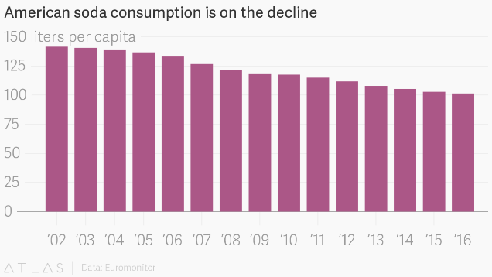

**Amazing Ways Coca Cola Is Using Ai & Big Data to Drive Success**

The production of these drinks generates a huge amount of data; from product creation and distribution to sales and customers feedback,

The Coca Cola company is a shining example of a business which has re-ordered itself based on data and intelligence. It has long shown an appreciation of the fact that today’s technology offers unprecedented opportunity to reassess just about every aspect of how business is conducted. Rethinking itself as a technology-driven company with a focus on strategic implementation of data and AI means it is likely to retain its place at the head of the pack for the foreseeable future

The Black Book model is advanced algorithm to help managers and employees

decision making . “Black Book” is a Java-based application created with the help of outside

firm Revenue Analytics, which combined the variables around agricultural fruit production,

the taste of each juice brand, the orange-squeezing and containers, trucking, shipping and

customer demand, to create a formula for what steps to take to synchronize Coca-Coca’s

global juice operations .It includes detailed data about more than 600 different flavors that

The Black Book model is advanced algorithm to help managers and employees

decision making . “Black Book” is a Java-based application created with the help of outside

firm Revenue Analytics, which combined the variables around agricultural fruit production,

the taste of each juice brand, the orange-squeezing and containers, trucking, shipping and

customer demand, to create a formula for what steps to take to synchronize Coca-Coca’s

global juice operations .It includes detailed data about more than 600 different flavors tha

1. **Healthy options**

Coca-Cola uses big data to produce orange juice that has a consistent taste year-round

If you ever wondered how orange juice can always taste so damn perfect every time you have it, it's because of an algorithm. Coca Cola, which makes Simply Orange and Minute Maid, has an algorithm called the "Black Book" which allows it to standardize Mother Nature. The Black Book has data on over 600 flavors that go into an orange, detailing the acidity, sweetness, etc. of each batch of juice. Once it profiles the raw juice, it spits out how to blend the juice to get into the perfectly consistent taste we're all used to. Even deeper, Black Book can analyze weather patterns, crops, etc. to adjust any sort of juicing plans. Black Book even uses satellites to monitor crops and tells farmers the optimal time to pick the fruit. It's considered every possible angle for orange juice, with math.

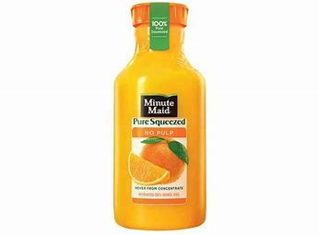

1. **Scanning Social Media**

Because 90% of consumers now base their purchasing decisions on social media content, Coca cola understand what people are saying about the products and brand, Theses data gives Coca-Cola important insights into who is drinking their drinks, where those people are located they’re emitting consistent brand messaging without offending anyone.In 2015, it analyzes over 20 billion impressions coming from 120,000 pieces of content. This sort of data monitoring was a good idea to bring back Surge:

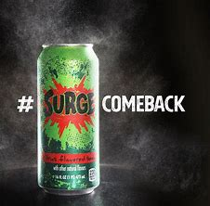

1. **The Coca-Cola Freestyle machine**

In 2009, Coca-Cola invited Segway inventor Dean Kamen to help design the next generation of their vending machine. The result was the Coca-Cola Freestyle machine, which could dispense well over 100 combinations of carbonated and non-carbonated soft drinks. They also produced a corresponding mobile app, with more than a million downloads, that allows customers to name and save their favorite combinations connect to the Freestyle machines to automatically pour them the drink.

Having poured more than 5 billion servings and thousands of flavor permutations, the data they’re generating is a fountain of marketing knowledge in helping the beverage giant shape product offerings for itself and its foodservice customers. According to Jennifer Mann, VP-general manager of Coke Freestyle, “Before Freestyle, Caffeine-Free Diet Coke was available in less than 1% of our dispensers in the U.S., now with Freestyle it’s available in every dispenser, and it’s become a top-five brand in the afternoon daypart.

1. **Big Data Flavor Shots**

In 2017, it was revealed that the launch of new flavour Cherry Sprite was inspired by data collected from those self-service drinks fountains that let customers mix their own drinks. Because the machines offer a choice of flavour “shots” for customers to add to their drinks, Coca-Cola could simply identify the most popular flavour combo and turn it into a ready-made beverage for a wider audience and they also use some natural language processing tools to scour the Internet and see what people are saying about their flavor creations .

[article by Forbes on the topic](https://www.forbes.com/sites/bernardmarr/2017/09/18/the-amazing-ways-coca-cola-uses-artificial-intelligence-ai-and-big-data-to-drive-success/2/#4ee3b19aecff):Coca-Cola and AI which talks about how “its products were mentioned somewhere in the world an average of just over once every two seconds“. This brings us to our next topic.

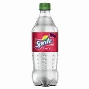

1. **Augmented Reality**

In another move powered by Big Data technology, Coca-Cola is trialling augmented reality (AR) in several its bottling plants across the globe. This technology involves using glasses or a headset that overlays computer graphics on top of what the user is looking at in the real world. This means technicians could see information about machines they’re repairing or servicing and get help with diagnosing and fixing technical issues. This technology can also be used to inspect and diagnose problems in machines and dispensers located in difficult-to-reach or remote places (such as a cruise ship in the middle of the ocean).