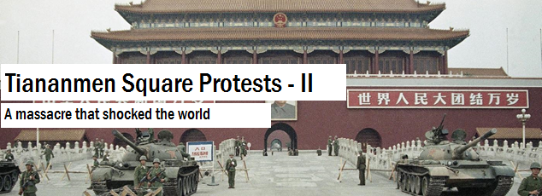

### *If you haven’t followed the first part,* [*click here*](https://www.curiosityaboard.com/tiananmen-square-protests-part-i/)*.*

### With the end of protests by the full-throated students nowhere in sight, the government had the option to deal with the situation with severe austerity. However, Zhao Ziyang, the General Secretary, felt that the students were no real threat to the government, and sought to control the situation by withdrawing an inflammatory editorial by Deng Xiaoping which described the students as a “tiny minority”, which had further made the students livid. Although, the government eventually decided not to do so as it would conspicuously display a weakness by the Party leadership.

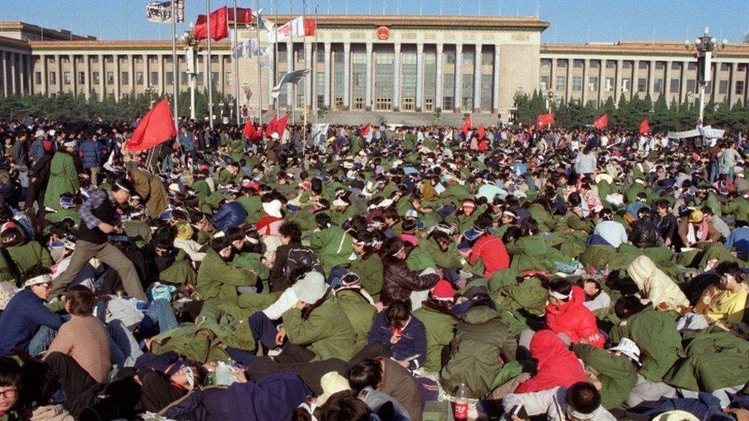*Students protesting in Tiananmen Square*

Meanwhile, students from various other cities poured into Beijing to join the protests. Other groups in the society like housewives, workers, doctors, and even sailors from the Chinese Navy also joined the protests which made the government even more ominous.

By 4th of May 1989, the number of protesters in Beijing had exceeded 100,000 again. On the 13th of May, the students took their next major fateful step. They announced a hunger strike, with the goal of getting the government to retract the April 26 editorial which deliberately denounced the magnitude of the protests.

More than a thousand students took part in the hunger strike, which engendered wide-spread sympathy for them from their fellow compatriots.

In the midst of the heating turmoil, arrived the leader of the Soviet Union, Mikhail Gorbachev in China for talks with Zhao. Due to Gorbachev's presence, a large delegation of foreign journalists and photographers conjointly descended on the strained and tense Chinese capital. This placed even more pressure on the Chinese Communist Party leadership.

During the last week of May tensions eased a bit due to Zhao’s appeal, and many of the student protesters started leaving as they were worn out by the protests. However, on June 2 the Communist Party leaders agreed to bring in the People's Liberation Army (PLA) to clear the protesters out of Tiananmen Square by force.

**The Tiananmen Square Massacre**

**O**nThe morning of June 3, 1989, the 27th and 28th divisions of the People's Liberation Army moved into Tiananmen Square on foot and in tanks, firing tear gas to disperse the demonstrators. They had been ordered not to shoot the protesters, thus, most of them did not carry firearms.

Not only the student protesters but also tens of thousands of workers and ordinary citizens of Beijing joined together to repel the Army. They used burned-out buses in order to make barricades, threw rocks and bricks at the soldiers, and even burned some tank crews alive inside their tanks. Thus, the first casualties of the Tiananmen Square Incident were actually the troops and not the protestors.

The student protest leadership was in a dilemma, if they should evacuate the Square to prevent further bloodshed or remain firm on their stand. Eventually they decided to remain.

Around 10:30 pm, the PLA returned to the Square with gigantic tanks rumbling down the streets. This time though the PLA opened fire and started firing indiscriminately. This created panic among the people which resulted in the death of a number of non-protestors as well.

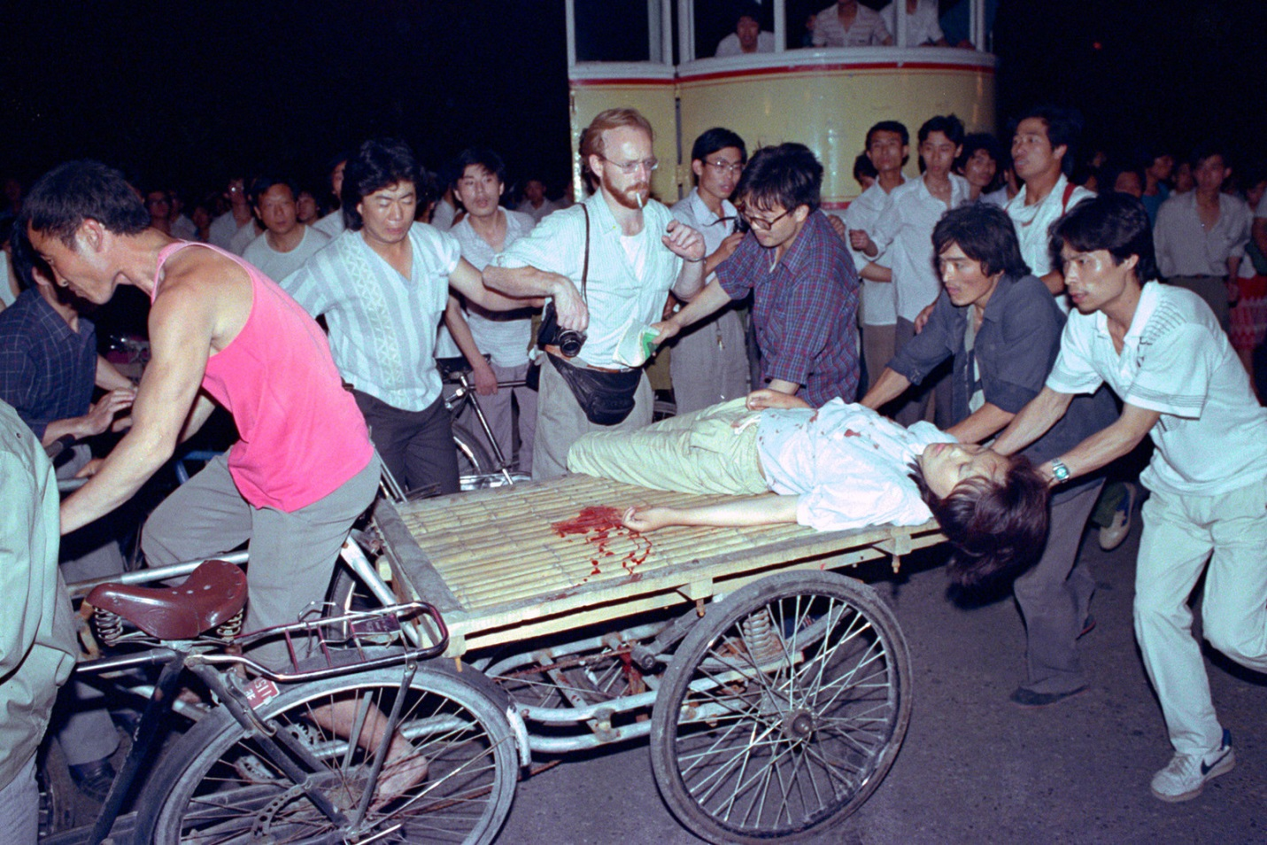*A wounded woman being tended to during the massacre*

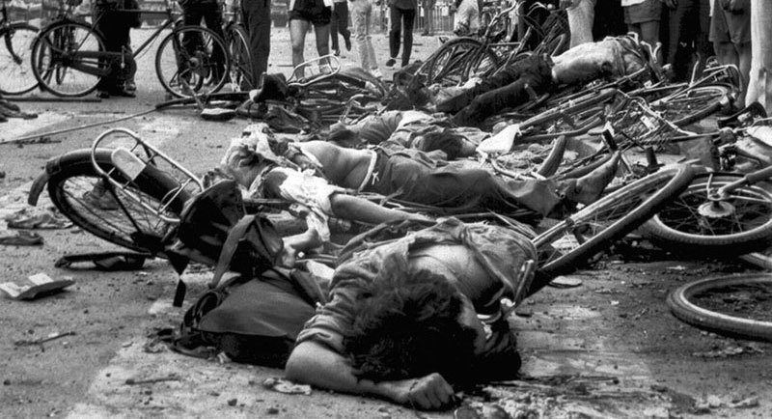*Bodies lying on the Tiananmen Square*

Throughout the night of June 3 and early hours of June 4, the troops beat and shot protesters causing mayhem across the entire area. Tanks drove straight into huge crowds, crushing anything that came in front of them. And, by the early morning of 4th June, 1989, the streets around Tiananmen Square had been cleared.

***The aftermath of the massacre will be covered in the next article. Stay tuned!***