Exercise 13

1.Which command displays the MSQL version?
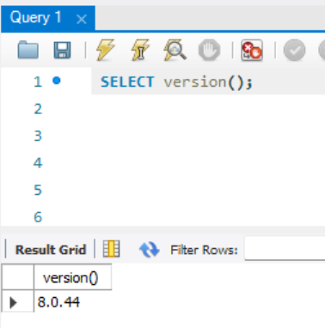
2. Use the Select command to evaluate 4x4x4 and name the column cube of 4.
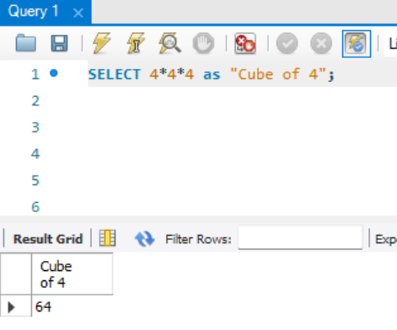
3. Display your name with SELECT.
