**Least Squares Optimization and Graphs – Assignment 3**

**By Marko Bandzo, ID: 1121089**

**Q1.**

Optic flow is essentially the pattern of apparent motion in a series of images. In this case, between two greyscale images. The images chosen for this exercise are shown below:

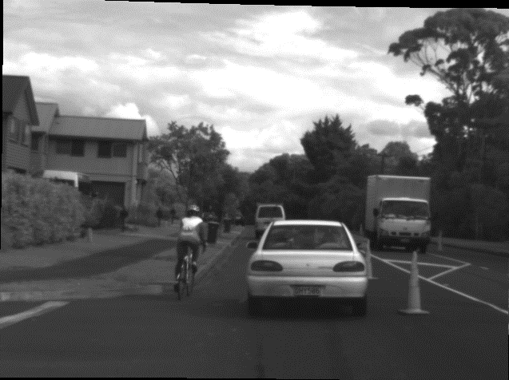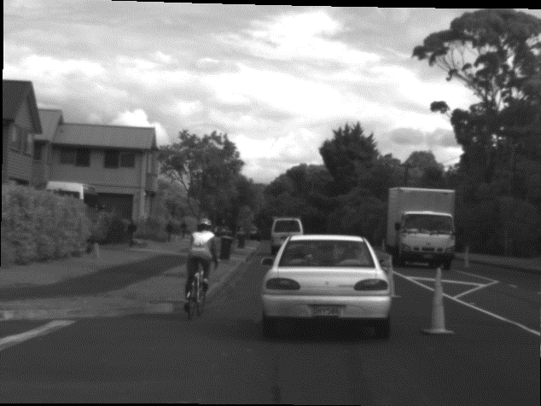

When viewing the images side by side, the human eye cannot really distinguish a difference. However, when viewed as a motion, the difference is clearly visible. Using a Horn-Schunck optical flow method in Matlab, we can display the difference in motion using only one image and vectors on that image which can represent the optical flow.

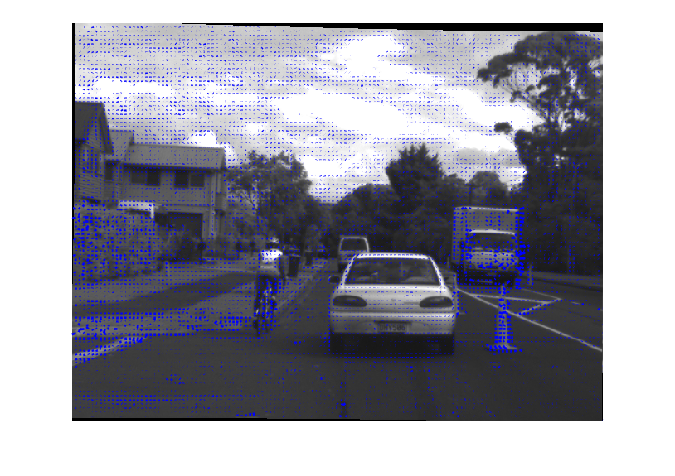Running the provided Horn-Schunck method gives the following image:

5 Iterations

1 Iteration

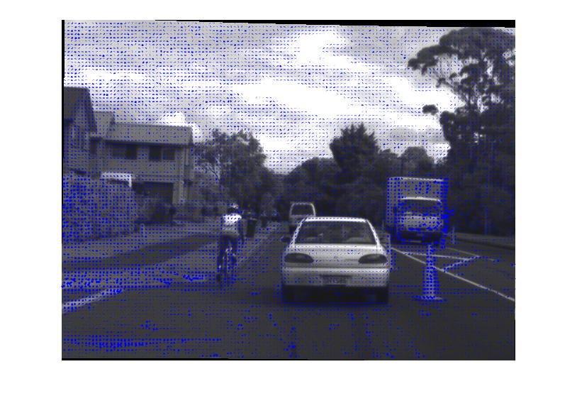

As we can see, the difference between one and five iterations is not very high. The main advantage to using more iterations is the flow is made more distinguished to the observer where the colour differentials are not very high; for example the pavement behind the car or the left side of the wall.

**Q2.**

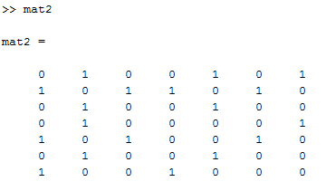To find the shortest possible path between nodes on the graphs provided, the first thing to be done is to assign adjacency matrices to each graph. The matrices are then implemented in Matlab and shown below (mat1 corresponds to graph1 etc):

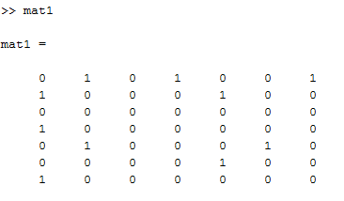Now, to run the dijkstra function:



This will return two variables: e for the minimum distance, and L for the nodes which the shortest path links to.

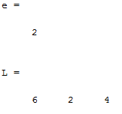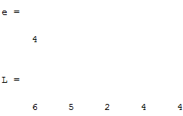

The left is the output for the function above, and the right is the output for the second matrix.