Of the total number of domestic killings that have been disposed, about 47 percent involved offenders who pleaded guilty to a lesser offense than for which they were charged. \*This data represents both male and female suspects charged in domestic murders from 2005-2013.

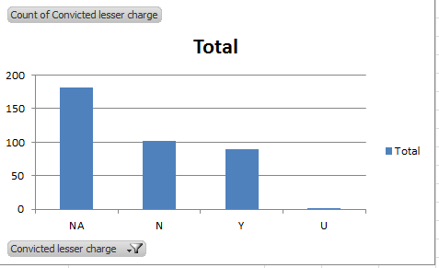

Of cases that have been disposed, 39 percent of offenders who killed women pled guilty to a lesser offense than for which there charged. \*This data represents women killed by men from 2005-2013.

