**East West University**

**Department of CSE**

**Lab Report 01**

**CSE 438**

**Digital Image Processing**

**Submitted To:**

Md. Mahir Ashhab

Lecturer

Department of Computer Science and Engineering

**Submitted By:**

Adri Saha

ID: 2019-1-60-024

Submission Date: 24 July 2022

LAB REPORT 01

Color Models

Output expected & got

**Main Image:**

import cv2 as cv

img=cv.imread('park.jpg')

cv.imshow('Boston',img)

BGR image

**BGR to HSV:**

hsv= cv.cvtColor(img,cv.COLOR_BGR2HSV)

cv.imshow('Boston in hsv',hsv)

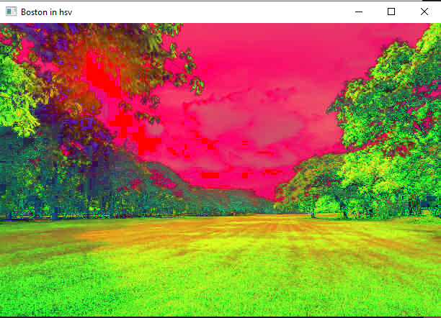

Output

**Expected:** We know RGB primary colors are remapped into dimensions that are simpler for people to understand using the cylindric HSV color model. Hue, saturation, and value are these dimensions, which are like the Munsell Color System. Hue describes the angle at which a color appears on the RGB color wheel.

So from this output we can say we got the right image.

**BGR to Grayscale:**

gray=cv.cvtColor(img,cv.COLOR_BGR2GRAY)

cv.imshow('Boston in gray',gray)

Output image

**Grayscale image:** Grayscale indicates that only the information about the light's intensity is represented by each pixel's value. Usually, just the range from deepest black to brightest white is visible in such images. In other words, the only colors present in the image are black, white, and gray, the latter of which includes several shades.

So here, we find this type of image. So, we can say we got the actual grayscale image.

**BGR to LAB:**

lab = cv.cvtColor(img, cv.COLOR_BGR2LAB)

cv.imshow('Boston in lab',lab)

Output

**LAB image:** Given that there are just three logical colors, an RGB image is simple to comprehend. However, "Lab" is a combination of two channels with a dual color scheme but no contrast (a+b) and one channel with no color (L). Since it is a Greyscale, the 'L' channel, or Lightness, is the most straightforward to comprehend.

Here we found that kind of lightless, no contrast image. So we can say the we got the actual output.

RGB intensity: BGR channel to Single Channel grayscale

**Reasons for why we couldn’t convert BGR image into single channel (B, G, R):**

1 channel images do not have colors since we need an additional dimension to represent them. When we have added split & merge, we can convert BGR to single channel (B,G,R).

**Using split & merge**

As we can’t convert grayscale image to BGR, we need to split the image into b,g,r.

That is how we can convert BGR image into single channel.

**Code:**

blank= np.zeros(img.shape[:2],dtype='uint8')

b,g,r= cv.split(img)

blue= cv.merge([b, blank, blank])

green= cv.merge([b, g, blank])

red= cv.merge([blank, blank, r])

cv.imshow("B",blue)

cv.imshow("G",green)

cv.imshow("R",red)

print(img.shape)

print(b.shape)

print(g.shape)

print(r.shape)

cv.waitKey(0)

Red:

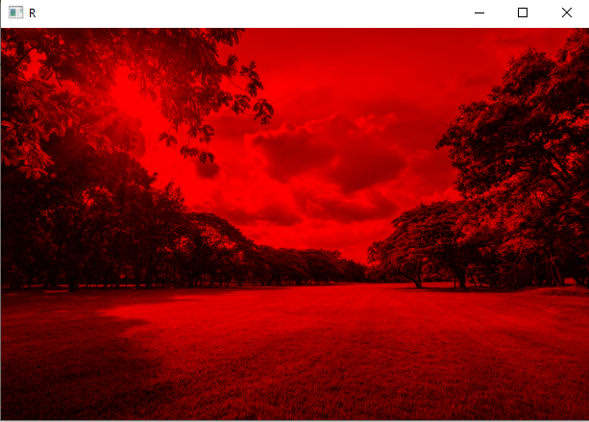

Green:

Blue:

**More Theory**

**Use of grayscale image:**

* Used for extracting descriptors instead of operating on color images directly
* Grayscale simplifies the algorithm and reduces computational requirements.

**BGR image:** An image is called BGR When the image file is read with the OpenCV function imread() , the order of colors is BGR (blue, green, red). The lower eight bits of the BGR's 24-bit representation are blue, the next eight are green, and the upper eight are red.

**RGB image:** The combination of the red, green, and blue intensities stored in each color plane at the pixel's location determines the color of each pixel. The red, green, and blue components of RGB images are each stored as an 8-bit image in graphics file formats. It is common to write RGB values as RGB(r,g,b), where r/g/b values are within the range of 0 and 255, respectively, or as #rrggbb, where rr/gg/bb are 8-bit hex values.

The arrangement of the red, green, and blue subpixels is the main difference between RGB and BGR. Although BGR is essentially in reverse of RGB, there is no negative impact on the intensity and accuracy of the colors.

**HSV image:** The Hue Saturation Value (HSV) scale gives a numerical reading of image that matches the color names it contains. From 0 to 360, hue is measured in degrees.

**Use of HSV image:**

* Used to separate color and luminance information in images.
* This simplifies our work when we need to determine the brightness of the image or frame.
* HSV is also applied in circumstances when color description is important.

**LAB image:** Given that there are just three logical colors, an RGB image is simple to comprehend. However, "Lab" is a combination of two channels with a dual color scheme but no contrast (a+b) and one channel with no color (L). Since it is a Greyscale, the 'L' channel, or Lightness, is the most straightforward to comprehend.

**Use of LAB image:**

* More color accuracy to designate colors, it makes use of three values (L, a, and b).
* To designate colors, it makes use of three values (L, a, and b). By indicating to a device how much of each color it needs, the RGB and CMYK color spaces determine a color.
* More like the human eye, Lab Color works.