**CSE302: Report on Lab Tasks**

**Lab Number: 01**

|  |  |
| --- | --- |
| Student ID | 2019-1-60-024 |
| Student Name | Adri Saha |
| Course Name | Database Management System |
| Course Code | CSE302 |
| Section | 01 |

Submitted to:

Dr. Mohammad Rezwanul Huq

Associate Professor,

Department of Computer Science & Engineering

**Experiment Name**: Introduction to Oracle Database XE and SQLPlus Tool for writing SQL queries

Date of submission: 1 July 2021

**Lab Task # 01 (Creating a table):**

1.(a). Write SQL statement to create a table ‘instructor_your_student_id’ which has 4 attributes –

i) id (number)

ii) name (text)

iii) dept_name (text)

iv) salary (number)

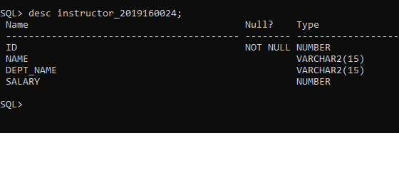

1.(b). Write SQL statement to create a table ‘course_your_student_id’ which has 4 attributes –

i) course_id (text)

ii) title (text)

iii) dept_name (text)

iv) credits (number)

**Lab Task # 02 (Inserting data into a table):**

2.(a). Write SQL statements to insert the following records into ‘instructor_your_student_id’ table:

2.(b). Write SQL statements to insert the following records into ‘course_your_student_id’ table:

**Lab Task # 03 (Writing Queries):**

1. Show instructor name only.

1. Show course id and title only.

1. Find instructor name and department of the instructor with id = 22222.

1. Find course title and credits of the courses offered by ‘Comp. Sci.’ department.

1. Find name and department of instructors who have a salary more than 70000.

1. Find course title of the courses which are not less than 4 credits.

1. Find name and department of instructors who have a salary in between 80000 and 100000 (bounds are inclusive).

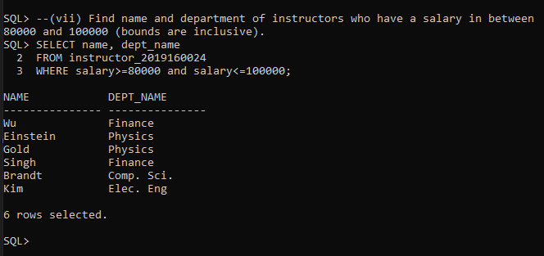

1. Find course titles and credits of the courses not offered by ‘Comp. Sci.’ department.

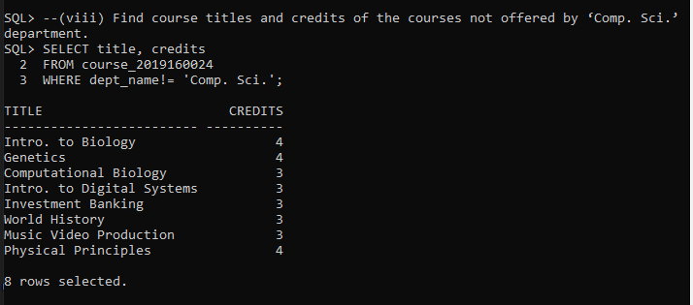

1. Display all records of instructor table.

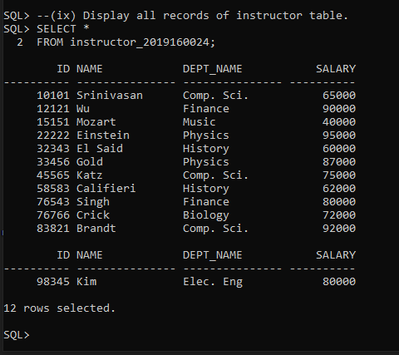

1. Find all courses (display all columns) which are offered by ‘Biology’ department and credits is not 4.

