**East West University**

**Department of CSE**

**Assignment**

**CSE 438**

**Digital Image Processing**

**Submitted To:**

Prof. Dr. Md. Haider Ali

Lecturer

Department of Computer Science and Engineering

**Submitted By:**

Adri Saha

ID: 2019-1-60-024

Submission Date: 06 August 2022

1. Make F(u,v) using attached image f(x,y) in a way, so that the max will be at the at the center.

128*128 pixel image

glColor3ub(IM.DATA[i+2], IM.DATA[i+1], IM.DATA[i]); //Color Image

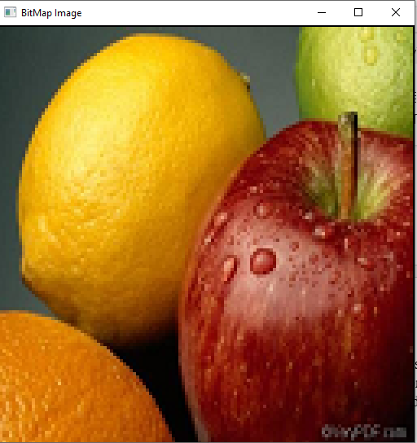

glColor3ub(Gr[y][x], Gr[y][x], Gr[y][x]); //grayscale Image

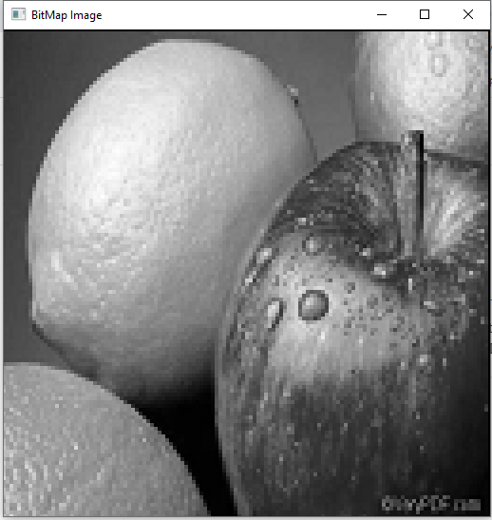

Fourier transform:

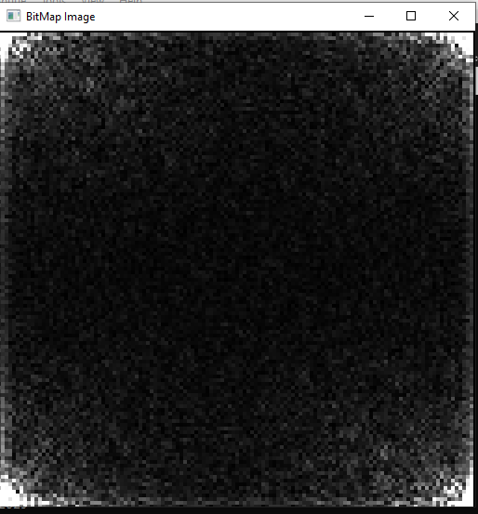

Figure: Bitmap image

White area accumulated on the 4 corners of the picture. Because we found 4 highest values.

Now, **we must accumulate white area in middle part of the picture.**

glColor3d(100*A[y][x], 100*A[y][x], 100*A[y][x]);

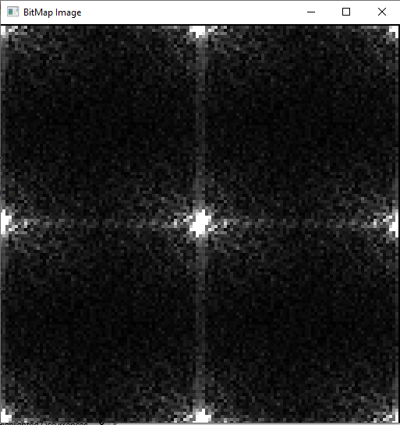

Figure: new bitmap image

Changing part on code:

Gray = (IM.DATA[i+2]+IM.DATA[i+1]+IM.DATA[i])/3;

glColor3ub(Gr[y][x], Gr[y][x], Gr[y][x]); //Color Image

