**East West University**

**Department of CSE**

**UML Use Case and Class Diagram**

**Project Name: Boi Binimoy**

**Submitted To:**

Md. Mohsin Uddin

Senior Lecturer

Department of Computer Science and Engineering

**Submitted By:**

Md. Mahmud Alam

ID: 2018-3-60-014

Adri Saha

ID: 2019-1-60-024

Rafid Mahmud Haque

ID: 2019-1-60-085

**UML Use Case Diagram:**

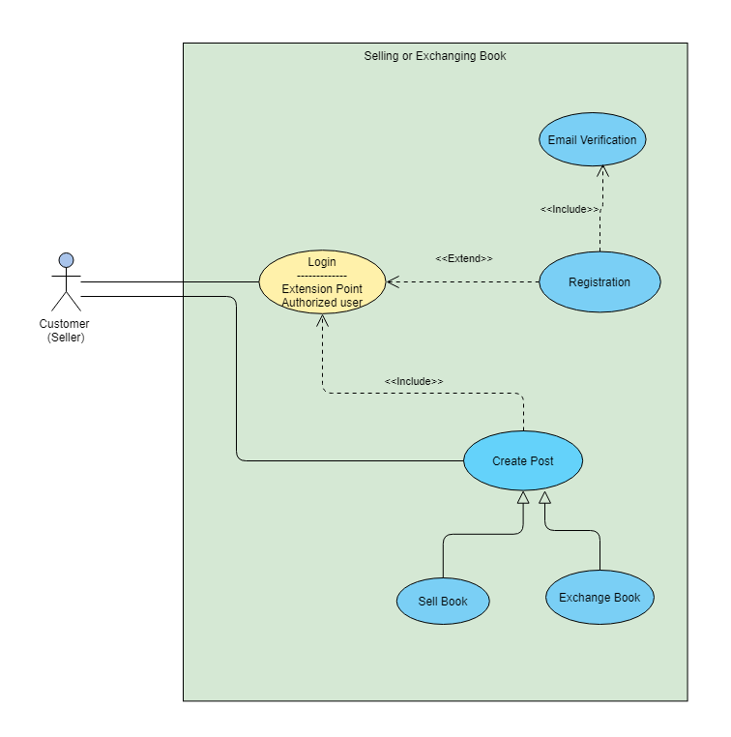

Figure 1: Use case diagram for Selling or exchanging Book.

|  |  |  |
| --- | --- | --- |
| Use Case [Number 1] | Login | |
| Goal in Context | The use case allows students to login as a member, who is already a member of our site. | |
| Precondition | Student must need to registration first. | |
| Success End Condition | Successfully logged in. | |
| Failed End Condition | Login is failed for typing invalid password or username. | |
| Primary Actors | Customer (Seller) | |
| Secondary Actors | Boibinimoy site | |
| Trigger | Student log into his account and click on create new post. | |
| Description | **Step** | **Branching Action** |
| Extension or Variation | **Step**   1. To log in student must need to **registration** first. 2. To create post ad for books l**ogin** is needed. | **Branching Action**  <<extend>>  <<include>> |

|  |  |  |
| --- | --- | --- |
| Use Case [Number 2] | Email Verification | |
| Goal in Context | The use case allows students to verify his/her email to complete registration successfully. | |
| Precondition | Student must need to fill the registration form on site. | |
| Success End Condition | Successfully verify email address. | |
| Failed End Condition | Verification is failed for not clicking on the link sent on email or for giving invalid email address or can’t access on the email. | |
| Primary Actors | Customer (Seller) | |
| Secondary Actors | Boibinimoy site | |
| Trigger | Student register into his account and open an account. | |
| Description | **Step** | **Branching Action** |
| Extension or Variation | **Step**   1. To email verification **registration** is must | **Branching Action**  <<include>> |

|  |  |  |
| --- | --- | --- |
| Use Case [Number 3] | Registration | |
| Goal in Context | The use case allows students to register and open an account on boibinimoy. | |
| Precondition | Student must need to verify email first. | |
| Success End Condition | Successfully done registration & created account. | |
| Failed End Condition | Login is failed for not verifying email or giving incorrect information. | |
| Primary Actors | Customer (Seller) | |
| Secondary Actors | Boibinimoy site | |
| Trigger | Student verify email address along with other information. | |
| Description | **Step** | **Branching Action** |
| Extension or Variation | **Step**   1. To register for an account **email verification** is must. | **Branching Action**  <<include>> |

|  |  |  |
| --- | --- | --- |
| Use Case [Number 4] | Sell book | |
| Goal in Context | The use case allows students to give posts for selling books if they have account on boibinimoy. | |
| Precondition | Student must need to registration & login first. | |
| Success End Condition | Successfully sell all books. | |
| Failed End Condition | Login is failed for typing invalid password or username. | |
| Primary Actors | Customer (Seller) | |
| Secondary Actors | Boibinimoy site | |
| Trigger | Student log into his account and click on create new post. | |
| Description | **Step** | **Branching Action** |
| Extension or Variation | **Step**   1. To sell books must need to create **post ad** for that book first. | **Branching Action**  <<include>> |

|  |  |  |
| --- | --- | --- |
| Use Case [Number 5] | Post Ad | |
| Goal in Context | The use case allows students to post ad for selling books if they have account on boibinimoy. | |
| Precondition | Student must need to registration & login first. | |
| Success End Condition | Successfully post for books. | |
| Failed End Condition | Login is failed for typing invalid password or username. | |
| Primary Actors | Customer (Seller) | |
| Secondary Actors | Boibinimoy site | |
| Trigger | Student log into his account and click on create new post. | |
| Description | **Step** | **Branching Action** |
| Extension or Variation | **Step**   1. To post ad for books l**ogin** is needed. 2. To **sell** books must need to create **post**. | **Branching Action**  <<include>>  <<include>> |

Figure 2: Use case Diagram for Buying, Exchanging and Searching Book.

|  |  |  |
| --- | --- | --- |
| Use Case [Number 6] | Buy Books | |
| Goal in Context | The use case allows students to buy books from any post. | |
| Precondition | Student must need to registration & login first. | |
| Success End Condition | Successfully buy desired books. | |
| Failed End Condition | Login is failed for typing invalid password or username. | |
| Primary Actors | Customer (Buyer) | |
| Secondary Actors | Boibinimoy site | |
| Trigger | Student log into his account  click on create new post.  Contact with the seller | |
| Description | **Step** | **Branching Action** |
| Extension or Variation | **Step**   1. To buy books must need to **browse** **post**. | **Branching Action**  <<include>> |

|  |  |  |
| --- | --- | --- |
| Use Case [Number 7] | Browse Ad | |
| Goal in Context | The use case allows students to browse their desired books. | |
| Precondition | Student must need to registration & login first. | |
| Success End Condition | Successfully find desired books. | |
| Failed End Condition | Login is failed for typing invalid password or username. | |
| Primary Actors | Customer (Buyer) | |
| Secondary Actors | Boibinimoy site | |
| Trigger | Student log into his account  click on create new post.  Contact with the seller | |
| Description | **Step** | **Branching Action** |
| Extension or Variation | **Step**   1. To browse post for books l**ogin** is needed. | **Branching Action**  <<include>> |

|  |  |  |
| --- | --- | --- |
| Use Case [Number 8] | Search Book | |
| Goal in Context | The use case allows students to search their desired books using searching option. | |
| Precondition | Student must need to registration & login first. | |
| Success End Condition | Successfully find desired books. | |
| Failed End Condition | Login is failed for typing invalid password or username. | |
| Primary Actors | Customer (Buyer) | |
| Secondary Actors | Boibinimoy site | |
| Trigger | Student log into his account  click on create new post.  Contact with the seller | |
| Description | **Step** | **Branching Action** |
| Extension or Variation | **Step**   1. To search their desired books must need to logged in. | **Branching Action**  <<include>> |

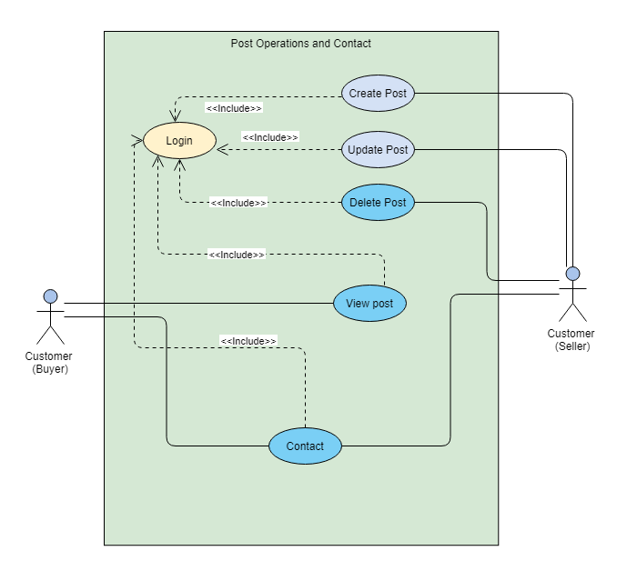

Figure 3: Use case diagram for Post operations and Contact.

|  |  |  |
| --- | --- | --- |
| Use Case [Number 9] | Update Ad | |
| Goal in Context | The use case allows students to make one of the crud operations which is update his/her post. | |
| Precondition | Student must need login first. | |
| Success End Condition | Successfully updated his/her post.. | |
| Failed End Condition | Login is failed for typing invalid password or username. | |
| Primary Actors | Customer (Buyer), Customer (Seller) | |
| Secondary Actors | Boibinimoy site | |
| Trigger | Student log into his account and go to profile.  View on post.  Click on update post. | |
| Description | **Step**  Customer (Buyer) to customer(seller) | **Branching Action**  Can contact |
| Extension or Variation | **Step**   1. To **update** posts for books login is needed. | **Branching Action**  <<include>> |

|  |  |  |
| --- | --- | --- |
| Use Case [Number 10] | Delete Ad | |
| Goal in Context | The use case allows students to make one of the crud operations which is delete his/her post. | |
| Precondition | Student must need login first. | |
| Success End Condition | Successfully deleted the post. | |
| Failed End Condition | Login is failed for typing invalid password or username. | |
| Primary Actors | Customer (Buyer), Customer (Seller) | |
| Secondary Actors | Boibinimoy site | |
| Trigger | Student log into his account and view post.  Click on delete post. | |
| Description | **Step**  Customer (Buyer) to customer(seller) | **Branching Action**  Can contact |
| Extension or Variation | **Step**  .   1. To **delete** books must need to logged in. | **Branching Action**  <<include>> |

|  |  |  |
| --- | --- | --- |
| Use Case [Number 11] | Update Profile | |
| Goal in Context | The use case allows students to make one of the crud operations which is update his/her profile. | |
| Precondition | Student must need to login first. | |
| Success End Condition | Successfully updated or changed profile information. | |
| Failed End Condition | Login is failed for typing invalid password or username. | |
| Primary Actors | Customer (Buyer), Customer (Seller) | |
| Secondary Actors | Boibinimoy site | |
| Trigger | Student log into his account and view post.  Click on update post. | |
| Description | **Step**  Customer (Buyer) to customer(seller) | **Branching Action**  Can contact |
| Extension or Variation | **Step**   1. To **update** posts for books login is needed. | **Branching Action**  <<include>> |

|  |  |  |
| --- | --- | --- |
| Use Case [Number 12] | Contact | |
| Goal in Context | The use case allows students to make one to one conversation between buyer and seller. | |
| Precondition | Student must need login first. | |
| Success End Condition | Successfully done conversation between dealer and customer. | |
| Failed End Condition | Login is failed for typing invalid password or username. | |
| Primary Actors | Customer (Buyer), Customer (Seller) | |
| Secondary Actors | Boibinimoy site | |
| Trigger | View post & click on seller profile from the post.  Make comment on the post & communicate with seller to buy book. | |
| Description | **Step**  Customer (Buyer) to customer(seller) | **Branching Action**  Can contact |
| Extension or Variation | **Step**   1. To view others posts and contact must need to logged in. | **Branching Action**  <<include>> |

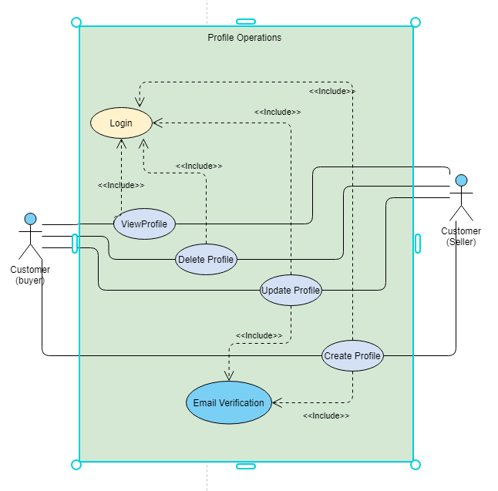

Figure 4: Use case diagram for Profile operations.

|  |  |  |
| --- | --- | --- |
| Use Case [Number 13] | View Profile | |
| Goal in Context | The use case allows customers to make one of the crud operations which is read or view their own profile. One customer can also view others profile. | |
| Precondition | Customer must need login first. | |
| Success End Condition | Successfully view own or other person’s profile. | |
| Failed End Condition | Login is failed for typing invalid password or username. | |
| Primary Actors | Customer (Buyer), Customer (Seller) | |
| Secondary Actors | Boibinimoy site | |
| Trigger | Student log into his account and view profile. | |
| Description | **Step**  Customer (Buyer) to customer(seller) | **Branching Action** |
| Extension or Variation | **Step**   1. To **view** profile l**ogin** is needed. | **Branching Action**  <<include>> |

|  |  |  |
| --- | --- | --- |
| Use Case [Number 14] | Delete Profile | |
| Goal in Context | The use case allows customers to make one of the crud operations which is delete their own profile. Customer & seller both can delete their profile. | |
| Precondition | Customer must need login first. | |
| Success End Condition | Successfully deleted profile. | |
| Failed End Condition | Login is failed for typing invalid password or username. | |
| Primary Actors | Customer (Buyer), Customer (Seller) | |
| Secondary Actors | Boibinimoy site | |
| Trigger | Student log into his account and view profile.  Click on update profile.  Delete profile. | |
| Description | **Step**  Customer (Buyer) to customer(seller) | **Branching Action** |
| Extension or Variation | **Step**   1. To **delete** profile must need to be **logged** in. | **Branching Action**  <<include>> |

|  |  |  |
| --- | --- | --- |
| Use Case [Number 15] | Update Profile | |
| Goal in Context | The use case allows customers to make one of the crud operations which is update their own profile by verifying email. | |
| Precondition | Customer must need to login first & then verify from email address. | |
| Success End Condition | Successfully updated seller or customer’s profile.. | |
| Failed End Condition | Login is failed for typing invalid password or username. | |
| Primary Actors | Customer (Buyer), Customer (Seller) | |
| Secondary Actors | Boibinimoy site | |
| Trigger | Student log into his account and view profile.  Click on update profile.  Verify email address and  then update information. | |
| Description | **Step**  Customer (Buyer) to customer(seller) | **Branching Action** |
| Extension or Variation | **Step**   1. To **update** profile **login** is needed. 2. To **update** profile must need to verify email address. | **Branching Action**  <<include>>  <<include>> |

|  |  |  |
| --- | --- | --- |
| Use Case [Number 16] | Create Profile | |
| Goal in Context | The use case allows customers to make one of the crud operations which is create their own profile by verifying email. | |
| Precondition | Customer must need login first & verify by email address. | |
| Success End Condition | Successfully created new profile. | |
| Failed End Condition | Profile creation is failed for typing invalid email or not verifying email address. | |
| Primary Actors | Customer (Buyer), Customer (Seller) | |
| Secondary Actors | Boibinimoy site | |
| Trigger | Student log into his account  Fill the information & crate profile | |
| Description | **Step**  Customer (Buyer) to customer(seller) | **Branching Action** |
| Extension or Variation | **Step**   1. To **create** profile **login** is **needed**. 2. To **create** profile **email verification** is needed. | **Branching Action**  <<include>>  <<include>> |

**UML Class Diagram:**

