STRATEGY
  - Object Behavioural (Policy)
Intent
Define a family of algorithms, encapsulate each one, and make them interchangeable. Strategy lets the algorithm vary independently from clients that use it.

Motivation
- Avoid linebreaking code (easier maintainability and extensibility)
- Different interchangeable algorithms support
- Avoid the difficulty of adding new algorithms or modifying new ones

Applicability
- Many related classes differ only in their behaviour (allows configuration for each class with diff behaviours)
- Diff variants of the same algorithm are needed
- An algorithm uses data that clients should not know about
- Redefine a class behaviour changing multiple conditionals statements to encapsulated Strategy classes

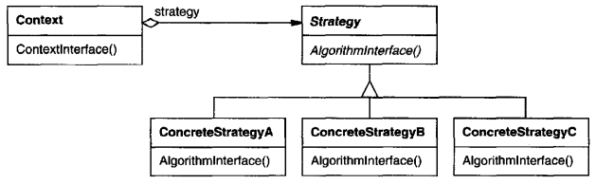
Structure

Participants
- Strategy: declares an interface common to all supported algorithms
- ConcreteStrategy: implements the algorithm using the Strategy interface
- Context: is configured with a ConcreteStrategy, have a reference to a Strategy object and may define an interface that lets Strategy access its data.
Collaboration
- Strategy and Context interact to implement the chosen algorithm. A context may pass all data required by the algorithm to the strategy when the algorithm is called
- A context forwards requests from its clients to its strategy. Clients usually create and pass a ConcreteStrategy object to the context; thereafter, clients interact with the context exclusively

Consequences
- Families of related algorithms: hierarchies of Strategy classes define a family of algorithms or behaviours for contexts to reuse. Inheritance can help factor out common functionality of the algorithms
- An alternative to subclassing: encapsulating the algorithm in separate Strategy classes lets you vary the algorithm independently of its context, making it easier to switch, understand, and extend
- Strategies eliminate conditional statements: the Strategy pattern offers an alternative to conditional statements for selecting desired behaviour, the Strategy pattern eliminates this case statement by delegating the linebreaking task to a Strategy object (code containing many conditional statements often indicates the need to apply the Strategy pattern)
- A choice of implementations: Strategies can provide different implementations of the same behaviour
- Clients must be aware of different Strategies: a client must understand how Strategies differ before it can select the appropriate one. Clients might be exposed to implementation issues. Therefore, you should use the Strategy pattern only when the variation in behaviour is relevant to clients
- Communication overhead between Strategy and Context: the Strategy interface is shared by all ConcreteStrategy classes whether the algorithms they implement are trivial or complex. Hence, it is likely that some ConcreteStrategy will not use all the information passed to them through this interface
- Increased number of objects: Strategies increase the number of objects in an application\

FACTORY METHOD
  - Class Creational (Virtual Constructor)
Intent
Define an interface for creating an object but let subclasses decide which class to instantiate. Factory Method lets a class defer instantiation to subclasses.

Motivation
The Factory Method pattern prevents the framework from creating invalid "empty" objects by delegating instantiation to subclasses. The framework defines an abstract method for creating objects, and concrete subclasses implement this method to return fully initialized, specific objects. This ensures only valid, complete objects are created while keeping the framework decoupled from concrete classes.

Applicability
- A class cannot anticipate the class of objects it must create
- A class wants its subclasses to specify the objects it creates
- Classes delegate responsibility to one of several helper subclasses, and you want to localize the knowledge of which helper subclass is the delegate

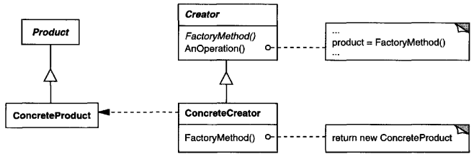
Structure

Participants
- Product: defines the interface of objects the factory method creates
- ConcreteProduct: implements the Product interface
- Creator: declares the factory method, which returns an object of type Product, it may also define a default implementation of the factory method that returns a default ConcreteProduct object and may call the factory method to create a Product object
- ConcreteCreator: overrides the factory method to return an instance of a ConcreteProduct

Collaboration
Creator relies on its subclasses to define the factory method so that it returns an instance of the appropriate ConcreteProduct.

Consequences
Factory methods eliminate the need to bind application-specific classes into your code. The code only deals with the Product interface and can therefore work with any user-defined ConcreteProduct classes
Clients might have to subclass the Creator class just to create a particular ConcreteProduct object. This adds another point of evolution when the client would not otherwise need to subclass the Creator

- Provides hooks for subclasses.
- Creating objects inside a class with a factory method is more flexible than creating an object directly. It gives subclasses a hook for providing an extended version of an object
- The factory method can be non-abstract, providing a reasonable default implementation that subclasses may optionally override
- Connects parallel class hierarchies.
- Parallel class hierarchies result when a class delegate some of its responsibilities to a separate class
- The Factory Method pattern localizes the knowledge of which classes belong together between these parallel hierarchies
- The factory method in the base class returns an instance of the appropriate class from the parallel hierarchy
- The hierarchies may be only partially parallel if some subclasses inherit the default factory method implementation and do not require a corresponding subclass in the parallel hierarchy

ABSTRACT FACTORY
  - Object Creational (Kit)
Intent
Provide an interface for creating families of related or dependent objects without specifying their concrete classes.

Motivation
The Abstract Factory pattern enables the creation of families of related objects without specifying their concrete classes. It defines an interface for generating various related objects while keeping client code independent of specific implementations. This approach ensures that all created objects are compatible with each other, as each concrete factory produces a complete set of coordinated products. Clients interact exclusively with abstract interfaces, remaining unaware of the concrete classes being instantiated. This maintains consistency across object families and allows the system to easily switch between different variants without modifying client code.

Applicability
- A system should be independent of how its products are created, composed, and represented.
- A system should be configured with one of multiple families of products.
- A family of related product objects is designed to be used together, and you need to enforce this constraint.
- You want to provide a class library of products, and you want to reveal just their interfaces, not their implementations.

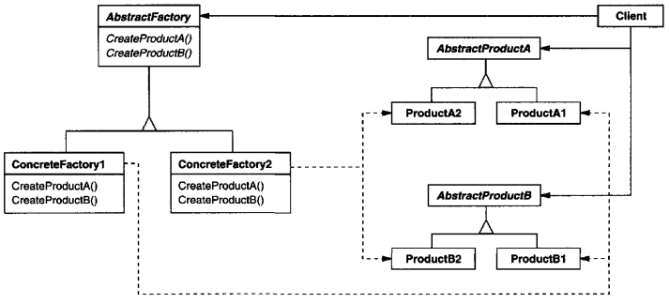
Structure

Participants
- AbstractFactory: declares an interface for operations that create abstract product objects.
- Concrete Factory: implements the operations to create concrete product objects.
- AbstractProduct: declares an interface for a type of product object.
- ConcreteProduct: defines a product object to be created by the corresponding concrete factory and implements the AbstractProduct interface.
- Client: uses only interfaces declared by AbstractFactory and AbstractProduct classes

Collaboration
- Normally a single instance of a ConcreteFactory class is created at run-time. This concrete factory creates product objects having a particular implementation. To create different product objects, clients should use a different concrete factory.
- AbstractFactory defers creation of product objects to its ConcreteFactory subclass.

Consequences
- Isolates concrete classes increases the control over the classes of objects that an application creates. It encapsulates the responsibility and the process of creating product objects and isolates clients from implementation classes. Clients manipulate instances through their abstract interfaces. Product class names are isolated in the implementation of the concrete factory (they do not appear in client code)
- Makes exchanging product families easy: the class of a concrete factory appears only once in an application. This makes it easy to change the concrete factory an application uses. It can use different product configurations simply by changing the concrete factory. Because an abstract factory creates a complete family of products, the whole product family changes at once.
- Promotes consistency among products: when product objects in a family are designed to work together, it is important that an application use objects from only one family at a time. AbstractFactory makes this easy to enforce.
- Supporting new kinds of products is difficult: extending abstract factories to produce new kinds of Products is not easy. That is because the AbstractFactory interface fixes the set of products that can be created. Supporting new kinds of products requires extending the factory interface, which involves changing the AbstractFactory class and all its subclasses.

COMPOSITE
  - Object Structural
Intent
Compose objects into tree structures to represent part-whole hierarchies. Composite lets clients treat individual objects and compositions of objects uniformly

Motivation
The Composite pattern addresses the problem of treating individual objects and compositions of objects uniformly. It uses recursive composition to allow clients to handle both primitive elements and complex containers identically.
The pattern centers on an abstract class that represents both primitives and containers. This class declares operations for the object's specific behaviour as well as operations for managing child components. Primitive subclasses implement the core behaviour but ignore child management operations, while composite subclasses implement child management and delegate behaviour to their children.
This structure enables clients to work with all objects through the same interface, eliminating the complexity of distinguishing between primitives and composites. The recursive nature allows composites to contain other composites, creating complex tree structures while maintaining a consistent interface.

Applicability
- Necessity to represent part-whole hierarchies of objects.
- Client needs to be able to ignore the difference between compositions of objects and individual objects. Clients will treat all objects in the composite structure uniformly
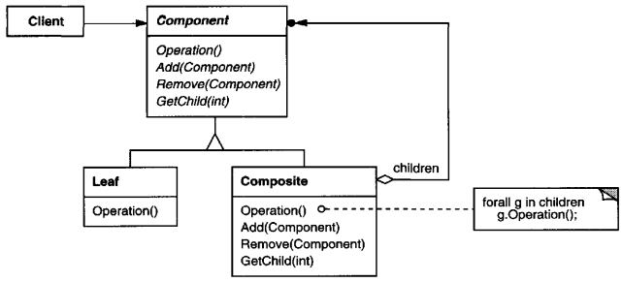
Structure
Participants
- Component: declares the interface for objects in the composition. It also implements default behaviour for the interface common to all classes, declares an interface for accessing and managing its child components and optionally defines an interface for accessing a component's parent in the recursive structure, and implements it if that is appropriate.
- Leaf: represents leaf objects in the composition, has no children and defines behaviour for primitive objects in the composition.
- Composite: defines behaviour for components having children, stores child components and implements child-related operations in the Component interface.
- Client: manipulates objects in the composition through the Component interface.
Collaboration
Clients use the Component class interface to interact with objects in the composite structure. If the recipient is a Leaf, then the request is managed directly. If the recipient is a Composite, then it usually forwards requests to its child components, possibly performing additional operations before and/or after forwarding.
Consequences
- Defines class hierarchies consisting of primitive objects and composite objects: primitive objects can be composed into more complex objects, which in turn can be composed recursively. Wherever client code expects a primitive object, it can also take a composite object.
- Clients can treat composite structures and individual objects uniformly: Clients normally do not know (and shouldn't care) whether they are dealing with a leaf or a composite component. This simplifies client code, because it avoids having to write tag-and-case-statement-style functions over the classes that define the composition. Clients became easier.
- Makes it easier to add new kinds of components: newly defined Composite or Leaf subclasses work automatically with existing structures and client code. Clients do not have to be changed for new Component classes.
- Can make your design overly general: The disadvantage of making it easy to add new components is that it makes it harder to restrict the components of a composite. Sometimes you want a composite to have only certain components. With Composite, it not possible to rely on the type of system to enforce those constraints, run-time checks are necessary.

STATE
  - Object Behavioural (Objects for States)
Intent
Allow an object to alter its behaviour when its internal state changes. The object will appear to change its class.

Motivation
The State pattern addresses the fundamental problem of managing object behaviour that changes dramatically based on internal state. Without this pattern, objects typically rely on complex conditional logic (lengthy switch statements or if-else chains) to manage state-dependent behaviour, which becomes difficult to maintain, extend, and understand as states multiply.
This pattern solves this by allowing an object to change its behaviour by delegating state-specific operations to separate state objects. Each state is encapsulated in its own class, making state transitions explicit and eliminating tangled conditional code. The result is a system where new states can be added without modifying existing code, and where state-specific behaviour is organized and clear.

Applicability
- An object's behaviour depends on its state, and it must change its behaviour at run-time depending on that state.
- Operations have large, multipart conditional statements that depend on the object's state. This state is usually represented by one or more enumerated constants. Often, several operations will contain this same conditional structure. The State pattern puts each branch of the conditional in a separate class. This lets you treat the object's state as an object in its own right that can vary independently from other objects.

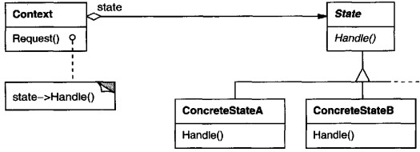
Structure

Participants
- Context: defines the interface of interest to clients and maintains an instance of a ConcreteState subclass that defines the current state.
- State: defines an interface for encapsulating the behaviour associated with a particular state of the Context.
- ConcreteState: subclasses and each subclass implement a behaviour associated with a state of the Context.

Collaboration
- Context delegates state-specific requests to the current ConcreteState object.
- A context may pass itself as an argument to the State object handling the request. This lets the State object access the context if necessary.
- Context is the primary interface for clients. Clients can configure a context with State objects. Once a context is configured, its clients do not have to deal with the State objects directly.
- Either Context or the ConcreteState subclasses can decide which state succeeds another and under what circumstances.

Consequences
- Localization and Partitioning of State-Specific Behaviour: The pattern consolidates all behaviour associated with a particular state into a dedicated object. This eliminates the need for complex conditional statements scattered throughout the code, making it easier to add new states and transitions by simply defining new subclasses. While this distribution across multiple classes increases the overall number of classes, it is a superior alternative to large, monolithic conditional blocks, which are difficult to maintain and extend. The logic for state transitions is also neatly partitioned within the state subclasses, making the code's structure and intent clearer.
- Explicit State Transitions: By representing states as distinct objects, the pattern makes state transitions explicit and atomic. This is a significant improvement over implementations where state is defined only by internal data values, as transitions become visible operations (reassigning a state object variable) rather than just scattered variable assignments. This explicit nature also helps protect the context from ending up in inconsistent internal states.
- Shareability of State Objects: State objects that have no instance variables—meaning the state is represented solely by the object's type—can be shared across multiple contexts. In this scenario, the state objects act as flyweights, possessing behaviour but no intrinsic state, leading to potential efficiency gains.

template mthod
  - Class Behavioural
Intent
Define the skeleton of an algorithm in an operation, deferring some steps to subclasses. Template Method lets subclasses redefine certain steps of an algorithm without changing the algorithm's structure.

Motivation
To define the overall structure of an algorithm in a single operation while allowing subclasses to refine specific steps. By placing the invariant sequence of actions in a base method and delegating certain operations to abstract methods, the pattern ensures consistent algorithm flow while enabling flexible and customizable behaviour in subclasses. This makes it possible to adapt parts of the process to different requirements without altering the fundamental algorithm.

Applicability
- to implement the invariant parts of an algorithm once while allowing subclasses to define the parts that can vary.
- when shared behaviour among subclasses should be centralized in a common class to reduce duplication. This involves identifying variations in existing code, separating them into new operations, and replacing the differing code with a template method that invokes those operations.
- to regulate how subclasses extend functionality by defining a template method that invokes specific “hook” operations, allowing controlled customization only at designated points.

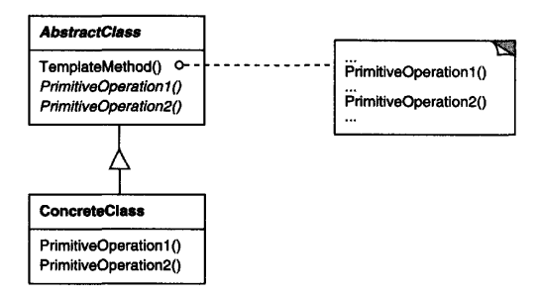
Structure

Participants
- AbstractClass: defines abstract primitive operations that concrete subclasses define to implement steps of an algorithm. Also implements a template method defining the skeleton of an algorithm. The template method calls primitive operations as well as operations defined in AbstractClass or those of other objects.
- ConcreteClass: implements the primitive operations to carry out subclass-specific steps of the algorithm.

Collaboration
ConcreteClass relies on AbstractClass to implement the invariant steps of the algorithm.
Consequences
Template methods are a key mechanism for promoting code reuse. They are especially valuable in class libraries because they make it possible to isolate and share common behaviour at a high level in a class hierarchy.
This pattern results in an inverted control structure often described as “Don’t call us, we’ll call you.” Instead of subclasses directing the flow, the parent class determines the algorithm and invokes subclass-provided operations at predefined points.

Within a template method, different kinds of operations can be invoked, including:
- concrete operations that perform fixed behaviour,
- general-purpose operations provided by the abstract class,
- abstract operations that subclasses must implement,
- factory methods that allow subclasses to determine which objects are created
- hook operations that provide optional extension points, typically with default or empty behaviour.
It is essential for template methods to clearly indicate which operations are required to be overridden and which are optional. This clarity ensures that subclass authors understand the intended extension points and can correctly adapt the behaviour.

Subclasses may extend the behaviour defined in the parent class by overriding operations. However, relying on subclasses to manually incorporate parent behaviour can lead to omissions. One way to avoid this issue is to shift control to the parent class by converting such operations into template methods. The parent class then invokes clearly defined hook operations at specific points, and subclasses extend the behaviour by overriding only those hooks. This approach ensures consistent execution of the parent’s logic while still allowing controlled customization.

Adapter
  - Class and Object Structural (Wrapper)
Intent
Convert the interface of a class into another interface clients expect. Adapter lets classes work together that couldn't otherwise because of incompatible interfaces.

Motivation
A reusable class may become unusable in certain applications simply because its interface doesn’t match the domain-specific interface the application expects. When an application requires objects to conform to a particular abstraction, existing classes with incompatible interfaces cannot be used directly.
Modifying those existing classes to fit the required interface is often impossible or undesirable, especially when their source code is unavailable or when they are part of a general-purpose toolkit that should not depend on domain-specific requirements.
The solution is to create an adapter that makes an existing class conform to the required interface. This can be done in two ways: inheriting the target interface while reusing the existing class's implementation, or composing an instance of the existing class and translating the expected interface into the one the class provides. These correspond to the class adapter and object adapter versions of the Adapter pattern.
An adapter may also supply functionality that the original class lacks but the application requires, ensuring the adapted class fully behaves according to the expected interface.

Applicability
Use the Adapter pattern when
- you want to use an existing class, and its interface does not match the one you need.
- you want to create a reusable class that cooperates with unrelated or unforeseen classes, that is, classes that don't necessarily have compatible interfaces.
- (object adapter only) you need to use several existing subclasses, but it's unpractical to adapt their interface by subclassing every one. An object adapter can adapt the interface of its parent class.

Structure

Class adapter
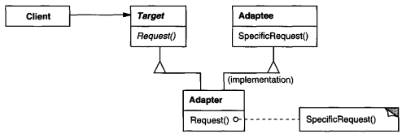

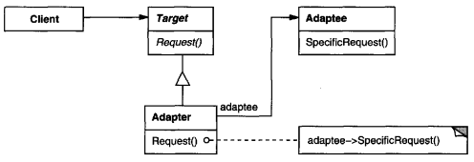
Object adapter

Participants
- Target:defines the domain-specific interface that Client uses.
- Client: collaborates with objects conforming to the Target interface.
- Adaptec: defines an existing interface that needs adapting.
- Adapter: adapts the interface of Adaptec to the Target interface.

Collaboration

Clients call operations on an Adapter instance. In turn, the adapter calls Adaptec operations that carry out the request.

Consequences
Class adapters
- Bind the adapter to a specific class, preventing adaptation of that class’s entire hierarchy.
- Allow overriding of the adapted class’s behavior because the adapter subclasses it.
- Require only one object, avoiding extra indirection.
Object adapters
- Allow a single adapter to work with multiple classes in the adapted hierarchy and can add functionality to all of them at once.
- Make behavior overriding more difficult, requiring subclassing of the adapted class and referencing that subclass instead.

Additional considerations when using the Adapter pattern:
- Degree of adaptation:
Adapters differ in how much they transform one interface into another, ranging from simple name changes to supporting an entirely different operation set. The required work depends on how similar the two interfaces are.
- Pluggable adapters:
Embedding interface adaptation into a class reduces assumptions about external interfaces and increases reusability. This allows integration into systems that expect different interfaces without forcing those systems to conform to a specific abstraction.
- Two-way adapters for transparency:
Adapters are not always transparent, since adapted objects no longer conform to the original interface. Two-way adapters solve this by supporting both interfaces simultaneously, allowing different clients to interact with the same object through different interface views.

command
  - Object Behavioural (Action or Transaction)
Intent
Encapsulate a request as an object, thereby letting you parameterize clients with different requests, queue or log requests, and support undoable operations.

Motivation
Sometimes it's necessary to issue requests without knowing which operation will be performed or which object will handle it. User interface elements often need to trigger actions, but they cannot contain the logic themselves, since only the application knows what actions should be performed and on which objects.
The Command pattern solves this by turning a request into an object. A central abstract Command class defines an interface for executing an operation. Concrete Command subclasses bind a specific receiver and define the execution logic, delegating the actual work to the receiver, which holds the necessary knowledge.
This pattern allows interface elements or other invokers to trigger operations without depending on specific classes or implementations. Commands encapsulate both the receiver and the action, letting invokers remain completely decoupled from the logic they trigger.
Commands can also be combined into sequences, enabling the creation of composite actions. This supports flexible user interface design, dynamic replacement of commands, context-dependent behavior, and command scripting. The key advantage is that the object issuing the request only needs to know how to invoke it—not how it is executed.

Applicability
- Parameterize objects with actions. Commands act as an object-oriented alternative to callbacks, allowing actions to be supplied as objects.
- Specify, queue, and execute requests at different times. Command objects can outlive the original request and can be transferred across processes if the receiver can be represented independently.
- Support undo. Commands can store the state needed to reverse their effects. The interface must include an Unexecute operation, and executed commands are kept in a history list to enable unlimited undo/redo through repeated calls to Unexecute and Execute.
- Support logging and recovery. By adding load/store operations, commands can be persisted and reapplied after a crash by reloading them and executing their stored requests.
- Structure systems around high-level operations built on primitives. This is common in systems that use transactions. Commands provide a uniform interface for invoking these operations and allow new types of transactions to be added easily.

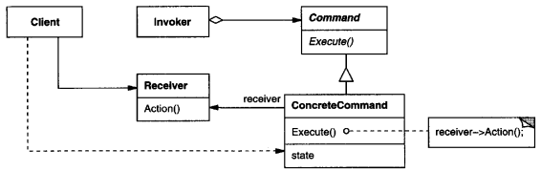
Structure

Participants
- Command: declares an interface for executing an operation.
- ConcreteCommand: defines a binding between a Receiver object and an action. - implements Execute by invoking the corresponding operation(s) on Receiver.
- Client: creates a ConcreteCommand object and sets its receiver.
- Invoker: asks the command to carry out the request.
- Receiver: knows how to perform the operations associated with carrying out a request. Any class may serve as a Receiver.

Collaboration
- The client creates a ConcreteCommand object and specifies its receiver.
- An Invoker object stores the ConcreteCommand object.
- The invoker issues a request by calling Execute on the command. When commands are undoable, ConcreteCommand stores state for undoing the command prior to invoking Execute.
- The ConcreteCommand object invokes operations on its receiver to carry out the request.

Consequences
- Command decouples the object that invokes the operation from the one that knows how to perform it.
- Commands are first-class objects. They can be manipulated and extended like any other object.
- You can assemble commands into a composite command. An example is the MacroCommand class described earlier. In general, composite commands are an instance of the Composite pattern.
- It's easy to add new Commands, because you don't have to change existing classes.

observer
  - Object Behavioural (Dependents or Publish-Subscribe)
Intent
Define a one-to-many dependency between objects so that when one object changes state, all its dependents are notified and updated automatically.

Motivation
When a system is divided into cooperating classes, maintaining consistency across related objects becomes necessary. Achieving this consistency should not rely on tight coupling, since that would limit reusability.
In many designs, different components depend on shared data but must remain independent of each other. Although they operate as if they are aware of one another, they should not be directly connected. Instead, they must stay synchronized with the shared data whenever it changes, and any number of components may depend on the same source.
The Observer pattern defines how to manage these dependencies. It involves two key roles: subject and observer. A subject can have any number of observers, and it notifies all of them whenever its state changes. Each observer then retrieves the necessary information from the subject to update itself and remain consistent.
This relationship is also known as publish–subscribe, where the subject acts as the publisher of change notifications and observers subscribe to updates without the subject needing to know their identities.

Applicability
- When an abstraction has two aspects, one dependent on the other. Encapsulating these aspects in separate objects lets you vary and reuse them independently.
- When a change to one object requires changing others, and you don't know how many objects need to be changed.
- When an object should be able to notify other objects without making assumptions about who these objects are. In other words, you don't want these objects tightly coupled.

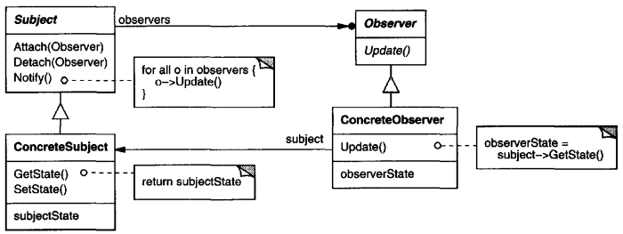
Structure

Participants
- Subject: knows its observers. Any number of Observer objects may observe a subject and provides an interface for attachingand detaching Observer objects.
- Observer: defines an updating interface for objects that should be notified ofchanges in a subject.
- ConcreteSubject: stores state ofinterest toConcreteObserver objects and sends a notification to its observers when itsstate changes.
- ConcreteObserver: maintains a reference to a ConcreteSubject object, stores state that should stay consistent with the subject's and implements the Observer updating interface to keep its state consistent with the subject's.

Collaboration
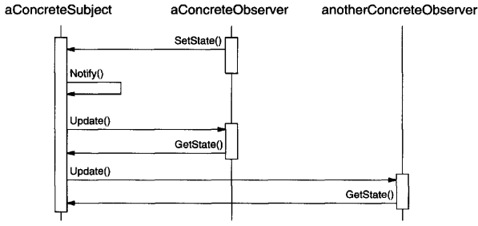
- ConcreteSubject notifies its observers whenever a change occurs that could make its observers' state inconsistent with its own.
- After being informed of a change in the concrete subject, a ConcreteObserver object may query the subject for information. ConcreteObserver uses this information to reconcile its state with that of the subject. The following interaction diagram illustrates the collaborations between a subject and two observers:

Consequences
- Abstract coupling between subject and observer: a subject only maintains a list of observers that follow a simple interface; it has no knowledge of their concrete types. This loose coupling allows subjects and observers to exist at different abstraction layers without violating system layering.
- Support for broadcast communication: notifications are automatically sent to all subscribed observers without specifying recipients. Observers can be added or removed freely, and each observer decides how to handle the notification.
- Possibility of unexpected updates: because observers are unaware of one another, changes to the subject may trigger cascades of updates whose cost or impact is not obvious. Poorly defined dependencies can cause unnecessary updates, and the basic notification mechanism may not indicate what changed, forcing observers to work harder to determine the update’s nature.

Decorator
  - Class type (Wrapper)
Intent
Attach additional responsibilities to an object dynamically. Decorators provide a flexible alternative to subclassing for extending functionality.

Motivation
Sometimes responsibilities need to be added to individual objects rather than to an entire class. Using inheritance for this is inflexible, because it applies added behavior statically to all subclass instances and prevents clients from controlling when and how these responsibilities are applied.
A more flexible approach is to wrap an object with another object that adds the desired responsibilities. This wrapper is called a decorator. A decorator conforms to the same interface as the object it decorates, making the decoration transparent to clients. It forwards requests to the wrapped object while optionally performing additional actions before or after forwarding.
Because decorators are transparent and share the same interface as the original component, they can be nested recursively, allowing multiple responsibilities to be added dynamically in any combination. Decorator subclasses can extend operations and introduce additional functionality. Crucially, decorated and undecorated objects remain interchangeable from the client's perspective, avoiding dependency on the presence or absence of decoration.

Applicability
- to add responsibilities to individual objects dynamically and transparently, that is, without affecting other objects.
- For responsibilities that can be withdrawn.
- When extension by subclassing is impractical. Sometimes a large number of independent extensions are possible and would produce an explosion of subclasses to support every combination. Or a class definition maybe hidden or otherwise unavailable for subclassing.

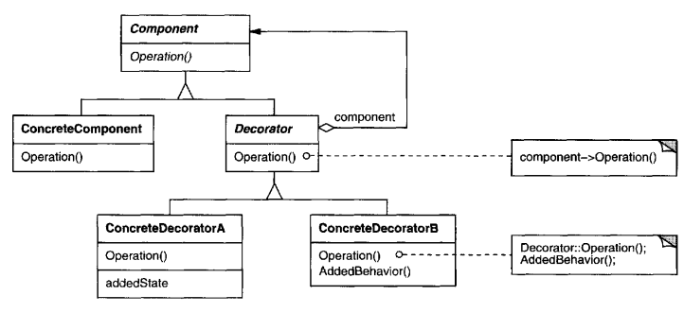
Structure

Participants
- Component: defines the interface for objects that can have responsibilities added to them dynamically.
- ConcreteComponent: defines an object to which additional responsibilities can be attached.
- Decorator: maintains a reference to a Component object and defines an interface that conforms to Component's interface.
- ConcreteDecorator: adds responsibilities to the component.

Collaboration
Decorator forwards requests to its Component object. It may optionally perform additional operations before and after forwarding the request.

Consequences
- Greater flexibility than static inheritance: responsibilities can be added or removed at runtime by attaching or detaching decorators. This avoids creating numerous subclasses for every feature combination and allows mixing responsibilities freely. It also supports applying the same responsibility multiple times, something inheritance handles poorly.
- Avoidance of overly complex base classes: instead of building large classes with many built-in features, functionality can be incrementally composed from small decorator objects. This ensures applications only incur costs for features they use and makes it easy to introduce new extensions without exposing or depending on complex internal details.
- Decorated objects are not identical to their components: even though decorators are transparent in behavior, they do not share object identity with the wrapped component, so identity-based assumptions are unsafe.
- Potential explosion of small objects: systems using decorators often contain many small, similar objects whose differences lie mainly in how they are linked together. While customizable for knowledgeable developers, such systems can be difficult to understand and debug.

visitor
  - Object behavioural
Intent
Represent an operation to be performed on the elements of an object structure. Visitor lets you define a new operation without changing the classes of the elements on which it operates.

Motivation
When an object structure contains many element types, each requiring different processing, embedding all operations inside the element classes leads to code that is hard to maintain, extend, and understand.
The Visitor pattern separates algorithms from the object structure by encapsulating each operation inside a visitor object. Elements “accept” a visitor and call back the appropriate method based on their concrete class.
This allows adding new operations (new visitors) without modifying the element hierarchy, as long as the set of element classes remains stable.

Applicability
- An object structure contains many classes with different interfaces, and operations depend on their concrete types.
- Many unrelated operations need to be performed on elements, and you want to avoid polluting element classes with this functionality.
- The classes of the object structure are stable but new operations need to be added frequently.
- You want to gather related operations into one object (a visitor) rather than scattering them across many classes.

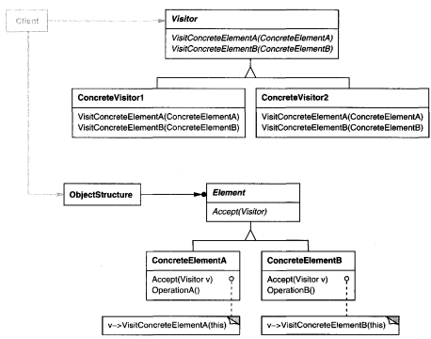
Structure

Participants
- Visitor: declares a Visit operation for each class of ConcreteElement.
- ConcreteVisitor: implements the operations declared by Visitor, defining the algorithm for each element type and possibly storing state accumulated during traversal.
- Element: defines an Accept(Visitor) operation.
- ConcreteElement: implements Accept by calling the appropriate Visit operation on the visitor.
- ObjectStructure: can enumerate and provide access to its elements so the visitor can process them. Can be a composite or a collection.

Collaboration
- A client creates a ConcreteVisitor and traverses the object structure.
- Each element receives the visitor and calls back the method corresponding to its concrete class, passing itself as an argument.
- The visitor performs the appropriate operation on the element.

Consequences
- Easy addition of new operations: new functionality is added by creating new Visitor subclasses without changing element classes.
- Related operations are grouped and unrelated ones are separated: this improves cohesion and keeps element classes clean.
- Can visit unrelated class hierarchies: visitors are not restricted by inheritance: they can define visit operations for any set of types.
- Can accumulate state: visitors can collect results during traversal without passing extra arguments everywhere.

1. May break encapsulation
Elements often must expose internal data via public methods so visitors can operate on them.
2. Hard to add new element type: very new element requires adding a new VisitX method to Visitor and all
ConcreteVisitors, making it costly if the element structure changes frequently.

prototype
  - Object Creational
Intent
Specify the kinds of objects to create using a prototypical instance, and create new objects by copying this prototype.

Motivation
In systems where object creation must be flexible and decoupled from concrete classes, creating objects directly through constructors or factory hierarchies can become restrictive or require many subclasses.
The Prototype pattern solves this by letting clients create new objects by cloning preconfigured instances called prototypes.
Each prototype represents a specific configuration, structure, or variant of a product. Instead of instantiating classes directly, clients duplicate these prototypes, enabling dynamic creation of products without binding code to concrete classes.
This greatly reduces the number of classes required and allows the system to introduce new product variants simply by registering new prototypes at run-time.

Applicability
- A system should be independent of how its products are created, composed, or represented.
- Product classes need to be specified at run-time (e.g., through dynamic loading).
- You want to avoid parallel factory hierarchies that duplicate the product hierarchy.
- Instances of a class differ only in a few configuration values, making it easier to store a few prototypes and clone them rather than instantiating them manually with repeated initialization logic.

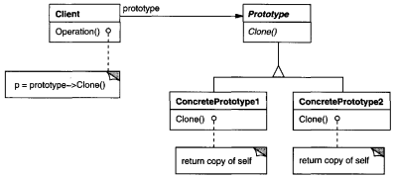
Structure

Participants
- Prototype: declares an interface for cloning itself.
- ConcretePrototype: implements the cloning operation, creating copies of itself.
- Client: creates new objects by requesting a prototype to clone itself.

Collaboration
The client requests a prototype to clone itself, receiving a new object configured identically to the prototype.

Consequences
- Allows adding and removing products at run-time: clients can dynamically register and replace prototypes, making the set of available products highly flexible.
- Enables creating new objects by varying values: clients can define new kinds of objects by configuring an instance and registering it as a prototype, reducing the need for new classes.
- Supports creation of objects with complex structures: prototypes can represent composite or deeply structured objects as long as cloning performs a deep copy, enabling reuse of large and complex configurations.
- Reduces subclassing: unlike Factory Method, Prototype avoids creating parallel creator hierarchies, since object creation is achieved through cloning rather than subclassing.
- Supports dynamic application configuration: in systems with dynamic class loading, prototypes act as creators without requiring compile-time references to constructors.
- Requires implementing a cloning operation: each ConcretePrototype must implement deep or shallow copy appropriately. This can be difficult when objects contain references that cannot or should not be copied, or when existing classes were not designed with cloning in mind.

