TEST CASES:

Test Case ID |  | TC_Smoke_01
Description |  | Set boat in the first position for true values
Module |  | BattleShip
Prepared By |  | Adrià Orozco | Date Prepared |  | 30/11/2020
Reviewed / Updated |  | Arnau Cruz | Date Reviewed |  | 03/12/2020
Tested By |  | Adrià and Arnau | Date Tested |  | 03/12/2020

Test Activities
Sl. No. | Step Description |  | Expected Results |  |  |  | Actual Results
1. | Run the project |  | Starter menu of battleship game |  |  |  | Ok
2. | Write 1 to start the game |  | Game started |  |  |  | Ok
3. | Set X coordinate |  | Program ask for the Y coordinate |  |  |  | Ok
4. | Set Y coordinate |  | Program ask for the orientation |  |  |  | Ok
5. | Set Orientation |  | Boat inserted correctly  Program ask for the X coordinate of the next boat |  |  |  | Ok  Ok

Test Data Sets
Data Type |  | Data Set 1 |  | Data Set 2 |  | Data Set 3
X Coordinate |  | 1 |  | 1
Y Coordinate |  | 1 |  | 1
Orientation |  | 0 (Right) |  | (Down)
Test Case Result |  |  |  | Both Datasets results are correct.

Test Case ID |  | TC_Smoke_02
Description |  | Set boat in the last positions for true values
Module |  | BattleShip.java
Prepared By |  | Adrià Orozco | Date Prepared |  | 30/11/2020
Reviewed / Updated |  | Arnau Cruz | Date Reviewed |  | 03/12/2020
Tested By |  | Adrià and Arnau | Date Tested |  | 03/12/2020

Test Activities
Sl. No. | Step Description |  | Expected Results |  |  |  | Actual Results
1. | Run the project |  | Starter menu of battleship game |  |  |  | Ok
2. | Write 1 to start the game |  | Game started |  |  |  | Ok
3. | Set X coordinate |  | Program ask for the Y coordinate |  |  |  | Ok
4. | Set Y coordinate |  | Program ask for the orientation |  |  |  | Ok
5. | Set Orientation |  | Boat inserted correctly  Program ask for the X coordinate of the next boat |  |  |  | Put the boat in another direction  Ok

Test Data Sets
Data Type |  | Data Set 1 |  | Data Set 2 |  | Data Set 3
X Coordinate |  | 10 |  | 10
Y Coordinate |  | 10 |  | 10
Orientation |  | 2 (Up) |  | 3(Left)
Test Case Result |  |  |  | Both of Datasets insert a boat in another direction, In the case of Orientation “Up” insert the boat to the left, and in the case of Ortientation “Left” insert the boat upside.

Test Case ID |  | TC_Smoke_02
Description |  | Set boat in the next limit values (1,10)
Module |  | BattleShip.java
Prepared By |  | Adrià Orozco | Date Prepared |  | 30/11/2020
Reviewed / Updated |  | Arnau Cruz | Date Reviewed |  | 03/12/2020
Tested By |  | Adrià and Arnau | Date Tested |  | 03/12/2020

Test Activities
Sl. No. | Step Description |  | Expected Results |  |  |  | Actual Results
1. | Run the project |  | Starter menu of battleship game |  |  |  | Ok
2. | Write 1 to start the game |  | Game started |  |  |  | Ok
3. | Set X coordinate |  | Program ask for the Y coordinate |  |  |  | Ok
4. | Set Y coordinate |  | Program ask for the orientation |  |  |  | Ok
5. | Set Orientation |  | Boat inserted correctly  Program ask for the X coordinate of the next boat |  |  |  | Put the boat in another direction  Ok

Test Data Sets
Data Type |  | Data Set 1 |  | Data Set 2 |  | Data Set 3
X Coordinate |  | 1 |  | 1
Y Coordinate |  | 10 |  | 10
Orientation |  | 3 (Left) |  | 1(Down)
Test Case Result |  |  |  | For the first Dataset the result is incorrect according to the fail that the game haves (Orientation left and up has to be interchanged)

Test Case ID |  | TC_Smoke_02
Description |  | Set boat in the next limit values (1,10)
Module |  | BattleShip.java
Prepared By |  | Adrià Orozco | Date Prepared |  | 30/11/2020
Reviewed / Updated |  | Arnau Cruz | Date Reviewed |  | 03/12/2020
Tested By |  | Adrià and Arnau | Date Tested |  | 03/12/2020

Test Activities
Sl. No. | Step Description |  | Expected Results |  |  |  | Actual Results
1. | Run the project |  | Starter menu of battleship game |  |  |  | Ok
2. | Write 1 to start the game |  | Game started |  |  |  | Ok
3. | Set X coordinate |  | Program ask for the Y coordinate |  |  |  | Ok
4. | Set Y coordinate |  | Program ask for the orientation |  |  |  | Ok
5. | Set Orientation |  | Boat inserted correctly  Program ask for the X coordinate of the next boat |  |  |  | Ok  Ok

Test Data Sets
Data Type |  | Data Set 1 |  | Data Set 2 |  | Data Set 3
X Coordinate |  | 1 |  | 1
Y Coordinate |  | 10 |  | 10
Orientation |  | 3 (Left) |  | 1(Down)
Test Case Result |  |  |  | Correct Result for Dataset 2

Test Case ID |  | TC_Smoke_03
Description |  | Set boat in the next limit values (10,0)
Module |  | BattleShip.java
Prepared By |  | Adrià Orozco | Date Prepared |  | 30/11/2020
Reviewed / Updated |  | Arnau Cruz | Date Reviewed |  | 03/12/2020
Tested By |  | Adrià and Arnau | Date Tested |  | 03/12/2020

Test Activities
Sl. No. | Step Description |  | Expected Results |  |  |  | Actual Results
1. | Run the project |  | Starter menu of battleship game |  |  |  | Ok
2. | Write 1 to start the game |  | Game started |  |  |  | Ok
3. | Set X coordinate |  | Program ask for the Y coordinate |  |  |  | Ok
4. | Set Y coordinate |  | Program ask for the orientation |  |  |  | Ok
5. | Set Orientation |  | Boat inserted correctly  Program ask for the X coordinate of the next boat |  |  |  | Put the boat in another direction  Ok

Test Data Sets
Data Type |  | Data Set 1 |  | Data Set 2 |  | Data Set 3
X Coordinate |  | 1 |  | 1
Y Coordinate |  | 10 |  | 10
Orientation |  | 2(Up) |  | 0(Right)
Test Case Result |  |  |  | For the first Dataset the result is incorrect according to the fail that the game haves (Orientation left and up has to be interchanged)

Test Case ID |  | TC_Smoke_03
Description |  | Set boat in the next limit values (10,0)
Module |  | BattleShip.java
Prepared By |  | Adrià Orozco | Date Prepared |  | 30/11/2020
Reviewed / Updated |  | Arnau Cruz | Date Reviewed |  | 03/12/2020
Tested By |  | Adrià and Arnau | Date Tested |  | 03/12/2020

Test Activities
Sl. No. | Step Description |  | Expected Results |  |  |  | Actual Results
1. | Run the project |  | Starter menu of battleship game |  |  |  | Ok
2. | Write 1 to start the game |  | Game started |  |  |  | Ok
3. | Set X coordinate |  | Program ask for the Y coordinate |  |  |  | Ok
4. | Set Y coordinate |  | Program ask for the orientation |  |  |  | Ok
5. | Set Orientation |  | Boat inserted correctly  Program ask for the X coordinate of the next boat |  |  |  | Ok  Ok

Test Data Sets
Data Type |  | Data Set 1 |  | Data Set 2 |  | Data Set 3
X Coordinate |  | 1 |  | 1
Y Coordinate |  | 10 |  | 10
Orientation |  | 2(Up) |  | 0(Right)
Test Case Result |  |  |  | Result for dataset2 is correct

Test Case ID |  | TC_Smoke_04
Description |  | Set boat in a middle value of the matrix expecting true results (5,5)
Module |  | BattleShip.java
Prepared By |  | Adrià Orozco | Date Prepared |  |  | 03/11/2020
Reviewed / Updated |  | Arnau Cruz | Date Reviewed |  |  | 03/12/2020
Tested By |  | Adrià and Arnau | Date Tested |  |  | 03/12/2020

Test Activities
Sl. No. | Step Description |  | Expected Results |  |  |  |  | Actual Results
1. | Run the project |  | Starter menu of battleship game |  |  |  |  | Ok
2. | Write 1 to start the game |  | Game started |  |  |  |  | Ok
3. | Set X coordinate |  | Program ask for the Y coordinate |  |  |  |  | Ok
4. | Set Y coordinate |  | Program ask for the orientation |  |  |  |  | Ok
5. | Set Orientation |  | Boat inserted correctly  Program ask for the X coordinate of the next boat |  |  |  |  | Ok  Ok

Test Data Sets
Data Type |  | Data Set 1 |  | Data Set 2 |  |  | Data Set 3
X Coordinate |  | 5 |  | 5 |  |  | 5
Y Coordinate |  | 5 |  | 5 |  |  | 5
Orientation |  | 0(Right) |  | 1(Down) |  |  | 2(Left)
Test Case Result |  |  |  | Result for Dataset1 and 2 are correct
Test Case ID |  |  |  | TC_Smoke_04
Description |  |  |  | Set boat in a middle value of the matrix expecting true results (5,5)
Module |  |  |  | BattleShip.java
Prepared By |  | Adrià Orozco | Date Prepared |  |  | 03/11/2020
Reviewed / Updated |  | Arnau Cruz | Date Reviewed |  |  | 03/12/2020
Tested By |  | Adrià and Arnau | Date Tested |  |  | 03/12/2020

Test Activities
Sl. No. | Step Description |  | Expected Results |  |  |  |  | Actual Results
1. | Run the project |  | Starter menu of battleship game |  |  |  |  | Ok
2. | Write 1 to start the game |  | Game started |  |  |  |  | Ok
3. | Set X coordinate |  | Program ask for the Y coordinate |  |  |  |  | Ok
4. | Set Y coordinate |  | Program ask for the orientation |  |  |  |  | Ok
5. | Set Orientation |  | Boat inserted correctly  Program ask for the X coordinate of the next boat |  |  |  |  | Put the boat in another direction  Ok

Test Data Sets
Data Type |  | Data Set 1 |  | Data Set 2 |  |  | Data Set 3
X Coordinate |  | 5 |  | 5 |  |  | 5
Y Coordinate |  | 5 |  | 5 |  |  | 5
Orientation |  | 0(Right) |  | 1(Down) |  |  | 2(Left)
Test Case Result |  |  |  | For the third Dataset the result is incorrect according to the fail that the game haves (Orientation left and up has to be interchanged)

Test Case ID |  |  |  | TC_Smoke_05
Description |  |  |  | Set boat on another boat
Module |  |  |  | BattleShip.java
Prepared By |  | Adrià Orozco | Date Prepared |  | 03/11/2020
Reviewed / Updated |  | Arnau Cruz | Date Reviewed |  | 03/12/2020
Tested By |  | Adrià and Arnau | Date Tested |  | 03/12/2020

Test Activities
Sl. No. | Step Description |  | Expected Results |  |  |  | Actual Results
1. | Run the project |  | Starter menu of battleship game |  |  |  | Ok
2. | Write 1 to start the game |  | Game started |  |  |  | Ok
3. | Set X coordinate |  | Program ask for the Y coordinate |  |  |  | Ok
4. | Set Y coordinate |  | Program ask for the orientation |  |  |  | Ok
5. | Set Orientation |  | Boat inserted correctly  Program ask for the X coordinate of the next boat |  |  |  | Ok  Ok
6. | Set X coordinate |  | Program ask for the Y coordinate |  |  |  | Ok
7. | Set Y coordinate |  | Program ask for the orientation |  |  |  | Ok
8. | Set Orientation |  | Boat not inserted  Program ask for the first X coordinate again |  |  |  | Ok  Ok

Test Data Sets
Data Type |  | Data Set 1 |  | Data Set 2 |  | Data Set 3
X Coordinate |  | 5 |  | 5
Y Coordinate |  | 5 |  | 5
Orientation |  | 0(Right) |  | 1(Down)
Test Case Result |  |  |  | Correct Result

Test Case ID |  |  |  | TC_Smoke_06
Description |  |  |  | Set the last coordinate of boat on another boat
Module |  |  |  | BattleShip.java
Prepared By |  | Adrià Orozco | Date Prepared |  | 03/11/2020
Reviewed / Updated |  | Arnau Cruz | Date Reviewed |  | 03/12/2020
Tested By |  | Adrià and Arnau | Date Tested |  | 03/12/2020

Test Activities
Sl. No. | Step Description |  | Expected Results |  |  |  | Actual Results
1. | Run the project |  | Starter menu of battleship game |  |  |  | Ok
2. | Write 1 to start the game |  | Game started |  |  |  | Ok
3. | Set X coordinate |  | Program ask for the Y coordinate |  |  |  | Ok
4. | Set Y coordinate |  | Program ask for the orientation |  |  |  | Ok
5. | Set Orientation |  | Boat inserted correctly  Program ask for the X coordinate of the next boat |  |  |  | Ok  Ok
6. | Set X coordinate |  | Program ask for the Y coordinate |  |  |  | Ok
7. | Set Y coordinate |  | Program ask for the orientation |  |  |  | Ok
8. | Set Orientation |  | Boat not inserted  Program ask for the first X coordinate again |  |  |  | Ok  Ok

Test Data Sets
Data Type |  | Data Set 1 |  | Data Set 2 |  | Data Set 3
X Coordinate |  | 5 |  | 3
Y Coordinate |  | 5 |  | 5
Orientation |  | 0(Right) |  | 1(Down)
Test Case Result |  |  |  | Correct Result

Test Case ID |  |  |  | TC_Smoke_07
Description |  |  |  | Set invalid coordinates
Module |  |  |  | BattleShip.java
Prepared By |  | Adrià Orozco | Date Prepared |  | 03/11/2020
Reviewed / Updated |  | Arnau Cruz | Date Reviewed |  | 03/12/2020
Tested By |  | Adrià and Arnau | Date Tested |  | 03/12/2020

Test Activities
Sl. No. | Step Description |  | Expected Results |  |  |  | Actual Results
1. | Run the project |  | Starter menu of battleship game |  |  |  | Ok
2. | Write 1 to start the game |  | Game started |  |  |  | Ok
3. | Set X coordinate |  | Program ask for the Y coordinate |  |  |  | Ok
4. | Set Y coordinate |  | Program ask for the orientation |  |  |  | Ok
5. | Set Orientation |  | Boat inserted correctly  Program ask for the X coordinate of the next boat |  |  |  | Ok  Ok
6. | Set X coordinate |  | Program ask again for the X coordinate |  |  |  | Ok

Test Data Sets
Data Type |  | Data Set 1 |  | Data Set 2 |  | Data Set 3
X Coordinate |  | -1 |  | -9 |  | 11
Y Coordinate |  | 5 |  | 5 |  | 5
Orientation |  | 0(Right) |  | 1(Down) |  | 0(Right)
Test Case Result |  |  |  | Correct Result

Test Case ID |  |  |  | TC_Smoke_08
Description |  |  |  | Shoot boat
Module |  |  |  | BattleShip.java
Prepared By |  | Adrià Orozco | Date Prepared |  | 03/11/2020
Reviewed / Updated |  | Arnau Cruz | Date Reviewed |  | 03/12/2020
Tested By |  | Adrià and Arnau | Date Tested |  | 03/12/2020

Test Activities
Sl. No. | Step Description |  | Expected Results |  |  |  | Actual Results
1. | Run the project |  | Starter menu of battleship game |  |  |  | Ok
2. | Write 1 to start the game |  | Game started |  |  |  | Ok
3. | Insert all the boats |  | Choose a coordinate to shoot |  |  |  | Ok
4. | Set X coordinate |  | Set Y coordinate |  |  |  | Ok
5. | Set Y coordinate |  | Result of the Shoot |  |  |  | Ok
6. | Set X coordinate |  | Set Y coordinate |  |  |  | Ok
7. | Set Y coordinate |  | Result of the Shoot |  |  |  | Ok
8.
9.

Test Data Sets
Data Type |  | Data Set 1 |  | Data Set 2 |  | Data Set 3
X Coordinate |  | 5 |  | 9 |  | 7
Y Coordinate |  | 5 |  | 9 |  | 7
Test Case Result |  |  |  | Correct Result, Shows the correct response to the interaction with the user. Miss or Hit.

Test Case ID |  |  |  | TC_Smoke_09
Description |  |  |  | Sunk boat
Module |  |  |  | BattleShip.java
Prepared By |  | Adrià Orozco | Date Prepared |  | 03/11/2020
Reviewed / Updated |  | Arnau Cruz | Date Reviewed |  | 03/12/2020
Tested By |  | Adrià and Arnau | Date Tested |  | 03/12/2020

Test Activities
Sl. No. | Step Description |  | Expected Results |  |  |  | Actual Results
1. | Run the project |  | Starter menu of battleship game |  |  |  | Ok
2. | Write 1 to start the game |  | Game started |  |  |  | Ok
3. | Insert all the boats |  | Choose a coordinate to shoot |  |  |  | Ok
4. | Set X coordinate |  | Set Y coordinate |  |  |  | Ok
5. | Set Y coordinate |  | Result of the Shoot |  |  |  | Ok
6. | Set X coordinate |  | Set Y coordinate |  |  |  | Ok
7. | Set Y coordinate |  | Result of the Shoot |  |  |  | Ok
8. | Set X coordinate |  | Set Y coordinate |  |  |  | Ok
9. | Set Y coordinate |  | Result of the Shoot (Sunked) |  |  |  | Shows only that the boat is hit

Test Data Sets
Data Type |  | Data Set 1 |  | Data Set 2 |  | Data Set 3
X Coordinate |  | 5 |  | 9 |  | 9
Y Coordinate |  | 5 |  | 9 |  | 10
Test Case Result |  |  |  | Incorrect Result, the game must show that the boat is sunk, we only know that we hit the boat, but never when we sunked-it

Test Case ID |  |  |  | TC_Smoke_10
Description |  |  |  | Invalid coordinates to shoot a boat
Module |  |  |  | BattleShip.java
Prepared By |  | Adrià Orozco | Date Prepared |  | 03/11/2020
Reviewed / Updated |  | Arnau Cruz | Date Reviewed |  | 03/12/2020
Tested By |  | Adrià and Arnau | Date Tested |  | 03/12/2020

Test Activities
Sl. No. | Step Description |  | Expected Results |  |  |  | Actual Results
1. | Run the project |  | Starter menu of battleship game |  |  |  | Ok
2. | Write 1 to start the game |  | Game started |  |  |  | Ok
3. | Insert all the boats |  | Choose a coordinate to shoot |  |  |  | Ok
4. | Set X coordinate |  | Set again the X coordinate |  |  |  | Ok

Test Data Sets
Data Type |  | Data Set 1 |  | Data Set 2 |  | Data Set 3
X Coordinate |  | -1 |  | 11 |  | 19
Y Coordinate |  | 5 |  | 10 |  | 7
Test Case Result |  |  |  | Correct Result

Test Case ID |  |  |  | TC_Smoke_11
Description |  |  |  | Shoot a boat coordinate that is already shooted
Module |  |  |  | BattleShip.java
Prepared By |  | Adrià Orozco | Date Prepared |  | 03/11/2020
Reviewed / Updated |  | Arnau Cruz | Date Reviewed |  | 03/12/2020
Tested By |  | Adrià and Arnau | Date Tested |  | 03/12/2020

Test Activities
Sl. No. | Step Description |  | Expected Results |  |  |  | Actual Results
1. | Run the project |  | Starter menu of battleship game |  |  |  | Ok
2. | Write 1 to start the game |  | Game started |  |  |  | Ok
3. | Insert all the boats |  | Choose a coordinate to shoot |  |  |  | Ok
4. | Set X coordinate |  | Set Y coordinate |  |  |  | Ok
5. | Set Y coordinate |  | Result of the Shoot |  |  |  | Ok
6. | Set X coordinate |  | Set Y coordinate |  |  |  | Ok
7. | Set Y coordinate |  | Set Y coordinate again |  |  |  | The game let you shoot again the same position

Test Data Sets
Data Type |  | Data Set 1 |  | Data Set 2 |  | Data Set 3
X Coordinate |  | 9 |  | 9
Y Coordinate |  | 9 |  | 9
Test Case Result |  |  |  | Incorrect result, the game let you shoot the same coordinate of a boat again and convert the hit shoot to a miss shoot on the board.

Test Case ID |  |  |  | TC_Smoke_12
Description |  |  |  | Shoot a coordinate that was a miss shoot before
Module |  |  |  | BattleShip.java
Prepared By |  | Adrià Orozco | Date Prepared |  | 03/11/2020
Reviewed / Updated |  | Arnau Cruz | Date Reviewed |  | 03/12/2020
Tested By |  | Adrià and Arnau | Date Tested |  | 03/12/2020

Test Activities
Sl. No. | Step Description |  | Expected Results |  |  |  | Actual Results
1. | Run the project |  | Starter menu of battleship game |  |  |  | Ok
2. | Write 1 to start the game |  | Game started |  |  |  | Ok
3. | Insert all the boats |  | Choose a coordinate to shoot |  |  |  | Ok
4. | Set X coordinate |  | Set Y coordinate |  |  |  | Ok
5. | Set Y coordinate |  | Result of the Shoot |  |  |  | Ok
6. | Set X coordinate |  | Set Y coordinate |  |  |  | Ok
7. | Set Y coordinate |  | Set Y coordinate again |  |  |  | The game let you shoot again the same position

Test Data Sets
Data Type |  | Data Set 1 |  | Data Set 2 |  | Data Set 3
X Coordinate |  | 5 |  | 5
Y Coordinate |  | 5 |  | 5
Test Case Result |  |  |  | Incorrect result, the game let you shoot the same coordinate

Test Case ID |  | TC_Smoke_13
Description |  | Invalid Orientation
Module |  | BattleShip
Prepared By |  | Adrià Orozco | Date Prepared |  | 06/11/2020
Reviewed / Updated |  | Arnau Cruz | Date Reviewed |  | 06/12/2020
Tested By |  | Adrià and Arnau | Date Tested |  | 06/12/2020

Test Activities
Sl. No. | Step Description |  | Expected Results |  |  |  | Actual Results
1. | Run the project |  | Starter menu of battleship game |  |  |  | Ok
2. | Write 1 to start the game |  | Game started |  |  |  | Ok
3. | Set X coordinate |  | Program ask for the Y coordinate |  |  |  | Ok
4. | Set Y coordinate |  | Program ask for the orientation |  |  |  | Ok
5. | Set Orientation |  | Program ask for the orientation again |  |  |  | Ok

Test Data Sets
Data Type |  | Data Set 1 |  | Data Set 2 |  | Data Set 3
X Coordinate |  | 5 |  | 5 |  | 5
Y Coordinate |  | 5 |  | 5 |  | 5
Orientation |  | -4 |  | 5 |  | 9
Test Case Result |  |  |  | Both Datasets results are correct.

EXPLORATORY TESTING:

Attack 1: Apply inputs that force all error messages to occur at least once.

  - Value from outside of the options of the menu.
Result: Error controlled, correct information to the user.
  - Value from outside the board
Result: Error well controlled, the user can’t put a boat outside the board, but there isn’t informative error to the user as is showed below.

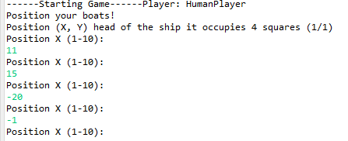

  - Input type
-Non numeric: The program doesn’t control if there is an input that isn’t a numeric value so the exception is not caught and the program crash.
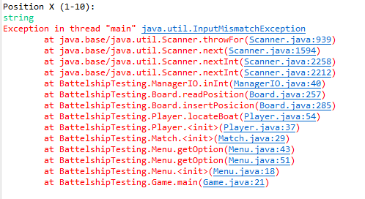
-Decimal value: The program doesn’t control if there is an input that isn’t an enter value so the exception is not caught when the user introduced a floating value and the program crash.
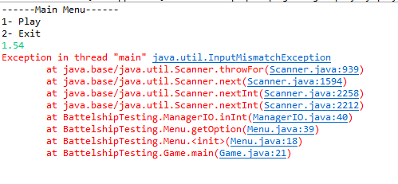
1.4 After discover that the type of the inputs of the user are integers, we made proves with the length of these and discover that the program doesn’t caught the exceptions if the value entered is bigger than the length of an integer and the program crashes too.
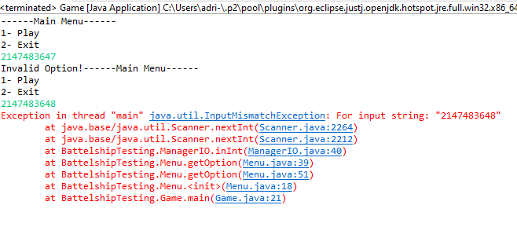

Attack 2: Apply inputs that force the software to establish default values

2.1 We tried to shoot positions already shooted to see if the program controlled it properly and the status of the board change or not.
The first case is to shoot a position where there is a boat and shoot it again.
Result: The first shoot is correctly showed at the board, but in the second shoot there is not informative error message, and there is a mistake on the code that actualize the position of the board like if there isn’t a boat there. Showed with screenshots below.
First shoot at position [9,3]:
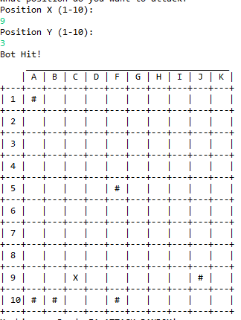

Second shoot at the same position:
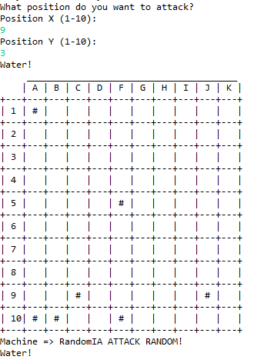

So now there is no way to know if there was a boat in there or if the boat has got more positions at this row/column.

2.2 On the other hand to shoot a position already shouted don’t change anything at the board, but there isn’t an informative error to the user.

Attack 3: Explore allowable character sets and potentially special meaning values in string fields

3.1 Reserved keywords
First off all we prove to insert an “\n”, as the type of the values entered is integer the program crashes on input a no numerical value:
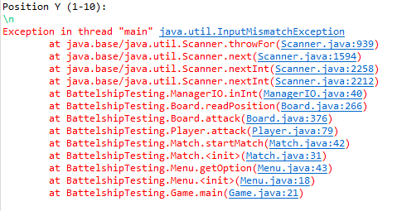

This happens with all the other options of special values like “+ or –“:
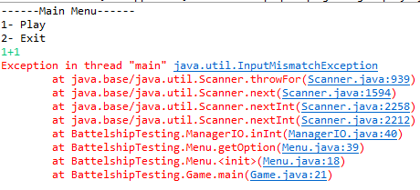
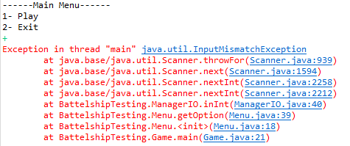

3.2 Special characters.

In case of NULL(^%) and EOF(^Z) the program behavior it’s the same:

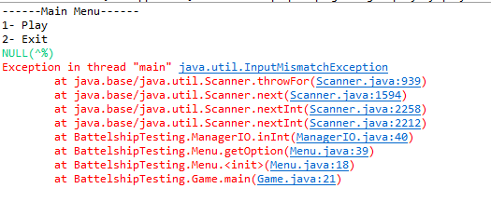
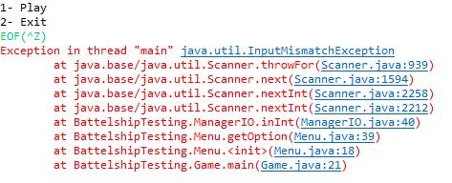

Attack 4:

RTF: This is the RTF from the code that we tested for the second practice.
Inspection Summary Report

Inspection Identification:

Project: BattleShip
Inspection ID: 02
Meeting Date: 07/12/2020

Work Product Description:

Inspectors Signature Preparation Time
Author: Cristian Vega Sánchez 1426805 1 hours
Moderator: Ismael Pajuelo Berjano 1456941 1 hours
Recorder: Adrià Orozco Lorente 1490952 1 hours
Reader: Arnau Cruz Gargallo 1494996 1 h 30 min
Inspector: Arnau Cruz Gargallo 1494996 1 h 30 min
Inspector: Adrià Orozco Lorente 1490952 1 hours
Inspector: Ismael Pajuelo Berjano 1456941 1 hours
Inspector: Ruben Campuzano 1528709 30 min
Inspector Javier Martinez Abril 1497512 30 min
Inspector: Alex Cruz Gargallo 1494995 30 min

Inspection Data

Pages or Lines of Code: 920 Meeting Time: 1h 40min

Planned for Inspection: All code Total Planning Effort: 5h 30min

Actually Inspected: All code

Total Overview Effort: 7h 10min
Total Preparation Effort: 5h 30min
Actual Rework Effort: 4 labor hours

Product Appraisal

ACCEPTED NOT ACCEPTED
___ as is ___ reinspect following rework
X conditionally upon verification ___ inspection not completed

Verifier: Juan Manuel Vicente, Keyao li

Projected Rework Completion Date: 14/12/2020

Inspection Issue Log

Project: | Origin: | Requirements, Design, Construction, Testing
Inspection ID: | Type: | Missing, Wrong, Extra, Usability, Performance,  Style, Clarity, Question
Meeting Date:  Recorder: | Severity: | Major, minor

Defects Found: 20, Major 4, Minor 16.

# | Origin | Type | Severity | Location | Description
1 | D, C | S | m | Board.java | Some print sentences are allocated on functions from the model classes.
2 | C | S | m | Board.java | Repeated conditionals into some functions that can be encapsulated into another procedures
3 | C | S | m | Board.java | The conditions of boatProtection() and isValidOrientation() can be replaced for the boat length instead of hard-code to reuse the code in case that new boats with different length are inserted.
5 | D | S | m | Board.java | Change the MAGIC NUMBERS that control the frontier values and others to Constants.
6 | D | S | m | Board.java | This class is too big and do so many things, it could be better to assign some responsibilities to another classes.
7 | D | S | m | Board.java | Add comments to isValidOrientation() function to see correctly all the options from the switch case.
8 | D | S | m | Board, ManagerIO.java | Some variables are not defined with a proper name.
9 | T | M | m | Board.java | At line 59 on the method showBoard() we can see that the test not cover all the sentences.
10 | D | S | m | Board.java | At isValidOrientation() and insertBoat() methods there isn’t no default case for switch case.
11 | D | S | m | Board.java | At showBoard() method there is no default este for nested conditions.
12 | C | W | M | ManagerIO.java | The game crash when the user insert a string instead of an integer.
13 | C | W | M | ManagerIO.java | The game crash when the user insert a longer value than the maximum length of an integer.
14 | C | W | M | ManagerIO.java | The scanner not use try catch sentences to check the input of the user.
15 | C | W | M | Board.java | The sentences of the switch case to control the orientation of the boat are interchanged, (Left and Up), so when the user tries to insert a boat in one of this orientations the result is incorrect.
16 | R | M | m | Board.java | The user can’t know when a boat is sunked.
17 | D | U | m | Board.java | The information of the shoots could be showed under the information board.
18 | D | U | m | Board.java | The board isn’t showed at the start of the game, so the user can’t know where he’ll put the first boat.
19 | D | U | m | Board.java | The information of the columns are showed with letters, and the user only can introduce numbers.
20 | D | U | m | Board.java | When the user shoot a position already shouted where there was a boat in there, the previous mark disappear showing that there isn’t a boat there.

Generic Checklist for Code Reviews

Structure
- Does the code completely and correctly implement the design?
- Does the code conform to any pertinent coding standards?
- Is the code well-structured, consistent in style, and consistently formatted?
- Are there any uncalled or unneeded procedures or any unreachable code?
- Are there any leftover stubs or test routines in the code?
- Can any code be replaced by calls to external reusable components or library functions?
- Are there any blocks of repeated code that could be condensed into a single procedure?
- Is storage use efficient?
- Are symbolics used rather than “magic number” constants or string constants?
- Are any modules excessively complex and should be restructured or split into multiple routines?

Documentation
- Is the code clearly and adequately documented with an easy-to-maintain commenting style?
- Are all comments consistent with the code?

Variables
- Are all variables properly defined with meaningful, consistent, and clear names?
- Do all assigned variables have proper type consistency or casting?
- Are there any redundant or unused variables?

Arithmetic Operations
- Does the code avoid comparing floating-point numbers for equality?
- Does the code systematically prevent rounding errors?
- Does the code avoid additions and subtractions on numbers with greatly different magnitudes?
- Are divisors tested for zero or noise?

Loops and Branches
- Are all loops, branches, and logic constructs complete, correct, and properly nested?
- Are the most common cases tested first in IF- -ELSEIF chains?
- Are all cases covered in an IF- -ELSEIF or CASE block, including ELSE or DEFAULT clauses?
- Does every case statement have a default?
- Are loop termination conditions obvious and invariably achievable?
- Are indexes or subscripts properly initialized, just prior to the loop?
- Can any statements that are enclosed within loops be placed outside the loops?
- Does the code in the loop avoid manipulating the index variable or using it upon exit from the loop?

Defensive Programming
- Are indexes, pointers, and subscripts tested against array, record, or file bounds?
- Are imported data and input arguments tested for validity and completeness?
- Are all output variables assigned?
- Are the correct data operated on in each statement?
- Is every memory allocation deallocated?
- Are timeouts or error traps used for external device accesses?
- Are files checked for existence before attempting to access them?
- Are all files and devices are left in the correct state upon program termination?

This is the RTF from our code of the first practice
Inspection Summary Report

Inspection Identification:

Project: HundirFlota
Inspection ID: 01
Meeting Date: 06/12/2020

Work Product Description:

Inspectors Signature Preparation Time
Author: Arnau Cruz Gargallo 1494996 1 hours
Moderator: Carlos Fernandez 1428230 30 min
Recorder: Adrià Orozco Lorente 1490952 1 hours
Reader: Zakaria el Haddad 1462424 30 min
Inspector: Carlos Fernandez 1428230 30 min
Inspector: Adrià Orozco Lorente 1490952 1 hours
Inspector: Zakaria el Haddad 1462424 30 min

Inspection Data

Pages or Lines of Code: 886 Meeting Time: 1hour 10min

Planned for Inspection: Board.java, Barco.java, Player.java, Main.java Total Planning Effort: 3 labor hours

Actually Inspected: Board.java, Barco.java, Player.java, Main.java

Total Overview Effort: 4 hours 10min
Total Preparation Effort: 3 labor hours
Actual Rework Effort: 2 labor hours

Product Appraisal

ACCEPTED NOT ACCEPTED
___ as is ___ reinspect following rework
X conditionally upon verification ___ inspection not completed

Verifier: Juan Manuel Vicente, Keyao li

Projected Rework Completion Date: 13/12/2020

Inspection Issue Log

Project: | Origin: | Requirements, Design, Construction, Testing
Inspection ID: | Type: | Missing, Wrong, Extra, Usability, Performance,  Style, Clarity, Question
Meeting Date:  Recorder: | Severity: | Major, minor

Defects Found: 14, Major 4, Minor 10.

# | Origin | Type | Severity | Location | Description
1 | D, C | S | m | Board.java | Some print sentences are allocated on functions from the model classes.
2 | D | S | m | Game, Board.java | Some variables not use the lowerCaseCammel notation.
3 | C | S | m | Board.java, Game.java | Repeated conditionals into some functions that can be encapsulated into another procedures
4 | C | S | m | Board.java | The conditions of checkSpace() can be replaced for the boat length instead of hard-coded to reuse the code in case that new boats with different length are inserted.
5 | D | S | m | Board, Barco,java | Change the MAGIC NUMBERS that control the frontier values and others to Constants.
6 | C | S | m | Board.java | Encapsulate some conditions from checkSpace() and insertLastPos(), into another functions in order to have functions with less lines of code.
7 | D | S | m | All classes | Remove redundant comments and add description comments.
8 | D | S | m | Main.java | Unused import sentences.
9 | R | W | M | Player.java | The game crash when the user shoot a position above 9.
10 | C | W | M | Player.java | The game crash when the user insert a string instead of an integer.
11 | C | W | M | Game.java | The game crash when the user insert a longer value than the maximum length of an integer.
12 | C | W | M | Game.java | The scanner not use try catch sentences to check the input of the user.
13 | D | U | m | Game.java | The length of the boat must be showed under the board information.
14 | D | U | m | Game.java | It could be better to ask for a direction instead of the last position of the boat.

Generic Checklist for Code Reviews

Structure
- Does the code completely and correctly implement the design?
- Does the code conform to any pertinent coding standards?
- Is the code well-structured, consistent in style, and consistently formatted?
- Are there any uncalled or unneeded procedures or any unreachable code?
- Are there any leftover stubs or test routines in the code?
- Can any code be replaced by calls to external reusable components or library functions?
- Are there any blocks of repeated code that could be condensed into a single procedure?
- Is storage use efficient?
- Are symbolics used rather than “magic number” constants or string constants?
- Are any modules excessively complex and should be restructured or split into multiple routines?

Documentation
- Is the code clearly and adequately documented with an easy-to-maintain commenting style?
- Are all comments consistent with the code?

Variables
- Are all variables properly defined with meaningful, consistent, and clear names?
- Do all assigned variables have proper type consistency or casting?
- Are there any redundant or unused variables?

Arithmetic Operations
- Does the code avoid comparing floating-point numbers for equality?
- Does the code systematically prevent rounding errors?
- Does the code avoid additions and subtractions on numbers with greatly different magnitudes?
- Are divisors tested for zero or noise?

Loops and Branches
- Are all loops, branches, and logic constructs complete, correct, and properly nested?
- Are the most common cases tested first in IF- -ELSEIF chains?
- Are all cases covered in an IF- -ELSEIF or CASE block, including ELSE or DEFAULT clauses?
- Does every case statement have a default?
- Are loop termination conditions obvious and invariably achievable?
- Are indexes or subscripts properly initialized, just prior to the loop?
- Can any statements that are enclosed within loops be placed outside the loops?
- Does the code in the loop avoid manipulating the index variable or using it upon exit from the loop?

Defensive Programming
- Are indexes, pointers, and subscripts tested against array, record, or file bounds?
- Are imported data and input arguments tested for validity and completeness?
- Are all output variables assigned?
- Are the correct data operated on in each statement?
- Is every memory allocation deallocated?
- Are timeouts or error traps used for external device accesses?
- Are files checked for existence before attempting to access them?
- Are all files and devices are left in the correct state upon program termination?

