-La sentencia WHERE puede actuar como un inner JOIN (para unir 2 tablas).

-En vez de utilizar funciones en el comando, puedo aplicar MAX y selección de VALOR, así:

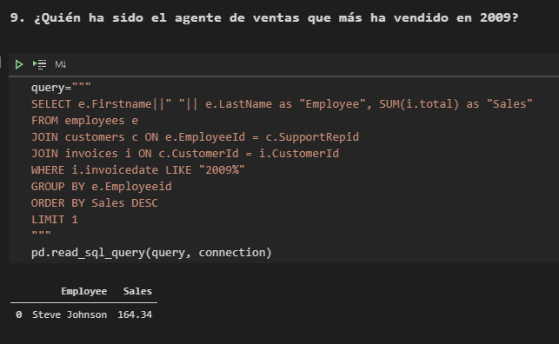

Security footage shows that there were 2 witnesses. The first witness lives at the last house on "Northwestern Dr". The second witness, named Annabel, lives somewhere on "Franklin Ave".

Someone killed the guard! He took an arrow to the knee!

Annabel dice: I saw the murder happen, and I recognized the killer from my gym when I was working out last week on January the 9th.

Morty Schapiro: 14887: I heard a gunshot and then saw a man run out. He had a "Get Fit Now Gym" bag. The membership number on the bag started with "48Z". Only gold members have those bags. The man got into a car with a plate that included "H42W".

Jeremy bowers(goldie): I was hired by a woman with a lot of money. I don't know her name but I know she's around 5'5" (65") or 5'7" (67"). She has red hair and she drives a Tesla Model S. I know that she attended the SQL Symphony Concert 3 times in December 2017.