**Question 1.1 List all tables in the employeesDB100 database.**

**Question 1.2 What is the primary key of the employees table?**

Employee number as it can only be unique

**Question 1.3 What is the primary key of the titles table?**

It’s a composite key made up from employee number, start date and end date so we cant have 2 instances where those three are the same

**Question 1.4 Show all details of employees whose initials are G.D.**

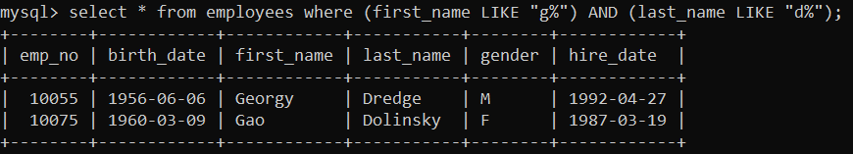

**Question 1.5 Show the department number and first 4 letters of each department.**

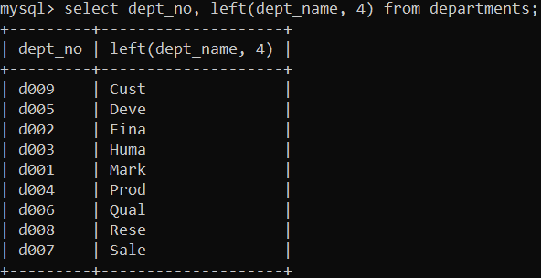

**Question 1.6 Show the department number and first 4 letters of each department but the columns should be entitled Number and Abbreviation respectively.**

**Question 1.7 What will be the result of running the following command? INSERT INTO employees VALUES (10100, "1993-02-13", "Jim", "Taylor", "M", "2020-01-31");**

We will get an error as we already have an entry with the employee number 10100



**Question 1.8 What will be the result of running the following command? INSERT INTO employees (emp_no, first_name, last_name) VALUES (10102, "Jim", "Taylor");**

No birth date in the input and it doesn’t have a default value

**Question 1.9 List only the name of the Department d005.**

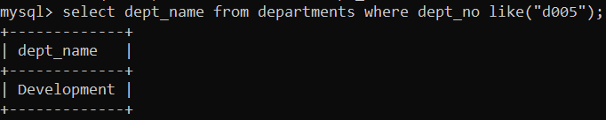

**Question 1.10 List all salaries greater than or equal to 101,000, but use an alias called money to display the results.**

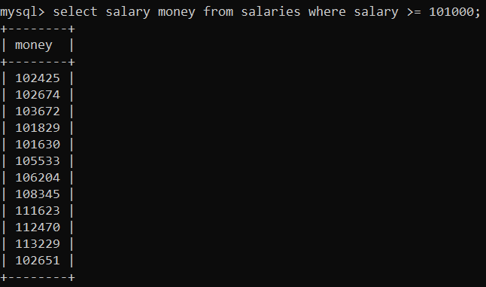

**Question 1.11 List all employees who were hired in 1987.**

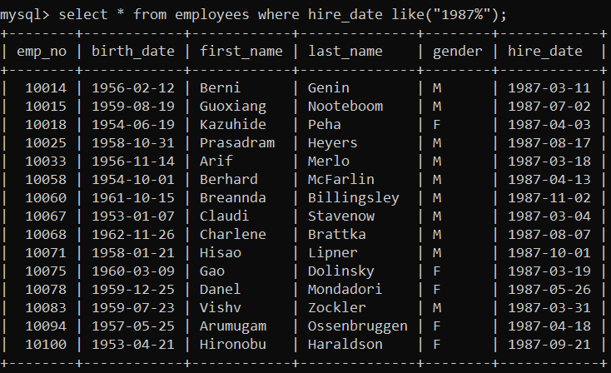

**Question 1.12 List all employees who were hired in 1987 but were born in the 1960s or later.**

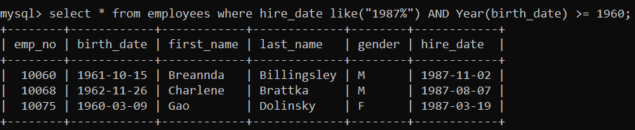

**Question 1.13 List the employee numbers of all employees who joined department d005 after June 1st 1986.**

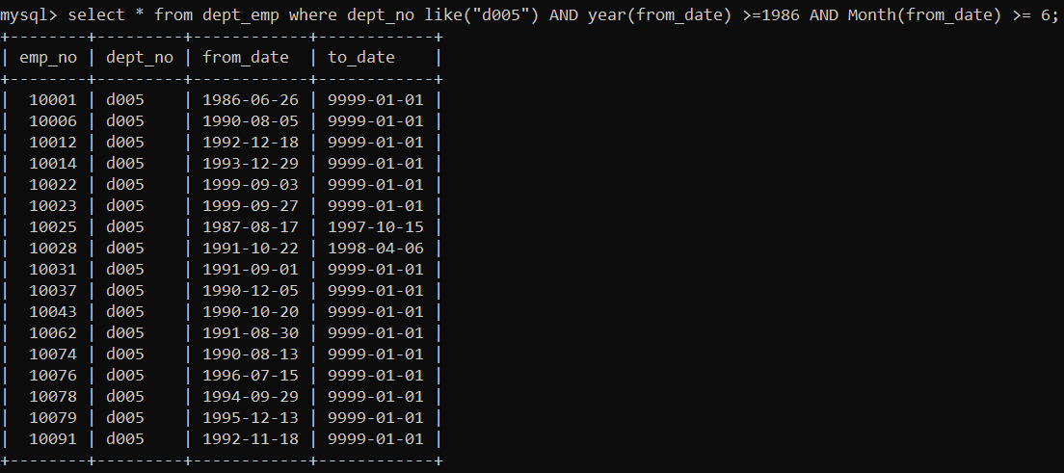

**Question 1.14 Show the emp_no, salary, from_date and to_date of all employees who earned more than 65,000 at any time during the 1980s.**

select emp_no, salary, from_date, to_date from salaries where salary >= 65000 AND (year(from_date) <= 1989 AND year(to_date) >= 1980);

**Question 1.15 Update the surname of all male employees born in November to have “Mr.” and a space before their surnames.**

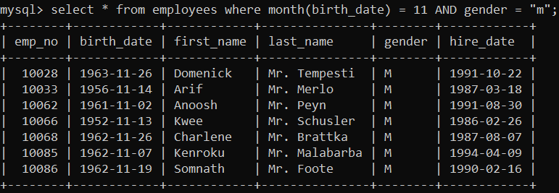

***Part 2 • Get salespersondb.sql from Learnonline and import into MySQL.***

**Question 2.1 Show the number of commissions as “Number of Commissions” (A NULL value is not a commission).**

**Question 2.2 Show the dob of the oldest salesperson.**

**Question 2.3 Show the total commission for the city of Boston.**

**Question 2.4 Show each city and the maximum commission for that city.**

**Question 2.5 Show each sid and the number of cities that salesperson works in.**

**Question 2.6 Show the name of the month salespeople were born in and the number of salespeople born in that month.**

**Question 2.7 Show cities and their average commission only if their average commission is > 3.5. Question**

**2.8 Show cities and their average commission but only include a commission in the average calculation if it is > 3.6.**

**Question 2.9 Show cities and their average commission only if their average commission is > 4.7. Only commission > 3.6 should be included in the average calculation.**

