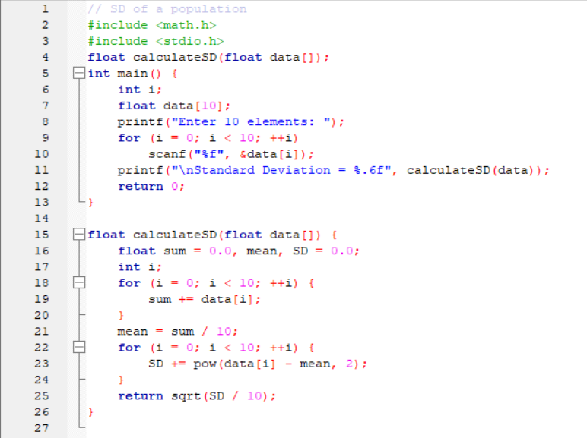

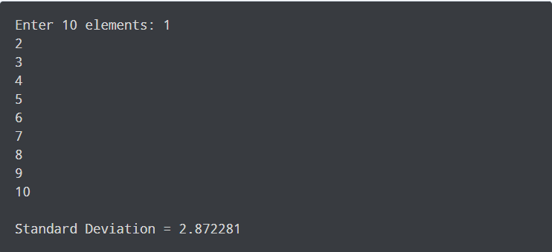

PSP0 PROJECT PLAN SUMMARY

Student: Adrian Jesus Lora Molina Date:12-06-21

Program: Programa A1 Program#: 1

Instructor: Juan Manuel González Calleros Language: C

|  |  |  |  |  |
| --- | --- | --- | --- | --- |
| **Time in phase (min.)** | **Plan** | **Actual** |  |  |
| Planning | 15 min | 20 min |  |  |
| Design | 10 min | 10 min |  |  |
| Code | 60 min | 120 min |  |  |
| Compile | 1 min | 1 min |  |  |
| Test | 1 min | 1 min |  |  |
| Postmortem | 1 min | 1 min |  |  |
| Total | 90 | 175 min |  |  |
| **Defects Injected** |  | **Actual** |  |  |
| Planning | 0 | 0 |  |  |
| Design | 0 | 0 |  |  |
| Code | 5 | 5 |  |  |
| Compile | 5 | 5 |  |  |
| Test | 0 | 0 |  |  |
| Total Development |  | ______________ |  |  |
| **Defects Removed** |  | **Actual** |  |  |
| Planning | 0 | 0 |  |  |
| Design | 0 | 0 |  |  |
| Code | 5 | 5 |  |  |
| Compile | 5 | 5 |  |  |
| Test | 0 | 0 |  |  |
| Total Development |  | ______________ |  |  |
| After Development |  | ______________ |  |  |

TIME RECORDING LOG

|  |  |  |  |  |  |  |
| --- | --- | --- | --- | --- | --- | --- |
| Date | Start | Stop | Interruption Time | Delta Time | Phase | Comments |
| 10-06-21 | 4:00 | 6:55 | 1:00 | 0:55 | 1 | Se me interrumpió ayudando con la despensa de las compras |

DEFECT RECORDING LOG

|  |  |  |  |  |  |  |
| --- | --- | --- | --- | --- | --- | --- |
| Date | Number | Type | Inject | Remove | Fix Time | Fix Defect |
| 10-06-21 | 11 | unknown | ; |  | 5 mins |  |

Description: ||=== Build file: "no target" in "no project" (compiler: unknown) ===|

C:\Users\ajlm_\OneDrive\Documentos\ITI\CURSOS\Ing de Software\Tareas\Programa A1.c||In function 'main':|

C:\Users\ajlm_\OneDrive\Documentos\ITI\CURSOS\Ing de Software\Tareas\Programa A1.c|11|error: expected ';' before 'printf'|

|  |  |  |  |  |  |  |
| --- | --- | --- | --- | --- | --- | --- |
| Date | Number | Type | Inject | Remove | Fix Time | Fix Defect |
| 10-06-21 | 11 | unknown | data |  | 5 min |  |

Description: ||=== Build file: "no target" in "no project" (compiler: unknown) ===|

C:\Users\ajlm_\OneDrive\Documentos\ITI\CURSOS\Ing de Software\Tareas\Programa A1.c||In function 'main':|

C:\Users\ajlm_\OneDrive\Documentos\ITI\CURSOS\Ing de Software\Tareas\Programa A1.c|11|error: too few arguments to function 'calculateSD'|

C:\Users\ajlm_\OneDrive\Documentos\ITI\CURSOS\Ing de Software\Tareas\Programa A1.c|4|note: declared here|

**Process Improvement Proposal (PIP)**

|  |  |  |
| --- | --- | --- |
| **PIP Number** | | |
|  |  | **Problem Description:** | |
| 11 |  |  | |
|  |  | ||=== Build file: "no target" in "no project" (compiler: unknown) ===| | |
|  |  | C:\Users\ajlm_\OneDrive\Documentos\ITI\CURSOS\Ing de Software\Tareas\Programa A1.c||In function 'main':|  C:\Users\ajlm_\OneDrive\Documentos\ITI\CURSOS\Ing de Software\Tareas\Programa A1.c|11|error: too few arguments to function 'calculateSD'| | |
|  |  | C:\Users\ajlm_\OneDrive\Documentos\ITI\CURSOS\Ing de Software\Tareas\Programa A1.c|4|note: declared here| | |
| 11 |  | ||=== Build file: "no target" in "no project" (compiler: unknown) ===| | |
|  |  | C:\Users\ajlm_\OneDrive\Documentos\ITI\CURSOS\Ing de Software\Tareas\Programa A1.c||In function 'main':| | |
|  |  | C:\Users\ajlm_\OneDrive\Documentos\ITI\CURSOS\Ing de Software\Tareas\Programa A1.c|11|error: expected ';' before 'printf' | |
|  |  |  | |
|  |  |  | |
|  | | |
| **PROPOSAL** | | |
| **PIP #** |  | **Proposal Description** | |
|  |  | Revisar la sintaxis de la línea | |
|  |  |  | |
|  |  |  | |
|  |  |  | |
|  |  |  | |
|  |  |  | |
|  |  |  | |
|  |  |  | |
|  |  |  | |
|  |  |  | |
| **Notes and Comments:** | | |
|  |  |  | |
|  |  |  | |
|  |  |  | |
|  |  |  | |
|  |  |  | |
|  |  |  | |
|  |  |  | |
|  |  |  | |
|  |  |  | |
|  |  |  | |