|  |  |  |  |
| --- | --- | --- | --- |
| **Nama** | Adrian Leo Pradana | **Kode Asisten** |  |
| **NPM** | 2106718344 |  |  |

**Jawaban**

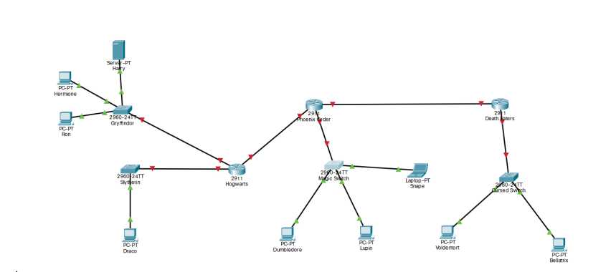

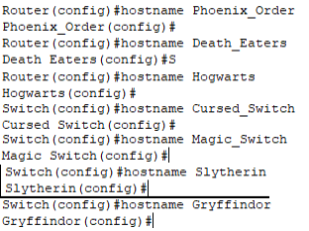

1. A
2. 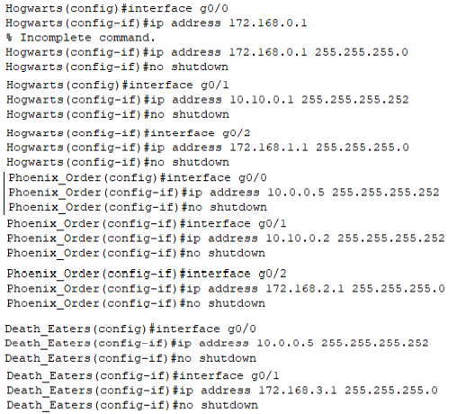A

