|  |  |  |  |
| --- | --- | --- | --- |
| **Nama** | Adrian Leo Pradana | **Kode Asisten** | EH |
| **NPM** | 2106718344 |  |  |

**Jawaban**

1. 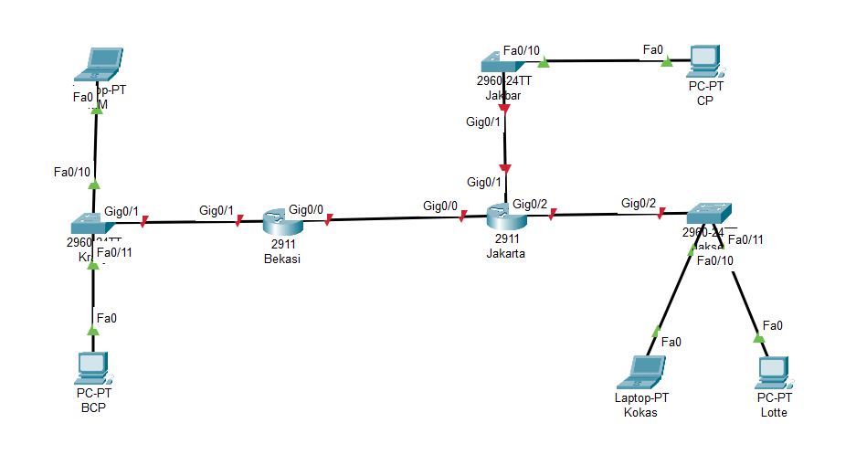Topologi
2. subnetting terhadap jaringan utama, sehingga menjadi beberapa jaringan sesuai dengan kebutuhan masing-masing wilayah

|  |  |  |  |  |  |
| --- | --- | --- | --- | --- | --- |
| Nama LAN/Subnet | Network  Address | Subnet Mask | First Usable Address | Last Usable Adress | Broadcast Address |
| Jakbar | 172.16.1.0 | 255.255.255.128 | 172.16.1.1 | 172.16.1.126 | 172.16.1.127 |
| Jaksel | 172.16.0.0 | 255.255.255.0 | 172.16.0.1 | 172.16.0.255 | 172.16.0.255 |
| Kranji | 172.16.1.128 | 255.255.255.192 | 172.16.1.129 | 172.16.1.190 | 172.16.1.191 |
| Bekasi - Jakarta | 172.16.1.192 | 255.255.255.252 | 172.16.1.193 | 172.16.1.193 | 172.16.1.195 |

1. Jaksel 🡪 /24 = 2^8 – 2 = 254 Host

Jakbar 🡪 /25 = 2^7 – 2 = 126 Host

Kranji 🡪 /26 = 2^6 – 2 = 62 Host

Bekasi – Jakarta 🡪 /30 = 2^2 – 2 = 2 Host

Jaksel 254 – 200 = 54 IP Address tidak terpakai

Jakbar 126 – 120 = 6 IP Address tidak terpakai

Kranji 62 – 60 = 2 IP Address tidak terpakai

Bekasi- Jakarta 2-2 = 0 IP Address tidak terpakai

1. IP Address

|  |  |  |  |  |
| --- | --- | --- | --- | --- |
| Device | Interface | IP Address | Subnet Mask | Default Gateway |
| Jakarta | G0/0 | 172.161.1.194 | 255.255.255.252 |  |
| G0/1 | 172.16.1.1 | 255.255.255.128 |
| G0/2 | 172.16.0.1 | 255.255.255.0 |
| Bekasi | G0/0 | 172.161.1.193 | 255.255.255.252 |
| G0/1 | 172.161.1.129 | 255.255.255.192 |
| PC CP | NIC | 172.16.1.2 | 255.255.255.128 | 172.16.1.1 |
| PC Kokas | NIC | 172.16.0.2 | 255.255.255.0 | 172.16.0.1 |
| PC Lotte | NIC | 172.16.0.3 | 255.255.255.0 | 172.16.0.1 |
| PC MM | NIC | 172.161.1.130 | 255.255.255.192 | 172.161.1.129 |
| PC BCP | NIC | 172.161.1.131 | 255.255.255.192 | 172.161.1.129 |

1. 