Software System for Mid to Large Sized software/IT company

For

Dr. Uskov

Computer Science and Information Systems Department

Team 03

CS 390 - 01

April 29, 2019

Table of Contents

Introduction........................................................................................... 3

Customer requirements…………………………………………………………………….. 3

System Feasibility………………………………………………………………………………. 3

System Requirements……………………………………………………………………… 3

System Scope…………..……………………………………………………………………… 3

System Functionality…………………………………………………………………………… 3

System constraints……………………………………………………………………………… 4

Platform and Environment………………………………………………………………… 4

Process Model……………………………………………………………………………………. 4

Use case Diagram……………………………………………………………………………… 5

Class Object Diagram…………………………………………………………………………. 6

DFD……………………………………………………………………………………………………. 7

Level-0 Diagram…………………………………………………………………………………. 7

STD……………………………………………………………………………………………………… 8

GUI Functional view……………………………………………………………………………. 9

INTRODUCTION

This project is to develop a software system for a mid to large sized IT or software development company. Our customer requirements are to:

* Available for all modern platforms
* Must be able to view and purchase products
* Must be able to interact with Chabot’s
* Must be able to view and apply for jobs
* Must be able to contact the company
* Be able to post and edit forums
* Be able to view and subscribe to services
* Be able to view case studies
* Be able to subscribe for membership
* Be able to view and comment on Demos

**System Feasibility and Requirements:**

The system feasibility for this project are to design a website for IT/Software development companies is an improvement over current software because it is more client orientated with functions such as:

Chat bots, Projects, Demos, News, Forums, Contacts, etc.

**System Requirements:**

The project scope, requirements functionality and constraints are:

System Scope: Provides a website where customers and potential clients are able to view projects, awards, forums, news, tools and other important objects and be able to communicate with Chabot’s and view demos of the products

Functionality: Communicate with Chabot’s, view news articles, post on the forums page, edit your profile for forums page, view available products, purchase products, view services, apple to services, view available careers and apply for jobs

Constraints:

Types of constraints that can be face are:

Build time, run time, cost of development, manpower, specification of equipment and technical tools, cost of maintenance

Platform and Environment:

The platform and environment that our system should run on is:

Operating Systems: Windows Vista, 7, 8, 10, Mac OS X V. 10.5 to MacOS 10.14, Linux 2.6 to Linux 5.0, IOS, Android OS, Windows Phone OS, Chrome OS

Access to internet: Required

Types of Computers: Anything that runs listed operating systems

Devices Used: Mobile Devices that run the listed Mobile Operating Systems

Process Model:

The process model that we will be using is an evolutionary prototype model because we want to make sure that all of the functionalities and the layout is up to the customer’s standards by delivering a robust prototype that can be constantly refined over time

The actors and class object for our system will be: Users, Contacts, Clients, System Administrators, Protocols, Servers, Services. Chabot’s, Forums, Projects, Products, Industries, Tools, Careers, Case studies, News, Demos, Awards, Databases and Members.

And some of the functions they will be able to perform are: Edit profile, Check stock, Verify Edits, Run protocols, Receive Documents, Receive Contacts, view clients, view tools, view projects, view contacts, view products, buy products, view careers, apply to careers, view forums, view clients, view case studies, view news, interact with Chabot’s, view awards, view industries, view demos, apply for services,  Review Products, Log in, receive edits, view users, edit news, send to database, respond to members, store actors and demos.

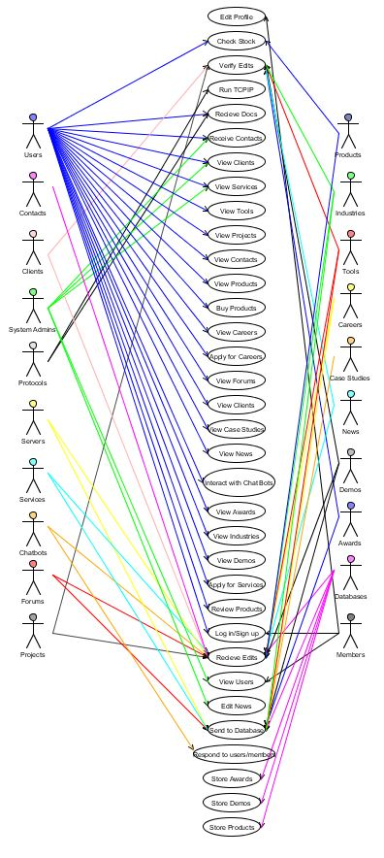Here are out diagrams:

Here is our class object diagram:

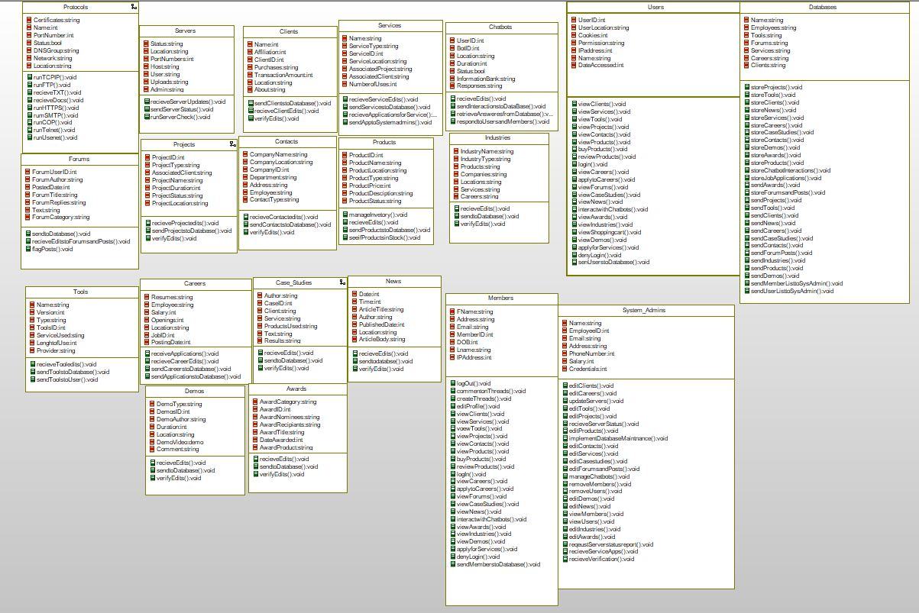

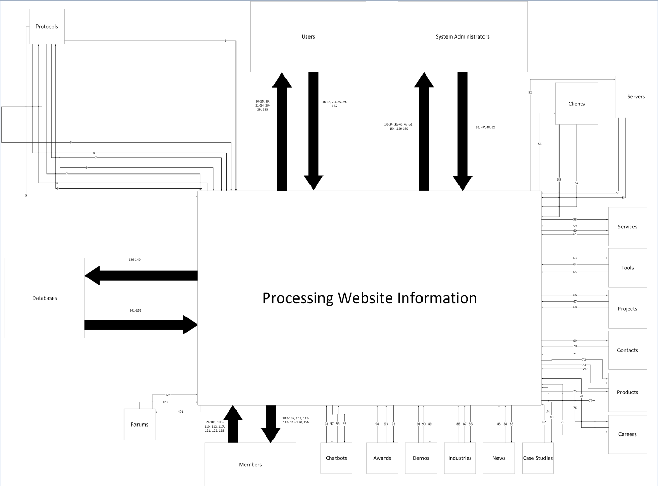Here is our context Data Flow Diagram:

Here is our level – 0 diagram:

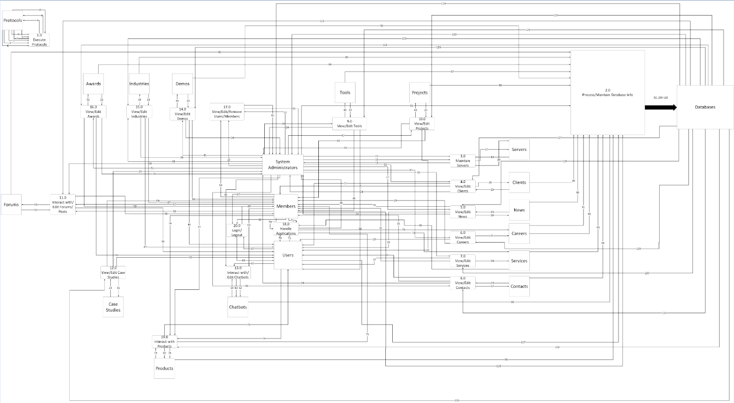

Here is out STD:

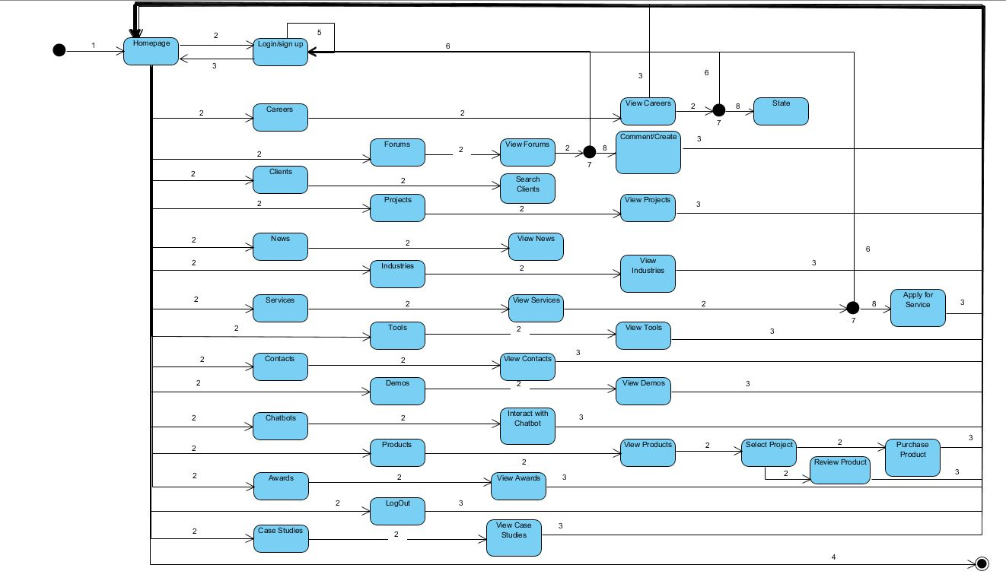

Here is the Functional view of the GUI:

