**TITLE**

**Authors: Iker Romero, Oihana Arambarri,**

**Julio Sebastian Zevallos, Raul Parra**

**Date:**

**INDEX**

1. **PROJECT CONTEXT**

**The “Erlete elkartea” needs an information system to manage its business. It must consist of two programs: a web application for the general public and members, and a Java application for the manager.**

**The applications need to handle purchases of items such as machinery, tools or jars.**

**Members must be able to book the extractor. Members will book the extractor for full days, they cannot book for a part of a day.**

**Members must pay thirty euros (30€) annually, plus 25 cents per kilo produced.**

**Honey is kept in metal bins, currently there are 3x 145Kg + 3x 217.5Kg + 1x 362.5Kg**

1. **APPLICATION ANALYSIS**

**The explanation of our project will be divided in three main parts:**

**The Java app will be given to company administrators.**

**The administrator will be able to control all accesses, passwords, users and keep track of the compatibility. He will also have the possibility to delete, add or change users and every record on our database.**

**The web will be divided in two parts,when the user isn't logged in and when the user is logged, when not logged the user will be able to read all the info about Erlete, in addition to registering an account or singing in.**

**When logged the user will be able to look at the list of partners and reservations besides reserving for themselves and looking at their honey production info.**

**We are going to use a MariaDB database to store member data (name, surname, password, produced honey, debt); honey (how much the cans have); extractor usage (who uses it on which day); tool, machine and jar purchases; and balance.**

**A trigger will be used so that when member debt is paid, Erlete’s balance will be increased.**

1. **APPLICATION DESIGN**
   1. USE CASE DIAGRAM 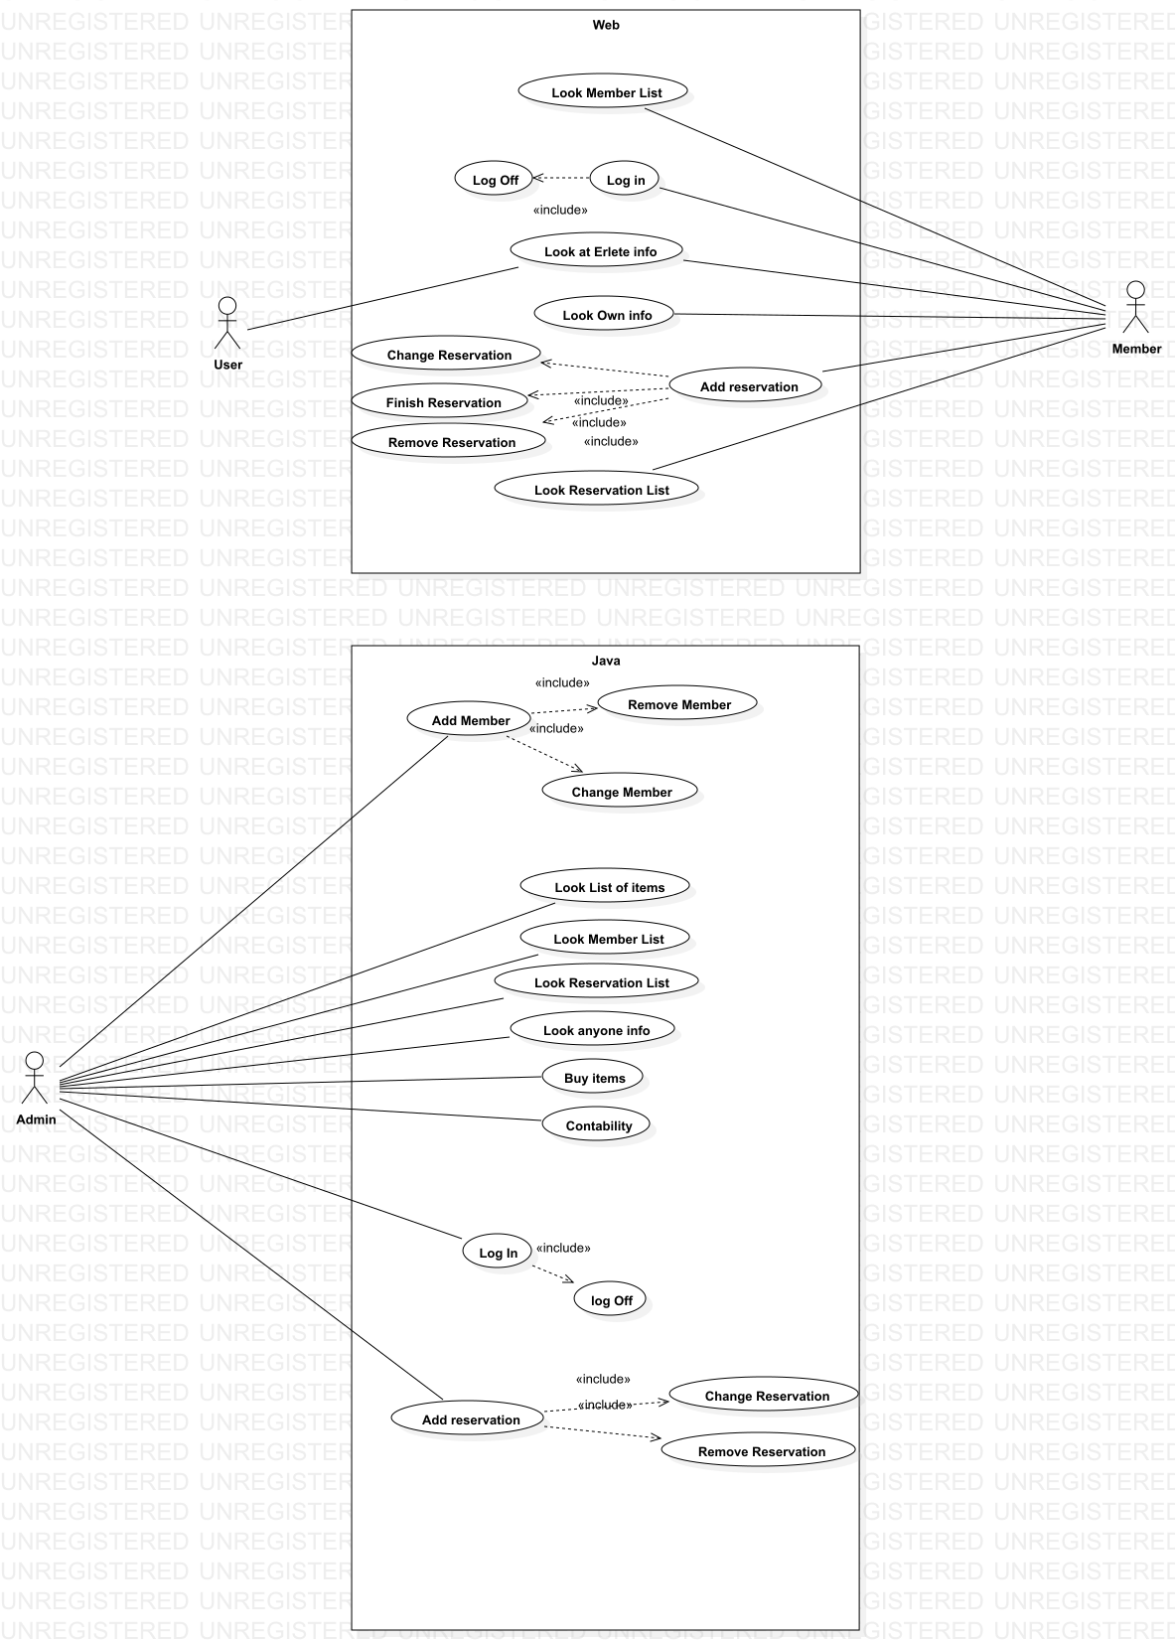

First of all I have thought that the one who will interact with the website is going to be the user or partner of Erlete,the user will have several options first of all will have to get on our page, once inside will have the option to see the list of all the partners,being able to reserve a date for the extractor,look at their own honey production and the general and finally the money that has and the one that should pay. That's why I thought that from the member come all the arrows and options to look at the list, book, look at the honey production and the money will end up in the database previously created.

On the other hand, the Java application will only be used by the administrator, so all the arrows of the administrator itself come out, with the possibility to change, add or delete anything from the database.

* 1. CLASS DIAGRAM

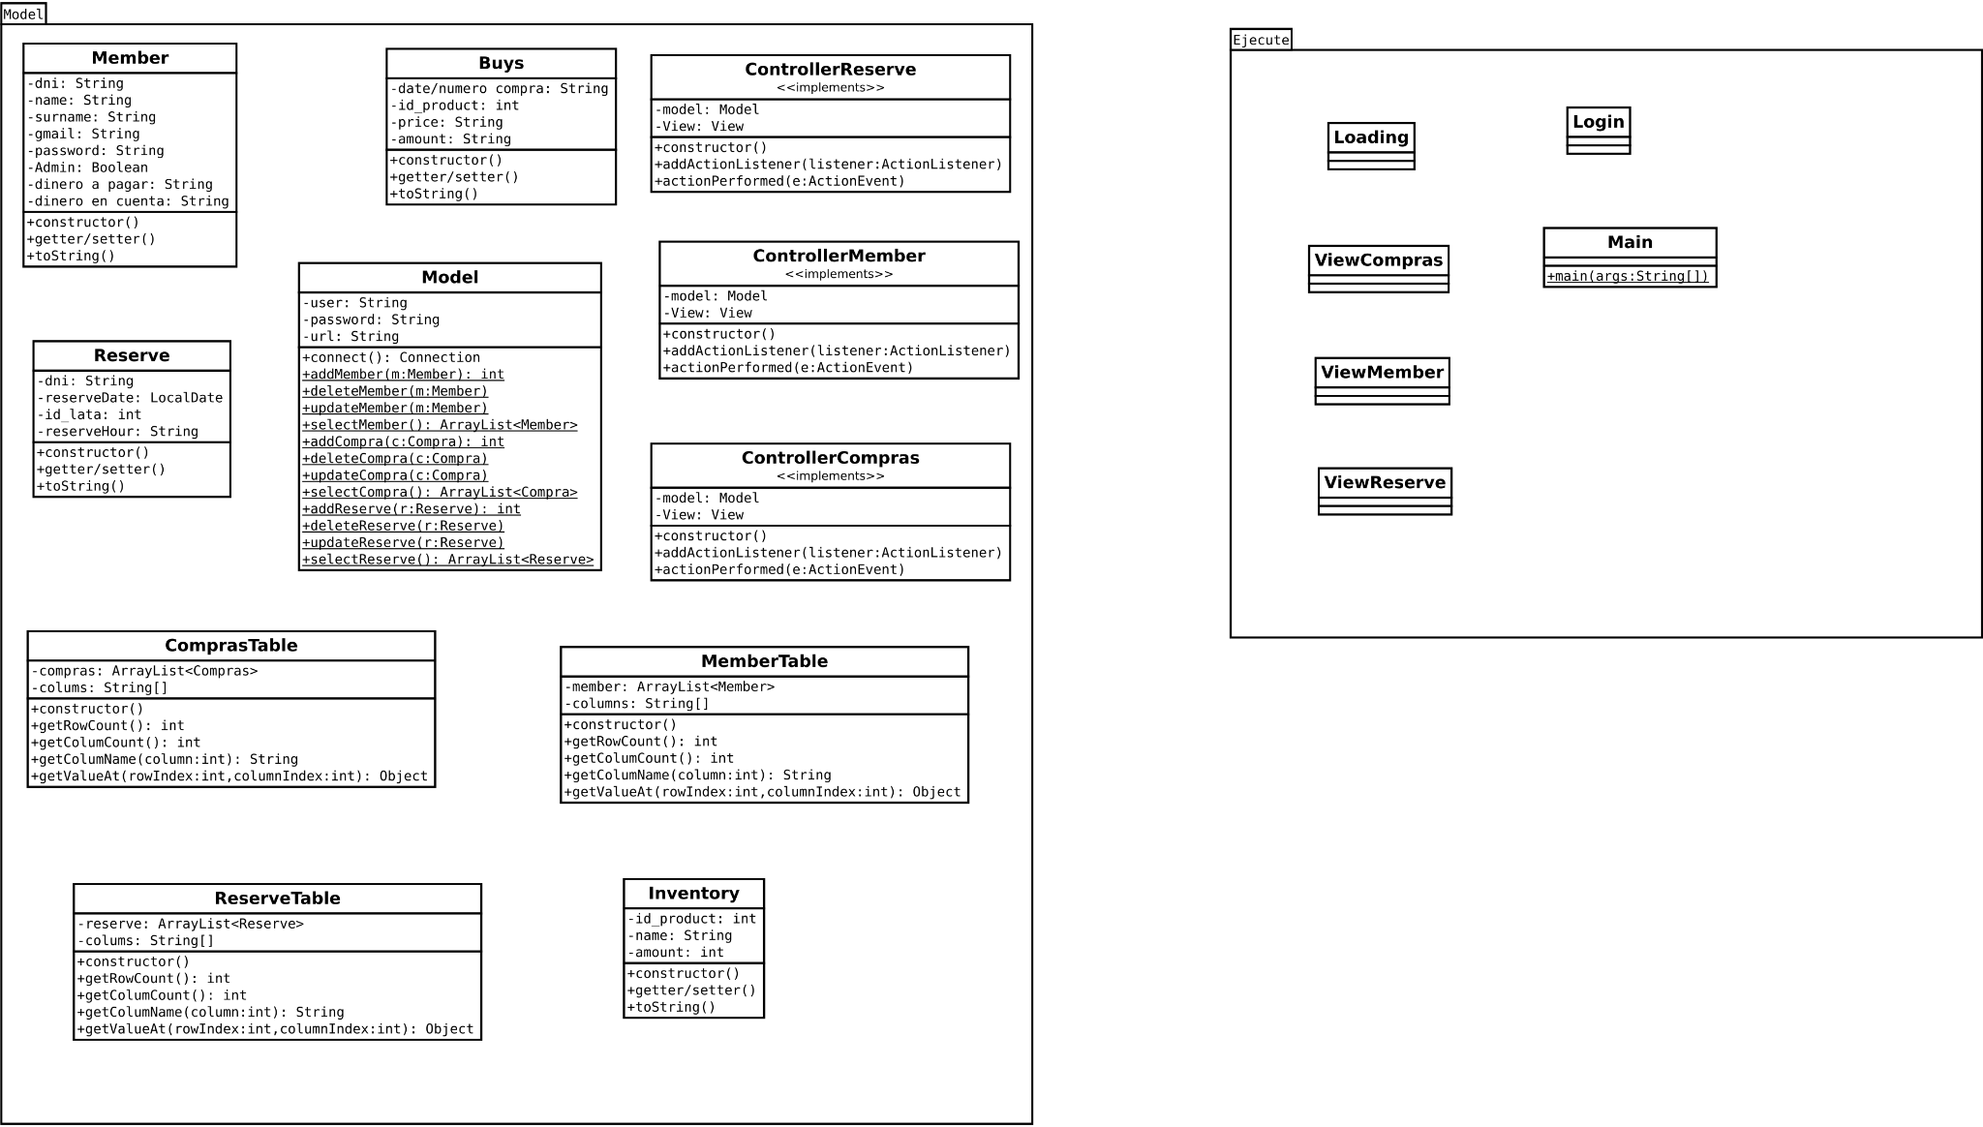

* 1. ACTIVITY DIAGRAM

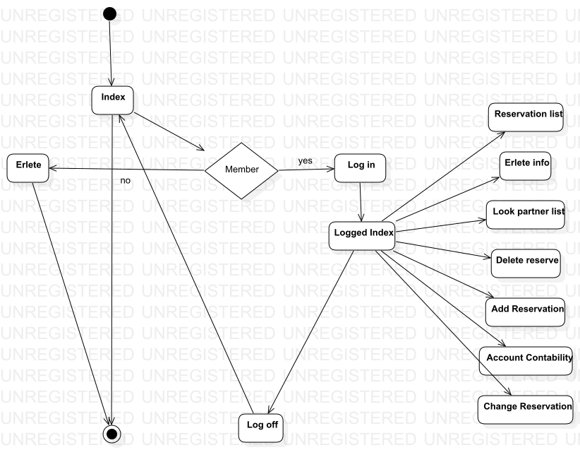

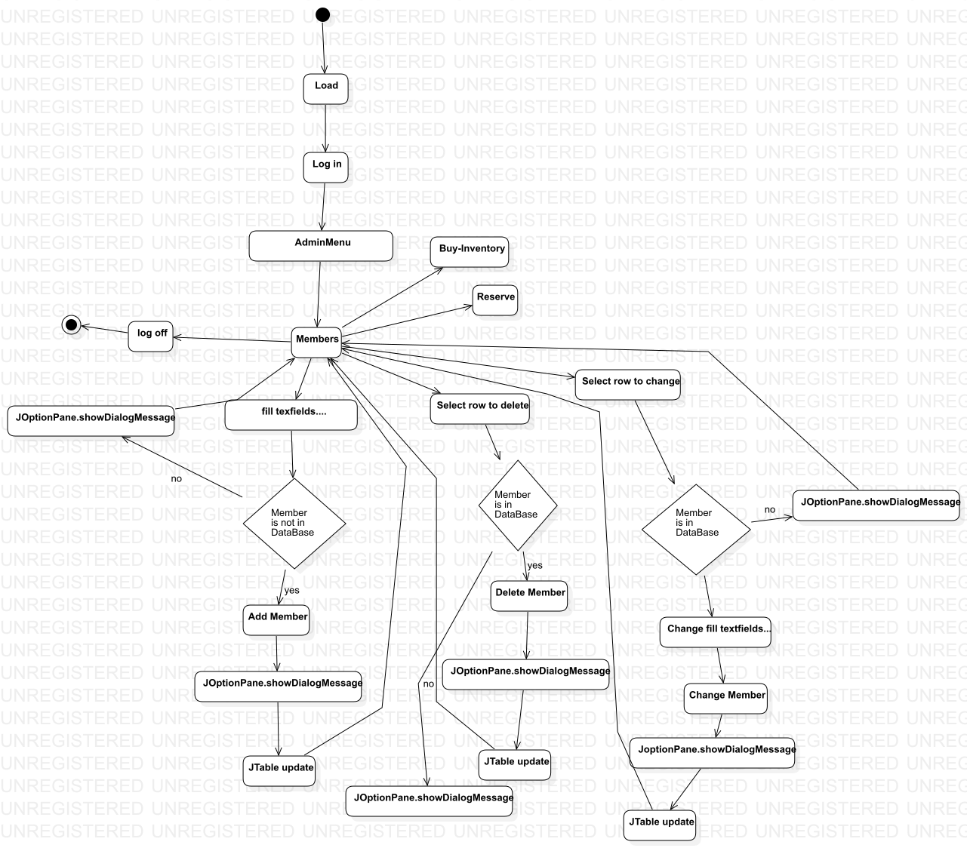

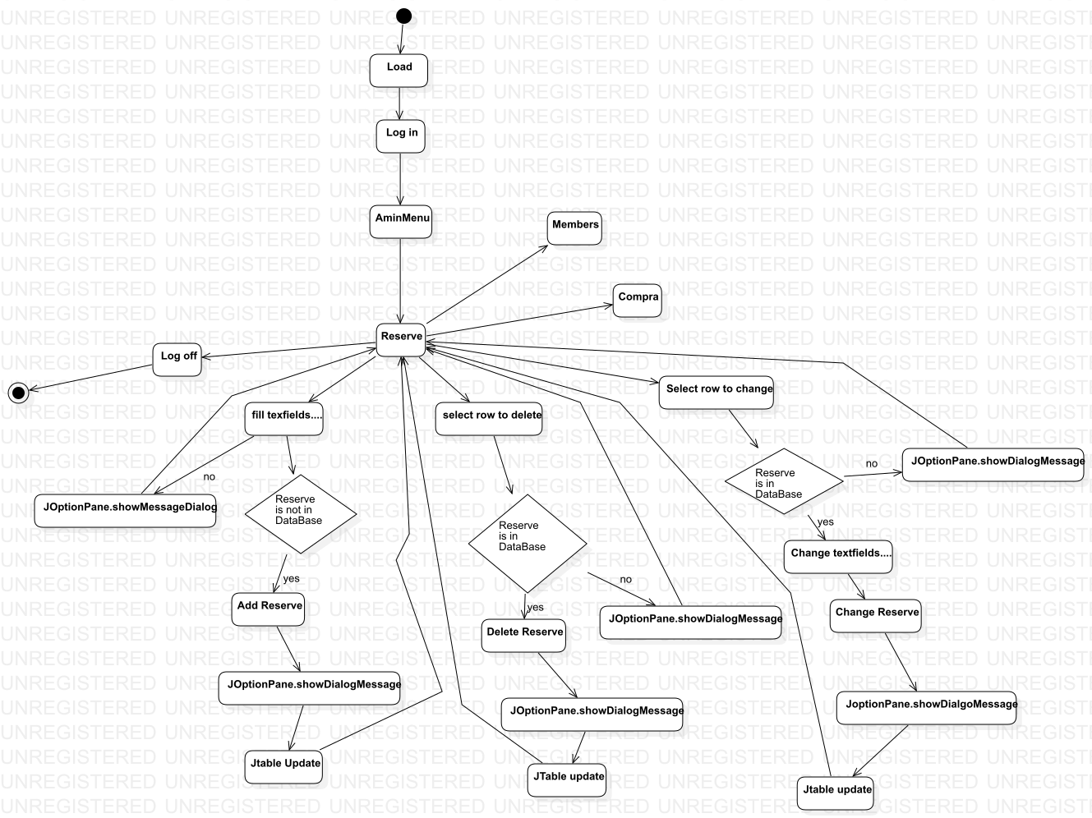

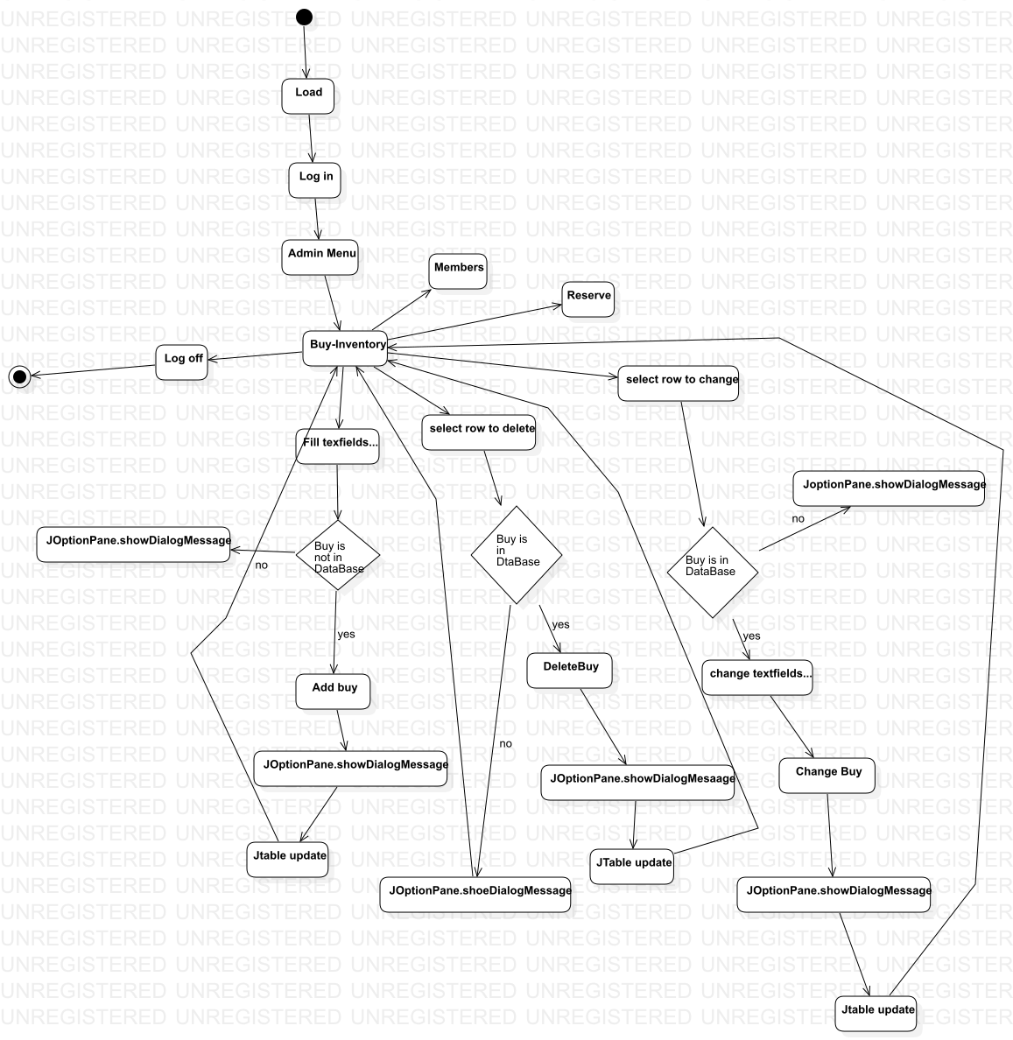

* 1. DATABASE DESIGN

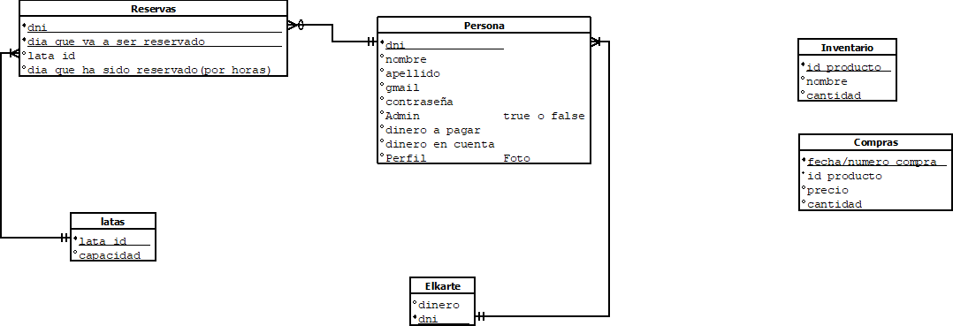

We have decided to make 6 tables, 4 of them will be related to each other, first of all we have the Person table where we will save all the user's data,the second table will be the Reservations table and it will be related to Person, where we will save the day reserved, when you have booked and the can, our third table will be that of the cans, so that we can make the relationship between these tables , this will have the capacity and the ID.There will be a fourth table related to Person called Elkarte, where the total money of Erlete will be saved.

Then we will have another 2 tables unrelated to any other calls Inventory and Purchases in the inventory we will save the id of the cans, their name and the amount there is. In the Purchasing table we have decided to save the purchase number, product ID, quantity, and price.

1. **TASK PLANNING AND REGISTER** 
   1. **TASK1: (name ,description): Goal and methodology:**Describe the goal and methodology that is going to be used in this task. If this task is going to be divided in smaller tasks, described them.
      1. Task1.1
      2. Task1.2

Fill a table like this one with the information provided

|  |  |  |  |  |
| --- | --- | --- | --- | --- |
|  | **Duration (hours)** | **Beginning date** | **Finishing date** | **Responsible** |
| Task 1  Install and configure LAMP eta Kontextua | 3 | 03/05/2021 | 03/05/2021 | Sebastian/Iker |
| Task 2 Análisis | 1 | 04/05/2021 | 04/05/2021 | Iker/Raul/Sebas |
| Task 3  Diagramas  -Activity  -Case | 2 | 05/05/2021 | 05/05/2021 | Oihana mainly |
| Task 4  Datu Basea eta Diagrama | 2 | 05/05/2021 | 05/05/2021 | Denok |
| Task 5 Web Diagram | 1 | 06/06/2021 | 06/06/2021 | Raul |
| Task 6  Base page php Session start and log-out |  | 06/06/2021 | 07/06/2021 | Iker/Sebastian |
| Task 7  Check all diagrams and finish them | 2 | 07/06/2021 | 07/06/2021 | Oihana Raul Iker |

1. **SOFTWARE APPLICATION IMPLEMENTATION/INSTALLATION**
2. **USERS GUIDE**
3. **THOUGHTS**
4. **BIBLIOGRAPHY**