|  |  |
| --- | --- |
| 3GPP TR 22.851 V19.0.0 (2023-06) | |
| Technical Report | |
| 3rd Generation Partnership Project;  Technical Specification Group TSG SA;  Feasibility Study on Network Sharing Aspect  (Release 19) | |
|  | |
|  |  |
| The present document has been developed within the 3rd Generation Partnership Project (3GPP TM) and may be further elaborated for the purposes of 3GPP. The present document has not been subject to any approval process by the 3GPPOrganizational Partners and shall not be implemented. This Specification is provided for future development work within 3GPPonly. The Organizational Partners accept no liability for any use of this Specification. Specifications and Reports for implementation of the 3GPP TM system should be obtained via the 3GPP Organizational Partners' Publications Offices. | |

|  |
| --- |
|  |
| ***3GPP***  Postal address  3GPP support office address  650 Route des Lucioles - Sophia Antipolis  Valbonne - FRANCE  Tel.: +33 4 92 94 42 00 Fax: +33 4 93 65 47 16  Internet  http://www.3gpp.org |
| ***Copyright Notification***  No part may be reproduced except as authorized by written permission. The copyright and the foregoing restriction extend to reproduction in all media.  © 2022, 3GPP Organizational Partners (ARIB, ATIS, CCSA, ETSI, TSDSI, TTA, TTC).  All rights reserved.  UMTS™ is a Trade Mark of ETSI registered for the benefit of its members  3GPP™ is a Trade Mark of ETSI registered for the benefit of its Members and of the 3GPP Organizational Partners LTE™ is a Trade Mark of ETSI registered for the benefit of its Members and of the 3GPP Organizational Partners  GSM® and the GSM logo are registered and owned by the GSM Association |

Contents

Foreword 4

Introduction 5

1 Scope 6

2 References 6

3 Definitions of terms, symbols and abbreviations 6

3.1 Terms 6

3.2 Symbols 7

3.3 Abbreviations 7

4 Overview 7

5 Use Cases 7

5.1 Use Case on Network Sharing without Direct Connections between the Shared Access and the Core Networks of the Participating Operators 7

5.1.1 Description 7

5.1.2 Pre-conditions 8

5.1.3 Service Flows 10

5.1.4 Post-conditions 10

5.1.5 Existing Features partly or fully covering Use Case Functionality 10

5.1.6 Potential New Requirements needed to support the Use Case 11

5.2 Use Case on Service Continuity and QoS 11

5.2.1 Description 11

5.2.2 Pre-conditions 11

5.2.3 Service Flows 11

5.2.4 Post-conditions 12

5.2.5 Existing Features partly or fully covering Use Case Functionality 12

5.2.6 Potential New Requirements needed to support the Use Case 12

5.3 Use Case on Network Access Control and Mobility between Sharing Parties 13

5.3.1 Description 13

5.3.2 Pre-conditions 13

5.3.3 Service Flows 13

5.3.4 Post-conditions 15

5.3.5 Existing Features partly or fully covering Use Case Functionality 15

5.3.6 Potential New Requirements needed to support the Use Case 15

5.4 Use Case on International Roaming Users in a Shared Network 16

5.4.1 Description 16

5.4.2 Pre-conditions 16

5.4.3 Service Flows 16

5.4.4 Post-conditions 17

5.4.5 Existing Features partly or fully covering Use Case Functionality 17

5.4.6 Potential New Requirements needed to support the Use Case 17

5.5 Use Case on Hosted Services 17

5.5.1 Description 17

5.5.2 Pre-conditions 17

5.5.3 Service Flows 18

5.5.4 Post-conditions 18

5.5.5 Existing Features partly or fully covering Use Case Functionality 18

5.5.6 Potential New Requirements needed to support the Use Case 18

5.6 Use Case on Emergency Call 19

5.6.1 Description 19

5.6.2 Pre-conditions 19

5.6.3 Service Flows 19

5.6.4 Post-conditions 20

5.6.5 Existing Features partly or fully covering Use Case Functionality 20

5.6.6 Potential New Requirements needed to support the Use Case 20

5.7 Use Case on Long-distance Mobility in and across Shared Networks 20

5.7.1 Description 20

5.7.2 Pre-conditions 21

5.7.3 Service Flows 21

5.7.4 Post-conditions 22

5.7.5 Existing Features partly or fully covering Use Case Functionality 22

5.7.6 Potential New Requirements needed to support the use case 23

5.8 Use Case on Support of PWS in Shared NG-RAN in Indirect Interconnection with the Participating Operators 23

5.8.1 Description 23

5.8.2 Pre-conditions 23

5.8.3 Service flows 24

5.8.4 Post-conditions 24

5.8.5 Existing requirements to PWS Support in Shared Networks 24

5.8.6 Potential New Requirements needed to support the Use Case 25

6 Other considerations 25

6.1 Considerations on security 25

7 Consolidated requirements 25

7.1 General 25

7.2 Consolidated Potential Requirements 26

7.2.1 Introduction 26

7.2.2 General aspects 26

7.2.3 Mobility 27

7.2.4 Network Access Control 27

7.2.5 Regulatory Services 28

7.2.6 Charging aspects 28

8 Conclusion and recommendations 28

Annex A (informative): Change history 29

# Foreword

This Technical Report has been produced by the 3rd Generation Partnership Project (3GPP).

The contents of the present document are subject to continuing work within the TSG and may change following formal TSG approval. Should the TSG modify the contents of the present document, it will be re-released by the TSG with an identifying change of release date and an increase in version number as follows:

Version x.y.z

where:

x the first digit:

1 presented to TSG for information;

2 presented to TSG for approval;

3 or greater indicates TSG approved document under change control.

y the second digit is incremented for all changes of substance, i.e. technical enhancements, corrections, updates, etc.

z the third digit is incremented when editorial only changes have been incorporated in the document.

In the present document, modal verbs have the following meanings:

**shall** indicates a mandatory requirement to do something

**shall not** indicates an interdiction (prohibition) to do something

The constructions "shall" and "shall not" are confined to the context of normative provisions, and do not appear in Technical Reports.

The constructions "must" and "must not" are not used as substitutes for "shall" and "shall not". Their use is avoided insofar as possible, and they are not used in a normative context except in a direct citation from an external, referenced, non-3GPP document, or so as to maintain continuity of style when extending or modifying the provisions of such a referenced document.

**should** indicates a recommendation to do something

**should not** indicates a recommendation not to do something

**may** indicates permission to do something

**need not** indicates permission not to do something

The construction "may not" is ambiguous and is not used in normative elements. The unambiguous constructions "might not" or "shall not" are used instead, depending upon the meaning intended.

**can** indicates that something is possible

**cannot** indicates that something is impossible

The constructions "can" and "cannot" are not substitutes for "may" and "need not".

**will** indicates that something is certain or expected to happen as a result of action taken by an agency the behaviour of which is outside the scope of the present document

**will not** indicates that something is certain or expected not to happen as a result of action taken by an agency the behaviour of which is outside the scope of the present document

**might** indicates a likelihood that something will happen as a result of action taken by some agency the behaviour of which is outside the scope of the present document

**might not** indicates a likelihood that something will not happen as a result of action taken by some agency the behaviour of which is outside the scope of the present document

In addition:

**is** (or any other verb in the indicative mood) indicates a statement of fact

**is not** (or any other negative verb in the indicative mood) indicates a statement of fact

The constructions "is" and "is not" do not indicate requirements.

# Introduction

Network sharing enables operators to maximize rollout and improve overall network quality. The 3GPP system supports different types of network sharing since Rel-5, most of which are inherited by 5G (Rel-15 onward). With the expanding of 5G deployments more network sharing scenarios can arise, depending on different operators’ strategies, commercial agreements, and specific rules/legislation in different countries. One of the challenges for the operators is the maintenance of the interconnections (e.g., number of network interfaces) between the shared NG-RAN and participating operators’ core networks, especially in the case of a large number of the shared base stations. It is therefore suggested to investigate other type of network sharing scenarios, where a NG-RAN is shared among multiple operators without necessarily assuming a direct connection between the shared radio access network and the participating operator’s core network.

# 1 Scope

The present document investigates use cases and potential new requirements related to 3GPP system enhanced support of specific 5G network sharing deployment scenarios, in particular where there is no direct interconnection between the shared NG-RAN and participating operators’ core networks. It includes the following aspects:

- Mobility and service continuity, e.g., when moving from a non-shared 4G/5G network to a shared 5G network and vice versa, with focus on CN aspects.

- Potential security requirements.

- Charging requirements (e.g., based on traffic differentiation in specific network sharing geographical areas).

- User/service experience (e.g., maintain the communication latency for voice, and SMS) when accessing the shared network, including scenarios of home-routed traffic or local breakout.

- Other aspects, e.g., regulatory requirements, emergency services, PWS support.

# 2 References

The following documents contain provisions which, through reference in this text, constitute provisions of the present document.

- References are either specific (identified by date of publication, edition number, version number, etc.) or non‑specific.

- For a specific reference, subsequent revisions do not apply.

- For a non-specific reference, the latest version applies. In the case of a reference to a 3GPP document (including a GSM document), a non-specific reference implicitly refers to the latest version of that document *in the same Release as the present document*.

1. 3GPP TR 21.905: "Vocabulary for 3GPP Specifications".
2. 3GPP TS 22.101: "Service principles".
3. 3GPP TS 22.261: "Service requirements for the 5G system".
4. 3GPP TS 29.513: "5G System; Policy and Charging Control signalling flows and QoS parameter mapping; Stage 3".
5. 3GPP TS 23.122: "Non-Access-Stratum (NAS) functions related to Mobile Station (MS) in idle mode".
6. 3GPP TS 22.011: "Service accessibility".
7. 3GPP TS 23.502: "Procedures for the 5G System".
8. 3GPP TS 22.071: "Location Services (LCS); Service description; Stage 1".
9. “Highway makes desert travel easy”, <http://en.people.cn/n3/2022/0706/c90000-10119553.html>

# 3 Definitions of terms, symbols and abbreviations

## 3.1 Terms

For the purposes of the present document, the terms given in 3GPP TR 21.905 [1] and the following apply. A term defined in the present document takes precedence over the definition of the same term, if any, in 3GPP TR 21.905 [1].

**Indirect Network Sharing**:describes the communication between the shared access NG-RAN and the Participating NG-RAN Operator’s core network being routed through the Hosting NG-RAN Operator’s core network.

**Hosted Service**: a service containing the operator's own application(s) and/or trusted third-party application(s) in the Service Hosting Environment, which can be accessed by the user.

**Service Hosting Environment**: the environment, located inside of 5G network and fully controlled by the operator, where Hosted Services are offered from.

**Hosting NG-RAN Operator**: the operator that has operational control of a shared NG-RAN.

NOTE 1: **Hosting NG-RAN Operator** can also be a Hosting RAN Operator. See 3GPP TS 22.101 [2].

**Participating NG-RAN Operator**: authorized operator that is sharing NG-RAN resources provided by a Hosting NG-RAN Operator.

NOTE 2: Participating NG-RAN Operator can also be participating operator. See 3GPP TS 22.101 [2].

**Shared NG-RAN**: NG-RAN that is shared among a number of operators.

## 3.2 Symbols

For the purposes of the present document, the following symbols apply:

<symbol> <Explanation>

## 3.3 Abbreviations

For the purposes of the present document, the abbreviations given in 3GPP TR 21.905 [1] and the following apply. An abbreviation defined in the present document takes precedence over the definition of the same abbreviation, if any, in 3GPP TR 21.905 [1].

HTA High Traffic Areas

LTA Low Traffic Areas

MOCN Multi-Operator Core Network

NG-RAN Next Generation Radio Access Network

SST Slice/Service Type

# 4 Overview

The present document introduces the newly supported network sharing scenario, where a NG-RAN is shared among multiple operators without necessarily assuming a direct connection between the shared radio access network and the participating operator’s core network. Use cases including service continuity and QoS, access control and mobility, international roamers in shared network, hosted services, long-distance road transport are analyzed. This study provides alternatives for existing operators who intend to deploy a NG Radio Access Network to complement the existing market, taking into account of operators’ business consideration, such as network planning, operation and other factors.

# 5 Use Cases

## 5.1 Use Case on Network Sharing without Direct Connections between the Shared Access and the Core Networks of the Participating Operators

### 5.1.1 Description

As stated in TS 22.261 [3] the increased density of access nodes needed to meet future performance objectives pose considerable challenges in deployment and acquiring spectrum and antenna locations. RAN sharing is seen as a technical solution to these issues.

Sharing access networks and network infrastructure has become more important part of 3GPP systems.

When two or more operators have respectively deployed or plan to deploy 5G access networks and core networks, a MOCN configuration can be considered for network sharing between these operators, i.e., a Multi-Operator Core Network (MOCN) in which multiple CN nodes are connected to the same radio access and the CN nodes are operated by different operators.

One of the challenges for the partners’ network operators is the maintenance generated by the interconnection (e.g., number of network interfaces) between the shared RAN and two or more core networks, especially for a large number of shared base stations.

For these reasons, it is suggested investigating other types of network sharing scenarios, where a 5G RAN is shared among multiple operators without necessarily assuming a direct connection between shared access and the core networks of the participating operators.

### 5.1.2 Pre-conditions

Two (or more) operators provide coverage with their respective radio access networks in different parts of a country but together cover the entire country.

There is an agreement between all the operators to work together and to build a shared network, but utilizing the different operator’s allocated spectrum appropriately in different parts of the coverage area (for example, Low Traffic Areas, LTA and High Traffic Areas, HTA).

The hosting operator 1, as illustrated below, can share its NG-RAN with the participating operators with or without direct connections between the shared access and the core networks of the participating operators.

The following preconditions apply,

1) 1. OP1 owns the NG-RAN to be shared with three other operators; OP2, OP3, and OP4.

2) 2. NG-RAN is shared with certain conditions, e.g., within a specific 5G frequency band or within specific area.

3) 3. NG-RAN does not have direct connections between the shared access and the core networks of the participating operators OP2 and OP3.

4) 4. OP4 has a MOCN arrangement with OP1.

5) 5. In this example UE 1 is subscribed to OP1, UE 2 is subscribed to OP 2, UE 3 is subscribed to OP3, and UE 4 is subscribed to OP4.

Both options of direct and indirect connections between the shared access and the core networks of the participating operators are illustrated in Figure 5.1.2-1 below.

Figure 5.1.2-2 shows the option of Indirect Network Sharing involving core network of hosting operator, as indirect connection between the shared access and the core networks of the participating operators.

OP 2 Core Network

OP 3 Core Network

OP 4 Core Network

OP 1 Core Network

Indirect Connection

Indirect Connection

N2

N2

UE 2 of OP2

UE 3 of OP3

UE 4 of OP4

UE 1 of OP 1



UE2's screen:

name of

OP 2

Figure 5.1.2-1: Different options both direct and indirect connections between the shared access and the core networks of the participating operators

OP 1 Core

Network

OP 2 Core Network

OP 3 Core Network

Indirect Connection for UE2

UE 2 of OP2



UE2's screen:

name of

OP 2

UE 3 of OP3

Indirect Connection for UE3

Figure 5.1.2-2: Indirect Network Sharing scenario involving core network of hosting operator between the shared access and the core networks of the participating operators

### 5.1.3 Service Flows

1) UE1 can successfully attach to NG-RAN, and the display of the network operator name is the name of OP1.

2) UE2 can successfully attach to NG-RAN, and the display of the network operator name is the name of OP2.

3) UE3 can successfully attach to NG-RAN, and the display of the network operator name is the name of OP3.

4) UE4 can successfully attach to NG-RAN, and the display of the network operator name is the name of OP4.

5) The service provider of UE 1 is OP1.

6) The service provider of UE 2 is OP2.

7) The service provider of UE 3 is OP3.

8) The service provider of UE 4 is OP4.

For UEs accessing the Shared NG-RAN, the network of the hosting operator needs to know which participating operator a UE is registered to and what type of network sharing (e.g., MOCN or otherwise) is in place for that participating operator. The inter-connection between participating operators’ core networks and Shared NG-RAN of the Hosting Operator can be supported via an element of the Hosting Operator.

### 5.1.4 Post-conditions

The hosting network will be able to provide accessing to all participating operators' users.

### 5.1.5 Existing Features partly or fully covering Use Case Functionality

Network sharing has been studied in previous releases, where related normative stage 1 requirements are introduced in 3GPP TS 22.101 [2] and TS 22.261[3].

3GPP TS 22.101 [2] introduces general requirements of network sharing, stated as follows:

*Network sharing shall be transparent to the user.*

*The specifications shall support both the sharing of:*

*(i) radio access network only;*

*(ii) radio access network and core network entities connected to radio access network.*

*NOTE: In a normal deployment scenario only one or the other option will be implemented.*

The provisioning of services and service capabilities is described in 3GPP TS 22.101 [2].

*The provision of services and service capabilities that is possible to offer in a network shall not be restricted by the existence of the network sharing It shall be possible for a core network operator to differentiate its service offering from other core network operators within the shared network.*

*It shall be possible to control the access to service capabilities offered by a shared network according to the core network operator the user is subscribed to.*

The selection of 3GPP access network is described in 3GPP TS 22.261 [3] clause 6.19 :

*The UE uses the list of PLMN/RAT combinations for PLMN selection, if available, typically during roaming situations. In non-roaming situations, the UE and subscription combination typically matches the HPLMN/EHPLMN capabilities and policies, from a SST (slice/service type) perspective. That is, a 5G UE accessing its HPLMN/EHPLMN should be able to access SSTs according to UE capabilities and the related subscription. […]*

*The 5G system shall support selection among any available PLMN/RAT combinations, identified through their respective PLMN identifier and Radio Access Technology identifier, in a prioritised order. The priority order may, subject to operator policies, be provisioned in an Operator Controlled PLMN Selector lists with associated RAT identifiers, stored in the 5G UE.*

*The 5G system shall support, subject to operator policies, a User Controlled PLMN Selector list stored in the 5G UE, allowing the UE user to specify preferred PLMNs with associated RAT identifier in priority order.*

### 5.1.6 Potential New Requirements needed to support the Use Case

[PR 5.1.6-001] The 5G system shall be able to support network sharing with indirect connection between the Shared NG-RAN and one or more Participating NG-RAN Operators’ core networks.

[PR 5.1.6-002] The 5G system shall be able to support means for Participating Operators to provide their operator’s name to a registered UE, for display to the user.

## 5.2 Use Case on Service Continuity and QoS

### 5.2.1 Description

In Indirect Network Sharing scenario, the requirements to the services provided by the participating operator and the hosting operator for a UE moving between their service areas needs to be clearly defined. These service considerations are based on their user subscriptions and charging requirements from the participating operator. The service principle is not expected to be significantly different from the MOCN access sharing. The business here includes not only the operator’s name displayed in the UE UI, but also the service logic provided by both the participating operator and the hosting operator for the services, such as voice, SMS and data communications for the UE.

### 5.2.2 Pre-conditions

Assumptions,

1. OP 1 is a Hosting NG-RAN Operator.

2. The core network of OP 2 does not have direct connection with OP1’s Shared NG-RAN.

3. There is connection between the OP1’s CN and OP2’s CN.

4. UE 1 belongs to OP 1. UE 2 and UE N belong to OP 2.

### 5.2.3 Service Flows

OP1 IMS

network

OP1 network

with E-UTRAN

and Shared NG-RAN

OP2 IMS

network

OP2 network

with E-UTRAN

and NG-RAN

connection between the OP1’s CN and OP2’s CN



UE 2 of

OP2

UE 1

of OP1

UE N

of OP2

Figure 5.2.3-1: Basic service scenario without direct connections between the Shared NG-RAN and the core networks of the participating operators

1. UE 2 successfully registers to OP 2’s PLMN via the Shared NG-RAN.

2. UE 1 successfully registers to OP 1's PLMN.

3. UE N successfully registers to OP 2's PLMN, via OP2’s wireless access network.

4. UE 2 initiates a service, for example a 5G voice call to user N, and succeeds under the shared network.

- OP 2 and OP1 do not need to expose the IMS network to each other, e.g., UE2 may also access services provided by their home environment in the same way even if the UE2 moves to the coverage of Shared NG-RAN of OP1, and it is not necessary to assume that the IMS network of OP1 is involved in this scenario.

- When UE 2 moves to OP 2's 4G area from the shared network, the call continues.

- When UE 2 moves to OP 2's 5G area from the shared network, the call does not drop.

1. UE2 may also use other services under the shared network, just as it usually does in the OP2’s network while OP1 and OP2 have different network services and service capabilities.
2. The network sharing partners may set a specific sharing allocation model for a network sharing method communicating with. It is necessary to understand the number of the users, and how long users using a certain shared network method will take. The collection of charging information associated with the sharing method that the UE accesses with should be possible.

### 5.2.4 Post-conditions

The service of UE 2 succeeds, when UE 2 moves between shared access network and participating operator’s network.

### 5.2.5 Existing Features partly or fully covering Use Case Functionality

SA1 has performed various studies on services aspects in previous releases. For the definition of service continuity and the description of user experience see 3GPP TS 22.261 [3]. Requirements to service capabilities are described in 3GPP TS 22.101 [2] as follows:

*The provision of services and service capabilities that is possible to offer in a network shall not be restricted by the existence of the network sharing It shall be possible for a core network operator to differentiate its service offering from other core network operators within the shared network.*

*It shall be possible to control the access to service capabilities offered by a shared network according to the core network operator the user is subscribed to.*

*The 3GPP System shall support service continuity for UEs that are moving between different Shared RANs or between a Shared RAN and a non-shared RAN.*

*Subscribers shall have a consistent user experience regardless of the domain used, subject to the constraints of the UE and access network.*

Some 5G specific requirements are described in TS 22.261 [3] as follows:

*The 5G system shall support mobility procedures between a 5G core network and an EPC with minimum impact to the user experience (e.g. QoS, QoE).*

*The 5G system shall support inter- and/or intra- access technology mobility procedures within 5GS with minimum impact to the user experience (e.g. QoS, QoE).*

In addition to the charging requirements of 5G system introduced in Chapter 9 of TS 22.261 [3], the following requirement is defined in TS 22.101 [2]:

*Charging and accounting solutions shall support the shared network architecture so that end users can be appropriately charged for their usage of the shared network, and network sharing partners can be allocated their share of the costs of the shared network resources.*

Further charging requirements are specified in TS 29.513 [4].

### 5.2.6 Potential New Requirements needed to support the Use Case

[PR 5.2.6-001] The 5G core network shall be able to support collection of charging information associated with a UE accessing a Shared NG-RAN using Indirect Network Sharing.

[PR 5.2.6-002] In case of Indirect Network Sharing and subject to Hosting and Participating Operators’ policies, the 3GPP system shall support service continuity for UEs that are moving between different Shared NG-RANs or between a Shared NG-RAN and a non-shared RAN (managed by Hosting and Participating Operators).

[PR 5.2.6-003] In case of Indirect Network Sharing and subject to Hosting and Participating Operators’ policies, the 3GPP system shall be able to minimize the impact to the user experience (e.g., QoS, QoE) of UEs in an active communication moving between different Shared NG-RANs or between a Shared NG-RAN and a non-shared RAN (managed by Hosting and Participating Operators).

[PR 5.2.6-004] In case of Indirect Network Sharing, the 5G system shall support a mechanism for a UE to access the subscribed PLMN services when entering a Shared NG-RAN.

## 5.3 Use Case on Network Access Control and Mobility between Sharing Parties

### 5.3.1 Description

It is worth mentioning that 5G networks have been designed to be able to provide shared facilities from the beginning. This means that in the case that the 4G network has both non-shared and shared E-UTRAN at the same time, there could be a number of different types of coverage in the same region:

- Non-shared E-UTRA coverage,

- Shared E-UTRA coverage,

- Non-shared 5G NR coverage,

- Shared 5G NR coverage.

This study introduces a new sharing method arises as without direct connection between Shared NG-RAN and the core network of participating operators. Therefore, network access control and mobility management need to be considered when introducing the potential requirements of this new sharing method with existing network.

### 5.3.2 Pre-conditions

1. It is assumed that OP1, OP2 and OP3 has deployed 4G and 5G networks.

NOTE: The home 4G and 5G network of OP1, OP2 and OP3 may be deployed with non-shared and shared wireless access technology.

- Both OP1 and OP3 are Hosting NG-RAN Operators, which shared NG-RAN with participating OP2.

- UEs subscribe to OP2’s home PLMN.

- UEs may register successfully to OP1 and OP3’s shared 5G network.

2. Both operators (i.e., OP1 and OP3) agreed to share their networks via indirect connection between the shared radio access network and the OP2’s core network.

3. Potential scenario1: The coverage of OP1 and OP3’s shared 5G network may overlap with OP2’s 4G network; may also overlap with OP2’s 5G network (i.e., at OP1 and OP2’s border, at OP3 and OP2’s border).

4. Potential scenario2: The coverage of OP1’s shared 5G network may overlap with OP3’s shared 5G network (i.e., at OP1’s and OP3’s border). Some parts of shared areas do not overlap the OP2’s network. There are none-shared areas in OP1 or OP3 networks as well.

### 5.3.3 Service Flows

Mobility and access control scenarios in shared network are illustrated in the following:

* Scenario 1 (Figure 5.3.3-1a): a UE with a subscription from OP2 moves between OP2’s own 4G access networks and either OP1’s or OP3’s shared 5G networks.
* Scenario 2 (Figure 5.3.3-1b): a UE with a subscription from OP2 moves between OP2’s own 5G access networks and either OP1’s or OP3’s shared 5G networks.
* Scenario 3 (Figure 5.3.3-2): a UE with a subscription from OP2 moves between coverage of OP1’s and OP3’s shared 5G access networks.

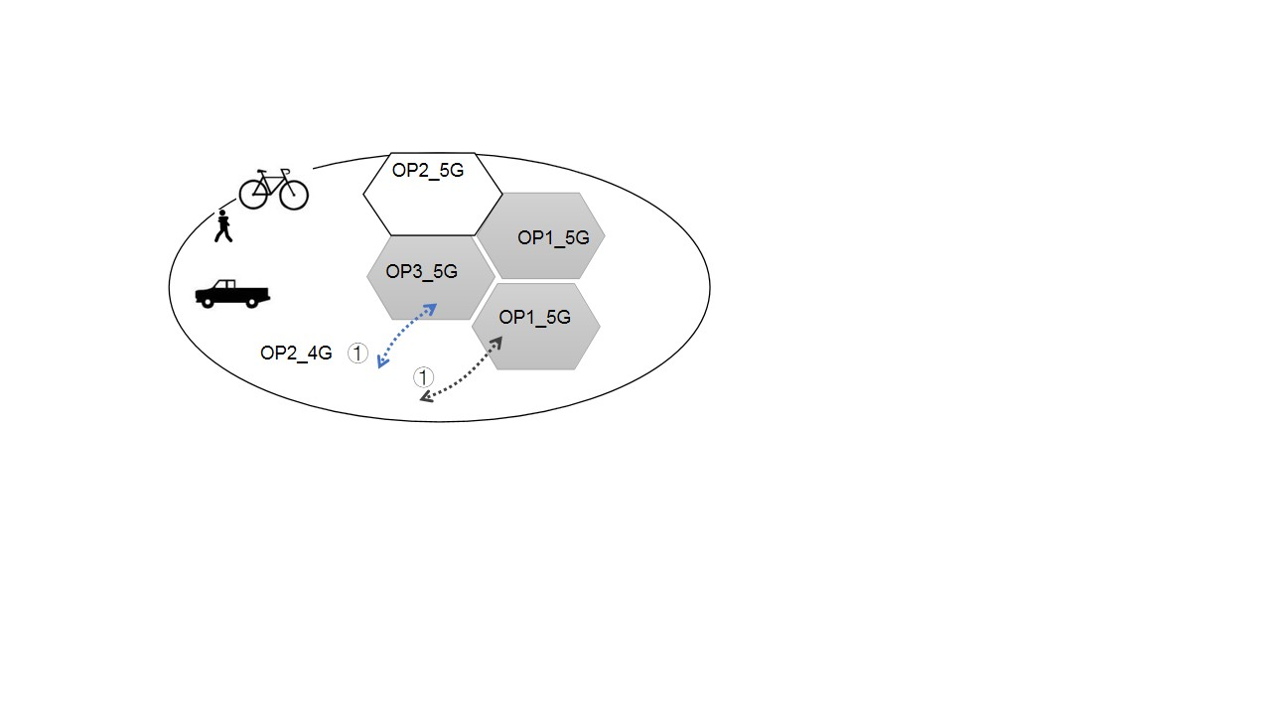

Figure 5.3.3-1a: Scenario 1: a UE with a subscription from OP2 moves between OP2’s own 4G access networks and either OP1’s or OP3’s shared 5G networks.

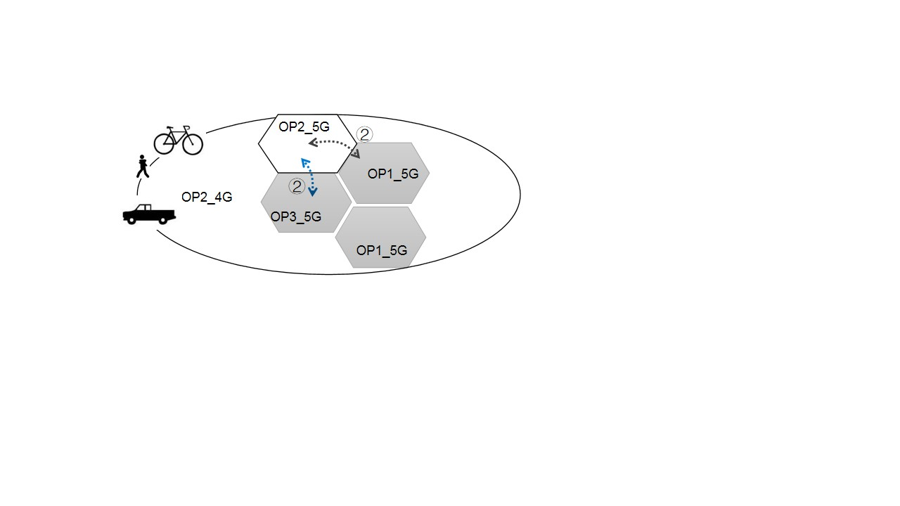

Figure 5.3.3-1b: Scenario 2: a UE with a subscription from OP2 moves between OP2’s own 5G access networks and either OP1’s or OP3’s shared 5G networks.

NOTE 1: OP1\_5G/OP3\_5G are OP1/OP3’s shared 5G network via indirect connection between the shared radio access network and the OP2’s core network in the Figure 5.3.3-1a and Figure 5.3.3-1b.

NOTE 2: OP2\_5G/OP2\_4G is OP2’s network, may be MOCN networks or non-shared network.

1. UE connects to the participating OP2\_4G network then accesses to the hosting OP1\_5G or OP3\_5G network when the UE crosses the border between the shared network managed by hosting operators and the OP2’s own 4G access networks in the scenario 1 (As shown as ① in Figure 5.3.3-1a).

2. UE connects to the participating OP2\_5G network then accesses to the hosting OP1\_5G or OP3\_5G network when the UE crosses the border between the shared network managed by hosting operator and the OP2’s own 5G access networks in the scenario 2 (As shown as ② in Figure 5.3.3-1b).

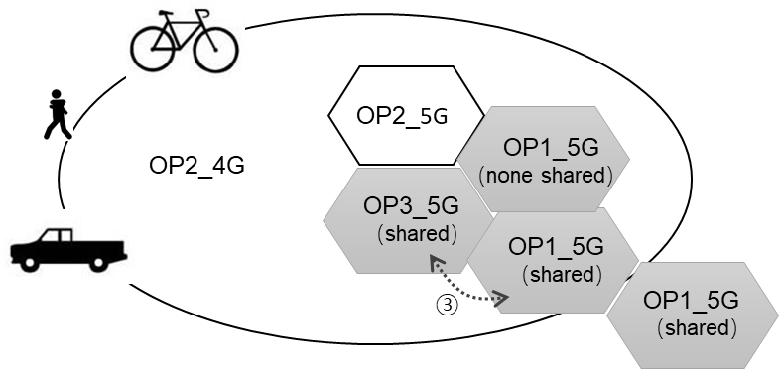

Figure 5.3.3-2: Scenario 3: a UE with a subscription from OP2 moves between coverage of OP1’s and OP3’s shared 5G access networks

3. UE connects to the hosting OP1\_5G network then accesses to the hosting OP3\_5G network when the UE crosses the border between the two shared networks managed by different hosting operators in the scenario 3 (As shown as ③ in Figure 5.3.3-2).

4. The UE accesses the shared network via indirect sharing network method in the specific geographical area as OP1\_5G (shared) and/or OP3\_5G (shared) shown in Figure 5.3.3-2, based on the agreements between the hosting and the participating operators.

5. The UE connects to an appropriate access network, when the user moves to an area where more than one operator's access networks provide connectivity, e.g., existing OP3’s 5G network and the OP2’s 4G network, or existing OP1’s 5G network and OP3’s 5G network, based on the agreement between the hosting and participating operators.

### 5.3.4 Post-conditions

All forms of mobility (i.e., between participating operators RAN and shared RAN for both CONNECTED mode and IDLE mode UE, see the clause 3.1 of TS 23.122 [5]) are successfully processed in a sharing scenario without direct connections between the shared access and the core networks of the participating operator.

### 5.3.5 Existing Features partly or fully covering Use Case Functionality

SA1 has performed various studies on mobility and network sharing in previous releases, where related normative stage 1 requirements are introduced in 3GPP TS 22.101 [2] and 22.261 [3].

3GPP TS 22.261 [3] introduces requirements of Diverse mobility management, stated as follows:

*The 5G system shall support inter- and/or intra- access technology mobility procedures within 5GS with minimum impact to the user experience (e.g. QoS, QoE).*

3GPP TS 22.261 [3] describes various access related requirements, stated as follows:

*Based on operator policy, the 5G system shall support steering a UE to select certain 3GPP access network(s).*

3GPP TS 22.101 [2] introduces requirements of mobility of network sharing, stated as follows:

*It shall be possible to support different mobility management rules, service capabilities and access rights as a function of the home PLMN of the subscribers.*

The above requirements are based on MOCN.

### 5.3.6 Potential New Requirements needed to support the Use Case

[PR 5.3.6-001] In case of indirect network sharing, the 3GPP system shall support mechanisms to minimize service interruptions for UEs that are moving between different Shared RANs or between a Shared RAN and a non-shared RAN (managed by Hosting and Participating Operators).

[PR 5.3.6-002] In case of Indirect Network Sharing and subject to Hosting and Participating Operators’ policies, the 3GPP system shall support access control for a UE accessing a Shared NG-RAN.

[PR 5.3.6-003] In case of Indirect Network Sharing and subject to Hosting and Participating Operators’ policies, the 3GPP system shall be able to select an appropriate radio access network (i.e., 4G, 5G) for a UE.

[PR 5.3.6-004] In case of Indirect Network Sharing and subject to Hosting and Participating Operators’ policies, the 3GPP system shall support a mechanism to enable a UE with a subscription to a Participating Operator to access an authorized Shared NG-RAN.

## 5.4 Use Case on International Roaming Users in a Shared Network

### 5.4.1 Description

There are network sharing scenarios in the process of 5G deployment due to different operators’ business consideration, such as network planning, operation and other factors, which introduce demand for 5G network sharing with indirect connection between the shared access network and a participating operator’s core network, especially in countries with a wide range of rural areas, where seamless 5G radio coverage is hard to achieve. Benefit from 5G network sharing technology, an operator can not only save investment for 5G deployment, but also expand 5G coverage in vaster area as well. However, in this case, it is also required to allow inbound international roaming subscribers to use the shared resources of a hosting operator. Therefore, it is suggested investigating how to realize the scenario in this situation.

### 5.4.2 Pre-conditions

In the 5G scenario, an operator may deploy its network as an applicable shared network to other operators.

As illustrated in Figure 5.4.2-1, three operators (OP1, OP2, OP3) are involved:

- OP1, as a Hosting NG-RAN Operator, owns an applicable Shared NG-RAN which can be shared to other operators (e.g., OP2).

- OP2, as a Participating NG-RAN Operator, has 5G network sharing agreement with OP1. In addition, OP2 may have its own non-shared 5G network.

- Shared NG-RAN of OP1 does not have direct connections between the shared access and the core networks of the participating operators OP2.

- OP3 is a roaming partner of OP2, but has no roaming agreement with OP1.

- UE subscribes to OP3’s network as a foreign operator’s network.



Figure 5.4.2-1: Scenario of International Roaming Users in a Shared Network

### 5.4.3 Service Flows

When a UE of OP3 travels to the coverage of OP2’s NG-RAN, it can enjoy services provided by their home environment in another country via OP2’s network.

When a UE of OP3 travels to the coverage of OP1’s shared NG-RAN, it can enjoy services provided by their home environment in another country via OP1’s shared access network and OP2’s network.

### 5.4.4 Post-conditions

It is the same for the service experience and treatment of OP2’s UE and OP3’s UE in the coverage of OP1’s Shared NG-RAN, based on the agreement between operators.

### 5.4.5 Existing Features partly or fully covering Use Case Functionality

3GPP TS 22.011 [6] introduces requirements on roaming in shared networks, as described below:

*The following requirements are applicable to GERAN, UTRAN, E-UTRAN and NG-RAN sharing scenarios:*

*- When network sharing exists between different operators and a user roams into the shared network it shall be possible for that user to register with a core network operator (among the network sharing partners) that the user’s home operator has a roaming agreement with, even if the operator is not operating a radio access network in that area.*

Other roaming related requirements are described in TS 22.101 [2]:

*3GPP specifications should be in compliance with the following objectives:*

*e) to provide support of roaming users by enabling users to access services provided by their home environment in the same way even when roaming.*

### 5.4.6 Potential New Requirements needed to support the Use Case

[PR 5.4.6-001] The 5G system shall enable Shared NG-RAN of a Hosting Operator with the indirect connection between Shared NG-RAN and a Participating NG-RAN Operator’s core network to provide services for inbound roaming users.

NOTE: Inbound roaming users mentioned above refer to the subscribers of a foreign operator having a roaming agreement with one participating operator.

## 5.5 Use Case on Hosted Services

### 5.5.1 Description

Subscribers have the opportunity to visit the Hosted Services via its own operator's network, specified in TS 22.261[3]. These Hosted Services contain applications provided by operators and/or trusted 3rd parties. Usually, operators use some technologies to optimize the path of the user plane to reduce latency and bandwidth pressure, if the Hosted Services run on the operator's Service Hosting Environment.

GSMA provides a scenario when Hosted Services of party operator is located at a shared edge node of hosting operator, the Hosted Services are also applicable for the users accessing through the PLMN of party operator. The sharing edge node means that hosting operator deploys applications on cloud resources in its edge node as requested by a party operator and provides an application endpoint to the party operator, referred to S2-2208120.

However, when users access through a shared network, it is still expected the Hosted Services to be available. This use case provides the possibility for subscribers visiting Hosted Services via shared networks.

### 5.5.2 Pre-conditions

Assumptions,

1. OP1 is a Hosting NG-RAN Operator.

2. The core network of OP2, as the participating operator, does not have direct connection with OP1’s shared NG-RAN.

3. There is connection between the OP1’s CN and OP2’s CN.

4. OP2 provides Hosted Services for subscribers in the local area 1 and 2. OP2 wishes to provide Hosted Services for subscribers accessing through OP1’s and OP2’s network in the local area 1.

### 5.5.3 Service Flows

local area 2

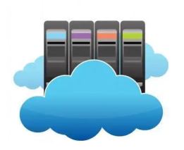

local area 1

OP1 network

with **Shared** NG-RAN

Service Hosting Environment could be managed by OP2

OP2 network

connection between the OP1’s CN and OP2’s CN



UE of

OP2

Figure 5.5.3-1: Scenario of visiting Hosted Services via shared network

1. UE is the subscriber of OP2, and enjoy the Hosted Services of OP2 in the local area 2.

2. UE is ready to move to the shared network of OP1. During this process, the Service Hosting Environment hosting the service may or may not change.

3. Available Service Hosting Environment can still be found in local area 1 to provide services for UE. The Hosted Services are applicable when the UE crosses the local area 1 and 2 and/or stay within area 1.

### 5.5.4 Post-conditions

The visiting hosted service via shared network succeeds, when UE moves between shared access network and participating operator’s network.

### 5.5.5 Existing Features partly or fully covering Use Case Functionality

Session 6.5 of TS 22.261 mainly introduces the relevant terms and related requirements of Hosted Services. Some typical requirements for service in network sharing are:

*5G is designed to meet diverse services with different and enhanced performances (e.g. high throughput, low latency and massive connections) and data traffic model (e.g. IP data traffic, non-IP data traffic, short data bursts and high throughput data transmissions).*

*User plane should be more efficient for 5G to support differentiated requirements. On one hand, a Service Hosting Environment located inside of operator's network can offer Hosted Services closer to the end user to meet localization requirement like low latency, low bandwidth pressure. These Hosted Services contain applications provided by operators and/or trusted 3rd parties. On the other hand, user plane paths can be selected or changed to improve the user experience or reduce the bandwidth pressure, when a UE or application changes location during an active communication.*

In addition, Chapter 4.23.9 of 23.502[7] provides some further work related with efficient user plane, which mainly describe additional PDU Session Anchor and Branching Point or UL CL controlled by I-SMF.

### 5.5.6 Potential New Requirements needed to support the Use Case

[PR 5.5.6-001] In case of Indirect Network Sharing, the 5G system shall support a mechanism to enable a UE subscribed to the participating operator to access the participating operator’s Hosted Services.

## 5.6 Use Case on Emergency Call

### 5.6.1 Description

The network is allowed to route the emergency call to the emergency response centre in the area where the operator provides services, as specified in TS 22.101[2], in accordance with national regulations and where the subscriber is located.

In order to route emergency calls to the correct emergency response centre, operators may need to use the UE location information. Operators may use different location information based on the requirement of the national regulation. Sometimes operators have to change the network configuration to provide correct routing or services related to location information in an area.

This use case provides the possibility that the subscriber of the participating operator may initiate an emergency call in the shared network, which leads to the problem to the service provider of routing the emergency call according to the location information of the hosting operator.

### 5.6.2 Pre-conditions

Assumptions:

1. OP-1 is a Hosting NG-RAN Operator. There is a connection between the OP-1’s CN and OP-2’s CN, while OP-2 as a participating operator indirectly sharing the network.

2. OP-2, as the participating operator, is an emergency call service provider. The network of OP-2 is connected to the emergency response centre located in Area 1.

3. OP-3 is the Hosting RAN operator of NG-RAN and E-UTRAN. And OP-3 and OP-2 have a sharing agreement with MOCN.

### 5.6.3 Service Flows



OP-1 IMS

network

OP-1 network

with E-UTRAN

and **Shared** NG-RAN

OP-2 IMS

network

OP-2 network

with E-UTRAN

and NG-RAN

connection between the OP-1’s CN and OP-2’s CN



UE of

OP-2

OP-3 shared E-UTRAN

and shared NG-RAN

connection between the OP-3’s RAN and OP-2’s CN

Area 1

Area 2

Area 3

Figure 5.6.3-1: Emergency call routing in network sharing scenarios IMG_256

1. UE is registered to OP-2. UE accesses the shared network of OP-1, and registered with the OP-2’s IMS. The nearest emergency response centre to UE's current geographic location is in Area 1, shown as Fig. 5.6.3-1.

2. UE initiates an emergency call in the shared network, it is most reasonable for the core network of OP-2 to route the emergency call to PSAP within area 1.

3. OP-2’s network routes the emergency call to PSAP in Area 1 according to the location information transmitted by the shared network.

### 5.6.4 Post-conditions

The emergency call can be correctly routed to the appropriate PSAP to serve the UE according to its location information.

### 5.6.5 Existing Features partly or fully covering Use Case Functionality

Chapter 10 of TS 22.101[2] defines the emergency call service. According to National regulations, the requirement of UE’s location of emergency call service is different in deployment scenarios, examples are:

*National regulations may require wireless networks to provide the emergency caller's location. This requirement typically overrides the caller's right to privacy with respect to their location being revealed, but remains in effect only as long as the authorities need to determine the caller's location. The interpretation of the duration of this privacy override may also be different, subject to national regulation. For example, some countries require location to be available from the wireless network only while the call is up, while others may allow PSAP's to unilaterally decide how long the location must be made available.*

*Therefore, the requirement for providing location availability is to allow the network to support providing a mobile caller's location to the authorities for as long as required by the national regulation in force for that network.*

*Note: See TS 22.071 [8] for location service requirements on emergency calls.*

### 5.6.6 Potential New Requirements needed to support the Use Case

[PR 5.6.6-001] Subject to national or regional regulatory and operator policies, the 5G system shall support emergency call from a UE accessing a Shared NG-RAN via Indirect Network Sharing.

[PR 5.6.6-002] Subject to national or regional regulatory and operator policies, the 5G system shall provide to the Participating Operator the location information of an emergency caller accessing a Shared NG-RAN via Indirect Network Sharing.

## 5.7 Use Case on Long-distance Mobility in and across Shared Networks

### 5.7.1 Description

Despite the aircraft and rail have been developed to serve more and more regions, road transport remains the most important way to deliver goods. As the logistics industry is booming, the total length of long-distance road transport has increased every year in the last ten years. How to provide communication service during long-distance transport is valuable to be discussed serving the transportation and logistics customers. Network sharing offers a way for the network operator to share the heavy deployment of mobile networks, as well as improve the service availability and user experience along the transport routes.

Compared with MOCN configuration, network sharing with the indirect connection between Shared NG-RAN and the core network of participating operators allows flexible access options for the sharing parties to consider. For example, one network operator needs to provide communication service along a dedicated transport route across dense urban, rural, and desert, but can’t find one hosting operator with full coverage of the whole route. It’s possible to cooperate with a terrestrial network operator and a 3GPP satellite network operator separately to ensure the full coverage. Also, with the agreement, it’s possible to leverage the temporary coverage enhancement plan of hosting operators for certain regions, such as deploying onboard base stations in dense urban, to provide better user experience to their own users.



Figure 5.7.1-1 Desert Highway across shared networks [9]

### 5.7.2 Pre-conditions

It is assumed that network operators OP1, OP2, and OP3 have deployed 5G networks respectively in a country. Their radio access network can provide coverage to different regions of the country, and together cover the entire country with overlapping in certain regions.

OP1 and OP3 are agreed with OP2 to share radio access network in the planned geographic area via the indirect connection between their shared radio access network and OP2’s core network.

- OP1 is a Hosting NG-RAN Operator, who has deployed different types of 5G access nodes (e.g., Macro, Micro, onboarding, and IAB). It only shares Macro base stations (e.g., 5G BS#A, BS#B, BS#C) with participating operator OP2 but allows to access to dedicated type of access nodes (e.g., onboarding) temporarily regarding the agreement and the policy.

- OP3 is another Hosting RAN Operator, sharing 3GPP Satellite access nodes with OP2.

- OP2 has non-shared 5G access network deployed in some regions of the country, as 4G&5G BS.

- UE on the vehicle supports all 5G RATs and has the subscription with OP2’s network.

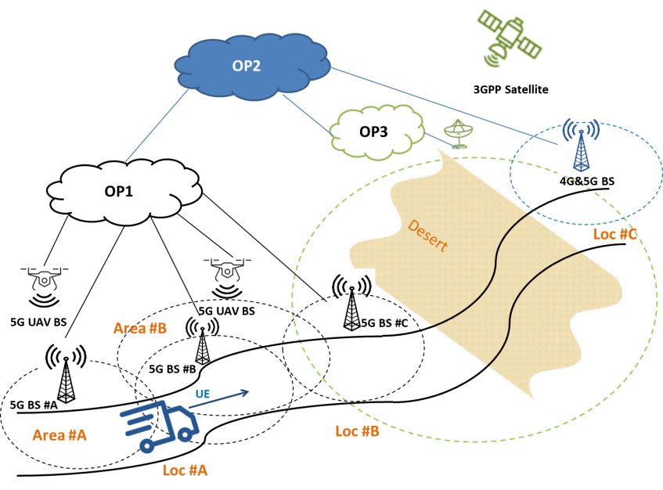

Figure 5.7.2-1: Long-distance mobility in and across shared networks

### 5.7.3 Service Flows

1. UE on the vehicle connects to OP2’s network via OP1 shared access nodes and is authorized to initiate a communication service (e.g., data transfer, IMS voice call) during the movement.

2. In geographic Area #A, UE connects to OP2’s network only through the access nodes like 5G BS #A based on the agreement and the policies of OP1 and OP2.

3. A regional earthquake happens and results in unstable performance of 5G BS #B in Area #B. OP1’s UAV base stations are shared to OP2 as a supplementary or an alternative access node based on OP1 and OP2 agreement.

4. When UE reaches Location Loc #A, where it can detect the radio signal of both 5G BS #B and UAV base station, UE will access a proper OP1 access node (e.g., 5G UAV BS ) to continue the service regarding the subscription, and the policy and agreement of OP1 and OP2.

5. When UE reaches Location Loc #B, where it can detect the radio signal of OP1 5G BS#C and OP3 Satellite access node, UE will access a proper Hosting RAN operator’s access node (e.g., OP3 Satellite) to continue the service regarding the subscription and the policy and agreement of OP1, OP3 and OP2.

6. When UE reaches Location Loc #C, where it can detect the radio signal of OP3 Satellite access node and OP2 4G&5G BS, UE will select OP2 5G BS to continue the service regarding the policies of OP3 and OP2.

### 5.7.4 Post-conditions

UE can get services with the displayed serving network as OP2’s network when move in OP1’s Shared NG-RAN, across OP1’s and OP3’s shared RANs, and across OP3’s shared RAN and OP2’s non-shared RAN.

OP2 ensures service continuity with proper mobility and access control to the shared access nodes of the same or different Host RAN Operators.

### 5.7.5 Existing Features partly or fully covering Use Case Functionality

The normative stage1 requirements of network sharing has been introduced to TS22.101 [2] and TS 22.261 [3] in previous releases. TS 22.101[2] specifies the service principle about Network Sharing that

*It shall be possible to support different mobility management rules, service capabilities and access rights as a function of the home PLMN of the subscribers. [clause 4.9]*

*The 3GPP System shall support a Shared RAN (E-UTRAN or NG-RAN) to cover a specific coverage area (e.g. from a complete network to a single cell, both outdoor and indoor). [clause 28.2.1]*

The network sharing has been extended to different types of access networks, as stated TS 22.261 [3].

*A 5G satellite access network shall support NG-RAN sharing.*

TS 22.261[3] has also illustrated general requirements about access, the mobility management and service continuity between different access networks as below.

*Based on operator policy, the 5G system shall support steering a UE to select certain 3GPP access network(s). [clause 6.3.2]*

*The 5G system shall support inter- and/or intra- access technology mobility procedures within 5GS with minimum impact to the user experience (e.g., QoS, QoE). [clause 6.2.2]*

*The 5G system shall support service continuity between 5G terrestrial access network and 5G satellite access networks owned by the same operator or owned by different operators having an agreement. [clause 6.2.3]*

In MOCN configuration, that multiple shared access networks have direct connections to the Participating Operator’s core network, the access control and mobility management are performed by Participating Operator’s core network directly.

However, in Indirect Network Sharing, besides Participating Operator’s core network, Host RAN Operator’s core network may be involved in the access control and mobility management. Also, UE may connect to Participating Operator’s core network via the shared access nodes of different Host RAN Operators.

TS 22.261[3] has defined requirements about multi-network connectivity and service delivery across operators as below.

*To provide a better user experience for their subscribers with UEs capable of simultaneous network access, network operators could contemplate a variety of sharing business models and partnership with other network and service providers to enable its subscribers to access all services via multiple networks simultaneously, and with minimum interruption when moving.*

*For a user with a single operator subscription, the use of multiple serving networks operated by different operators shall be under the control of the home operator.*

### 5.7.6 Potential New Requirements needed to support the use case

[PR 5.7.6-001] Subject to the agreement between Hosting Operators and Participating Operator, the 5G system shall support a mechanism to authorize a UE with the subscription to the Participating Operator to obtain services in a Shared NG-RAN of Hosting Operators using Indirect Network Sharing.

[PR 5.7.6-002] In case of Indirect Network Sharing, based on the Hosting and Participating Operators’ policies, the 5G system shall enable the Participating Operator to provide steering information to the Hosting Operator.

NOTE 1: Such steering information for a given UE of the Participating Operator could be applied by the Hosting Operator to select amongst the Hosting Operator’s available shared access network(s).

[PR 5.7.6-003] In case of Indirect Network Sharing, the 5G system shall be able to apply different access control for different access networks of Shared NG-RANs based on the Hosting and Participating Operator’s agreement and policies.

## 5.8 Use Case on Support of PWS in Shared NG-RAN in Indirect Interconnection with the Participating Operators

### 5.8.1 Description

Operators 1 and 2, both licensed to operate a 4G network and a 5G network share the 5G part of the radio access network in some areas of the country.

The Public Safety Agency sends the PWS message in a certain area covered by NG-RAN1 and RAN2 of Operator 1 and Operator 2 respectively and by the shared NG-RAN area of Operator 1 and Operator 2.

### 5.8.2 Pre-conditions

* Operator 1 owns NG-RAN 1 which is not shared.
* Operator 2 owns RAN 2 which is not shared.
* NG-RAN is a shared NG-RAN between Operator 1 and Operator 2.
* Operator 1 is the hosting operator.
* Operator 2 is a participating operator. Operator 1 and Operator 2 share NG-RAN in an indirect sharing method.
* Operator 1 has a regulatory obligation to broadcast PWS message to all UEs operating on NG-RAN 1 and NG-RAN.
* Operator 2 has a regulatory obligation to broadcast PWS message to all UEs operating on NG-RAN and RAN 2.
* UEs operating in NG-RAN 1 or RAN 2 may handover to NG-RAN during the period the PWS message is periodically rebroadcasting.
* UEs subscribed to Operator 1 operating in NG-RAN may handover to NG-RAN 1 during the period the PWS message is periodically rebroadcasting (and vice versa).
* UEs subscribed to Operator 2 operating in NG-RAN may handover to RAN 2 during the period the PWS message is periodically rebroadcasting (and vice versa).

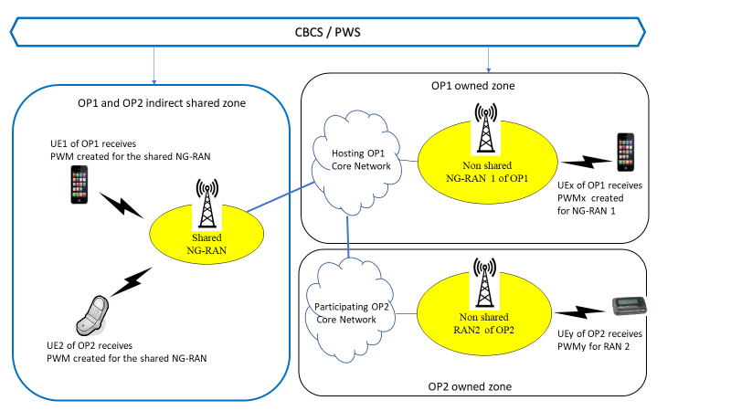

Figure 5.8.2-1 PWS Scenario in Indirect Network Sharing

### 5.8.3 Service flows

1) The Public Safety Agency (PSA) sends the PWS message in a certain Shared NG-RAN radio coverage area designated by the PSA where Operator 1 and Operator 2 share the RAN access.

2) Operator 1 and Operator 2 both broadcast the PWS message in the area covered by their respective not shared RAN they have regulatory obligations (NG-RAN 1 and RAN 2).

3) The UEs served by NG-RAN 1 and RAN 2 receive the warning message from their corresponding operating radio access.

4) The UEs served by Shared NG-RAN of the hosting Operator 1 receive the public warning message created for the specific region which is covered by NG-RAN.

### 5.8.4 Post-conditions

For UEs subscribed to unshared accesses NG-RAN 1 and RAN 2, the public warning message can only be received by UEs subscribed to these operators owning the access.

UEs served by Shared NG-RAN receive the public warning message issued by the PSA in the radio coverage area of the Shared NG-RAN designated for the warning message.

The UEs only display one copy of the PWS message according to and regardless of the RAN it is operating in or may handover to.

The UEs present new content of public warning messages after entering and leaving the shared network.

### 5.8.5 Existing requirements to PWS Support in Shared Networks

See TS 22.101 [2].

**28.2.5 PWS support of Shared E-UTRAN/NG-RAN**

A Participating Operator potentially has regulatory obligations to initiate the broadcast of PWS messages regardless of E-UTRAN/NG-RAN sharing.

The following requirements apply:

The shared E-UTRAN/NG-RAN shall be able to broadcast PWS messages originated from the core networks of all Participating Operators.

NOTE 1: Rel-11 design requires a shared PWS core. However, some regulatory obligations require a solution in which no common PWS core network entity is involved.

**28.3.5 PWS support of Shared GERAN or UTRAN**

A Participating Operator potentially has regulatory obligations to initiate the broadcast of PWS messages regardless of GERAN or UTRAN sharing.

The following requirements apply:

The shared GERAN or UTRAN shall be able to broadcast PWS.

NOTE 2: The Hosting RAN Operator is responsible for the delivery of PWS messages to the UEs.

Identifying, changing, and adding appropriate functionality in the network will definitely lead to a better shared-network operation.

### 5.8.6 Potential New Requirements needed to support the Use Case

[PR 5.8.6-001] Subject to regulatory requirements and mutual agreement between the Participating Operators and the Hosting Operator, the 5G system shall be able to support PWS when connectivity is provided via Indirect Network Sharing.

[PR 5.8.6-002] Subject to regulatory requirements and mutual agreement between the Participating Operators and the Hosting Operator, Shared NG-RAN in Indirect Network Sharing shall be able to broadcast PWS messages originated from the core network of the Hosting Operator.

# 6 Other considerations

## 6.1 Considerations on security

Different from MOCN configuration, which routes UE to the core network of a participating operator directly through Shared RAN of hosting operator, Indirect Network Sharing needs to involve the core network of the Hosting NG-RAN Operator in the signaling exchange. The interoperability between the core networks of Hosting NG-RAN Operators and participating operator will expose more information about the subscribers, the operator’s policies and operations of respective core networks, especially those irrelevant to Indirect Network Sharing. Therefore, more security relative to user privacy and the operator’s policy can be taken into account for the Indirect Network Sharing configuration.

No potential security requirements are identified.

# 7 Consolidated requirements

## 7.1 General

Potential requirements on Indirect Network Sharing have been identified in Section 5 out of the use cases under the following aspects:

- General

- Mobility

- Network access control

- Regulatory services

- Charging

These requirements have been especially introduced to support the newly defined network sharing scenario, where a NG-RAN is shared among multiple operators without necessarily assuming a direct connection between the shared NG-RAN and the Participating NG-RAN Operator’s core network.

NOTE: These enhanced requirements may go beyond existing RAN sharing requirements in Rel-13.

## 7.2 Consolidated Potential Requirements

### 7.2.1 Introduction

Indirect Network Sharing is another type of NG-RAN sharing, to facilitate the operators to extend the availability of 5G services to more coverage areas for their subscribers. It can allow NG-RAN resources to be used by two or more operators simultaneously while minimizing the impact on the network and associated services.

The deployment of Indirect Network Sharing is expected to be transparent to the users when they obtain network services in subscribed PLMN as other NG-RAN sharing configuration (e.g., MOCN). The involvement of the core network of the Hosting Operator e.g., for signaling exchange between the users and the core network of Participating Operator could cause exposure of the subscriber’s information to the hosting network.

Thus, extra scrutiny is expected to avoid sharing information not needed for the Indirect Network Sharing operation between the hosting operator and the participating operator.

### 7.2.2 General aspects

Table 7.2.2-1 General requirements

| CPR # | Consolidated Potential Requirement | Original PR # | Comment |
| --- | --- | --- | --- |
| CPR 7.2.2-001 | The 5G system shall be able to support Indirect Network Sharing between the Shared NG-RAN and one or more Participating NG-RAN Operators’ core networks, by means of the connection being routed through the Hosting NG-RAN Operator’s core network. | [PR 5.1.6-001] | Align with the definitions. |
| CPR 7.2.2-002 | In case of Indirect Network Sharing, the 5G system shall be able to support means for a Participating NG-RAN Operator to provide its information on operator/network name to UEs, e.g., for display to the user. | [PR 5.1.6-002] | Align with the definitions.  Updated wording |
| CPR 7.2.2-003 | In case of Indirect Network Sharing, UEs shall be able to access their subscribed PLMN services when accessing a Shared NG-RAN, where the subscribed PLMN is one of the Participating NG-RAN Operators. | [PR 5.2.6-004] | Align with the definitions.  Updated wording |
| CPR 7.2.2-004 | Subject to the agreement between hosting operators and the participating operator, the 5G system shall support a mechanism to enable a UE to obtain its subscribed services, including Hosted Services, of participating operator via a Shared NG-RAN using Indirect Network Sharing.  NOTE: the requirement assumes no impact to UE. | [PR 5.5.6-001]  [PR 5.7.6-001] | Align with the definitions.  PRs merged. |

### 7.2.3 Mobility

Table 7.2.3-1 Consolidated Requirements to Mobility

| CPR | Consolidated Potential Requirement | Original PR | Comment |
| --- | --- | --- | --- |
| CPR 7.2.3-001 | In case of Indirect Network Sharing scenario and subject to hosting and participating operators’ policies, the 5G system shall support service continuity and minimize the impact on the user experience and service interruptions between different Shared NG-RANs and/or between a Shared NG-RAN and a non-Shared NG-RAN networks. | [PR 5.2.6-002]  [PR 5.3.6-001]  [PR 5.2.6-003] | PRs merged |
| CPR 7.2.3-002 | In case of indirect network sharing, the 5G system shall enable the Shared NG-RAN of a hosting operator to provide services for inbound roaming users.  NOTE: Inbound roaming users may not have a roaming agreement with the hosting operator but only with a participating operator. | [PR 5.4.6-001] | PR modified |

### 7.2.4 Network Access Control

Table 7.2.4-1 Consolidated Requirements on Network Access Control

| CPR # | Consolidated Potential Requirement | Original PR # | Comment |
| --- | --- | --- | --- |
| CPR 7.2.4-001 | In case of Indirect Network Sharing and subject to Hosting and Participating Operators’ policies, the 5G system shall support a mechanism to enable a UE with a subscription to a Participating Operator to select an appropriate radio access network (i.e., E-UTRAN, NG-RAN) and/or access an authorized Shared NG-RAN. | [PR 5.3.6-004]  [PR 5.3.6-003] |  |
| CPR 7.2.4-002 | In case of Indirect Network Sharing and subject to Hosting and Participating Operators’ policies, the 5G system shall support access control for a UE accessing a Shared NG-RAN and be able to apply differentiated access control for different access networks of Shared NG-RANs when more than one Shared NG-RAN are available for the Participating Operator to choose from. | [PR 5.3.6-002]  [PR 5.7.6-003] |  |
| CPR 7.2.4-003 | In case of Indirect Network Sharing, based on the Hosting and Participating Operators’ policies, the 5G system shall enable the Participating Operator to provide steering information to the Hosting Operator in order to assist a UE with network selection amongst the Hosting Operator’s available Shared RAN(s). | [PR 5.7.6-002] |  |

NOTE: the above requirements assume no UE impacts.

### 7.2.5 Regulatory Services

Table 7.2.5-1 Consolidated Requirements to the Regulatory Services

| CPR | Consolidated Potential Requirement | Original PR # | Comment |
| --- | --- | --- | --- |
| CPR 7.2.5-001 | In case of Indirect Network Sharing and subject to regulatory requirements and mutual agreement between the participating operators and the hosting operator, the 5G system shall support regulatory services (e.g., PWS, emergency calls). | [PR 5.6.6-001]  [PR 5.8.6-001] | PRs merged |
| CPR 7.2.5-002 | In Indirect Network Sharing, the 5G system shall be able to provide a UE accessing a Shared NG-RAN network with positioning service in compliance with regulatory requirements. | [PR 5.6.6-002] | PR modified |
| CPR 7.2.5-003 | Subject to regulatory requirements and mutual agreement between the participating operators and the hosting operator the Shared NG-RAN operator shall be able to broadcast PWS messages originated from the core network of the hosting operator. | [PR 5.8.6-002] | PR modified |

### 7.2.6 Charging aspects

Table 7.2.6-1 Charging requirements

| CPR # | Consolidated Potential Requirement | Original PR # | Comment |
| --- | --- | --- | --- |
| CPR 7.2.6-001 | The 5G core network shall be able to support collection of charging information associated with a UE accessing a Shared NG-RAN using Indirect Network Sharing. | [PR 5.2.6-001] | Align with the definitions.  shared network  ->Shared NG-RAN |

# 8 Conclusion and recommendations

This document analyzes a number of use cases to enhance the support of network sharing. Some considerations and the resulting potential consolidated requirements have been captured in clauses 6 and 7.

It is recommended to proceed with normative work and include the consolidated requirements identified in order to better serve communication services.

Annex A (informative):  
Change history

|  |  |  |  |  |  |  |  |
| --- | --- | --- | --- | --- | --- | --- | --- |
| **Change history** | | | | | | | |
| **Date** | **Meeting** | **TDoc** | **CR** | **Rev** | **Cat** | **Subject/Comment** | **New version** |
| 05/2022 | SA1#98e | S1-221092 |  |  |  | Initial Skeleton | 0.0.0 |
| 05/2022 | SA1#98e |  |  |  |  | Incorporation of approved pCRs: S1-221271; S1-221292; S1-221272 | 0.1.0 |
| 09/2022 | SA1#99e |  |  |  |  | Incorporation of approved pCRs: S1-222392; S1-222393; S1-222394; S1-222395; S1-222396 | 0.2.0 |
| 11/2022 | SA1#100 |  |  |  |  | Incorporation of approved pCRs: S1-223623; S1-223624; S1-223682; S1-223626; S1-223683; S1-223599 | 0.3.0 |
| 12/2022 | SA#98e | SP-221266 |  |  |  | Raised to v.1.0.0 by MCC for presentation for information to SA#98e | 1.0.0 |
| 02/2023 | SA1#101 |  |  |  |  | Incorporation of approved pCRs: S1-230579; S1-230746; S1-230361; S1-230580; S1-230067; S1-230781; S1-230782; S1-230583 | 1.1.0 |
| 05/2023 | SA1#102 |  |  |  |  | Incorporation of approved pCRs: S1-231523; S1-231182; S1-231138; S1-231525; S1-231506; S1-231526; S1-231723; S1-231527; S1-231522 | 1.2.0 |
| 06/2023 | SA#100 | SP-230508 |  |  |  | MCC clean-up for approval by SA | 2.0.0 |
| 06/2023 | SA#100 | SP-230508 |  |  |  | Raised to v.19.0.0 by MCC following approval by SA | 19.0.0 |