3GPP TR 22.890 V19.0.0 (2022-09)

Technical Report

3rd Generation Partnership Project;

Technical Specification Group Services and System Aspects;

Study on Supporting of Railway Smart Station Services;

Stage 1

(Release 19)



The present document has been developed within the 3rd Generation Partnership Project (3GPP TM) and may be further elaborated for the purposes of 3GPP.  
The present document has not been subject to any approval process by the 3GPPOrganizational Partners and shall not be implemented.  
This Report is provided for future development work within 3GPPonly. The Organizational Partners accept no liability for any use of this Specification.  
Specifications and Reports for implementation of the 3GPP TM system should be obtained via the 3GPP Organizational Partners' Publications Offices.

Keywords

LTE, 5G, Railway,

***3GPP***

Postal address

3GPP support office address

650 Route des Lucioles - Sophia Antipolis

Valbonne - FRANCE

Tel.: +33 4 92 94 42 00 Fax: +33 4 93 65 47 16

Internet

http://www.3gpp.org

***Copyright Notification***

No part may be reproduced except as authorized by written permission.  
The copyright and the foregoing restriction extend to reproduction in all media.

© 2022, 3GPP Organizational Partners (ARIB, ATIS, CCSA, ETSI, TSDSI, TTA, TTC).

All rights reserved.

UMTS™ is a Trade Mark of ETSI registered for the benefit of its members

3GPP™ is a Trade Mark of ETSI registered for the benefit of its Members and of the 3GPP Organizational Partners  
LTE™ is a Trade Mark of ETSI registered for the benefit of its Members and of the 3GPP Organizational Partners

GSM® and the GSM logo are registered and owned by the GSM Association

Contents

Foreword 5

Introduction 5

1 Scope 6

2 References 6

3 Definitions and abbreviations 6

3.1 Definitions 6

3.2 Abbreviations 7

4 Overviews 7

5 Performance communication applications related use cases 7

5.1 Emergency use case of smart station – fire in station 7

5.1.1 Description 7

5.1.2 Pre-conditions 7

5.1.3 Service Flows 8

5.1.4 Post-conditions 8

5.1.5 Existing features partly or fully covering the use case functionality 8

5.1.6 Potential New Requirements needed to support the use case 8

5.2 Multiple trains' stops at the same platform 9

5.2.1 Description 9

5.2.2 Pre-conditions 9

5.2.3 Service Flows 10

5.2.4 Post-conditions 10

5.2.5 Existing features partly or fully covering the use case functionality 10

5.2.6 Potential New Requirements needed to support the use case 10

5.2.6.1 Requirements related to the Service layer 10

5.2.6.2 Requirements related to the Transport layer 10

6 Business communication applications related use cases 11

6.1 Transportation convenience service for the passengers for the reduced mobility 11

6.1.1 Description 11

6.1.2 Pre-conditions 12

6.1.3 Service Flows 12

6.1.4 Post-conditions 12

6.1.5 Existing features partly or fully covering the use case functionality 12

6.1.6 Potential New Requirements needed to support the use case 13

6.2 Smart kiosk of Railway Smart Station 13

6.2.1 Description 13

6.2.2 Pre-conditions 13

6.2.3 Service Flows 13

6.2.4 Post-conditions 14

6.2.5 Existing features partly or fully covering the use case functionality 14

6.2.6 Potential New Requirements needed to support the use case 14

6.3 Multiple concurrent mobility services 14

6.3.1 Description 14

6.3.2 Pre-conditions 14

6.3.3 Service Flows 15

6.3.4 Post-conditions 15

6.3.5 Existing features partly or fully covering the use case functionality 15

6.3.6 Potential New Requirements needed to support the use case 15

6.4 Operation of platform screen doors 15

6.4.1 Description 15

6.4.2 Pre-conditions 16

6.4.3 Service Flows 16

6.4.4 Post-conditions 17

6.4.5 Existing features partly or fully covering the use case functionality 17

6.4.6 Potential New Requirements needed to support the use case 17

6.5 Automatic monitoring of Railway Smart Station 17

6.5.1 Description 17

6.5.2 Pre-conditions 18

6.5.3 Service Flows 18

6.5.4 Post-conditions 18

6.5.5 Existing features partly or fully covering the use case functionality 18

6.5.6 Potential New Requirements needed to support the use case 19

7 Potential Consolidated Requirements 19

7.1 Introduction 19

7.2 Functional aspects 20

7.3 Performance 20

8 Conclusions and Recommendations 20

Annex A: Change history 21

# Foreword

This Technical Report has been produced by the 3rd Generation Partnership Project (3GPP).

The contents of the present document are subject to continuing work within the TSG and may change following formal TSG approval. Should the TSG modify the contents of the present document, it will be re-released by the TSG with an identifying change of release date and an increase in version number as follows:

Version x.y.z

where:

x the first digit:

1 presented to TSG for information;

2 presented to TSG for approval;

3 or greater indicates TSG approved document under change control.

y the second digit is incremented for all changes of substance, i.e. technical enhancements, corrections, updates, etc.

z the third digit is incremented when editorial only changes have been incorporated in the document.

# Introduction

The railway station is a major touchpoint to customers including passengers. The railway community is considering the railway smart station services for the railway station operations and customers. Many railway companies are planning to adapt the smart station services and some companies have launched their smart station projects to provide the services.

The railway smart station provides various station operation and value add service for passengers including the business communication. The Future Railway Mobile Communication System (FRMCS) Functional Working Group (FWG) of the International Union of Railways (UIC) and ITS/Vehicle/Railway ICT Project Group of Telecommunication Technology Association(TTA) have studied and considered use cases [2] and requirements [3][4][5] for the smart railway station.

This document is based on the inputs by the activities.

# 1 Scope

The present document analyses use cases of smart railway station such as station operation monitoring and control, passenger supporting services and evolution use cases of business and performance applications currently included in TR22.989 in order to derive potential requirements.

# 2 References

The following documents contain provisions, which through reference in this text, constitute provisions of the present document.

- References are either specific (identified by date of publication, edition number, version number, etc.) or non‑specific.

- For a specific reference, subsequent revisions do not apply.

- For a non-specific reference, the latest version applies. In the case of a reference to a 3GPP document (including a GSM document), a non-specific reference implicitly refers to the latest version of that document *in the same Release as the present document*.

[1] 3GPP TR 21.905: "Vocabulary for 3GPP Specifications".

[2] UIC MG-7900v2.0.0, Future Railway Mobile Communication System – Use cases, Feb. 2020.

[3] UIC FU-7100v5.0.0, Future Railway Mobile Communication System – User Requirements Specification, Feb. 2020.

[4] TTA TTAK.KO-06.0507/R1, Requirements for Smart Railway Device - Information Model, Dec. 2020.

[5] TTA TTAK.KO-06.0508/R1, Requirements for Smart Railway Platform - Information Model, Dec. 2020.

[6] 3GPP TR 22.990. “Study on off-network for rail”.

[7] 3GPP TS 22.280: " Mission Critical Services Common Requirements (MCCoRe)"

[8] 3GPP TS 22.282: “Mission Critical (MC) data”.

[9] 3GPP TS 22.289: “Mobile communication system for railways”.

# 3 Definitions and abbreviations

## 3.1 Definitions

For the purposes of the present document, the terms and definitions given in 3GPP TR 21.905 [1] and the following apply. A term defined in the present document takes precedence over the definition of the same term, if any, in 3GPP TR 21.905 [1].

**Mobile Intelligent Assistant:** 5G enabled robot with autonomous movements and artificial intelligence to support passengers in the Railway Smart Station.

**Railway Smart Station:** a train station where the 5G and other ICT technologies such as IoT and AI, are used for providing assisting railway services.

**Zone:** A 2-dimensional region of a pre-determined size.

**Zone resolution:** The pre-determined size of the given zone.

## 3.2 Abbreviations

For the purposes of the present document, the abbreviations given in 3GPP TR 21.905 [1] and the following apply. An abbreviation defined in the present document takes precedence over the definition of the same abbreviation, if any, in 3GPP TR 21.905 [1].

AI Artificial Intelligence

FRMCS Future Railway Mobile Communication System

ITS Intelligent Transport System

IoT Internet of Things

MCX Mission Critical X, with X = PTT or X= Video or X= Data

# 4 Overviews

The railway station is a major touchpoint to customers including passengers. The railway community is considering the Railway Smart Station services for the railway station operations and customers. Many railway companies are planning to adopt the Railway Smart Station services and some companies have already launched their own projects to provide such services over Mission Critical Services (MCPTT, MCVideo, MCData Services).

TR 22.889/989 provides basic requirements and focuses on the railway communication system having three categories critical, performance and business communications. While the critical and performance communications address the safe movement of trains, business communications provide value-added services for passengers. The Railway Smart Station services provide assistance of station operation and value-added services for passengers, e.g., subway station evacuation guidance via the passenger's UE.

The objectives of this technical report are as follows:

• Study use cases related to Railway Smart Station Services and deduce requirements from those. For example:

* Use cases of station operation monitoring and control
* Use cases of passenger supporting services
* Evolution use cases of business and performance applications currently included in TR22.889/989

• Analysis gaps between the requirements identified and the functionality already provided by 3GPP (e.g., 22.261, 22.228, or MCX specifications)

# 5 Performance communication applications related use cases

## 5.1 Emergency use case of smart station – fire in station

### 5.1.1 Description

The fire in station use case is to describe an emergency situation and managing the situation in context of railway smart station. Through this use case work, technical keywords are deduced and numbers of potential requirements are come from the keywords.

### 5.1.2 Pre-conditions

Fire detectors are 3GPP UEs. The passengers have their own 3GPP UEs as their smart phone.

There is a fire situation in somewhere of a railway smart station. A fire detector senses the situation and report to railway smart station system via 3GPP network.

Some passengers also recognize and register the situation to the station system via railway smart station app in their 3GPP UEs and some of them notify it to the fire fighting force and/or police.

### 5.1.3 Service Flows

1. The Railway Smart Station System indicates the fire situation from the fire detector. While the fire is getting bigger and bigger, the number of fire detectors providing sensing information is also increasing. The system indicates the location and directions of the fire spreading by analysing the information from the detectors.

2. The Railway Smart Station System starts a fire emergency protocol. It declares the situation to the near firehouses and police stations, and provides the station information via a specific interface that is not in scope of 3GPP, e.g. the station map. It finds available devices in the station and controls the devices to handle the situation. For example, the system controls fire sprinklers to start supress the fire efficiently. An evacuation warning and emergency exit information are announced to people in the station via the audio broadcasting devices. Emergency messages are sent to the people as well. The system controls emergency lamps and direction lights to give guidance information for evacuating the people.

3. The system notices the situation to the neighbour stations and the incoming trains. The trains make emergency stop at a safe place and evacuate their passengers. The system sends emergency protocol information to the railway workers in the station depends on their group roles in the protocol.

4. The system video-streams the fire site using a camera near the fire place. The people in the station could watch the streaming and get the information of the fire site, e.g. location and range of the site.

5. The system gets UEs information and sets up roles to UEs of the workers, firefighters and police officers, and downloads information on the UEs to support the role via interfacing the systems of the fire department and the police. The role is changed dynamically depends on the status of duty of the workers, firefighters and officers.

6. The system and the UEs of the people get cooperation to count the number of people in the station. The people is included in the rescue group autonomously.

### 5.1.4 Post-conditions

The devices in the station are monitored and controlled by the Railway Smart Station System.

The railway workers, firefighters, police officers are on their duty using their UEs.

The people in the station and the incoming train, escape the station and move to the safe place by using their UEs which are interfaced by the system.

### 5.1.5 Existing features partly or fully covering the use case functionality

The role and group management are fully covered by 3GPP system and MCX framework.

### 5.1.6 Potential New Requirements needed to support the use case

[PR-5.1.6-1] The 5G system shall support to access various networks which are used to monitor and control features for the devices in the station.

[PR-5.1.6-2] The 5G system shall support to connect massive number of devices in a specific area in the station, which is defined to monitor and/or control.

[PR-5.1.6-3] The 5G system should support to interface external system to control the UEs that belongs to the external system.

[PR-5.1.6-4] The 5G system should support counting number of UEs in a specific area in the station under the condition of category of UE and status of UE.

[Editor's note: The requirements are FFS.]

## 5.2 Multiple trains' stops at the same platform

### 5.2.1 Description

It is needed to reduce train intervals to increase the track capacity. If the train intervals are less than some threshold, multiple trains should stop at the same platform. This is because we can reduce the interval between trains, but for safety reasons, reducing the time for passengers to get on and off and increasing the speed of trains entering the station is limited. In general, it takes more than 1 minute for the train to enter and exit the platform, including the time for passengers to get on and off, so if the train interval becomes shorter than 1 minute, there could be two trains on the platform.

The scenario when two trains stop at the same platform is as follows:

- The passenger information system (PIS) of a smart station displays that Train 1 will stop in front of the platform, and Train 2 will stop at the back of the platform. Train 1 & 2 may have different routes.

- Step 1: A previous train is departing the platform, and Train 1 enters the platform while a part of the previous train is still at the platform. According to the previous train's location, Train 1 slows down its speed and goes in front of the platform.

- Step 2: After the previous train left the platform, Train 1 stops in front of the platform.

- Step 3: While Train 1 is stopping for passengers to get on and off, Train 2 enters the platform

- Step 4: Train 2 stops behind Train 1 and opens its doors. While the passengers of Train 2 are getting on and off, Train 1 start to depart the platform.

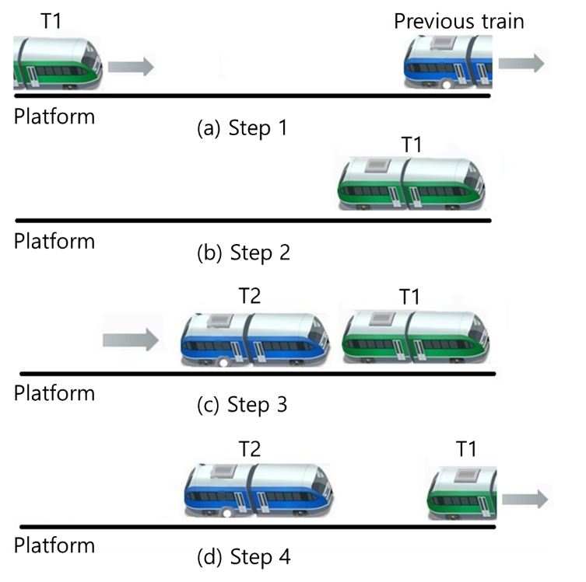

Figure 6.2.1-1 Two trains' stops at the same platform

### 5.2.2 Pre-conditions

- Each train has at least one onboard UE (i.e., FRMCS UE), supporting both on-network and off-network communications.

- There is an edge server per station and the edge server can determine which platform trains stop and transmit/receive data to onboard UEs of Trains 1&2 through the 3GPP network.

- Each edge server can transmit/receive information to the PIS.

- Onboard UEs know the identities of the edge server on the train route.

### 5.2.3 Service Flows

1. Train 1 is stopping at Platform A of the smart station, and Train 2 is approaching. Trains 1 & 2 are connected and authorized to transmit/receive information to the server at the smart station.

2. The server determines that Train 2 stops at Platform A. The server informs Train 2 of the platform where Train 2 will stop, the stop location within the platform, and the existence of Train 1 at the platform. Also, the server informs Train 1 that Train 2 will stop behind Train 1.

3. Train 2 establishes a connection with Train 1 through on-network and then notifies the server of the connection establishment with Train 1. Trains 1&2 can share information such as acceleration/deceleration, braking, location, etc., through the connection to stop at the same platform.

4. The server allows Train 2 to enter the platform.

5. For redundancy, Train 2 can add a connection with Train 1 through off-network before entering the platform.

6. Train 2 stops behind Train 1 at Platform A and opens its doors for passengers to get on and off. Train 1 starts to depart.

### 5.2.4 Post-conditions

- Train 1 establishes a connection with the server at the next station while Train 1 has a connection with the server at the current station.

- When the distance between Trains 1 and 2 becomes longer, Trains 1 and 2 stop sharing the information and disconnect from each other.

### 5.2.5 Existing features partly or fully covering the use case functionality

TR 22.990[6] covers utilizing off-network and on-network communications at the same time and the traffic characteristic of off-network communications.

### 5.2.6 Potential New Requirements needed to support the use case

#### 5.2.6.1 Requirements related to the Service layer

[PR 5.2.6-1] A single mobile FRMCS UE shall be able to connect to multiple edge servers simultaneously which are located along rail tracks.

Note: The above requirement is intended to be included in Section 5.5 of TS22.282[8].

[Editor's note: The potential requirements for FRMCS UEs to identify the edge servers are FFS]

[Editor's note: The potential requirements for edge servers to authorize the FRMCS UEs are FFS]

#### 5.2.6.2 Requirements related to the Transport layer

[PR 5.2.6-2] The FRMCS System shall support the following traffic characteristics of data transfer:

Note: This table is intended to be included in Section 6.2 of TS 22.289[9].

|  |  |  |  |  |  |  |  |  |  |
| --- | --- | --- | --- | --- | --- | --- | --- | --- | --- |
| **Scenario**  **(Note 5)** | **End-to-end latency** | **Reliability**  **(Note 1)** | **UE speed** | **UE Relative**  **Speed** | **User experienced data rate** | **Payload**  **size**  **(Note 2)** | **Area traffic density** | **Overall UE density** | **Service area dimension (Note 3)** |
| Multiple trains' stops at the same platform (Korea, urban railway) | ≤10 ms | 99.9999% | ≤100 km/h | ≤50km/h | ≤1Mb/s | Small to large | ≤ 1 Mb/s/km | ≤ 5 (100m) | ≤ 15 km  along rail tracks including bad weather conditions  (Note 4) |
|  | NOTE 1: Reliability as defined in TS 22.289 sub-clause 3.1.  NOTE 2: Small: payload ≤ 256 octets, Medium: payload ≤512 octets; Large: payload 513 -1500 octets.  NOTE 3: Estimates of maximum dimensions.  NOTE 4: Non-Line-of-Sight (NLOS) between UEs shall be supported  NOTE 5: Off-network traffic characteristics are not addressed in this table since it can be covered by TR22.990. | | | | | | | | |

Table 5.2.6.2-1: Traffic characteristics for multiple trains' stops at the same platform

# 6 Business communication applications related use cases

## 6.1 Transportation convenience service for the passengers for the reduced mobility

### 6.1.1 Description

In the Railway Smart Station, a transportation convenience service for the passengers with the reduced mobility can be feasible, such as a mobility service for the passengers to arrive at the desired destination.

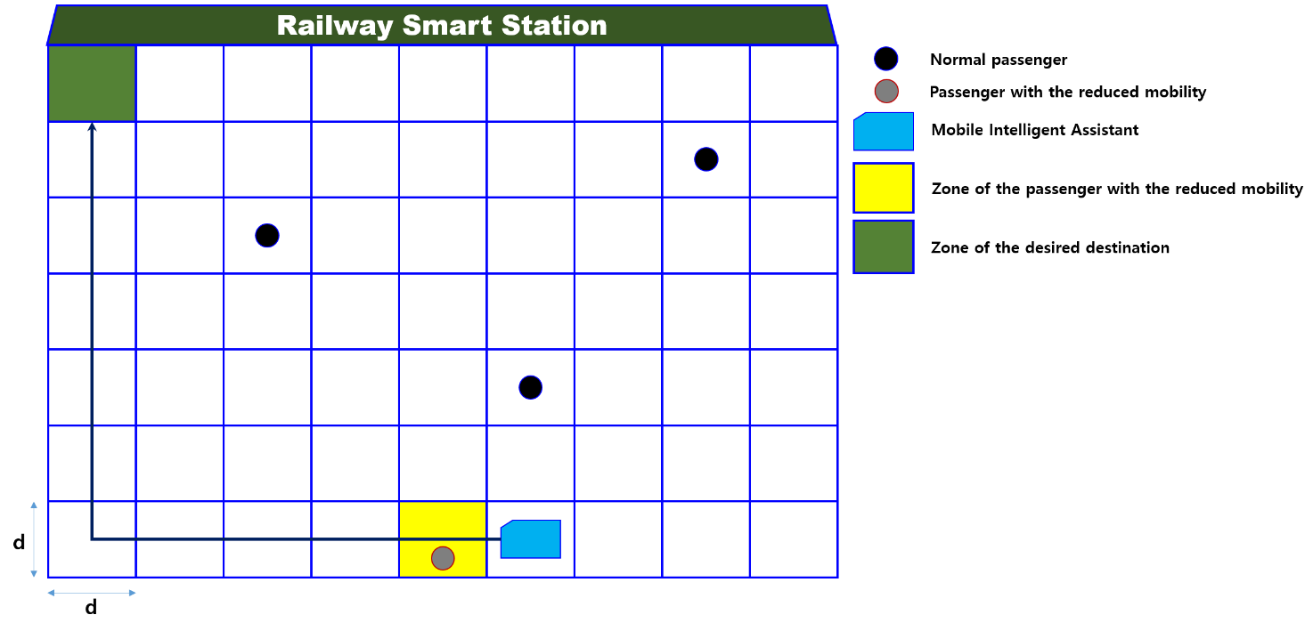

Figure 6.1.1-1. Example of transport convenience service for passenger with reduced mobility

### 6.1.2 Pre-conditions

1. There exist feasible Mobile Intelligent Assistants in the Railway Smart Station, where the Mobile Intelligent Assistants support 3GPP system.

2. The Mobile Intelligent Assistants are operated under the central control system via 3GPP access.

3. There is at least one passenger with reduced mobility in the Railway Smart Station, where the weak passenger has difficulty moving toward the desired destination.

4. The passenger has an equipment supporting 3GPP access.

### 6.1.3 Service Flows

1. A passenger with reduced mobility is reserved in advance, where a Railway Smart Station already knows that the passenger needs help to get to the desired destination.

2. Once the passenger enters the Railway Smart Station, one Mobile Intelligent Assistant stands by for mobile support to the desired destination.

3. The Mobile Intelligent Assistant takes the passenger to the desired place.

### 6.1.4 Post-conditions

1. The Railway Smart Station traces and manages the route of movement of the passenger with reduced mobility.

### 6.1.5 Existing features partly or fully covering the use case functionality

[R-5.11-001] The MCX Service shall support obtaining and conveying Location information describing the position of the MCX UE.

[R-5.11-002] The MCX Service should support obtaining and conveying high accuracy Location information describing the position of the MCX UE.

[R-5.11-002a] The MCX Service shall be able to provide a mechanism for obtaining high accuracy Location information by integrating position information from multiple external sources (e.g. magnetometers, orientation sensors, GNSS)

[R-5.11-003] The MCX Service shall provide for the flexibility to convey future formats of Location information.

[R-6.12-002] The MCX Service shall support conveyance of Location information provided by 3GPP location services.

Note: Please refer to TS 22.280 V17.6.0 [7].

### 6.1.6 Potential New Requirements needed to support the use case

[R-6.1.6-1] The MCX service shall be able to support obtaining and conveying location information as a scalable zone information describing the position of the MCX UE.

Editor's note: This requirement is FFS.

## 6.2 Smart kiosk of Railway Smart Station

### 6.2.1 Description

A smart kiosk in the railway smart station provides various information to passengers, such as location information service with 3D or metaverse enabled station map, simple ticketing service, and other information providing services via interfacing smart station devices and systems, e.g. CCTV, sensors.

The kiosk co-operates with a Mobile Intelligent Assistant such as robot, to support passengers if the kiosk operating system decides that it is necessary.

### 6.2.2 Pre-conditions

A passenger has ticketed of a train.

A passenger has a UE, which is a Railway Smart Station service enabled.

A kiosk has a UE, which is a Railway Smart Station service enabled.

A Mobile Intelligent Assistant has a UE, which is a Railway Smart Station service enabled.

A passenger has made a permission to handle his/her identification to FRMCS, such as the smart station system.

### 6.2.3 Service Flows

1. A passenger is standing in front of a smart kiosk to search his train's platform.

2. The passenger's UE make a proximity connection with the kiosk or vice versa by using 5G Off-network communication.

3. The passenger sends identification information of the passenger (e.g. customer id) or the train.(e.g. train number).

4. The kiosk shows the path to the platform of the train with 3D or metaverse enabled map of the smart station and transmits the information to the passenger's UE.

5. The passenger gets physical ticket or receipt from the kiosk and the passenger is a transport vulnerable, asks guidance to the kiosk by the Mobile Intelligent Assistant, a.k.a. guidance robot of the smart station.

6. The kiosk asks the location of the Mobile Intelligent Assistant to the FRMCS, and arranges the closest one to the passenger and bring the Mobile Intelligent Assistant the passenger, for example, in front of the kiosk.

7. The Mobile Intelligent Assistant comes to the passenger and confirms the identification information of the passenger by connecting the UE via 5G Off-network communication of the passenger.

7. The passenger gets on the Mobile Intelligent Assistant and moves to the platform.

### 6.2.4 Post-conditions

The passenger gets on the train and enjoys his/her journey.

The Mobile Intelligent Assistant is released from the passenger service and ready to organise other service.

### 6.2.5 Existing features partly or fully covering the use case functionality

MCX location, identity and group management cover the related functionality of this use case.

### 6.2.6 Potential New Requirements needed to support the use case

[PR-6.2.6-1] The 5G System shall support the proximity connections between the UE, the kiosk and the Mobile Intelligent Assistant.

[PR-6.2.6-2] The 5G System shall be able to provide functions to handle the smart station information for making display 3D or metaverse enabled smart station map and generating path information by a kiosk.

## 6.3 Multiple concurrent mobility services

### 6.3.1 Description

In the Railway Smart Station, a transportation convenience service for the passengers with the reduced mobility can be feasible, such as a mobility service for the passengers to arrive at the desired destination.

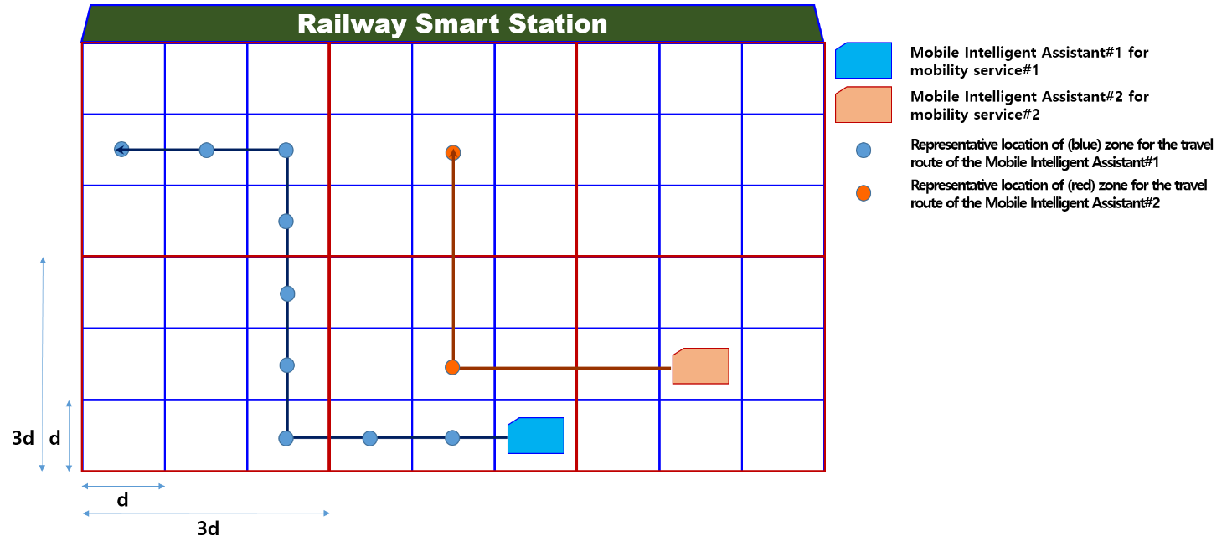

Figure 6.3.1-1. Example of multiple concurrent mobility services

### 6.3.2 Pre-conditions

1. There exist feasible Mobile Intelligent Assistants in the smart station, where the Mobile Intelligent Assistants support 3GPP system.

2. The Mobile Intelligent Assistants are operated under the central control system via 3GPP access.

3. Each Mobile Intelligent Assistant supports corresponding mobility service.

4. There exist more than or equal to two mobility services, where each mobility service requires different location accuracy, and is supported by different Mobile Intelligent Assistant.

### 6.3.3 Service Flows

1. Two different mobility services are initiated by the central control system.

2. A Mobile Intelligent Assistant#1 and a Mobile Intelligent Assistant#2 move along the predetermined path. Here, each path is characterized by the representative location of corresponding zone.

3. The Mobile Intelligent Assistant#1 and the Mobile Intelligent Assistant#2 moves along the representative location of blue and red zone.

5. Two different mobility services are completed by the Mobile Intelligent Assistant #1 and the Mobile Intelligent Assistant #2, where the completion time can be different.

### 6.3.4 Post-conditions

1. Two different mobility services are supported in the Railway Smart Station.

### 6.3.5 Existing features partly or fully covering the use case functionality

[R-5.11-001] The MCX Service shall support obtaining and conveying Location information describing the position of the MCX UE.

[R-5.11-002] The MCX Service should support obtaining and conveying high accuracy Location information describing the position of the MCX UE.

[R-5.11-002a] The MCX Service shall be able to provide a mechanism for obtaining high accuracy Location information by integrating position information from multiple external sources (e.g. magnetometers, orientation sensors, GNSS)

[R-5.11-003] The MCX Service shall provide for the flexibility to convey future formats of Location information.

[R-6.12-002] The MCX Service shall support conveyance of Location information provided by 3GPP location services.

Note: Please refer to TS 22.280 [7].

### 6.3.6 Potential New Requirements needed to support the use case

[PR-6.3.6-1] The MCX service shall support obtaining and conveying location information describing the positions of each MCX UE with different location accuracy simultaneously.

Note: The above requirement is intended to be included in Sections 5.11 and 6.12 of TS 22.280 [7].

## 6.4 Operation of platform screen doors

### 6.4.1 Description

For the safety of a platform, there is the need of screen doors placed on the edge of the platform to prevent dangerous situation when the train approaching the platform and passengers getting on and off the train. The screen doors are opened before the opening of train doors, and are closed after the closing of train doors. If there is emergency situation, the designated CCTVs are controlled to aim the emergency spot and rely the video of the spot to the train driver's monitors and the railway station staff's monitors including their UEs to assist their actions to cover the situation.



Figure 6.4.2-1 Operation of train and screen doors with CCTVs in a platform

### 6.4.2 Pre-conditions

Some CCTVs are pre-designated to aim each part of the platform in case of emergency.

The CCTVs, train driver, the staffs of the station are pre-defined as a group for the emergency.

In the train, a Trainborne System is to control the train doors. The Screen Door Controller handles the screen doors in the platform of the station. Between the system and the doors, a synchronisation is maintained to open and close the train's doors and the screen doors at the same time.

During the train approaching the platform of station, the Trainborne System and Screen Door Controller checking that the train stops in the right place and aligns the doors well.

### 6.4.3 Service Flows

1. The CCTVs in the train and in the platform, start video-recording each doors and displays the videos on the Train Driver's monitors. If the Train Driver finds abnormal status during monitoring the videos from the CCTVs, the Train Driver could open or close all the doors in the platform and the train manually.

2. Trainborne System notices the Screen Door Controller to open the train doors.

3. Screen Door Controller announces the screen door opening to the passengers in the platform via displays that are attached each screen doors and/or speakers of the train and the platform.

4. Screen Door Controller opens screen doors and notices to the Trainborne System.

5. Trainborne System makes announcement for the train door opening to the passengers in the train.

6. Trainborne System opens the train doors.

7. During a pre-defined time, train door sensors and screen door sensors detect passenger's moving. During the passengers are getting on and off the train, passengers could keep the doors open through pushing an emergency button on the doors. In this case, a notice is sent to the Train Driver and the staffs of the station in the pre-defined group to let them know this situation, and the designated CCTVs are controlled to aim the emergency spot with the location information of the emergency button to assist the Train Driver and the staff to figure out the situation.

8. The time is up, Trainborne System and Screen Door Controller announce to passengers the doors are closing. During the doors are closing, the sensors in the doors detected passengers or obstacles such as bag and umbrella in the door area, the doors are stopped closing and re-opened by the Trainborne System and Screen Door Controller automatically, and the Train Driver is noticed the situation by the Trainborne System. CCTVs are aimed the location of the doors, video-records the situation and display it on the Train Driver's monitors. The Train Driver could select a CCTV from the list of CCTVs in the platform, handles the CCTV to get closer video manually.

9. Trainborne System notices the train doors closing to the Screen Door Controller and closes the train doors.

10. Screen Door Controller closes the screen doors and notices the completion of closing door to the Trainborne System.

11. Trainborne System notices ready-to-go to the Train Driver.

### 6.4.4 Post-conditions

All the doors are closed and the train moves to the next station.

### 6.4.5 Existing features partly or fully covering the use case functionality

The group management are fully covered by 5G system and MCX framework.

Note: Please refer to TS 22.281 V17.0.0.

[R-5.1.3.1.2-001] The MCVideo service shall provide a mechanism for an MCVideo user to remotely control a camera on another MCVideo UE subject to relevant authorization.

[R-5.1.9.2.2-001] The MCVideo service shall provide a mechanism for an authorized MCVideo User to push video to another MCVideo User.

[R-5.1.9.2.2-002] The MCVideo service shall provide a mechanism for an MCVideo administrator to authorize an MCVideo user to push a video to another MCVideo user.

[R-5.1.9.2.2-008] The MCVideo service shall provide a mechanism for an MCVideo User to suspend and to resume receiving an incoming video stream from an MCVideo push.

Note: Please refer to TS 22.280 V18.2.0 [7].

[R-5.1.1-002] The MCX Service shall provide a mechanism by which an MCX UE makes a MCX Service group transmission to any MCX Service Group(s) for which the current MCX User is authorized.

[R-5.1.1-006] The MCX Service shall provide a mechanism for a dispatcher or authorized user to configure which content source shall be able to transmit the content to an MCX Service Group (e.g. video cameras near an incident).

[R-5.21.1.2-004] The MCX Service shall provide a mechanism for an MCX User to request an authorized MCX User (e.g., a dispatcher) to send an MCX Communication (e.g., video or data) to the MCX UE (downlink pull).

### 6.4.6 Potential New Requirements needed to support the use case

[PR-6.4.6-1] The FRMCS shall be able to provide a mechanism to trigger an emergency alert based on a combination of UE location (e.g. the location of the specific platform door / train door) and application-generated trigger (e.g. train door did not close properly due to a blockage).

## 6.5 Automatic monitoring of Railway Smart Station

### 6.5.1 Description

The monitoring of a railway station is a hard work. It should be made in 24 hours a day, 7 days a week. It is carried out through dozens of CCTVs, a controller could not check all the CCTVs at a moment. To assist monitoring CCTV, a AI system gives help to the controller. The AI system is a part of Railway Smart Station services, and it has live streaming video input from CCTVs in the Railway Smart Station. The AI system inspects the input video streams, finds abnormal situations such as illegal riding, neglected wandering of suspicious object, unauthorized entry, or user falls from the platform. If it detects abnormal situation, makes notice of warning to the Station Staff and Control office.

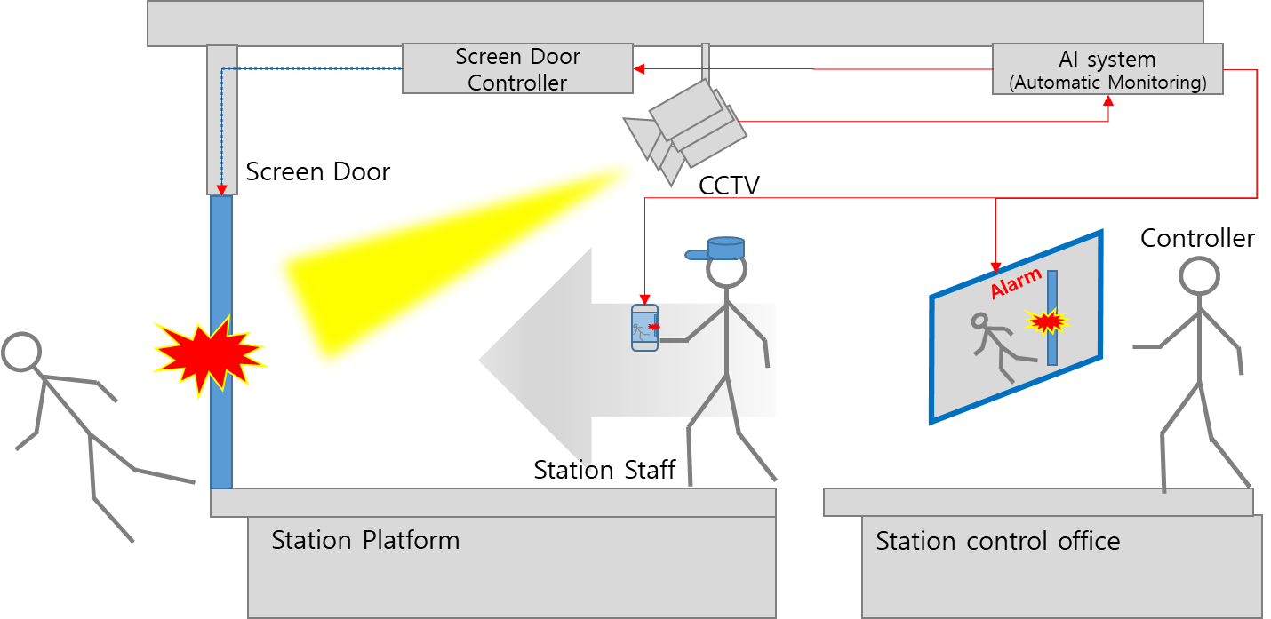

Figure 6.5.1-1 Use case of Automatic Monitoring that covers emergency situation

### 6.5.2 Pre-conditions

Some CCTVs are pre-designated to aim each part of the station in case of emergency.

A system of AI is trained to provide automatic monitoring functions for the railway smart station.

Some abnormal cases are pre-defined in the system.

### 6.5.3 Service Flows

1. The CCTVs in the station provide live streaming videos on the situation of the station such as platforms of the station.

2. The AI system looks at the video data from the dozens of CCTVs.

3. An abnormal situation is occurred. A passenger has fallen from the platform.

4. The AI system makes an alarm to the controller of the station to let him know the situation. The ​​system also sends a notification alarm to station staff who are close to the place where the situation occurred.

5. The staff arrives at the accident site, rescues the passenger, and organizes the surrounding situation.

6. The controller is aware of the situation and contacts the train to prevent it from entering the platform.

7. The AI system records the video, call history, and actions taken in the process of handling abnormal situations as data of the future learning.

### 6.5.4 Post-conditions

Passengers are rescued, circumstances are cleared up, and trains are allowed to enter the platform.

The data recorded by the AI ​​system is later used in audits for handling the case.

### 6.5.5 Existing features partly or fully covering the use case functionality

The group management are fully covered by 5G system and MCX framework.

Note: Please refer to TS 22.280 V18.2.0 [7].

[R-5.11-009] The MCX Service shall provide a means for an MCX UE to send a Location information update whenever a trigger condition is satisfied (e.g., initial registration, distance travelled, elapsed time, cell change, tracking area change, PLMN change, MCX Service communication initiation).

[R-6.15.4-004] The MCX Service shall provide a mechanism for a Mission Critical Organization to log at least the following metadata per communication: depending on service this may include; start time, date, MCX User ID, functional alias(es), MCX Group ID, Location information of the transmitting Participant, end time or duration, end reason, type of communication (e.g., MCX Service Emergency, regroup, private) and success/failure indication.

Note: Please refer to TS 22.281 V17.0.0.

[R-5.1.3.3.2-001] The MCVideo service shall provide a mechanism for an authorised MCVideo User to remotely start and stop local recording of video.

[R-5.1.3.3.2-002] The MCVideo service shall provide a mechanism for an authorised MCVideo User to remotely set triggers for automatic commencement of video transmission to authorised MCVideo Users; such triggers to include motion detection, time of day, face recognition, licence plate recognition, location and speed.

### 6.5.6 Potential New Requirements needed to support the use case

No new potential requirements identified.

# 7 Potential Consolidated Requirements

## 7.1 Introduction

The requirements below refer to a "*Railway Smart Station Services"*, which is acting as an application a FRMCS and the outer systems.

The potential consolidated requirements are mainly focusing the 5G Network characteristics and the interfaces between FRMCS/MCX Functions and Railway Smart Station Services as the application of FRMCS and outer system of 3GPP.



Figure 7.3-1 Scope of the Potential Consolidated Requirements

## 7.2 Functional aspects

**Table 7.2-1 Functional Aspects Consolidated Requirements**

| **CPR #** | **Consolidated Potential Requirement** | **Original PR #** | **Comment** |
| --- | --- | --- | --- |
| CPR 7.2-1 | The MCX service shall support obtaining and conveying MCX UE location information describing the positions of each MCX UE with different location accuracy simultaneously. | PR 6.3.6-1 | intended to be included in clauses 5.11 and 6.12 of TS 22.280 |
| CPR 7.2-2 | The FRMCS shall be able to provide a mechanism to trigger an emergency alert based on a combination of UE location (e.g. the location of the specific platform door / train door) and application-generated trigger (e.g. train door did not close properly due to a blockage) | PR-6.4.6-1 | intended to be included in a new clause of TS 22.280 |

## 7.3 Performance

Table 7.3-1: KPIs for Railway Smart Station Services

|  |  |  |  |  |  |  |  |  |  |
| --- | --- | --- | --- | --- | --- | --- | --- | --- | --- |
| **Scenario**  **(Note 5)** | **End-to-end latency** | **Reliability**  **(Note 1)** | **UE speed** | **UE Relative**  **Speed** | **User experienced data rate** | **Payload**  **size**  **(Note 2)** | **Area traffic density** | **Overall UE density** | **Service area dimension (Note 3)** |
| Multiple trains' stops at the same platform (Korea, urban railway) | ≤10 ms | 99.9999% | ≤100 km/h | ≤50km/h | ≤1Mb/s | Small to large | ≤ 1 Mb/s/km | ≤ 5 (100m) | ≤ 15 km  along rail tracks including bad weather conditions  (Note 4) |
|  | NOTE 1: Reliability as defined in TS 22.289 sub-clause 3.1.  NOTE 2: Small: payload ≤ 256 octets, Medium: payload ≤512 octets; Large: payload 513 -1500 octets.  NOTE 3: Estimates of maximum dimensions.  NOTE 4: Non-Line-of-Sight (NLOS) between UEs shall be supported  NOTE 5: Off-network traffic characteristics are not addressed in this table since it can be covered by TR22.990. | | | | | | | | |

Note: This table is intended to be included in clause 6.2 of TS 22.289 [9].

# 8 Conclusions and Recommendations

This technical report collects use cases and derives potential requirements related to RAILSS. This TR also clarifies whether the identified requirements are supported by the current 5G system or whether they are new potential requirements.

The consolidated potential requirements that are related to KPIs will be considered to be added in TS22.289. Most of other requirements may target MCX specifications, such as TS22.280 [7], TS22.281, and TS22.282 [8].

Annex A:  
Change history

|  |  |  |  |  |  |  |  |
| --- | --- | --- | --- | --- | --- | --- | --- |
| **Change history** | | | | | | | |
| **Date** | **Meeting** | **TDoc** | **CR** | **Rev** | **Cat** | **Subject/Comment** | **New version** |
| 09/2022 | SA#97e | SP-220935 |  |  |  | Raised to v.1.0.0 by MCC, solving missing Figure 6.5.1-1 (taken from S1-222357) | 1.0.0 |
| 09/2022 | SA#97e | - |  |  |  | Raised to v.19.0.0 by MCC following SA one-step approval | 19.0.0 |