3GPP TR 22.893 V10.0.0 (2009-12)

Technical Report

3rd Generation Partnership Project;

Technical Specification Group SA;

Study into identification of advanced requirements for IP interconnection of services;

(Release 10)

 

The present document has been developed within the 3rd Generation Partnership Project (3GPP TM) and may be further elaborated for the purposes of 3GPP.   
The present document has not been subject to any approval process by the 3GPPOrganizational Partners and shall not be implemented.   
This Specification is provided for future development work within 3GPPonly. The Organizational Partners accept no liability for any use of this Specification.  
Specifications and reports for implementation of the 3GPP TM system should be obtained via the 3GPP Organizational Partners' Publications Offices.

Keywords

LTE, services

***3GPP***

Postal address

3GPP support office address

650 Route des Lucioles - Sophia Antipolis

Valbonne - FRANCE

Tel.: +33 4 92 94 42 00 Fax: +33 4 93 65 47 16

Internet

[http://www.3gpp.org](http://www.3gpp.org/)

***Copyright Notification***

No part may be reproduced except as authorized by written permission.  
The copyright and the foregoing restriction extend to reproduction in all media.

© 2009, 3GPP Organizational Partners (ARIB, ATIS, CCSA, ETSI, TTA, TTC).

All rights reserved.

UMTS™ is a Trade Mark of ETSI registered for the benefit of its members

3GPP™ is a Trade Mark of ETSI registered for the benefit of its Members and of the 3GPP Organizational Partners  
LTE™ is a Trade Mark of ETSI currently being registered for the benefit of its Members and of the 3GPP Organizational Partners

GSM® and the GSM logo are registered and owned by the GSM Association

Contents

Foreword 4

1 Scope 5

2 References 5

3 Definitions and abbreviations 5

3.1 Definitions 5

3.2 Abbreviations 6

4 IP Inter-connect scenarios 6

4.1 Inter-Operator direct connection 6

4.2 Inter-Operator indirect connection 6

4.2.1 Transport Only mode 6

4.2.2 Service Transit mode 7

4.2.3 Hubbing mode 8

4.2.4 Use of multiple Indirect modes. 8

4.3 Operator to 3rd party connection 9

4.4 Interconnect use cases 10

4.4.1 Interconnect use case for interworking between CS and IMS-services 10

4.4.2 Use Cases for Transport Mode Connections 11

4.4.2.1 Use Case - Operator B has CS services only 11

4.4.2.2 Use Case – Operator B has CS services only, SLA covers CS & IMS 12

4.4.3 Use Cases for Service Transit mode Connections 13

4.4.3.1 Use Case – Operator B has CS services only, Interworking handled by Operator A 13

4.4.3.2 Use Case – Operator B has CS services only, Interworking delegated to Intermediate Carrier 14

4.4.3.3. Use Case – CS & IMS Domains, Fully Transparent Intermediate Carrier 15

4.4.4 Use Cases for Hubbing mode Connections 15

4.4.4.1 Use Case – Operator A has CS & IMS Domains, Operator B has CS Domain, Interworking 15

4.4.4.2 Use Case – Operator A has IMS Domain, Operator B has CS Domain, No Interworking 16

4.4.4.3 Use Case – CS & IMS Domains, IMS voice Interworking 16

5 Requirements for IP Inter-connect 17

5.1 Introduction 17

5.2 Service requirements 17

5.3 Technical requirements 18

5.4 Security requirements 19

5.5 Charging requirements 19

5.6 Interworking requirements 19

5.7 Private domain addressing requirements 19

5.8 Number Portability requirements 20

6 Requirements of the IP-Interconnection Intermediate Carrier 20

6.1 Introduction 20

6.2 General requirements 20

6.3 Media Layer 20

6.3.1 Transcoding 20

6.4 Transport Layer 20

6.4.1 IP version interworking 21

6.5 Application signalling 21

6.5.1 SIP signalling inter-working 21

6.6 Routeing 21

7 Conclusions 21

Annex A: Change history 23

# Foreword

This Technical Report has been produced by the 3rd Generation Partnership Project (3GPP).

The contents of the present document are subject to continuing work within the TSG and may change following formal TSG approval. Should the TSG modify the contents of the present document, it will be re-released by the TSG with an identifying change of release date and an increase in version number as follows:

Version x.y.z

where:

x the first digit:

1 presented to TSG for information;

2 presented to TSG for approval;

3 or greater indicates TSG approved document under change control.

y the second digit is incremented for all changes of substance, i.e. technical enhancements, corrections, updates, etc.

z the third digit is incremented when editorial only changes have been incorporated in the document.

# 1 Scope

This document studies the technical requirements for carrier grade inter-operator IP Interconnection of Services for the support of Multimedia services provided by IMS and for legacy voice and video PSTN/PLMN services transported over IP infrastructure (e.g. VoIP). These requirements should take into account the new and developing, convergent interconnect models currently being developed outside 3GPP.

Requirements should fulfil:

* Identification of the technical requirements for IP Service Interconnection (service control and user plane aspects) between Service Providers.
* Identification of requirements for the Stage 2 & 3 work to identify relevant existing specifications, initiate enhancements and the development of the new specifications as necessary.
* Supporting of IP Service Interconnection models as defined by other bodies (e.g. GSMA, ETSI, ITU-T).

# 2 References

The following documents contain provisions which, through reference in this text, constitute provisions of the present document.

* References are either specific (identified by date of publication, edition number, version number, etc.) or non‑specific.
* For a specific reference, subsequent revisions do not apply.
* For a non-specific reference, the latest version applies. In the case of a reference to a 3GPP document (including a GSM document), a non-specific reference implicitly refers to the latest version of that document *in the same Release as the present document*.

[1] 3GPP TR 21.905: "Vocabulary for 3GPP Specifications".

[2] GSMA PRD IR.34: "Inter-Service Provider IP Backbone Guidelines"

[3] 3GPP TS 23.003: "Numbering, addressing and identification"

# 3 Definitions and abbreviations

## 3.1 Definitions

For the purposes of the present document, the terms and definitions given in TR 21.905 [1] and the following apply. A term defined in the present document takes precedence over the definition of the same term, if any, in TR 21.905 [1].

**IP-Interconnection Intermediate Carrier:** a intermediate entity that provides interconnection in different levels (Service, Transport) (e.g. IPX).

**IP Service Interconnection**: An IP interconnection where the definition scope goes beyond the pure technical/network scope and takes into account the requirements for the services supported by that interconnection.

**IP Packet Exchange:** a relationship model and requirements set defined by GSMA aiming at resolving all IP Service Interconnection functions between/among Service Providers of User-to-User services, through a specialized player called IPX Provider (IPXP), assuring:

* Openness: for any kind of Service Provider.
* Quality and security: through a private IPX network, as an alternative to the Internet.
* Efficiency: multi-service support (one-connection, one agreement).
* Cascade responsibility in the chain of interconnecting operators.

**Operator:** The entity which offers telecommunication services to the end user by means of a wireless or fixed access (i.e. mobile or fixed network operator).

**Service Provider:** A Service Provider is either a network operator or another entity that provides services to a subscriber (e.g. a MVNO).

**User-to-User Services:**  Are retail services that allow communication between End Users. U2U services need E2E (End-to-End) network support.

## 3.2 Abbreviations

For the purposes of the present document, the abbreviations given in TR 21.905 [1] and the following apply. An abbreviation defined in the present document takes precedence over the definition of the same abbreviation, if any, in TR 21.905 [1].

IPX IP Packet eXchange

GRX GPRS Roaming eXchange

IPXP IPX Provider

U2U User to User

E2E End to End

# 4 IP Inter-connect scenarios

## 4.1 Inter-Operator direct connection

This scenario is where the IP Service Interconnection is direct between operators' core networks without the use of any IP-Interconnection Intermediate Carrier. The relationship between the operators is bilateral to support User to User services.

This scenario allows operators complete control over the interconnection but may not be efficient for most inter-operator connections owing to the cost and complexity of maintaining individual connections. It will probably be used for inter-connection on high traffic routes.

## 4.2 Inter-Operator indirect connection

This scenario is where the IP connection between core networks uses an IP-Interconnection Intermediate Carrier that may have additional functionality (e.g. SIP Proxy). An example is the IPX network. The connection can be made on 3 modes:

* Transport Only,
* Service Transit,
* Hubbing,

These modes are further explained below.

NOTE: More complex scenarios are possible by concatenating the modes below.

### 4.2.1 Transport Only mode

An indirect connection mode where the IP-Interconnection Intermediate Carrier simply relays the IP traffic from one operator to another or first converts the TDM traffic to IP traffic if required and then relays it. There is no additional functionality in the IP-Interconnection Intermediate Carrier; it should also, however, ensure that end to end security is maintained.

Note that TDM break-out was not covered by GSMA/IR.34 [2]

For this mode, the agreement between the two interconnected Service Providers and the IP-Interconnection Intermediate Carrier(s) mainly relates to providing IP connectivity between the two Service Providers in a similar fashion to providing leased transport capacity and it may include the capability to support different levels of QoS.

For each pair of Service Providers interconnected using a Transport Only connection, an agreement with the IP-Interconnection Intermediate Carrier(s) is needed. This needs to include bandwidth requirements and the required QoS parameters and these need to be consistent end-to-end.

Agreements on service level are established directly between each of the two interconnected Service Providers in a similar fashion as for the Inter-Operator direct connection.



Figure 1: Service Provider A interconnection to Service Providers B and C using Transport Only connections

### 4.2.2 Service Transit mode

An indirect connection mode where, in addition to the relaying of IP traffic (following conversion of the TDM traffic to IP traffic if required), the IP-Interconnection Intermediate Carrier has service awareness and can treat the traffic accordingly; it should also ensure that end-to-end security is maintained.

For this mode, the agreement between the two interconnected Service Providers and the IP-Interconnection Intermediate Carrier(s) includes, besides providing IP connectivity between the two Service Providers, some level of service awareness by the Intermediate Carrier(s). To apply this service awareness, the IP-Interconnection Intermediate Carrier may need to inspect communication services established between the two Service Providers using the Service Transit connection. To perform this inspection, the Intermediate Carrier uses the IP-Interconnection Intermediate Carrier Proxy (IIC-Proxy). The IIC-Proxy may be used to identify to which Service Transit connection a communication service pertains, as well as to some level recognize the service itself. The latter does not imply that service transparency between the two Service Providers cannot be achieved.

The level of service awareness required by the IP-Interconnection Intermediate Carrier should be defined in the Service Level Agreement between the Service Provider and the IP-Interconnection Intermediate Carrier but may include determining if the session is voice, real-time video or data. Further awareness, e.g. of the type of data service offered, may be required depending on the agreement between the Service Provider and the IP-Interconnection Intermediate Carrier.

Service Transparency means that the IP-Interconnection Intermediate Carrier does not modify the communication between the Service Providers in any way. but it routes the call to the correct network destination ( i.e. CS vs IMS).

For each pair of Service Providers interconnected using a Service Transit connection, an agreement with the IP-Interconnection Intermediate Carrier(s) is needed. This needs to include bandwidth requirements and the QoS parameters used for different services.

In addition to the Service Transit agreement with the IP-Interconnection Intermediate Carrier(s), the two Service Providers may still have an end-to-end Service Level Agreement directly with each other.



Figure 2: Service Provider A interconnection to Service Providers D and E using Service Transit connections

### 4.2.3 Hubbing mode

An indirect connection mode, where the IP-Interconnection Intermediate Carrier relays the IP traffic (following conversion of the TDM traffic to IP traffic if required) to multiple destinations and provides additional service functionality for the Operator including service awareness, destination routeing, charging and end-to-end security.

For this mode, each Service Provider has an agreement the with the IP-Interconnection Intermediate Carrier to establish communication service to other Service Providers with which no end-to-end Service Level Agreement need exist between the Service Providers. The application of the necessary bandwidth and QoS parameters needs to be consistent end-to-end along the chain of inter-connected entities. The IP-Interconnection Intermediate Carrier(s) should ensure this.

To achieve this, the IP-Interconnection Intermediate Carrier needs be service aware such that the Service Level Agreements with both originating and terminating Service Providers for each can be fulfilled. To apply this service awareness, the IP-Interconnection Intermediate Carrier needs to inspect the communication services that are being.provided. To perform this inspection, the Intermediate Carrier uses the IP-Interconnection Intermediate Carrier Proxy (IIC-Proxy). The IIC-Proxy is, among other things, used to identify the destination Service Provider and to route the communication service accordingly.

The level of service awareness required by IP-Interconnection Intermediate Carrier is as defined in clause 4.2.2, above.



Figure 3: Service Provider A interconnection to Service Providers X and Y using Hubbing mode

### 4.2.4 Use of multiple Indirect modes.

A Service Provider may use different types of IP interconnections to different Service Providers. The Service Provider may for example use a direct connection to one Service Provider, an indirect Transport Only mode connection to a second Service Provider, a Service Transit indirect connection to a third Service Provider and, in addition, indirect Hubbing mode may be used to inter-connect to other Service Providers.



Figure 4: Service Provider A interconnection to other Service Providers using different connection modes

In addition, it is expected that Service Providers may wish to use several types of interconnections between them, e.g. both a direct connection and an indirect connection. It is furthermore expected that a Service Provider may select by agreement which indirect connection modes to use e.g. Transport Only mode as well as Hubbing mode.

Note, that a hybrid mode, whereby, for example, connection from Service Provider A to Service Provider B uses Transport Only and connection from Service Provider B to Service Provider A uses Hubbing is not envisaged as the Service level Agreement between Service Providers is expected to be symmetrical.

As each Inter-Operator IP connection may be under the control of different agreements with the other Service Provider and/ or IP-Interconnection Intermediate Carrier, it is important that the Service Providers (and IP-Interconnection Intermediate Carrier) can identify not only between which Service Providers a communication is established but also which Inter-Operator IP connection mode the communication pertains to. This is in particular important for indirect connections, as it is expected that one single IP interface between a Service Provider and the IP-Interconnection Intermediate Carrier may be used for multiple indirect IP connections.

## 4.3 Operator to 3rd party connection

This scenario is where Operators have an IP connection to third party such as an Application Provider (e.g to a messaging provider) either direct or using an IP-Interconnection Intermediate Carrier (e.g IPX or Internet). The 3rd party does not have its own mobile or fixed network but could have customers that access using the Internet, for example, Google or MSN.

This scenario can be considered as a particular one of previous scenarios (see clauses 4.1 and 4.2) where the Operators and 3rd Party Application Providers can interconnect.

End to end connection between an Operator's end users and a 3rd Party's end users could be made either directly or over an IP-Interconnection Intermediate Carrier such as the IPX. Alternatively, the 3rd Party could simply provide a service such as music or video download. An Operator's end users could access this either directly or over an IP-Interconnection Intermediate Carrier such as the IPX.

## 4.4 Interconnect use cases

### 4.4.1 Interconnect use case for interworking between CS and IMS-services

When there exist networks that support both CS and IMS services, as well as networks that only support a single type of service (e.g. CS only services), then there is a need for interworking at the service level between CS domain services and IMS domain services. One basic example of service interworking would be between CS voice service and IMS MMTel service.

This service interworking can be an important capability, particularly during periods of migration between CS networks and IMS networks. During this migration period, some Operators may support IMS-based services only while other Operators may support the corresponding service over legacy PLMN only.

In general, use of an interworking capability will reduce the functionality of the overall E2E user service. The possibility to have the session on the same E2E service should be used whenever possible; Interworking should only be invoked when necessary.

As a basis for these use cases it is assumed that the Inter-operator IP Interconnection between the two Operators uses the same IP interconnection for both circuit switch services and IP multimedia services as shown in Figure 5.



Figure 5: One IP-interconnection used to interconnect both CS- and IMS-Core Networks

Some basic interworking scenarios are shown below



Figure 6: Call from a CS user of Operator A to User of Operator B (supporting CS only)

In this case no service inter working between the CS services provided by Operator A and the CS service provided by Operator B is needed (assuming the same set of services is supported), and the call should be delivered as an end-to-end CS call



Figure 7: Call from an IMS user of Operator A to User of Operator B (supporting CS only)

In this case inter-working between the IMS services provided by Operator A and the CS service provided by Operator B is needed to provide end-to-end connectivity between the two users.



Figure 8: Call from an IMS user of Operator A to IMS User of Operator B (supporting IMS only)

In this case no inter-working between the IMS services provided by Operator A and the IMS service provided by Operator B is needed, and the call should be delivered as an end-to-end Multimedia call



Figure 9: Call from an CS user of Operator A to IMS User of Operator B (supporting IMS only)

In this case inter-working between the CS services provided by Operator A and the IMS service provided by Operator B is needed to provide end-to-end connectivity between the two users.

The scenarios above show that there are different options for where interworking occurs. There is a need to understand what information is used by the network to determine where and how interworking should occur. This information could be in the form of Service Level Agreements and/or part of the signalling for a session.

Where and how inter-working can be performed or avoided for these and other use cases need be studied and further explored in the context of the different interconnect scenarios, such that the relevant requirement can be identified. These use cases are described in the clauses below.

### 4.4.2 Use Cases for Transport Mode Connections

#### 4.4.2.1 Use Case - Operator B has CS services only

**Pre-Condition**

Operator A has CS and IMS domain services; Operator B has CS domain services only.

Transport agreement exists between Operator A, Intermediate Carrier and Operator B

Service Level agreement between Operator A and Operator B is:-

Only CS services are supported on the Interconnect

**Call Flow**

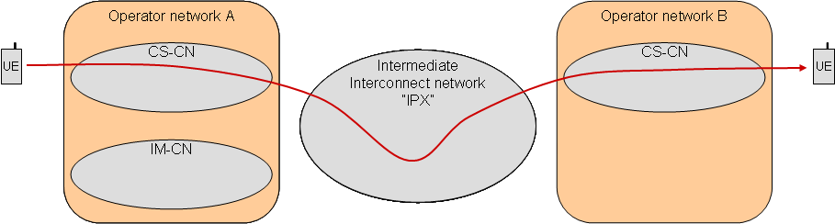

Figure 10: transport mode, no interworking

Operator A is aware that the call originates in CS domain and no interworking is performed.

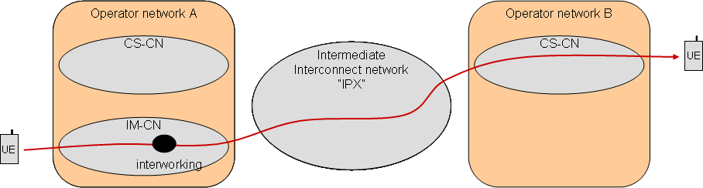

Figure 11: transport mode, originating network interworking

Operator A is aware that the call originates in IMS domain, and based upon Agreement performs interworking between the originating IMS service and the terminating CS service.

#### 4.4.2.2 Use Case – Operator B has CS services only, SLA covers CS & IMS

**Pre-Condition**

Operator A has CS and IMS domain services, Operator B has CS domain services only.

Transport agreement exists between Operator A, Intermediate Carrier and Operator B

Service Agreement between Operator A and Operator B is :-

Both CS and IMS services are supported on the Interconnect

**Call Flow**



Figure 12: transport mode, no interworking

Operator A is aware that the call originates in CS domain and no interworking is performed. Operator B delivers the call to UE-B and no interworking is performed.

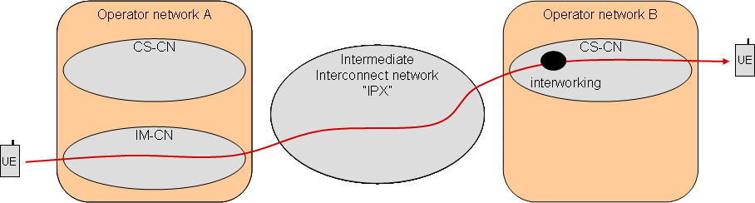

Figure 13: transport mode, terminating network interworking

Operator A is aware that the call originates in IMS domain, and based upon SLA no interworking is performed. Operator B identifies from the incoming session signalling that the call originates in IMS domain and performs interworking between the originating IMS service and the terminating CS service.

### 4.4.3 Use Cases for Service Transit mode Connections

The use case for Service Transit connection mode are similar to those for Transport Only connection mode, because in both cases a service aware agreement exists between Operator A and Operator B. However, the Service Transit mode ensures that the Intermediate Carrier is service aware, and so it is possible for Operators to delegate the interworking capability to the Intermediate Carrier that the Operator uses.

To perform this interworking, when needed, the IP-Interconnect Intermediate Carrier to which the delegating Operator interconnects needs to know the service capabilities of that Operator.

#### 4.4.3.1 Use Case – Operator B has CS services only, Interworking handled by Operator A

**Pre-Condition**

Operator A has CS and IMS domain services, Operator B has CS domain services only.

Service Agreement between Operator A and Operator B is :-

Only CS services are supported on the Interconnect

Service Agreement between Operator A and Intermediate Carrier is :-

Basic Service Transit with no interworking

**Call Flow**

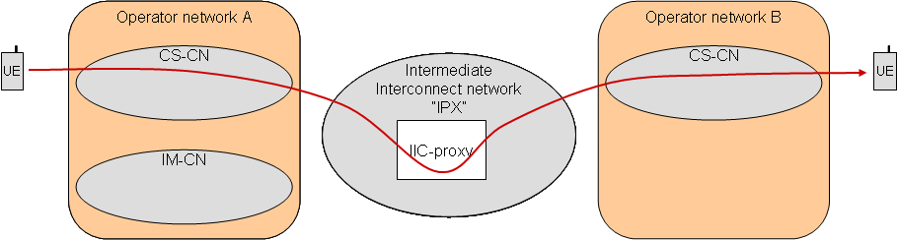

Figure 14: service transit mode, no interworking

Operator A is aware that the call originates in CS domain and no interworking is performed before the session is delivered to the Intermediate Carrier. Based upon the incoming signalling, the Intermediate Carrier determines that interworking is not needed and no interworking is performed.

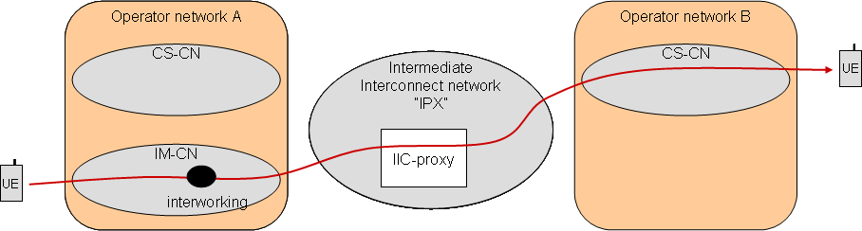

Figure 15: service transit mode, originating network interworking

Operator A is aware that the call originates in IMS domain and based upon Agreements performs interworking between the originating IMS service and the terminating CS service. Based upon the incoming signalling, the Intermediate Carrier determines that interworking is not needed and no interworking is performed.

#### 4.4.3.2 Use Case – Operator B has CS services only, Interworking delegated to Intermediate Carrier

**Pre-Condition**

Operator A has CS and IMS domain services, Operator B has CS domain services only.

Service Agreement between Operator A and Operator B is :-

Only CS services are supported on the Interconnect

Service Agreement between Operator A and Intermediate Carrier is :-

All CS and IMS services are supported on the Interconnect

Intermediate Carrier agrees to perform Interworking on behalf of Operator A for all services

**Call Flow**



Figure 16: service transit mode, no interworking

Operator A is aware that the call originates in CS domain and no interworking is performed as the session is delivered to the Intermediate Carrier. The Intermediate Carrier identifies from the incoming session signalling that the session originates in the CS domain. The Intermediate Carrier acts transparently, and no interworking is performed.

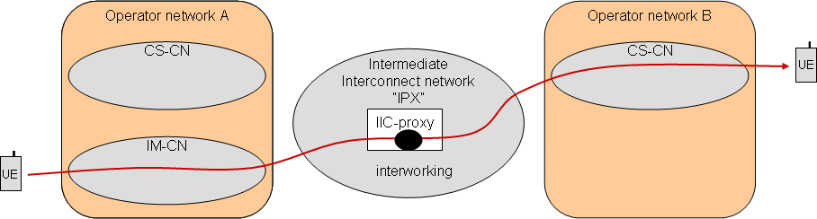

Figure 17: service transit mode, Intermediate network interworking

Operator A is aware that the call originates in IMS domain and no interworking is performed as the session is delivered to the Intermediate Carrier. The Intermediate Carrier identifies from the incoming session signalling that the session originates in the IMS domain and based upon Service Agreements performs interworking between the originating IMS service and the terminating CS service.

#### 4.4.3.3. Use Case – CS & IMS Domains, Fully Transparent Intermediate Carrier



Figure 18: service transit mode, no Intermediate network interworking

**Pre-Condition**

Operator A has a CS and IMS domain, Operator B has a CS and IMS domain.

Service Agreement between Operator A and IP-Interconnect Intermediate Carrier is :-

All CS and IMS domain services are supported on the Interconnect

Intermediate Carrier agrees to perform Interworking on behalf of Operator A for all services

Service Agreement between Operator B and IP-Interconnect Intermediate Carrier is :-

All CS and IMS domain services are supported on the Interconnect

IP-Interconnect Intermediate Carrier agrees to perform Interworking on behalf of Operator B for all services

**Call Flow**

For all sessions between Operator A & Operator B, the IP-Interconnect Intermediate Carrier should act transparently and not perform any Interworking. CS sessions should be identified by the IP-Interworking Intermediate Carrier and delivered to the CS domain of Operator B. IMS sessions should be identified by the IP-Interconnect Intermediate Carrier and should be delivered to the IMS domain of Operator B. This means the IPX Carrier would route the SIP-I calls to the CS domain and the SIP calls to the IMS domain.

### 4.4.4 Use Cases for Hubbing mode Connections

The use case for Hubbing mode connections place more responsibility upon the Intermediate Carrier because there is no agreement between Operator A and Operator B. Indeed, Operator A may not have determined who the destination operator is.

#### 4.4.4.1 Use Case – Operator A has CS & IMS Domains, Operator B has CS Domain, Interworking

**Pre-Condition**

Operator A has a CS and IMS domain services, Operator B has a CS domain services.

Service Agreement between Operator A and Intermediate Carrier is :-

All IMS domain services are supported on the Interconnect

Intermediate Carrier agrees to perform Interworking on behalf of Operator A for all services

Service Agreement between Operator B and Intermediate Carrier is :-

All CS domain services are supported on the Interconnect

Intermediate Carrier agrees to perform Interworking on behalf of Operator B for all services

**Call Flow**



Figure 19: Hubbing mode, Intermediate network interworking

All (IMS) sessions from Operator A to Operator B require Interworking. The IMS sessions are delivered to the Intermediate Carrier. The Intermediate Carrier identifies that the incoming session is an IMS session and based upon Agreements attempts to perform interworking. For sessions that can be interworked, the session is delivered to the CS domain of Operator B. Some IMS sessions may not be interworked if there is no equivalent in the CS domain.

#### 4.4.4.2 Use Case – Operator A has IMS Domain, Operator B has CS Domain, No Interworking

**Pre-Condition**

Operator A has a IMS domain services, Operator B has a CS domain services.

Service Agreement between Operator A and Intermediate Carrier is :-

All IMS domain services are supported on the Interconnect

Intermediate Carrier provides basic Hubbing for Operator A, but interworking is not provided

Service Agreement between Operator B and Intermediate Carrier is :-

All CS domain services are supported on the Interconnect

Intermediate Carrier provides basic Hubbing for Operator B, but interworking is not provided

**Call Flow**

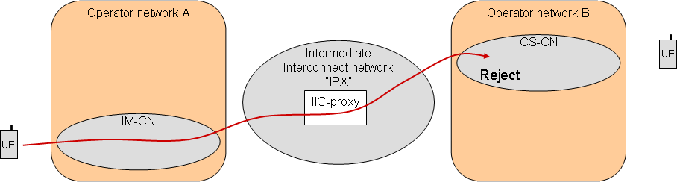

Figure 20: Hubbing mode, no interworking

All (IMS) sessions from Operator A to Operator B require Interworking but no interworking point is defined. Some or all IMS sessions towards Operator B may fail. This scenario is therefore not recommended, it is included to demonstrate the risk of not providing interworking at the IP-Interconnect Intermediate Carrier.

#### 4.4.4.3 Use Case – CS & IMS Domains, IMS voice Interworking

**Pre-Condition**

Operator A has a CS and IMS domain, Operator B has a CS and IMS domain.

Service Agreement between Operator A and Intermediate Carrier is :-

All CS and IMS services are supported on the Interconnect

Intermediate Carrier agrees to perform Interworking on behalf of Operator A for all services

Service Agreement between Operator B and Intermediate Carrier is :-

All CS services are supported on the Interconnect

All IMS services except Voice are supported on the Interconnect

Intermediate Carrier agrees to perform Interworking on behalf of Operator B for all services

**Call Flow**

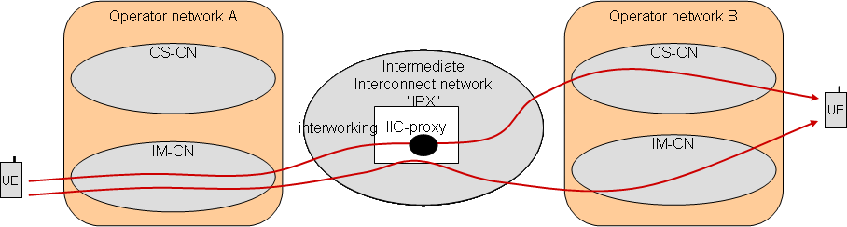

Figure 21: Hubbing mode, Intermediate network interworking for IMS voice

CS sessions from Operator A to Operator B do not require Interworking by the Intermediate Carrier, and should be delivered to the CS domain of Operator B.

IMS non-voice sessions from Operator A to Operator B do not require Interworking by the Intermediate Carrier, and should be delivered to the IMS domain of Operator B

IMS voice sessions from Operator A to Operator B do require Interworking by the Intermediate Carrier, and should be delivered to the CS domain of Operator B

# 5 Requirements for IP Inter-connect

## 5.1 Introduction

1. The requirements described in this clause will apply equally to any of the above mentioned interconnection scenarios and may apply to the originating or terminating Service Provider depending on the scenario and individual case considered.

## 5.2 Service requirements

In IP Service Interconnection, signalling and different media types do have different QoS requirements.

IP Service Interconnection of Service Providers shall support QoS features E2E:

* It shall be possible to differentiate classes of traffic and to mark these types of traffic.
* It shall be possible to reject a new service request or a modification to an existing service according to static and dynamic policies applied in the interconnection.
* All the Service Providers involved in the transport of the service data (signalling and media) shall be able to treat the different traffic types according to their marking in order to guarantee an adequate E2E QoS.

IP Service Interconnection shall support Emergency services and suitable prioritization of these services for interconnection within the same country.

IP Service Interconnection shall support Priority service and suitable prioritization of this service for interconnection within a country where Priority Service is applicable.

IP Service Interconnection shall support mechanisms for lawful interception where these are needed for interconnection.

Transparent service interoperability (as defined in clause 4.2.2) must be ensured across all the segments involved in service delivery (E2E).

## 5.3 Technical requirements

Requirements defined for each service shall be fulfilled in multiservice scenarios where several services are provided over the same IP Service Interconnection.

Service Providers may use different Inter-Operator connections, e.g.direct or different indirect modes for each service independently.

Interconnection Points shall be uniquely defined between each pair of Service Providers (i.e. by means of a SLA), and work in a consistent manner regardless the access network (i.e. fixed, mobile CS, mobile PS) used by the end-user.

The Inter-Operator connection that is used for the establishment of a service between two Service Providers, shall be uniquely identified. To achieve this unique identification, also when multiple modes of indirect interconnections across intermediate networks are used, information about the IP Interconnection Intermediate Carrier and mode of indirect interconnection may be needed in addition to information about the interconnected service providers. This information could be used by the IP-Interconnect Intermediate Carrier for advanced routeing capabilities (e.g. least cost routeing) and inter-operator accounting.

It shall be possible to use one single IP interconnection between a pair of Service Providers for both IP multimedia services and legacy circuit-switch services (over IP) at the same time.

It shall be possible for the IP Interconnection Intermediate Carrier to identify whether a communication pertains to a circuit switched service or a particular IP Multimedia service (e.g. MMTel, PSTN emulation). This allows the IP Interconnection Intermediate Carrier to perform Interworking when necessary and if allowed by the Service Provider and to perform routeing to the correct interconnect point.

It shall be possible for the terminating Service Provider to determine which communication domain to use (i.e. circuit switched service or an IP Multimedia service) based on the type of communication from the originating Service Provider (direct or via an IP-Interconnect Intermediate carrier). This allows the terminating Service Provider supporting both a Circuit-switched core network and an IP Multimedia Core network to direct the call to the appropriate domain.

It shall be possible for the originating Service Provider to determine which communication domain to use (i.e. circuit switched service or an IP Multimedia service) based on the type of destination. This allows the originating Service Provider supporting both a Circuit-switched core network and an IP Multimedia Core network to direct the call to the appropriate domain.

Transparent E2E IP connectivity and interworking (for both IPv4 and IPv6 addressing schemes) shall be possible in all IP inter-connect scenarios. To facilitate this, mechanisms for IP Interworking (e.g. IP address and/or port translation, IP version translation) should be employed.

Transcoding in the media path shall be possible to enable communication between domains.

It shall be possible to apply load balancing mechanisms (including mechanisms such as call gapping) and dynamic selection of routes at the interconnection point of a Service Provider's network in all modes..

It shall be possible to monitor QoS parameters to provide real-time evaluation of network performance.

Service Providers should be able to apply static and dynamic policies in the interconnection points, in order to allocate resources and manage traffic accordingly, taking into account different sources of information such as service signalling, network congestion, real-time QoS parameters.

Where required by local regulation or Operator policy, emergency calls at an interconnection point:

- Are identified emergency calls by the destination (e.g. "112" or SIP URI), or by an indication in the call establishment request;

- have call establishment requests processed in preference to other call establishment requests in the event of restricted availability of resources;

- may still be established when ordinary calls meet congestion at the interconnect point.

When the network resources are under load conditions, and where required by local regulation or Operator policy, emergency calls and priority calls should have a priority to network resources over "ordinary" calls.

Where required by local regulation or Operator policy, priority calls at a point of interconnect:

- are identified as priority calls by an indication in the call establishment request;

- have call establishment requests processed in preference to other call establishment requests in the event of restricted availability of resources;

It should be noted that emergency and priority calls do not affect any established calls of any category.

## 5.4 Security requirements

Service Provider's interconnection points must offer protection against DoS attacks (e.g. attacks coming from unknown/untrusted sources, volume-based attacks), discarding the packets and generating real-time filters for future situations.

It shall be possible to statically and dynamically control which Service Providers can access the Service Provider's network interconnection point.

Service Provider's' network interconnection points shall have recovery mechanisms so that interconnection link remains active after any attacks or security issues.

## 5.5 Charging requirements

1. IP Service Interconnection of Service Providers shall support E2E cascade charging. Other charging models (e.g. bill and keep) should be supported as well.
2. It shall be possible for the Service Providers to generate detailed charging information (e.g. CDRs…) at the interconnection point for signalling and media (in a service IP flow basis). The detailed charging information shall allow the Service Providers to differentiate charging based on originating network, terminating network, intermediate carrier used, duration, bandwidth, volume etc.

## 5.6 Interworking requirements

Where a bi-lateral agreement exists between two Service Providers, the interworking capability shall be provided by the Service Providers where necessary.

In the case of a Service Transit mode connection, the interworking capability may be delegated by the Service Provider to the IP Interconnection Intermediate Carrier.

For Hubbing mode connections, the IP Interconnection Intermediate Carrier may, if allowed by the Service Provider, provide interworking between CS and IMS domain services when necessary.

## 5.7 Private domain addressing requirements

In addition to addresses based on TEL URIs ,e.g. MSISDN and E.164 numbers, and SIP URIs in the form user@<service provider domain> ,it shall be possible to support IMS services across an Inter-Operator IP connection where the destination user is identified by SIP URI containing a private domain name e.g. John.Smith@enterpriseX.com.

To support IMS services where the destination user is identified by an address in the form <user>@<Private domain> , and where the destination user is not served by the originating Service provider, the capability to resolve the Private domain name to the serving service provider is required. The resolution capability should be done such that the service can be delivered to the addressed user by its Service provider using the original user address. The capability should allow the use of direct and indirect IP interconnections.

NOTE: To facilitate resolution of a private domain name to a service provider domain that can be used for routeing of the service, new facilities similar to ENUM may be needed.

## 5.8 Number Portability requirements

The Service Provider and the IP-interconnect Intermediate Carrier should support the different Number Portability solutions to ensure that the most suitable routeing is used based on the destination and the type of service (e.g. CS or IMS).

# 6 Requirements of the IP-Interconnection Intermediate Carrier

## 6.1 Introduction

With an IP-interconnection intermediate carrier (e.g. IPX) the focus expands from just Transport/Connectivity interconnection functions (e.g. GRX) to the concept of IP Service Interconnection, adding:

* proxy/signalling interworking functions enhancing the network level (e.g IPv4/IPv6 interworking)
* service-aware functions (service level)
* formalization of the agreement functions to be provided (agreements level), both in bilateral arrangements or multilateral/hubbing arrangements (more efficient since one single contract resolves all relations)

## 6.2 General requirements

3GPP specification should support following requirements:

* The IP-interconnection Intermediate Carrier shall be capable to act transparently towards connected parties.
* IP-interconnection Intermediate Carrier shall be capable to act in a service agnostic manner.
* The introduction of an IP-interconnection Intermediate Carrier should have minimal impacts in the Service Provider's network.
* Interconnection scenarios with more than one IP-interconnection Intermediate Carrier shall be supported.

## 6.3 Media Layer

Different types of media (e.g. speech, video, files, etc…) shall be supported in all IP inter-connect scenarios.

### 6.3.1 Transcoding

1. Use of transcoding should be minimized.
2. For "end-to-end" media session, a codec negotiation procedure may be applied between end interconnected parties using different media codecs.
3. The IP-interconnection Intermediate Carrier may provide functionalities to transcode the user plane.

## 6.4 Transport Layer

1. IP-interconnection intermediate carrier shall be able to support tunnelled traffic (e.g. GRE) and non-tunnelled traffic, for both control and user planes.

Although it shall be possible to apply Service Provider defined policy at the interconnection point, this does not preclude applying any intermediate carrier defined policy in case an indirect connectivity shall be used, according to SLAs defined between the Service Provider and IP-interconnection Intermediate Carrier. Concretely:

* Authorization and granting of resources: open/close gates for traffic flows
* E2E QoS: traffic classifying and marking (e.g. Diffserv support) for both inbound and outbound traffic.
* Monitoring of resources being used

### 6.4.1 IP version interworking

1. Transparent end-to-end IP connectivity and interworking (for both IPv4 and IPv6 addressing schemes) shall be possible in all IP inter-connect scenarios. To achieve this, mechanisms for IP Interworking (e.g. IP address and/or port translation, IP version translation) may be employed at IP-interconnection Intermediate Carrier.

## 6.5 Application signalling

### 6.5.1 SIP signalling inter-working

IP-Interconnection Intermediate carrier should be capable of supporting interworking between e.g.:

* Different SIP versions
  + SIP-I (as defined in 3GPP TS29.235 and ITU-T recommendation Q.1912.5)
  + IMS Profile SIP (as defined in 3GPP TS24.229)
  + SIP (as defined in RFC3261)
* BICC/ISUP signalling
* H.323
* All variants of described above (e.g. international and regional variants)

To facilitate end to end cascade charging, CDR analysis and cross-network fault finding, a simple means of referencing a single call as it traverses networks should be provided in all application signalling specified in 3GPP.

Note: this is expected to apply to SIP-I, IMS Profile SIP and BICC networks.

## 6.6 Routeing

1. It shall be possible to configure the media route taking into account state information related to network entities.
2. QoS metering and reporting could be applied to decide the next hops in the media path by providing real-time evaluation of network and route performance in border nodes. Another use could be SLA verification.
3. The IP-interconnection Intermediate Carrier shall be able to route traffic correctly to the destination (e.g. on IP layer)
4. The IP-interconnection Intermediate Carrier shall be capable of resolving names across domains interconnected. (e.g. DNS, ENUM).
5. 3GPP TS 23.003 [3], Section 13 (Numbering, addressing and identification within the IP multimedia core network subsystem) gives details of SIP and E.164 numbering
6. 3GPP TS 23.003 [3], Section 20 (Addressing and Identification for IMS Centralized Services) gives details of address resolution and routeing requirements that should be taken into account.

# 7 Conclusions

New requirements for the IP-interconnection of operators using an IP-interconnection Intermediate Carrier have been identified in sections 5 and 6 in this Technical Report. It is therefore recommended that these sections are used as a basis for introducing new requirements into 3GPP Technical Specifications.

It is also recommended that requirements from other organisations working on IP Interconnection (e.g. GSMA) are obtained and also included in the changes to 3GPP Technical Specifications. Overlapping with activities carried out by GSMA (e.g. IPX) and other bodies in the area of IP interconnection should be avoided.

This report recommends that, as far as possible, new requirements are captured in one single place in an existing specification. Therefore, it is recommended to introduce a new section in the TS 22.101.

However, it is also recognized that some of the identified requirements only concern IMS and Interconnection of IP Multimedia Networks. For such requirements the proposal is to introduce a new section in TS 22.228.

Annex A:  
Change history

|  |  |  |  |  |  |  |  |  |  |  |  |
| --- | --- | --- | --- | --- | --- | --- | --- | --- | --- | --- | --- |
| Change history | | | | | | | | | | | |
| **TSG SA#** | **SA Doc.** | **SA1 Doc** | **Spec** | **CR** | **Rev** | **Rel** | **Cat** | **Subject/Comment** | **Old** | **New** | **WI** |
| 2009-12 | SP-090850 | - | 22.893 | - | - | 10 |  | Raised by MCC to v.10.0.0 after approval of SA#46 | 2.0.0 | 10.0.0 |  |