3GPP TR 22.985 V10.0.0 (2011-03)

Technical Report

3rd Generation Partnership Project;

Technical Specification Group Services and System Aspects;

Service requirements for the User Data Convergence (UDC) (Release 10)



The present document has been developed within the 3rd Generation Partnership Project (3GPP TM) and may be further elaborated for the purposes of 3GPP.   
The present document has not been subject to any approval process by the 3GPPOrganizational Partners and shall not be implemented.   
This Specification is provided for future development work within 3GPPonly. The Organizational Partners accept no liability for any use of this Specification.  
Specifications and reports for implementation of the 3GPP TM system should be obtained via the 3GPP Organizational Partners' Publications Offices.

Keywords

network topology, user data, home registry

***3GPP***

Postal address

3GPP support office address

650 Route des Lucioles - Sophia Antipolis

Valbonne - FRANCE

Tel.: +33 4 92 94 42 00 Fax: +33 4 93 65 47 16

Internet

http://www.3gpp.org

***Copyright Notification***

No part may be reproduced except as authorized by written permission.  
The copyright and the foregoing restriction extend to reproduction in all media.

© 2011, 3GPP Organizational Partners (ARIB, ATIS, CCSA, ETSI, TTA, TTC).

All rights reserved.

UMTS™ is a Trade Mark of ETSI registered for the benefit of its members

3GPP™ is a Trade Mark of ETSI registered for the benefit of its Members and of the 3GPP Organizational Partners  
LTE™ is a Trade Mark of ETSI currently being registered for the benefit of its Members and of the 3GPP Organizational Partners

GSM® and the GSM logo are registered and owned by the GSM Association

Contents

Foreword 4

1 Scope 5

2 References 5

3 Definitions, symbols and abbreviations 5

3.1 Definitions 5

3.2 Symbols 5

3.3 Abbreviations 5

4 General description 6

4.1 Introduction 6

5 User Data 8

5.1 User data basic concept 8

5.2 User data category 8

5.2.1 Introduction 8

5.2.2 User Subscription Data 8

5.2.3 User content Data 8

5.2.4 User Behaviour Data 9

5.2.5 User Status Data 9

5.3 User data convergence 9

5.4 Common baseline information model and data model 10

5.4.1 Introduction to User Data Modelling 10

5.4.2 Requirements for the baseline information model 11

5.4.3 Requirement for data models 11

5.4.4 Management of information model and data model 11

6 Requirement of user data convergence 13

6.1 Introduction 13

6.2 Redundancy, Scalability and Load control Aspects 14

6.3 Network Considerations 14

6.4 User data interface 14

6.5 Subscription/Notification 14

6.6 Access control 14

6.7 Management of user data 15

6.7.1 Self care system: 15

6.7.2 Application server and user service configuration 15

6.8 Data federation 15

Annex A: Change history 16

# Foreword

This Technical Report has been produced by the 3rd Generation Partnership Project (3GPP).

The contents of the present document are subject to continuing work within the TSG and may change following formal TSG approval. Should the TSG modify the contents of the present document, it will be re-released by the TSG with an identifying change of release date and an increase in version number as follows:

Version x.y.z

where:

x the first digit:

1 presented to TSG for information;

2 presented to TSG for approval;

3 or greater indicates TSG approved document under change control.

y the second digit is incremented for all changes of substance, i.e. technical enhancements, corrections, updates, etc.

z the third digit is incremented when editorial only changes have been incorporated in the document.

# 1 Scope

The present document describes the concept of the 3GPP User Data Convergence (UDC). It furthermore collects some architectural requirements and should be taken as guideline in stage 2 and 3 work.

The UDC will simplify the overall network topology and interfaces, avoid data duplication and inconsistency and simplify creation of new services by providing easy access to the user data.

Special consideration is put on the following areas:

- Categorization of the user data of services which would be converged in UDC

- Identification of the requirements on the common data model framework with focus on extensibility

- Identification of the requirements on the UDC for the support of new services including their provisioning

# 2 References

The following documents contain provisions which, through reference in this text, constitute provisions of the present document.

* References are either specific (identified by date of publication, edition number, version number, etc.) or non‑specific.
* For a specific reference, subsequent revisions do not apply.
* For a non-specific reference, the latest version applies. In the case of a reference to a 3GPP document (including a GSM document), a non-specific reference implicitly refers to the latest version of that document *in the same Release as the present document*.

[1] 3GPP TR 21.905: "Vocabulary for 3GPP Specifications".

# 3 Definitions, symbols and abbreviations

## 3.1 Definitions

## 3.2 Symbols

## 3.3 Abbreviations

For the purposes of the present document, the abbreviations given in TR 21.905 [1] and the following apply. An abbreviation defined in the present document takes precedence over the definition of the same abbreviation, if any, in TR 21.905 [1].

UDC User Data Convergence

UDR User Data Repository

# 4 General description

## 4.1 Introduction

In the current 3GPP system, user data are scattered in several domains (e.g. CS, PS, IMS) and different network entities (e.g. HLR, HSS, Application Servers). With the increase of user data entities and the resulting data types, it is more difficult for integrated services to access necessary user information from plural entities.

The scenario mentioned herein is kind of called “User Data Silo”, which is the major paradigm of user data deployment for the time being, as illustrated by Fig.1.

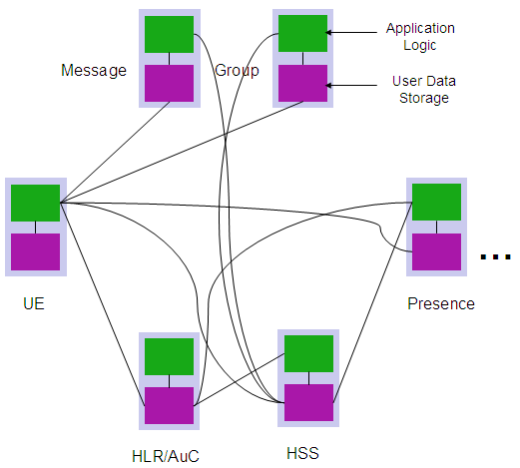

Figure 1 User Data Silo

With the user data silos, user data are independently accessed, stored and managed independently. That brings many challenges to network deployment and evolution. Different user data access interfaces impose complexity on network topology as well as on application development, especially for booming Internet services and incoming IP-based UE applications; separated user data increases management workload. Moreover, new networks and services such as IMS are expected, so that the introduction of their user data only makes things worse, not to mention network and service convergence even if those user data have a lot in common and are correlated to each other. Separation also undermines the value of user data mining.

User data convergence is required to ensure the consistency of storage and data models. User data convergence will simplify overall network topology and interfaces, overcome the data capacity bottleneck of a single entry point, avoid data duplication and inconsistency and reduce CAPEX and OPEX. Also it will simplify the creation of new services and facilitate service development and deployment though a common set of user data. Finally it will promote service and network convergence to support the increasing number of new services including Internet services and UE applications. In this regard, a new facility User Data Repository (UDR) should be considered for user data convergence.

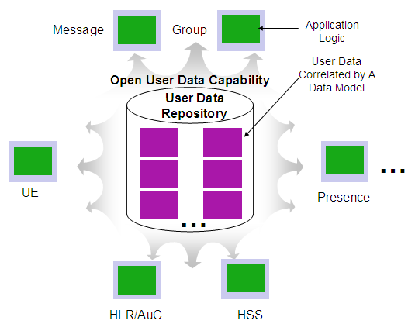

Figure 2 User Data Convergence

As illustrated by Fig. 2, User Data Convergence, as opposed to User Data Silo, is simply to move the user data from where it belonged, to a facility here called User Data Repository (UDR) where it can be accessed, stored and managed in a common way. Despite of the diversity of user data structures for different services, user data can be decomposed and reformed by a common data model framework (e.g. tree-like data model, rational data model) provided by UDR. In that case, user data categorized by services can be regrouped and identified by user ID, leaving no data redundancy. Also, convergence in data model will unify the user data access interface and its protocol, which will promote new service application development. Thereby, the capability of user data convergence can be open to creation of data-less applications.

# 5 User Data

## 5.1 User data basic concept

There are plenty of data distributed in the 3GPP system which is used to perform the services, for instance, the configuration data of a network entity, the session data of a multimedia call, the IP address of a terminal, etc. With respect to user data, it refers to all kinds of the information related to users who make use of the services provided by the 3GPP system.

In 3GPP system, user data is spread widely through the different entities (e.g. HLR, HSS, VLR, Application servers) and also the type of user data is various. It is of paramount importance to categorize the user data before going through the convergence of user data.

## 5.2 User data category

### 5.2.1 Introduction

The UDC shall support multiple application user data simultaneously, e.g. HSS and others.

Any application can retrieve data from the UDC and store data in it. The applications shall be responsible of updating the UDC with the dynamic changes of the user profile due to traffic reasons (e.g. user status, user location…) or as a consequence of subscriber procedures.

The hereafter data classification highlights some major differences regarding two of the characteristics : Size per user and real time applicability.

### 5.2.2 User Subscription Data

Before a user can enjoy a service, he may need to subscribe the service first. The subscription data relates to the necessary information the mobile system ought to know to perform the service. User identities (e.g. MSISDN, IMSI, IMPU, IMPI), service data (e.g. service profile in IMS) , and transparent data (data stored by Application Servers for service execution) are the examples of the subscription data. This kind of user data has a lifetime as long as the user is permitted to use the service and may be modified during the lifetime.

User may be accessed and configured via various means, e.g. customer service, web interface, UE Presence service.

The subscription data is composed of different types such as authentication data, configuration data, etc. Different type of data may require different levels of security.

### 5.2.3 User content Data

Some applications may have to store content defined by the user and that here may be quite large (e.g. Photos, videos)

User content data can reach very high volume (e.g. Hundreds of Mbytes and more), and the size required to store them may largely vary over time. They generally do not require the real time constraints as user profile data may require.

Storage of user data content is not typically subject of UDR.

Storage of user data content is not typically subject of UDR. UDC on user content data can be achieved by converging them with links or references, such as URLs, to other entity.

### 5.2.4 User Behaviour Data

Such data concerns the usage of services by a user as services are consumed. Generally there are event data records that can be generated on various events in the usage of services by a user and that can be used not only for charging or billing purposes but e.g. for user profiling regarding user behaviour and habits, and that can be valuable for marketing purposes.

The amount of such data is also quite different from other categories, they present a cumulative effect as such data can be continuously generated by the network implying a need for corresponding storage.

Usage data may require real time aspects about their collection (e.g. for on line charging), they are also often characterized by a high amount of back office processing (e.g. Billing, user profiling).

The data related to user behavior comprises

- call-related or session-related dynamic data (e.g. session state, MSRN) which are transitory and only valid during a session

- location-related data (e.g. VLR number, SGSN number) or/and registration status (e.g. MS status, registration status in IMS domain) which are valid between location updates or registrations

Processing of user behaviour data such as for CRM, billing, data mining is not typically subject of UDR. Those might be processed with lower priority or by external systems whereby UDR supports mass data transfer.

### 5.2.5 User Status Data

This kind of user data contains call-related or session-related dynamic data (e.g. MSRN, P-TMSI), which are typically stored in VLR or SGSN. These dynamic data are only used by their owner transitorily and proprietarily, and hardly shared by other services in the short term.

## 5.3 User data convergence

The user data repository is to facilitate the share and the provisioning of user-related data throughout services of 3GPP system. Accessing user data from a centralized database simplifies the development and deployment of new integrated services. There are many kinds of user data in the 3GPP system. But it is not advisable to converge all these data in user data repository. In respect of the session-related dynamic data, it is only used transitorily and proprietarily which would be hardly shared by other services in the short term. Therefore, convergence of subscription data, customized user data and partially user behavior data, such as location-related data and registration status should be subject of UDC. From the data distribution point of view, subscription data mainly exist in HLR, HSS and application servers of current 3GPP network. The subscription data and charging are located in SPR, Location-related and registration-status-related data exist in HLR and HSS. Taking one with another, it is feasible for user data repository to contain the data within network entities including e.g.:

- HLR/HSS

- SPR

- Application servers

- MMS relay/server

## 5.4 Common baseline information model and data model

### 5.4.1 Introduction to User Data Modelling

An Information Model denotes an abstract, formal representation of entity types, including their properties and relationships, the operations (e.g. read, write…) that can be performed on them, and related rules and constrains. In the information model, entities might have network topology relationship with each other.

The Common Baseline Information Model does not define the models that are associated with each application and that are under their responsibility.

In Figure3, we start from a Common Baseline Information Model. It is the subject of 3GPP to standardize a Common Baseline Information Model for telecommunication applications.

Operators can further extend the Common Baseline Information Model by means of specialization. A Specialized Information Model describes the specific relationships between the information in a given particular case. The Specialized Information Model takes into account the specific applications, the functionality included and the relevant business information. A Specialized Information Model is operator specific and it shall not be standardized by 3GPP.

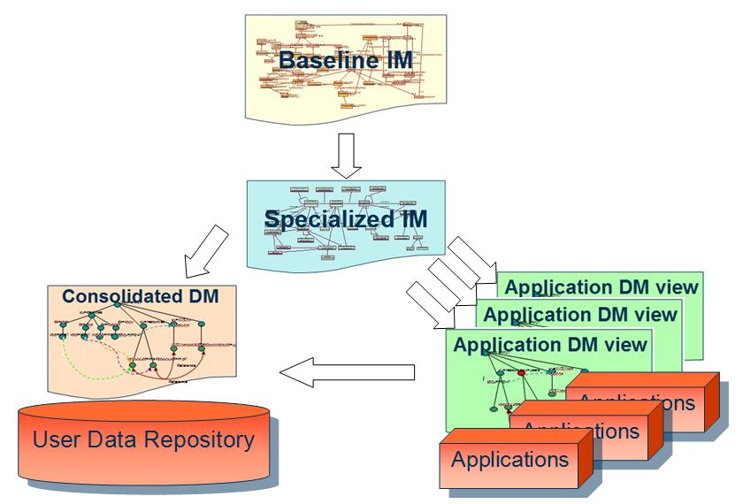

Figure 3: Information Model versus Data Model

The implementation of the Specialized Information Model for a given application leads to an Application Data Model View. This includes implementation and protocol-specific details, e.g. mapping managed objects onto lower-level protocol constructs. It also includes all the specific data that are required by an application**.**

An Application Data Model View is created also for security and authorization purposes, i.e. to keep applications stable when data model is changed.

Since a single Specialized Information Model is able to serve a number of applications, several Application Data Model Views are possible (one per application). Application Data Model views shall not be standardized by 3GPP.

An implementation of the whole Specialized Information Model in the User Data Repository for all the applications leads to the Consolidated Data Model. Applications, though, only see a portion of the Consolidated Data Model, i.e., Applications only see the data that is required by the application. The Consolidated Data Model shall not be standardized by 3GPP.

## 5.4.2 Requirements for the baseline information model

In order to accommodate multiple applications and services, existing and new ones, a common baseline information model shall be developed. It should be subject to some basic requirements.

This information model shall denote an abstract, formal representation of entity types, including their properties and relationships, and the operations (e.g. read, write…) that can be performed on them.

Note: The information model provides for an abstract description of entities, relationships etc.. The actual data model is derived from the information model. The data model is to be implemented in the UDR.

The information model shall, at minimum, clearly distinguish a number of concepts as entity types:

* Subscriber with relation to several users (e.g. a company and its employees),
* A user attached to different subscriptions (e.g. for a private and a professional service usage)
* A user using multiple devices (e.g. mobiles or fixed)
* Grouping of users to certain categories
* A particular user is a member of a certain group
* Service providers’ services provided by network operators
* Enterprise services provided by network operators

The implementation of this information model is operator specific.

The baseline information model shall be future proof. It shall not be tied to any specific implementation of the data base or its interfaces. It shall provide flexibility (in its data structure and content), extensibility and multi-application approach.

By extensible, it shall be understood that new applications and/or new service profiles can be added by the operator, if necessary. The flexibility shall permit new data for existing applications to be introduced, or modified.

## 5.4.3 Requirement for data models

The data model is a practical implantation of the information model, e.g. Tree-like modelling. It shall be possible to derive one or more data models from the common information model.

Each application shall only interface the UDC for the data it is dealing with, and not be impacted by other data that UDC stores for other applications. It corresponds to the concept of a data view specific to a given application.

An application can allow access by other applications to data for which it is responsible. This can be done under certain constraint customized by operators.

For this purpose, the external view of the data of an application can be exposed to other applications. Particular attention should be given when it concerns write operations: The application responsible for the data will have to ensure the consistency of the data that are updated. Focus is on the common way such data are exposed by an application, and on the common mechanism that can be used. The data view or the exposed data model remains under the responsibility of the application and is out of the scope of this release.

## 5.4.4 Management of information model and data model

The UDR should have the capacity to easily integrate data models within the information model as well as integrating new user data needed by the applications by upgrading the data model. The UDR may specify a minimum set of rules to be respected to allow an easy integration in the UDR, it concerns in particular the main identifiers that could be common to several applications.

Changes to a specific data model should not affect any running application other than the one using such data model.

When the data model is upgraded due to new-coming user data, the data views exposed to the running applications should be kept unchanged in case the application logic needs upgrade.

The user data model should be extensible in its data structure and content, in order to constantly accommodate changes in its data structure as user data convergence requires.

Operator should be able to impose customized constrains on data model, like which user data is accessible and which data is not.

Under those constrains above, different application should be allowed to create their own different and unchanged data model view, to ensure security and application logic stability.

# 6 Requirement of user data convergence

## 6.1 Introduction

The UDC concept shall support a layered architecture, separating the data from the application logic, so that user data is stored in a logically unique repository allowing access from core and service layer entities, named application front-ends.

The network elements, which data are identified to be converged into the UDR in this TR, should support splitting the functionality of the network element from the data store.

To reduce operational costs and to facilitate the deployment of the UDC, each front-end application should provide access to different application functions (i.e. each front-end application should support multiple interfaces and application functions).

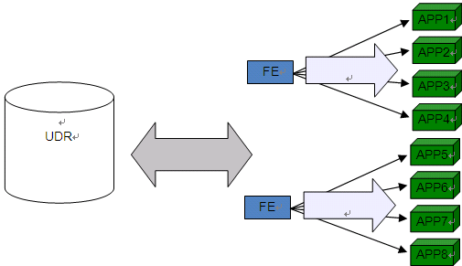

Figure 4: Multi-application FE Scenario

The network elements, which data are identified to be converged into the UDR in this TR, should support splitting the functionality of the network element from the data store.

Future network elements and functionalities should be designed to access profile data remotely via the defined reference point and without storing them permanently locally, i.e. the front-ends shall work in a subscriber data-less configuration so that, after completion of a request, the subscriber data local copy is deleted and the next application level transaction for the same subscriber can be served by a different front end.

Third party applications and non trusted network elements should only be able to access the user data after proper authentication and authorization taking into account security and privacy requirements, i.e. it should be possible to present different views on the data to the parties which require access, dependent on the authorization.

## 6.2 Redundancy, Scalability and Load control Aspects

In order to avoid single point of failure, the UDC shall support distribution and redundancy of subscriber data, e.g. via multiple geographically distributed subscriber data replicas.

Distribution and redundancy shall not imply data in the different replicas to differ, i.e. the UDC shall provide methods for data consistency.

UDC shall allow independent scalability of network traffic and data storage.

Load control and overload protection mechanisms shall be implemented.

## 6.3 Network Considerations

UDC concept shall be backwards compatible with 3GPP R8 systems, i.e. it shall not have an impact on traffic mechanisms, reference points and protocols of existing network elements.

The layered architecture shall not have an impact on the security available in the existing networks, i.e. it shall preserve user authentication and authorization of services across domains, ensuring secured users’ access to network.

## 6.4 User data interface

UDC shall provide other network elements with the capability to access the data.

* The UDC interface shall be independent of the structure of the common user data model, i.e. the changes of common user data model shall not effect the interface
* The UDC interface shall support creation, deletion, read and modification of user data in UDC
* The UDC interface shall support notification of the related entities about changes of user data which they have subscribed to.
* Operations carried on by UDC shall support the ACID (Atomicity, Consistency, Isolation, and Durability) characteristics.

## 6.5 Subscription/Notification

UDC should allow the applications to subscribe to specific events which will likely occur on specific user data, and notify the applications when those events do appear. The events can be changes on existing user data, addition of user data, and so on. Specifically, UDC shall allow applications to subscribe to specific events on specific data of specific users or all users.

## 6.6 Access control

UDC shall provide applications with controlled access. Accordingly, UDC shall authenticate and authorize applications or users. The authentication and authorization can be customized diversely, based on the following criteria.

* application type
* application identifier
* the users which are requested
* the user data which are requested
* the request type (e.g. query, modify, create, delete)

## 6.7 Management of user data

Due to the logical centralization of user data, it is necessary for UDC to support the provisioning (or business support system) on the user data, that is, user data manipulations like add, delete, change and other operations. However, the provisioning should not be allowed to manipulate on the user baseline information model, which is about how the user data are constructed. The interoperation between UDC and the provisioning is out of the scope of this TR.

-The UDC should support following provisioning possibilities of user data:

- Provisioning from an OSS system of the operator on an individual basis or on a bulk basis

- Provisioning from self care systems interfacing subscribers or users that should allow large amounts of users to initiate provisioning actions with good response time

- Provisioning via Applications servers that often offer user service configurations facilities (eg via Ut interface) and that will control the validity of user requests before storing the data in the UDC

### 6.7.1 Self care system:

A self care system is typically a web application that can be accessed by a PC through which the user can access its user profile and configure its service, its user preferences (in the limits of what is authorized by the service provider and its subscription). Many users can simultaneously have active sessions with the web server to configure their services. They are also expecting web type response time of a few seconds for their request to be updated in the network (and not e.g. One day later).

Examples can concern supplementary services configuration, definition of identity aliases, configuration of IP centrex users.

### 6.7.2 Application server and user service configuration

Application servers can offer interfaces through which the user via its terminal can configure its service without using an external provisioning system. 3GPP has defined the Ut interface for this purpose and concerns AS in general.

## 6.8 Data federation

Some services may depend on user data scattered over UDC and other network elements. UDC may support the ability to access necessary network elements to fetch user data on behalf of these services. Such services would access the respective component in the UDC solution to acquire user data without perceiving where these data is located. It is not envisaged that this functionality would be part of UDR. However, the architecture is not subject of this TR and it is understood that in some cases, the data federated may belong to non-standard domain which could make this capability an implementation issue.

In case of data federation using the UDC solution impacts on existing Network Elements in which the data is located should be minimized.

Annex A:  
Change history

|  |  |  |  |  |  |  |  |  |  |  |  |
| --- | --- | --- | --- | --- | --- | --- | --- | --- | --- | --- | --- |
| Change history | | | | | | | | | | | |
| **TSG SA#** | **SA Doc.** | **SA1 Doc** | **Spec** | **CR** | **Rev** | **Rel** | **Cat** | **Subject/Comment** | **Old** | **New** | **WI** |
| SP-42 | SP-080787 | S1-084359 | 22.985 | - | - | Rel-9 | - | One-step-approved by SA#42 | 1.0.0 | 9.0.0 | UDC |
| 2011-03 | - | - | - | - | - | - | - | Update to Rel-10 version (MCC) | 9.0.0 | 10.0.0 |  |